Supplementary Table

Table S1 Evaluation of the crystallite size of synthesized nanoparticles through X-ray diffraction analysis.

Sample | 2θ (°) | (hkl) | FWHM (°) | D (nm) | D_{average} (nm)
AgNPs | 38.2626 | 111 | 0.0191 | 7.76 | 8.08
AgNPs | 43.9674 | 200 | 0.0235 | 6.44 | 8.08
AgNPs | 64.5727 | 220 | 0.0173 | 9.61 | 8.08
AgNPs | 77.3941 | 311 | 0.0211 | 8.50 | 8.08
ZnONPs | 31.8258 | 100 | 0.7690 | 9.94 | 8.35
ZnONPs | 34.4964 | 002 | 1.0758 | 7.05 | 8.35
ZnONPs | 36.2824 | 101 | 0.7803 | 9.67 | 8.35
ZnONPs | 47.6096 | 102 | 0.7018 | 10.36 | 8.35
ZnONPs | 56.6690 | 110 | 0.7018 | 9.96 | 8.35
ZnONPs | 62.9536 | 103 | 0.7950 | 8.52 | 8.35
ZnONPs | 68.1973 | 112 | 1.4332 | 4.59 | 8.35
ZnONPs | 69.0673 | 201 | 0.9757 | 6.71 | 8.35

Supplementary Figure

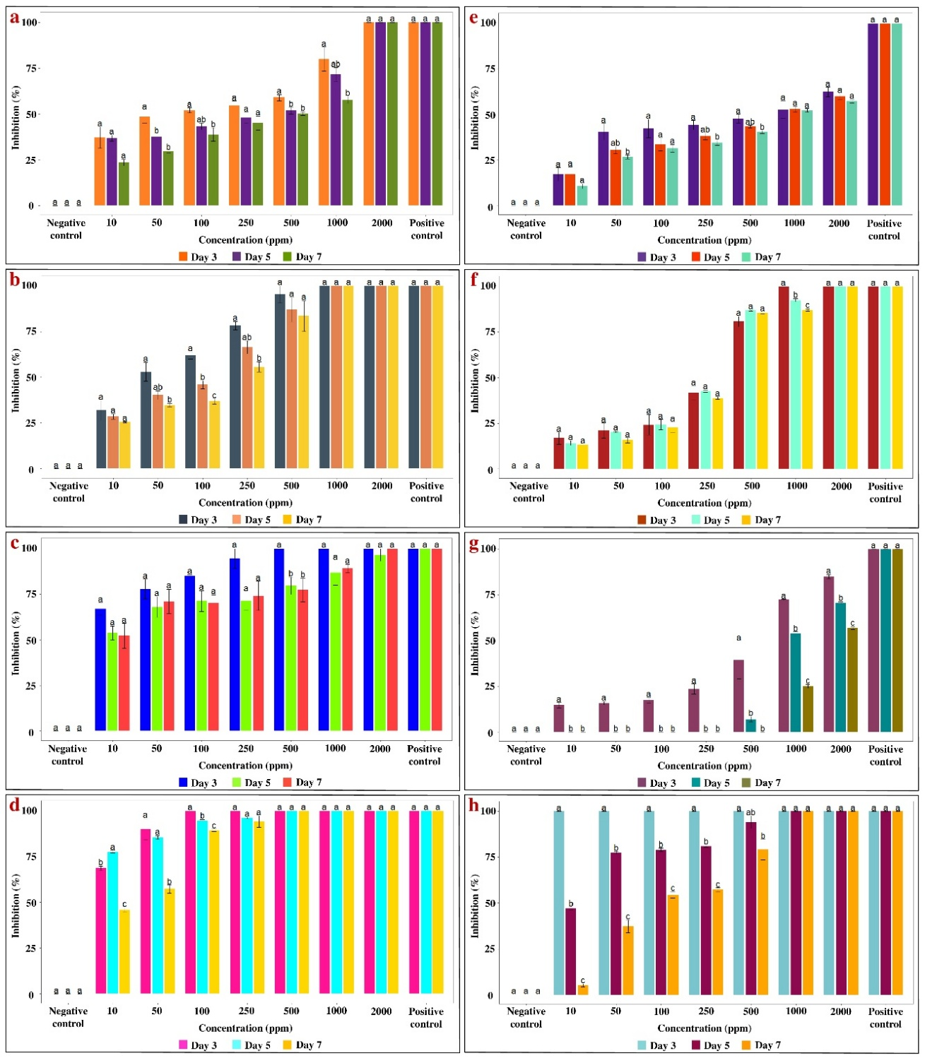
Fig. S1. Bar plot analysis of AgNPs (first row) and ZnONPs (second row) exhibits the percentage inhibition against four phytopathogenic fungi at different concentrations and days intervals against: (a, e) Colletotrichum gloeosporioides, (b, f) Colletotrichum falcatum, (c, g) Rhizoctonia solani, and (d, h) Sclerotinia sclerotiorum. The inhibition percentages of specific concentrations of the Ag nanoformulations displayed significant differences, as indicated by distinct letters based on Tukey’s test. Groups labelled with different letters were significantly different, whereas groups with same letter did not show a significant difference.

