Supplementary Materials

Supplementary Figure 1. Flowchart of ctDNA collection and sequencing.
Supplementary Figure 2. Association of genetic mutations with baseline clinicopathological characteristics.
Supplementary Figure 3. Association of gene alternations with PFS and OS.
Supplementary Figure 4. Association of mTBI level with treatment efficacy.
Supplementary Figure 5. The multivariate COX analysis of baseline characteristics and mTBI status in placebo group.
Supplementary Figure 6. Kaplan-Meier plots by PI3K pathway status in bireociclib and placebo group.
Supplementary Figure 7. Kaplan-Meier plots by MYC pathway status in bireociclib and placebo group.
Supplementary Figure 8. Kaplan-Meier plots by gBRCA-included HRRm status in bireociclib and placebo group.
Supplementary Figure 9. Kaplan-Meier plots by gBRCA or non-gBRCA-included HRRm status in bireociclib and placebo group.
Supplementary Figure 10. Interaction analysis between PIK3CA/ESR1 co-mutation status and treatment for PFS.
Supplementary Figure 11. Interaction analysis between ESR1 mutation status and treatment in all PIK3CA-mutation patients for PFS.
Supplementary Figure 12. Kaplan-Meier plots of dynamic ctDNA status for survival outcomes in placebo group.
Supplementary Figure 13. Kaplan-Meier plots of PFS in patients treated with bireociclib versus placebo, categorized by dynamic changes in ctDNA status.
Supplementary Figure 14. Kaplan-Meier plots of dynamic mTBI change for survival outcomes in placebo group.
Supplementary Figure 15. Associations between dynamic PIK3CA and ESR1 status with survival outcomes in placebo group.
Supplementary Figure 16. The mutation frequency of each gene across three time points in placebo group.
Supplementary Figure 17. Gene heatmap of longitudinal paired (C1D1, C5D1, EOT) samples in bireociclib group.
Supplementary Figure 18. Gene heatmap of longitudinal paired (C1D1, C5D1, EOT) samples in palcebo group.
Supplementary Table 1. 1021 Gene list and the targeted regions.
Supplementary Table 2. Clinicopathologic features and survival outcomes in ITT and ctDNA-evaluable populations.
Supplementary Table 3. The univariate COX analysis of baseline characteristics and mTBI for PFS in bireociclib group.
Supplementary Table 4. The univariate COX analysis of baseline characteristics and mTBI for PFS in placebo group.
Supplementary Figure 1. Flowchart of ctDNA collection and sequencing.
Abbreviations: ctDNA, circulating tumor DNA; C5D1, day 1 of cycle 5; EOT, end of treatment.

Supplementary Figure 2. Association of genetic mutations with baseline clinicopathological characteristics.
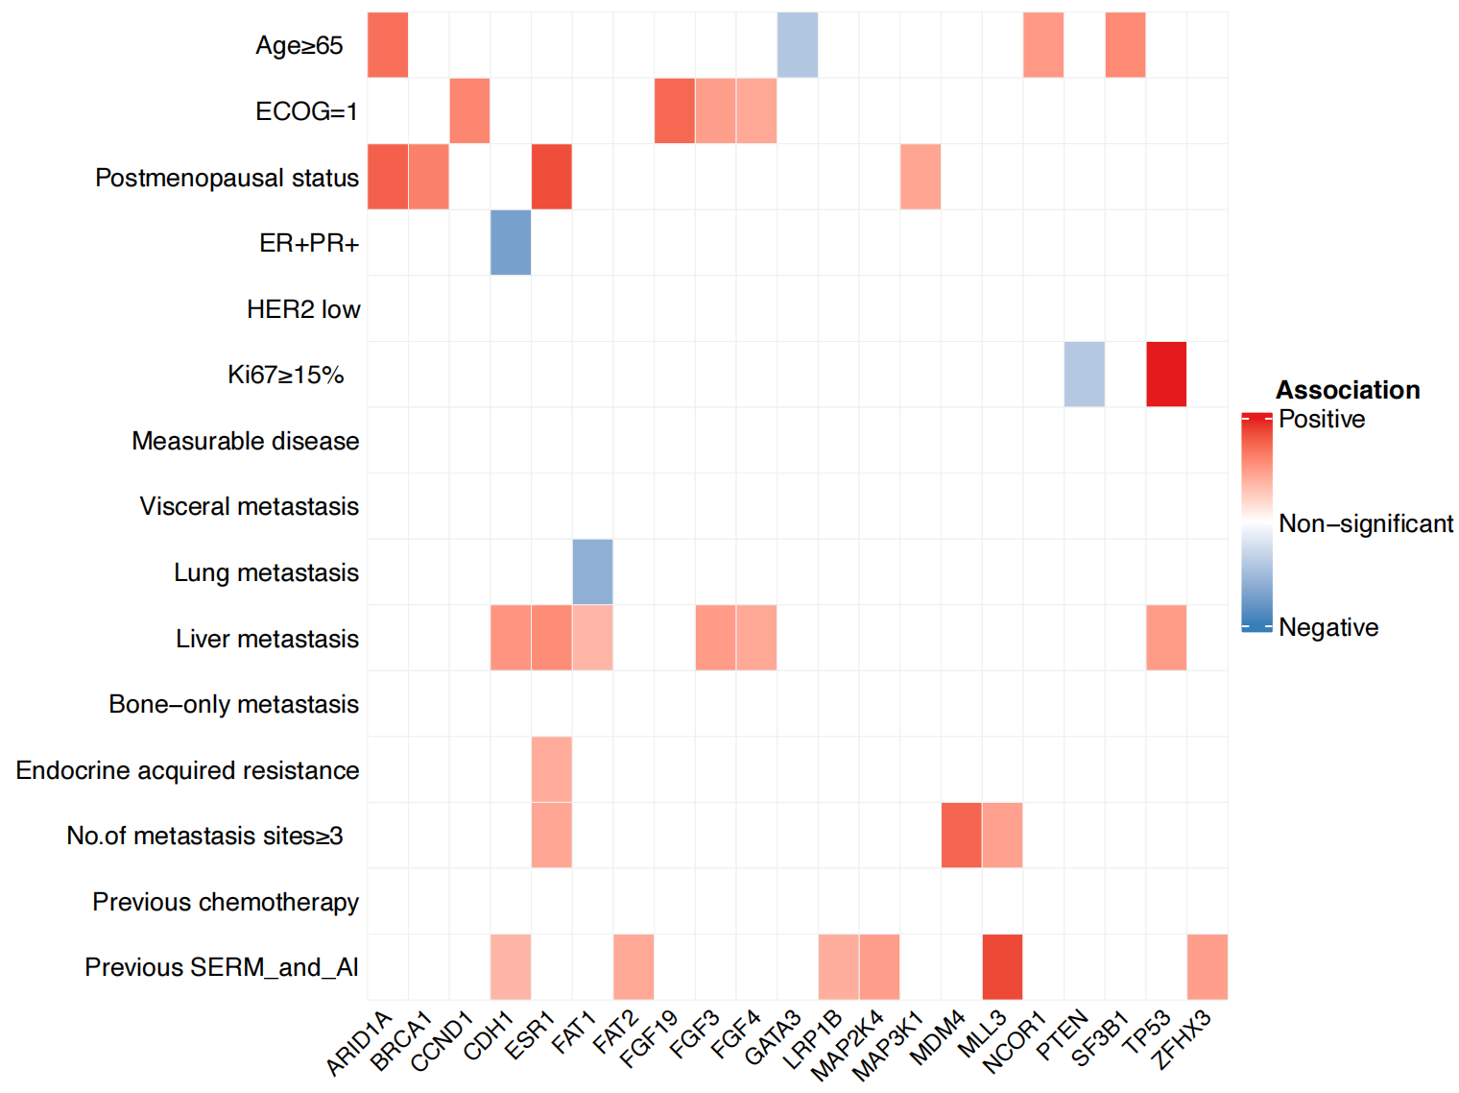
Abbreviations: ECOG, Eastern Cooperative Oncology Group; ER, estrogen receptor; PR, progesterone receptor; HER2, human epidermal growth factor receptor 2; SERM, selective estrogen receptor modulator; AI, aromatase inhibitor.

Supplementary Figure 3. Association of gene alternations with PFS and OS.
- Association of gene alternations with PFS in bireociclib group. (B) Association of gene alternations with PFS in placebo group. (C) Association of gene alternations with OS in bireociclib group. (D) Association of gene alternations with OS in placebo group.
Abbreviations: PFS, progression-free survival; OS, overall survival.

Supplementary Figure 4. Association of mTBI level with treatment efficacy.
(A) Association of mTBI level with treatment efficacy in bireociclib group. (B) Association of mTBI level with treatment efficacy in placebo group.
Abbreviations: mTBI, molecular tumor burden index.

Supplementary Figure 5. The multivariate COX analysis of baseline characteristics and mTBI status in placebo group.
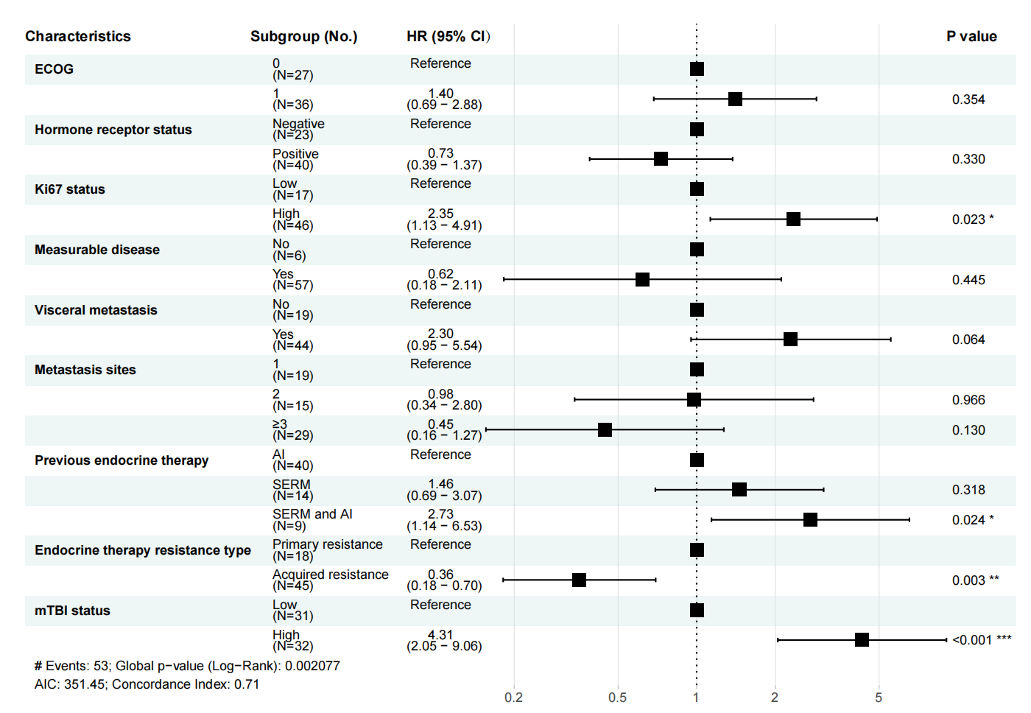
Abbreviations: N/No., number; HR, hazard ratio; CI, confidential interval; ECOG, Eastern Cooperative Oncology Group; mTBI, molecular tumor burden index; AI, aromatase inhibitor; SERM, selective estrogen receptor modulator.

Supplementary Figure 6. Kaplan-Meier plots by PI3K pathway status in bireociclib and placebo group.
(A) PFS by PI3K pathway status in bireociclib group. (B) PFS by PI3K pathway status in placebo group. (C) OS by PI3K pathway status in bireociclib group. (D) OS by PI3K pathway status in placebo group.
Abbreviations: n, number; HR, hazard ratio; CI, confidential interval.
Remarks: The PI3K pathway includes the following genes: EIF4EBP1, AKT1, AKT2, AKT3, AKT1S1, DEPDC5, DEPTOR, INPP4B, MAPKAP1, MLST8, MTOR, NPRL2, NPRL3, PDK1, PIK3CA, PIK3CB, PIK3R1, PIK3R2, PIK3R3, PPP2R1A, PTEN, RHEB, RICTOR, RPTOR, RPS6, RPS6KB1, STK11, TSC1, TSC2.

Supplementary Figure 7. Kaplan-Meier plots by MYC pathway status in bireociclib and placebo group.
(A) PFS by MYC pathway status in bireociclib group. (B) PFS by MYC pathway status in placebo group. (C) OS by MYC pathway status in bireociclib group. (D) OS by MYC pathway status in placebo group.
Abbreviations: n, number; HR, hazard ratio; CI, confidential interval.
Remarks: The MYC pathway includes the following genes: MAX, MGA, MLX, MLXIP, MLXIPL, MNT, MXD1, MXD3, MXD4, MXI1, MYC, MYCL1, MYCN.

Supplementary Figure 8. Kaplan-Meier plots by gBRCA-included HRRm status in bireociclib and placebo group.
(A) PFS by gBRCA-included HRRm status in bireociclib group. (B) PFS by gBRCA-included HRRm status in placebo group. (C) OS by gBRCA-included HRRm status in bireociclib group. (D) OS by gBRCA-included HRRm status in placebo group.
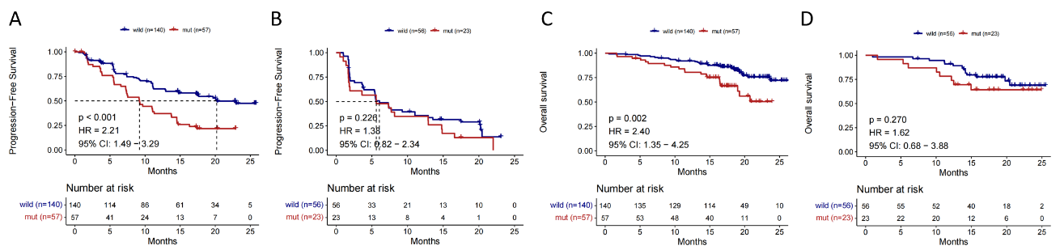
Abbreviations: gBRCA, germline BRCA; HRR, homologous recombination repair gene; n, number; HR, hazard ratio; CI, confidential interval.
Remarks: HRR includes ATM, ATR, BAP1, BARD1, BLM, BRCA1, BRCA2, BRIP1, CHEK1, CHEK2, CDK12, FANCA, FANCC, FANCD2, FANCF, FANCM, MRE11A, NBN, PALB2, RAD50, RAD51C, RAD51D, WRN and XRCC2.

Supplementary Figure 9. Kaplan-Meier plots by gBRCA or non-gBRCA-included HRRm status in bireociclib and placebo group.
(A) PFS by gBRCA status in bireociclib group. (B) PFS by gBRCA status in placebo group. (C) OS by gBRCA status in bireociclib group. (D) OS by gBRCA status in placebo group. (E) PFS by HRR status in bireociclib group. (F) PFS by HRR status in placebo group. (G) OS by HRR status in bireociclib group. (H) OS by HRR status in placebo group.
Abbreviations: gBRCA, germline BRCA; HRR, homologous recombination repair gene; n, number; HR, hazard ratio; CI, confidential interval.
Remarks: HRR includes ATM, ATR, BAP1, BARD1, BLM, BRCA1, BRCA2, BRIP1, CHEK1, CHEK2, CDK12, FANCA, FANCC, FANCD2, FANCF, FANCM, MRE11A, NBN, PALB2, RAD50, RAD51C, RAD51D, WRN and XRCC2.

Supplementary Figure 10. Interaction analysis between PIK3CA/ESR1 co-mutation status and treatment for PFS.
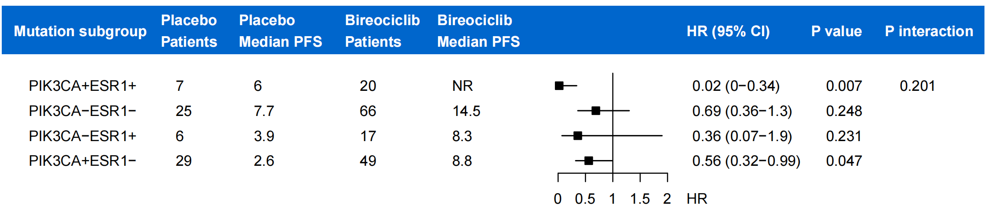
Abbreviations: PFS, progression-free survival; HR, hazard ratio; CI, confidential interval.
Remarks: The interaction analysis was adjusted for clinicopathological features, including ECOG score, HR status, Ki67 expression level, measurable disease, visceral metastases, number of metastatic sites, prior endocrine therapy, and type of endocrine resistance.

Supplementary Figure 11. Interaction analysis between ESR1 mutation status and treatment in all PIK3CA-mutation patients for PFS.
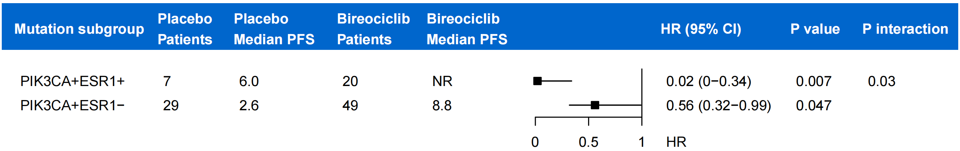
Abbreviations: PFS, progression-free survival; HR, hazard ratio; CI, confidential interval.
Remarks: The interaction analysis was adjusted for clinicopathological features, including ECOG score, HR status, Ki67 expression level, measurable disease, visceral metastases, number of metastatic sites, prior endocrine therapy, and type of endocrine resistance.

Supplementary Figure 12. Kaplan-Meier plots of dynamic ctDNA status for survival outcomes in placebo group.
(A) PFS of different C1D1-C5D1 ctDNA status subgroups. (B) OS of different C1D1-C5D1 ctDNA status subgroups.
Abbreviations: PFS, progression-free survival; OS, overall survival; C1D1, day 1 of cycle 1; C5D1, day 1 of cycle 5.

Supplementary Figure 13. Kaplan-Meier plots of PFS in patients treated with bireociclib versus placebo, categorized by dynamic changes in ctDNA status.
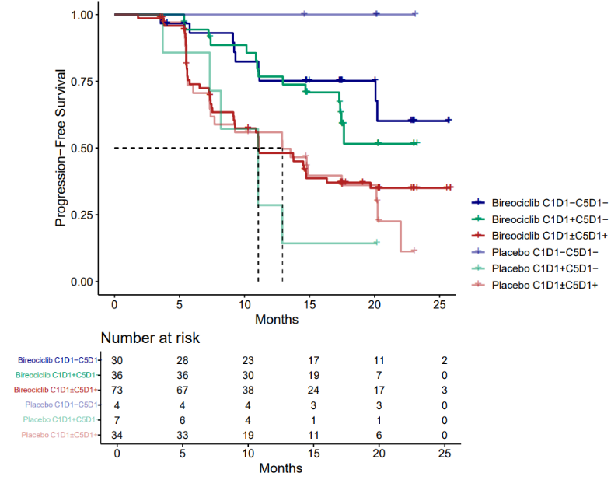

Supplementary Figure 14. Kaplan-Meier plots of dynamic mTBI change for survival outcomes in placebo group.
(A) PFS of dynamic mTBI subgroups. (B) OS of dynamic mTBI subgroups.
Abbreviations: PFS, progression-free survival; OS, overall survival; mTBI, molecular tumor burden index; ΔTBI, the disparity between on-treatment and baseline TBI value; HR, hazard ratio; CI, confidential interval.

Supplementary Figure 15. Associations between dynamic PIK3CA and ESR1 status with survival outcomes in placebo group.
(A) Kaplan-Meier curves for PFS of dynamic PIK3CA status subgroups. (B) Kaplan-Meier curves for PFS of dynamic ESR1 status subgroups. (C) Kaplan-Meier plots for OS of dynamic PIK3CA status subgroups. (D) Kaplan-Meier plots for OS of dynamic ESR1 status subgroups.
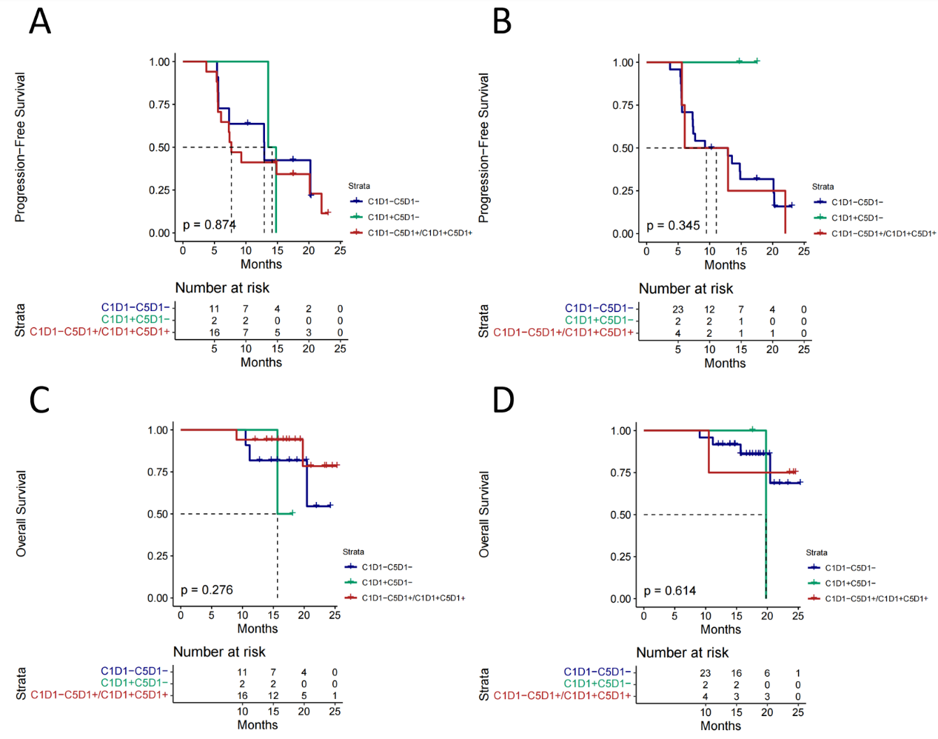
Abbreviations: C1D1, day 1 of cycle 1; C5D1, day 1 of cycle 5.

Supplementary Figure 16. The mutation frequency of each gene across three time points in placebo group.

Abbreviations: C1D1, day 1 of cycle 1; C5D1, day 1 of cycle 5; EOT, end of treatment.

Supplementary Figure 17. Gene heatmap of longitudinal paired (C1D1, C5D1, EOT) samples in bireociclib group.
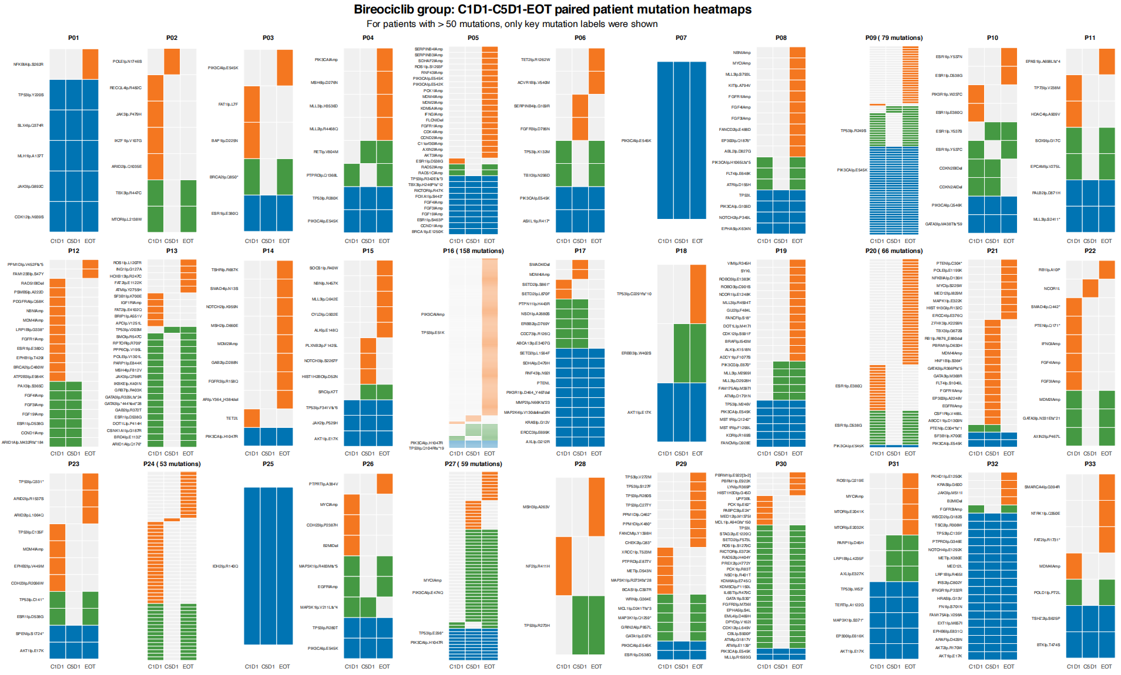
Abbreviations: C1D1, day 1 of cycle 1; C5D1, day 1 of cycle 5; EOT, end of treatment; P, patient.
Remarks: Blue, green, and orange boxes indicate gene loci with mutations detected in all three, any two, or only one timepoint, respectively.

Supplementary Figure 18. Gene heatmap of longitudinal paired (C1D1, C5D1, EOT) samples in palcebo group.
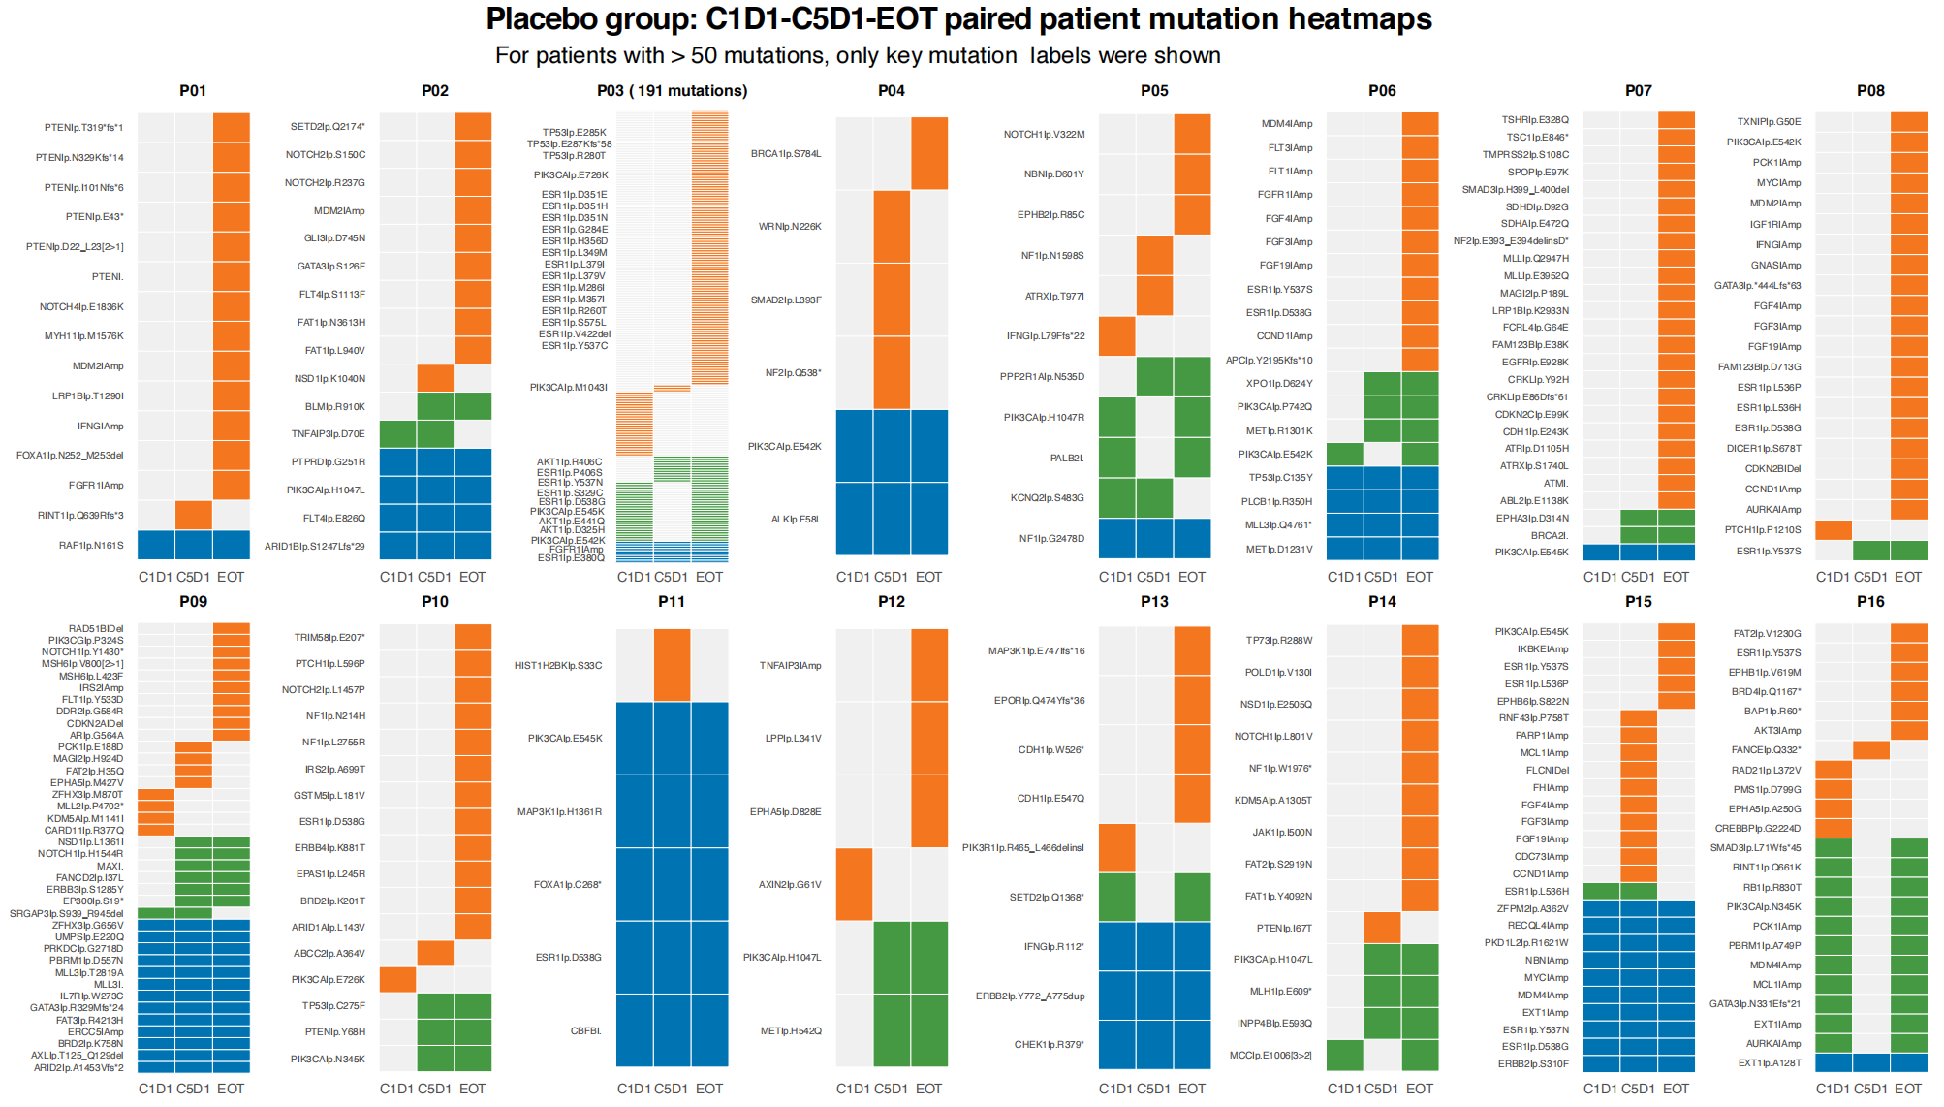
Abbreviations: C1D1, day 1 of cycle 1; C5D1, day 1 of cycle 5; EOT, end of treatment; P, patient.
Remarks: Blue, green, and orange boxes indicate gene loci with mutations detected in all three, any two, or only one timepoint, respectively.

Supplementary Table 1. 1021 Gene list and the targeted regions.
Gene | Coverage | Gene | Coverage | Gene | Coverage
ABCA13 | selected CDSs | FCRL4 | selected CDSs | PASK | selected CDSs
ABCB1 | selected CDSs | FGF10 | selected CDSs | PAX3 | selected CDSs
ABCC1 | selected CDSs | FGF12 | selected CDSs | PAX5 | Whole CDS
ABCC11 | selected CDSs | FGF14 | selected CDSs | PAX7 | selected CDSs
ABCC2 | selected CDSs | FGF19 | Whole CDS | PBRM1 | Whole CDS
ABCG2 | selected CDSs | FGF23 | selected CDSs | PC | selected CDSs
ABL1 | Whole CDS | FGF3 | Whole CDS | PCDH18 | selected CDSs
ABL2 | selected CDSs | FGF4 | Whole CDS | PCK1 | Whole CDS
ACACA | selected CDSs | FGF6 | selected CDSs | PCSK6 | selected CDSs
ACIN1 | selected CDSs | FGFR1 | Whole CDS,no-coding region, SNP for CNV | PCSK7 | selected CDSs
ACTB | selected CDSs | FGFR2 | Whole CDS,no-coding region | PDCD1 | Whole CDS
ACTG1 | selected CDSs | FGFR3 | Whole CDS,no-coding region, SNP for CNV | PDCD11 | selected CDSs
ACTG2 | selected CDSs | FGFR4 | Whole CDS | PDCD1LG2 | Whole CDS
ACVR1B | Whole CDS | FH | Whole CDS | PDE4DIP | selected CDSs
ACVR2A | selected CDSs | FLCN | Whole CDS | PDGFB | selected CDSs
ACVRL1 | selected CDSs | FLG | selected CDSs | PDGFRA | Whole CDS,no-coding region, SNP for CNV
ADAM29 | selected CDSs | FLI1 | selected CDSs | PDGFRB | Whole CDS
ADAMTS5 | selected CDSs | FLNC | selected CDSs | PDILT | selected CDSs
ADCY1 | selected CDSs | FLT1 | Whole CDS | PDK1 | Whole CDS
AFF1 | selected CDSs | FLT3 | Whole CDS | PER1 | selected CDSs
AFF2 | selected CDSs | FLT4 | Whole CDS | PGR | selected CDSs
AFF3 | selected CDSs | FMN2 | selected CDSs | PHF1 | selected CDSs
AHNAK | selected CDSs | FN1 | selected CDSs | PHF6 | selected CDSs
AKAP9 | selected CDSs | FNDC4 | selected CDSs | PIK3C2A | selected CDSs
AKT1 | Whole CDS | FOXA1 | Whole CDS | PIK3C2B | selected CDSs
AKT2 | Whole CDS | FOXA2 | selected CDSs | PIK3C2G | selected CDSs
AKT3 | Whole CDS | FOXL2 | Whole CDS | PIK3C3 | selected CDSs
ALB | selected CDSs | FOXO1 | selected CDSs | PIK3CA | Whole CDS
ALK | Whole CDS,no-coding region, SNP for CNV | FOXO3 | selected CDSs | PIK3CB | Whole CDS
AMOT | selected CDSs | FOXP1 | Whole CDS | PIK3CG | Whole CDS
ANGPT1 | selected CDSs | FOXQ1 | selected CDSs | PIK3R1 | Whole CDS
ANK3 | selected CDSs | FRMPD4 | selected CDSs | PIK3R2 | Whole CDS
ANKRD11 | selected CDSs | FUBP1 | Whole CDS | PIM1 | selected CDSs
ANKRD30A | selected CDSs | FUS | selected CDSs | PKD1L2 | selected CDSs
ANKRD30B | selected CDSs | FXR1 | selected CDSs | PKHD1 | selected CDSs
APC | Whole CDS | FYN | selected CDSs | PLAG1 | selected CDSs
APEX1 | selected CDSs | FZD1 | selected CDSs | PLCB1 | selected CDSs
APOBEC3B | selected CDSs | G3BP1 | selected CDSs | PLCG1 | selected CDSs
AR | Whole CDS | G3BP2 | selected CDSs | PLCG2 | selected CDSs
ARAF | Whole CDS | GAB2 | selected CDSs | PLK1 | selected CDSs
ARAP3 | selected CDSs | GABRA6 | selected CDSs | PLXNA1 | selected CDSs
ARFGEF1 | selected CDSs | GALNT12 | Whole CDS | PLXNB2 | selected CDSs
ARFGEF2 | selected CDSs | GATA1 | selected CDSs | PMS1 | Whole CDS
ARHGAP29 | selected CDSs | GATA2 | selected CDSs | PMS2 | Whole CDS,no-coding region
ARHGAP35 | selected CDSs | GATA3 | Whole CDS | PNRC1 | selected CDSs
ARID1A | Whole CDS | GFRAL | selected CDSs | POLD1 | Whole CDS
ARID1B | Whole CDS | GIGYF1 | selected CDSs | POLE | Whole CDS
ARID2 | Whole CDS | GKN2 | selected CDSs | POLQ | selected CDSs
ARID4B | selected CDSs | GLB1L3 | selected CDSs | POM121 | selected CDSs
ARID5B | selected CDSs | GLI1 | selected CDSs | POM121L12 | selected CDSs
ARNT | selected CDSs | GLI2 | selected CDSs | POT1 | Whole CDS
ASCL4 | selected CDSs | GLI3 | selected CDSs | POU2AF1 | selected CDSs
ASH1L | selected CDSs | GMPS | selected CDSs | PPM1D | selected CDSs
ASMTL | selected CDSs | GNA11 | Whole CDS | PPP1R17 | selected CDSs
ASPM | selected CDSs | GNA13 | selected CDSs | PPP2R1A | Whole CDS
ASTN1 | selected CDSs | GNAQ | Whole CDS | PPP6C | selected CDSs
ASXL1 | Whole CDS | GNAS | Whole CDS | PRDM1 | Whole CDS
ASXL2 | selected CDSs | GNG2 | selected CDSs | PRDM16 | selected CDSs
ATIC | selected CDSs | GPC3 | selected CDSs | PREX2 | selected CDSs
ATM | Whole CDS | GPR124 | selected CDSs | PRF1 | selected CDSs
ATP11B | selected CDSs | GPS2 | selected CDSs | PRKAA1 | selected CDSs
ATP12A | selected CDSs | GPX1 | selected CDSs | PRKAR1A | Whole CDS
ATP1A1 | selected CDSs | GRB7 | selected CDSs | PRKCB | selected CDSs
ATP2B3 | selected CDSs | GRIN2A | Whole CDS | PRKCI | selected CDSs
ATR | Whole CDS | GRM3 | Whole CDS | PRKDC | selected CDSs
ATRX | Whole CDS | GSK3B | selected CDSs | PRRX1 | selected CDSs
AURKA | Whole CDS | GSTM5 | selected CDSs | PRX | selected CDSs
AURKB | Whole CDS | GSTP1 | selected CDSs | PSG2 | selected CDSs
AXIN1 | Whole CDS | GUSB | selected CDSs | PSIP1 | selected CDSs
AXIN2 | Whole CDS | H3F3A | selected CDSs | PSMB1 | selected CDSs
AXL | Whole CDS | H3F3B | selected CDSs | PSMB5 | selected CDSs
B2M | Whole CDS | H3F3C | selected CDSs | PTCH1 | Whole CDS
BAP1 | Whole CDS | HCLS1 | selected CDSs | PTCH2 | Whole CDS
BARD1 | Whole CDS | HCN1 | selected CDSs | PTEN | Whole CDS
BAZ2B | selected CDSs | HDAC1 | Whole CDS | PTGS1 | selected CDSs
BBC3 | selected CDSs | HDAC4 | selected CDSs | PTGS2 | selected CDSs
BBS9 | selected CDSs | HDAC9 | selected CDSs | PTPN11 | Whole CDS
BCAS1 | selected CDSs | HECW1 | selected CDSs | PTPN13 | selected CDSs
BCL10 | selected CDSs | HEY1 | selected CDSs | PTPN2 | selected CDSs
BCL11A | selected CDSs | HGF | Whole CDS | PTPRB | selected CDSs
BCL11B | selected CDSs | HIST1H1C | selected CDSs | PTPRD | Whole CDS
BCL2 | Whole CDS | HIST1H1D | selected CDSs | PTPRK | selected CDSs
BCL2A1 | selected CDSs | HIST1H1E | selected CDSs | PTPRO | selected CDSs
BCL2L1 | Whole CDS | HIST1H2AC | selected CDSs | PTPRS | selected CDSs
BCL2L11 | selected CDSs,no-coding region | HIST1H2AG | selected CDSs | PTPRT | selected CDSs
BCL3 | selected CDSs | HIST1H2AL | selected CDSs | PTPRU | selected CDSs
BCL6 | selected CDSs | HIST1H2AM | selected CDSs | RAB35 | selected CDSs
BCL9 | selected CDSs | HIST1H2BC | selected CDSs | RAC1 | Whole CDS
BCOR | Whole CDS | HIST1H2BD | selected CDSs | RAC2 | selected CDSs
BCORL1 | selected CDSs | HIST1H2BJ | selected CDSs | RAD21 | selected CDSs
BCR | selected CDSs | HIST1H2BK | selected CDSs | RAD50 | Whole CDS
BIRC3 | selected CDSs | HIST1H2BO | selected CDSs | RAD51 | Whole CDS
BLM | Whole CDS | HIST1H3B | selected CDSs | RAD51B | Whole CDS
BMPR1A | Whole CDS | HIST1H3C | selected CDSs | RAD51C | Whole CDS
BMPR2 | selected CDSs | HIST1H3D | selected CDSs | RAD51D | Whole CDS
BNC2 | selected CDSs | HIST1H3F | selected CDSs | RAD52 | Whole CDS
BPTF | selected CDSs | HIST1H3G | selected CDSs | RAD54B | selected CDSs
BRAF | Whole CDS,no-coding region | HIST1H3H | selected CDSs | RAD54L | Whole CDS
BRCA1 | Whole CDS,no-coding region, SNP for CNV | HIST1H3I | selected CDSs | RAF1 | Whole CDS,no-coding region
BRCA2 | Whole CDS, SNP for CNV | HIST1H4I | selected CDSs | RANBP2 | selected CDSs
BRD2 | selected CDSs | HIST3H3 | selected CDSs | RARA | Whole CDS
BRD3 | selected CDSs | HLA-A | selected CDSs | RASA1 | selected CDSs
BRD4 | Whole CDS,no-coding region | HLA-B | selected CDSs | RASGRP1 | selected CDSs
BRIP1 | Whole CDS | HLA-C | selected CDSs | RB1 | Whole CDS, SNP for CNV
BRSK1 | selected CDSs | HLF | selected CDSs | RBL1 | selected CDSs
BRWD1 | selected CDSs | HMCN1 | selected CDSs | RBM10 | Whole CDS
BTK | Whole CDS | HNF1A | Whole CDS | RECQL | Whole CDS
BTLA | selected CDSs | HNF1B | selected CDSs | RECQL4 | Whole CDS
BUB1 | selected CDSs | HNRPDL | selected CDSs | REL | selected CDSs
C11orf30 | Whole CDS | HOXA11 | selected CDSs | RELN | selected CDSs
C15orf23 | selected CDSs | HOXA13 | selected CDSs | RET | Whole CDS,no-coding region
C15orf55 | selected CDSs | HOXA3 | selected CDSs | RFC1 | selected CDSs
C1QA | selected CDSs | HOXA9 | selected CDSs | RGS3 | selected CDSs
C1S | selected CDSs | HOXB13 | Whole CDS | RHEB | selected CDSs
C3orf70 | selected CDSs | HOXC13 | selected CDSs | RHOA | Whole CDS
C7orf53 | selected CDSs | HOXD11 | selected CDSs | RHOH | selected CDSs
C8orf34 | selected CDSs | HOXD13 | selected CDSs | RHOT1 | selected CDSs
CACNA1E | selected CDSs | HRAS | Whole CDS | RICTOR | Whole CDS
CADM2 | selected CDSs | HSD3B1 | selected CDSs | RINT1 | Whole CDS
CALR | selected CDSs | HSP90AA1 | selected CDSs | RIT1 | selected CDSs
CAMTA1 | selected CDSs | HSP90AB1 | selected CDSs | RNASEL | selected CDSs
CARD11 | Whole CDS | HSPA8 | selected CDSs | RNF43 | Whole CDS
CASP1 | selected CDSs | HSPD1 | selected CDSs | ROBO1 | selected CDSs
CASP8 | Whole CDS | HSPH1 | selected CDSs | ROBO2 | selected CDSs
CASQ2 | selected CDSs | ICK | selected CDSs | ROBO3 | selected CDSs
CBFB | Whole CDS | ICOSLG | selected CDSs | ROCK1 | selected CDSs
CBL | Whole CDS | ID3 | selected CDSs | ROS1 | Whole CDS,no-coding region
CBLB | selected CDSs | IDH1 | Whole CDS | RPGR | selected CDSs
CBR1 | selected CDSs | IDH2 | Whole CDS | RPS6KB1 | selected CDSs
CBR3 | selected CDSs | IFITM3 | selected CDSs | RPS6KB2 | selected CDSs
CCDC168 | selected CDSs | IFNG | Whole CDS | RPTOR | Whole CDS
CCNA1 | selected CDSs | IFNGR1 | Whole CDS | RSPO2 | selected CDSs,no-coding region
CCNB3 | selected CDSs | IGF1 | selected CDSs | RSPO3 | selected CDSs
CCND1 | Whole CDS, SNP for CNV | IGF1R | Whole CDS | RUNX1 | Whole CDS
CCND2 | Whole CDS | IGF2 | selected CDSs | RUNX1T1 | selected CDSs
CCND3 | Whole CDS | IGF2R | selected CDSs | RUNX2 | selected CDSs
CCNE1 | Whole CDS | IGLL5 | selected CDSs | RXRA | selected CDSs
CCT3 | selected CDSs | IKBKE | Whole CDS | RYR1 | selected CDSs
CCT5 | selected CDSs | IKZF1 | Whole CDS | RYR2 | selected CDSs
CCT6B | selected CDSs | IKZF2 | selected CDSs | SBDS | selected CDSs
CD22 | selected CDSs | IKZF3 | selected CDSs | SCUBE2 | selected CDSs
CD274 | Whole CDS, SNP for CNV | IL10 | selected CDSs | SDC4 | selected CDSs,no-coding region
CD33 | selected CDSs | IL1RAPL1 | selected CDSs | SDHA | Whole CDS
CD5L | selected CDSs | IL21R | selected CDSs | SDHAF2 | Whole CDS
CD74 | selected CDSs,no-coding region | IL6 | selected CDSs | SDHB | Whole CDS
CDA | selected CDSs | IL6ST | selected CDSs | SDHC | Whole CDS
CDC73 | Whole CDS | IL7R | Whole CDS | SDHD | Whole CDS
CDH1 | Whole CDS | IMPG1 | selected CDSs | SEC31A | selected CDSs
CDH11 | selected CDSs | ING1 | selected CDSs | SEMA3A | selected CDSs
CDH18 | selected CDSs | INHBA | selected CDSs | SEMA3E | selected CDSs
CDH23 | selected CDSs | INPP4A | selected CDSs | SEMA6A | selected CDSs
CDK12 | Whole CDS | INPP4B | Whole CDS | SERPINA7 | selected CDSs
CDK13 | selected CDSs | INPPL1 | selected CDSs | SERPINB3 | Whole CDS
CDK4 | Whole CDS | INSR | selected CDSs | SERPINB4 | Whole CDS
CDK6 | Whole CDS | IRF2 | Whole CDS | SETBP1 | selected CDSs
CDK8 | Whole CDS | IRF4 | selected CDSs | SETD2 | Whole CDS
CDKN1A | Whole CDS | IRF6 | selected CDSs | SETDB1 | selected CDSs
CDKN1B | Whole CDS | IRS1 | selected CDSs | SF1 | selected CDSs
CDKN2A | Whole CDS, SNP for CNV | IRS2 | Whole CDS | SF3A1 | selected CDSs
CDKN2B | Whole CDS | ITGB3 | selected CDSs | SF3B1 | Whole CDS
CDKN2C | Whole CDS | ITK | selected CDSs | SFPQ | selected CDSs
CEBPA | Whole CDS | ITSN1 | selected CDSs | SGCZ | selected CDSs
CHD1 | selected CDSs | JAK1 | Whole CDS | SGK1 | selected CDSs
CHD1L | selected CDSs | JAK2 | Whole CDS | SH2B3 | selected CDSs
CHD4 | selected CDSs | JAK3 | Whole CDS | SH2D1A | selected CDSs
CHD6 | selected CDSs | JARID2 | selected CDSs | SH3PXD2A | selected CDSs
CHD8 | selected CDSs | JUN | Whole CDS | SHH | selected CDSs
CHD9 | selected CDSs | KALRN | selected CDSs | SI | selected CDSs
CHEK1 | Whole CDS | KAT6A | selected CDSs | SIN3A | selected CDSs
CHEK2 | Whole CDS | KAT6B | selected CDSs | SLC16A1 | selected CDSs
CHFR | selected CDSs | KCNJ5 | selected CDSs | SLC1A2 | selected CDSs
CHI3L1 | selected CDSs | KCNQ2 | selected CDSs | SLC22A16 | selected CDSs
CHN1 | selected CDSs | KDM2B | selected CDSs | SLC22A18 | selected CDSs
CIC | Whole CDS | KDM5A | Whole CDS | SLC22A2 | selected CDSs
CIITA | selected CDSs | KDM5C | Whole CDS | SLC22A3 | selected CDSs
CLDN18 | selected CDSs | KDM6A | Whole CDS | SLC34A2 | selected CDSs,no-coding region
CLP1 | selected CDSs | KDR | Whole CDS, SNP for CNV | SLCO1B3 | selected CDSs
CLSPN | selected CDSs | KEAP1 | Whole CDS | SLIT1 | selected CDSs
CLTC | selected CDSs | KEL | selected CDSs | SLIT2 | selected CDSs
CNOT3 | selected CDSs | KIF5B | selected CDSs,no-coding region | SLX4 | Whole CDS
CNOT4 | selected CDSs | KIT | Whole CDS,no-coding region, SNP for CNV | SMAD2 | Whole CDS
CNTN1 | selected CDSs | KLF4 | selected CDSs | SMAD3 | Whole CDS
CNTN5 | selected CDSs | KLHL6 | selected CDSs | SMAD4 | Whole CDS
CNTNAP1 | selected CDSs | KLK1 | selected CDSs | SMARCA4 | Whole CDS
CNTNAP5 | selected CDSs | KRAS | Whole CDS, SNP for CNV | SMARCB1 | Whole CDS
COL1A1 | selected CDSs | KRTAP5-5 | selected CDSs | SMARCD1 | selected CDSs
COL2A1 | selected CDSs | L3MBTL1 | selected CDSs | SMARCE1 | selected CDSs
COL5A1 | selected CDSs | LAMA2 | selected CDSs | SMC1A | selected CDSs
COL5A2 | selected CDSs | LATS1 | selected CDSs | SMC1B | selected CDSs
COL5A3 | selected CDSs | LATS2 | selected CDSs | SMO | Whole CDS
COPS2 | selected CDSs | LCP1 | selected CDSs | SNCAIP | selected CDSs
CPS1 | selected CDSs | LEF1 | selected CDSs | SNTG1 | selected CDSs
CREBBP | Whole CDS | LGALS8 | selected CDSs | SNX29 | selected CDSs
CRIPAK | selected CDSs | LIFR | selected CDSs | SOCS1 | Whole CDS
CRKL | Whole CDS | LPHN2 | selected CDSs | SOD2 | selected CDSs
CRLF2 | selected CDSs | LPP | selected CDSs | SOS1 | selected CDSs
CRNKL1 | selected CDSs | LRP1B | Whole CDS | SOX10 | selected CDSs
CRTC1 | selected CDSs | LRP2 | selected CDSs | SOX17 | selected CDSs
CSF1 | selected CDSs | LRP4 | selected CDSs | SOX2 | Whole CDS
CSF1R | Whole CDS | LRP5 | selected CDSs | SOX9 | Whole CDS
CSF3R | selected CDSs | LRP6 | selected CDSs | SPEN | selected CDSs
CSMD1 | selected CDSs | LRRC7 | selected CDSs | SPOP | Whole CDS
CSMD3 | selected CDSs | LRRK2 | selected CDSs | SPRR3 | selected CDSs
CSNK1A1 | selected CDSs | LYN | selected CDSs | SPSB4 | selected CDSs
CSNK1G3 | selected CDSs | LZTS1 | selected CDSs | SPTA1 | selected CDSs
CTCF | Whole CDS | MACF1 | selected CDSs | SRC | Whole CDS
CTLA4 | selected CDSs | MAD1L1 | selected CDSs | SRD5A2 | selected CDSs
CTNNA1 | Whole CDS | MAF | Whole CDS | SRGAP1 | selected CDSs
CTNNA2 | selected CDSs | MAGI2 | selected CDSs | SRGAP3 | selected CDSs
CTNNB1 | Whole CDS | MAML2 | selected CDSs,no-coding region | SRSF2 | selected CDSs
CTNND1 | selected CDSs | MAML3 | selected CDSs | SRSF7 | selected CDSs
CUL3 | Whole CDS | MAP2K1 | Whole CDS | STAG1 | selected CDSs
CUX1 | selected CDSs | MAP2K2 | Whole CDS | STAG2 | Whole CDS
CXCR4 | selected CDSs | MAP2K4 | Whole CDS | STAT1 | selected CDSs
CYBA | selected CDSs | MAP3K1 | Whole CDS | STAT3 | Whole CDS
CYLD | Whole CDS | MAP3K13 | selected CDSs | STK11 | Whole CDS
CYP19A1 | selected CDSs | MAPK1 | Whole CDS | SUCLG1 | selected CDSs
CYP1A1 | selected CDSs | MAPK3 | selected CDSs | SUCLG2 | selected CDSs
CYP1B1 | selected CDSs | MAX | Whole CDS | SUFU | Whole CDS
CYP2A13 | selected CDSs | MCC | selected CDSs | SULT1A1 | selected CDSs
CYP2C8 | selected CDSs | MCL1 | Whole CDS | SUZ12 | selected CDSs
CYP2D6 | selected CDSs | MCM3 | selected CDSs | SVEP1 | selected CDSs
CYP3A4 | selected CDSs | MDC1 | selected CDSs | SYK | Whole CDS
CYP3A5 | selected CDSs | MDM2 | Whole CDS | SYNCRIP | selected CDSs
DAXX | Whole CDS | MDM4 | Whole CDS | SYNE1 | selected CDSs
DCC | selected CDSs | MECOM | selected CDSs | TAF1 | selected CDSs
DDR1 | Whole CDS | MED12 | Whole CDS | TAF15 | selected CDSs
DDR2 | Whole CDS | MEF2B | Whole CDS | TAF1L | selected CDSs
DDX3X | selected CDSs | MEF2C | selected CDSs | TAL1 | selected CDSs
DDX5 | selected CDSs | MEN1 | Whole CDS | TBL1XR1 | selected CDSs
DEK | selected CDSs | MET | Whole CDS,no-coding region, SNP for CNV | TBX15 | selected CDSs
DHX35 | selected CDSs | MGA | selected CDSs | TBX22 | selected CDSs
DHX9 | selected CDSs | MIB1 | selected CDSs | TBX3 | Whole CDS
DIAPH1 | selected CDSs | MIOS | selected CDSs | TCEB1 | selected CDSs
DICER1 | Whole CDS | MITF | Whole CDS | TCF12 | selected CDSs
DIS3L2 | selected CDSs | MKL1 | selected CDSs | TCF3 | selected CDSs
DLC1 | selected CDSs | MLH1 | Whole CDS | TCF4 | selected CDSs
DMD | selected CDSs | MLH3 | Whole CDS | TCF7L2 | Whole CDS
DNAH6 | selected CDSs | MLL | Whole CDS | TCL1A | selected CDSs
DNAJB1 | selected CDSs | MLL2 | Whole CDS | TEC | selected CDSs
DNM2 | selected CDSs | MLL3 | Whole CDS | TENM3 | selected CDSs
DNMT1 | selected CDSs | MLL4 | selected CDSs | TERC | Whole CDS
DNMT3A | Whole CDS | MLLT3 | selected CDSs | TERT | selected CDSs,no-coding region
DNMT3B | selected CDSs | MMP11 | selected CDSs | TET1 | selected CDSs
DOCK2 | selected CDSs | MMP2 | selected CDSs | TET2 | Whole CDS
DOCK7 | selected CDSs | MN1 | selected CDSs | TFDP1 | selected CDSs
DOT1L | Whole CDS | MNDA | selected CDSs | TFDP2 | selected CDSs
DPYD | selected CDSs | MNX1 | selected CDSs | TFE3 | selected CDSs,no-coding region
DRGX | selected CDSs | MPL | Whole CDS | TGFBR1 | selected CDSs
DTX1 | selected CDSs | MRE11A | Whole CDS | TGFBR2 | Whole CDS
DUSP22 | selected CDSs | MS4A1 | Whole CDS | THBS2 | selected CDSs
DYSF | selected CDSs | MSH2 | Whole CDS,no-coding region | TJP1 | selected CDSs
E2F3 | selected CDSs | MSH3 | Whole CDS | TLE1 | selected CDSs
EBF1 | selected CDSs | MSH4 | selected CDSs | TLL2 | selected CDSs
ECT2L | selected CDSs | MSH6 | Whole CDS | TLR4 | selected CDSs
EED | selected CDSs | MSN | selected CDSs | TLX3 | selected CDSs
EEF1A1 | selected CDSs | MSR1 | selected CDSs | TMEM127 | Whole CDS
EGFL7 | selected CDSs | MST1R | Whole CDS | TMEM132D | selected CDSs
EGFR | Whole CDS,no-coding region, SNP for CNV | MTHFR | selected CDSs | TMPRSS2 | Whole CDS,no-coding region
EGR3 | selected CDSs | MTOR | Whole CDS | TNFAIP3 | Whole CDS
EIF1AX | Whole CDS | MTRR | selected CDSs | TNFRSF14 | Whole CDS
EIF2AK3 | selected CDSs | MUC5B | selected CDSs | TNFSF11 | selected CDSs
EIF2C3 | selected CDSs | MUTYH | Whole CDS | TNN | selected CDSs
EIF3A | selected CDSs | MYC | Whole CDS,no-coding region | TOP1 | Whole CDS
EIF4A2 | selected CDSs | MYCL1 | Whole CDS,no-coding region | TOP2A | Whole CDS
EIF4G3 | selected CDSs | MYCN | Whole CDS | TP53 | Whole CDS
ELAC2 | selected CDSs | MYD88 | Whole CDS | TP53BP1 | selected CDSs
ELF1 | selected CDSs | MYH11 | selected CDSs | TP63 | selected CDSs
ELF3 | selected CDSs | MYH14 | selected CDSs | TP73 | selected CDSs
ELMO1 | selected CDSs | MYH9 | selected CDSs | TPM3 | selected CDSs,no-coding region
ELN | selected CDSs | MYO3A | selected CDSs | TPR | selected CDSs
EME2 | selected CDSs | MYOD1 | selected CDSs | TRAF2 | selected CDSs
EMID2 | selected CDSs | NAP1L1 | selected CDSs | TRAF7 | selected CDSs
EML4 | selected CDSs,no-coding region | NAV3 | selected CDSs | TRIM24 | selected CDSs
EP300 | Whole CDS | NBN | Whole CDS | TRIM58 | selected CDSs
EPAS1 | Whole CDS | NCAM2 | selected CDSs | TRIO | selected CDSs
EPC1 | selected CDSs | NCF2 | selected CDSs | TRPC5 | selected CDSs
EPCAM | Whole CDS | NCF4 | selected CDSs | TRRAP | selected CDSs
EPHA1 | selected CDSs | NCK1 | selected CDSs | TSC1 | Whole CDS
EPHA2 | Whole CDS | NCOA3 | selected CDSs | TSC2 | Whole CDS
EPHA3 | Whole CDS | NCOA4 | selected CDSs,no-coding region | TSHR | Whole CDS
EPHA4 | selected CDSs | NCOR1 | Whole CDS | TSHZ2 | selected CDSs
EPHA5 | Whole CDS | NCOR2 | selected CDSs | TSHZ3 | selected CDSs
EPHA7 | selected CDSs | NCSTN | selected CDSs | TTF1 | selected CDSs
EPHB1 | Whole CDS | NDUFA13 | selected CDSs | TUBA3C | selected CDSs
EPHB2 | selected CDSs | NF1 | Whole CDS | TUBB3 | selected CDSs
EPHB4 | selected CDSs | NF2 | Whole CDS | TUSC3 | selected CDSs
EPHB6 | Whole CDS | NFATC4 | selected CDSs | TXNIP | selected CDSs
EPOR | selected CDSs | NFE2L2 | Whole CDS | TYMS | selected CDSs
EPPK1 | selected CDSs | NFE2L3 | selected CDSs | TYR | selected CDSs
EPS15 | selected CDSs | NFKBIA | Whole CDS | U2AF1 | Whole CDS
ERBB2 | Whole CDS, SNP for CNV | NKX2-1 | Whole CDS | UBE2D2 | selected CDSs
ERBB2IP | selected CDSs | NKX3-1 | selected CDSs | UBR5 | selected CDSs
ERBB3 | Whole CDS | NLRC3 | selected CDSs | UGT1A1 | selected CDSs
ERBB4 | Whole CDS | NOD1 | selected CDSs | UMPS | selected CDSs
ERCC1 | Whole CDS | NOS3 | selected CDSs | UPF3B | selected CDSs
ERCC2 | selected CDSs | NOTCH1 | Whole CDS | USH2A | selected CDSs
ERCC3 | Whole CDS | NOTCH2 | Whole CDS,no-coding region | USP6 | selected CDSs
ERCC4 | Whole CDS | NOTCH3 | Whole CDS | USP8 | selected CDSs
ERCC5 | Whole CDS | NOTCH4 | selected CDSs | VEGFA | Whole CDS
ERG | Whole CDS,no-coding region | NPM1 | Whole CDS | VEZF1 | selected CDSs
ERRFI1 | Whole CDS | NQO1 | selected CDSs | VHL | Whole CDS
ESR1 | Whole CDS | NR1I2 | selected CDSs | VIM | selected CDSs
ESR2 | selected CDSs | NR2F2 | selected CDSs | VTCN1 | selected CDSs
ETS1 | selected CDSs | NR4A2 | selected CDSs | WASF3 | selected CDSs
ETV1 | selected CDSs | NRAS | Whole CDS | WDR90 | selected CDSs
ETV5 | selected CDSs | NRG1 | selected CDSs | WDTC1 | selected CDSs
ETV6 | selected CDSs,no-coding region | NRP2 | selected CDSs | WHSC1 | selected CDSs
EWSR1 | selected CDSs | NRXN1 | selected CDSs | WHSC1L1 | selected CDSs
EXT1 | Whole CDS | NSD1 | Whole CDS | WIPF1 | selected CDSs
EXT2 | Whole CDS | NTHL1 | Whole CDS | WNK1 | selected CDSs
EZH2 | Whole CDS | NTM | selected CDSs | WNT5A | selected CDSs
EZR | selected CDSs,no-coding region | NTRK1 | Whole CDS,no-coding region | WRN | Whole CDS
F8 | selected CDSs | NTRK2 | Whole CDS,no-coding region | WSCD2 | selected CDSs
FAM123B | Whole CDS | NTRK3 | Whole CDS,no-coding region | WT1 | Whole CDS
FAM131B | selected CDSs | NUMA1 | selected CDSs | WWOX | selected CDSs
FAM135B | selected CDSs | NUP107 | selected CDSs | WWP1 | selected CDSs
FAM157B | selected CDSs | NUP210 | selected CDSs | WWP2 | selected CDSs
FAM175A | Whole CDS | NUP93 | selected CDSs | XIAP | selected CDSs
FAM46C | selected CDSs | NUP98 | selected CDSs | XPC | selected CDSs
FAM5C | selected CDSs | OBSCN | selected CDSs | XPO1 | Whole CDS
FANCA | Whole CDS | OGDH | selected CDSs | XRCC1 | selected CDSs
FANCC | Whole CDS | OMD | selected CDSs | XRCC2 | Whole CDS
FANCD2 | Whole CDS | OPCML | selected CDSs | XRCC3 | selected CDSs
FANCE | Whole CDS | OR11G2 | selected CDSs | YAP1 | selected CDSs
FANCF | Whole CDS | OR2T4 | selected CDSs | YY1AP1 | selected CDSs
FANCG | Whole CDS | OR4A15 | selected CDSs | ZBTB16 | selected CDSs
FANCL | Whole CDS | OR4C6 | selected CDSs | ZC3H11A | selected CDSs
FANCM | Whole CDS | OR5L2 | selected CDSs | ZFHX3 | selected CDSs
FAP | selected CDSs | OR6F1 | selected CDSs | ZFP36L1 | selected CDSs
FAS | Whole CDS | P2RY8 | selected CDSs | ZFP36L2 | selected CDSs
FASLG | selected CDSs | P4HB | selected CDSs | ZFPM2 | selected CDSs
FAT1 | Whole CDS | PABPC1 | selected CDSs | ZIC3 | selected CDSs
FAT2 | Whole CDS | PABPC3 | selected CDSs | ZMAT3 | Whole CDS
FAT3 | selected CDSs | PAG1 | selected CDSs | ZNF217 | selected CDSs
FAT4 | selected CDSs | PAK1 | selected CDSs | ZNF384 | selected CDSs
FBXW7 | Whole CDS | PAK3 | selected CDSs | ZNF521 | selected CDSs
FCGR1A | selected CDSs | PALB2 | Whole CDS | ZNF638 | selected CDSs
FCGR2A | selected CDSs | PARK2 | Whole CDS | ZNF750 | selected CDSs
FCGR2B | selected CDSs | PARP1 | Whole CDS | ZNF804B | selected CDSs
FCGR3A | selected CDSs
Abbreviation: CDS, Coding Sequence.

Supplementary Table 2. Clinicopathologic features and survival outcomes in ITT and ctDNA-evaluable populations.
Characteristics | Category | ITT |  | ctDNA Analysis Population
Characteristics | Category | Bireociclib (N=204)  N (%) | Placebo (N=101)  N (%) | Bireociclib (N=197)  N (%) | Placebo (N=80）  N (%)
Age | <65 | 161 (78.9) | 85 (84.2) | 155 (78.7) | 66 (82.5)
 | ≥65 | 43 (21.1) | 16 (15.8) | 42 (21.3) | 14 (17.5)
Age, median (range), years | / | 54.5 (32-73) | 55 (31-74) | 55 (32-73) | 54.5 (31-74)
ECOG performance status score | 0 | 83 (40.7) | 45 (44.6) | 81 (41.1) | 38 (47.5)
 | 1 | 121 (59.3) | 56 (55.4) | 116 (58.9) | 42 (52.5)
Menopausal status | Premenopausal or perimenopause | 75 (36.8) | 38 (37.6) | 71 (36.0) | 33 (41.2)
 | Postmenopausal | 129 (63.2) | 63 (62.4) | 126 (64.0) | 47 (58.8)
Hormone receptor status | ER+PR+ | 156 (76.5) | 72 (71.3) | 149 (75.6) | 53 (66.2)
 | ER+PR− | 48 (23.5) | 29 (28.7) | 48 (24.4) | 27 (33.8)
HER2 status | Negative | 71 (34.8) | 43 (42.6) | 65 (33.0) | 37 (46.2)
 | Low | 133 (65.2) | 58 (57.4) | 132 (67.0) | 43 (53.8)
Ki67 status | ＜15% | 47 (23.0) | 26 (25.7) | 45 (22.8) | 22 (27.5)
 | ≥15% | 149 (73.0) | 68 (67.3) | 145 (73.6) | 52 (65.0)
 | NE | 8 (3.9) | 7 (6.9) | 7 (3.6) | 6 (7.5)
Measurable disease | Yes | 185 (90.7) | 90 (89.1) | 180 (91.4) | 72 (90.0)
 | No | 19 (9.3) | 11 (10.9) | 17 (8.6) | 8 (10.0)
Visceral metastases | Yes | 141 (69.1) | 68 (67.3) | 138 (70.1) | 55 (68.8)
 | Lung | 79 (38.7) | 45 (44.6) | 78 (39.6) | 38 (47.5)
 | Liver | 62 (30.4) | 37 (36.6) | 60 (30.5) | 32 (40.0)
 | No | 63 (30.9) | 33 (32.7) | 59 (29.9) | 25 (31.2)
 | Bone-only | 26 (12.7) | 14 (13.9) | 23 (11.7) | 11 (13.8)
No. of recurrent/metastatic sites | 1 | 62 (30.4) | 33 (32.7) | 59 (29.9) | 23 (28.7)
 | 2 | 70 (34.3) | 27 (26.7) | 67 (34.0) | 23 (28.7)
 | ≥3 | 72 (35.3) | 41 (40.6) | 71 (36.0) | 34 (42.5)
Previous chemotherapy | Only received neoadjuvant/adjuvant chemotherapy | 129 (63.2) | 64 (63.4) | 124 (62.9) | 51 (63.7)
 | Received chemotherapy for metastatic disease | 47 (23.0) | 28 (27.7) | 46 (23.4) | 22 (27.5)
 | No previous chemotherapy | 28 (13.7) | 9 (8.9) | 27 (13.7) | 7 (8.8)
Previous endocrine therapy | SERM | 61 (29.9) | 28 (27.7) | 57 (28.9) | 20 (25.0)
 | AI | 109 (53.4) | 58 (57.4) | 107 (54.3) | 48 (60.0)
 | both SERM and AI | 34 (16.7) | 15 (14.9) | 33 (16.8) | 12 (15.0)
Endocrine therapy resistance type | Primary resistance | 54 (26.5) | 24 (23.8) | 52 (26.4) | 22 (27.5)
 | Acquired resistance | 150 (73.5) | 77 (76.2) | 145 (73.6) | 58 (72.5)
Median PFS (95%CI), months | / | 14.7 (11.1-22.9) | 7.3 (5.5-12.9) | 14.7 (11.1-20.2) | 6 (5.4-11)
HR (95%CI), p value | / | 0.55 (0.41-0.75), P<0.001 |  | 0.48 (0.35-0.66), P<0.001
Abbreviation: ITT, intention-to-treat; ctDNA, circulating tumor DNA; N/No., number; ECOG, Eastern Cooperative Oncology Group; ER, estrogen receptor; PR, progesterone receptor; HER2, epidermal growth factor receptor 2; SERM, selective estrogen receptor modulator.; AI, aromatase inhibitor; PFS, progression-free survival; CI, confidential interval; HR, hazard ratio.

Supplementary Table 3. The univariate COX analysis of baseline characteristics and mTBI for PFS in bireociclib group.
Characteristics | Subgroup | Patients | HR (95% CI) | P
Age | <65 | 119
 | ≥65 | 33 | 0.67 (0.37-1.20) | 0.179
ECOG | 0 | 58
 | 1 | 94 | 1.63 (1.03-2.57) | 0.036
Menopausal status | Premenopausal or perimenopause | 53
 | postmenopausal | 99 | 1.31 (0.84-2.06) | 0.230
Hormone receptor status | negative | 38
 | positive | 114 | 0.64 (0.40-1.01) | 0.058
HER2 status | negative | 50
 | low | 102 | 1.22 (0.77-1.94) | 0.388
Ki67 status | low | 28
 | high | 118 | 1.86 (0.98-3.51) | 0.056
Measurable disease | No | 12
 | Yes | 140 | 2.96 (1.08-8.11) | 0.034
Visceral metastasis | No | 44
 | Yes | 108 | 2.14 (1.27-3.61) | 0.004
Metastasis sites | 1 | 44
 | 2 | 43 | 1.23 (0.69-2.20) | 0.481
 | ≥3 | 65 | 1.71 (1.02-2.89) | 0.043
Previous chemotherapy | No | 22
 | Only received neoadjuvant/adjuvant chemotherapy | 91 | 0.87 (0.47-1.61) | 0.664
 | Received chemotherapy for metastatic disease | 39 | 1.05 (0.53-2.06) | 0.890
Previous endocrine therapy | AI | 88
 | SERM | 40 | 0.47 (0.27-0.82) | 0.008
 | SERM and AI | 24 | 0.95 (0.54-1.66) | 0.854
Endocrine therapy resistance type | primary resistance | 39
 | acquired resistance | 113 | 0.86 (0.54-1.38) | 0.538
mTBI status | low | 66
 | high | 86 | 2.21 (1.42-3.47) | 0.001
Abbreviation: HR, hazard ratio; CI, confidential interval; ECOG, Eastern Cooperative Oncology Group; mTBI, molecular tumor burden index; AI, aromatase inhibitor; SERM, selective estrogen receptor modulator.

Supplementary Table 4. The univariate COX analysis of baseline characteristics and mTBI for PFS in placebo group.
Characteristics | Subgroup | Patients | HR (95% CI) | P
Age | <65 | 54
 | ≥65 | 13 | 1.63 (0.85-3.13) | 0.138
ECOG | 0 | 30
 | 1 | 37 | 1.22 (0.71-2.10) | 0.475
Menopausal status | Premenopausal or perimenopause | 26
 | postmenopausal | 41 | 1.05 (0.61-1.80) | 0.868
Hormone receptor status | negative | 23
 | positive | 44 | 0.88 (0.50-1.54) | 0.649
HER2 status | negative | 29
 | low | 38 | 1.14 (0.67-1.96) | 0.628
Ki67 status | low | 17
 | high | 46 | 1.92 (0.99-3.74) | 0.055
Measurable disease | No | 6
 | Yes | 61 | 0.88 (0.37-2.05) | 0.762
Visceral metastasis | No | 20
 | Yes | 47 | 1.37 (0.76-2.49) | 0.293
Metastasis sites | 1 | 19
 | 2 | 17 | 1.14 (0.53-2.45) | 0.732
 | ≥3 | 31 | 1.31 (0.70-2.48) | 0.399
Previous chemotherapy | No | 4
 | Only received neoadjuvant/adjuvant chemotherapy | 44 | 0.49 (0.14-1.66) | 0.250
 | Received chemotherapy for metastatic disease | 19 | 0.33 (0.09-1.31) | 0.115
Previous endocrine therapy | AI | 41
 | SERM | 16 | 0.90 (0.47-1.71) | 0.744
 | SERM and AI | 10 | 0.98 (0.45-2.13) | 0.955
Endocrine therapy resistance type | Primary resistance | 19
 | Acquired resistance | 48 | 0.49 (0.28-0.87) | 0.015
mTBI status | low | 32
 | high | 35 | 1.78 (1.04-3.03) | 0.034
Abbreviation: HR, hazard ratio; CI, confidential interval; ECOG, Eastern Cooperative Oncology Group; mTBI, molecular tumor burden index; AI, aromatase inhibitor; SERM, selective estrogen receptor modulator.

