Impact of green clay authigenesis on K–Mg–Fe sequestration in marine settings

Andre Baldermann¹*, Santanu Banerjee², György Czuppon³, Martin Dietzel¹, Juraj Farkaš⁴, Stefan Lӧhr⁵, Ulrike Moser¹, Esther Scheiblhofer¹, Nicky M. Wright⁶ and Thomas Zack^{4,7}

¹Institute of Applied Geosciences, Graz University of Technology, NAWI Graz Geocenter, Graz, Austria; baldermann@tugraz.at; martin.dietzel@tugraz.at; ulrike.moser@student.tugraz.at; esther.scheiblhofer@student.tugraz.at
²Department of Earth Sciences, Indian Institute of Technology Bombay, Powai, Mumbai, India; santanu@iitb.ac.in
³Institute for Geological and Geochemical Research, Research Centre for Astronomy and Earth Sciences, Eötvös Loránd Research Network, Budapest, Hungary; czuppon@geochem.hu
⁴Department of Earth Sciences, Metal Isotope Group (MIG), University of Adelaide, North Terrace, Adelaide, Australia; juraj.farkas@adelaide.edu.au
⁵Department of Earth and Environmental Sciences, Macquarie University, Sydney, Australia; stefan.loehr@mq.edu.au
⁶Earthbyte Group, School of Geosciences, University of Sydney, Sydney, Australia; nicky.wright@sydney.edu.au
⁷Department of Earth Sciences, University of Gothenburg, Göteborg, Sweden; thomas.zack@gu.se

Figure S1, S2, S3 and S4
Table S1, S2, S3, S4 and S5

Study site
The study site is located in a railway outcrop near the village Langenstein within the WNW-ESE-trending Subhercynic Cretaceous Basin, north of the Harz Mountains, set in the Northern German basin. The biostratigraphy of the profile is well established based on index fossils of the Cenomanian (Late Cretaceous), such as the ammonites Mantelliceras dixoni (M. dixoni) and Acanthoceras rhotomagense, the inoceramic bivalves Inoceramus atlanticus and Inoceramus pictus, the oyster Pycnodonte and planktic foraminifera (Wilmsen et al., 2005).
The ~15 m thick Langenstein profile was logged at a resolution of ~5 cm. Eight hand-sized samples were collected from the bottom part of the profile (lowermost 5 m) for subsequent petrographic, mineralogical, chemical and isotopic analyses. This interval covers the onset and the progression of the globally expressed Cenomanian transgression, and hosts glauconite-rich strata within the well-constrained M. dixoni Zone of the Lower Cenomanian. The duration of the M. dixoni Zone has been estimated to be 1.8 Myr, lasting from ~97.9 Myr to ~96.1 Myr (Gradstein et al., 2004). The stratigraphic age of the studied interval was verified further by glauconite polytype quantification coupled to K-Ar dating of different grain size sub-fractions of glauconite, which yielded a formation age of 95.0 ± 1.8 Myr (Baldermann et al., 2017) for glauconite grains collected at 3.9 m in the profile (top of M. dixoni Zone).

Sample material
Our field observations, together with visual and petrographic inspection of samples, identify five lithofacies across the Langenstein profile (Fig. S1). Lithofacies 1 (sample S1) occurs at the bottom part of the profile and appears as cross-bedded, arkosic sandstones (so-called Neocomian sandstones) of Lower Cretaceous age. The sandstones comprise sub-rounded quartz, feldspar (albite and orthoclase), mica, chlorite, kaolinite, neomorphic calcite spar, Fe-(hydr)oxides and authigenic illite-smectite that replaces the weathered feldspar (Fig. 1a). The sandstones have a yellowish-grayish brown color. The absence of marine faunal elements suggests a continental-fluviatile origin of this lithofacies (Wilmsen, 2007; Baldermann et al., 2017). These sandstones are unconformably overlain by a conglomerate (lithofacies 2, samples S2-3), ~30 cm thick. It contains quartz, pebbles of reworked Neocomian sandstones, dolomitic limestone, reworked iron crusts and phosphorite granules, and is consolidated by Fe-(hydr)oxides, mainly hematite cement (Fig. 1b-c). We note that this poorly exposed lithofacies is devoid of glauconite, so that the lithostratigraphic log of the Langenstein profile is hereby updated. Based on rare findings of siliceous sponge remains and phosphatized fossil fragments, Wilmsen et al. (2005) have argued that this basal ironstone conglomerate was deposited on the inner shelf and marks the onset of the transgression at this locality, and thus the change from continental to marine sedimentation. Lithofacies 3 (sample S4) is a sandstone rich in glauconite (~70 wt.%) and silicate detritus (~20 wt.% of mica/illite, feldspar, quartz and lithoclasts), ~40 cm thick, which is weakly consolidated by calcite spar, micrite and Fe-(oxy)hydroxide cement (Fig.1d). The glauconitic sandstone was deposited in a proximal shelf setting that developed at the onset of the Cenomanian transgression, as indicated by bioturbation features and marine faunal elements, such as molluscs, brachiopods and benthic foraminifera (Wilmsen, 2003). Lithofacies 4 appears as glauconitic sandy marlstones with bioclastic debris (samples S5-6) grading into glauconitic bioturbated mudstones to packstones with calcispheres and foraminifera (sample S7; Fig. 1e-g). The glauconitized interval (so-called Glauconitic Pläner Limestones) is marked by a continuous decrease in glauconite content up-section. The total glauconite content is dominated by glauconitized faecal pellets and subordinate infills within foraminifera chambers (cf. insert in Fig. 1e). Minor proportions of rounded quartz grains, bio-apatites and bioclasts indicate deposition on the shallow shelf to mid-shelf regions during the Lower to Middle Cenomanian (Wilmsen, 2003; Baldermann et al., 2017). The Glauconitic Pläner Limestones are overlain by marine mudstones and packstones poor in silicate detritus and glauconite (~1 wt.%, lithofacies 5, sample S8; Fig. 1h; so-called Pläner Limestones), and subsequently deposited glauconite-free mudstones rich in calcareous nannofossils (so-called Poor rhotomagense Limestone). The limestones were accumulated on mid-shelf to outer shelf settings during the Middle and Upper Cenomanian time (Wilmsen et al., 2005). Due to the paucity of glauconite in these limestones, the pelagic facies is not taken into further consideration in this study.
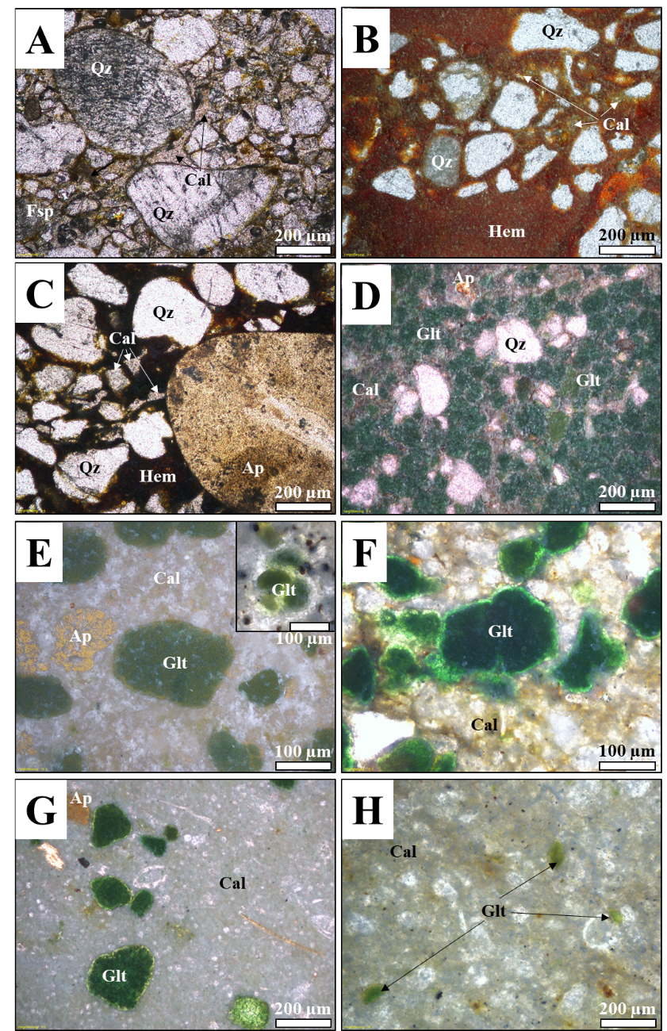
Fig. S1: Lithofacies at Langenstein. The photomicrographs show A) an arkosic sandstone (‘Neocomian’) made of quartz (Qz), feldspar (Fsp), calcite spar and Fe-(hydr)oxides in a clayey matrix. B-C) Ironstone conglomerate containing quartz, apatite (Ap) and neomorphic calcite hosted in hematite (Hem) cement. D) Glauconite sandstone rich in glauconitized faecal pellets, which is consolidated by calcitic micrite (Cal) and Fe-(oxy)hydroxides. E-G) Glauconitic Pläner Limestones appearing as glauconitic bioclastic sandy marlstones to highly fossiliferous glauconitic bioturbated mudstones to packstones. Note the apatite content and the occurrence of glauconitized foraminifera. H) Pläner Limestones made of marly mud- to packstones. Note the scarcity of glauconite. The overlying Poor rhotomagense Limestone are not shown.

Diagenetic history
The aforementioned sedimentary sequence was buried to a maximum depth of 1000-1500 m during the Late Cretaceous, corresponding to a burial temperature of ~50 to 65 °C, as inferred from stable oxygen and carbon isotopic signatures of syntectonic calcite veins and seismic data (Baldermann et al., 2017). Authigenic illite-smectite formed due to burial diagenesis in the terminal Cretaceous (68.0 ± 1.6 Myr, determined by K-Ar dating; Baldermann et al., 2017) and occurs in small quantities within the pore spaces of all rock types. Subsequently, the sedimentary sequence was uplifted in two stages, which occurred during the development of the Harz Thrust Fault in the Lower Coniacian to Campanian and in the Tertiary (Voigt et al., 2006). Post-depositional alteration of the glauconite-bearing strata, such as (sub)recent surface weathering or local soil formation, is negligible (Baldermann et al., 2017).

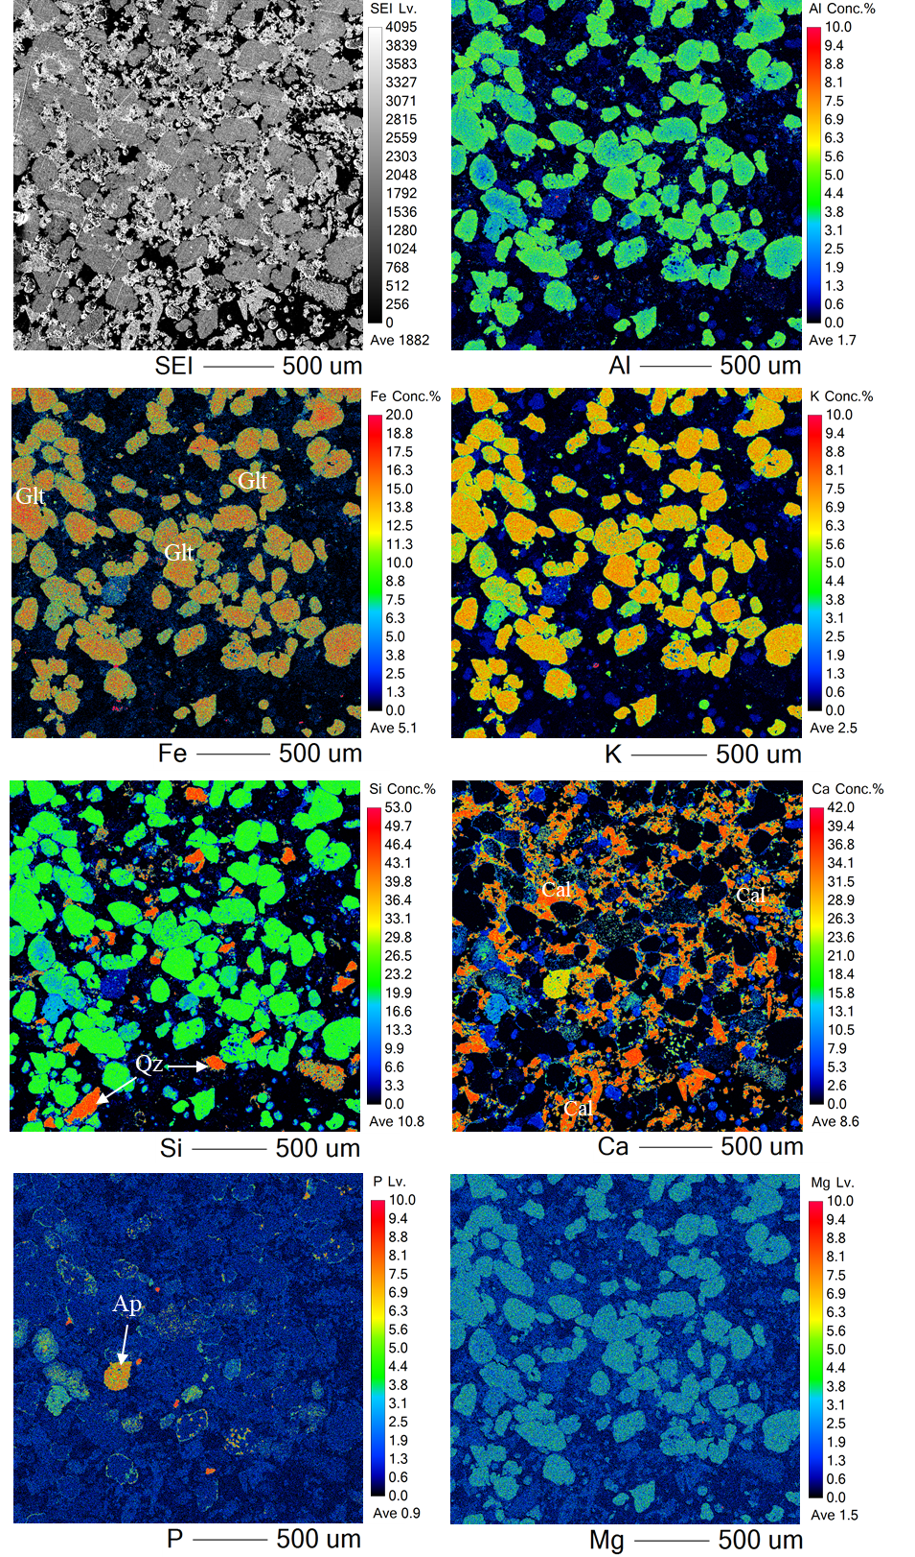
Supplementary Figure 2: The spatial element distribution maps of Al, Fe, K, Si, Ca, P and Mg, as well as the SEI image of sample P5 (lower part of the Glauconitic Pläner Limestones) show glauconite (Glt) in high abundance and a few quartz (Qz) and bio-apatite (Ap) grains hosted in a calcite matrix (Cal). Note that the majority of the glauconites has a homogenous composition.
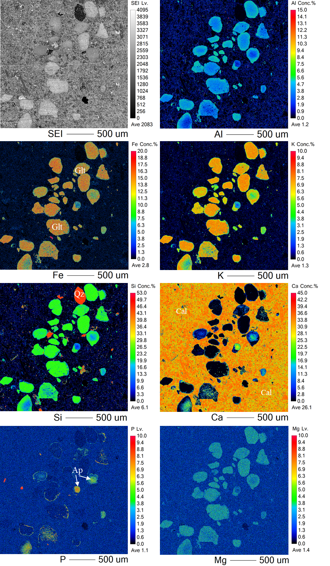
Supplementary Figure 3: The spatial element distribution maps of Al, Fe, K, Si, Ca, P and Mg, as well as the SEI image of sample P6 (middle part of the Glauconitic Pläner Limestones) show glauconite (Glt) in moderate abundance and a few quartz (Qz) and bio-apatite or apatized grains (Ap) hosted in a calcite matrix (Cal). Note that the majority of the glauconites has a homogenous composition.
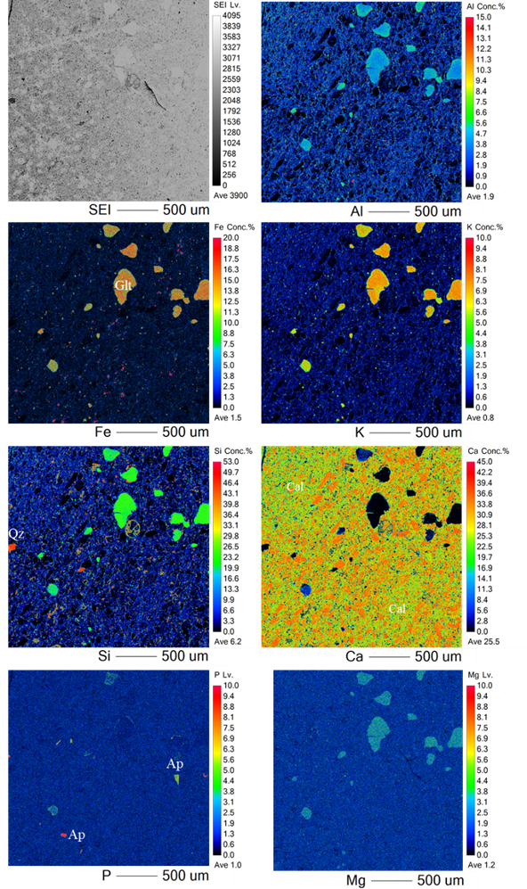
Supplementary Figure 4: The spatial element distribution maps of Al, Fe, K, Si, Ca, P and Mg, as well as the SEI image of sample P7 (uppermost part of the Glauconitic Pläner Limestones) show glauconite (Glt) in low abundance and a few quartz (Qz) and bio-apatite (Ap) grains hosted in a dominant calcite matrix (Cal). Note that the majority of the glauconites has a homogenous composition.
Supplementary Table 1: Chemical composition of the authigenic green grains (glauconite) from the glauconite-sandstone (S4), as well as from the lower (S5), middle (S6) and upper (S7) part of the Glauconitic Pläner Limestones from Langenstein determined by electron microprobe analyses.
Sample | Al₂O₃ | MgO | SiO₂ | Na₂O | CaO | Fe₂O₃ | FeO | K₂O | P₂O₅ | Total
code | (wt.%) | (wt.%) | (wt.%) | (wt.%) | (wt.%) | (wt.%) | (wt.%) | (wt.%) | (wt.%) | (wt.%)
P4-1 | 8.360 | 3.780 | 51.910 | 0.011 | 0.110 | 20.448 | 1.841 | 8.640 | 0.085 | 95.185
P4-2 | 8.340 | 3.780 | 50.340 | 0.025 | 0.138 | 21.014 | 1.892 | 8.430 | 0.013 | 93.972
P4-3 | 8.520 | 3.820 | 50.940 | 0.035 | 0.125 | 20.581 | 1.853 | 7.920 | 0.085 | 93.879
P4-4 | 8.580 | 3.850 | 51.800 | 0.049 | 0.123 | 20.548 | 1.850 | 8.620 | 0.054 | 95.474
P4-5 | 8.340 | 3.520 | 49.830 | 0.052 | 0.091 | 20.781 | 1.871 | 8.450 | 0.056 | 92.991
P4-6 | 8.660 | 3.560 | 51.580 | 0.022 | 0.132 | 19.893 | 1.791 | 8.160 | 0.038 | 93.836
P4-7 | 7.810 | 3.370 | 51.220 | 0.058 | 0.154 | 21.603 | 1.945 | 8.100 | 0.077 | 94.337
P4-8 | 8.580 | 3.590 | 51.800 | 0.039 | 0.141 | 20.992 | 1.890 | 8.310 | 0.075 | 95.417
P4-9 | 8.820 | 3.580 | 51.250 | 0.000 | 0.183 | 19.859 | 1.788 | 8.140 | 0.080 | 93.700
P4-10 | 8.570 | 3.790 | 51.730 | 0.033 | 0.120 | 21.292 | 1.917 | 8.360 | 0.116 | 95.928
P4-11 | 9.770 | 3.830 | 52.850 | 0.046 | 0.307 | 18.926 | 1.704 | 7.950 | 0.551 | 95.934
P4-12 | 8.870 | 4.020 | 51.730 | 0.025 | 0.091 | 20.026 | 1.803 | 8.520 | 0.209 | 95.294
P4-13 | 9.260 | 3.510 | 52.030 | 0.027 | 0.152 | 19.582 | 1.763 | 8.140 | 0.114 | 94.578
P4-14 | 9.200 | 3.800 | 52.060 | 0.000 | 0.116 | 19.359 | 1.743 | 7.640 | 0.062 | 93.980
P4-15 | 8.585 | 3.455 | 46.889 | 0.088 | 6.343 | 15.986 | 1.439 | 7.441 | 4.028 | 94.253
P4-16 | 8.586 | 3.718 | 52.570 | 0.030 | 0.418 | 21.731 | 1.956 | 8.551 | 0.032 | 97.592
P4-17 | 7.798 | 3.605 | 51.626 | 0.063 | 0.395 | 22.534 | 2.029 | 8.096 | 0.076 | 96.220
P4-18 | 8.451 | 3.700 | 51.878 | 0.038 | 0.383 | 21.828 | 1.965 | 8.819 | 0.112 | 97.174
P4-19 | 9.581 | 3.876 | 52.339 | 0.021 | 0.391 | 19.276 | 1.735 | 8.068 | 0.042 | 95.329
P4-20 | 9.374 | 3.937 | 52.552 | 0.042 | 0.314 | 17.060 | 1.536 | 8.738 | 0.074 | 93.627
P4-21 | 9.244 | 4.131 | 52.721 | 0.029 | 0.339 | 17.224 | 1.551 | 8.575 | 0.044 | 93.857
P4-22 | 9.541 | 4.246 | 52.057 | 0.055 | 0.334 | 17.518 | 1.577 | 8.568 | 0.058 | 93.954
P4-23 | 9.234 | 4.125 | 52.013 | 0.000 | 0.456 | 18.220 | 1.640 | 8.444 | 0.076 | 94.210
P4_Average | 8.786 | 3.765 | 51.553 | 0.034 | 0.494 | 19.838 | 1.786 | 8.290 | 0.268 | 94.814
P4_deviation | 0.533 | 0.227 | 1.240 | 0.021 | 1.281 | 1.705 | 0.153 | 0.347 | 0.826 | 1.187

Sample | Al₂O₃ | MgO | SiO₂ | Na₂O | CaO | Fe₂O₃ | FeO | K₂O | P₂O₅ | Total
code | (wt.%) | (wt.%) | (wt.%) | (wt.%) | (wt.%) | (wt.%) | (wt.%) | (wt.%) | (wt.%) | (wt.%)
P5-1 | 8.930 | 4.180 | 51.120 | 0.008 | 0.209 | 21.292 | 1.917 | 9.140 | 0.067 | 96.864
P5-2 | 9.010 | 4.200 | 52.310 | 0.016 | 0.242 | 21.747 | 1.958 | 8.990 | 0.092 | 98.566
P5-3 | 8.370 | 4.230 | 52.600 | 0.011 | 0.205 | 21.647 | 1.949 | 9.440 | 0.101 | 98.553
P5-4 | 7.880 | 3.900 | 53.070 | 0.036 | 0.433 | 21.692 | 1.953 | 9.360 | 0.188 | 98.512
P5-5 | 8.610 | 4.050 | 49.170 | 0.008 | 0.239 | 21.581 | 1.943 | 9.290 | 0.056 | 94.946
P5-6 | 8.750 | 3.900 | 52.730 | 0.011 | 0.227 | 20.959 | 1.887 | 9.110 | 0.067 | 97.641
P5-7 | 8.340 | 4.190 | 51.020 | 0.047 | 0.180 | 22.092 | 1.989 | 9.190 | 0.071 | 97.118
P5-8 | 8.130 | 3.940 | 55.230 | 0.052 | 0.113 | 21.070 | 1.897 | 8.610 | 0.056 | 99.098
P5-9 | 8.350 | 4.250 | 50.220 | 0.011 | 0.141 | 21.492 | 1.935 | 9.050 | 0.085 | 95.534
P5-10 | 7.910 | 3.850 | 51.180 | 0.091 | 0.194 | 22.614 | 2.036 | 9.250 | 0.063 | 97.187
P5-11 | 7.950 | 4.140 | 52.650 | 0.055 | 0.204 | 21.614 | 1.946 | 8.950 | 0.092 | 97.601
P5-12 | 8.500 | 4.290 | 52.700 | 0.074 | 0.191 | 21.548 | 1.940 | 9.080 | 0.081 | 98.402
P5-13 | 8.070 | 3.880 | 51.110 | 0.000 | 0.148 | 21.770 | 1.960 | 9.200 | 0.056 | 96.193
P5-14 | 8.340 | 3.950 | 50.070 | 0.011 | 1.480 | 21.470 | 1.933 | 8.910 | 0.704 | 96.867
P5-15 | 8.350 | 4.030 | 51.430 | 0.038 | 0.294 | 21.970 | 1.978 | 9.150 | 0.105 | 97.344
P5-16 | 7.310 | 3.620 | 44.110 | 0.060 | 7.860 | 18.893 | 1.701 | 7.990 | 3.830 | 95.374
P5-17 | 8.000 | 3.870 | 51.560 | 0.014 | 0.148 | 22.114 | 1.991 | 8.090 | 0.081 | 95.867
P5-18 | 8.290 | 3.850 | 51.970 | 0.065 | 0.160 | 21.092 | 1.899 | 8.990 | 0.108 | 96.424
P5-19 | 8.520 | 3.920 | 51.560 | 0.011 | 0.207 | 21.237 | 1.912 | 9.030 | 0.069 | 96.466
P5-20 | 8.040 | 4.120 | 49.340 | 0.019 | 1.870 | 22.514 | 2.027 | 8.660 | 1.126 | 97.716
P5-21 | 7.740 | 3.720 | 50.430 | 0.016 | 0.153 | 21.159 | 1.905 | 9.230 | 0.056 | 94.409
P5-22 | 8.490 | 3.890 | 50.660 | 0.036 | 0.209 | 21.914 | 1.973 | 8.870 | 0.036 | 96.078
P5-23 | 8.420 | 4.330 | 49.470 | 0.063 | 1.940 | 20.392 | 1.836 | 8.680 | 1.077 | 96.208
P5-24 | 7.820 | 3.990 | 51.520 | 0.036 | 0.196 | 22.347 | 2.012 | 8.940 | 0.056 | 96.917
P5-25 | 8.160 | 4.150 | 50.710 | 0.000 | 0.146 | 21.503 | 1.936 | 8.890 | 0.094 | 95.589
P5-26 | 8.050 | 4.240 | 50.640 | 0.000 | 0.155 | 23.325 | 2.100 | 8.850 | 0.096 | 97.456
P5-27 | 7.900 | 3.780 | 52.870 | 0.038 | 0.212 | 21.270 | 1.915 | 9.190 | 0.078 | 97.253
P5-28 | 8.870 | 4.190 | 52.620 | 0.030 | 0.208 | 21.503 | 1.936 | 9.060 | 0.034 | 98.451
P5-29 | 7.690 | 4.110 | 51.860 | 0.000 | 0.192 | 21.870 | 1.969 | 8.320 | 0.114 | 96.125
P5-30 | 7.600 | 3.980 | 46.160 | 0.047 | 4.340 | 19.881 | 1.790 | 8.260 | 2.276 | 94.334
P5-31 | 8.100 | 3.910 | 51.180 | 0.003 | 0.278 | 21.925 | 1.974 | 9.120 | 0.134 | 96.624
P5-32 | 8.140 | 4.010 | 47.720 | 0.000 | 0.703 | 24.069 | 2.167 | 8.330 | 0.236 | 95.375
P5-33 | 8.030 | 3.900 | 48.710 | 0.031 | 0.269 | 26.124 | 2.352 | 8.690 | 0.111 | 98.217
P5-34 | 8.140 | 4.240 | 51.900 | 0.000 | 0.175 | 22.381 | 2.015 | 8.880 | 0.083 | 97.814
P5-35 | 8.240 | 3.920 | 52.010 | 0.057 | 0.184 | 21.559 | 1.941 | 8.670 | 0.103 | 96.685
P5-36 | 6.990 | 3.630 | 47.170 | 0.122 | 5.130 | 21.148 | 1.904 | 7.690 | 2.790 | 96.573
P5-37 | 8.730 | 4.120 | 52.110 | 0.016 | 0.085 | 21.170 | 1.906 | 8.840 | 0.045 | 97.022
P5-38 | 8.960 | 3.910 | 51.310 | 0.000 | 0.076 | 20.515 | 1.847 | 8.970 | 0.128 | 95.715
P5-39 | 9.030 | 4.160 | 52.900 | 0.016 | 0.074 | 20.859 | 1.878 | 8.990 | 0.103 | 98.010
P5-40 | 8.530 | 4.110 | 52.440 | 0.016 | 0.068 | 21.092 | 1.899 | 9.030 | 0.101 | 97.287
P5-41 | 9.000 | 4.210 | 52.390 | 0.068 | 0.087 | 19.981 | 1.799 | 8.750 | 0.106 | 96.391
P5-42 | 9.300 | 4.190 | 51.670 | 0.030 | 0.121 | 20.515 | 1.847 | 9.110 | 0.106 | 96.888
P5-43 | 9.470 | 4.430 | 51.610 | 0.022 | 0.049 | 20.226 | 1.821 | 9.420 | 0.085 | 97.133
P5-44 | 9.010 | 4.080 | 50.690 | 0.000 | 0.071 | 20.392 | 1.836 | 9.030 | 0.083 | 95.193
P5-45 | 9.120 | 4.410 | 50.420 | 0.003 | 0.091 | 21.048 | 1.895 | 8.950 | 0.103 | 96.040
P5-46 | 9.390 | 4.140 | 51.220 | 0.027 | 0.075 | 20.570 | 1.852 | 8.840 | 0.052 | 96.166
P5-47 | 8.620 | 3.870 | 51.560 | 0.014 | 0.065 | 20.248 | 1.823 | 8.930 | 0.054 | 95.183
P5-48 | 7.060 | 4.230 | 52.720 | 0.019 | 0.074 | 22.936 | 2.065 | 9.140 | 0.094 | 98.338
P5-49 | 7.050 | 4.500 | 51.700 | 0.033 | 0.077 | 22.414 | 2.018 | 9.000 | 0.072 | 96.864
P5-50 | 6.810 | 4.350 | 51.660 | 0.033 | 0.041 | 23.658 | 2.130 | 9.050 | 0.076 | 97.808
P5-51 | 6.470 | 4.240 | 50.040 | 0.017 | 0.059 | 23.947 | 2.156 | 8.820 | 0.116 | 95.865
P5-52 | 6.990 | 4.230 | 51.930 | 0.069 | 0.053 | 23.413 | 2.108 | 8.730 | 0.148 | 97.671
P5-53 | 6.370 | 3.900 | 51.030 | 0.000 | 0.071 | 23.713 | 2.135 | 8.960 | 0.027 | 96.206
P5-54 | 6.340 | 4.040 | 52.380 | 0.008 | 0.047 | 23.880 | 2.150 | 8.730 | 0.130 | 97.705
P5-55 | 6.660 | 4.170 | 52.830 | 0.036 | 0.025 | 23.647 | 2.129 | 9.090 | 0.121 | 98.707
P5-56 | 6.040 | 3.930 | 50.850 | 0.006 | 0.078 | 24.602 | 2.215 | 8.980 | 0.080 | 96.781
P5-57 | 6.130 | 3.740 | 51.810 | 0.031 | 0.075 | 23.980 | 2.159 | 9.000 | 0.025 | 96.949
P5-58 | 6.260 | 4.080 | 50.480 | 0.116 | 0.086 | 25.524 | 2.298 | 8.750 | 0.060 | 97.654
P5-59 | 6.440 | 3.980 | 52.120 | 0.000 | 0.056 | 24.180 | 2.177 | 9.270 | 0.029 | 98.252
P5-60 | 6.740 | 4.250 | 51.920 | 0.075 | 0.066 | 23.169 | 2.086 | 9.230 | 0.121 | 97.657
P5-61 | 6.920 | 4.450 | 52.730 | 0.072 | 0.048 | 23.713 | 2.135 | 9.290 | 0.049 | 99.407
P5-62 | 6.720 | 4.250 | 49.790 | 0.031 | 0.091 | 23.813 | 2.144 | 9.010 | 0.063 | 95.911
P5-63 | 6.620 | 4.150 | 50.840 | 0.028 | 0.044 | 23.613 | 2.126 | 9.040 | 0.038 | 96.499
P5-64 | 5.900 | 3.600 | 52.480 | 0.034 | 0.088 | 23.802 | 2.143 | 8.990 | 0.058 | 97.095
P5-65 | 6.090 | 3.840 | 50.820 | 0.006 | 0.068 | 23.658 | 2.130 | 8.940 | 0.051 | 95.603
P5-66 | 5.850 | 4.000 | 51.790 | 0.039 | 0.293 | 24.657 | 2.220 | 8.910 | 0.139 | 97.899
P5-67 | 5.690 | 3.990 | 50.650 | 0.003 | 0.057 | 24.458 | 2.202 | 9.090 | 0.094 | 96.234
P5-68 | 6.050 | 4.090 | 53.000 | 0.048 | 0.044 | 24.513 | 2.207 | 9.180 | 0.067 | 99.199
P5-69 | 6.070 | 4.280 | 50.660 | 0.039 | 0.065 | 24.835 | 2.236 | 8.960 | 0.087 | 97.233
P5-70 | 6.560 | 4.400 | 52.440 | 0.014 | 0.032 | 22.880 | 2.060 | 9.120 | 0.090 | 97.596
P5-71 | 6.330 | 4.320 | 51.480 | 0.000 | 0.055 | 23.513 | 2.117 | 9.080 | 0.070 | 96.965
P5-72 | 6.490 | 4.290 | 50.800 | 0.056 | 0.044 | 24.013 | 2.162 | 9.290 | 0.108 | 97.253
P5-73 | 6.260 | 4.130 | 52.870 | 0.003 | 0.040 | 23.736 | 2.137 | 9.270 | 0.079 | 98.524
P5-74 | 6.330 | 3.970 | 53.000 | 0.000 | 0.039 | 23.369 | 2.104 | 8.970 | 0.090 | 97.872
P5-75 | 6.350 | 3.860 | 49.320 | 0.000 | 0.053 | 23.747 | 2.138 | 9.210 | 0.051 | 94.729
P5-76 | 6.500 | 4.440 | 53.290 | 0.006 | 0.041 | 22.947 | 2.066 | 9.290 | 0.083 | 98.663
P5-77 | 7.250 | 4.370 | 50.640 | 0.022 | 0.052 | 22.414 | 2.018 | 9.150 | 0.025 | 95.941
P5-78 | 7.150 | 4.000 | 52.260 | 0.008 | 0.044 | 21.859 | 1.968 | 9.280 | 0.081 | 96.650
P5-79 | 7.100 | 4.020 | 49.590 | 0.000 | 0.080 | 22.747 | 2.048 | 9.210 | 0.049 | 94.844
P5-80 | 7.980 | 4.330 | 52.260 | 0.038 | 0.052 | 20.881 | 1.880 | 9.210 | 0.063 | 96.694
P5-81 | 8.560 | 4.130 | 51.410 | 0.003 | 0.071 | 20.548 | 1.850 | 9.020 | 0.058 | 95.650
P5_Average | 7.621 | 4.081 | 51.268 | 0.027 | 0.399 | 22.323 | 2.010 | 8.966 | 0.223 | 96.918
P5_deviation | 1.041 | 0.204 | 1.627 | 0.027 | 1.149 | 1.473 | 0.133 | 0.309 | 0.583 | 1.164

Sample | Al₂O₃ | MgO | SiO₂ | Na₂O | CaO | Fe₂O₃ | FeO | K₂O | P₂O₅ | Total
code | (wt.%) | (wt.%) | (wt.%) | (wt.%) | (wt.%) | (wt.%) | (wt.%) | (wt.%) | (wt.%) | (wt.%)
P6-1 | 6.530 | 4.530 | 52.600 | 0.000 | 0.302 | 23.813 | 2.144 | 9.020 | 0.025 | 98.964
P6-2 | 6.870 | 4.470 | 53.490 | 0.080 | 0.256 | 23.636 | 2.128 | 8.900 | 0.038 | 99.868
P6-3 | 7.820 | 4.730 | 54.970 | 0.008 | 0.315 | 21.170 | 1.906 | 9.030 | 0.036 | 99.985
P6-4 | 7.520 | 4.410 | 51.500 | 0.000 | 0.373 | 22.358 | 2.013 | 8.830 | 0.054 | 97.058
P6-5 | 8.310 | 4.610 | 53.250 | 0.055 | 0.309 | 21.359 | 1.923 | 9.000 | 0.047 | 98.863
P6-6 | 7.670 | 4.640 | 51.850 | 0.003 | 0.240 | 22.269 | 2.005 | 8.960 | 0.000 | 97.637
P6-7 | 7.270 | 4.280 | 50.290 | 0.000 | 0.259 | 23.169 | 2.086 | 8.760 | 0.020 | 96.134
P6-8 | 6.620 | 4.180 | 51.180 | 0.017 | 0.243 | 23.014 | 2.072 | 8.700 | 0.105 | 96.130
P6-9 | 7.020 | 4.430 | 52.460 | 0.022 | 0.432 | 22.769 | 2.050 | 8.900 | 0.040 | 98.123
P6-10 | 7.290 | 4.160 | 50.880 | 0.014 | 0.251 | 22.214 | 2.000 | 8.790 | 0.022 | 95.621
P6-11 | 8.120 | 4.150 | 52.410 | 0.038 | 0.496 | 21.559 | 1.941 | 8.740 | 0.067 | 97.522
P6-12 | 8.370 | 4.210 | 53.440 | 0.071 | 0.280 | 21.903 | 1.972 | 8.730 | 0.052 | 99.028
P6-13 | 8.810 | 4.340 | 51.690 | 0.000 | 0.286 | 20.870 | 1.879 | 8.450 | 0.072 | 96.397
P6-14 | 8.120 | 4.430 | 51.730 | 0.036 | 1.600 | 20.848 | 1.877 | 8.420 | 0.737 | 97.797
P6-15 | 8.210 | 4.490 | 53.340 | 0.025 | 0.558 | 21.514 | 1.937 | 8.610 | 0.200 | 98.884
P6-16 | 8.770 | 4.180 | 52.550 | 0.016 | 0.437 | 21.092 | 1.899 | 8.700 | 0.020 | 97.665
P6-17 | 8.560 | 4.380 | 53.380 | 0.011 | 0.286 | 20.559 | 1.851 | 8.920 | 0.070 | 98.016
P6-18 | 7.970 | 4.150 | 52.580 | 0.022 | 0.231 | 20.959 | 1.887 | 8.780 | 0.029 | 96.607
P6-19 | 7.660 | 4.270 | 52.510 | 0.041 | 2.090 | 21.592 | 1.944 | 8.540 | 1.008 | 99.655
P6-20 | 8.230 | 3.940 | 51.400 | 0.000 | 1.396 | 20.703 | 1.864 | 8.340 | 0.270 | 96.143
P6-21 | 8.010 | 4.310 | 52.690 | 0.000 | 0.108 | 22.181 | 1.997 | 8.590 | 0.027 | 97.913
P6-22 | 7.370 | 4.400 | 53.540 | 0.028 | 0.162 | 22.147 | 1.994 | 8.870 | 0.036 | 98.546
P6-23 | 7.440 | 4.290 | 53.670 | 0.038 | 0.093 | 21.692 | 1.953 | 8.900 | 0.029 | 98.105
P6-24 | 8.430 | 4.130 | 52.940 | 0.038 | 0.231 | 21.492 | 1.935 | 8.620 | 0.054 | 97.870
P6-25 | 8.850 | 4.190 | 52.970 | 0.000 | 0.116 | 20.848 | 1.877 | 8.810 | 0.036 | 97.697
P6-26 | 8.820 | 4.090 | 53.110 | 0.003 | 0.215 | 20.459 | 1.842 | 8.570 | 0.174 | 97.282
P6-27 | 8.760 | 4.230 | 53.750 | 0.011 | 0.222 | 20.270 | 1.825 | 8.670 | 0.232 | 97.971
P6-28 | 8.790 | 4.390 | 53.450 | 0.035 | 0.146 | 20.204 | 1.819 | 8.690 | 0.034 | 97.557
P6-29 | 8.290 | 4.050 | 51.140 | 0.033 | 1.025 | 20.215 | 1.820 | 8.450 | 1.525 | 96.548
P6-30 | 9.100 | 4.620 | 53.860 | 0.014 | 0.127 | 21.548 | 1.940 | 8.610 | 0.063 | 99.882
P6-31 | 8.890 | 4.340 | 52.140 | 0.000 | 0.541 | 20.304 | 1.828 | 8.880 | 0.049 | 96.971
P6-32 | 7.400 | 3.600 | 46.980 | 0.052 | 2.480 | 19.526 | 1.758 | 7.940 | 4.250 | 93.986
P6-33 | 9.200 | 4.670 | 53.290 | 0.000 | 0.386 | 19.182 | 1.727 | 8.770 | 0.360 | 97.584
P6-34 | 9.610 | 4.220 | 53.190 | 0.000 | 0.301 | 18.471 | 1.663 | 8.980 | 0.252 | 96.687
P6-35 | 9.570 | 4.100 | 51.930 | 0.011 | 0.267 | 19.526 | 1.758 | 9.180 | 0.314 | 96.655
P6-36 | 9.550 | 4.200 | 50.140 | 0.000 | 1.490 | 17.405 | 1.567 | 8.580 | 1.803 | 94.735
P6-37 | 10.170 | 4.380 | 52.370 | 0.000 | 0.493 | 19.082 | 1.718 | 8.690 | 0.436 | 97.338
P6_Average | 8.216 | 4.302 | 52.396 | 0.019 | 0.515 | 21.133 | 1.903 | 8.728 | 0.340 | 97.552
P6_deviation | 0.875 | 0.221 | 1.393 | 0.021 | 0.567 | 1.397 | 0.126 | 0.232 | 0.776 | 1.364
Sample | Al₂O₃ | MgO | SiO₂ | Na₂O | CaO | Fe₂O₃ | FeO | K₂O | P₂O₅ | Total
code | (wt.%) | (wt.%) | (wt.%) | (wt.%) | (wt.%) | (wt.%) | (wt.%) | (wt.%) | (wt.%) | (wt.%)
P7-1 | 7.840 | 4.540 | 52.700 | 0.000 | 0.090 | 21.203 | 1.909 | 9.380 | 0.036 | 97.698
P7-2 | 7.240 | 4.300 | 53.940 | 0.017 | 0.088 | 22.692 | 2.043 | 9.370 | 0.085 | 99.774
P7-3 | 7.370 | 4.490 | 52.290 | 0.006 | 0.088 | 22.525 | 2.028 | 9.100 | 0.063 | 97.959
P7-4 | 8.510 | 4.460 | 53.820 | 0.022 | 0.101 | 19.726 | 1.776 | 9.430 | 0.018 | 97.862
P7-5 | 7.680 | 4.400 | 53.290 | 0.000 | 0.134 | 21.481 | 1.934 | 9.210 | 0.036 | 98.165
P7-6 | 8.220 | 4.510 | 53.280 | 0.000 | 0.099 | 21.492 | 1.935 | 9.110 | 0.099 | 98.744
P7-7 | 9.140 | 4.290 | 53.490 | 0.081 | 0.128 | 20.570 | 1.852 | 9.360 | 0.063 | 98.974
P7-8 | 8.310 | 4.400 | 53.980 | 0.005 | 0.084 | 21.425 | 1.929 | 9.300 | 0.072 | 99.506
P7-9 | 9.500 | 4.200 | 51.060 | 0.011 | 0.761 | 18.715 | 1.685 | 7.620 | 1.011 | 94.562
P7-10 | 7.590 | 4.190 | 52.970 | 0.077 | 0.080 | 22.392 | 2.016 | 9.370 | 0.040 | 98.725
P7-11 | 6.780 | 4.420 | 51.820 | 0.000 | 0.105 | 23.958 | 2.157 | 9.210 | 0.054 | 98.503
P7-12 | 8.000 | 4.360 | 52.340 | 0.033 | 0.069 | 22.481 | 2.024 | 9.250 | 0.067 | 98.624
P7-13 | 7.130 | 3.940 | 52.980 | 0.033 | 0.095 | 23.302 | 2.098 | 9.300 | 0.058 | 98.937
P7-14 | 7.310 | 4.360 | 52.640 | 0.044 | 0.085 | 22.880 | 2.060 | 9.240 | 0.063 | 98.682
P7-15 | 7.280 | 4.250 | 51.740 | 0.072 | 0.097 | 22.703 | 2.044 | 9.320 | 0.049 | 97.554
P7-16 | 7.440 | 4.240 | 50.540 | 0.011 | 0.078 | 21.503 | 1.936 | 9.250 | 0.054 | 95.051
P7-17 | 7.330 | 4.500 | 53.130 | 0.066 | 0.083 | 23.325 | 2.100 | 9.250 | 0.013 | 99.797
P7-18 | 7.220 | 4.360 | 52.150 | 0.011 | 0.120 | 23.091 | 2.079 | 9.170 | 0.121 | 98.322
P7-19 | 7.630 | 4.150 | 53.370 | 0.006 | 0.165 | 22.492 | 2.025 | 9.270 | 0.107 | 99.214
P7-20 | 7.760 | 4.400 | 51.720 | 0.022 | 0.073 | 23.125 | 2.082 | 9.190 | 0.112 | 98.483
P7-21 | 7.300 | 4.040 | 52.600 | 0.028 | 0.088 | 23.102 | 2.080 | 9.280 | 0.027 | 98.545
P7-22 | 7.730 | 4.140 | 51.630 | 0.039 | 0.098 | 22.969 | 2.068 | 9.210 | 0.031 | 97.915
P7-23 | 7.970 | 4.040 | 53.440 | 0.066 | 0.108 | 22.203 | 1.999 | 9.180 | 0.018 | 99.023
P7-24 | 7.560 | 4.110 | 52.790 | 0.027 | 0.099 | 21.625 | 1.947 | 9.210 | 0.045 | 97.413
P7-25 | 7.470 | 4.150 | 53.050 | 0.060 | 0.121 | 22.292 | 2.007 | 9.390 | 0.089 | 98.629
P7-26 | 7.940 | 4.200 | 52.990 | 0.017 | 0.128 | 22.858 | 2.058 | 9.070 | 0.072 | 99.332
P7_Average | 7.740 | 4.286 | 52.683 | 0.029 | 0.125 | 22.159 | 1.995 | 9.194 | 0.096 | 98.307
P7_deviation | 0.611 | 0.163 | 0.873 | 0.026 | 0.131 | 1.177 | 0.106 | 0.334 | 0.189 | 1.212

Supplementary Table 2: Measured δ¹³C and δ¹⁸O isotopic compositions of calcite within the Langenstein profile. GLP – Glauconitic Pläner Limestones.
Sample  code | Sample  type | δ¹³C  (‰, PDB) | δ¹⁸C  (‰, PDB) | Position in  profile (m)
S1 | Neocomian sandstone | -0.78 | -5.42 | -0.50
S2 | Basal conglomerate | -7.51 | -7.53 | 0.10
S4-1 | Glauconite-sandstone | -6.03 | -7.26 | 0.50
S4-2 | Glauconite-sandstone | 0.43 | -5.02 | 0.60
S5-1 | GLP | 1.07 | -3.40 | 1.10
S5-2 | GLP | 0.95 | -3.65 | 1.60
S6 | GLP | 1.33 | -3.65 | 2.40
S7 | GLP | 1.44 | -3.91 | 2.90
S8 | Pläner Limestone | 2.13 | -3.85 | 3.40

Supplementary Table 3: K–Mg–Fe sequestration rates calculated for the authigenic green grains (glauconite) from the glauconite-sandstone (S4) and Glauconitic Pläner Limestones (S5-7) from Langenstein. The rates were calculated using measured glauconite abundances and compositions across the profile, assuming a constant sedimentation rate of 1.3 m·Myr⁻¹ and a sediment density of 2.7 g·cm⁻³.
Sample | Position in | Glauconite | K | Mg | Fe | K burial rate | Mg burial rate | Fe burial rate
code | profile (m) | (wt.%) | (wt.%) | (wt.%) | (wt.%) | (mmol·cm⁻²·kyr⁻¹) | (mmol·cm⁻²·kyr⁻¹) | (mmol·cm⁻²·kyr⁻¹)
S4-1 | 0.6 | 68 | 6.9 | 2.3 | 15.3 | 42.1 | 22.6 | 65.4
S5-2 | 1.6 | 25 | 7.4 | 2.5 | 17.2 | 16.6 | 9.0 | 27.0
S6 | 2.4 | 5 | 7.2 | 2.6 | 16.3 | 3.2 | 1.9 | 5.1
S7 | 2.9 | 1 | 7.6 | 2.6 | 17.0 | 0.7 | 0.4 | 1.1

Supplementary Table 4: K–Mg–Fe sequestration rates associated with glauconite formation from the Holocene to Triassic. The rates were calculated using a constant sedimentation rate of 1.3 m·Myr⁻¹ and a sediment density of 2.7 g·cm⁻³. Glauconite abundance is from Banerjee et al. (2016).
Geological period | Glauconite  abundance  on shelf (wt.%) | Glauconite  composition  K (wt.%) | 2SD | Sedimentation  rate  (m·Myr⁻¹) | K burial rate  (mmol·cm⁻²·kyr⁻¹)  avg | 2SD
Holocene | 5.6 | 7 | 1 | 1.3 | 3.5 | 0.5
Plio-Pleistocene | 5.5 | 7 | 1 | 1.3 | 3.4 | 0.5
Miocene | 4.8 | 7 | 1 | 1.3 | 3.0 | 0.4
Oligocene | 4.8 | 7 | 1 | 1.3 | 3.0 | 0.4
Eocene | 10.9 | 7 | 1 | 1.3 | 6.9 | 1.0
Paleocene | 5.5 | 7 | 1 | 1.3 | 3.4 | 0.5
Late Cretaceous | 15.6 | 7 | 1 | 1.3 | 9.8 | 1.4
Early Cretaceous | 9.9 | 7 | 1 | 1.3 | 6.3 | 0.9
Jurassic | 2.7 | 7 | 1 | 1.3 | 1.7 | 0.2
Triassic | 2.7 | 7 | 1 | 1.3 | 1.7 | 0.2
Geological period | Glauconite  abundance  on shelf (wt.%) | Glauconite  composition  Mg (wt.%) | 2SD | Sedimentation  rate  (m·Myr⁻¹) | Mg burial rate  (mmol·cm⁻²·kyr⁻¹)  avg | 2SD
Holocene | 5.6 | 4 | 1 | 1.3 | 3.3 | 0.8
Plio-Pleistocene | 5.5 | 4 | 1 | 1.3 | 3.2 | 0.8
Miocene | 4.8 | 4 | 1 | 1.3 | 2.8 | 0.7
Oligocene | 4.8 | 4 | 1 | 1.3 | 2.8 | 0.7
Eocene | 10.9 | 4 | 1 | 1.3 | 6.3 | 1.6
Paleocene | 5.5 | 4 | 1 | 1.3 | 3.2 | 0.8
Late Cretaceous | 15.6 | 4 | 1 | 1.3 | 9.0 | 2.2
Early Cretaceous | 9.9 | 4 | 1 | 1.3 | 5.7 | 1.4
Jurassic | 2.7 | 4 | 1 | 1.3 | 1.6 | 0.4
Triassic | 2.7 | 4 | 1 | 1.3 | 1.6 | 0.4
Geological period | Glauconite  abundance  on shelf (wt.%) | Glauconite  composition  Fe (wt.%) | 2SD | Sedimentation  rate  (m·Myr⁻¹) | Fe burial rate  (mmol·cm⁻²·kyr⁻¹) | 2SD
Holocene | 5.6 | 23 | 2 | 1.3 | 8.1 | 0.7
Plio-Pleistocene | 5.5 | 23 | 2 | 1.3 | 7.9 | 0.7
Miocene | 4.8 | 23 | 2 | 1.3 | 7.0 | 0.6
Oligocene | 4.8 | 23 | 2 | 1.3 | 7.0 | 0.6
Eocene | 10.9 | 23 | 2 | 1.3 | 15.8 | 1.4
Paleocene | 5.5 | 23 | 2 | 1.3 | 7.9 | 0.7
Late Cretaceous | 15.6 | 23 | 2 | 1.3 | 22.5 | 2.0
Early Cretaceous | 9.9 | 23 | 2 | 1.3 | 14.4 | 1.3
Jurassic | 2.7 | 23 | 2 | 1.3 | 3.9 | 0.3
Triassic | 2.7 | 23 | 2 | 1.3 | 3.9 | 0.3

Supplementary Table 5: K–Mg–Fe palaeo-fluxes associated with glauconite formation from the Holocene to Triassic. Calculations are based on the average K–Mg–Fe sequestration rates (cf. Table S4) and estimated ‘low’ and ‘high’ shelf areas (0-200 m) through time.
Geological  period | Average  K burial rate  (mmol·cm⁻²·kyr⁻¹) | World  shelf  area (m²)¹ | 2SD | World  shelf  area (m²)² | 2SD | Shallow ocean  K palaeo-flux  (Tmol·yr⁻¹)¹ | 2SD | Shallow ocean  K palaeo-flux  (Tmol·yr⁻¹)² | 2SD
Holocene | 3.5 | 17.9 | 9.2 |  |  | 0.036 | 0.018
Plio-Pleistocene | 3.4 | 15.5 | 3.5 | 62.3 | 0.12 | 0.029 | 0.007 | 0.116 | 0.0002
Miocene | 3.0 | 12.5 | 1.4 | 66.4 | 4.17 | 0.018 | 0.002 | 0.098 | 0.006
Oligocene | 3.0 | 11.9 | 1.9 | 73.3 | 1.4 | 0.017 | 0.003 | 0.108 | 0.002
Eocene | 6.9 | 21.4 | 9.3 | 78.1 | 1.44 | 0.160 | 0.070 | 0.584 | 0.011
Paleocene | 3.4 | 23.6 | 2.6 | 78.8 | 0.61 | 0.044 | 0.005 | 0.147 | 0.001
Late Cretaceous | 9.8 | 25.5 | 3.9 | 82.2 | 3.1 | 0.389 | 0.059 | 1.254 | 0.047
Early Cretaceous | 6.3 | 25.1 | 6.0 | 75.9 | 7.52 | 0.156 | 0.037 | 0.472 | 0.047
Jurassic | 1.7 | 16.2 | 7.8 | 68.9 | 4.91 | 0.008 | 0.004 | 0.032 | 0.002
Triassic | 1.7 | 11.3 | 8.0 | 56.8 | 2.29 | 0.005 | 0.004 | 0.027 | 0.001
Geological  period | Average  Mg burial rate  (mmol·cm⁻²·kyr⁻¹) | World  shelf  area (m²)¹ | 2SD | World  shelf  area (m²)² | 2SD | Shallow ocean  Mg palaeo-flux  (Tmol·yr⁻¹)¹ | 2SD | Shallow ocean  Mg palaeo-flux  (Tmol·yr⁻¹)² | 2SD
Holocene | 3.3 | 17.9 | 9.2 |  |  | 0.033 | 0.017
Plio-Pleistocene | 3.2 | 15.5 | 3.5 | 62.3 | 0.12 | 0.027 | 0.006 | 0.107 | 0.0002
Miocene | 2.8 | 12.5 | 1.4 | 66.4 | 4.17 | 0.017 | 0.002 | 0.090 | 0.006
Oligocene | 2.8 | 11.9 | 1.9 | 73.3 | 1.4 | 0.016 | 0.003 | 0.099 | 0.002
Eocene | 6.3 | 21.4 | 9.3 | 78.1 | 1.44 | 0.147 | 0.064 | 0.537 | 0.010
Paleocene | 3.2 | 23.6 | 2.6 | 78.8 | 0.61 | 0.041 | 0.005 | 0.135 | 0.001
Late Cretaceous | 9.0 | 25.5 | 3.9 | 82.2 | 3.1 | 0.357 | 0.054 | 1.152 | 0.043
Early Cretaceous | 5.7 | 25.1 | 6.0 | 75.9 | 7.52 | 0.144 | 0.034 | 0.433 | 0.043
Jurassic | 1.6 | 16.2 | 7.8 | 68.9 | 4.91 | 0.007 | 0.003 | 0.030 | 0.002
Triassic | 1.6 | 11.3 | 8.0 | 56.8 | 2.29 | 0.005 | 0.003 | 0.024 | 0.001
Geological  period | Average  Fe burial rate  (mmol·cm⁻²·kyr⁻¹) | World  shelf  area (m²)¹ | 2SD | World  shelf  area (m²)² | 2SD | Shallow ocean  Fe palaeo-flux  (Tmol·yr⁻¹)¹ | 2SD | Shallow ocean  Fe palaeo-flux  (Tmol·yr⁻¹)² | 2SD
Holocene | 8.1 | 17.9 | 9.2 |  |  | 0.082 | 0.042
Plio-Pleistocene | 7.9 | 15.5 | 3.5 | 62.3 | 0.12 | 0.067 | 0.015 | 0.268 | 0.001
Miocene | 7.0 | 12.5 | 1.4 | 66.4 | 4.17 | 0.042 | 0.005 | 0.225 | 0.014
Oligocene | 7.0 | 11.9 | 1.9 | 73.3 | 1.4 | 0.040 | 0.006 | 0.248 | 0.005
Eocene | 15.8 | 21.4 | 9.3 | 78.1 | 1.44 | 0.368 | 0.160 | 1.344 | 0.025
Paleocene | 7.9 | 23.6 | 2.6 | 78.8 | 0.61 | 0.101 | 0.011 | 0.339 | 0.003
Late Cretaceous | 22.5 | 25.5 | 3.9 | 82.2 | 3.1 | 0.895 | 0.135 | 2.884 | 0.109
Early Cretaceous | 14.4 | 25.1 | 6.0 | 75.9 | 7.52 | 0.359 | 0.086 | 1.085 | 0.107
Jurassic | 3.9 | 16.2 | 7.8 | 68.9 | 4.91 | 0.017 | 0.008 | 0.074 | 0.005
Triassic | 3.9 | 11.3 | 8.0 | 56.8 | 2.29 | 0.012 | 0.009 | 0.061 | 0.002
¹Scotese and Wright (2018), Wessel et al. (2019); ²Cao et al. (2017), Golonka et al. (2006), Matthews et al. (2016)

References cited
Baldermann, A. et al. The role of Fe on the formation and diagenesis of interstratified glauconite-smectite and illite-smectite: A case study of Upper Cretaceous shallow-water carbonates. Chem. Geol. 453, 21-34 http://dx.doi.org/10.1016/j.chemgeo.2017.02.008 (2017).
Banerjee, S., Bansal, U. & Thorat, A.V. A review on palaeogeographic implications and temporal variation in glaucony composition. J. Palaeogeogr. 5, 43-71 http://dx.doi.org/10.1016/j.jop.2015.12.001 (2016).
Cao, W. et al. Improving global paleogeography since the late Paleozoic using paleobiology. Biogeosciences 14, 5425–5439 https://doi.org/10.5194/bg-14-5425-2017 (2017).
Golonka, J., Krobicki, M., Pajak, J., Giang, N. V. & Zuchiewicz, W. Global Plate Tectonics and Paleogeography of Southeast Asia. Faculty of Geology, Geophysics and Environmental Protection, AGH University of Science and Technology, Arkadia, Krakow, Poland (2006).
Gradstein, F.M., Ogg, J.G. & Smith, A.G. A geologic time scale. Cambridge (University Press) 1-589 (2004).
Matthews, K.J. et al. Global plate boundary evolution and kinematics since the late Paleozoic. Global Planet. Change 146, 226-250 https://doi.org/10.1016/j.gloplacha.2016.10.002 (2016).
Scotese, C.R. & Wright, N. PALEOMAP Paleodigital Elevation Models (PaleoDEMS) for the Phanerozoic. Retrieved from https://www.earthbyte.org/paleodem‐resource‐scotese‐and‐wright‐2018/ (2018).
Voigt, T., Wiese, F., von Eynatten, H., Franzke, H.-J. & Gaupp, R. Facies evolution of syntectonic Upper Cretaceous deposits in the Subhercynian Cretaceous Basin and adjoining areas (Germany). Z. dt. Ges. Geowiss. 157, 203-244 https://doi.org/10.1127/1860-1804/2006/0157-0203 (2006).
Wessel, P. et al. The Generic Mapping Tools version 6. Geochem Geophys. 20, 5556-5564 https://doi.org/10.1029/2019GC008515 (2019).
Wilmsen M. Sequence stratigraphy and palaeoceanography of the Cenomanian Stage in northern Germany. Cret. Res. 24, 525-568 https://doi.org/10.1016/S0195-6671(03)00069-7 (2003).
Wilmsen, M. Accommodation- versus capacity-controlled deposition in the Cenomanian (Upper Cretaceous) of northern Germany. Beringeria 37, 239-251 (2007).
Wilmsen, M., Niebuhr, B. & Hiss, M. The Cenomanian of northern Germany: facies analysis of a transgressive biosedimentary system. Facies 51, 242-263 https://doi.org/10.1007/s10347-005-0058-5 (2005).

