Supplementary materials

Table S1. Definitions of the presence of infection, organ dysfunction, and comorbidities.
Group | Code type | Code
Infection | ICD 10 codes in the primary or trigger-for-hospitalization diagnosis | A01-A02.0, A03-A09.9, A19-A20.3, A21-A21.3, A22-A22.2, A23-A24.0, A25-A26.0, A27-A28.1, A31-A32.12, A36-A39, A39.1-A39.3, A42-A42.2, A43-A46.0, A48-A49.9, A59-A59.9, A65-A65.0, A69-A69.1, A74, A74.8-A75.9, A77-A81.9, A83-A96.9, A98-B00.59, B01-B10.89, B25-B27.99, B29.4, B33-B34.9, B37-B37.6, B38-B50.9, B54-B55, B55.1-B55.9, B58-B60.8, B64, B67-B67.99, B91, B95-B99.9, G00-G08.0, G14-G14.6, H05.01-H05.039, H60.2-H60.23, H70.0-H70.009, I00, I02, I02.9, I26.01-I26.09, I26.90-I26.99, I33-I33.9, I38-I39.9, I40.0-I40.9, I76, I96-I96.9, I98.1, J01-J06.9, J09-J22.9, J36-J36.0, J39.0-J39.1, J85-J86.9, K35-K37.9, K57-K57.93, K61-K61.4, K63.0-K63.1, K65-K65.9, K67.8, K75.0-K75.1, K75.3, K76.3, K77.0, K81.0, K81.2, K83.0, K95.01, K95.81, L02-L08.9, M00-M02.9, M86-M86.9, M89.6-M89.69, N10-N10.9, N15.1-N15.9, N30-N30.91, N39.0, N41.0, N41.2-N41.3, N45-N45.9, N70-N77.8, R78.81, T80.2-T80.29, T81.4, T82.6-T82.7, T83.5, T83.6, T84.5-T84.7, T85.7, T88.0, U04
Organ dysfunction, IHME¹¹ | ICD 10 codes in the primary, concomitant or complication diagnoses | D65-D65.9, D69.5-D69.59, E87.2-E87.99, G93.4-G93.49, I46-I46.9, I95.1-I95.9, J80-J80.9, J95.2-J95.3, J96-J96.92, K72-K72.91, N00-N01.9, N17-N17.9, R09.02, R09.2, R40.0-R40.4, R41.82, R55-R55.0, R57-R57.9
Organ dysfunction, Angus¹⁴ | ICD 10 codes in the primary, concomitant or complication diagnoses | I95, R57, Z99.1, D65, D68.9, D69.5, D69.6, F05.0, F05.8, F05.9, G63.1, G93.4, R41, K72.0, K72.9, K76.2, K76.3, N17, N99.0
Organ dysfunction, Martin¹⁵ | ICD 10 codes in the primary, concomitant or complication diagnoses | I95.1, I95.9, R03.1, R57, J95.1, J95.2, J80, R06.0, R06.3, R06.4, R06.8, R09.2, J96.0, J96.9, D65, D68.9, D69.3, D69.4, D69.5, D69.6, F05.0, F05.8, F05.9, G93.1, G93.4, R40, R41.8, R41.0, N00, N01, N17, N19, Z49.1, K72.0, K72.9, K76.2, E87.2
Charlson Comorbidity Index
Myocardial infarction | ICD 10 codes in the concomitant or complication diagnoses | I21.x, I22.x, I25.2
Congestive heart failure | ICD 10 codes in the concomitant or complication diagnoses | I09.9, I11.0, I13.0, I13.2, I25.5, I42.0, I42.5–I42.9, I43.x, I50.x, P29.0
Peripheral vascular disease | ICD 10 codes in the concomitant or complication diagnoses | I70.x, I71.x, I73.1, I73.8, I73.9, I77.1, I79.0, I79.2, K55.1, K55.8, K55.9, Z95.8, Z95.9
Cerebrovascular disease | ICD 10 codes in the concomitant or complication diagnoses | G45.x, G46.x, H34.0, I60.x–I69.x
Dementia | ICD 10 codes in the concomitant or complication diagnoses | F00.x–F03.x, F05.1, G30.x, G31.1
Chronic pulmonary disease | ICD 10 codes in the concomitant or complication diagnoses | I27.8, I27.9, J40.x–J47.x, J60.x–J67.x, J68.4, J70.1, J70.3
Rheumatic disease | ICD 10 codes in the concomitant or complication diagnoses | M05.x, M06.x, M31.5, M32.x–M34.x, M35.1, M35.3, M36.0
Peptic ulcer disease | ICD 10 codes in the concomitant or complication diagnoses | K25.x–K28.x
Mild liver disease | ICD 10 codes in the concomitant or complication diagnoses | B18.x, K70.0–K70.3, K70.9, K71.3–K71.5, K71.7, K73.x, K74.x, K76.0, K76.2–K76.4, K76.8, K76.9, Z94.4
Diabetes without chronic complication | ICD 10 codes in the concomitant or complication diagnoses | E10.0, E10.1, E10.6, E10.8, E10.9, E11.0, E11.1, E11.6, E11.8, E11.9, E12.0, E12.1, E12.6, E12.8, E12.9, E13.0, E13.1, E13.6, E13.8, E13.9, E14.0, E14.1, E14.6, E14.8, E14.9
Diabetes with chronic complication | ICD 10 codes in the concomitant or complication diagnoses | E10.2–E10.5, E10.7, E11.2–E11.5, E11.7, E12.2–E12.5, E12.7, E13.2– E13.5, E13.7, E14.2–E14.5, E14.7
Hemiplegia or paraplegia | ICD 10 codes in the concomitant or complication diagnoses | G04.1, G11.4, G80.1, G80.2, G81.x, G82.x, G83.0–G83.4, G83.9
Renal disease | ICD 10 codes in the concomitant or complication diagnoses | I12.0, I13.1, N03.2–N03.7, N05.2–N05.7, N18.x, N19.x, N25.0, Z49.0–Z49.2, Z94.0, Z99.2
Any malignancy, including lymphoma and leukemia, except malignant neoplasm of skin | ICD 10 codes in the concomitant or complication diagnoses | C00.x–C26.x, C30.x–C34.x, C37.x–C41.x, C43.x, C45.x–C58.x, C60.x–C76.x, C81.x–C85.x, C88.x, C90.x–C97.x
Moderate or severe liver disease | ICD 10 codes in the concomitant or complication diagnoses | I85.0, I85.9, I86.4, I98.2, K70.4, K71.1, K72.1, K72.9, K76.5, K76.6, K76.7
Metastatic solid tumor | ICD 10 codes in the concomitant or complication diagnoses | C77.x–C80.x
AIDS/HIV | ICD 10 codes in the concomitant or complication diagnoses | B20.x–B22.x, B24.x

Table S2 Modified definition for calculation of SOFA subscores
SOFA subscore | 1 | 2 | 3 | 4
Respiratory | Oxygenation | High-flow nasal cannula oxygen or non-invasive positive pressure ventilation | Mechanical ventilation | N.A.
Coagulation | Platelets < 150×10³/μL | Platelets < 100×10³/μL | Platelets < 50×10³/μL | Platelets < 20×10³/μL
Liver | Bilirubin > 1.2 mg/dL | Bilirubin > 2.0 mg/dL | Bilirubin > 6.0 mg/dL | Bilirubin > 12.0 mg/dL
Cardiovascular | N.A. | DOA < 5 or any DOB | DOA 5.1 to 15, AD ≤0.1, or NAD ≤0.1 | DOA > 15, AD > 0.1, or NAD > 0.1
Neurological | Japan Coma Scale =  1, 2, or 3 | Japan Coma Scale =  10 or 20 | Japan Coma Scale =  30 or 100 | Japan Coma Scale =  200 or 300
Renal | Creatinine > 1.2 mg/dL | Creatinine > 2.0 mg/dL | Creatinine > 3.5 mg/dL | Creatinine > 5.0 mg/dL
AD adrenaline, DOA dopamine, DOB dobutamine, NAD noradrenaline, N.A. not applicable

Figure S1
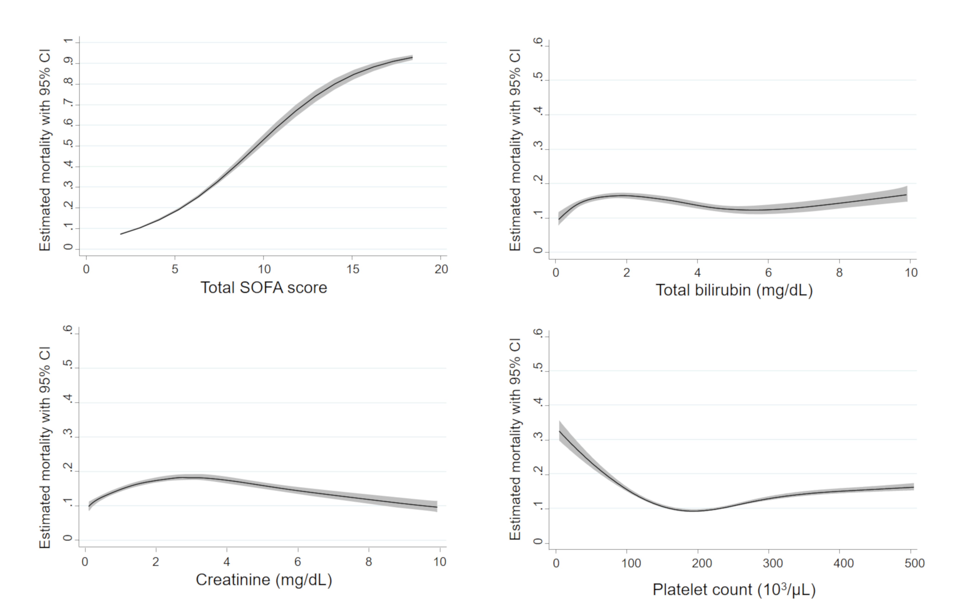
Figure S1. Sensitivity analyses of non-linear prognostic association of SOFA subscores using a multiple imputation technique to calculate missing values for biomarkers. The black line represents the fitted line of the association between biomarkers and the estimated mortality risk, and the shaded region represents the 95% confidence interval. SOFA Sequential Organ Failure Assessment

