Supporting Information S6 – Benchmarking tool and access the model

Accessing the Model:
To access the model described in this paper, the interested reader is directed to the following public repo:

https://david-leake.github.io/carbonpredict/

As well as the following CRAN package:

https://cran.r-project.org/package=carbonpredict

Example function use:
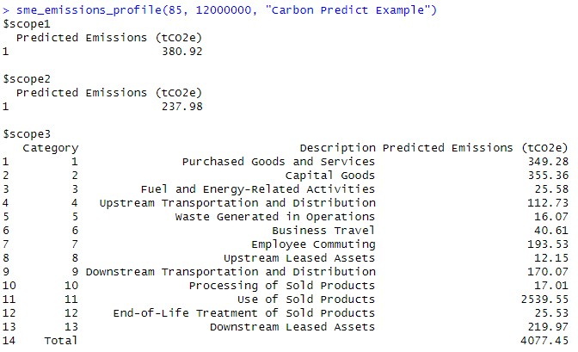
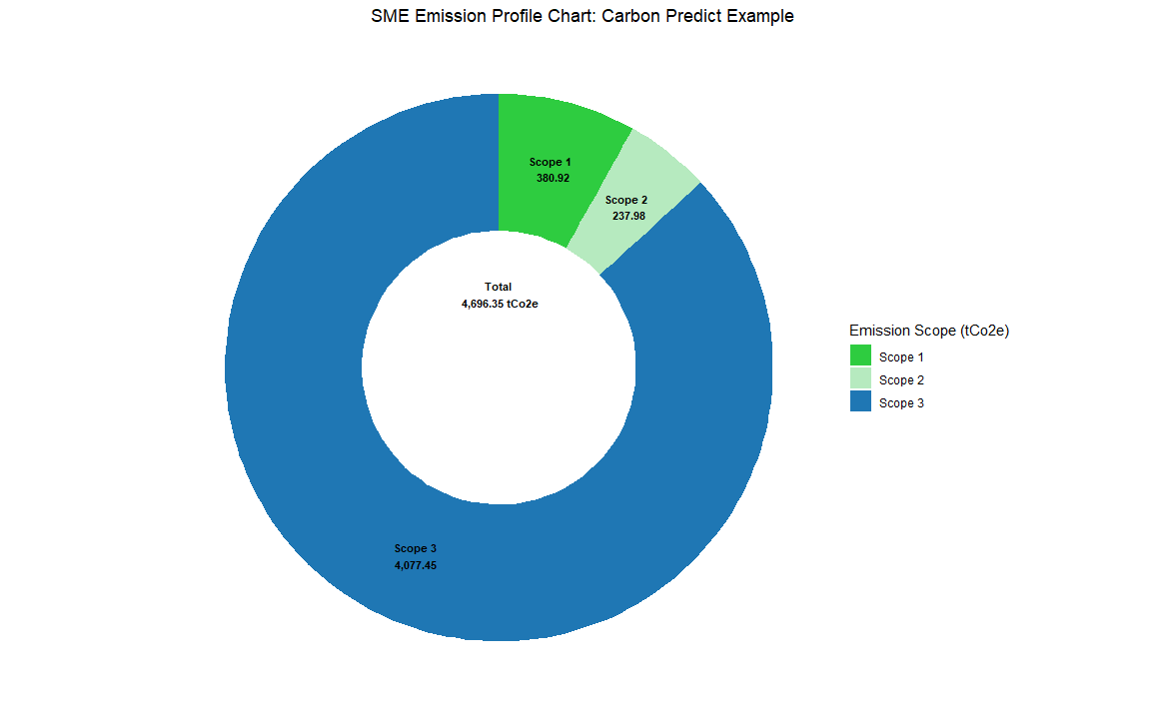

Benchmarking to create total Scope 3:
To approximate total Scope 3 emissions, one accurately measured category can be scaled using benchmarking proportions to estimate emissions from the remaining categories (Buchenau et al., 2025). This approach allows us to construct a more complete picture of Scope 3 emissions while avoiding reliance on the weaker predictions typically associated with Categories 6 and 9. For this purpose, we use the underlying data from Figure 2 in Buchenau et al. (2025), which reports the percentage contribution of each Scope 3 category to the total using underlying CDP data. These contributions are disaggregated by firm type (manufacturing vs. services) and by firm size (SMEs vs. large enterprises). Given the SME focus of our model, we use data specific to SMEs only. These are presented in Table S9.

To align the data with our modelling needs, we make two key adjustments to the reported percentages:

Exclusion of Categories 14 and 15 (Franchises and Investments): These categories may only apply to a small subset of SMEs, yet they appear disproportionately large in the SME manufacturing data. To avoid overrepresentation, we exclude them from our scaling approach.

Removal of Category 3 (Fuel- and Energy-Related Activities): This category is estimated separately in our model, using a method aligned with our Scope 1 and 2 emissions calculations.

Following these exclusions, we normalize the remaining category percentages. To estimate emissions for individual Scope 3 categories, we divide our predicted emissions for Categories 1 and 4 by their share of the normalized benchmark. This gives us an estimate of total Scope 3 emissions. We then allocate emissions to each remaining category based on the adjusted percentages.

Table S8. Benchmarking percentages used to generate full emissions profile
GHG Category | Raw Data | Remaining Share | Used in Model
Services
category 11 | 51% | 51% | 63%
category 15 | 16% |  | 0%
category 2 | 7% | 7% | 9%
category 1 | 7% | 7% | 9%
category 13 | 4% | 4% | 5%
category 7 | 4% | 4% | 5%
category 9 | 3% | 3% | 4%
category 3 | 3% |  | 0%
category 4 | 2% | 2% | 3%
category 6 | 1% | 1% | 1%
category 12 | 1% | 1% | 1%
category 14 | 0% |  | 0%
category 10 | 0% | 0% | 0%
category 5 | 0% | 0% | 0%
category 8 | 0% | 0% | 0%
Total | 100% | 81% | 100%
Manufacturing
category 14 | 75% |  | 0%
category 15 | 9% |  | 0%
category 11 | 9% | 9% | 54%
category 1 | 2% | 2% | 15%
category 10 | 2% | 2% | 14%
category 2 | 2% | 2% | 11%
category 12 | 0% | 0% | 2%
category 3 | 0% |  | 0%
category 4 | 0% | 0% | 1%
category 13 | 0% | 0% | 1%
category 8 | 0% | 0% | 0%
category 9 | 0% | 0% | 0%
category 5 | 0% | 0% | 0%
category 7 | 0% | 0% | 0%
category 6 | 0% | 0% | 0%
Total | 100% | 16% | 100%

