Supplementary Information
Table S1 Information on the 45S nrDNA sequences from 12 assembled Apiaceae species.
Species | Length  (bp) | 18s  (bp) | ITS1  (bp) | 5.8s  (bp) | ITS2  (bp) | 26s  (bp)
Ag | 5,812 | 1,809 | 216 | 164 | 224 | 3,399
Ar | 5,806 | 1,809 | 214 | 163 | 231 | 3,389
Gl* | 5,812 | 1,809 | 215 | 163 | 231 | 3,394
Ad | 5,813 | 1,809 | 213 | 164 | 227 | 3,400
Aj | 5,805 | 1,809 | 215 | 162 | 231 | 3,388
Ls† | 5,815 | 1,809 | 216 | 163 | 233 | 3,394
Pj‡ | 5,815 | 1,809 | 216 | 163 | 233 | 3,394
Ct | 5,806 | 1,809 | 215 | 163 | 231 | 3,388
Co | 5,806 | 1,809 | 215 | 163 | 231 | 3,388
Lo | 5,807 | 1,809 | 215 | 163 | 232 | 3,388
As | 5,806 | 1,809 | 217 | 163 | 233 | 3,384
Bk | 5,806 | 1,809 | 245 | 156 | 235 | 3,361
* : KX757778.1, † : KX757775.1, ‡ : KX757777.1

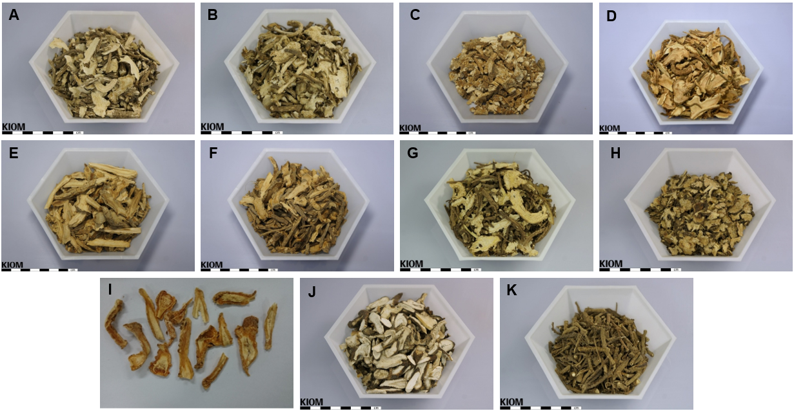
Figure S1 Dried root morphology of 12 medicinal plants in the Apiaceae family. A. Angelica gigas. B. Angelica reflexa. C. Glehnia littoralis. D. Angelica dahurica. E. Ledebouriella seseloides. F. Peucedanum japonicum. G. Conioselinum tenuissimum. H. Cnidium officinale. I. Levisticum officinale. J. Anthriscus sylvestris. K. Bupleurum komarovianum. This image was provided by the Korean Medicine Research Institute (https://oasis.kiom.re.kr/herblib/hminfo/mdhrpt/mdhrptList.do).

A
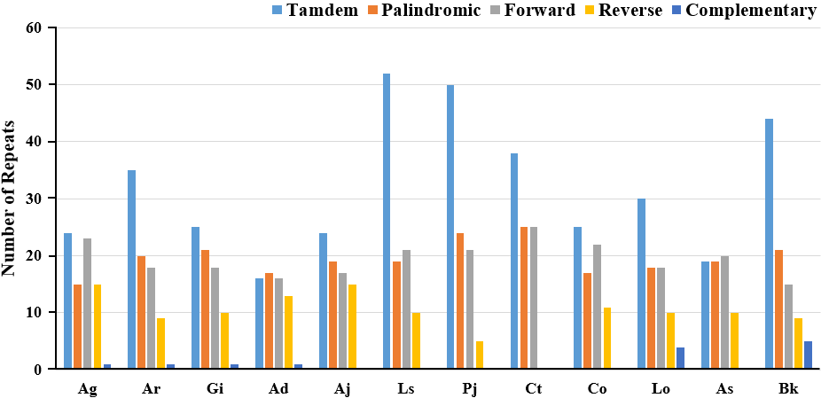
B
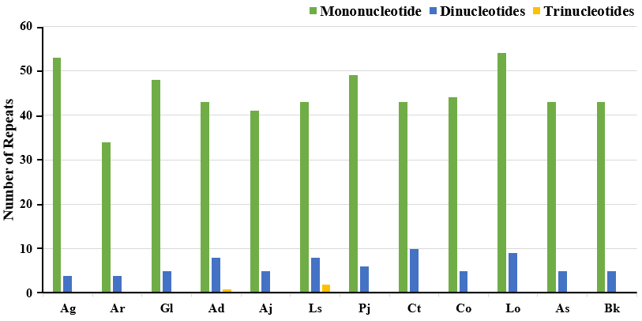
Figure S2 Repeat structure and SSR sequences in the plastomes of 12 Apiaceae species. A. Distribution of repeat types in 12 Apiaceae species. The bar graph displays the counts of different repeat types (tandem, palindromic, forward, reverse, and complementary) in the 12 Apiaceae species. B. Types and abundance of simple sequence repeats (SSRs) detected in the plastomes of the 12 Apiaceae species.

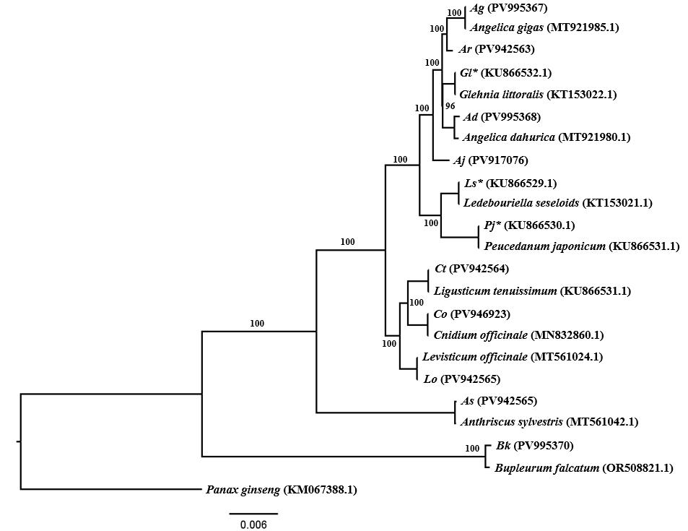
Figure S3 Maximum-likelihood phylogenetic tree of 12 Apiaceae species inferred from complete plastome sequences. The tree was constructed using RAxML [44] with 1000 bootstrap replicates under the GTRGAMMA substitution model. Bootstrap values greater than 50% are shown above the branches. Panax ginseng (KM067588.1) was used as the outgroup. Among the 12 plastomes, nine were newly assembled in this study. The other three, previously assembled by our laboratory, are indicated by an asterisk.

