SUPPLEMENTARY MATERIAL
Health risks and source apportionment assessment of heavy metals in PM_{2.5}: A one year observation study in Chengdu

Xiaoqiong Feng^{a,c}, Jiaxiu Guo^{b*}, Zhijiong Huang^{d}, Tao Jiang^{c}, Hong Liu^{c}, Xiaotong Lv^{c}
ª College of Architecture & Environment, Sichuan University, Chengdu 610041, China
^{b} College of Carbon Neutrality Future Technology, Sichuan University, Chengdu 610065, Sichuan, China
^{c} Sichuan Academy of Eco-Environmental Sciences, Chengdu 610041, China
^{d} Institute for Environmental and Climate Research, Jinan University, Guangzhou 510632, China
*Corresponding author: College of Carbon Neutrality Future Technology, Sichuan University, Chengdu 610065, Sichuan, China. guojiaxiu@scu.edu.cn

Supplementary Tables:

Table S1 MDL of each HM（ng/m³）
Element | Cr | Mn | Co | Cu | Zn | Cd | Ba | Pb | Fe
MDL | 4.08 | 4.44 | 5.38 | 1.27 | 2.43 | 1.8 | 20.04 | 2.041 | 15.46

Table S2 Monthly data detection rates of HMs during the study period
Month | Cr | Mn | Co | Cu | Zn | Cd | Ba | Pb | Fe
2023-01 | 99% | 99% | 99% | 97% | 99% | 64% | 99% | 98% | 99%
2023-02 | 99% | 99% | 99% | 99% | 99% | 91% | 99% | 99% | 99%
2023-03 | 97% | 97% | 97% | 97% | 97% | 99% | 97% | 97% | 97%
2023-04 | 99% | 99% | 99% | 99% | 99% | 99% | 99% | 99% | 99%
2023-05 | 100% | 100% | 100% | 100% | 100% | 100% | 100% | 100% | 100%
2023-06 | 99% | 99% | 99% | 99% | 99% | 99% | 99% | 99% | 99%
2023-07 | 100% | 100% | 100% | 100% | 100% | 100% | 100% | 100% | 100%
2023-08 | 100% | 100% | 100% | 100% | 99% | 100% | 100% | 100% | 100%
2023-09 | 100% | 100% | 100% | 100% | 100% | 100% | 100% | 100% | 99%
2023-10 | 94% | 94% | 94% | 94% | 94% | 94% | 94% | 94% | 93%
2023-11 | 100% | 100% | 100% | 100% | 100% | 100% | 100% | 100% | 100%
2023-12 | 87% | 87% | 87% | 87% | 87% | 87% | 87% | 87% | 87%

Table S3 The parameters for health risk assessment
Parameter | Unit | Definition | Male | Female | Children | Reference
IR | m³/day | Inhalation rate | 17.4 | 14.1 | 8.6 | Duan et al., 2015; M.o.E. Protection, 2013
EF | d/s | Seasonal exposure frequency | 90 (Spring, summer, autumn and Winter) | 90 (Spring, summer, autumn and Winter) | 90 (Spring, summer, autumn and Winter) | This study
EF | d/s | Seasonal exposure frequency | 7 (Spring Festival) | 7 (Spring Festival) | 7 (Spring Festival) | This study
EF | d/a | Annual exposure frequency | 360 | 360 | 360 | Shi et al., 2025
ED | a | Exposure duration | 30 | 30 | 6 | Chakraborty et al., 2024
BW | kg | Body weight | 63.6 | 55.4 | 15 | Hossain et al., 2021; M.o.E. Protection, 2013
ATn | d | Average time for non-carcinogens | ED × 365 days × 24 h/day | ED × 365 days × 24 h/day | ED × 365 days × 24 h/day | Liu et al., 2021
ATn | d | Average time for carcinogens | 70 year × 365 days/year × 24 h | 70 year × 365 days/year × 24 h | 70 year × 365 days/year × 24 h | Liu et al., 2021

Table S4 HMs exposure reference dose and carcinogenic slope coefficient
HMs | RfD (mg/(kg·day)) | SF ((kg·day)/mg) | Reference
Cr | 3.0×10⁻⁴ | 5.1×10² | USEPA, 2011
Mn | 1.4×10⁻¹ | 5.6×10¹ | USEPA, 2011; Li et al., 2022
Co | 5.7×10⁻⁵ | 9.8×10¹ | USEPA, 2011
Cu | 4.0×10⁻² | / | Nargis et al., 2022
Zn | 3.0×10⁻¹ | / | USEPA, 2011
Cd | 1.0×10⁻³ | 1.5×10¹ | Rahat, et al., 2025; USEPA, 2011
Ba | 2.0×10⁻¹ | / | USEPA, 2011
Pb | 3.5×10⁻³ | 4.2×10⁻² | Nargis et al., 2022
Fe | 7.0×10⁻¹ | / | Peng et al., 2025

Table S5 Comparison of the results of this study with those of other study (ng/m³)
HM | Sampling period
HM | January 2023-December 2023 | March 2017-February 2018 | October 2014-July 2015 | April 2009- January 2020
Cr | 3.37 | 8.3 | 5.6 | 17.9
Mn | 18.67 | 48 | 33.8 | 137.6
Co | 30.66 | / | / | /
Cu | 10.97 | 73 | 18.7 | 54.1
Zn | 58.4 | 167 | 238 | 822.9
Cd | 15.66 | 10 | / | 9.5
Ba | 125.84 | 78 | / | /
Pb | 13.41 | 40 | 55.4 | 320.5
Fe | 328.37 | 967 | 456 | /
Reference | This study | Jin et al., 2021 | Wang et al., 2018 | Li et al., 2016

Table S6 Monthly industrial electricity consumption in 2023 in Chengdu (million kilowatt-hours)
Season | Month | Industrial electricity consumption
Spring | March | 3079.4
Spring | April | 3331.2
Spring | May | 3394.1
Spring | Subtotal | 9804.8
Summer | June | 3439.1
Summer | July | 3600.5
Summer | August | 3645.1
Summer | Subtotal | 10684.7
Autumn | September | 3462.1
Autumn | October | 3200.3
Autumn | November | 3377.7
Autumn | Subtotal | 10040.2
Winter | December | 3467.8
Winter | January | 2671.0
Winter | February | 3015.5
Winter | Subtotal | 9154.3

Supplementary Figures:

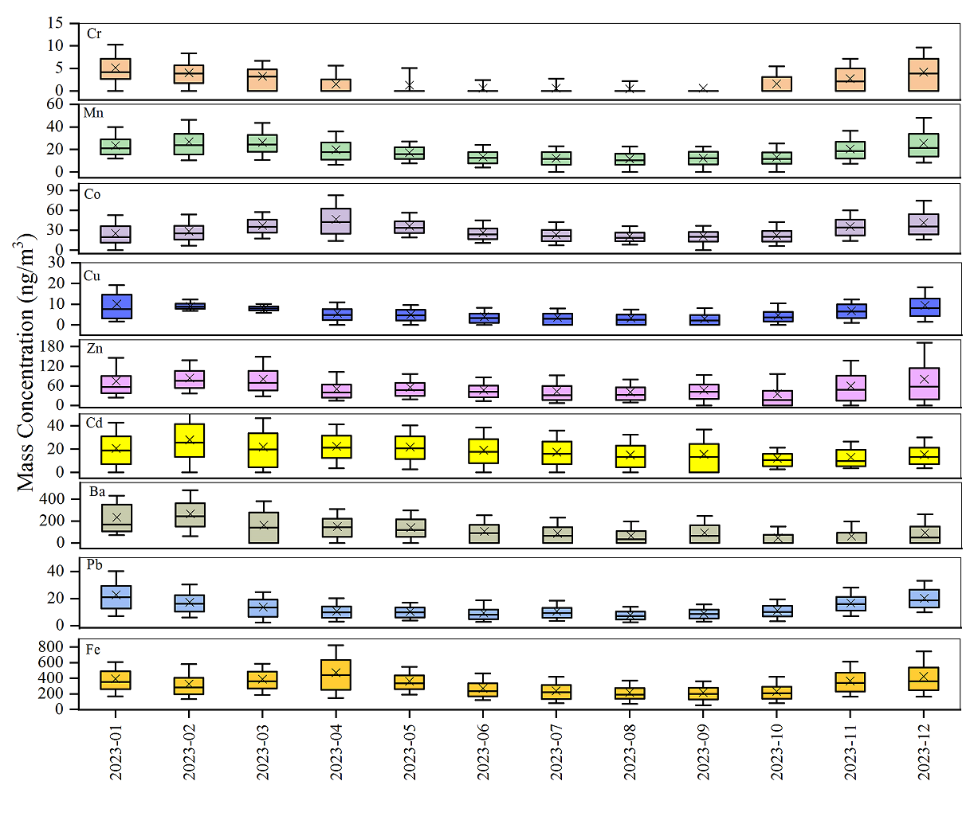
Fig. S1 Monthly average concentration distribution of each heavy metal
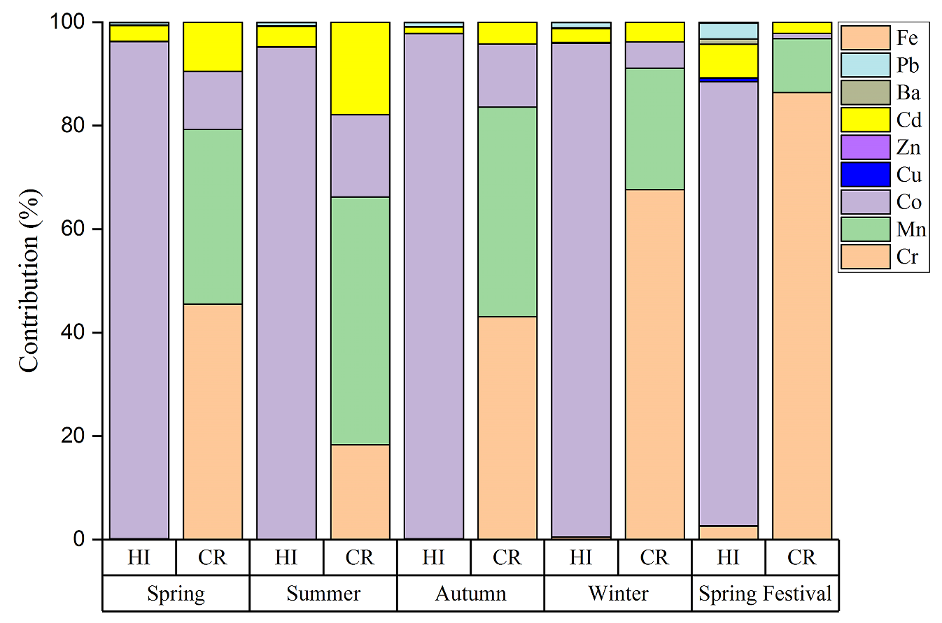
Fig. S2 The contributions of various metals to health risks during the spring, summer, autumn, winter, and Spring Festival. HI: Hazard Index, HQ: Hazard Quotient.

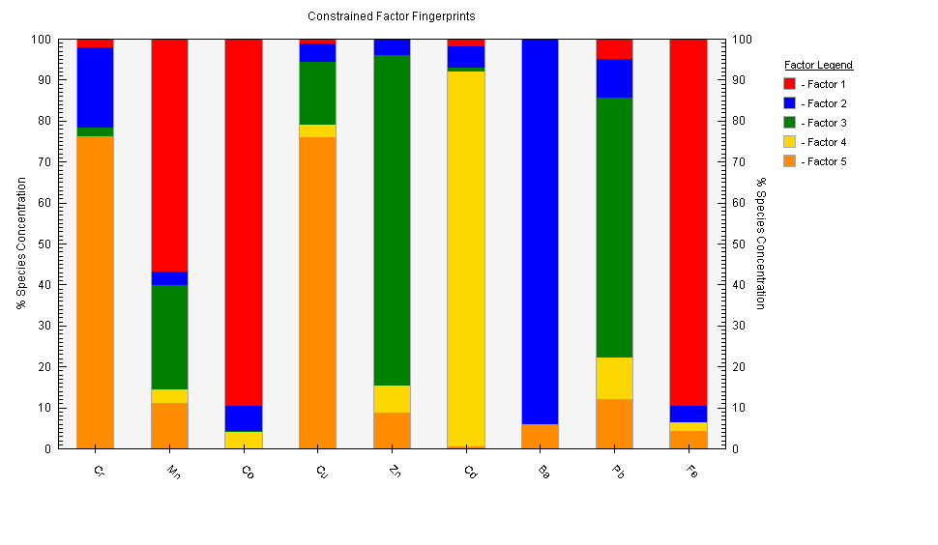Fig. S3 Factor fingerprints for HMs derived using PMF model during the study period

Reference

USEPA, 2011. Risk Assessment Guidance for Superfund. In: Part A: Human Health Evaluation Manual; Part E, Supplemental Guidance for Dermal Risk Assessment; Part F, Supplemental Guidance for Inhalation Risk Assessment.
Nargis, A., Habib, A., Islam, M.N., Chen, K., Sarker, M.S.I., Al-Razee, A.N.M., Liu, W., Liu, G., Cai, M., 2022. Source identification, contamination status and health risk assessment of heavy metals from road dusts in Dhaka, Bangladesh. J. Environ. Sci. 121, 159–174.
Li, X.,Yan, C.Q., Wang, C.Y., Ma, J.J., Li, W.X., Liu, J.Y., Liu, Y., 2022. PM_{2.5}⁃bound elements in Hebei Province, China: Pollution levels, source apportionment and health risks. Sci. Total Environ. 806(Pt 1): 150440
Peng, J.M., Yu, R.L., Hu G.R., Chen, Y.T., Wu, Y.Q., 2025. Sources and Health Risks of Heavy Metals in Atmospheric PM_{2.5}, Based on APCS-MLR and PMF Models. Environ. Sci. https://doi.org/10.13227/j.hjkx.202409324. (in Chinese)
Duan, X., Zhao, X., Wang, B., Chen, Y., Cao, S., 2015. Highlights of the Chinese Exposure Factors Handbook.
Hossain, M.A., Haque, S.S., Sarkar, M.S., Khan, M.D.H., 2021. Health Risk Assessment of Black Carbon Emission from Fossil Fuel, J. Eng. Sci. 12, 23-28.
Liu, S., Tian, H., Bai, X., Zhu, C., Wu, B., Luo, L., Hao, Y., Liu, W., Lin, S., Zhao,,S., Wang,,K., Liu, K., Gao, J., Zhang, Q., Zhang, K., Kan, H., Liu, Y., Hao, J., 2021. Significant but Spatiotemporal-Heterogeneous Health Risks Caused by Airborne Exposure to Multiple Toxic Trace Elements in China, Environ. Sci. Technol. 55 (19), 12818–12830.
Jin, Q., Liu, Y.M., Feng, M., Huang, C.M., 2021. High‑resolution temporal metallic elements in PM_{2.5} in Chengdu, Southwest China: variations, extreme events, and effects of meteorological parameters. Air Qual. Atmos. Health. 14:1893–1909.
Shi, J.L., Zhu, C.S., Qu, Y., Zhou, Y., Wang, N., Wang, L.Y., Li, Q., Wang, Q.Y., Liu, S.X., Cao, J., 2025. Health risk assessment of source-specific elemental carbon (using dual carbon isotopes) and heavy metals in the Tibetan Plateau. J. Hazard. Mater. 492, 138094.
M.o.E. Protection, 2013a. Exposure factors handbook of Chinese population (Adults Volume). China Environmental Science Press.
M.o.E. Protection, 2013b. Exposure factors handbook of Chinese population (Children Volume). China Environmental Science Press.
Chakraborty, M., Rahat, M.M.R., Choudhury, T.R., Nigar, R., Liu, G., Habib, A., 2024. Heavy metal contamination and health risk assessment of road dust from landfills in Dhaka-Narayanganj, Bangladesh. Emerg. Contam. 10, 100278.
Rahat, M.M.R., Rumman, R., Ferdousi, F.K., Zhao, S.Z., Siddique, M.A.B., Zhang, G., Liu, G.R., Habib, A., 2025. Heavy metals in atmospheric fine particulate matter (PM_{2.5}) in Dhaka, Bangladesh: Source apportionment and associated health risks. Environ. Res. 271, 121071.
Li, Y.P., Zhang, Z.S., Liu, H.F., Zhou, H., Fan, Z.Y., Lin, M., Wu, D.L., Xia, B.C., 2016. Characteristics, sources and health risk assessment of toxic heavy metals in PM_{2.5} at a megacity of southwest China. Environ. Geochem. Health. 38:353–362.
Wang, H., Qiao, B., Zhang, L., Yang, F., Jiang, X., 2018. Characteristics and sources of trace elements in PM_{2.5} in two megacities in Sichuan Basin of southwest China. Environ. Pollu. 242:1577–1586.

