Nanoselenium enhanced wheat resistance to aphids by regulating biosynthesis of DIMBOA and volatile components
Chunran Zhou ^{a, 1}, Dong Li ^{a, 1}, Xinlei Shi ª, Jingbang Zhang ª, Quanshun An ª, Yangliu Wu ª, Lu Kang ª, Jia-Qi Li ª and Canping Pan ^{a,} *
Department of Applied Chemistry, College of Science, China Agriculture University, Beijing 100193, China Yuanmingyuan west road 2, Beijing 100193, P R China
*Corresponding authors
Canping Pan: canpingp@cau.edu.cn
Total number of pages: 14
Total number of figures: 4
Total number of tables: 7

SUPPORTING TABLES AND FIGURES
Figure S1. Wheat growth index among all treatments. A: wheat height. B: root length. C: fresh weight of wheat
Figure S2. Effect of different ratios and combinations of metabolites and nano-Se
on luteolin(A), and quercetin(B) contents in wheat seedlings
Figure S3. Effect of different ratios and combinations of metabolites and nano-Se on caffeic acid (A), ferulic acid (B), chlorogenic acid (C), 4-hydroxy-3,5-dimethoxycinnamic acid (D), and 4-hydroxycinnamic acid (E) contents in wheat seedlings
Figure S4. Effect of different ratios and combinations of metabolites and nano-Se on jasmonic acid (A), salicylic acid (B), DIMBOA(C), and melatonin(D) contents in wheat seedlings
Table S1. Parameters for phytohormone analysis by LC-MS/MS
Table S2. Parameters for flavone compounds analysis by LC-MS/MS
Table S3. Parameters for phenolic acids compounds analysis by LC-MS/MS
Table S4. Analysis conditions of GC-IMS unit
Table S5. Gas chromatographic conditions
Table S6. Primer of RT-qPCR for Genes Involved in DIMBOA and MT Responses
Table S7. Qualitative compounds listed by GC-IMS analysis

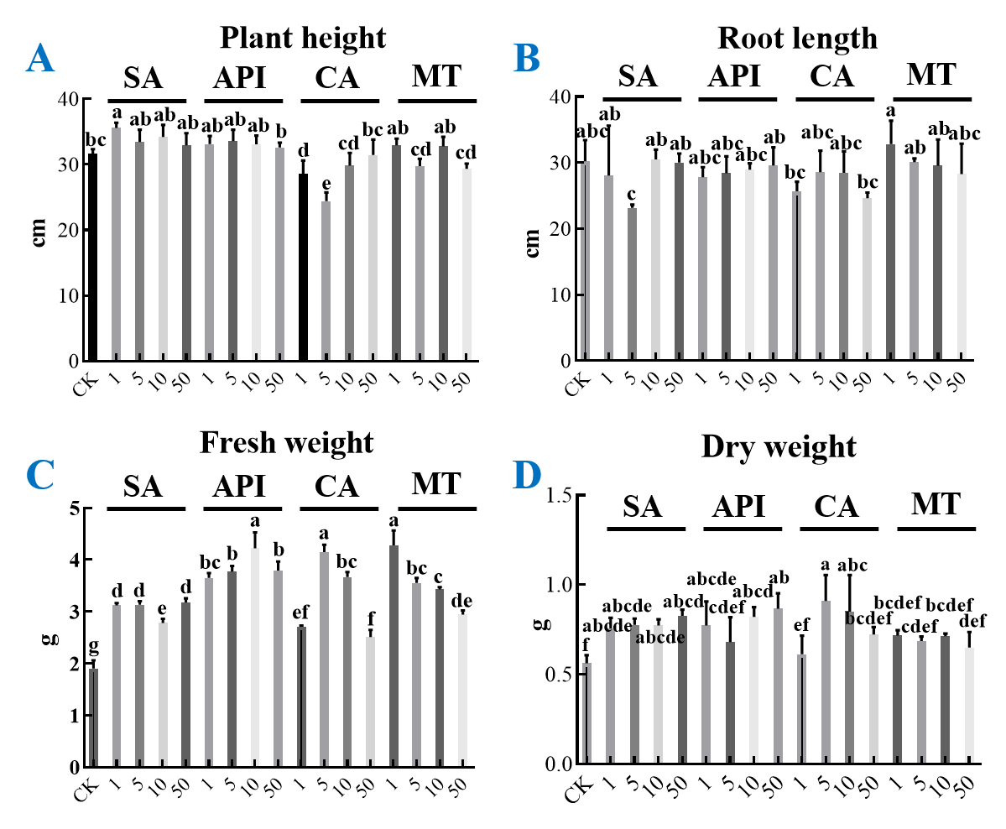
Figure S1. Wheat growth index among all treatments. A: wheat height. B: root length. C: fresh weight of wheat. D: dry weight of weight. The horizontal axis represents for different concentrations. Salicylic acid (SA), apigenin (API), caffeic acid (CA), and melatonin (MT). Different letters among treatments indicate significant different at p<0.05.

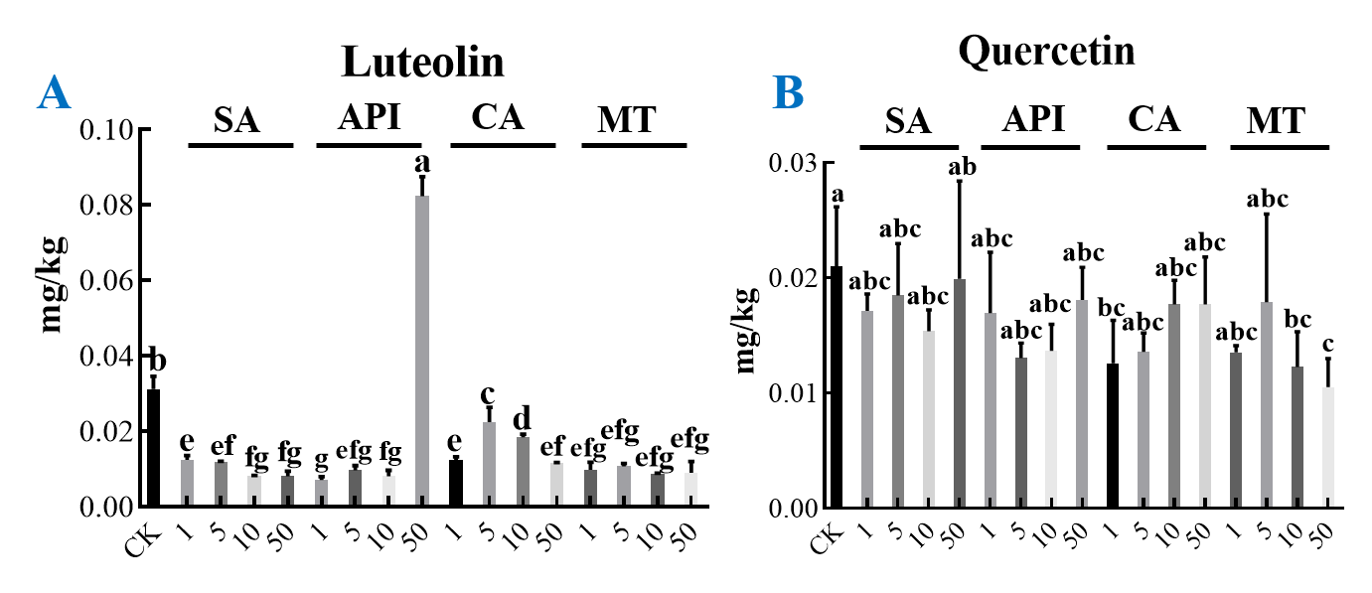
Figure S2. Effect of different ratios and combinations of metabolites and nano-Se on luteolin(A) and quercetin(B) contents in wheat seedlings. The horizontal axis represents for different concentrations. Salicylic acid (SA), apigenin (API), caffeic acid (CA), and melatonin (MT). Different letters among treatments indicate significant different at p<0.05.

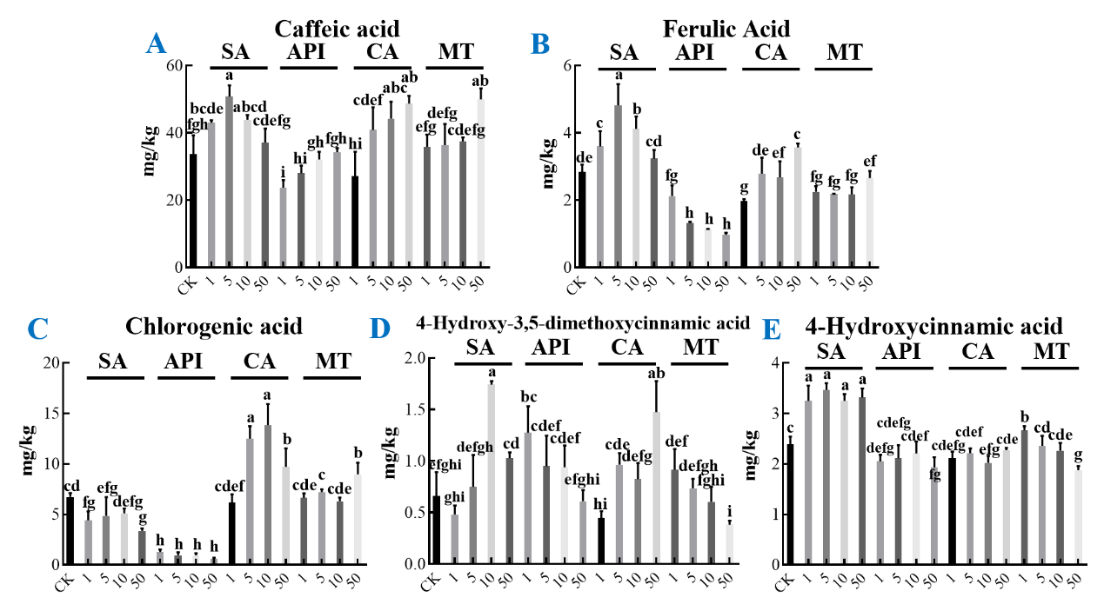
Figure S3. Effect of different ratios and combinations of metabolites and nano-Se on caffeic acid (A), ferulic acid (B), chlorogenic acid (C), 4-hydroxy-3,5-dimethoxycinnamic acid (D), and 4-hydroxycinnamic acid (E) contents in wheat seedlings. The horizontal axis represents for different concentrations. Salicylic acid (SA), apigenin (API), caffeic acid (CA), and melatonin (MT). Different letters among treatments indicate significant different at p<0.05.

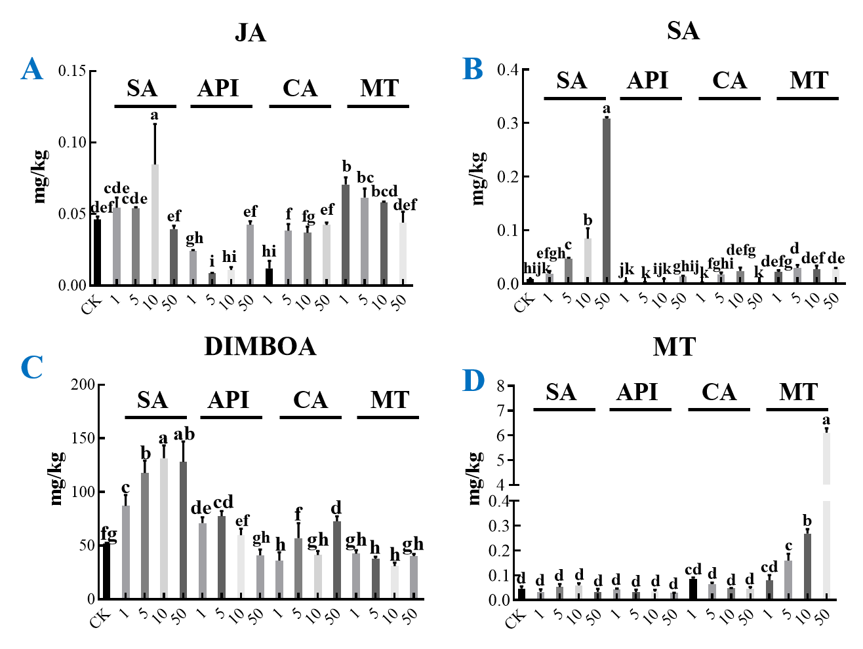
Figure S4. Effect of different ratios and combinations of metabolites and nano-Se on jasmonic acid (A), salicylic acid (B), DIMBOA(C), and melatonin(D) contents in wheat seedlings. The horizontal axis represents for different concentrations. Salicylic acid (SA), apigenin (API), caffeic acid (CA), and melatonin (MT). Different letters among treatments indicate significant different at p<0.05.

Table S1. Parameters for phytohormone analysis by LC-MS/MS
Name | Precursor/quantitative transition(m/z) | Precursor/qualitative transition(m/z) | Retention time(min) | Collision energy (CE)(V) | Polarity | Delta EMV
Jasmonic acid | 209.2/59.1 | 209.2/59.1 | 1.81 | 5/5 | Negative | 500
Salicylic acid | 137.1/93.1 | 137.1/137.1 | 1.64 | 5/15 | Negative | 500
Melatonin | 233/174 | 233/216.2 | 0.962 | 10/10 | Positive | 800

Table S2. Parameters for flavone compounds analysis by LC-MS/MS

Name | Precursor/quantitative transition (m/z) | Precursor/qualitative transition (m/z) | Retention time(min) | Collision energy (CE)(V) | Polarity | Delta EMV (-)
Apigenin | 269/117 | 269/225 | 2.982 | 150(40) | Negative | 300
Luteolin | 285/133 | 285/175 | 1.956 | 160(35) | Negative | 300
Quercetin | 301/151 | 301/178.9 | 2.068 | 140(20) | Negative | 300
Rutin | 609.2/300 | 609.2/270.9 | 1.013 | 200(35) | Negative | 300
Kaempferol | 285/117 | 285/153 | 3.354 | 155(45) | Negative | 300
Myricetin | 317/151 | 317/137 | 1.416 | 135(30) | Negative | 300

Table S3. Parameters for phenolic acids compounds analysis by LC-MS/MS
Name | Precursor/quantitative transition(m/z) | Precursor/qualitative transition (m/z) | Retention time(min) | Collision energy (CE)(V) | Polarity | Delta EMV (-)
Ferulic Acid | 193/134 | 193/177.8 | 2.637 | 90(18) | Negative | 300
Chlorogenic acid | 353.1/191.1 | 353.1/127.1 | 3.37 | 65(15) | Negative | 300
Caffeic acid | 179/135 | 179/79.1 | 0.964 | 160(15) | Negative | 300
4-Hydroxy-3,5-Dimethoxycinnamic acid | 223.1/208 | 223.1/163.8 | 7.718 | 90(10) | Negative | 300
4-Hydroxybenzoic acid | 137/93.1 | 137/65.1 | 8.592 | 70(15) | Negative | 300
Syringic acid | 197/182 | 197/167 | 4.279 | 70(10) | Negative | 300
Vanillic acid | 167/152 | 167/123 | 2.925 | 70(10) | Negative | 300
4-Hydroxycinnamic acid | 139/139 | 139/95 | 2.8 | 5(5) | Negative | 300

Table S4. Analysis conditions of GC-IMS unit
GC-IMS unit
Analysis time | 30 min
Chromatographic column | FS-SE-54-CB-1 15m ID:0.53mm
Column temperature | 60℃
Carrier gas/drift gas | N₂
IMS temperature | 45℃
Automatic headspace injection unit
Injection volume | 500μL
Incubation time | 20 min
- Incubation temperature | 60℃
Injection needle temperature | 85℃
Hatching speed | 500 rpm

Table S5. Gas chromatographic conditions
Time | E1 | E2 | R
00:00,000 | 150mL/min | 2 ml/min | rec
02:00,000 | 150mL/min | 2 ml/min | -
10:00,000 | 150mL/min | 10 ml/min | -
20:00,000 | 150mL/min | 100 ml/min | stop

Table S6. Primer of RT-qPCR for Genes Involved in DIMBOA and MT Responses¹⁻³
Target gene | Sequence
TaASMT2 | Forward: CAACCTTATGGATAGACCTCGATGACAC  Reverse: GCTGATGGATGTGGCAATGATGGTA
TaCOMT | Forward: GGGCAGAAGCAAGCAGAGATGG  Reverse: CGATGGCGTTCTTCAGCGTCAT
TaBx1A | Forward: ACCTGGCCACAACGGCA  Reverse: CGTGTTCAGGTTTTGATATGCC
TaBx3A | Forward: CGACTTGTTCAACGAGATCATC  Reverse: TCTGGCCTCTCCCAAGACGA
TaBx4A | Forward: TAAGGGAGTCCACACCCGG  Reverse: GGAACAAGGTGAAGCCTCTCC

Table S7. Qualitative compounds listed by GC-IMS analysis
Count | Compound | CAS# | Formula | MW | RI | Rt [sec] | Dt [RIPrel]
1 | 2-butanone monomer | 78-93-3 | C₄H₈O | 72.1 | 593.2 | 145.495 | 1.06276
2 | 2-butanone dimer | 78-93-3 | C₄H₈O | 72.1 | 593.2 | 145.495 | 1.25154
3 | 3-methylbutanal | 590-86-3 | C₅H₁₀O | 86.1 | 644.9 | 169.985 | 1.41366
4 | Ethanol | 64-17-5 | C₂H₆O | 46.1 | 519.3 | 110.509 | 1.04782
5 | Acetoin | 513-86-0 | C₄H₈O₂ | 88.1 | 712.5 | 210.802 | 1.33793
6 | Ethyl Acetate monomer | 141-78-6 | C₄H₈O₂ | 88.1 | 610.2 | 153.584 | 1.09815
7 | Ethyl Acetate dimer | 141-78-6 | C₄H₈O₂ | 88.1 | 609 | 152.982 | 1.3418
8 | acetone | 67-64-1 | C₃H₆O | 58.1 | 528.3 | 114.774 | 1.12019
9 | 1-Propanol | 71-23-8 | C₃H₈O | 60.1 | 570.7 | 134.85 | 1.11485
10 | 2-methyl-1-propanol | 78-83-1 | C₄H₁₀O | 74.1 | 618.1 | 157.322 | 1.16823
11 | 3-Pentanone | 96-22-0 | C₅H₁₀O | 86.1 | 682.6 | 187.885 | 1.34706
12 | Isopentyl alcohol | 123-51-3 | C₅H₁₂O | 88.1 | 728.2 | 224.074 | 1.49383
13 | 2-pentenal (E) monomer | 1576-87-0 | C₅H₈O | 84.1 | 740.6 | 234.496 | 1.11108
14 | 2-pentenal (E) dimer | 1576-87-0 | C₅H₈O | 84.1 | 744.2 | 237.561 | 1.36827
15 | Ethyl 2-methylpropanoate | 97-62-1 | C₆H₁₂O₂ | 116.2 | 751.6 | 243.778 | 1.56122
16 | hexanal monomer | 66-25-1 | C₆H₁₂O | 100.2 | 789.3 | 277.17 | 1.25631
17 | hexanal dimer | 66-25-1 | C₆H₁₂O | 100.2 | 790 | 277.973 | 1.56764
18 | (E)-2-hexenal monomer | 6728-26-3 | C₆H₁₀O | 98.1 | 835.2 | 330.558 | 1.1833
19 | (E)-2-hexenal dimer | 6728-26-3 | C₆H₁₀O | 98.1 | 844.5 | 341.396 | 1.52356
20 | 2-heptanone monomer | 110-43-0 | C₇H₁₄O | 114.2 | 891 | 395.587 | 1.2632
21 | 2-heptanone dimer | 110-43-0 | C₇H₁₄O | 114.2 | 890.3 | 394.785 | 1.63927
22 | Cyclohexanone monomer | 108-94-1 | C₆H₁₀O | 98.1 | 895.6 | 403.214 | 1.15299
23 | Cyclohexanone dimer | 108-94-1 | C₆H₁₀O | 98.1 | 893.6 | 399.569 | 1.45599
24 | Heptanal monomer | 111-71-7 | C₇H₁₄O | 114.2 | 898.5 | 408.507 | 1.33363
25 | Heptanal dimer | 111-71-7 | C₇H₁₄O | 114.2 | 901.3 | 413.735 | 1.70054
26 | benzaldehyde monomer | 100-52-7 | C₇H₆O | 106.1 | 954.4 | 511.387 | 1.15436
27 | benzaldehyde dimer | 100-52-7 | C₇H₆O | 106.1 | 954 | 510.705 | 1.47206
28 | 2,4-heptadienal (E, E) monomer | 4313-03-5 | C₇H₁₀O | 110.2 | 1019.6 | 631.508 | 1.19067
29 | 2,4-heptadienal (E, E) dimer | 4313-03-5 | C₇H₁₀O | 110.2 | 1020.3 | 632.872 | 1.62486
30 | 2,4-heptadienal (Z, Z) monomer | 5910-85-0 | C₇H₁₀O | 110.2 | 1005.2 | 604.89 | 1.19521
31 | 2,4-heptadienal (Z, Z) dimer | 5910-85-0 | C₇H₁₀O | 110.2 | 1003.7 | 602.16 | 1.62789
32 | Methyl hexanoate monomer | 106-70-7 | C₇H₁₄O₂ | 130.2 | 921.7 | 451.224 | 1.28533
33 | Methyl hexanoate dimer | 106-70-7 | C₇H₁₄O₂ | 130.2 | 920.8 | 449.53 | 1.68619
34 | 2-heptenal (E) monomer | 18829-55-5 | C₇H₁₂O | 112.2 | 954.3 | 511.235 | 1.25472
35 | 2-heptenal (E) dimer | 18829-55-5 | C₇H₁₂O | 112.2 | 954.4 | 511.373 | 1.67148
36 | 1-octen-3-ol | 3391-86-4 | C₈H₁₆O | 128.2 | 985 | 567.626 | 1.16106
37 | 6-Methyl-5-hepten-2-one | 110-93-0 | C₈H₁₄O | 126.2 | 992.6 | 581.621 | 1.18077
38 | 2-Pentylfuran | 3777-69-3 | C₉H₁₄O | 138.2 | 995.9 | 587.779 | 1.25964
39 | 2-acetylfuran monomer | 1192-62-7 | C₆H₆O₂ | 110.1 | 909.2 | 428.238 | 1.1174
40 | 2-acetylfuran dimer | 1192-62-7 | C₆H₆O₂ | 110.1 | 907.7 | 425.439 | 1.45399
41 | Ethyl hexanoate | 123-66-0 | C₈H₁₆O₂ | 144.2 | 1004.6 | 603.749 | 1.33642
42 | phenylacetaldehyde | 122-78-1 | C₈H₈O | 120.2 | 1046.9 | 681.974 | 1.25327
43 | 2-octenal (E) | 2548-87-0 | C₈H₁₄O | 126.2 | 1064.3 | 714.185 | 1.33482
44 | n-Nonanal monomer | 124-19-6 | C₉H₁₈O | 142.2 | 1107 | 792.98 | 1.47698
45 | n-Nonanal dimer | 124-19-6 | C₉H₁₈O | 142.2 | 1106.3 | 791.668 | 1.94877

SUPPORTING REFERENCES
1. Back, K.; Tan, D. X.; Reiter, R. J., Melatonin biosynthesis in plants: multiple pathways catalyze tryptophan to melatonin in the cytoplasm or chloroplasts. J Pineal Res 2016, 61, 426-437.
2. Sue, M.; Nakamura, C.; Nomura, T., Dispersed benzoxazinone gene cluster: molecular characterization and chromosomal localization of glucosyltransferase and glucosidase genes in wheat and rye. Plant Physiol 2011, 157, 985-97.
3. Taiji Nomura, A. I., Ryo C. Yanagita, Takashi R. Endo, and Hajime Iwamura§, Three genomes differentially contribute to the biosynthesis of benzoxazinones in hexaploid wheat. PNAS 2005, 102, 45.

