Nanoselenium transformation and inhibition of cadmium accumulation by regulating lignin biosynthesis pathway and plant hormone signal transduction in pepper plants
Dong Lia, Chunran Zhoua, Jinling Maa, Yangliu Wua, Lu Kanga, Quanshun Ana, Jingbang Zhanga, Kailing Dengb, Jia-Qi Lia and Canping Pan*, a
ª Innovation Center of Pesticide Research, Department of Applied Chemistry, College of Science, China Agricultural University, Beijing 100193, China
^{b} Institute of Food Science and Technology, Chinese Academy of Agricultural Sciences, Beijing 100193, China
*Corresponding authors
Canping Pan: canpingp@cau.edu.cn
Total number of pages: 8
Total number of figures: 2
Total number of tables: 4

SUPPORTING TABLES AND FIGURES
Table S1. UPLC-MS/MS parameters of plant hormones
Figure S1. GO class of different treatments in the root
Table S2. UPLC-MS/MS parameters of lignin-related metabolites
Figure S2. GO class of different treatments in the leaves
Table S3. Primer sequences for qPCR
Table S4. Statistics of the number of differentially expressed genes
Table S1. UPLC-MS/MS parameters of plant hormones
Name | Precursor/quantitative ion (m/z) | Precursor/qualitative ion (m/z) | Retention time (min) | Collision energy (CE) (V) | Polarity | Delta EMV(-)
JA | 209.2/59.1 | 209.2/209.2 | 1.81 | 5/5 | Negative | 500
SA | 137.1/93.1 | 137.1/137.1 | 1.64 | 5/15 | Negative | 500
ABA | 263.3/153.1 | 263.3/219.2 | 1.75 | 10/10 | Negative | 500
BL | 481.4/445.1 | 481.4/315.1 | 4.37 | 4/10 | Positive | 500

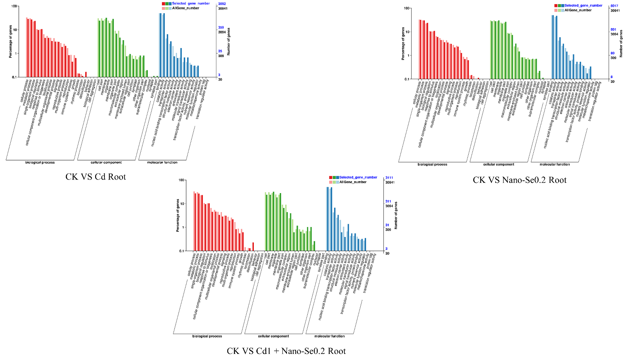
Figure S1. GO class of different treatments in the root

Table S2. UPLC-MS/MS parameters of lignin-related metabolites
Name | Precursor/quantitative ion (m/z) | Precursor/qualitative ion (m/z) | Retention time (min) | Fragmentor(F)(V) | Collision energy (CE) (V) | Polarity
p-coumaric acid | 163.1/119 | 163.1/163.1 | 0.39 | 90 | 20 | Negative
coniferaldehyde | 179.1/91.1 | 179.1/119 | 0.66 | 90 | 30/20 | Positive
p-coumaraldehyde | 149.1/131 | 149.1/103 | 1.27 | 90 | 10/20 | Positive
phenylalanine | 180.1/120 | 180.1/163.1 | 1.03 | 90 | 10/10 | Positive
cinnamic acid | 147.1/103 | 147.1/62.2 | 0.61 | 60 | 10/10 | Negative
p-Coumaryl alcohol | 151/110 | 151/128.1 | 2.39 | 60 | 4/4 | Positive
caffeyl alcohol | 167.2/84.9 | 167.2/126 | 2.51 | 60 | 4/10 | Positive
sinapyl alcohol | 153.1/111.9 | 153.1/67.7 | 1.16 | 60 | 4/10 | Positive

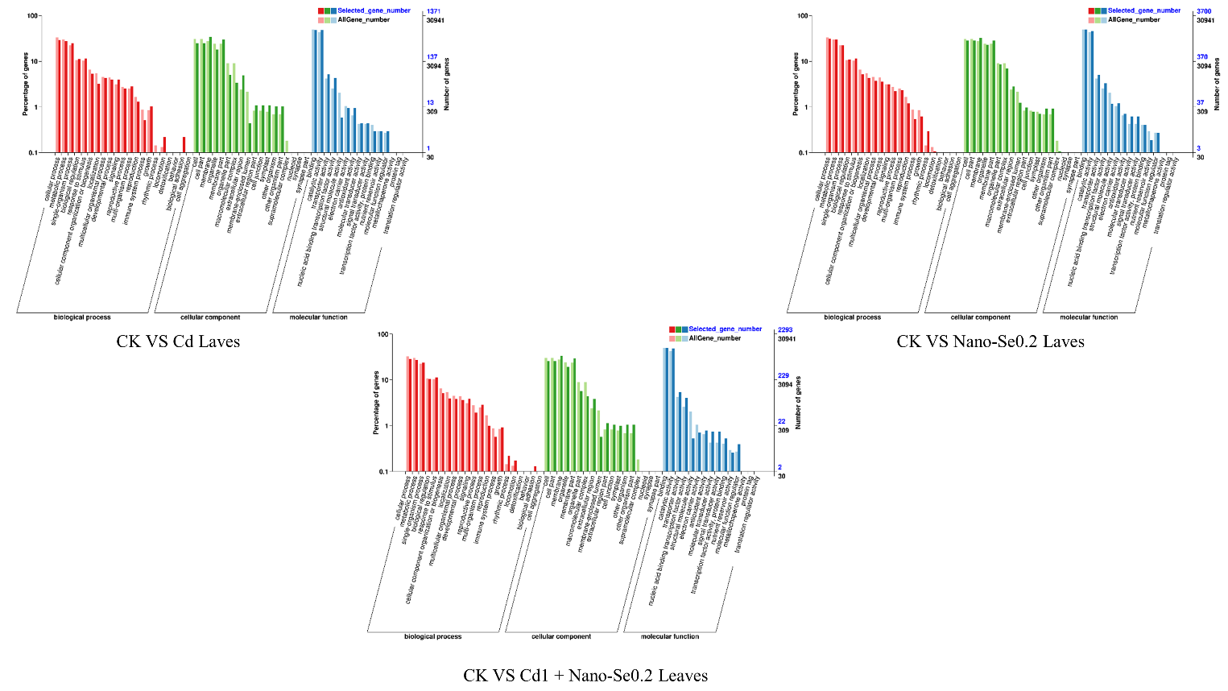
Figure S2. GO class of different treatments in the leaves

Table S3. Primer sequences for qPCR
Gene | Abbreviation | Sequence
Phe ammonia lyase | PAL | Forward: ATTCGCGCTGCAACTAAGAT Reverse:CACCGTGTAAGGCCTTGTTT
Coumaric acid 3-hydroxylase | C3H | Forward: GCCATCTTCTGCACCATTTT  Reverse: GGCCTGTAATGGAGTCCTCA
Hydroxycinnamoyl transferase | HCT | Forward: ATGCAGGGATGAAGATGGAC  Reverse: TAATCAACGGCCGGAATAAG
Caffeic acid O-methyltransferase | COMT | Forward: CCTGCGAATGGAAAAGTGAT  Reverse: TCTTTGCCTCCTGGGTTATG
4-coumarate: CoA ligase | 4CL | Forward: TCCATCGGCATCTTCGATAGT  Reverse: TCAACTTCAGGACACCACCG
Cinnamyl alcohol dehydrogenase | CAD | Forward: CTGGTTGGCTTCCCAAGTGA  Reverse: TACCTGCAAGAGGAGAGCCA
Brassinosteroid signaling positive regulator | BZR1 | Forward: CCGAGCTTGCTAGCTGATGA  Reverse: CCCAAACTAAACTTAAAGGCCTCA
Lipoxygenase 3 | LOX3 | Forward: TGGTGATCCTGCGAATGGTT  Reverse: CGTCCCAATCAAACGTGACA
Isochorismate synthase 2 | ICS2 | Forward: CGCCTTACAGCTCTGGCACTA  Reverse: CGAGGGAGGAGCAGATGGT
9-cis-epoxycarotenoid dioxygenase | NCED1 | Forward: GAAAAGGAATGGAAATCGGA  Reverse: CGGGGACGTATATTCTAAAC

Table S4. Statistics of the number of differentially expressed genes
#Parameters | Group | DEGs_total | DEGs_up | DEGs_down
Software：DESeq2_edgeR | L01&L02&L03&L04_vs_LC01&LC02&LC03&LC04 | 1888 | 862 | 1026
Software：DESeq2_edgeR | L01&L02&L03&L04_vs_LCS01&LCS02&LCS03&LCS04 | 3204 | 1475 | 1729
Software：DESeq2_edgeR | L01&L02&L03&L04_vs_LS01&LS02&LS03&LS04 | 5187 | 2794 | 2393
Software：DESeq2_edgeR | R01&R02&R03&R04_vs_RC01&RC02&RC03&RC04 | 4975 | 2486 | 2489
Software：DESeq2_edgeR | R01&R02&R03&R04_vs_RCS01&RCS02&RCS03&RCS04 | 4296 | 2061 | 2235
Software：DESeq2_edgeR | R01&R02&R03&R04_vs_RS01&RS02&RS03&RS04 | 11080 | 5688 | 5392

