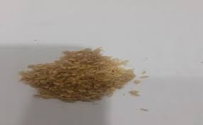
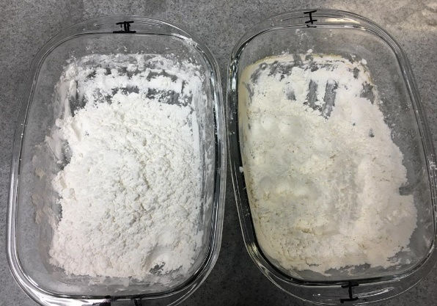
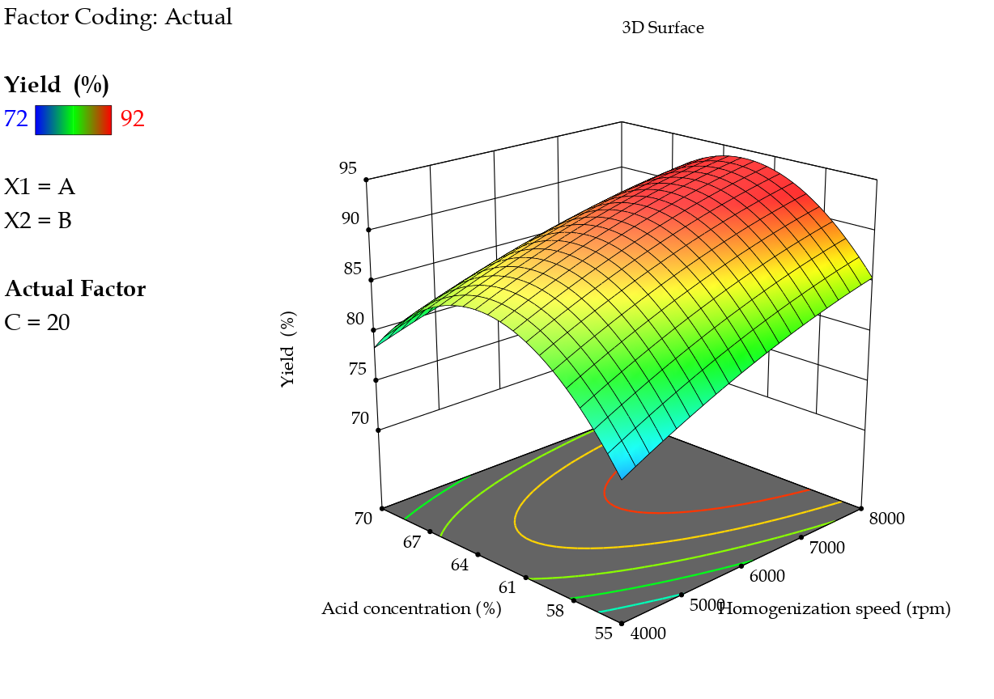
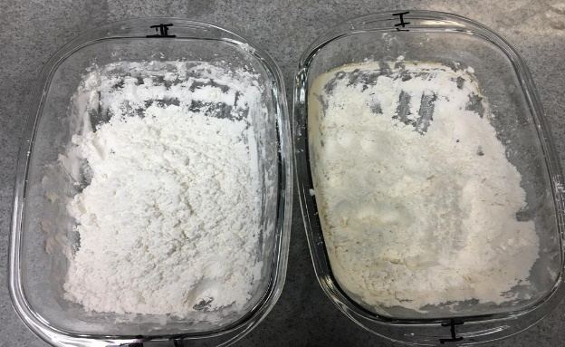
Millet husk
NaOH/Ethanol
NaCl/ Acetic acid
Cellulose
Hydrolysis with sulfuric acid
Box Behnken design
CNCs

