Supplemental Table 1 The distribution of missing data for all variables
Variables | Missing ratio(%)
Temperature | 3.21
SBP | 1.23
DBP | 1.23
Heart rate | 1.73
Respiratory rate | 7.16
PT | 2.47
PT_activity | 2.47
INR | 2.47
APTT | 2.47
FIB | 2.47
TT | 2.47
D_D | 2.97
FDP | 2.97
RDW_SD | 2.47
PLT | 2.47
PCT | 10.12
PDW | 10.12
MPV | 10.12
GLU | 6.17
K | 0.74
Cl | 0.74
HCO3 | 0.98
Procalcitonin | 0.49
CRP | 0.24
PH | 34.81
PO2 | 35.06
PCO2 | 35.31
Lac | 37.53
BE | 77.78
Variables with a missing data ratio exceeding 15% (namely, PH, PO2, PCO2,BE, and Lac) were excluded from further analysis.
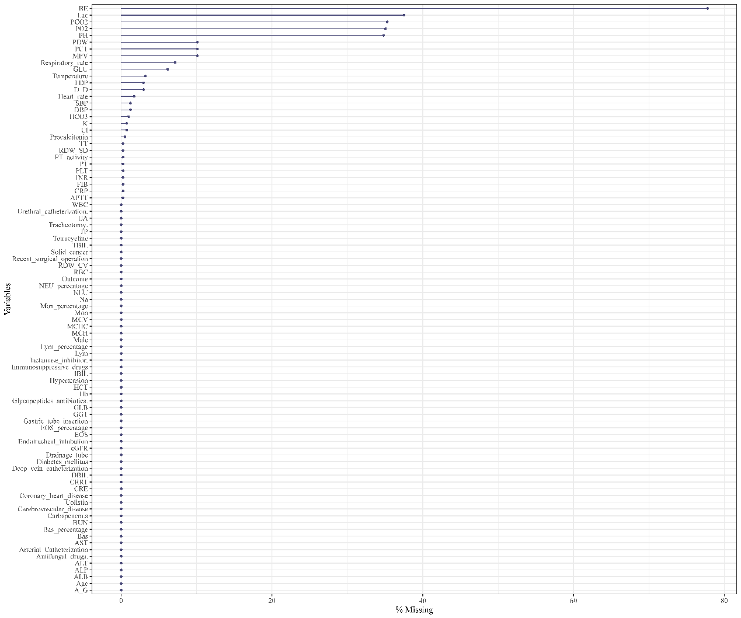
Supplemental Fig.1 The distribution of missing data for all variables

Supplemental Table 2 variables selected by LASSO regression
Variables | Nonzero coefficient
Carbapenem antibiotics | 0.090107723
Deep vein catheterization | 0.248735933
CRRT | 0.875702311
APTT | 0.016917378
DBIL | 0.335135853
Procalcitonin | 2.617007085
CRP | 1.114877404
After lasso regression, seven variables had nonzero coefficients.

Supplemental Table 3 Evaluation metrics results of seven models in the training set
Model | AUC（95%CI） | Accuracy | Sensitivity | Specificity | F1 Score | Kappa | Youden's J | PPV | NPV
Logistic | 0.881  (0.825-0.931) | 0.873 | 0.591 | 0.959 | 0.684 | 0.607 | 0.55 | 0.813 | 0.886
Decision Tree | 0.899  (0.854-0.941) | 0.884 | 0.682 | 0.945 | 0.732 | 0.658 | 0.627 | 0.789 | 0.907
Random Forest | 1 | 1 | 1 | 1 | 1 | 1 | 1 | 1 | 1
XGBoost | 0.962  (0.937-0.984) | 0.898 | 0.621 | 0.982 | 0.739 | 0.678 | 0.603 | 0.911 | 0.895
LightGBM | 0.998  (0.994-0.999) | 0.975 | 0.939 | 0.986 | 0.947 | 0.931 | 0.926 | 0.954 | 0.982
SVM | 0.881  (0.824-0.932) | 0.856 | 0.5 | 0.963 | 0.617 | 0.534 | 0.463 | 0.805 | 0.864
ANN | 0.897  (0.844-0.943) | 0.877 | 0.652 | 0.945 | 0.711 | 0.633 | 0.596 | 0.782 | 0.899
All seven machine learning models demonstrated excellent predictive performance in the training set. All models achieved accuracy and AUC values of 0.88 or above, among which the XGBoost model attained the highest AUC.

Supplemental Table 4. Model hyperparameters
Models | Optimal parameter combination
Decision Tree | ccp_alpha': 0.0, 'max_depth': 5, 'max_features': None, 'min_samples_split': 10
Random Forest | n_estimators = 150 , max_features = 2
XGBoost | learning_rate': 0.2, 'max_depth': 3, 'n_estimators': 50, 'subsample': 0.8
LightGBM | colsample_bytree': 0.6, 'learning_rate': 0.1, 'n_estimators': 100, 'num_leaves': 50, 'subsample': 0.6
SVM | C': 0.1, 'degree': 2, 'gamma': 'scale', 'kernel': 'linear'
ANN | activation': 'logistic', 'hidden_layer_sizes': (100,)
Model hyperparameters were optimized via a grid search coupled with 5-fold cross-validation. The key parameter settings for each model are summarized below; all other parameters were retained at their default values.

