Supplementary Material

Supplementary Figures and Tables

Supplementary Figures
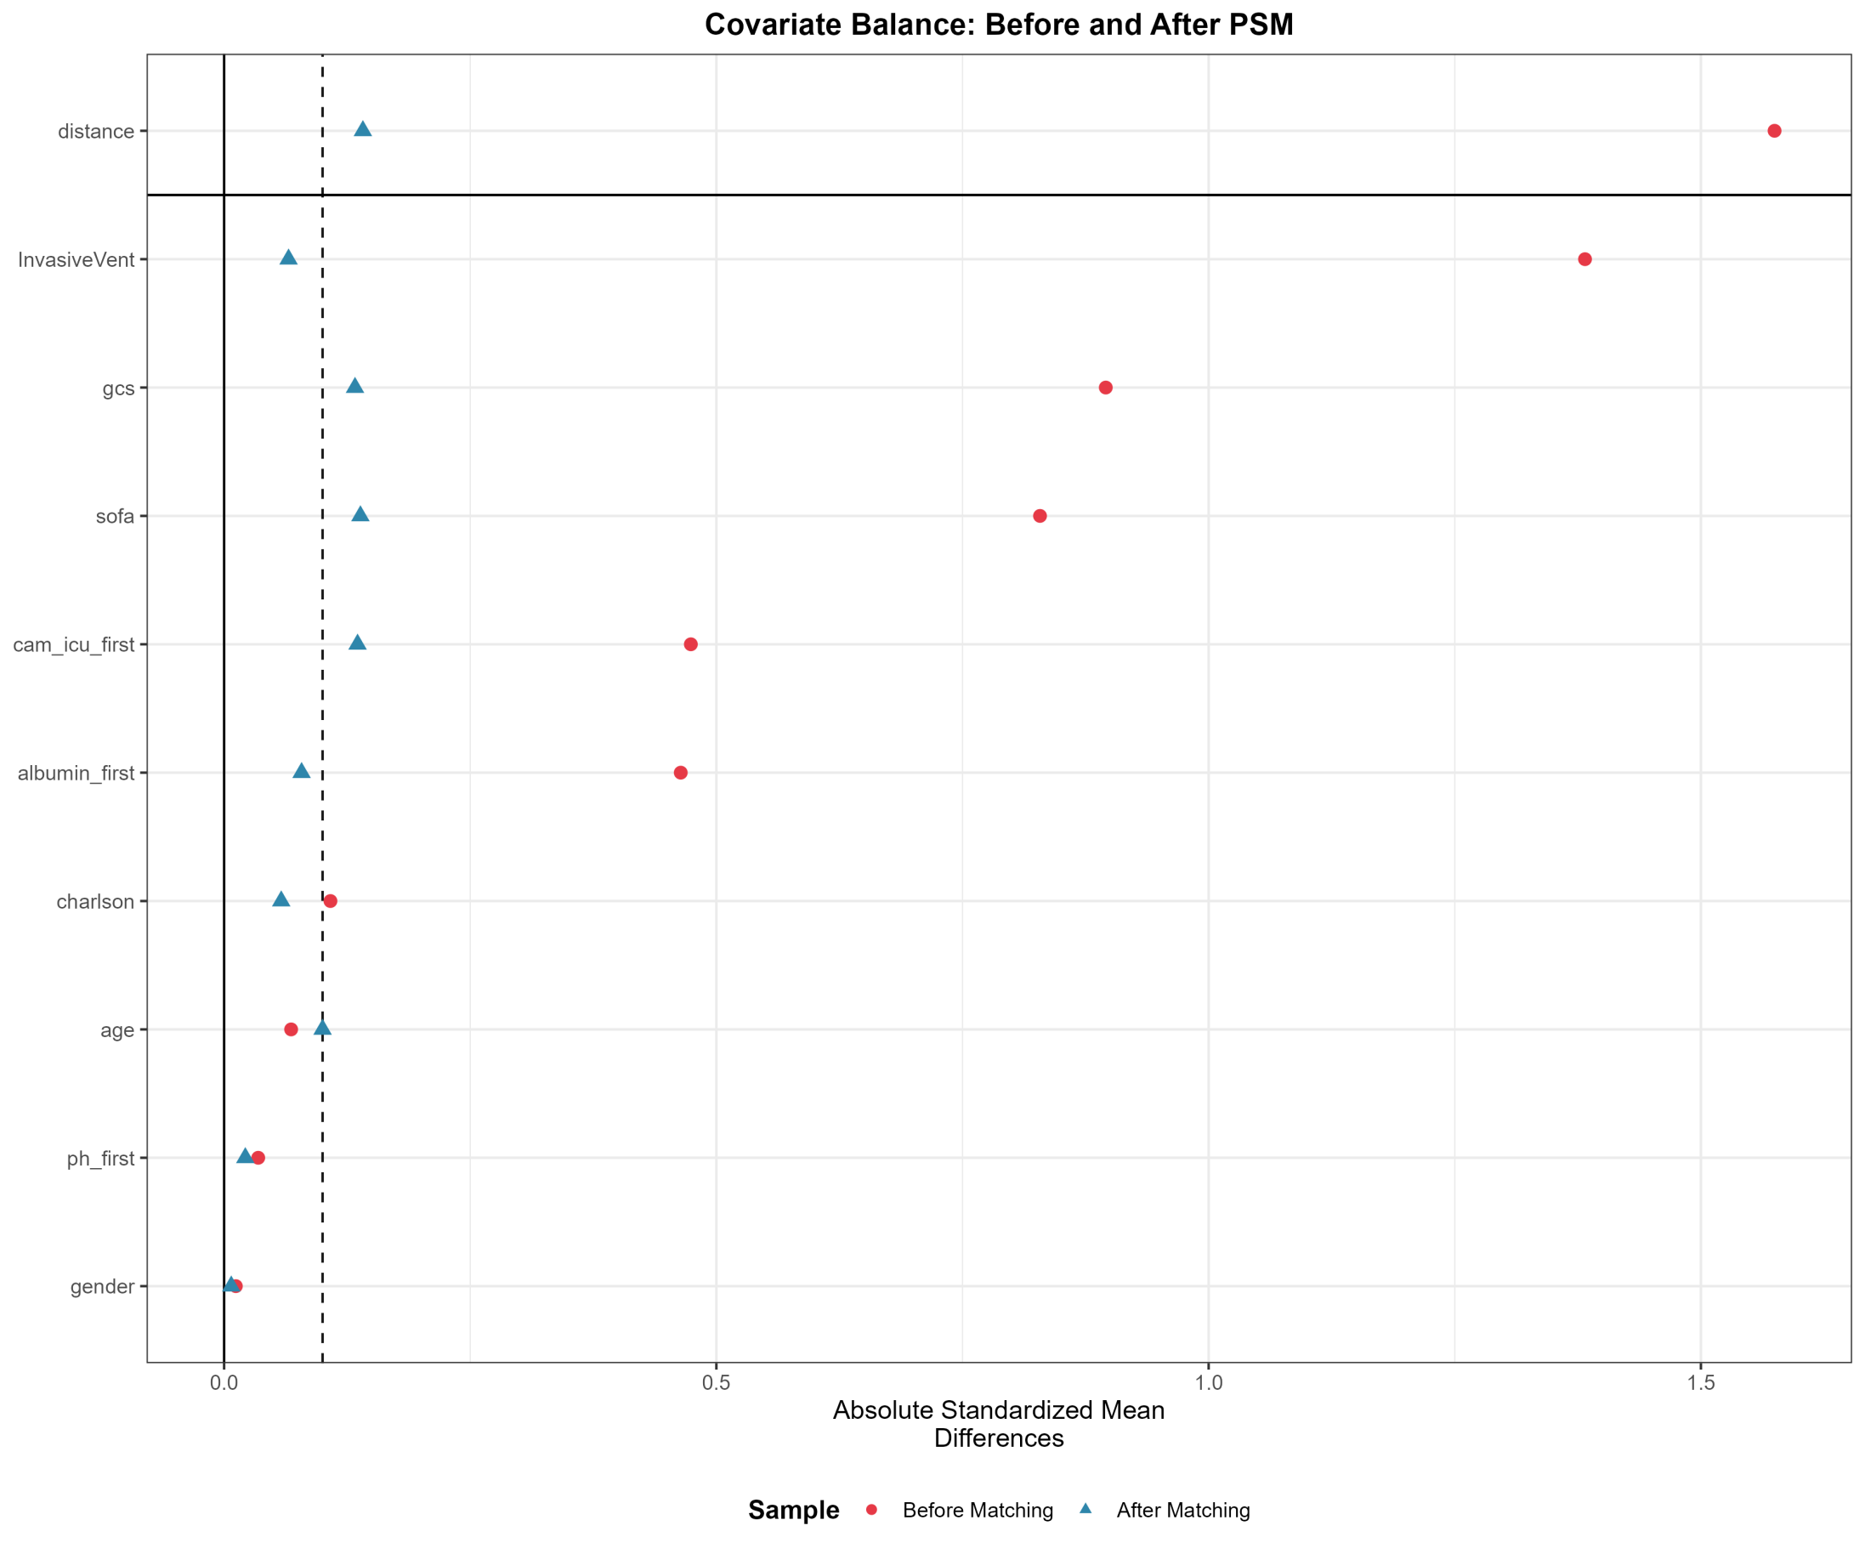

Supplementary Figure 1. Love Plot Showing Covariate Balance Before and After Propensity Score Matching
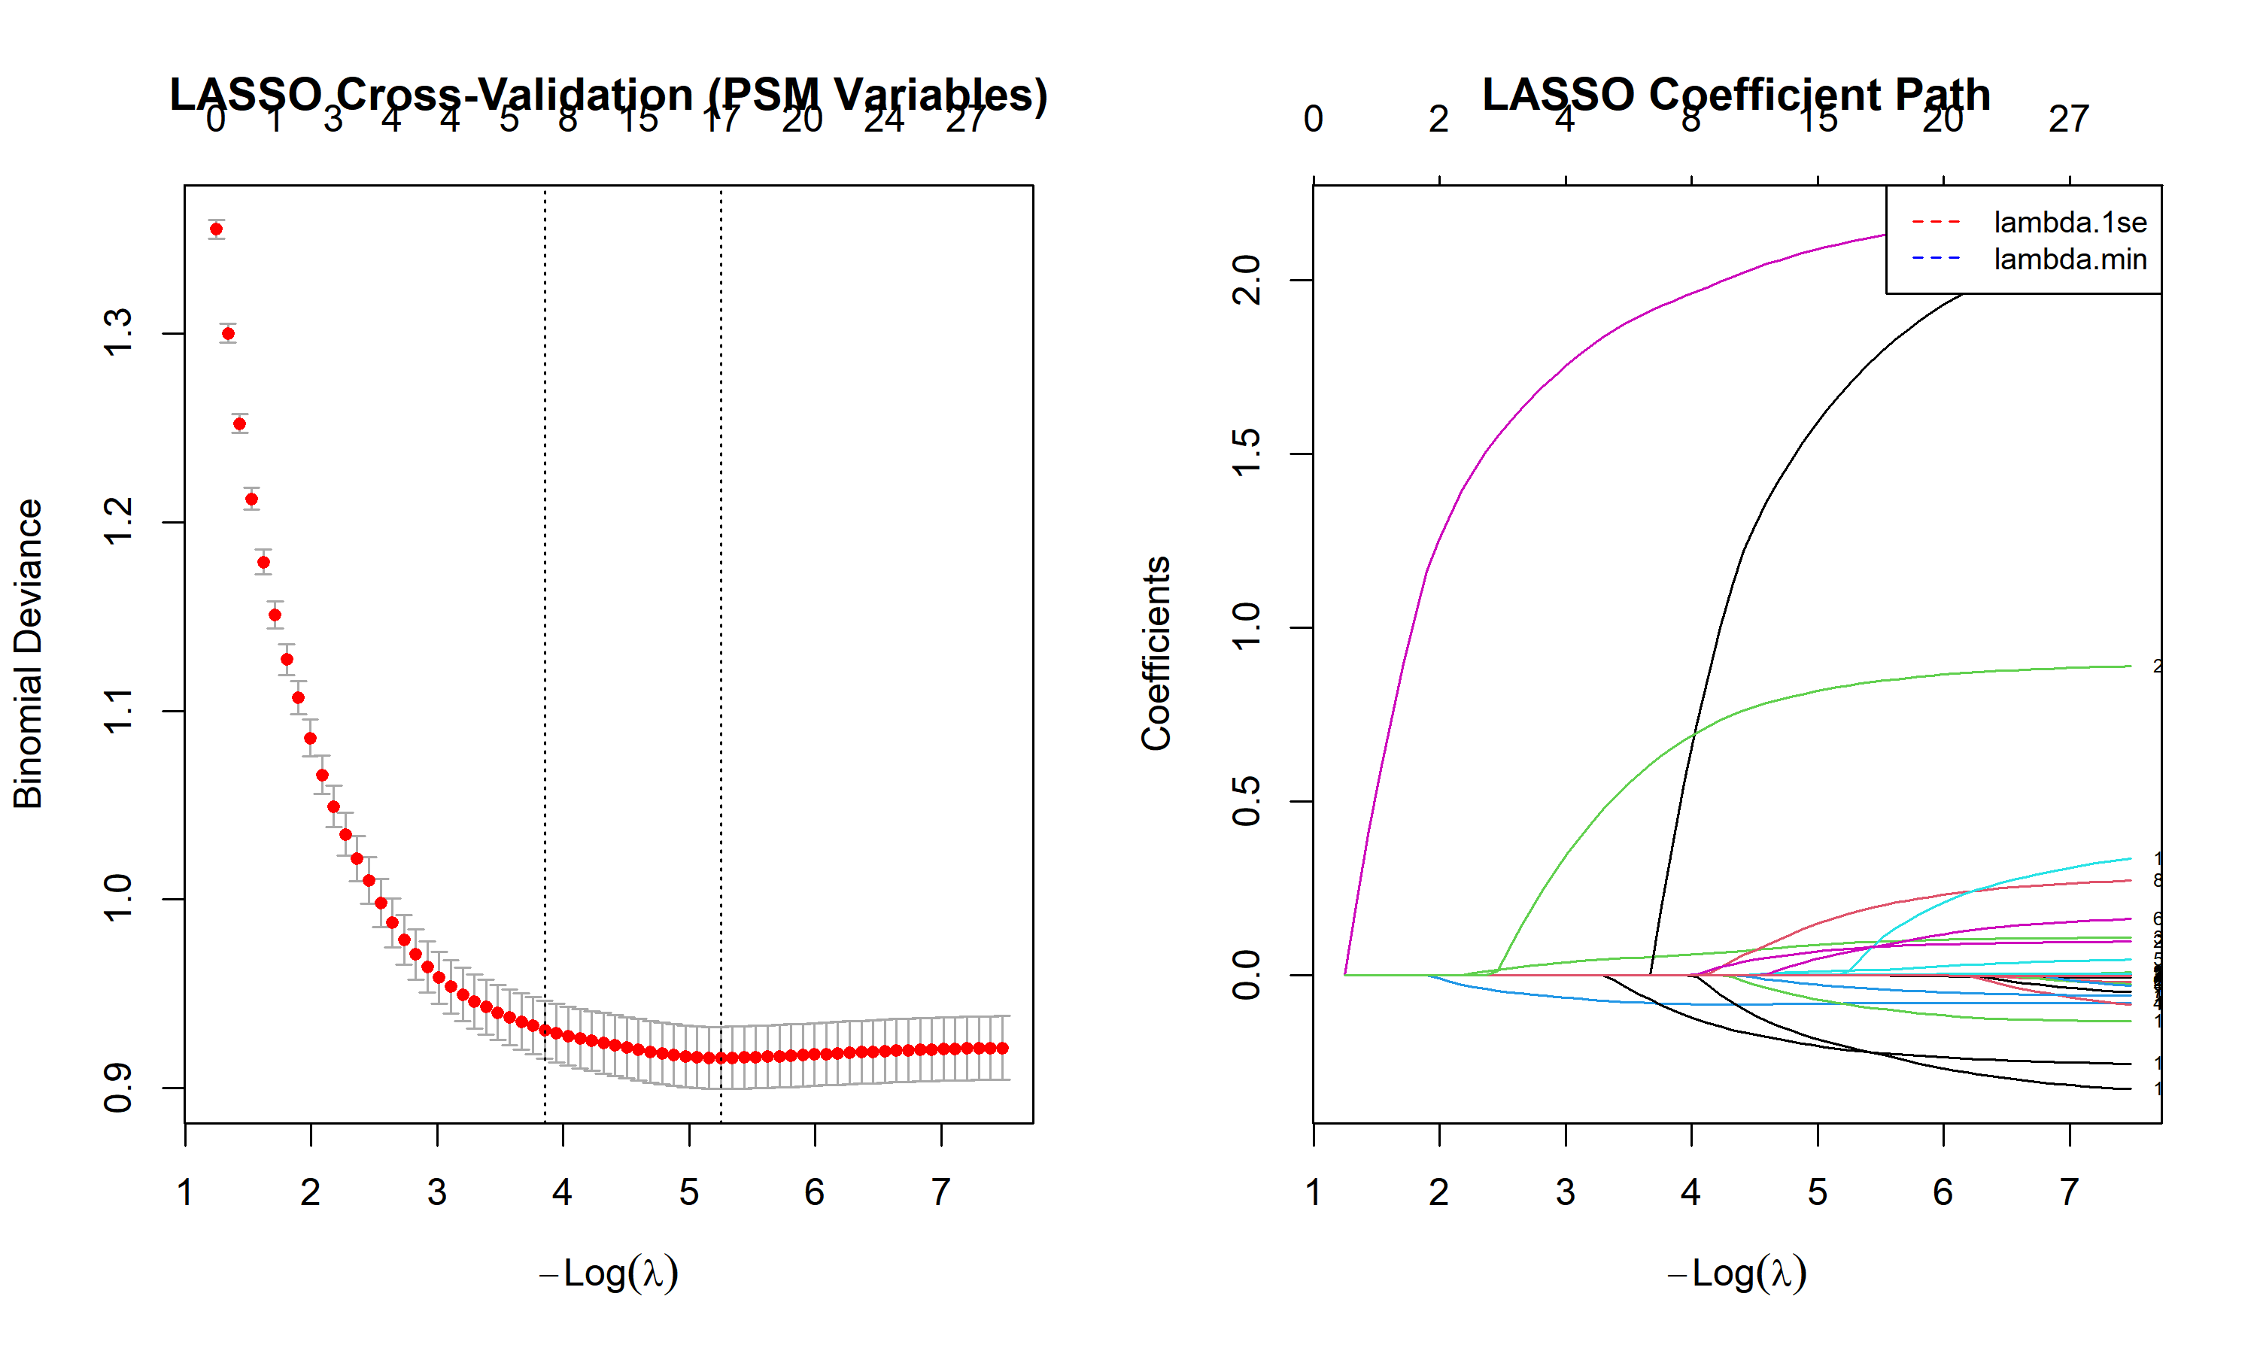

Supplementary Figure 2. Tuning Parameter Selection and Variable Shrinkage in LASSO Regression
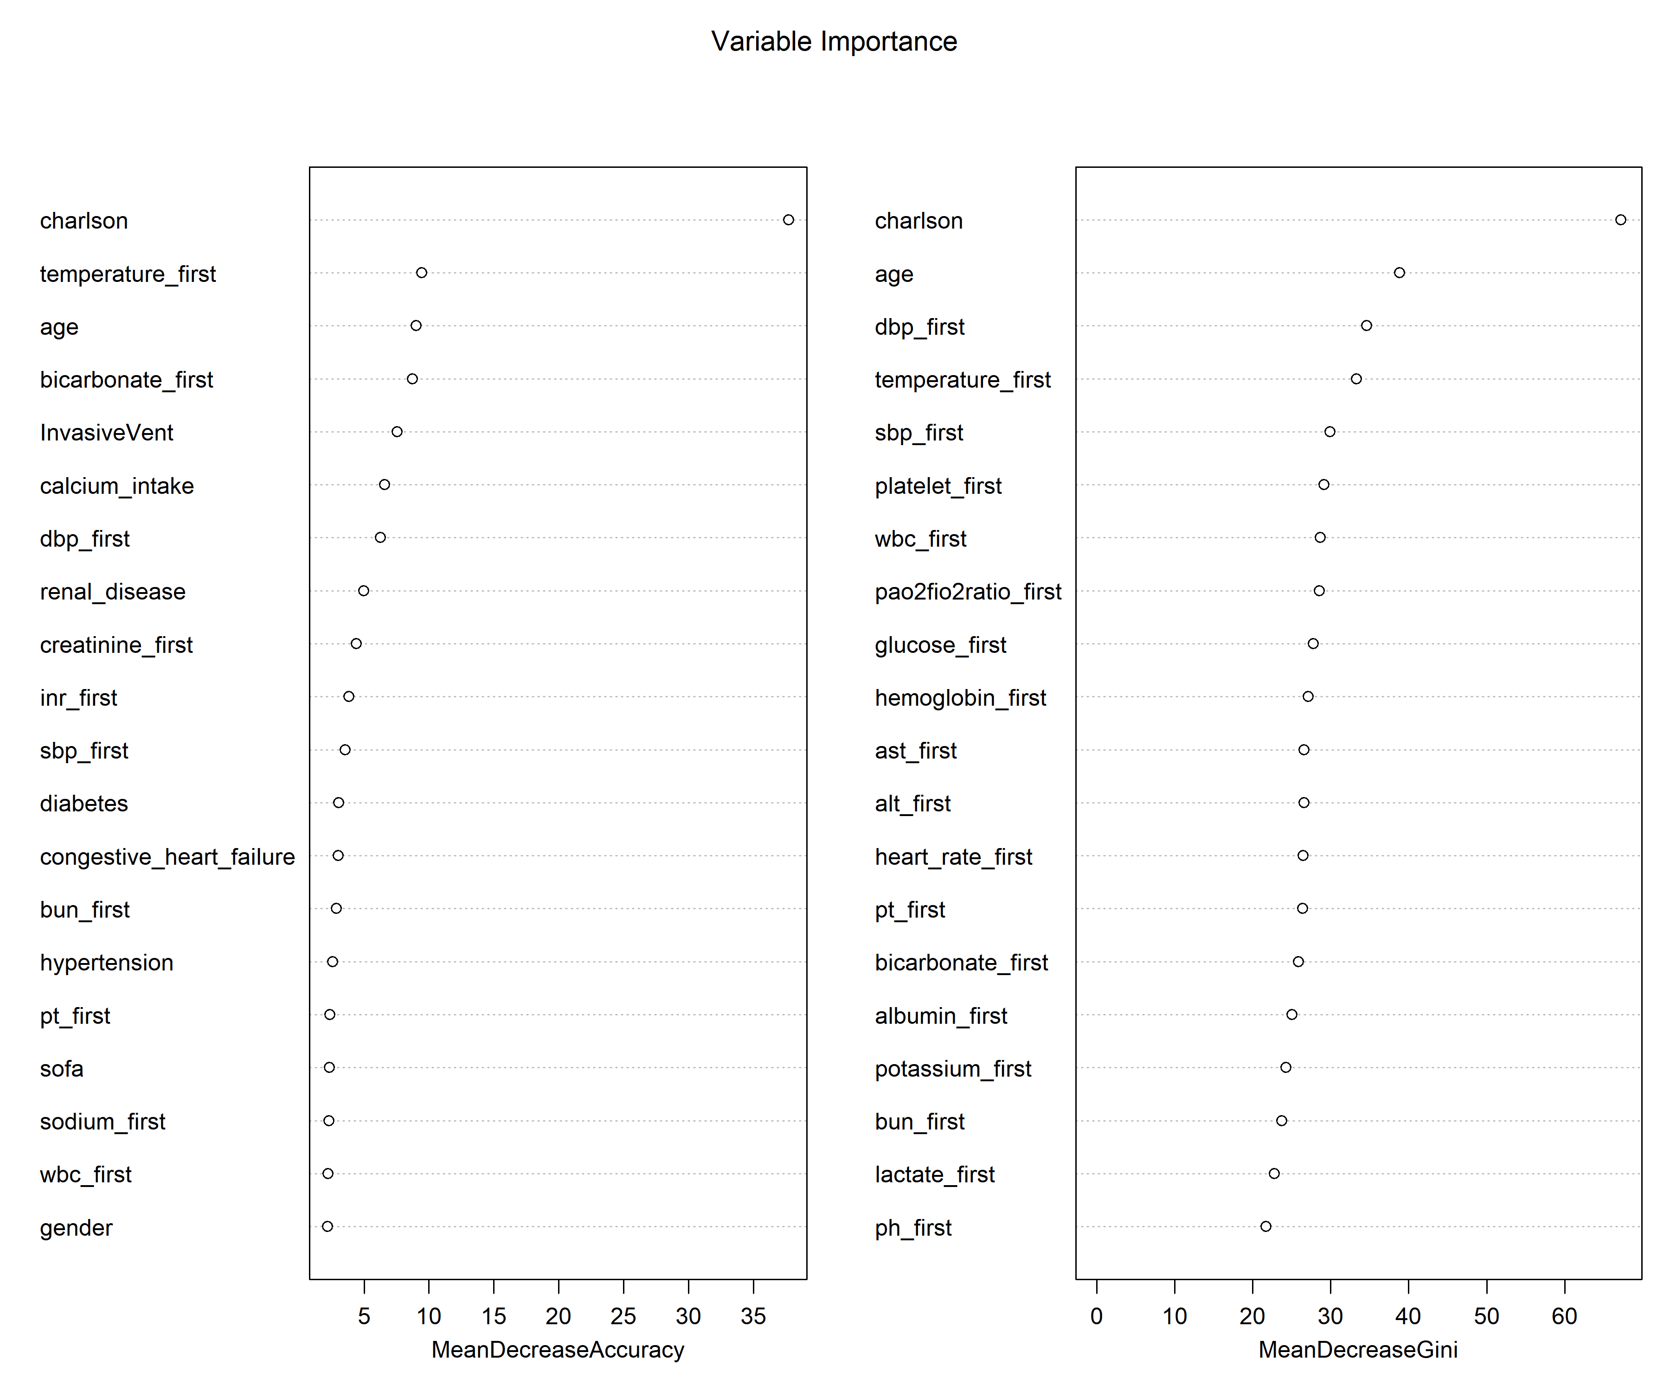
Supplementary Figure 3. Variable Importance from Random Forest Analysis: Mean Decrease in Accuracy and Gini Index.
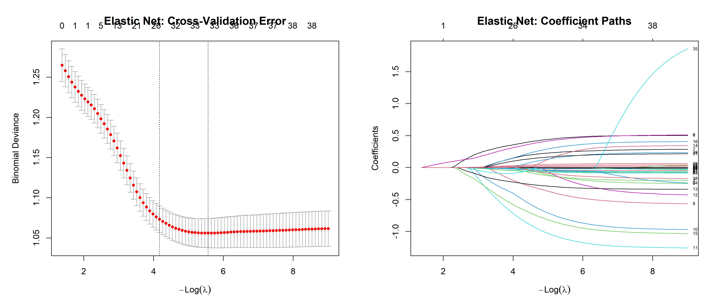
Supplementary Figure 4. Elastic Net Variable Selection: Cross-Validation Curve and Coefficient Trajectories

1.2 Supplementary Tables
Variation | Overall | Non-Ca | Ca | p | test | SMD
n | 4020 | 2355 | 1665
Age,median [IQR] | 69.47 [57.90, 80.06] | 69.96 [58.29, 80.81] | 68.70 [57.53, 79.23] | 0.018 | nonnorm | 0.067
Gender, n (%) | 2159 (53.7) | 1259 (53.5) | 900 (54.1) | 0.734 |  | 0.012
Los hospital,median [IQR] | 8.73 [4.67, 16.32] | 6.61 [3.85, 11.64] | 13.65 [7.16, 22.39] | <0.001 | nonnorm | 0.446
Los icu,median [IQR] | 4.50 [2.28, 9.65] | 3.15 [1.85, 6.00] | 7.74 [3.83, 14.66] | <0.001 | nonnorm | 0.608
In-hospital mortality, n (%) | 766 (19.1) | 280 (11.9) | 486 (29.2) | <0.001 |  | 0.438
ICU mortality, n (%) | 511 (12.7) | 177 (7.5) | 334 (20.1) | <0.001 |  | 0.37
Current smoker, n (%) | 174 (4.3) | 96 (4.1) | 78 (4.7) | 0.393 |  | 0.03
Alcohol abuse, n (%) | 27 (0.7) | 14 (0.6) | 13 (0.8) | 0.606 |  | 0.023
Hypertension, n (%) | 2325 (57.8) | 1358 (57.7) | 967 (58.1) | 0.819 |  | 0.008
Diabetes mellitus, n (%) | 1022 (25.4) | 557 (23.7) | 465 (27.9) | 0.002 |  | 0.098
Congestive heart failure, n (%) | 606 (15.1) | 297 (12.6) | 309 (18.6) | <0.001 |  | 0.165
Renal disease, n (%) | 551 (13.7) | 302 (12.8) | 249 (15.0) | 0.059 |  | 0.062
SOFA score, median [IQR] | 4.00 [2.00, 6.00] | 3.00 [2.00, 5.00] | 6.00 [4.00, 8.00] | <0.001 | nonnorm | 0.948
GCS score, median [IQR] | 12.00 [8.00, 14.00] | 13.00 [10.00, 14.00] | 8.00 [6.00, 12.00] | <0.001 | nonnorm | 0.956
Charlson comorbidity index, median [IQR] | 6.00 [4.00, 7.00] | 5.00 [4.00, 7.00] | 6.00 [4.00, 8.00] | <0.001 | nonnorm | 0.107
Invasive mechanical ventilation, n (%) | 1707 (42.5) | 430 (18.3) | 1277 (76.7) | <0.001 |  | 1.443
Immunomodulator use, n (%) | 60 (1.5) | 34 (1.4) | 26 (1.6) | 0.864 |  | 0.01
Glucocorticoid use, n (%) | 897 (22.3) | 519 (22.0) | 378 (22.7) | 0.646 |  | 0.016
Antihypertensive drug use, n (%) | 2270 (56.5) | 1153 (49.0) | 1117 (67.1) | <0.001 |  | 0.374
First-line antibiotic use, n (%) | 2352 (58.5) | 992 (42.1) | 1360 (81.7) | <0.001 |  | 0.892
Temperature, °C, median [IQR] | 36.78 [36.50, 37.06] | 36.78 [36.56, 37.00] | 36.83 [36.50, 37.17] | 0.004 | nonnorm | 0.075
Heart rate, bpm, median [IQR] | 81.00 [70.00, 93.00] | 80.00 [70.00, 91.00] | 82.00 [71.00, 95.00] | <0.001 | nonnorm | 0.156
Systolic blood pressure, mmHg, median [IQR] | 136.00 [121.00, 150.00] | 137.00 [122.00, 150.00] | 135.00 [120.00, 151.00] | 0.393 | nonnorm | 0.014
Diastolic blood pressure, mmHg, median [IQR] | 74.00 [63.00, 85.00] | 74.00 [64.00, 85.00] | 73.00 [63.00, 85.00] | 0.045 | nonnorm | 0.055
pH, median [IQR] | 7.42 [7.38, 7.46] | 7.42 [7.37, 7.46] | 7.42 [7.38, 7.46] | 0.023 | nonnorm | 0.036
PaO₂/FiO₂ ratio, median [IQR] | 328.00 [222.50, 426.00] | 340.00 [232.00, 438.00] | 308.00 [212.00, 411.11] | <0.001 | nonnorm | 0.181
PaO₂, mmHg, median [IQR] | 154.00 [99.00, 230.00] | 158.00 [104.00, 235.50] | 145.00 [95.00, 221.00] | 0.001 | nonnorm | 0.084
PaCO₂, mmHg, median [IQR] | 37.00 [32.00, 41.00] | 37.00 [32.00, 42.00] | 36.00 [32.00, 41.00] | 0.008 | nonnorm | 0.078
White blood cell count, ×10⁹/L, median [IQR] | 9.80 [7.60, 12.90] | 9.30 [7.10, 11.80] | 11.00 [8.50, 14.20] | <0.001 | nonnorm | 0.148
Absolute lymphocyte count, ×10⁹/L, median [IQR] | 1.26 [0.84, 1.81] | 1.30 [0.90, 1.89] | 1.20 [0.78, 1.73] | <0.001 | nonnorm | 0.021
Absolute neutrophil count, ×10⁹/L, median [IQR] | 7.95 [5.44, 10.81] | 7.18 [4.99, 9.80] | 8.86 [6.35, 11.97] | <0.001 | nonnorm | 0.364
Platelet count, ×10⁹/L, median [IQR] | 208.00 [164.00, 262.00] | 210.00 [167.50, 263.00] | 203.00 [157.00, 259.00] | 0.001 | nonnorm | 0.094
Red blood cell count, ×10¹²/L, median [IQR] | 4.08 [3.62, 4.51] | 4.15 [3.71, 4.56] | 3.98 [3.50, 4.44] | <0.001 | nonnorm | 0.241
Hemoglobin, g/dL, median [IQR] | 12.30 [10.90, 13.50] | 12.50 [11.10, 13.70] | 12.00 [10.50, 13.30] | <0.001 | nonnorm | 0.238
Serum albumin, g/dL, median [IQR] | 3.60 [3.20, 4.00] | 3.70 [3.30, 4.00] | 3.40 [3.00, 3.80] | <0.001 | nonnorm | 0.485
Serum creatinine, mg/dL, median [IQR] | 0.90 [0.70, 1.10] | 0.90 [0.70, 1.10] | 0.90 [0.70, 1.20] | 0.001 | nonnorm | 0.107
Blood urea nitrogen, mg/dL, median [IQR] | 16.00 [12.00, 22.00] | 15.00 [12.00, 21.00] | 17.00 [12.00, 24.00] | <0.001 | nonnorm | 0.186
Blood glucose, mg/dL, median [IQR] | 125.00 [104.00, 155.00] | 119.00 [102.00, 146.00] | 132.00 [109.00, 167.00] | <0.001 | nonnorm | 0.227
Fasting blood glucose, mg/dL, median [IQR] | 121.00 [101.00, 150.00] | 114.00 [98.00, 137.00] | 132.00 [109.00, 166.00] | <0.001 | nonnorm | 0.366
Serum potassium, mmol/L, median [IQR] | 4.00 [3.60, 4.30] | 4.00 [3.70, 4.30] | 3.90 [3.60, 4.30] | 0.002 | nonnorm | 0.051
Serum sodium, mmol/L, median [IQR] | 139.00 [137.00, 142.00] | 139.00 [137.00, 142.00] | 139.00 [136.00, 142.00] | 0.013 | nonnorm | 0.02
Serum bicarbonate, mmol/L, median [IQR] | 23.00 [21.00, 25.00] | 23.00 [21.00, 25.00] | 23.00 [21.00, 25.00] | <0.001 | nonnorm | 0.163
Serum lactate, mmol/L, median [IQR] | 1.30 [1.00, 1.90] | 1.30 [1.00, 1.80] | 1.40 [1.00, 2.00] | <0.001 | nonnorm | 0.1
Serum triglycerides, mg/dL, median [IQR] | 103.50 [74.00, 148.00] | 98.00 [72.00, 137.00] | 113.00 [78.00, 165.00] | <0.001 | nonnorm | 0.23
Prothrombin time, seconds, median [IQR] | 12.50 [11.60, 13.90] | 12.40 [11.60, 13.60] | 12.80 [11.70, 14.30] | <0.001 | nonnorm | 0.12
Partial thromboplastin time, seconds, median [IQR] | 28.40 [26.00, 31.60] | 28.40 [26.20, 31.60] | 28.30 [25.70, 31.70] | 0.17 | nonnorm | 0.022
INR, median [IQR] | 1.10 [1.10, 1.30] | 1.10 [1.10, 1.20] | 1.20 [1.10, 1.30] | <0.001 | nonnorm | 0.141
ALT, U/L, median [IQR] | 21.00 [14.00, 32.00] | 19.00 [13.00, 29.00] | 23.00 [16.00, 39.00] | <0.001 | nonnorm | 0.118
AST, U/L, median [IQR] | 26.00 [19.00, 39.00] | 23.00 [18.00, 35.00] | 30.00 [21.00, 46.00] | <0.001 | nonnorm | 0.114
Total fluid intake in first 24h, mL, median [IQR] | 120.00 [20.82, 899.25] | 200.00 [44.13, 983.90] | 65.00 [9.50, 500.00] | <0.001 | nonnorm | 0.107
Total fluid output in first 24h, mL, median [IQR] | 275.00 [125.00, 500.00] | 300.00 [150.00, 500.00] | 250.00 [100.00, 500.00] | <0.001 | nonnorm | 0.01
Urine output in first 24h, mL, median [IQR] | 250.00 [123.75, 400.00] | 275.00 [150.00, 450.00] | 200.00 [100.00, 400.00] | <0.001 | nonnorm | 0.165
CAM-ICU, n (%) | 805 (20.0) | 254 (10.8) | 551 (33.1) | <0.001 |  | 0.56
Dystonia occurrence, n (%) | 1144 (28.5) | 625 (26.5) | 519 (31.2) | 0.002 |  | 0.102

Supplementary Table S1. Baseline Characteristics in the Unmatched Cohort
Variation | Overall | Non-Ca | Ca | p | test | SMD
n | 1662 | 831 | 831
Age,median [IQR] | 70.53 [59.82, 81.00] | 71.56 [61.20, 81.15] | 69.44 [58.73, 80.57] | 0.068 | nonnorm | 0.102
Gender, n (%) | 853 (51.3) | 428 (51.5) | 425 (51.1) | 0.922 |  | 0.007
Los hospital,median [IQR] | 10.74 [5.20, 19.07] | 8.64 [4.10, 17.23] | 12.65 [7.03, 20.75] | <0.001 | nonnorm | 0.119
Los icu,median [IQR] | 5.08 [2.57, 10.87] | 3.86 [2.00, 9.11] | 6.27 [3.38, 12.39] | <0.001 | nonnorm | 0.191
In-hospital mortality, n (%) | 428 (25.8) | 218 (26.2) | 210 (25.3) | 0.695 |  | 0.022
ICU mortality, n (%) | 282 (17.0) | 153 (18.4) | 129 (15.5) | 0.133 |  | 0.077
Current smoker, n (%) | 67 (4.0) | 32 (3.9) | 35 (4.2) | 0.803 |  | 0.018
Alcohol abuse, n (%) | 8 (0.5) | 3 (0.4) | 5 (0.6) | 0.723 |  | 0.035
Hypertension, n (%) | 951 (57.2) | 464 (55.8) | 487 (58.6) | 0.275 |  | 0.056
Diabetes mellitus, n (%) | 462 (27.8) | 231 (27.8) | 231 (27.8) | 1 |  | <0.001
Congestive heart failure, n (%) | 275 (16.5) | 124 (14.9) | 151 (18.2) | 0.086 |  | 0.088
Renal disease, n (%) | 257 (15.5) | 138 (16.6) | 119 (14.3) | 0.222 |  | 0.063
SOFA score, median [IQR] | 5.00 [3.00, 7.00] | 5.00 [3.00, 7.00] | 5.00 [3.00, 7.00] | 0.019 | nonnorm | 0.148
GCS score, median [IQR] | 10.00 [7.00, 13.00] | 10.00 [7.00, 14.00] | 9.00 [7.00, 13.00] | 0.005 | nonnorm | 0.13
Charlson comorbidity index, median [IQR] | 6.00 [4.00, 8.00] | 6.00 [4.00, 8.00] | 6.00 [4.00, 8.00] | 0.448 | nonnorm | 0.057
Invasive mechanical ventilation, n (%) | 881 (53.0) | 429 (51.6) | 452 (54.4) | 0.28 |  | 0.055
Immunomodulator use, n (%) | 23 (1.4) | 13 (1.6) | 10 (1.2) | 0.675 |  | 0.031
Glucocorticoid use, n (%) | 393 (23.6) | 217 (26.1) | 176 (21.2) | 0.021 |  | 0.116
Antihypertensive drug use, n (%) | 970 (58.4) | 436 (52.5) | 534 (64.3) | <0.001 |  | 0.241
First-line antibiotic use, n (%) | 1105 (66.5) | 475 (57.2) | 630 (75.8) | <0.001 |  | 0.403
Temperature, °C, median [IQR] | 36.83 [36.50, 37.11] | 36.78 [36.50, 37.11] | 36.83 [36.50, 37.17] | 0.094 | nonnorm | 0.083
Heart rate, bpm, median [IQR] | 83.00 [71.00, 95.00] | 81.00 [71.00, 92.00] | 84.00 [71.00, 96.00] | 0.009 | nonnorm | 0.126
Systolic blood pressure, mmHg, median [IQR] | 136.00 [120.00, 151.00] | 137.00 [120.00, 151.25] | 135.00 [121.00, 150.00] | 0.738 | nonnorm | 0.007
Diastolic blood pressure, mmHg, median [IQR] | 73.00 [62.00, 86.00] | 73.00 [62.00, 86.00] | 73.00 [63.00, 86.00] | 0.982 | nonnorm | 0.006
pH, median [IQR] | 7.42 [7.37, 7.46] | 7.42 [7.37, 7.46] | 7.42 [7.38, 7.46] | 0.399 | nonnorm | 0.022
PaO₂/FiO₂ ratio, median [IQR] | 314.00 [212.50, 420.00] | 320.00 [216.67, 420.00] | 310.00 [209.00, 414.00] | 0.294 | nonnorm | 0.024
PaO₂, mmHg, median [IQR] | 148.00 [95.00, 222.00] | 152.00 [99.00, 221.50] | 144.00 [91.00, 222.50] | 0.168 | nonnorm | 0.036
PaCO₂, mmHg, median [IQR] | 36.00 [32.00, 42.00] | 37.00 [32.00, 42.00] | 36.00 [32.00, 41.00] | 0.195 | nonnorm | 0.061
White blood cell count, ×10⁹/L, median [IQR] | 10.30 [7.90, 13.50] | 9.90 [7.50, 13.15] | 10.70 [8.30, 13.90] | <0.001 | nonnorm | 0.021
Absolute lymphocyte count, ×10⁹/L, median [IQR] | 1.20 [0.81, 1.77] | 1.20 [0.81, 1.77] | 1.21 [0.80, 1.76] | 0.613 | nonnorm | 0.029
Absolute neutrophil count, ×10⁹/L, median [IQR] | 8.32 [5.81, 11.34] | 8.02 [5.45, 10.89] | 8.64 [6.31, 11.74] | <0.001 | nonnorm | 0.125
Platelet count, ×10⁹/L, median [IQR] | 205.00 [157.00, 262.00] | 204.00 [154.00, 262.00] | 205.00 [161.50, 263.00] | 0.676 | nonnorm | 0.022
Red blood cell count, ×10¹²/L, median [IQR] | 3.99 [3.53, 4.46] | 4.01 [3.55, 4.47] | 3.98 [3.50, 4.42] | 0.174 | nonnorm | 0.052
Hemoglobin, g/dL, median [IQR] | 12.00 [10.60, 13.40] | 12.00 [10.70, 13.40] | 12.00 [10.60, 13.30] | 0.6 | nonnorm | 0.014
Serum albumin, g/dL, median [IQR] | 3.50 [3.10, 3.90] | 3.50 [3.10, 3.90] | 3.50 [3.00, 3.80] | 0.037 | nonnorm | 0.079
Serum creatinine, mg/dL, median [IQR] | 0.90 [0.70, 1.10] | 0.90 [0.70, 1.20] | 0.90 [0.70, 1.10] | 0.099 | nonnorm | 0.085
Blood urea nitrogen, mg/dL, median [IQR] | 17.00 [12.00, 23.00] | 17.00 [12.00, 23.00] | 16.00 [12.00, 23.00] | 0.278 | nonnorm | 0.024
Blood glucose, mg/dL, median [IQR] | 131.00 [108.00, 165.00] | 131.00 [107.00, 162.50] | 131.00 [108.00, 166.00] | 0.891 | nonnorm | 0.001
Fasting blood glucose, mg/dL, median [IQR] | 127.00 [104.00, 157.00] | 123.00 [102.00, 152.00] | 132.00 [107.00, 165.50] | <0.001 | nonnorm | 0.134
Serum potassium, mmol/L, median [IQR] | 4.00 [3.60, 4.30] | 4.00 [3.60, 4.30] | 4.00 [3.60, 4.30] | 0.778 | nonnorm | 0.006
Serum sodium, mmol/L, median [IQR] | 139.00 [137.00, 142.00] | 139.00 [137.00, 142.00] | 139.00 [136.00, 142.00] | 0.035 | nonnorm | 0.09
Serum bicarbonate, mmol/L, median [IQR] | 23.00 [21.00, 25.00] | 23.00 [21.00, 25.00] | 23.00 [21.00, 25.00] | 0.383 | nonnorm | 0.073
Serum lactate, mmol/L, median [IQR] | 1.30 [1.00, 2.00] | 1.40 [1.00, 2.00] | 1.30 [1.00, 1.90] | 0.302 | nonnorm | 0.076
Serum triglycerides, mg/dL, median [IQR] | 106.00 [74.00, 150.00] | 106.00 [74.00, 150.00] | 105.00 [74.00, 150.50] | 0.756 | nonnorm | 0.064
Prothrombin time, seconds, median [IQR] | 12.70 [11.70, 14.10] | 12.80 [11.90, 14.20] | 12.60 [11.60, 14.05] | 0.026 | nonnorm | 0.061
Partial thromboplastin time, seconds, median [IQR] | 28.30 [25.80, 31.60] | 28.30 [25.80, 31.80] | 28.30 [25.90, 31.15] | 0.765 | nonnorm | 0.081
INR, median [IQR] | 1.20 [1.10, 1.30] | 1.20 [1.10, 1.30] | 1.10 [1.10, 1.30] | 0.087 | nonnorm | 0.027
ALT, U/L, median [IQR] | 21.00 [14.00, 34.00] | 20.00 [13.00, 33.00] | 22.00 [15.00, 35.00] | <0.001 | nonnorm | 0.051
AST, U/L, median [IQR] | 28.00 [19.00, 43.00] | 27.00 [18.00, 41.00] | 29.00 [21.00, 44.50] | 0.001 | nonnorm | 0.086
Total fluid intake in first 24h, mL, median [IQR] | 100.00 [17.26, 756.04] | 120.00 [21.42, 800.00] | 100.00 [13.36, 702.50] | 0.061 | nonnorm | 0.042
Total fluid output in first 24h, mL, median [IQR] | 250.00 [110.00, 500.00] | 250.00 [100.00, 500.00] | 250.00 [124.50, 500.00] | 0.766 | nonnorm | 0.026
Urine output in first 24h, mL, median [IQR] | 200.00 [100.00, 400.00] | 225.00 [105.00, 400.00] | 200.00 [100.00, 400.00] | 0.219 | nonnorm | 0.063
CAM-ICU, n (%) | 457 (27.5) | 202 (24.3) | 255 (30.7) | 0.004 |  | 0.143
Dystonia occurrence, n (%) | 543 (32.7) | 230 (27.7) | 313 (37.7) | <0.001 |  | 0.214

Supplementary Table S2. Table 1. Baseline characteristics of the matched cohort.
Variable | SMD_Before | SMD_After | Improvement | Balance_Before | Balance_After
Age | 0.067 | 0.102 | -0.034 | Good | Acceptable
Gender | 0.012 | 0.007 | 0.005 | Good | Good
Length of hospital stay (LOS) | 0.446 | 0.119 | 0.327 | Poor | Acceptable
Length of ICU stay (LOS) | 0.608 | 0.191 | 0.416 | Poor | Acceptable
In-hospital mortality | 0.438 | 0.022 | 0.416 | Poor | Good
ICU mortality | 0.37 | 0.077 | 0.293 | Poor | Good
Current smoker | 0.03 | 0.018 | 0.011 | Good | Good
Alcohol abuse | 0.023 | 0.035 | -0.012 | Good | Good
Hypertension | 0.008 | 0.056 | -0.048 | Good | Good
Diabetes mellitus | 0.098 | 0 | 0.098 | Good | Good
Congestive heart failure | 0.165 | 0.088 | 0.077 | Acceptable | Good
Renal disease | 0.062 | 0.063 | -0.002 | Good | Good
SOFA score | 0.948 | 0.148 | 0.8 | Poor | Acceptable
GCS score | 0.956 | 0.13 | 0.826 | Poor | Acceptable
Charlson comorbidity index | 0.107 | 0.057 | 0.05 | Acceptable | Good
Invasive mechanical ventilation | 1.443 | 0.055 | 1.388 | Poor | Good
Immunomodulator use | 0.01 | 0.031 | -0.021 | Good | Good
Glucocorticoid use | 0.016 | 0.116 | -0.1 | Good | Acceptable
Antihypertensive drug use | 0.374 | 0.241 | 0.133 | Poor | Poor
First-line antibiotic use | 0.892 | 0.403 | 0.489 | Poor | Poor
Temperature | 0.075 | 0.083 | -0.008 | Good | Good
Heart rate | 0.156 | 0.126 | 0.03 | Acceptable | Acceptable
Systolic blood pressure | 0.014 | 0.007 | 0.008 | Good | Good
Diastolic blood pressure | 0.055 | 0.006 | 0.049 | Good | Good
pH | 0.036 | 0.022 | 0.014 | Good | Good
PaO₂/FiO₂ ratio | 0.181 | 0.024 | 0.157 | Acceptable | Good
PaO₂ | 0.084 | 0.036 | 0.048 | Good | Good
PaCO₂ | 0.078 | 0.061 | 0.017 | Good | Good
White blood cell count | 0.148 | 0.021 | 0.126 | Acceptable | Good
Absolute lymphocyte count | 0.021 | 0.029 | -0.008 | Good | Good
Absolute neutrophil count | 0.364 | 0.125 | 0.239 | Poor | Acceptable
Platelet count | 0.094 | 0.022 | 0.072 | Good | Good
Red blood cell count | 0.241 | 0.052 | 0.189 | Poor | Good
Hemoglobin | 0.238 | 0.014 | 0.224 | Poor | Good
Serum albumin | 0.485 | 0.079 | 0.405 | Poor | Good
Serum creatinine | 0.107 | 0.085 | 0.022 | Acceptable | Good
Blood urea nitrogen | 0.186 | 0.024 | 0.162 | Acceptable | Good
Blood glucose | 0.227 | 0.001 | 0.227 | Poor | Good
Fasting blood glucose | 0.366 | 0.134 | 0.232 | Poor | Acceptable
Serum potassium | 0.051 | 0.006 | 0.044 | Good | Good
Serum sodium | 0.02 | 0.09 | -0.07 | Good | Good
Serum bicarbonate | 0.163 | 0.073 | 0.091 | Acceptable | Good
Serum lactate | 0.1 | 0.076 | 0.024 | Acceptable | Good
Serum triglycerides | 0.23 | 0.064 | 0.166 | Poor | Good
Prothrombin time | 0.12 | 0.061 | 0.059 | Acceptable | Good
Partial thromboplastin time | 0.022 | 0.081 | -0.06 | Good | Good
INR | 0.141 | 0.027 | 0.115 | Acceptable | Good
ALT | 0.118 | 0.051 | 0.067 | Acceptable | Good
AST | 0.114 | 0.086 | 0.028 | Acceptable | Good
Total fluid intake in first 24h | 0.107 | 0.042 | 0.066 | Acceptable | Good
Total fluid output in first 24h | 0.01 | 0.026 | -0.016 | Good | Good
Urine output in first 24h | 0.165 | 0.063 | 0.102 | Acceptable | Good
CAM-ICU | 0.56 | 0.143 | 0.417 | Poor | Acceptable
Dystonia occurrence | 0.102 | 0.214 | -0.112 | Acceptable | Poor

Supplementary Table S3.Standardized Mean Differences and Balance Assessment Before and After Propensity Score Matching
Variable | Coefficient
Calcium intake | 0.379
age | -0.028
gender1 | -0.036
sofa | -0.021
gcs | -0.014
charlson | 0.363
hypertension | 0.162
diabetes | -0.294
Congestive heart failure | -0.015
renal_disease | -0.528
smoker | -0.795
InvasiveVent | -0.208
glucocorticoid | -0.666
Antihypertensive drug | 0.156
heart_rate_first | <0.001
Sbp | -0.005
dbp | 0.013
Po2 | -0.001
Lactate | -0.053
Neutrophils abs | -0.001
Rbc | 0.195
Creatinine | 0.020
Bun | -0.010
Potassium | 0.092
Sodium | 0.019
Bicarbonate | -0.049
Pt | -0.033
Ast | <0.001

Supplementary Table S4.LASSO Regression Coefficients for Variable Selection in Propensity Score Model

Variable | Coefficient | OR
InvasiveVent | 1.940 | 6.960
Cam icu | 0.656 | 1.927
Ph | 0.388 | 1.474
Albumin | -0.100 | 0.905
Gcs | -0.081 | 0.922
SOFA | 0.058 | 1.060

Supplementary Table S5.LASSO-Penalized Logistic Regression Results for Dystonia in Matched Cohort
Variable | MeanDecreaseGini
Charlson | 57.695
Age | 29.711
Dbp | 27.098
Temperature | 26.541
Lymphocytesabs | 25.711
Rbc | 23.181
Ptt | 22.700
Sbp | 22.682
Pao2fio2ratio | 22.478
Po2 | 22.462
Bmi | 22.456
Platelet | 22.250
Wbc | 21.951
Glucose | 21.388
Neutrophilsabs | 21.271
Pt | 21.240
Alt | 21.075
Ast | 21.002
Bicarbonate | 20.247
Heartrate | 19.867
Potassium | 19.424
Hemoglobin | 19.366
Albumin | 19.276
Bun | 18.866
Lactate | 17.812
Pco2 | 17.756
Sodium | 16.950
Ph | 16.632
Creatinine | 16.288
Sofa | 12.890
Gcs | 12.571
Inr | 11.175
Calciumintake | 7.233
Invasivevent | 5.832
Glucocorticoid | 4.038
Renaldisease | 3.162
Hypertension | 2.894
Diabetes | 2.758
Antihypertensivedrug | 2.694
Camicu | 2.492
Gender | 2.384
Congestiveheartfailure | 2.325
Smoker | 1.419
Immunomodulator | 0.361
Alcoholabuse | 0.076

Supplementary Table S6.Random Forest Importance

term | estimate | std.error | statistic | p.value | conf.low | conf.high
(Intercept) | 0.005 | 1.941 | -2.682 | 0.007 | 0.000 | 0.241
calcium_intake1 | 1.657 | 0.118 | 4.271 | <0.001 | 1.315 | 2.092
age | 0.962 | 0.005 | -7.451 | <0.001 | 0.952 | 0.972
antihypertensive_drug1 | 1.322 | 0.123 | 2.274 | 0.023 | 1.040 | 1.682
bicarbonate_first | 0.924 | 0.017 | -4.544 | <0.001 | 0.893 | 0.956
bun_first | 0.977 | 0.005 | -4.459 | <0.001 | 0.967 | 0.987
charlson | 1.516 | 0.031 | 13.296 | <0.001 | 1.428 | 1.614
diabetes1 | 0.591 | 0.143 | -3.694 | <0.001 | 0.446 | 0.779
glucocorticoid1 | 0.407 | 0.160 | -5.598 | <0.001 | 0.296 | 0.555
hemoglobin_first | 1.104 | 0.030 | 3.251 | 0.001 | 1.040 | 1.172
InvasiveVent1 | 0.727 | 0.125 | -2.545 | 0.011 | 0.568 | 0.929
lactate_first | 0.879 | 0.046 | -2.820 | 0.005 | 0.801 | 0.959
potassium_first | 1.190 | 0.091 | 1.909 | 0.056 | 0.995 | 1.424
smoker1 | 0.287 | 0.358 | -3.479 | 0.001 | 0.136 | 0.560
sodium_first | 1.040 | 0.013 | 3.074 | 0.002 | 1.014 | 1.066
sofa | 0.961 | 0.021 | -1.886 | 0.059 | 0.922 | 1.001

Supplementary Table S7.Multivariate Stepwise Results

Method | N_Variables | Variables
Univariate | 24 | age, sofa, charlson, diabetes, congestive_heart_failure, smoker, InvasiveVent, glucocorticoid, antihypertensive_drug, temperature_first, dbp_first, ph_first, po2_first, pco2_first, lactate_first, rbc_first, hemoglobin_first, bun_first, potassium_first, sodium_first, bicarbonate_first, pt_first, inr_first, alt_first
LASSO | 27 | age, gender, sofa, gcs, charlson, hypertension, diabetes, congestive_heart_failure, renal_disease, smoker, InvasiveVent, glucocorticoid, antihypertensive_drug, heart_rate_first, sbp_first, dbp_first, po2_first, lactate_first, neutrophils_abs_first, rbc_first, creatinine_first, bun_first, potassium_first, sodium_first, bicarbonate_first, pt_first, ast_first
Elastic Net | 30 | age, gender, sofa, gcs, charlson, hypertension, diabetes, congestive_heart_failure, renal_disease, smoker, InvasiveVent, glucocorticoid, antihypertensive_drug, heart_rate_first, sbp_first, dbp_first, po2_first, lactate_first, neutrophils_abs_first, rbc_first, creatinine_first, bun_first, potassium_first, sodium_first, bicarbonate_first, pt_first, ptt_first, inr_first, ast_first, cam_icu_first
Random Forest | 10 | charlson, age, dbp_first, temperature_first, lymphocytes_abs_first, rbc_first, ptt_first, sbp_first, pao2fio2ratio_first, po2_first
Clinical | 10 | age, gender, sofa, gcs, charlson, hypertension, diabetes, renal_disease, creatinine_first, lactate_first
Consensus | 30 | age, antihypertensive_drug, ast_first, bicarbonate_first, bun_first, charlson, congestive_heart_failure, creatinine_first, dbp_first, diabetes, gcs, gender, glucocorticoid, heart_rate_first, hypertension, inr_first, InvasiveVent, lactate_first, neutrophils_abs_first, po2_first, potassium_first, pt_first, ptt_first, rbc_first, renal_disease, sbp_first, smoker, sodium_first, sofa, temperature_first

Supplementary Table S8.Variable Selection Summary

Analysis | OR | Lower | Upper | P_value | Group | OR_CI | P_formatted | Significance
Univariate - Original Data | 1.254 | 1.092 | 1.439 | 0.001 | Univariate Analysis | 1.25 (1.09-1.44) | 0.001 | **
Univariate - After PSM | 1.579 | 1.285 | 1.943 | <0.001 | Univariate Analysis | 1.58 (1.28-1.94) | <0.001 | ***
Multivariate - Univariate (PSM) | 1.669 | 1.324 | 2.108 | <0.001 | Univariate Analysis | 1.67 (1.32-2.11) | <0.001 | ***
Multivariate - LASSO (PSM) | 1.601 | 1.267 | 2.028 | <0.001 | Multivariate Analysis | 1.60 (1.27-2.03) | <0.001 | ***
Multivariate - ElasticNet (PSM) | 1.639 | 1.295 | 2.079 | <0.001 | Multivariate Analysis | 1.64 (1.29-2.08) | <0.001 | ***
Multivariate - RandomForest (PSM) | 1.682 | 1.346 | 2.106 | <0.001 | Multivariate Analysis | 1.68 (1.35-2.11) | <0.001 | ***
Multivariate - Clinical (PSM) | 1.618 | 1.313 | 1.996 | <0.001 | Multivariate Analysis | 1.62 (1.31-2.00) | <0.001 | ***
Multivariate - Consensus (PSM) | 1.657 | 1.315 | 2.092 | <0.001 | Multivariate Analysis | 1.66 (1.32-2.09) | <0.001 | ***
Multivariate - Stepwise (PSM) | 1.657 | 1.315 | 2.092 | <0.001 | Multivariate Analysis | 1.66 (1.32-2.09) | <0.001 | ***
Sensitivity - IPTW | 1.194 | 0.949 | 1.503 | 0.130 | Sensitivity Analysis | 1.19 (0.95-1.50) | 0.13

Supplementary Table S9.Association Between Parenteral Calcium Supplementation and Dystonia: Results from Multiple Analytical Approaches

