Metals | Haliclona simulans | Haliclona sp1. | Niphates sp. | Callyspongia  (Cladochalina) sp. | Callyspongia  (Callyspongia) sp.1 | Callyspongia  (Callyspongia) sp.2 | Callyspongia  (Callyspongia) sp.3 | Mycale sp.1 | Mycale phyllophila | Tedania sp. | Spongia officinalis
As | 6.54 | 6.63 | 6.17 | 5.91 | 5.91 | 6.71 | 6.63 | 5.93 | 6.34 | 6.37 | 7.07
Co | 6.25 | 6.23 | 4.99 | 4.82 | 4.87 | 4.89 | 4.88 | 4.82 | 5.35 | 5.21 | 5.64
Cr | 3.79 | 3.81 | 4.09 | 3.95 | 4.00 | 4.03 | 4.02 | 3.93 | 4.41 | 4.21 | 3.98
Cu | 3.66 | 3.68 | 4.10 | 3.84 | 3.84 | 3.96 | 3.98 | 3.79 | 4.11 | 3.80 | 4.76
Mn | 4.93 | 4.96 | 5.36 | 5.10 | 5.21 | 5.24 | 5.23 | 5.12 | 6.22 | 6.28 | 5.31
Ni | 5.65 | 5.57 | 3.55 | 3.50 | 3.42 | 3.46 | 3.50 | 3.35 | 3.68 | 3.61 | 5.00
Zn | 5.31 | 5.35 | 4.34 | 4.25 | 4.24 | 4.44 | 4.32 | 4.34 | 4.52 | 4.62 | 4.59
Fe | 5.16 | 5.21 | 5.50 | 5.30 | 5.39 | 5.45 | 5.45 | 5.39 | 5.82 | 5.64 | 5.29
V | 2.70 | 2.74 | 3.06 | 2.87 | 2.93 | 2.99 | 2.97 | 2.89 | 3.38 | 3.22 | 2.96
Ba | 4.00 | 4.06 | 4.23 | 4.10 | 4.06 | 4.21 | 4.16 | 4.14 | 4.59 | 4.34 | 3.91
Mo | 1.77 | 1.81 | 1.83 | 1.52 | 1.60 | 1.96 | 1.90 | 2.12 | 2.18 | 1.96 | 2.73
Cd | 6.36 | 6.35 | 5.29 | 4.62 | 4.53 | 5.23 | 5.19 | 4.94 | 5.27 | 4.89 | 4.95
Pb | 4.14 | 4.18 | 4.58 | 4.35 | 4.41 | 4.51 | 4.49 | 4.35 | 4.79 | 4.63 | 4.30
Appendix Table 1 Bioenrichment coefficient of natural sponges (the results were log-transformed of heavy metal content in sponges relative to background levels in seawater)

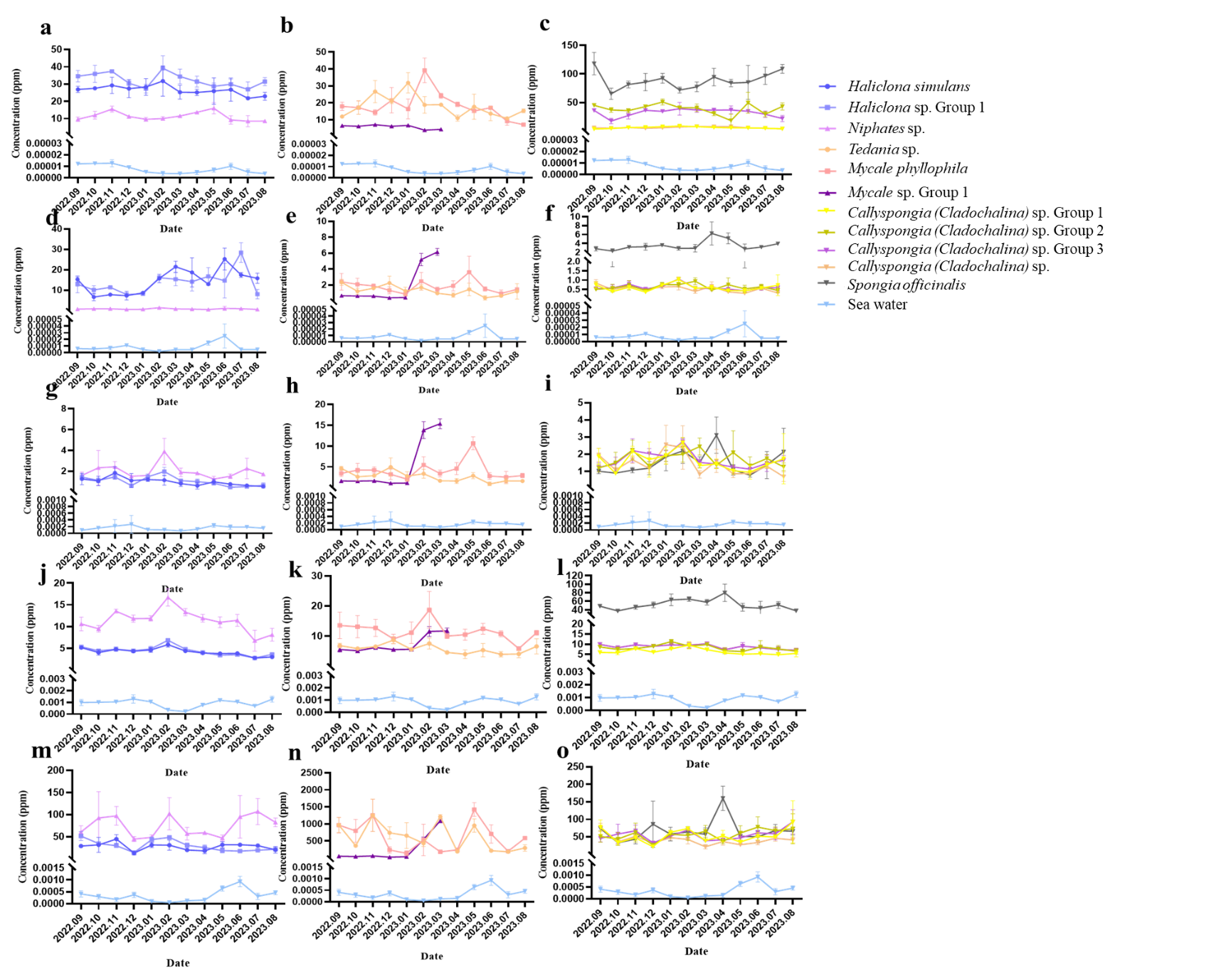 Appendix Figure 1 Changes of metal concentration in sponges
a-c: As; d-f: Co; g-i: Cr; j-l: Cu; m-o: Mn

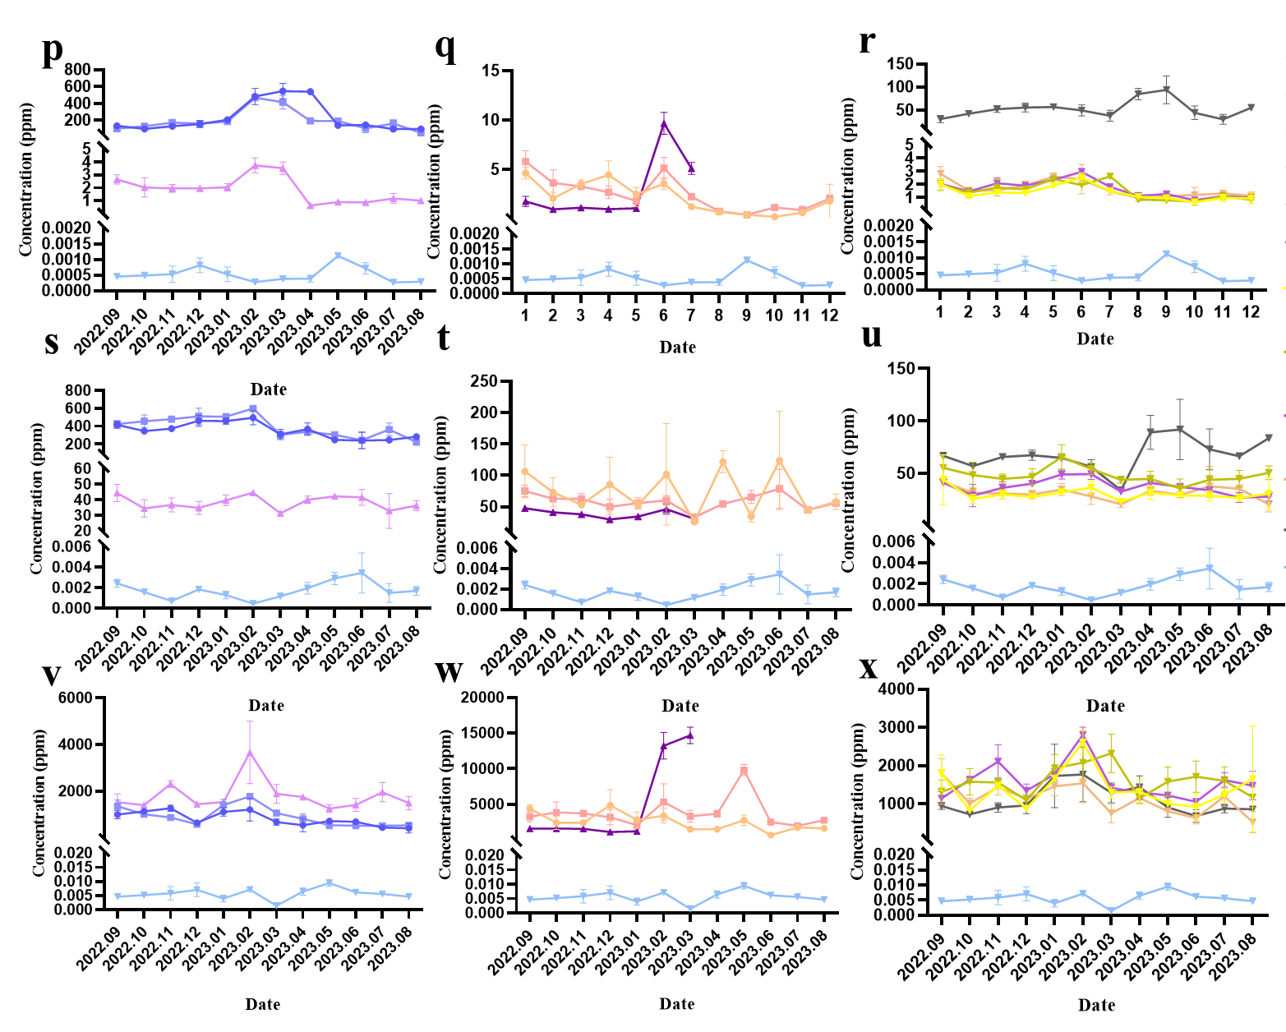
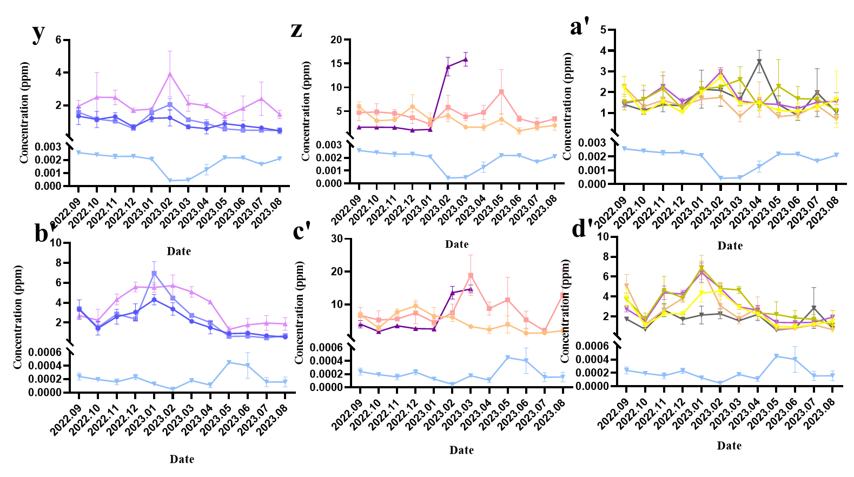
Appendix Figure 1 Changes of metal concentration in sponges (continued)
p-r: Ni; s-u: Zn; v-x: Fe; y-a' : V; b'-d' : Ba

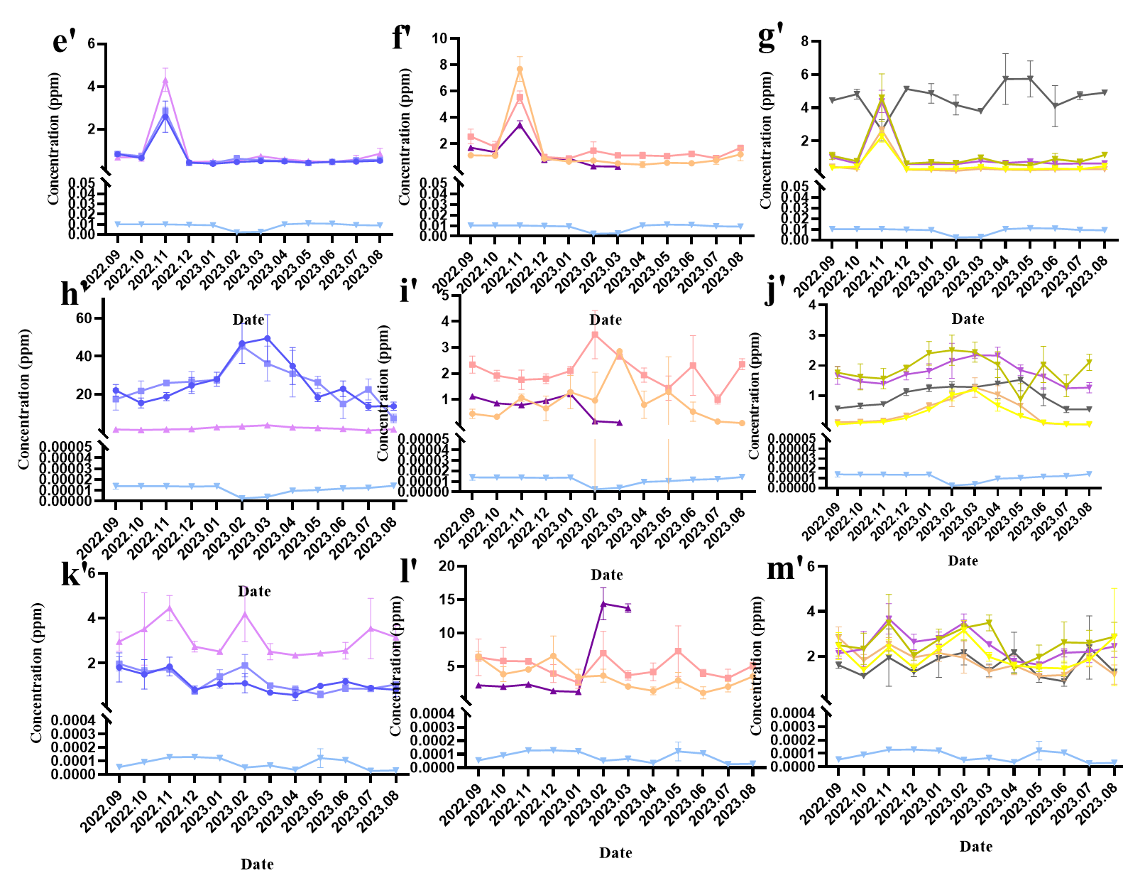
Appendix Figure 1 Changes of metal concentration in sponges (continued)
e'-g' : Mo; h'-j' : Cd; k'-m' : Pb

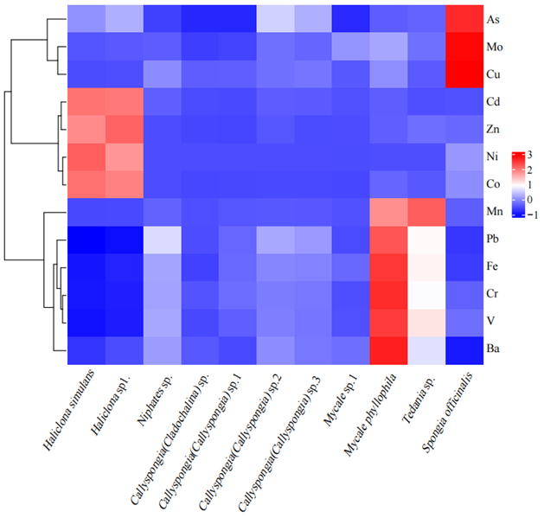
Appendix Figure 2 Heat map of heavy metal content in natural spongs (Haliclona sp. shows high enrichment correlation for Co, Ni, Zn and Cd；Mycale phyllophila shows high enrichment correlation for Ba; Spongia officinalis shows high enrichment correlation for As, Cu and Mo)

Appendix Table 2 The correlation between natural sponge and seasonal variation of heavy metal concentration in seawater
p-value | Haliclona simulans | Haliclona sp1. | Niphates sp. | Callyspongia  (Callyspongia) sp.1 | Callyspongia  (Callyspongia) sp.2 | Callyspongia  (Callyspongia) sp.3 | Callyspongia  (Cladochalina) sp. | Mycale sp.1 | Mycale phyllophila | Tedania sp. | Spongia officinalis
As | 0.31 | 0.37 | 0.40 | 0.06 | 0.76 | 0.32 | 0.31 | 0.94 | 0.87 | 0.86 | 0.81
Co | 0.31 | 0.97 | 0.97 | 0.05 | 0.54 | 0.07 | 0.07 | 0.47 | 0.64 | 0.45 | 0.93
Cr | 0.63 | 0.04* | 0.39 | 0.45 | 0.71 | 1.00 | 0.20 | 0.70 | 0.35 | 0.56 | 0.16
Cu | 0.31 | 0.17 | 0.16 | 0.11 | 0.36 | 0.41 | 0.49 | 0.73 | 0.53 | 0.35 | 0.11
Mn | 0.88 | 0.07 | 0.92 | 0.84 | 0.22 | 0.75 | 0.71 | 0.78 | 0.046* | 0.52 | 0.48
Ni | 0.30 | 0.47 | 0.29 | 0.31 | 0.41 | 0.48 | 0.64 | 0.41 | 0.30 | 0.76 | 0.07
Zn | 0.08 | 0.04 | 0.32 | 0.88 | 0.23 | 0.52 | 0.17 | 0.49 | 0.07 | 0.31 | 0.07
Fe | 0.16 | 0.21 | 0.52 | 0.81 | 0.20 | 0.73 | 0.08 | 0.63 | 0.55 | 0.62 | 0.43
V | 0.56 | 0.25 | 0.05 | 0.21 | 0.12 | 0.15 | 0.80 | 0.21 | 0.92 | 0.32 | 0.10
Ba | 0.19 | 0.11 | 0.04* | 0.06 | 0.22 | 0.07 | 0.23 | 0.66 | 0.81 | 0.60 | 0.02*
Mo | 0.61 | 0.79 | 0.64 | 0.58 | 0.73 | 0.87 | 0.42 | 0.29 | 0.89 | 0.53 | 0.06
Cd | 0.0003** | 0.002** | 0.002* | 0.0001** | 0.20 | 0.005** | 0.002** | 0.86 | 0.04* | 0.30 | 0.04*
Pb | 0.33 | 0.78 | 0.83 | 0.25 | 0.88 | 0.46 | 0.86 | 0.43 | 0.98 | 0.40 | 0.15
** indicates a highly significant correlation at the two-tailed 0.01 level;
* indicates a significant correlation at the two-tailed 0.05 level.

Appendix Table 3 Physical properties of sponges
Species | Density | Porosity | Moisture content | Organic matter | Inorganic matter
Species | (kg/m³) | (%) | (%) | (%) | (%)
Haliclona simulans | 107.8±0.6 | 92.4±2.1 | 90.6 | 68.3±1.7 | 31.7±1.7
Haliclona sp1. | 101.0±5.3 | 93.3±0.9 | 87.4±0.3 | 58.4±0.8 | 41.6±0.8
Niphates sp. | 57.9±0.8 | 95.6±3.7 | 89±0.7 | 51.9±2.6 | 48.1±2.6
Callyspongia(Cladochalina) sp. | 76.6±0.2 | 95.8±1 | 87.6±1.8 | 48.6±2.7 | 51.4±2.7
Callyspongia(Callyspongia) sp.1 | 79.0±0.1 | 92.9±0.5 | 88.4±1.2 | 57.6±0.9 | 42.4±0.9
Callyspongia(Callyspongia) sp.2 | 97.1±0.1 | 94.7±1.7 | 87.5±0.2 | 57.2±4 | 42.8±4
Callyspongia(Callyspongia) sp.3 | 88.3±0.2 | 92.8±1.1 | 87.4±0.6 | 56.8±2.6 | 43.2±2.6
Mycale sp.1 | 83.1±0.4 | 93.4±0.9 | 87.4±1.1 | 54.5±2.1 | 56.1±0.8
Mycale phyllophila | 130.5±1.1 | 76.7±7.1 | 90.1±0.9 | 63.2±1.3 | 37.3±1.4
Tedania sp. | 112.4±0.1 | 90.6±0.7 | 91.6±1.2 | 68.7±0.9 | 31.3±0.9
Spongia officinalis | 113.4±0.3 | 84.7±1.3 | 87.3±2.5 | 53.8±1.7 | 46.2±1.7

Appendix Table 4 Porosity of spongy biomimetic materials
 | Polyurethane | Polyether | Melamine | Polyester | Nylon | 30 kg/m³ polyurethane | 50 kg/m³ polyurethane | 90 kg/m³ polyurethane | 130 kg/m³ polyurethane
Porosity（%） | 95.7±1 | 97.2±0.5 | 99.2±0.5 | 91.9±2.8 | 93.6±1.2 | 96.7±0.8 | 92.5±0.6 | 90.6±0.5 | 86.8±2

Supplementary 2.2 Natural Sponges Sampling and Pre-Processing Details
Instrument specifications: Vacuum freeze dryer (LGJ-10D-50, GIPP, China); homogenization performed with a corundum ceramic mortar and pestle (to avoid metal contamination);
Pre-processing parameters: Freeze-drying duration (≥48 h); 0.1 g dry weight per replicate (3 replicates per species) placed in 15 mL polypropylene centrifuge tubes; digestion reagent (65% analytically ultrapure HNO₃, 1 mL per tube) with cold digestion (25°C, 12 h) followed by thermal digestion (80°C, 12 h);

Supplementary 2.4 Seawater Collection and Pre-Processing Details
Filtration and storage: 0.45 μm hydrophilic acetate fiber membrane; acidification with concentrated distilled HNO₃ (GR grade) to pH 2; high-density polyethylene bottles (500 mL, pre-rinsed with 10% HNO₃ and ultrapure water);
Solid-phase extraction: Cation exchange resin (732 type, 0.3–1.25 mm particle size); ammonium acetate solution (1 mol/L) used to adjust pH to 5; trichloromethane (AR grade, 0.5 mL per 100 mL seawater) for active silicate preservation; chloroform (AR grade, 0.2 mL per 50 mL seawater) for ammonium salt preservation.

Supplementary 2.8 The instrument's operating parameters
The instrument's operating parameters were as follows: radio frequency power set to 1600 W; plasma gas flow rate of 15 L/min; auxiliary gas flow rate of 1.2 L/min; nebulizing gas flow rate of 0.7 L/min; compensating gas flow rate of 0.5 L/min; and the temperature of the nebulizing chamber maintained at 2°C.

