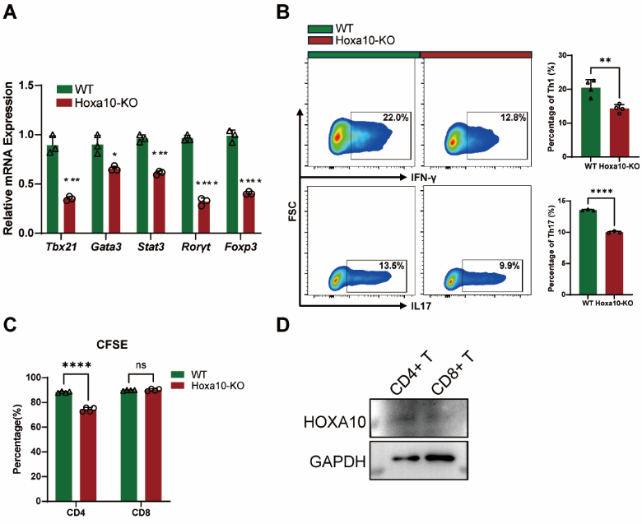
Supplementary Data Fig.1 Hoxa10 deficiency does not significantly alter the polarization of CD4⁺ T cells and activation of CD8⁺ T cells. A) qPCR analysis of transcription factor mRNA levels in CD4⁺ T cells 72 hours after activation. B) Proportions of IFN-γ and IL-17A expressing cells in Th1 and Th17 polarization conditions, respectively, analyzed by flow cytometry. C) Proliferation of CD4⁺ and CD8⁺ T cells assessed by CFSE dilution. D) Western blot analysis of Hoxa10 protein levels in unstimulated CD4⁺ and CD8⁺ T cells.

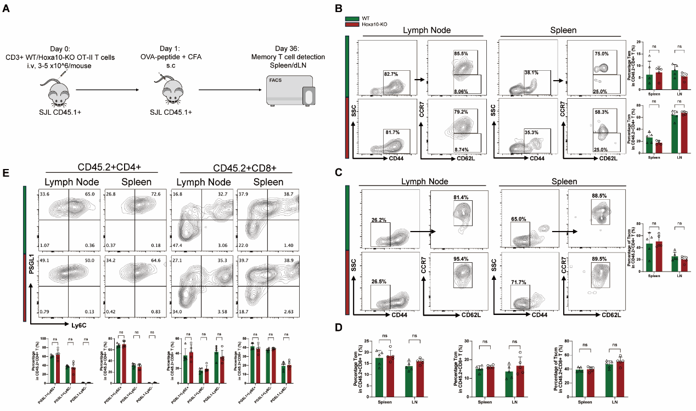
Supplementary Data Fig.2 Hoxa10 deficiency has no effect on the formation of memory T cells. A) Schematic diagram of the in vivo memory T cell induction model. CD45.2⁺CD3⁺ T cells were isolated from WT and Hoxa10-KO OTII mice and transferred in CD45.1⁺ SJL host mice on Day 0. After 24h, host mice were immunized with OVA peptide emulsified in CFA. After 35 days, spleen and dLN were collected for analyzation. B) CD45.2⁺ CD4⁺ effector (Tem) and central memory T cells (Tcm) and C) CD45.2⁺ CD4⁺ stem cell-like memory T cells (Tscm) in spleen and dLN were detected by Flow cytometry on Day 36. D) The proportions of CD45.2⁺ CD8⁺ memory T cells in spleen and dLN were detected by FACS on Day 36. E) Flow cytometry analysis of the expression of PSGL1 and Ly6C in CD45.2⁺ T cells from spleen and dLN on Day 36. Data are presented as mean ± SD, with n = 5 per group.

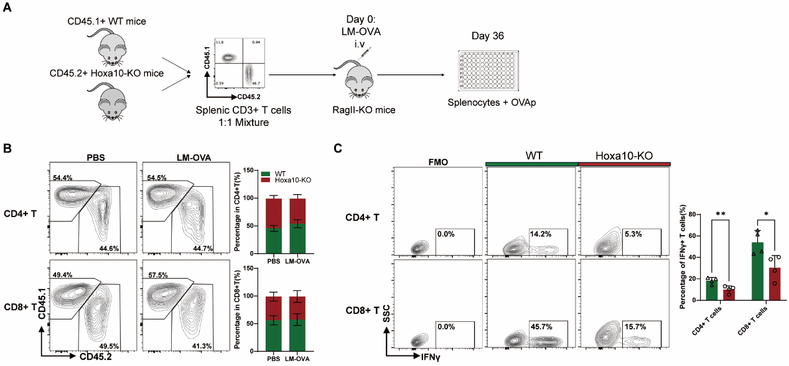
Supplementary Data Fig.3 Hoxa10 promotes memory T cell activation in Listeria monocytogenes infection model. A) Schematic diagram of Listeria monocytogenes infection model. Splenic T cells from CD45.1⁺ WT and CD45.2⁺ Hoxa10-KO donor mice were isolated and mixed at a 1:1 ratio by cell number. 3-5 x 10^6 mixed T cells were injected into Rag2-KO host mice followed by LM-OVA infection. After 36 days, splenocytes were stimulated with OVA peptide for 24h. The FACS figure showed the percentage of CD45.1⁺ and CD45.2⁺ T cells in the mixture prior to injection. B) Proportions of CD45.1⁺ and CD45.2⁺ T cells in spleen 36 days after LM infection, analyzed by flow cytometry. C) Proportions of IFN-γ-expressing T cells in splenocytes after OVA restimulation. Data are presented as mean ± SD, with n = 4 per group.

