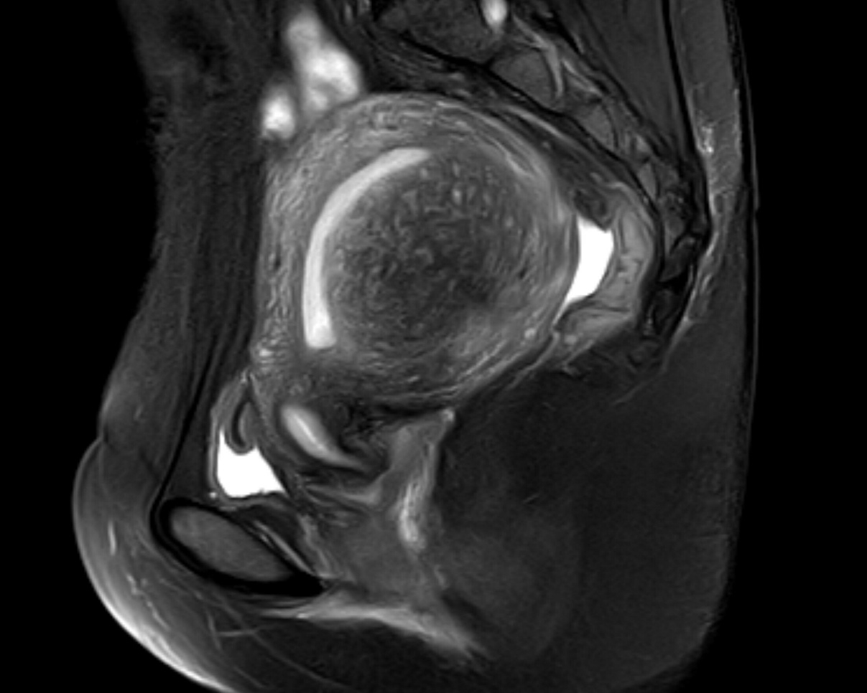

Supplementary Fig.1 Focal adenomyosis
Sagittal T2-weighed image; focal asymmetric thickening of the junctional zone forming an ill-defined area of low signal intensity.

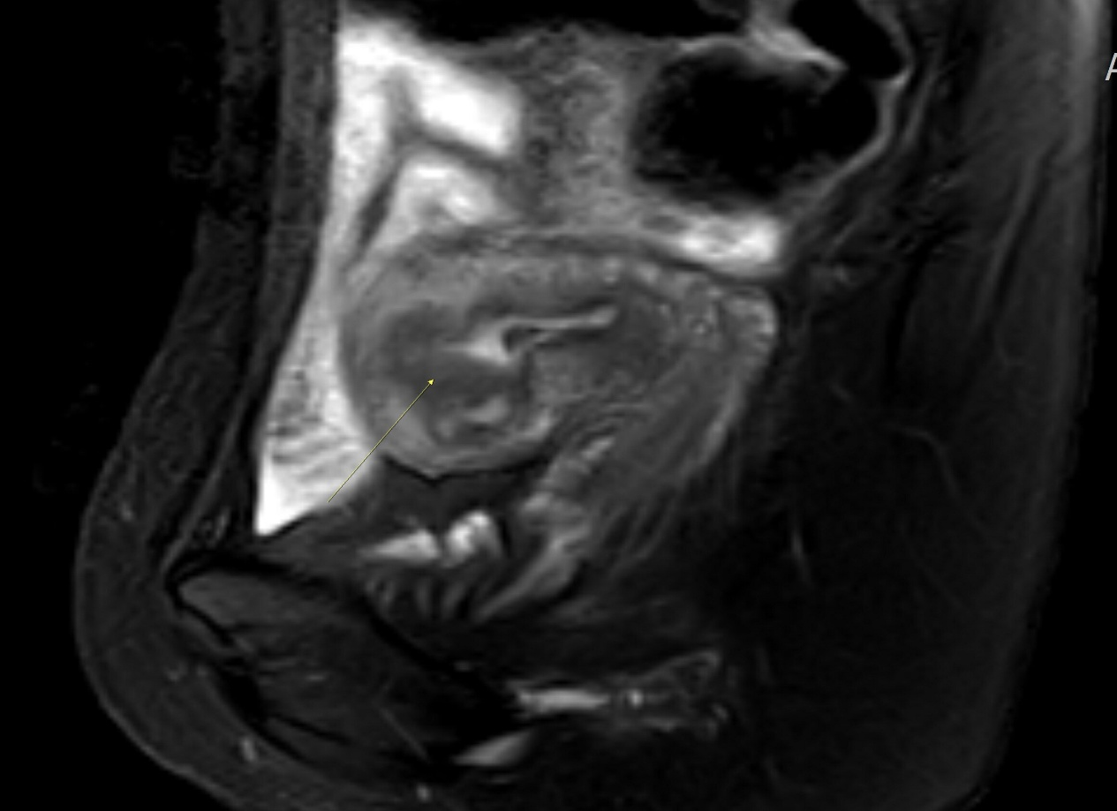
Supplementary Fig.2 Abnormal JZ
Sagittal T2-weighted images; thickened junctional zone with striated high-signal intensity areas radiating from the endometrium toward the myometrium (yellow arrow).

