Supplementary Material

Low-intensity wildfire in old-growth Douglas fir and western hemlock forest consumed deep duff, thinned from below, and created challenges for fire management – a case study from the west slopes of the Cascades

Matthew B. Dickinson, USFS, Northern Research Station, 359 Main Road, Delaware, OH 43015¹
Joseph D. Birch, University of Idaho, 875 Perimeter Drive, Moscow, ID 83844
Jacob J. Bukoski, Oregon State University, 3100 SW Jefferson Way, Corvallis, OR 97333
Ramona J. Butz, USFS, Pacific Southwest Region, 1330 Bayshore Way, Eureka, CA 95501
Elena Cox, University of Nevada Reno, 1664 N Virginia Street, Reno, NV 89557
Lanny Flaherty, USFS, Wallowa-Whitman National Forest, 3502 Highway 30, La Grande, OR 97850
Erin Hanan, University of Nevada Reno, 1664 N Virginia Street, Reno, NV 89557
Jessica Miesel, University of Idaho, 875 Perimeter Drive, Moscow, ID 83844
Benjamin E. Nash, USFS, Pacific Northwest Research Station, HJ Andrews Experimental Forest, 91991 Blue River Reservoir Road, Blue River, OR 97413
Georgia S. Seyfried, Oregon State University, 3100 SW Jefferson Way, Corvallis, OR 97333
Marissa Vossmer. BLM, Arcata Field Office, 1695 Heindon Road, Arcata, CA 95521
Yuzhe Wang, Fujian Agriculture and Forestry University, Fuzhou 350002, China
Reed Williams, BurnBot, 310 Shaw Road, South San Francisco, CA 94080

Table S1. Fire weather conditions at the time the Lookout Fire first entered plots. Fuel moisture was obtained from the Trout Creek Remote Access Weather Station (RAWS), the most representative RAWS in proximity (20 miles from plots) and elevation (700 m). Air temperature (at 1.5 m), relative humidity (RH), and wind speed data are from the H. J. Andrews Watershed 7 Meteorological Station (WS7MET), which is at an elevation of 3274 feet and near FBAT plots. Plot wind was taken with an anemometer affixed to the plot camera at 1.5 m above ground. Days since rain is assessed from 4 September, the last day with measured rain before plots burned at the Trout Creek and McKenzie Bridge RAWS. We choose to use days since measured rain instead of days since wetting rain (e.g., 0.1 inch) because of our expectation that it would best signal the start of a drying trend.
Plot | Temp (°C)¹ | RH¹ | Fuel moisture (%)² |  | Wind (kph)¹ |  | Plot wind (kph) |  | Days since rain¹
Plot | Temp (°C)¹ | RH¹ | 10 hr | 1000 hr | 20 min Avg | Peak | 20 min Avg | Peak | Days since rain¹
1 | 17 | 45 | 16 | 15 | 2.4 | 16.9 | 0.0 | 0.0 | 15
2 | 26 | 27 | 9 | 16 | 1.6 | 5.5 | 1.9 | 6.4 | 12
3 | 18 | 41 | 17 | 16 | 0.8 | 2.9 | 1.3 | 4.8 | 14
4 | 19 | 42 | 17 | 16 | 0.8 | 2.9 | 0.0 | 0.0 | 14
5 | 28 | 21 | 14 | 18 | 0.5 | 3.5 | 4.0 | 9.7 | 10
11 | 15 | 77 | 14 | 18 | 0.0 | 0.6 | 0.0 | 0.0 | 10
12 | 19 | 54 | 9 | 16 | 0.3 | 2.1 | 2.7 | 6.4 | 12
Avg | 20.3 | 43.8 | 13.7 | 16.4 | 0.9 | 4.9 | 1.4 | 3.9 | 12.4
SD | 4.9 | 18.3 | 3.5 | 1.1 | 0.8 | 5.5 | 1.6 | 3.9 | 2.0
¹Meteorological data from benchmark stations at the HJ Andrews Experimental Forest, 1967 to present (https://andlter.forestry.oregonstate.edu/data/abstract.aspx?dbcode=MS001)
²10 and 1000 hr fuels refer to the drying timelag of particles of a diameter between 0.6-2.5 and 7.5-20 cm, respectively.

Table S2. Fire behavior on FBAT plots on the Lookout Fire. Flame length (FL) and flame angle (FA) were estimated from video where available. Rate of spread estimated from both video and fire arrival sensors are reported where available. Fire arrival is the time the fire was first detected at the plot. Departure time is the last time a fire arrived at a sensor. Intensity is a measure of flame-front heat release rate and is the product of heat of combustion (constant) and measured spread rate and surface fuel consumption (Byram 1959). Spread rate from sensors is for a nominal plot size of 30 m. Surface fires typically range up to 2000 kW/m and these fires were on the very low end of that range because of low spread rates. Transit time is the difference between first and last fire arrival time where at least three times were collected. Videos of fire spread on plots can be found at Dickinson et al. (2024).

Plot | Fire type | FL (cm) | FA (%) | ROS (m hr⁻¹) |  | Intensity (kW m⁻¹) | Fire detection date & time (PDT) |  | Transit time (hr)
 |  |  |  | Video | Sensors |  | First | Last | Transit time (hr)
1 | Backing downslope | N/A | N/A | N/A | N/A | N/A | 9/19 13:19 | N/A¹ | N/A
2 | Backing downslope | 15 | 75 | 2.0 | 0.2 | 2.2 | 9/16 15:02 | 9/20 00:57 | 82
3 | Backing downslope | 30 | 65 | 24.1 | 1.0 | 18.2 | 9/18 21:14 | 9/19 2:53 | 6
4 | N/A² | N/A | N/A | N/A | 2.4 | 35.5 | 9/18 21:11 | 9/19 0:27 | 3
5 | Backing downslope against wind, short-range spotting | 91 | 25 | 26.4 | 4.6 | 61.4 | 9/14 16:55 | 9/14 18:21 | 1.5
11 | Spreading upslope against down-slope winds | 30 | 60 | 2.0 | 0.4 | 11.2 | 9/14 0:53 | 9/15 21:34 | 44
12 | Backing downslope against wind | 18 | 45 | 2.0 | 0.40 | 5.7 | 9/16 21:32 | 9/19 12:41 | 63
Avg | N/A | 37 | 54 | 11 | 1.6 | 22 | NA | NA | 33
SD | N/A | 31 | 19 | 13 | 1.2 | 22 | NA | NA | 35
¹ Less than three fire arrival times obtained because of patchy spread.
² Camera failed on Plot 4. We infer from other information that fire backed downslope through the plot.

Table S3. Direct (immediate) fire effects on pole (2.5 to <15.2 cm DBH) and canopy trees (>15.2 cm DBH). Minimum and maximum bole char heights and the percentage of the pre-fire live canopy affected by the fire and the percentage charred or consumed are reported. Plot 5 experienced the most extensive vertical spread up tree boles and the highest intensities.
Tree Diameter Class | Plot | Bole Char (m) |  | Crown Effects (%)¹
Tree Diameter Class | Plot |  |  | Total affected |  |  | Torch
Tree Diameter Class | Plot | Avg min | Avg max | Avg | Min | Max | Avg | Min | Max
Poles | 1 | 0.2 | 1.0 | 56 | 5 | 100 | 3 | 0 | 10
Poles | 2 | 0.1 | 0.1 | 4 | 0 | 20 | 0 | 0 | 0
Poles | 3 | 0.2 | 1.7 | 48 | 0 | 100 | 2 | 0 | 15
Poles | 4 | 0.7 | 1.0 | 17 | 20 | 80 | 17 | 0 | 60
Poles | 5 | 0.2 | 3.4 | 100 | 100 | 100 | 0 | 0 | 0
Poles | 11 | 0.2 | 0.8 | 74 | 0 | 100 | 1 | 0 | 10
Poles | 12 | 0.1 | 0.3 | 0 | 0 | 0 | 0 | 0 | 0
Poles | Avg | 0.2 | 1.2 | 43 | 18 | 71 | 3 | 0 | 14
Poles | SD | 0.2 | 1.1 | 38 | 37 | 43 | 6 | 0 | 21
Canopy | 1 | 0.3 | 6.3 | 1 | 0 | 5 | 0 | 0 | 0
Canopy | 2 | 0.4 | 2.3 | 9 | 0 | 25 | 0 | 0 | 1
Canopy | 3 | 0.4 | 4.1 | 0 | 0 | 0 | 0 | 0 | 0
Canopy | 4 | 1.5 | 6.3 | 9 | 0 | 100 | 17 | 0 | 100
Canopy | 5 | 1.8 | 15.1 | 45 | 0 | 100 | 0 | 0 | 0
Canopy | 11 | 0.1 | 0.6 | 25 | 0 | 45 | 0 | 0 | 0
Canopy | 12 | 0.3 | 1.2 | 0 | 0 | 0 | 0 | 0 | 0
Canopy | Avg | 0.7 | 5.1 | 12.6 | 0 | 39 | 2 | 0 | 14
Canopy | SD | 0.7 | 5.0 | 17 | 0 | 44 | 6 | 0 | 38
¹Total affected is the sum of injured (“scorched”) and consumed or charred (“torched”) foliage.
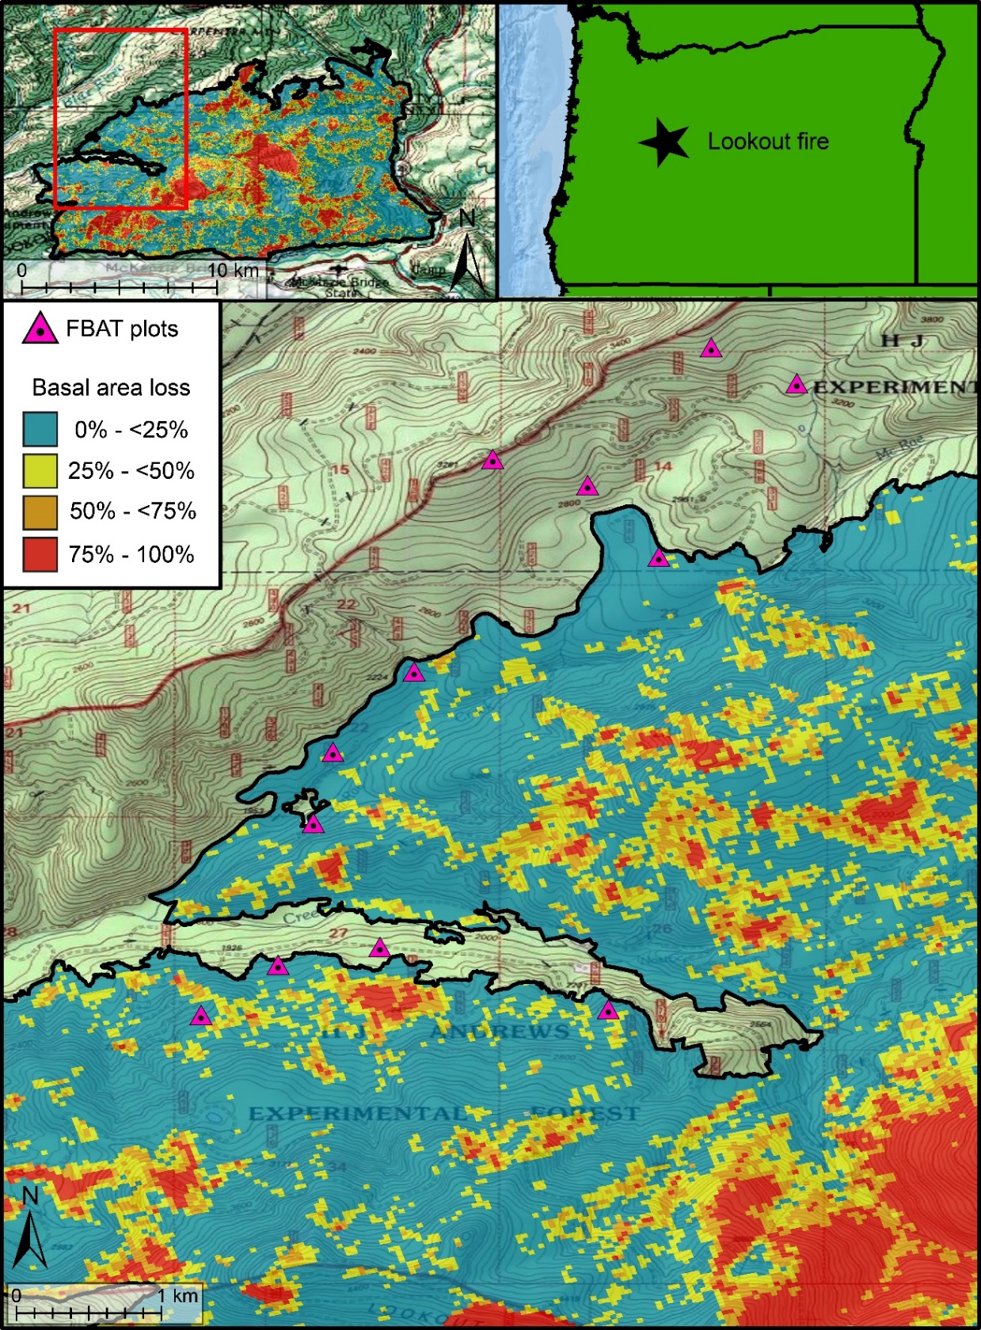
Figure S1. Rapid Assessment of Vegetation Condition after Wildfire (RAVG) map of expected basal area loss for the 2023 Lookout Fire in west central Oregon. The area shown in detail is the NW side of the 2023 Lookout Fire where monitoring plots were installed. Pre- (19 October 2022) and post-fire Sentinel images (19 October 2023) were differenced to characterize severity. Seven of a total of 12 plots burned (those shown within the final fire perimeter).

References
Byram GM. 1959. Combustion of forest fuels. In: KP Davis (Ed). Forest fire: control and use. New York: McGraw-Hill.
Dickinson, Matthew. B.; Ewell, Carol M.; Dailey, Scott N.; Pasquale, Richard; Birch Joseph D.; Hanan, Erin J.; Knapp, Eric E.; Miesel, Jessica R. 2024. Fire Behavior Assessment Team: in-fire videos from 2020 to 2023. Fort Collins, CO: Forest Service Research Data Archive. https://doi.org/10.2737/RDS-2024-0032.

