Supplementary Information
Overcharge for Reviving Failed Li-O₂ Batteries
Kai Chen,^{1,2} Dong-Yue Yang,^{1,2} Jin Wang,¹ Gang Huang,¹ Xin-Bo Zhang^{1,2,}*
¹State Key Laboratory of Rare Earth Resource Utilization, Changchun Institute of Applied Chemistry, Chinese Academy of Sciences, Changchun 130022, China
²University of Science and Technology of China, Hefei 230026, China

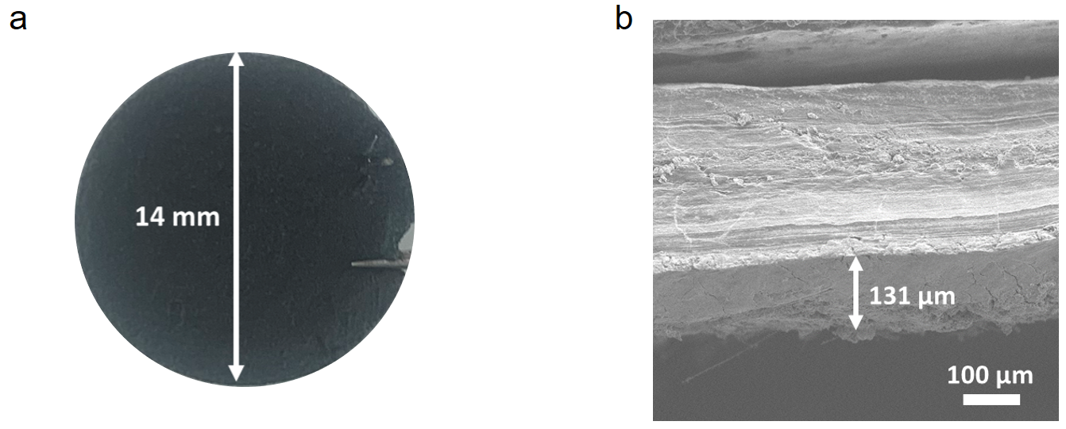
Supplementary Figure 1. (a) Optical picture and (b) cross-section image of the Li anode after initial battery failure.
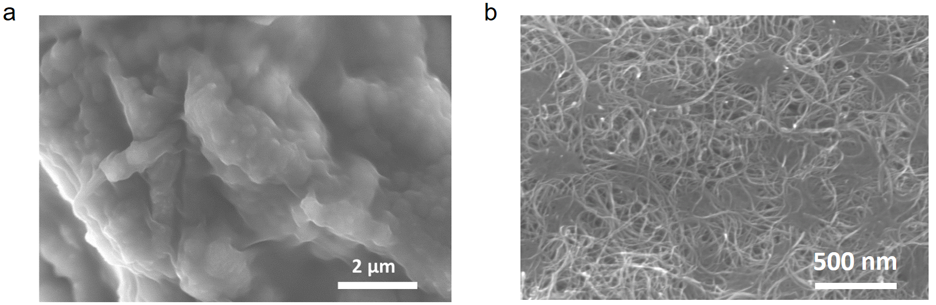
Supplementary Figure 2. SEM images of (a) CNT cathode disassembled from the failed Li-O₂ battery and (b) pristine CNT cathode.

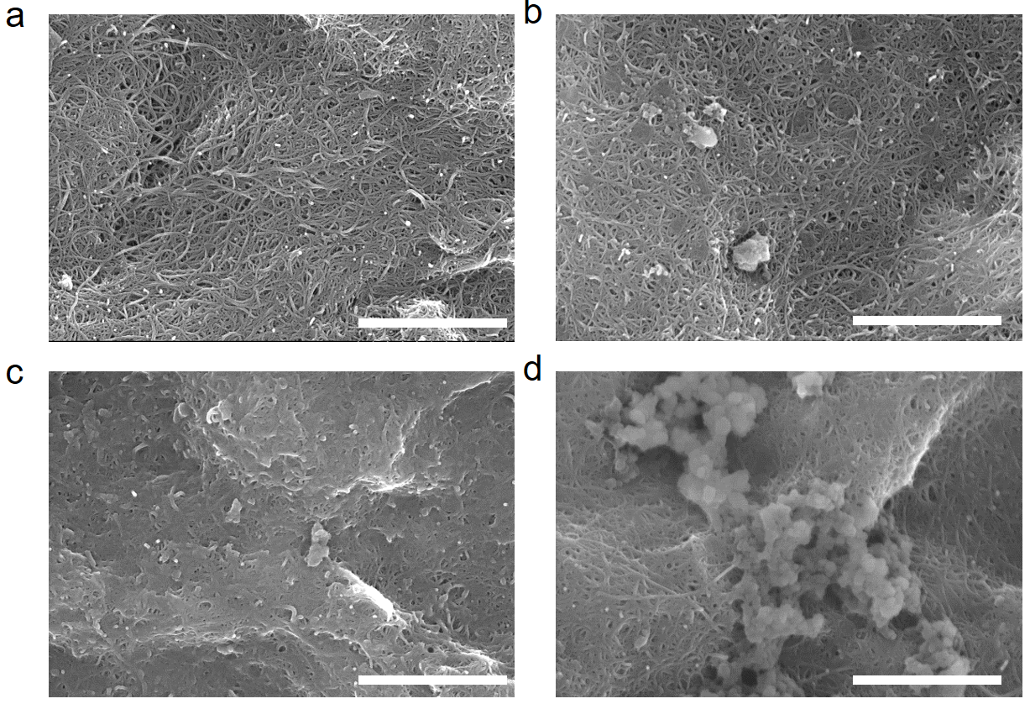
Supplementary Figure 3. The morphologies of cathodes after discharge and charge at a fixed capacity of (a) 0.1, (b) 0.2, (c) 0.4, and (d) 0.8 mAh. Scale bar: 2 µm.

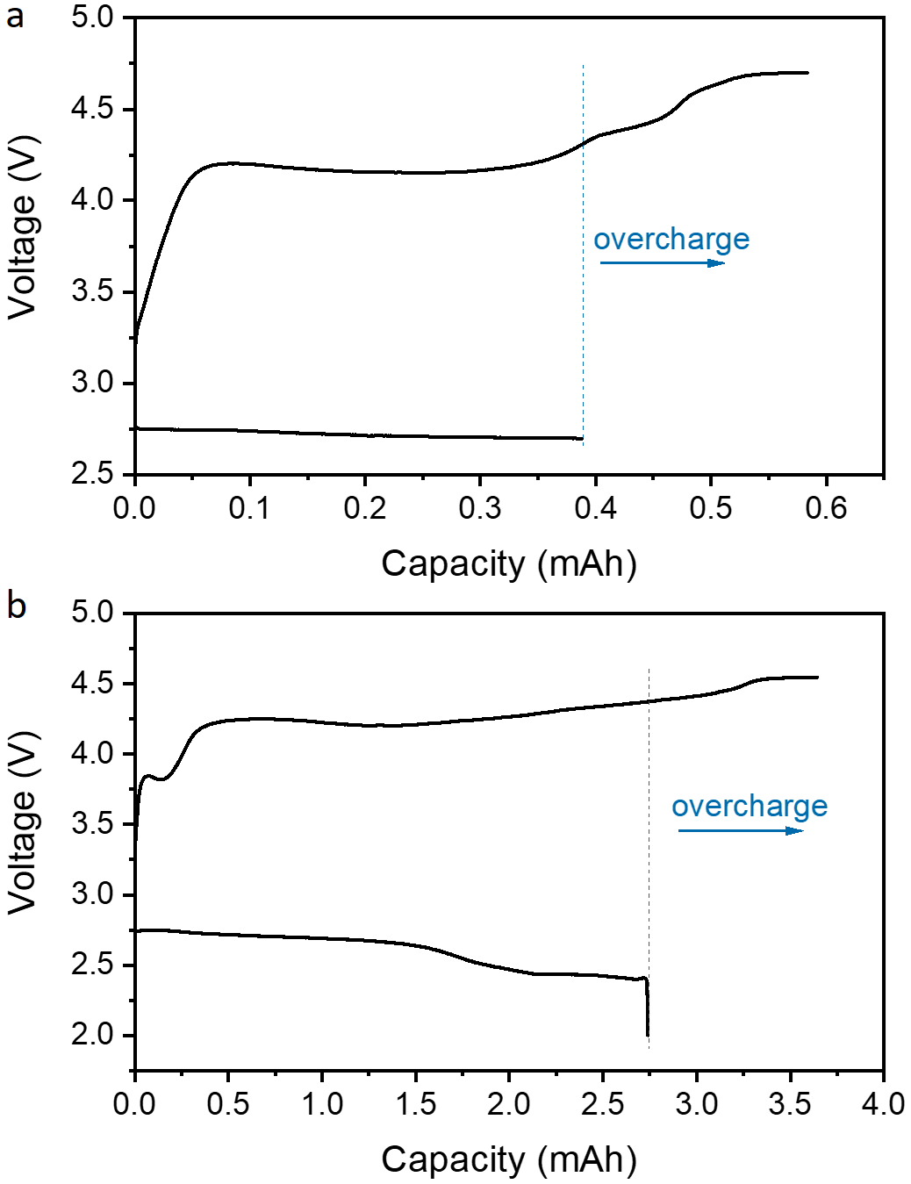
Supplementary Figure 4. Overcharge curves after (a) light discharge and (b) deep discharge of Li-O₂ batteries at 50 µA.

Supplementary Figure 5. FTIR spectra of cathodes after 10th discharge, 10th charge, 50th discharge, and 50th charge.

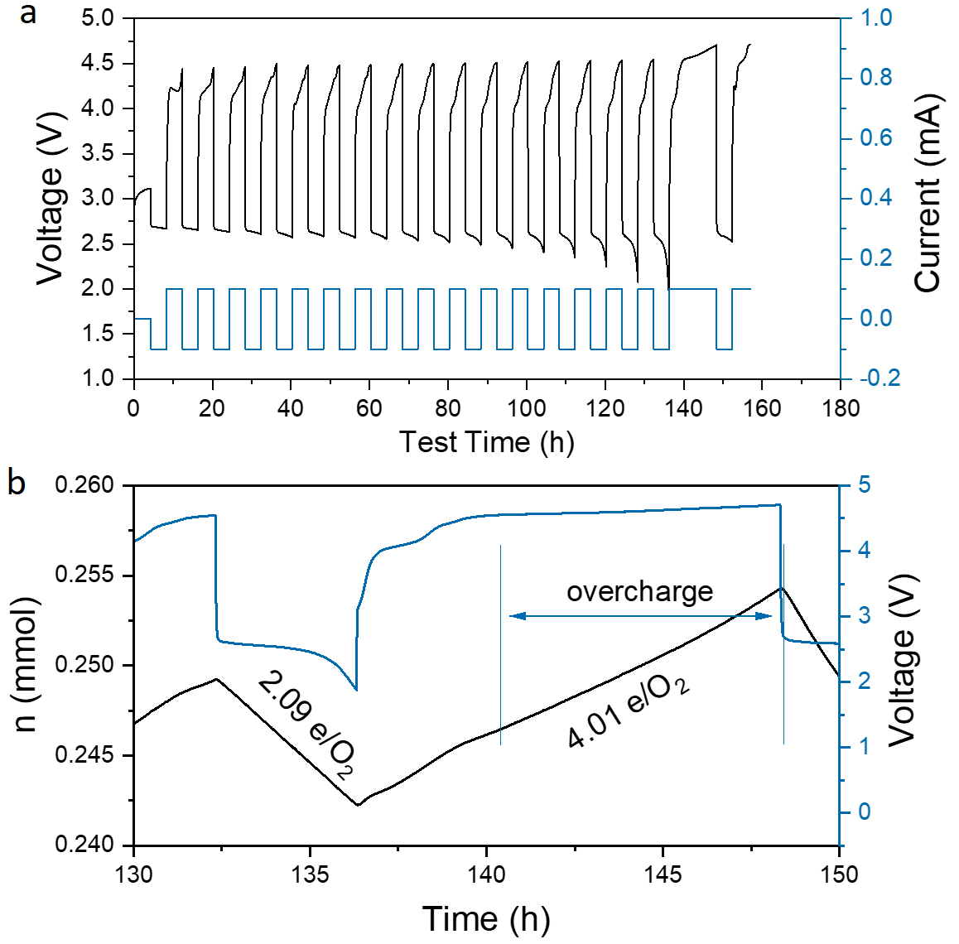
Supplementary Figure 6. (a) Overcharge of Li-O₂ battery after cycling at 0.1 mA and a fixed capacity of 0.4 mAh. (b) Pressure test of the Li-O₂ battery during overcharge.

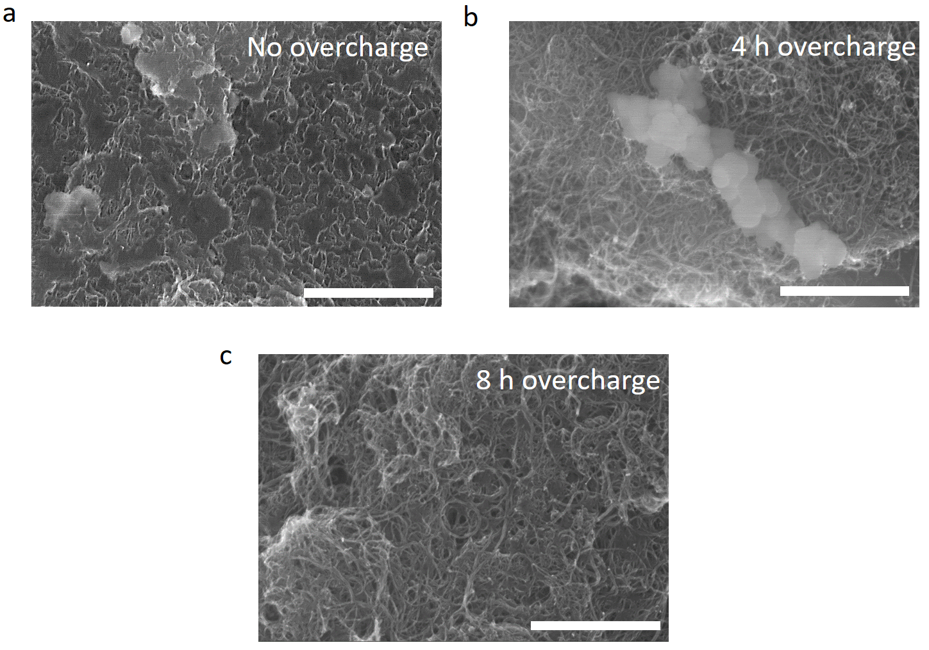
Supplementary Figure 7. SEM images of cathodes after cycling of Li-O₂ battery for 15 cycles without overcharge (a) and overcharged for 4 h (b) and 8 h (c). Scale bar: 2 µm

Supplementary Figure 8. Electrochemical impedance spectroscopy (EIS) of Li-O₂ batteries after discharge 15 cycles, then charge 2 h, 4 h, 8 h.

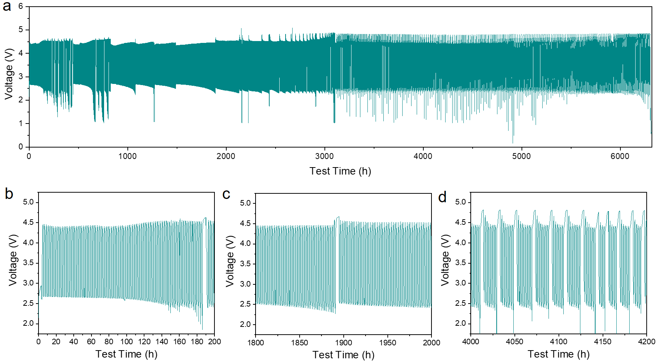
Supplementary Figure 9. (a) Cycling performance of a Li-O₂/CO₂ battery revived with overcharge (2714 cycles). (b-d) The enlargements of the profile in (a). The current density is 500 mA/g and the capacity limitation is 500 mAh/g.

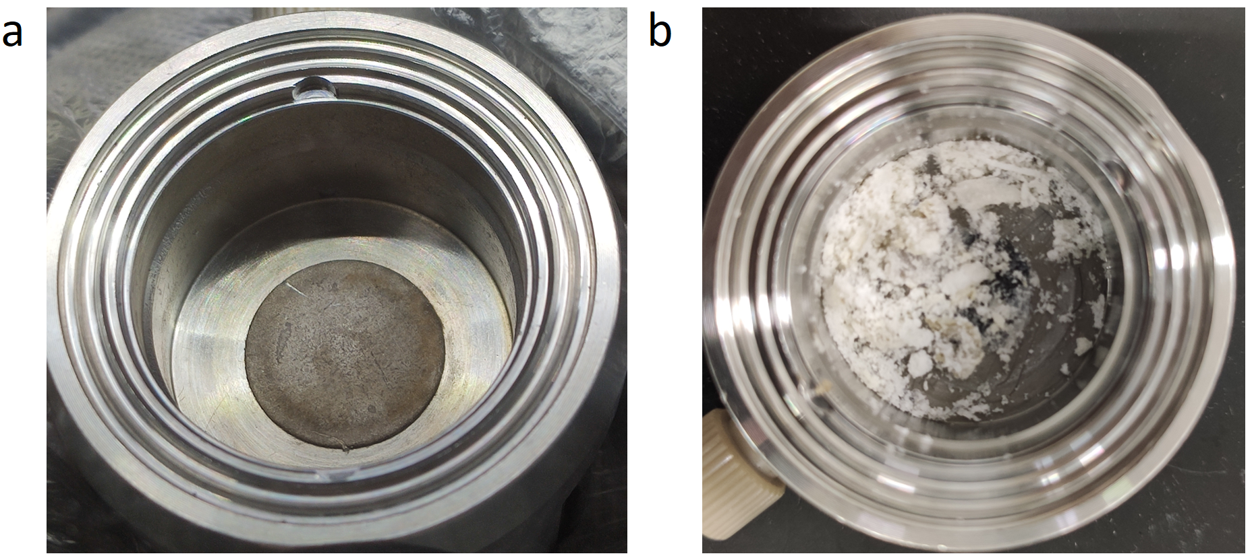
Supplementary Figure 10. Li anodes after cycling in Li-O₂/CO₂ battery for 626 cycles (a) and after battery failure (b).

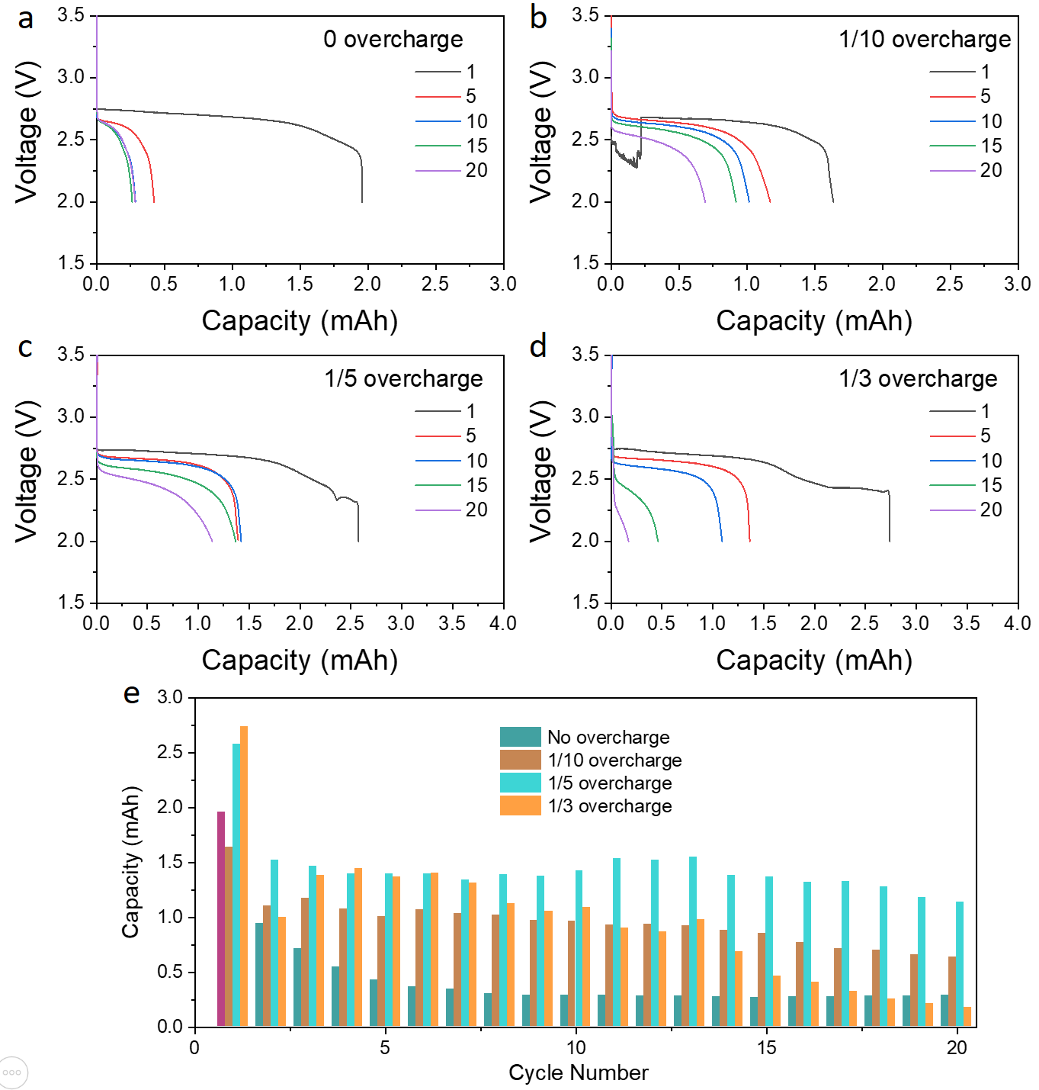
Supplementary Figure 11. (a-d) Discharge curves and (e) discharge capacities of Li-O₂ batteries in the first 20 cycles with different overcharge ratios. The current density is 200 mA/g.

Supplementary Figure 12. Cycling performance of a Li-O₂ battery at 200 mA/g and 2000 mAh/g with 50 mM LiI in the electrolyte. Overcharge capacity is 6000 mAh/g at 200 mA/g.
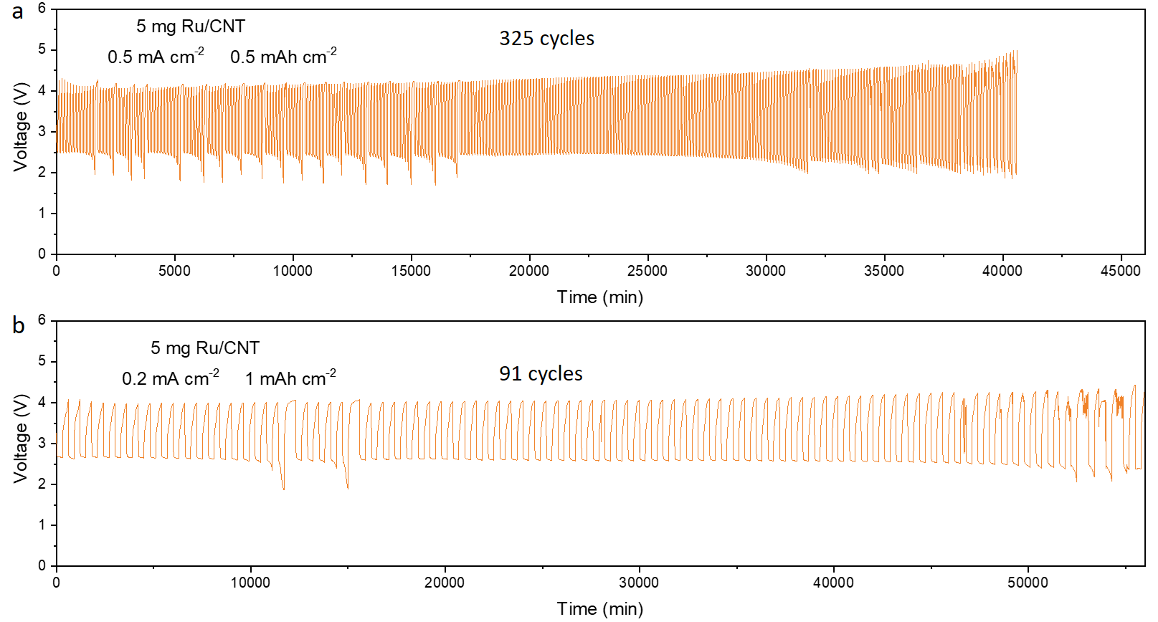
Supplementary Figure 13. Cycling performance of Li-O₂ batteries with 5 mg cm⁻² Ru/CNT cathodes.
Supplementary Figure 14. Cycling performance of a Li-O₂ battery with super P cathode (0.4 mg) and a fixed capacity of 500 mAh g⁻¹ at 250 mA g⁻¹.

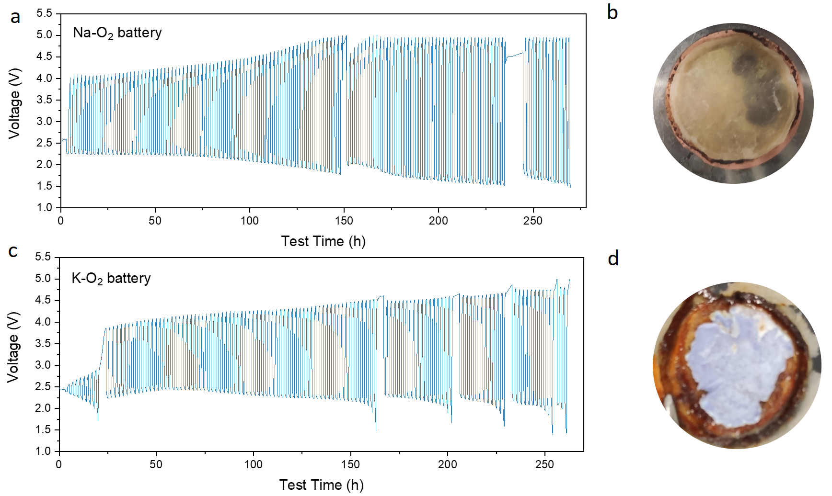
Supplementary Figure 15. Cycling performance of (a) a Na-O₂ battery and (c) a K-O₂ battery. The current density is 44.2 µA cm⁻² and the capacity limitation is 44.2 µA cm⁻². Optical pictures of the (b) front side of Na anode and (d) backside of K anode after cycling.

Supplementary Table 1. A comparison of performances of Li-O₂ batteries with a high cathode loading or current density. Note: X μL indicates the amount of electrolyte was not given by the authors.
Report | Electrolyte | Cathode mass loading | Current | Capacity | Cycle | Remark
1 | 100 mg molten salt + 1g LAGP | 0.2 g cm⁻² Ni composite cathode | 0.2 mA cm⁻² | 0.5 mAh cm⁻² | 150 | 150 °C
2 | 100 μL 50 mM TEMPO-COOH in 1 M LiTFSI/TEGDME | Bare P50 carbon paper | 0.1 mA cm⁻² | 0.2 mAh cm⁻² | 190 | Redox mediator (RM) in electrolyte
3 | 1M LiOTf + 0.5 M NaOTf/TEGDME | Bare H23I6 carbon paper | 0.05 mA cm⁻² | 0.5 mAh cm⁻² | 30 | Na⁺ as RM
4 | 20-μm-thick Ionic liquid-based gel polymer electrolyte | 3 mg cm⁻² Ketjen black | 0.25 mA cm⁻² | 2.5 mAh cm⁻² | 20
5 | 10 μL 1M LiOTf /TEGDME + P(VDF-HFP) polymer electrolyte | 1 mg cm⁻² CNT film | 0.4 mA cm⁻² | 1 mAh cm⁻² | 60
6 | 70 μL 1 M LiNO₃/DMAc | 5 mg cm⁻² glass carbon | 0.5 mA cm⁻² | 1 mAh cm⁻² | 120 | A seed layer on cathode
7 | X μL 1 M LiNO₃/DMA | 1.0 mg CNF/Pt−Au−Ru | 0.5 mA cm⁻² | 5 mAh cm⁻² | 6
8 | X μL 1 M LiNO₃/DMSO | 0.8 mg MoSe₂@CNT | 0.28 mA cm⁻² | 0.56 mAh cm⁻² | 100
9 | X μL 1.0 M LiTFSI/TEGDME | 1.5 mg NiCo₂O₄/graphene oxide aerogel | 0.1 mA cm⁻² | 0.25 mAh cm⁻² | 400 | A Li host is used.
10 | X μL 1.0 M LiTFSI/TEGDME | 0.4 mg cm⁻² NiCo₂O₄/CC | 0.2 mA cm⁻² | 0.3 mAh cm⁻² | 200
11 | 200 μL 1.0 M LiTFSI/TEGDME | 2 mg cm⁻² TiC | 0.1 mA cm⁻² | 0.5 mAh cm⁻² | 100
12 | X μL LiTFSI (0.5 M), LiNO₃ (0.5 M), and LiI (0.05 M) dissolved in TEGDME | 0.4 mg cm⁻² MoC–Mo₂C/NCNTs | 0.123 mA cm⁻² | 0.2 mAh cm⁻² | 164
13 | X μL 1.0 M LiTFSI/TEGDME | 0.8 mg cm⁻² N-MoS₂ | 0.08 mA cm⁻² | 0.4 mAh cm⁻² | 224
14 | X μL 1.0 M LiTFSI/TEGDME | 0.5 mg cm⁻² Co@NC/PPC800 | 0.1 mA cm⁻² | 0.5 mAh cm⁻² | 136
15 | X μL 1.0 M LiTFSI/TEGDME | 0.56 mg cm⁻² CoPt/AFC | 0.05 mA cm⁻² | 0.2 mAh cm⁻² | 156
16 | 180 μL 1.0 M LiTFSI/TEGDME | 0.6 mg cm⁻² Co-SAs/N-C | 0.24 mA cm⁻² | 0.6 mAh cm⁻² | 260
17 | X μL 1.0 M LiTFSI/TEGDME | 1.0 mg cm⁻² CNT@MoS₂ | 0.5 mA cm⁻² | 0.5 mAh cm⁻² | 190
This work | 130 μL 1 M LiFSI/TEGDME | 5 mg cm⁻² Ru/CNT | 0.5 mA cm⁻² | 0.5 mAh cm⁻² | 325 | Without RM or host
This work | 130 μL 1 M LiFSI/TEGDME | 5 mg cm⁻² Ru/CNT | 1 mA cm⁻² | 0.2 mAh cm⁻² | 900 | Without RM or host
SUPPLEMENTARY REFERENCES
1. Xia, C., Kwok, C.Y., and Nazar, L.F. (2018). A high-energy-density lithium-oxygen battery based on a reversible four-electron conversion to lithium oxide. Science 361, 777-781.
2. Kim, J., Jung, G.Y., Hwang, C., Jeong, J., Baek, K., Lee, J., Kang, S.J., Kwak, S.K., and Song, H.-K. (2021). A dismutase-biomimetic bifunctional mobile catalyst for anti-aging lithium–oxygen batteries. J. Power Sources 492, 229633.
3. Bi, X., Li, M., Liu, C., Yuan, Y., Wang, H., Key, B., Wang, R., Shahbazian-Yassar, R., Curtiss, L.A., Lu, J., et al. (2020). Cation Additive Enabled Rechargeable LiOH-Based Lithium-Oxygen Batteries. Angew. Chem. Int. Ed. 59, 22978-22982.
4. Woo, H.-S., Son, H., Min, J.-Y., Rhee, J., Lee, H.-T., and Kim, D.-W. (2020). Ionic liquid-based gel polymer electrolyte containing zwitterion for lithium-oxygen batteries. Electrochim. Acta 345, 136248.
5. Yu, W., Xue, C., Hu, B., Xu, B., Li, L., and Nan, C.-W. (2020). Oxygen- and dendrite-resistant ultra-dry polymer electrolytes for solid-state Li–O₂ batteries. Energy Storage Mater. 27, 244-251.
6. Oh, G., Seo, S., Kim, W., Cho, Y., Kwon, H., Kim, S., Noh, S., Kwon, E., Oh, Y., Song, J., et al. (2021). Seed Layer Formation on Carbon Electrodes to Control Li₂O₂ Discharge Products for Practical Li-O₂ Batteries with High Energy Density and Reversibility. ACS Appl. Mater. Interfaces 13, 13200-13211.
7. Jung, W.-B., Park, H., Jang, J.-S., Kim, D.Y., Kim, D.W., Lim, E., Kim, J.Y., Cho, S., Suk, J., Kang, Y., et al. (2021). Polyelemental Nanoparticles as Catalysts for a Li–O₂ Battery. ACS Nano 15, 4235-4244.
8. He, B., Li, G., Li, J., Wang, J., Tong, H., Fan, Y., Wang, W., Sun, S., and Dang, F. (2021). MoSe₂@CNT Core–Shell Nanostructures as Grain Promoters Featuring a Direct Li₂O₂ Formation/Decomposition Catalytic Capability in Lithium‐Oxygen Batteries. Adv. Energy Mater. 11, 229633.
9. Ma, Y., Wei, L., Gu, Y., Hu, J., Chen, Y., Qi, P., Zhao, X., Peng, Y., Deng, Z., and Liu, Z. (2020). High-Performance Li-O₂ Batteries Based on All-Graphene Backbone. Adv. Funct. Mater. 30, 2007218.
10. Song, K., Yang, B., Li, Z., Lv, Y., Yu, Y., Yuan, L., Shen, X., and Hu, X. (2020). Direct synthesis of ACo₂O₄ (A = Ni, Cu, Fe, Zn) nanowires on carbon cloth as an oxygen electrode catalyst for rechargeable lithium-oxygen batteries. Appl. Surf. Sci. 529, 147064.
11. Jeong, M.-G., Kwak, W.-J., Shin, H.-J., Sun, Y.-K., and Jung, H.-G. (2020). Perpendicularly aligned TiC-coated carbon cloth cathode for high-performance Li-O₂ batteries. Chem. Eng. J. 399, 125699.
12. Oh, Y.J., Kim, J.H., Lee, J.Y., Park, S.-K., and Kang, Y.C. (2020). Design of house centipede-like MoC–Mo₂C nanorods grafted with N-doped carbon nanotubes as bifunctional catalysts for high-performance Li–O₂ batteries. Chem. Eng. J. 384, 123344.
13. Fan, X., Huang, Y., Wang, H., Zheng, F., Tan, C., Li, Y., Lu, X., Ma, Z., and Li, Q. (2021). Efficacious nitrogen introduction into MoS₂ as bifunctional electrocatalysts for long-life Li-O₂ batteries. Electrochim. Acta 369, 137653.
14. Liang, H., Jia, L., and Chen, F. (2020). Three-dimensional self-standing Co@NC octahedron/biochar cathode for non-aqueous Li-O₂ batteries: efficient catalysis for reversible formation and decomposition of LiOH. J. Mater. Sci. 55, 7792-7804.
15. Xia, H., Xie, Q., Tian, Y., Chen, Q., Wen, M., Zhang, J., Wang, Y., Tang, Y., and Zhang, S. (2021). High-efficient CoPt/activated functional carbon catalyst for Li-O₂ batteries. Nano Energy 84, 105877.
16. Wang, P., Ren, Y., Wang, R., Zhang, P., Ding, M., Li, C., Zhao, D., Qian, Z., Zhang, Z., Zhang, L., et al. (2020). Atomically dispersed cobalt catalyst anchored on nitrogen-doped carbon nanosheets for lithium-oxygen batteries. Nat. Commun. 11, 1576.
17. Song, M., Tan, H., Li, X., Tok, A.I.Y., Liang, P., Chao, D., and Fan, H.J. (2019). Atomic‐Layer‐Deposited Amorphous MoS₂ for Durable and Flexible Li–O₂ Batteries. Small Methods 4, 1900274.

