Supplementary Information:
Head-to-head comparison of [¹⁷⁷Lu]Lu-FAP-2286 and [¹⁶¹Tb]Tb-FAP-2286 efficacy in a PDAC model: Is there an added benefit of internal conversion and Auger electrons for FAP-TRT?

Circe D. van der Heide¹, Carolline M. Ntihabose^{1,2}, Mark Konijnenberg¹, Hanyue Ma¹, Debra Stuurman¹, Corrina de Ridder³, Yann Seimbille¹, Michail C. Doukas⁴, Erik de Blois¹, Simone U. Dalm¹
¹Department of Radiology & Nuclear Medicine, Erasmus MC, Rotterdam, The Netherlands
²Department of Hospital Pharmacy, Erasmus MC, Rotterdam, The Netherlands.
³Department of Experimental Urology, Erasmus MC, Rotterdam, The Netherlands.
⁴Department of Pathology, Erasmus MC, Rotterdam, The Netherlands.

Supplementary materials & methods
Radiochemistry
The molar activity for in vitro studies and in vivo biodistribution studies ranged from 20-80 MBq/nmol and all labeling solutions were prepared in 1.5 mL microtubes (Sarsted, Etten-Leur, The Netherlands). The radiolabeling solutions for in vitro studies contained water with Kolliphor® HS 15 (2 mg/mL) (Sigma Aldrich, Saint-Louis MS, USA) to prevent stickiness, sodium acetate (1 µL, 2.5 M), and quenchers (ascorbic acid/gentisic acid 10 µL, 50 mM and L-methionine 10 µL, 50 mM) to minimize radiolysis. These mixtures were incubated at 90 °C for 20 min and then left to cool down for 5 min. Next, 5 µl of diethylenetriaminepentaacetic acid (DTPA; 3 mg/mL) was added to chelate the unbound radionuclide, and 3.5 µL 5% Tween® 20 (Sigma Aldrich, Saint-Louis MS, USA) was added to improve solubility of the radiopharmaceuticals.

For in vivo therapy studies, the labelling mixture consisted of FAP-2286 with either Lu-177 or Tb-161 at a molar activity of 80 MBq/nmol. The mixture was prepared with water containing Koliphor® HS 15 (2 mg/mL), sodium acetate (2 µL, 2.5 M), and quenchers (ascorbic acid/gentisic acid 20 µL, 50 mM and L-methionine 20 µL, 50 mM). The stability of the labeling mixture was confirmed using high-performance liquid chromatography (HPLC) (Alliance 2695 XE, Waters™, Etten Leur, The Netherlands). The activities were measured using VIK-202 and VDC 404 dose calibrators (Comecer, Castel Bolognese, Italy). Prior to every assay radiochemical yield was determined by instant-thin-layer chromatography (iTLC) prior to use. Labeling of [¹⁷⁷Lu]Lu-FAP-2286 and [¹⁶¹Tb]Tb-FAP-2286 gave radiochemical yield (RCY) of >98% and radiochemical purity of (RCP) of >97%.

Quality control of [¹⁷⁷Lu]Lu-FAP-2286 and [¹⁶¹Tb]Tb-FAP-2286
The radiochemical yield (RCY) was determined by instant-thin-layer chromatography (iTLC) on silica gel coated glass fiber iTLC-SG sheets (Agilent, Folsom CA, USA). The plates were cut into 0.5 x 10 cm strips and dried for 20 min at 200 °C prior to usage. Elution was performed using a sodium citrate solution (0.1 M, pH 5). The radiochemical purity (RCP) was determined by high-performance liquid chromatography (HPLC) using an Alliance 2695 XE HPLC (Waters™, Etten-Leur, The Netherlands). It included a W2998 PDA detector, a 1 inch NaI(TI) Scionic crystal (Bunnik, The Netherlands) connected to a Bpad single channel analyzer radiodetector and signal amplifier (Brightspec, Zellik, Belgium). The HPLC system was operated using Empower 3 software (Waters™). Samples were injected onto an analytical C18 Symmetry® column (Waters™) (250.0 x 4.6 mm, 5 µm) eluted with a gradient of methanol (containing 0.1% trifluoroacetic acid) with a flowrate of 1 mL/min for 25 min. Region of interest and retention time were determined by iTLC and HPLC, respectively, for [¹⁷⁷Lu]Lu-FAP-2286 and [¹⁶¹Tb]Tb-FAP-2286, while [¹⁷⁷Lu]Lu-DTPA and [¹⁶¹Tb]Tb-DTPA were used as control.

Stability studies
Stability was determined using an Acquity Arch system equipped with a diode array detector, a radioactivity detector, a Canberra Osprey multichannel analyzer, Empower 3 software and an analytical C18 Symmetry® column (Waters™) (250.0 x 4.6 mm, 5 µm). The solution was eluted with a gradient of methanol (0-100% in H₂O containing 0.1% trifluoroacetic acid) with a flowrate of 1 mL/min for 25 min. Region of interest and retention time were determined by iTLC and HPLC, respectively, for [¹⁷⁷Lu]Lu-FAP-2286 and [¹⁶¹Tb]Tb-FAP-2286, while [¹⁷⁷Lu]Lu-DTPA and [¹⁶¹Tb]Tb-DTPA were used as control. During the validation of the method, the retention time of the radiopharmaceuticals (13.5-13.9 min), radiolyzed radiopharmaceutical (13.00-13.50 min), and unbound/[¹⁷⁷Lu]Lu-DTPA/[¹⁶¹Tb]Tb-DTPA (2.00-3.00 min) were determined. After 2 and 24 h of incubation in PBS, the samples were injected onto the radio-UPLC. For the radiopharmaceuticals incubated in mouse serum, first 30 µL of the mixture was transferred to a new Eppendorf tube, and the proteins were precipitated by adding 30 µL of acetonitrile. Following the tubes were vortexed vigorously and centrifuged (5000x g) at 4 °C for 20 min and subsequently injected onto the radio-UPLC.

Affinity
To determine whether radiolabeling with Lu-177 and Tb-161 affected the affinity of FAP-2286, a competition binding assay was performed on HT1080-huFAP cells. This resulted in a similar competition binding curve and IC₅₀ for both compounds, which was 2.9 ± 7.2 nM for [¹⁷⁷Lu]Lu-FAP-2286 and 1.5 ± 3.2 nM for [¹⁶¹Tb]Tb-FAP-2286.

Animal studies

For biodistribution studies, C57/BL6 male mice (7 weeks old) were inoculated with T110299 cells, and tumors were allowed to grow for 11 days, resulting in an average tumor volume of 431 ± 173 mm³ and 315 ± 159 mm³ for the mice receiving Lu-177 and Tb-161, respectively (Fig. S1). For monotherapy efficacy studies, mice (6 weeks old) were inoculated with T110299 cells, and tumors were grown for 7 days to reach an average tumor size of 89 ± 38 mm³. IV injections were administered at day 7, 10, 14, and 17 after T110299 cell inoculation. In the tandem therapy study mice were inoculated at 9 weeks old. Tumors were left to grow for 7 days, reaching an average tumor size of 219 ± 83 mm³, and the four IV injections were administered on day 8, 11, 15, and 18 after T110299 cell inoculation.
.

Animals were monitored multiple days per week, and the tumor size was measured twice a week using a caliper. Tumor volume was calculated by using the following formula: π/6(tumor length ×tumor width)^{1.5}. Animals were euthanized when tumor size was ≥2000 mm³ or when other preset humane endpoint criteria were met. For all animals (half of the) tumors and kidneys were collected and directly fixated in 10% buffered formalin after euthanasia or snap frozen in liquid nitrogen. During one study one mouse died during handling at day 14, and was therefore excluded from the analyses.

Immunohistochemistry
Formalin-fixed paraffin embedded (FFPE) tissue slices of the T110299 tumors were stained with hematoxylin and eosin (H&E) and were subjected to a immunohistochemistry (IHC) DAB staining with anti-FAP polyclonal antibody EPR20021 (Abcam, Cambridge, UK) in 1/50 dilution as previously described [1].

Supplemental Table S1. Groups and numbers of C57BL/6 male mice used in biodistribution studies.
Experiment | Groups |  | Number of animals | Age at inoculation of TT110299 cells
Biodistribution | 1 h | [¹⁷⁷Lu]Lu-FAP-2286 | 5 | 6 weeks
Biodistribution | 1 h | [¹⁶¹Tb]Tb-FAP-2286 | 5 | 6 weeks
Biodistribution | 4 h | [¹⁷⁷Lu]Lu-FAP-2286 | 5 | 6 weeks
Biodistribution | 4 h | [¹⁶¹Tb]Tb-FAP-2286 | 5 | 6 weeks
Biodistribution | 24 h | [¹⁷⁷Lu]Lu-FAP-2286 | 5 | 6 weeks
Biodistribution | 24 h | [¹⁶¹Tb]Tb-FAP-2286 | 5 | 6 weeks
Biodistribution | 48 h | [¹⁷⁷Lu]Lu-FAP-2286 | 5 | 6 weeks
Biodistribution | 48 h | [¹⁶¹Tb]Tb-FAP-2286 | 5 | 6 weeks
Biodistribution | 4 h + block | [¹⁷⁷Lu]Lu-FAP-2286 | 4 | 6 weeks
Biodistribution | 4 h + block | [¹⁶¹Tb]Tb-FAP-2286 | 4 | 6 weeks

Supplemental Table S2. Groups and numbers of C57BL/6 male mice used in therapy studies.
Experiment | Groups | Number of animals | Age at inoculation of TT110299 cells
Therapy efficacy (single) | [¹⁷⁷Lu]Lu-FAP-2286 | 10 | 6 weeks
Therapy efficacy (single) | [¹⁶¹Tb]Tb-FAP-2286 | 10 | 6 weeks
Therapy efficacy (single) | Vehicle | 8 | 6 weeks
Therapy effect on immunohistochemistry (single) | [¹⁷⁷Lu]Lu-FAP-2286 | 12 | 6 weeks
Therapy effect on immunohistochemistry (single) | [¹⁶¹Tb]Tb-FAP-2286 | 12 | 6 weeks
Therapy effect on immunohistochemistry (single) | Vehicle | 8 | 6 weeks
Therapy efficacy tandem | [¹⁷⁷Lu]Lu-FAP-2286  > [¹⁶¹Tb]Tb-FAP-2286 | 13 | 9 weeks
Therapy efficacy tandem | [¹⁶¹Tb]Tb-FAP-2286  > [¹⁷⁷Lu]Lu-FAP-2286 | 13 | 9 weeks
Therapy efficacy tandem | Vehicle | 9 | 9 weeks

Statistics
Prior to statistical analyses, data was always tested for normality, and outliers were first removed using a Grubbs’ test (α = 0.05). The stability was compared per solution using an unpaired multiple t test. Binding competition curves were determined with a non-linear regression Log(inhibitor) vs. response analysis with variable slope, which was used to determine the IC₅₀ values. For in vitro and ex vivo radiopharmaceutical studies, a 2-way ANOVA was performed to test for differences in uptake and localization of the radiopharmaceutical. For the ex vivo biodistribution data, differences in organ uptake between the two radiopharmaceuticals were tested for significance with multiple unpaired t-tests. Survival benefit was determined using a Kaplan-Meijer curve and statistical test. Radiotracer binding on the autoradiography was analyzed for the pooled samples, thus not per tissue, and tested with a Paired t test when data was normally distributed (BC samples) or a Wilcoxon test when non-normal distribution was observed (i.e. PDAC samples).

Supplementary data
Quality control [¹⁷⁷Lu]Lu-FAP-2286 and [¹⁶¹Tb]Tb-FAP-2286
[¹⁷⁷Lu]Lu-DTPA and [¹⁶¹Tb]Tb-DTPA peaks showed a retention time of 2-3 min, while [¹⁷⁷Lu]Lu-FAP-2286 and [¹⁶¹Tb]Tb-FAP-2286 peaked at ~14 min. To assess radiolysis, the radiolabeling was performed without the addition of quenchers. Quality control over time (24 h) showed the presence of peaks at ~13 min, indicating the degradation of the radiopharmaceuticals by radiolysis. These degradation products were clearly differentiated from the intact radiopharmaceuticals.

b
a
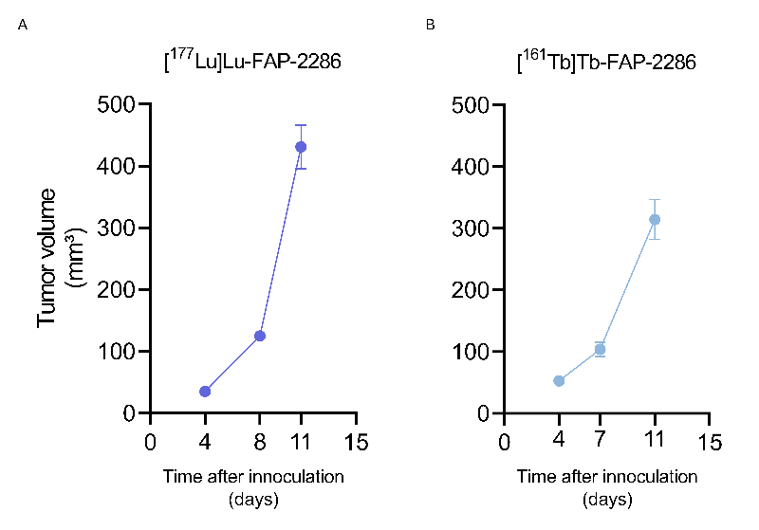

Supplemental Fig. S1. Tumor growth of C57/BL6 mice inoculated with T110299 cells that received (a) [¹⁷⁷Lu]Lu-FAP-2286 and (b) [¹⁶¹Tb]Tb-FAP-2286 before biodistribution studies

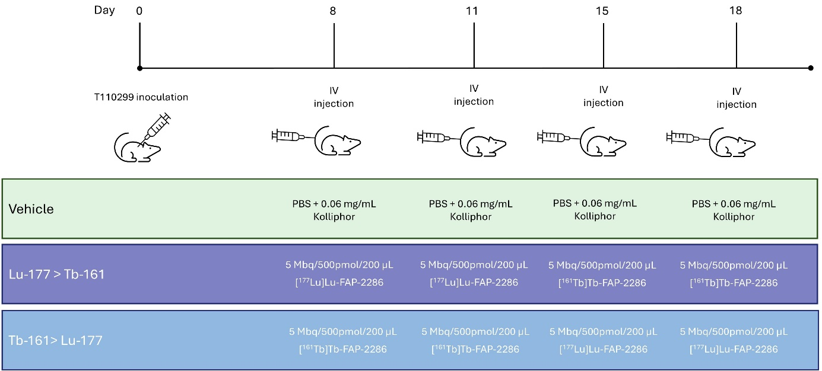
Supplemental Fig. S2. Timeline of C57/BL6 mice inoculated with T110299 cells that received tandem therapy with vehicle, sequential [¹⁷⁷Lu]Lu-FAP-2286 and [¹⁶¹Tb]Tb-FAP-2286, or vice versa.

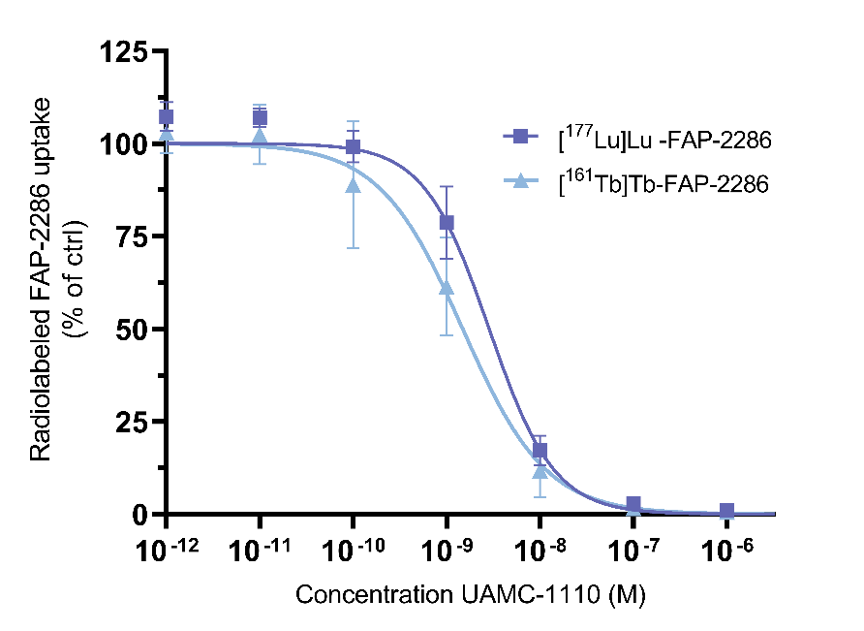
Supplemental Fig. S3 Competition binding assay on HT1080-huFAP cells using 1 nM [¹⁷⁷Lu]Lu-FAP-2286 (n=3) or [¹⁶¹Tb]Tb-FAP-2286 (n=4), simultaneous with increasing concentrations of UAMC-1110. Data are normalized to the uptake without UAMC-1110, and expressed as mean ± SD.

Supplemental Table S3. Stability of [¹⁶¹Tb]Tb-FAP-2286 and [¹⁷⁷Lu]Lu-FAP-2286 (50 MBq/nmol) in labeling solution, PBS and mouse serum over time (n=3).
Compound | Labeling solution |  |  | PBS |  | Mouse serum
Compound | 0 h | 2 h | 24 h | 2 h | 24 h | 2 h | 24 h
[¹⁷⁷Lu]Lu-FAP-2286 | 97.7 ±1.3% | 97.6 ±0.6% | 93.4 ±2.1% | 98.1 ±0.7% | 95.7 ±0.5% | 70.0 ±0.5% | 13.0 ±0.5%
[¹⁶¹Tb]Tb-FAP-2286 | 97.1 ±0.4% | 95.2 ±2.8% | 93.4 ±2.6% | 97.3 ±0.6% | 94.6 ±0.2% | 75.8 ±1.0% | 12.2 ±0.5%
p value | 0.703 | 0.144 | >0.999 | 0.104 | 0.036 | 0.000005 | 0.177

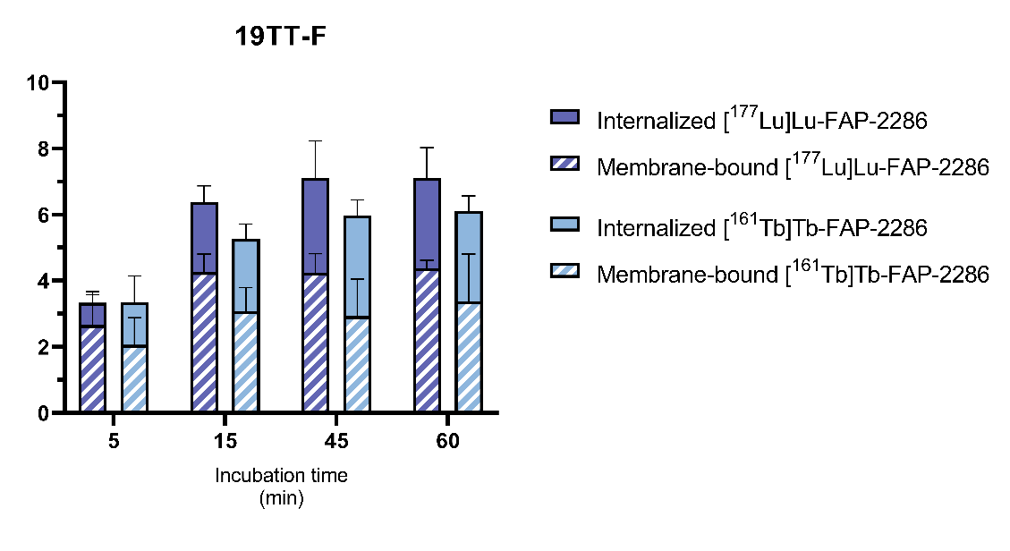
Supplemental Fig. S4. Uptake of 1 nM Radiolabeled FAP-2286 by 19TT-F breast cancer fibroblasts (n=3).
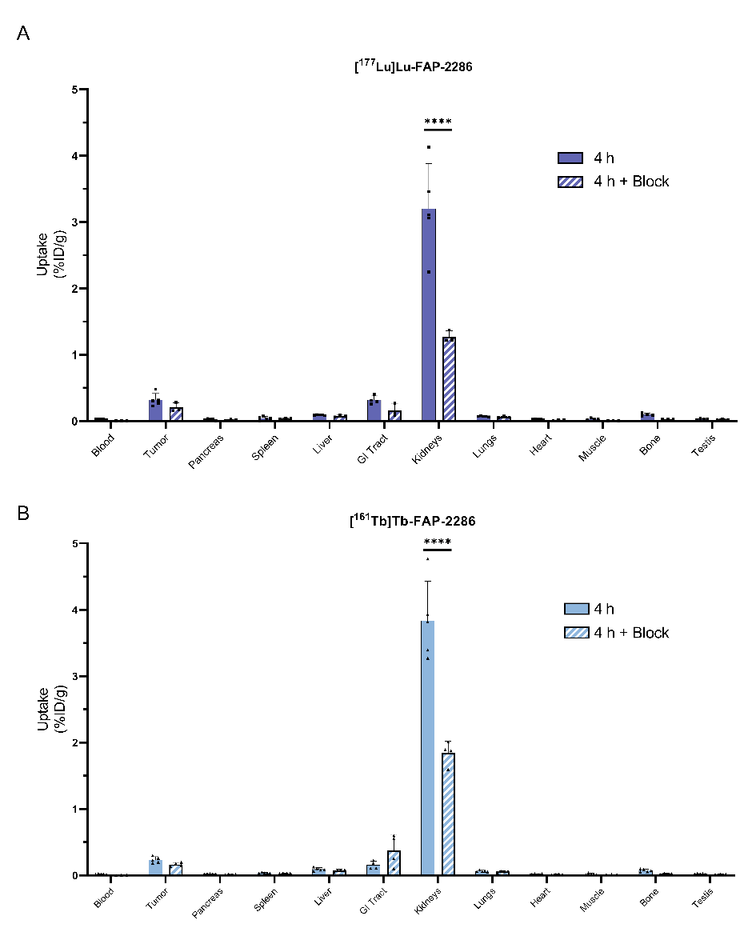
b
a
Supplemental Fig. S5. Ex vivo biodistribution of 1 nM (a) [¹⁷⁷Lu]Lu-FAP-2286 and (b) [¹⁶¹Tb]Tb-FAP-2286 4 h p.i. without or with co-injection of UAMC-1110 (Block). **** p < 0.0001
Supplemental Fig. S6. Ex vivo autoradiography of PDAC299 xenograft tumors collected after biodistribution studies, demonstrating the quantification of bound (A) [¹⁷⁷Lu]Lu-FAP-2286 and (C) [¹⁶¹Tb]Tb-FAP-2286 at 1, 4, 24, and 48 h p.i. A comparison of bound (B) [¹⁷⁷Lu]Lu-FAP-2286 and (D) [¹⁶¹Tb]Tb-FAP-2286 at 4 h without and significantly lower with block (UAMC-1110) as determined by an unpaired t-test. ** p < 0.01.

Supplemental Table S4. Biodistribution of [¹⁷⁷Lu]Lu-FAP-2286 in PDAC299 xenografted mice.
 | 1 h |  |  | 4 h |  |  | 4 h + Block |  |  | 24 h |  |  | 48 h
 | Mean | SD | N | Mean | SD | N | Mean | SD | N | Mean | SD | N | Mean | SD | N
Blood | 1,34 | 0,28 | 5 | 0,03 | 0,00 | 5 | 0,01 | 0,00 | 3 | 0,00 | 0,00 | 5 | 0,00 | 0,00 | 5
Tumor | 1,85 | 0,39 | 5 | 0,32 | 0,10 | 5 | 0,21 | 0,07 | 3 | 0,20 | 0,07 | 5 | 0,12 | 0,02 | 5
Pancreas | 0,37 | 0,07 | 5 | 0,02 | 0,01 | 5 | 0,02 | 0,01 | 3 | 0,01 | 0,00 | 5 | 0,01 | 0,00 | 5
Spleen | 0,27 | 0,05 | 5 | 0,04 | 0,03 | 5 | 0,03 | 0,01 | 3 | 0,03 | 0,00 | 5 | 0,02 | 0,00 | 5
Liver | 0,43 | 0,11 | 5 | 0,09 | 0,01 | 5 | 0,07 | 0,01 | 3 | 0,06 | 0,02 | 5 | 0,05 | 0,01 | 5
GI tract | 0,81 | 0,58 | 5 | 0,32 | 0,06 | 4 | 0,16 | 0,09 | 3 | 0,04 | 0,02 | 5 | 0,02 | 0,00 | 5
Kidneys | 7,85 | 1,96 | 5 | 3,20 | 0,68 | 5 | 1,27 | 0,09 | 3 | 1,17 | 0,43 | 5 | 0,53 | 0,09 | 5
Lungs | 0,87 | 0,19 | 5 | 0,07 | 0,01 | 5 | 0,06 | 0,01 | 3 | 0,02 | 0,01 | 5 | 0,01 | 0,00 | 4
Heart | 0,50 | 0,10 | 5 | 0,03 | 0,00 | 5 | 0,01 | 0,00 | 3 | 0,01 | 0,00 | 4 | 0,01 | 0,00 | 5
Muscle | 0,33 | 0,08 | 4 | 0,03 | 0,01 | 4 | 0,01 | 0,00 | 3 | 0,01 | 0,00 | 5 | 0,01 | 0,00 | 5
Bone | 0,85 | 0,19 | 5 | 0,10 | 0,02 | 4 | 0,03 | 0,00 | 3 | 0,04 | 0,01 | 5 | 0,03 | 0,01 | 5
Testis | 0,27 | 0,09 | 4 | 0,03 | 0,01 | 4 | 0,02 | 0,01 | 3 | 0,02 | 0,00 | 5 | 0,01 | 0,00 | 5

Supplemental Table S5. Biodistribution of [¹⁶¹Tb]Tb-FAP-2286 in PDAC299 xenografted mice.
 | 1 h |  |  | 4 h |  |  | 4 h + Block |  |  | 24 h |  |  | 48 h
 | Mean | SD | N | Mean | SD | N | Mean | SD | N | Mean | SD | N | Mean | SD | N
Blood | 0,77 | 0,15 | 4 | 0,02 | 0,01 | 5 | 0,00 | 0,00 | 3 | 0,00 | 0,00 | 4 | 0,00 | 0,00 | 5
Tumor | 1,39 | 0,45 | 4 | 0,23 | 0,05 | 5 | 0,17 | 0,03 | 4 | 0,16 | 0,00 | 4 | 0,10 | 0,03 | 5
Pancreas | 0,22 | 0,05 | 4 | 0,03 | 0,00 | 5 | 0,02 | 0,00 | 4 | 0,01 | 0,00 | 5 | 0,01 | 0,00 | 5
Spleen | 0,17 | 0,04 | 4 | 0,04 | 0,01 | 5 | 0,03 | 0,00 | 4 | 0,03 | 0,00 | 5 | 0,02 | 0,00 | 5
Liver | 0,25 | 0,06 | 4 | 0,09 | 0,02 | 5 | 0,07 | 0,02 | 4 | 0,05 | 0,00 | 5 | 0,05 | 0,01 | 5
GI tract | 0,36 | 0,30 | 4 | 0,16 | 0,06 | 4 | 0,38 | 0,24 | 4 | 0,03 | 0,00 | 5 | 0,02 | 0,00 | 5
Kidneys | 6,09 | 1,41 | 4 | 3,84 | 0,59 | 5 | 1,84 | 0,18 | 4 | 1,24 | 0,07 | 5 | 0,54 | 0,06 | 5
Lungs | 0,64 | 0,20 | 4 | 0,06 | 0,01 | 5 | 0,06 | 0,01 | 4 | 0,02 | 0,00 | 5 | 0,01 | 0,00 | 5
Heart | 0,25 | 0,06 | 4 | 0,02 | 0,00 | 4 | 0,01 | 0,00 | 4 | 0,01 | 0,00 | 5 | 0,01 | 0,00 | 5
Muscle | 0,20 | 0,05 | 4 | 0,02 | 0,01 | 5 | 0,01 | 0,00 | 3 | 0,01 | 0,00 | 5 | 0,01 | 0,00 | 5
Bone | 0,54 | 0,08 | 4 | 0,07 | 0,02 | 5 | 0,03 | 0,01 | 4 | 0,03 | 0,00 | 5 | 0,02 | 0,00 | 5
Testis | 0,16 | 0,02 | 4 | 0,02 | 0,00 | 5 | 0,02 | 0,00 | 3 | 0,01 | 0,00 | 5 | 0,01 | 0,00 | 5

Supplemental Table S6. Predicted dose activity in murine organs expressed in mGy/MBq, based on in vivo biodistribution studies.
 | [¹⁶¹Tb]Tb-FAP-2286 | [¹⁷⁷Lu]Lu-FAP-2286
Tumor | 40.64 | 37.56
Brain | 2.91 | 2.45
Large intestine | 14.47 | 11.52
Small intestine | 8.17 | 6.92
Stomach wall | 9.94 | 7.44
Heart | 7.06 | 5.60
Kidneys | 260.97 | 183.66
Liver | 17.61 | 14.09
Lungs | 9.90 | 7.94
Pancreas | 8.78 | 6.97
Skeleton | 18.76 | 17.61
Spleen | 10.61 | 7.53
Thyroid | 9.85 | 7.67
Bladder | 2.89 | 2.37
Total body | 8.97 | 7.38

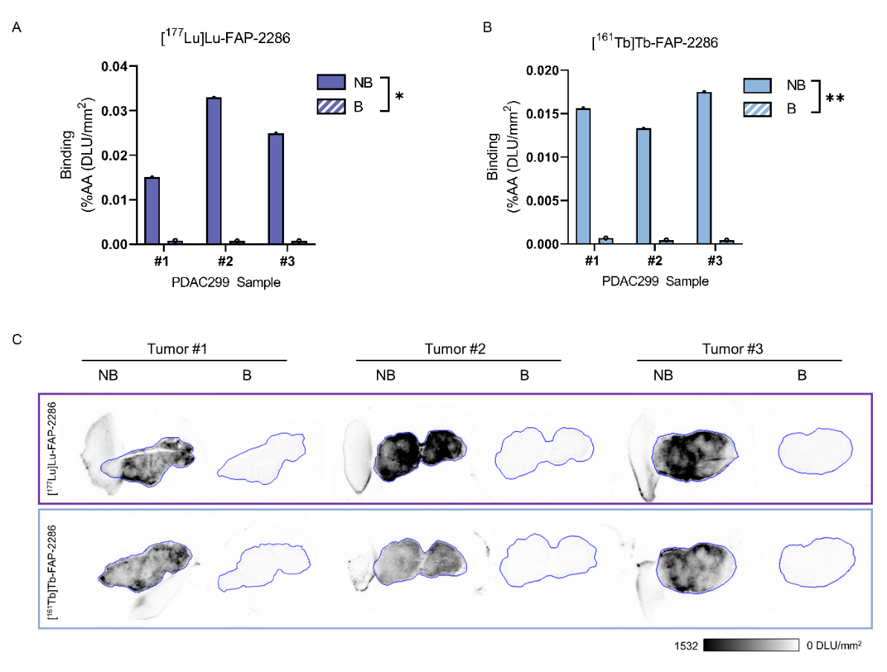
c
a
b
Supplemental Fig. S7. In vitro autoradiography on treatment naïve PDAC299 material incubated with (a) 1 nM [¹⁷⁷Lu]Lu-FAP-2286 or (b) [¹⁶¹Tb]Tb-FAP-2286 in the absence (NB) or presence (B) of 1 mM UAMC-1110 quantified as % added activity and (c) a visual of the autoradiography. * p < 0.05, ** p < 0.01
a
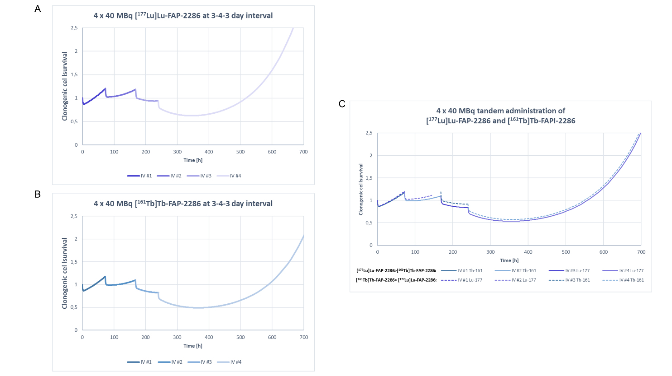
c
b
Supplemental Fig. S8. Tumor control probability calculated for four consecutive IV injections of (a) [¹⁷⁷Lu]Lu-FAP-2286 or (b) [¹⁶¹Tb]Tb-FAP-2286, or (c) tandem therapy of both radiopharmaceuticals, based on a doubling time (TD) of 3 days, and the cell radiosensitivity (𝛼) of 1.0 /Gy.
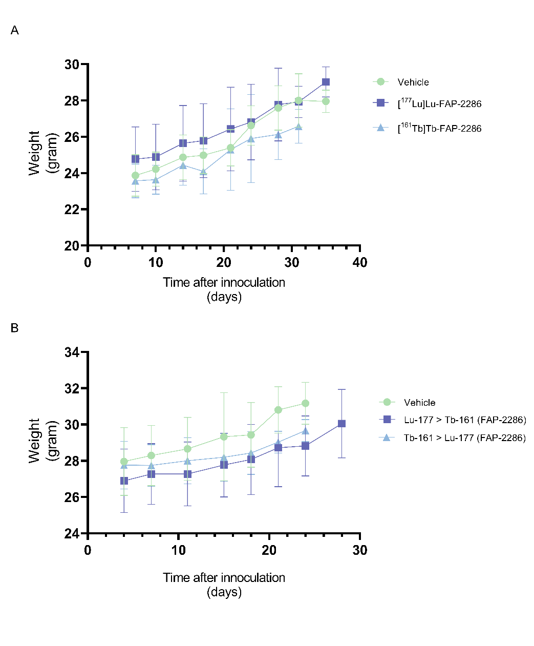
a
b
Supplemental Fig. S9. Average weight of the mice (a) receiving 4×40 MBq/500 pmol [¹⁷⁷Lu]Lu-FAP-2286, 4×40 MBq/500 pmol [¹⁶¹Tb]Tb-FAP-2286, or vehicle injections. (b) Weight of mice receiving tandem therapy of received 2×40 MBq/500 pmol [¹⁷⁷Lu]Lu-FAP-2286 followed by 2×40 MBq/500 pmol [¹⁶¹Tb]Tb-FAP-2286, or in the reversed order, or vehicle injections.
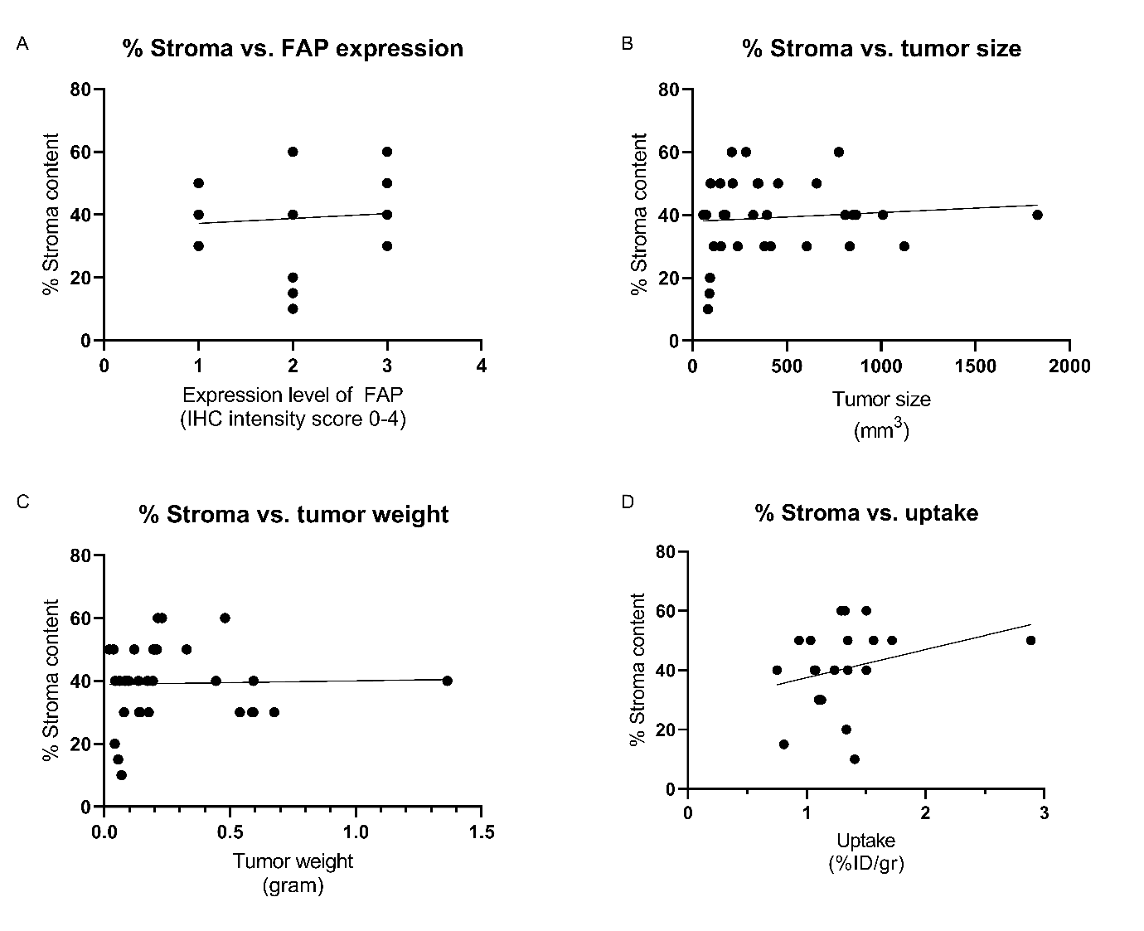
a
c
d
b
Supplemental Fig. S10. Correlation graphs for the stroma density of the tumors collected after IV1-IV4 and (A) the level of FAP expression as scored 0-4 of intensity, (B) the tumor size as measured by caliper, (C) the tumor weight ex vivo, and (D) the radiopharmaceutical uptake.
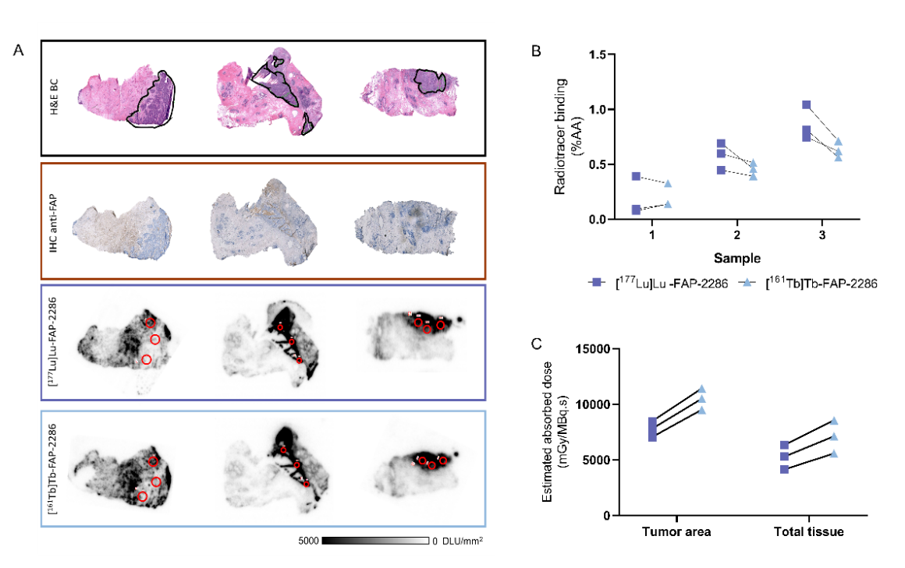
c
b
a
Supplemental Fig. S11. In vitro autoradiography on patient PDAC samples. (A) H&E staining of PDAC patient material with tumor indicated in green (top panel) and the autoradiography of performed with 177Lu and 161Tb labeled FAP-2286. (B) Quantification of the radiopharmaceutical binding in three indicated areas (red circles), with non-significant differences determined by 2-way ANOVA. (C) Calculated absorbed dose to the tumor area and to the total tissue slice in mGy/MBq.s calculated by Monte Carlo simulations.
References
1. van der Heide, C.D., et al., In vitro and ex vivo evaluation of preclinical models for FAP-targeted theranostics: differences and relevance for radiotracer evaluation. EJNMMI Res, 2024. 14(1): p. 125.

