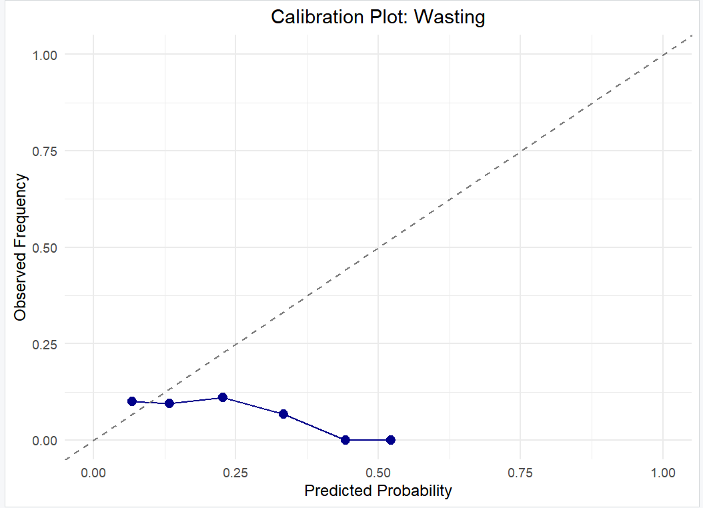
Supplementary Figure S2. Calibration Plot for Wasting Predictions. This plot assesses the agreement between the predicted probabilities of wasting from the XGBoost model and the observed frequencies. The solid blue line represents the calibration curve, the dashed diagonal line represents perfect calibration, and the histogram shows the distribution of predictions. The curve shows good calibration at lower probabilities but suggests a slight tendency for the model to overestimate risk at higher predicted probabilities (e.g., above 0.6). This indicates that while the model is generally reliable, its predictions for high-risk cases may be slightly overstated.
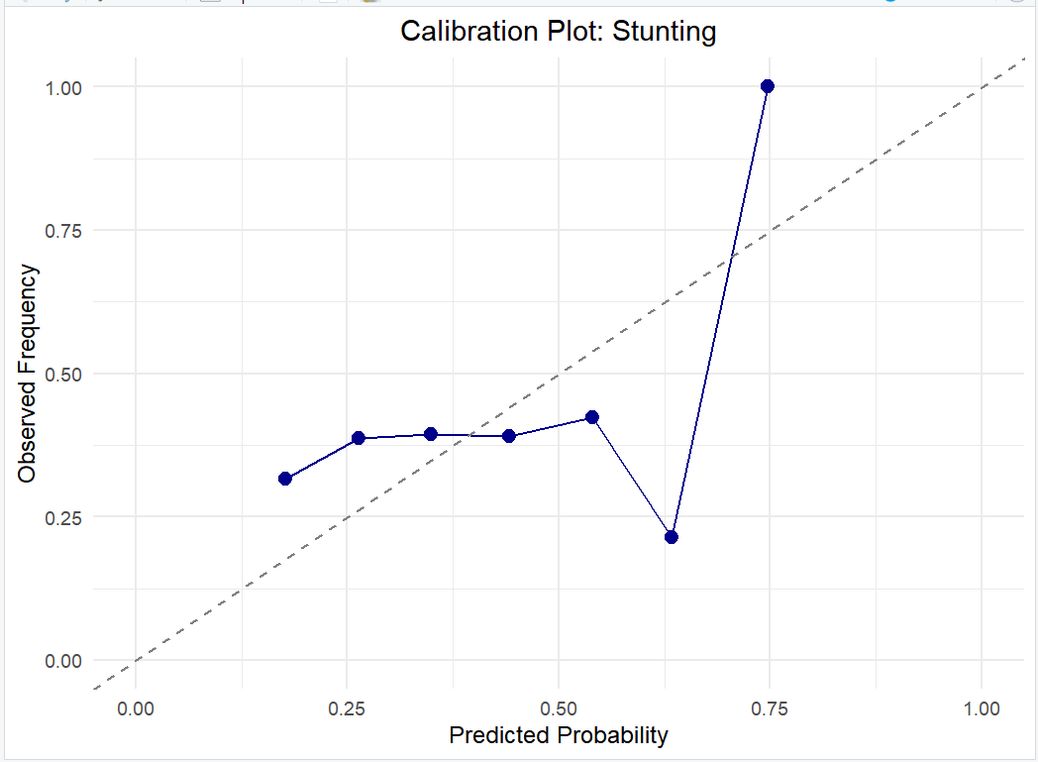

Supplementary Figure S1. Calibration Plot for Stunting Predictions. This plot assesses the agreement between the predicted probabilities of stunting from the XGBoost model and the observed frequencies. The solid blue line represents the calibration curve of the model, the dashed diagonal line represents the ideal perfect calibration, and the histogram shows the distribution of predicted probabilities. The close alignment of the calibration curve to the ideal line, particularly in the mid-range of probabilities (0.2 to 0.7), indicates that the model's predictions are well-calibrated. For example, when the model predicts a 30% risk of stunting, the observed frequency is approximately 30%.

