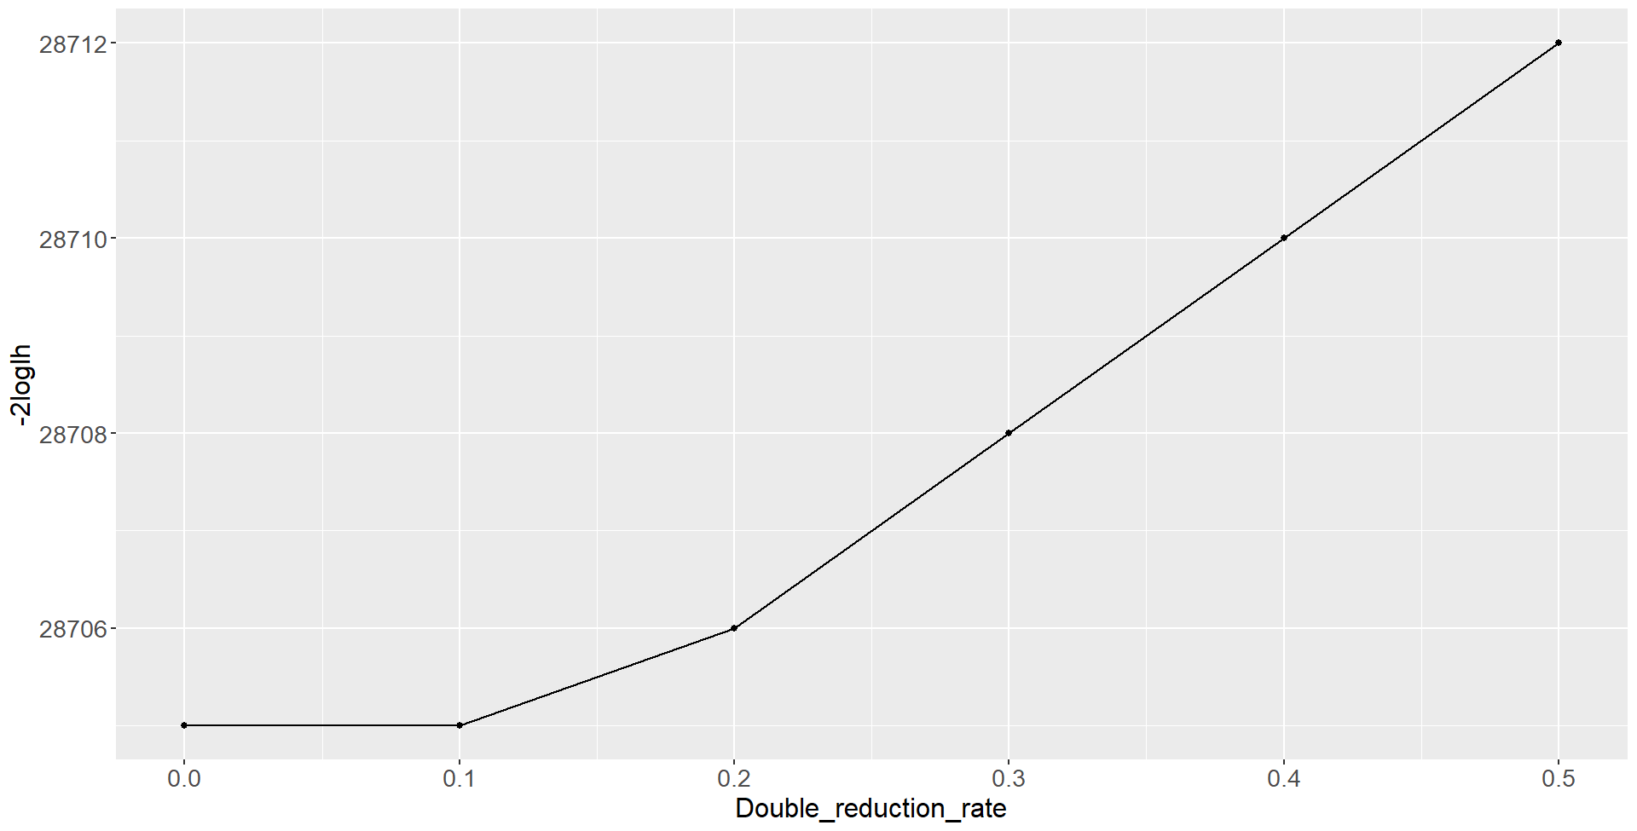
Fig. 1 -2Log-likelihood values of model depending on double reduction rate assumed when constructing the pedigree-based relationship.
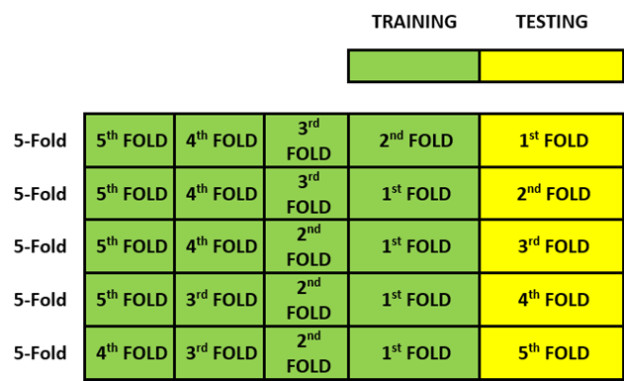

Fig. 2 Diagram shows 5-Fold cross validation scheme of models.

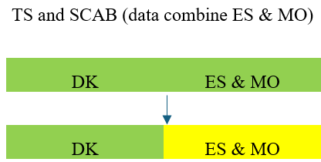
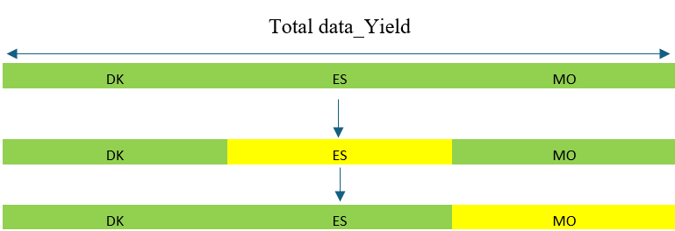
Fig 3. Diagram illustrating the leave-one-environment-out cross-validation scheme used for model evaluation.
For the Yield trait, the ES dataset was masked and predicted using the DK and MO datasets, followed by masking the MO dataset and predicting it using DK and ES.
For the Tuber Size and Scab traits, the ES and MO datasets were combined and treated as a single environment; thus, ES & MO were masked and predicted using the DK dataset.

