Appendix :

Poor-quality sequences (too much N)
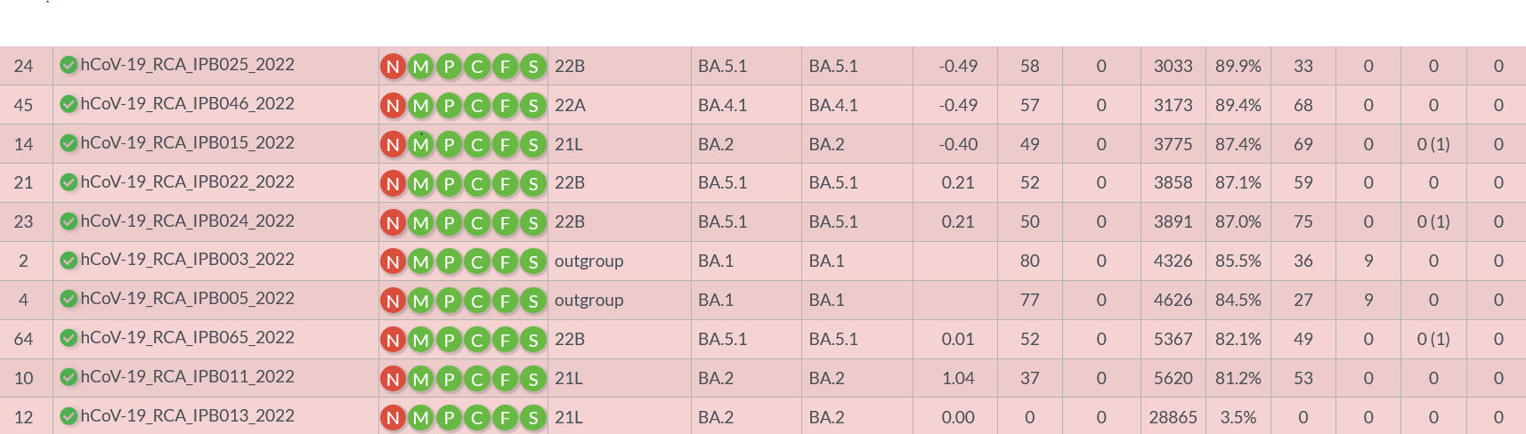

https://doi.org/10.1093/molbev/msaa015

