Supplementary Figure 1. Crude rheumatic heart disease mortality rate per 100,000 by sex, in the United States of America (1968–2023).

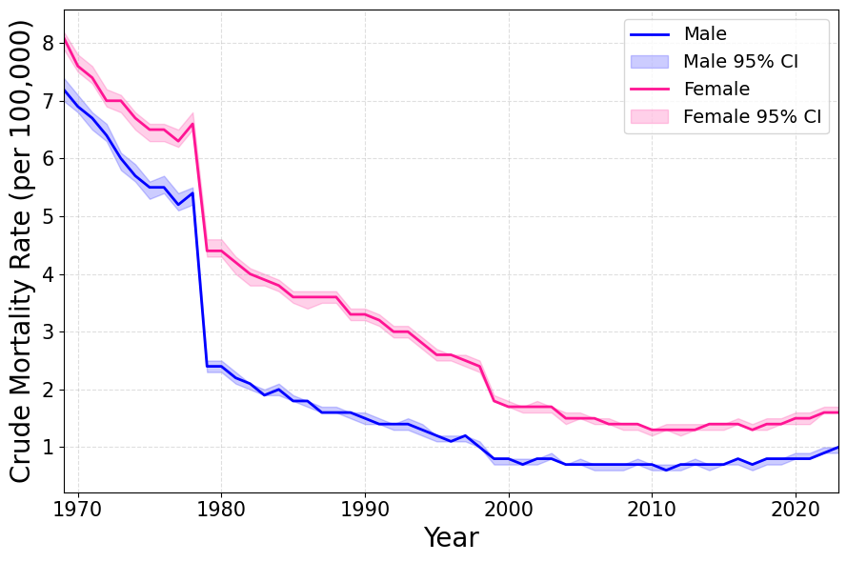

Supplementary Figure 2. Age-specific distribution RHD mortality in the United States across three representative years: 1970, 2000, and 2023.
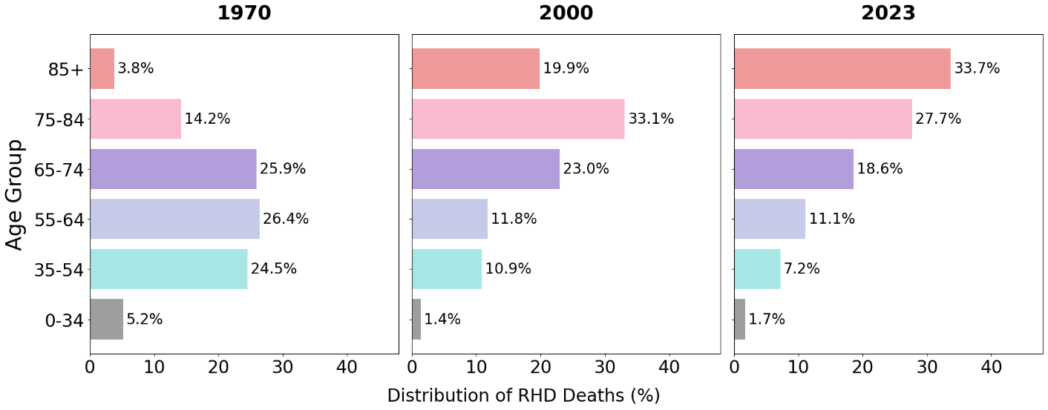

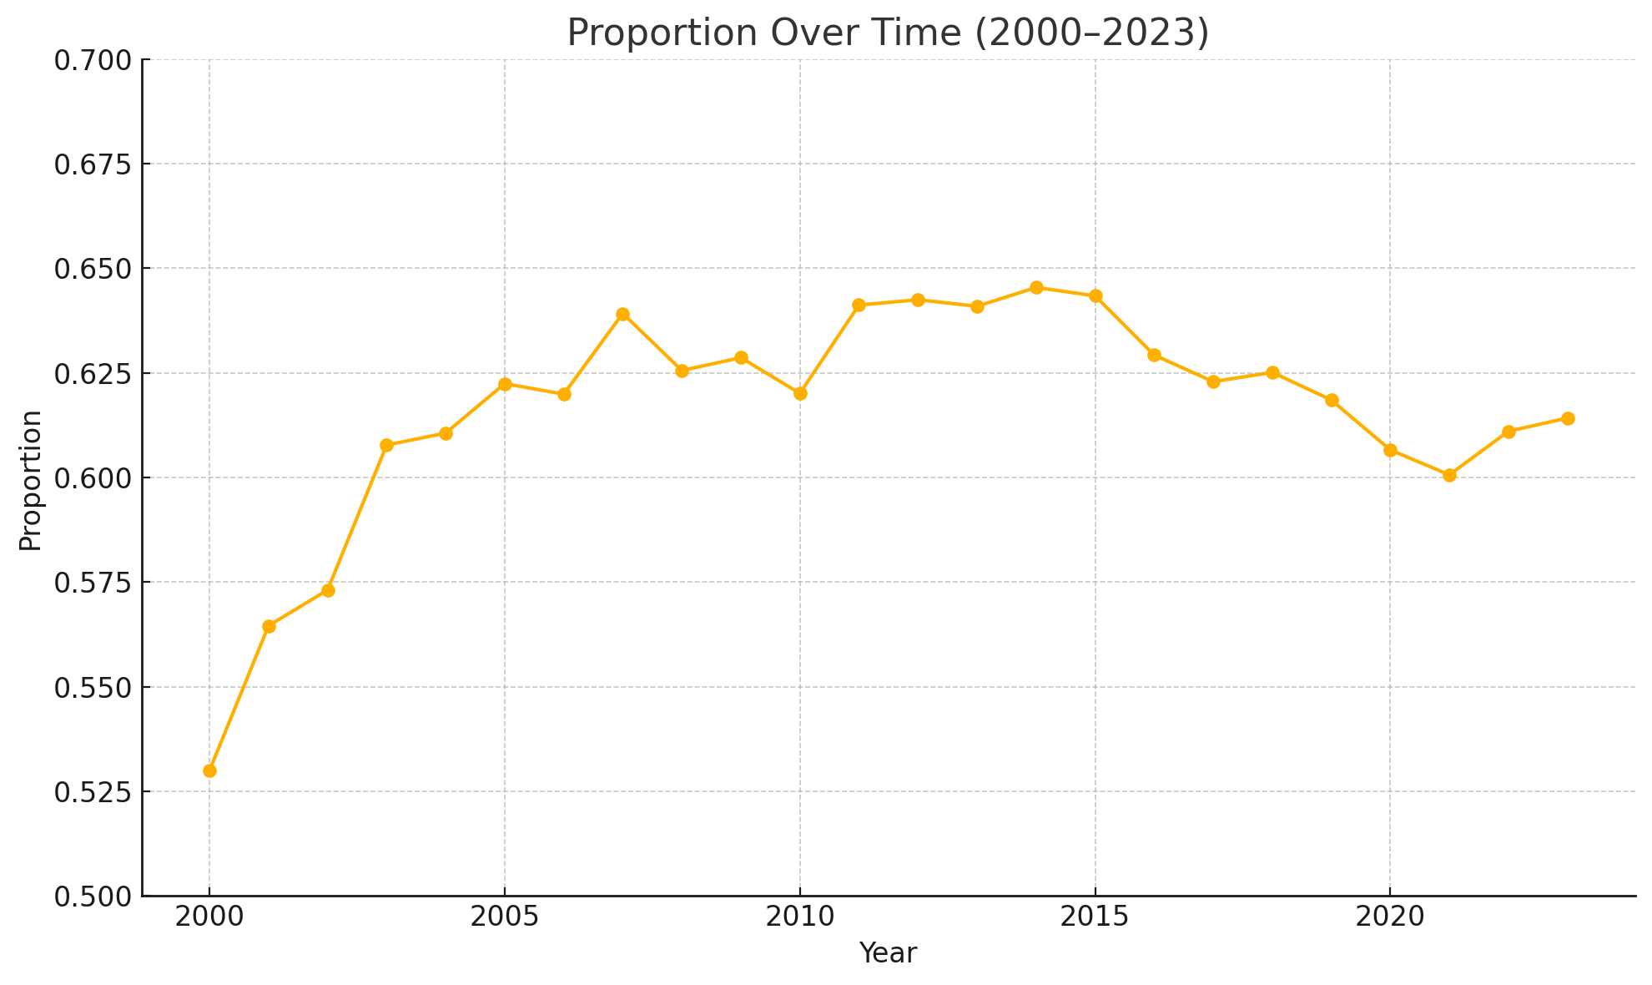
Supplementary Figure 3. Percentage of RHD-related deaths occurring in individuals aged ≥75 years, 2000–2023.

Supplementary Table 1. STROBE Statement—checklist of items that should be included in reports of observational studies

 | Item No. | Recommendation | Page No. | Line No.
Title and abstract | 1 | (a) Indicate the study’s design with a commonly used term in the title or the abstract | 1 | 1-2
Title and abstract | 1 | (b) Provide in the abstract an informative and balanced summary of what was done and what was found | 3-4 | 43-71
Introduction
Background/rationale | 2 | Explain the scientific background and rationale for the investigation being reported | 5-6 | 72-100
Objectives | 3 | State specific objectives, including any prespecified hypotheses | 6 | 96-100
Methods
Study design | 4 | Present key elements of study design early in the paper | 6 | 104-107
Setting | 5 | Describe the setting, locations, and relevant dates, including periods of recruitment, exposure, follow-up, and data collection | 6 | 104-118
Participants | 6 | (a) Cohort study—Give the eligibility criteria, and the sources and methods of selection of participants. Describe methods of follow-up  Case-control study—Give the eligibility criteria, and the sources and methods of case ascertainment and control selection. Give the rationale for the choice of cases and controls  Cross-sectional study—Give the eligibility criteria, and the sources and methods of selection of participants | 6-8 (Study is a retrospective population-based time-trend study) | N/A  120-140
Participants | 6 | (b) Cohort study—For matched studies, give matching criteria and number of exposed and unexposed  Case-control study—For matched studies, give matching criteria and the number of controls per case | N/A | N/A
Variables | 7 | Clearly define all outcomes, exposures, predictors, potential confounders, and effect modifiers. Give diagnostic criteria, if applicable | 6-8 | 109-118
Data sources/ measurement | 8* | For each variable of interest, give sources of data and details of methods of assessment (measurement). Describe comparability of assessment methods if there is more than one group | 6-7 | 102-130
Bias | 9 | Describe any efforts to address potential sources of bias | N/A | N/A
Study size | 10 | Explain how the study size was arrived at | 7 | 132-140
Continued on next page
Quantitative variables | 11 | Explain how quantitative variables were handled in the analyses. If applicable, describe which groupings were chosen and why | 7-8 | 142-154
Statistical methods | 12 | (a) Describe all statistical methods, including those used to control for confounding | 7-8 | 142-154
Statistical methods | 12 | (b) Describe any methods used to examine subgroups and interactions | 7-8 | 142-154
Statistical methods | 12 | (c) Explain how missing data were addressed | 7-8 | 142-154
Statistical methods | 12 | (d) Cohort study—If applicable, explain how loss to follow-up was addressed  Case-control study—If applicable, explain how matching of cases and controls was addressed  Cross-sectional study—If applicable, describe analytical methods taking account of sampling strategy | N/A | N/A
Statistical methods | 12 | (e) Describe any sensitivity analyses | N/A | N/A
Results
Participants | 13* | (a) Report numbers of individuals at each stage of study—eg numbers potentially eligible, examined for eligibility, confirmed eligible, included in the study, completing follow-up, and analysed | 8 | 156
Participants | 13* | (b) Give reasons for non-participation at each stage | No non-participants in this study
Participants | 13* | (c) Consider use of a flow diagram | N/A | N/A
Descriptive data | 14* | (a) Give characteristics of study participants (eg demographic, clinical, social) and information on exposures and potential confounders | 9 | 160-181
Descriptive data | 14* | (b) Indicate number of participants with missing data for each variable of interest | N/A | N/A
Descriptive data | 14* | (c) Cohort study—Summarise follow-up time (eg, average and total amount)
Outcome data | 15* | Cohort study—Report numbers of outcome events or summary measures over time | Adapted for the study  8-9 | 160-181
Outcome data | 15* | Case-control study—Report numbers in each exposure category, or summary measures of exposure | Adapted for the study  8-9 | 160-181
Outcome data | 15* | Cross-sectional study—Report numbers of outcome events or summary measures | Adapted for the study  8-9 | 160-181
Main results | 16 | (a) Give unadjusted estimates and, if applicable, confounder-adjusted estimates and their precision (eg, 95% confidence interval). Make clear which confounders were adjusted for and why they were included | N/A | N/A
Main results | 16 | (b) Report category boundaries when continuous variables were categorized | No category boundaries were relevant for this study | N/A
Main results | 16 | (c) If relevant, consider translating estimates of relative risk into absolute risk for a meaningful time period | N/A | N/A
Continued on next page
Other analyses | 17 | Report other analyses done—eg analyses of subgroups and interactions, and sensitivity analyses | N/A | N/A
Discussion
Key results | 18 | Summarise key results with reference to study objectives | 15 | 249-255
Limitations | 19 | Discuss limitations of the study, taking into account sources of potential bias or imprecision. Discuss both direction and magnitude of any potential bias | 18 | 320-333
Interpretation | 20 | Give a cautious overall interpretation of results considering objectives, limitations, multiplicity of analyses, results from similar studies, and other relevant evidence | 18 | 336-339
Generalisability | 21 | Discuss the generalisability (external validity) of the study results | N/A | N/A
Other information
Funding | 22 | Give the source of funding and the role of the funders for the present study and, if applicable, for the original study on which the present article is based | 2 | 28

Supplementary Table 2. The Reporting of studies Conducted using Observational Routinely-collected health Data (RECORD) Statement, extended from the STROBE statement, that should be reported in observational studies using routinely collected health data.

RECORD items | Location in manuscript where items are reported
Title and abstract
RECORD 1.1: The type of data used should be specified in the title or abstract. When possible, the name of the databases used should be included. | 1.1: Lines 1-2  1.2: Lines 1-2  1.3: N/A
RECORD 1.2: If applicable, the geographic region and timeframe within which the study took place should be reported in the title or abstract. | 1.1: Lines 1-2  1.2: Lines 1-2  1.3: N/A
RECORD 1.3: If linkage between databases was conducted for the study, this should be clearly stated in the title or abstract. | 1.1: Lines 1-2  1.2: Lines 1-2  1.3: N/A
Methods
RECORD 6.1: The methods of study population selection (such as codes or algorithms used to identify subjects) should be listed in detail. If this is not possible, an explanation should be provided. | 6.1: Lines 103-141  6.2: N/A  6.3 N/A – study no linkage
RECORD 6.2: Any validation studies of the codes or algorithms used to select the population should be referenced. If validation was conducted for this study and not published elsewhere, detailed methods and results should be provided. | 6.1: Lines 103-141  6.2: N/A  6.3 N/A – study no linkage
RECORD 6.3: If the study involved linkage of databases, consider use of a flow diagram or other graphical display to demonstrate the data linkage process, including the number of individuals with linked data at each stage. | 6.1: Lines 103-141  6.2: N/A  6.3 N/A – study no linkage
RECORD 7.1: A complete list of codes and algorithms used to classify exposures, outcomes, confounders, and effect modifiers should be provided. If these cannot be reported, an explanation should be provided. | 7.1: Lines 109-140
RECORD 12.1: Authors should describe the extent to which the investigators had access to the database population used to create the study population. | 12.1: Lines 109-118, database is publicly available
RECORD 12.2: Authors should provide information on the data cleaning methods used in the study. | 12.1: Lines 109-118, database is publicly available
RECORD 12.3: State whether the study included person-level, institutional-level, or other data linkage across two or more databases. The methods of linkage and methods of linkage quality evaluation should be provided. | 12.3: Lines 109-118
Results
RECORD 13.1: Describe in detail the selection of the persons included in the study (i.e., study population selection) including filtering based on data quality, data availability and linkage. The selection of included persons can be described in the text and/or by means of the study flow diagram. | 13.1: Lines 110-159
Discussion
RECORD 19.1: Discuss the implications of using data that were not created or collected to answer the specific research question(s). Include discussion of misclassification bias, unmeasured confounding, missing data, and changing eligibility over time, as they pertain to the study being reported. | 19.1: Lines 327-333
Other Information
RECORD 22.1: Authors should provide information on how to access any supplemental information such as the study protocol, raw data, or programming code. | 20.1: Lines 38-39

Variables | Beta | p-value
Crude Rate | -5.5 | P<0.0001
Male CMR | -24.7 | P<0.0001
Female CMR | -13.7 | P<0.0001
Black/ African American | -0.03 | P<0.0001
Hispanic | 0.02 | P=0.799
White | -0.003 | P<0.0001
American Indian | 0.07 | P=0.866
Asian / Pacific Islander | 0.24 | P=0.013
<35 | -0.05 | P<0.0001
35-54 | -0.01 | P<0.0001
55-74 | -0.005 | P<0.0001
75-84 | -0.02 | P<0.0001
>85 | 0.05 | P<0.0001
Large Central Metro | -0.04 | P<0.0001
Noncore nonmetro | -0.08 | P=0.048
Supplementary Table 3. Univariate linear regression results identifying independent predictors of annual change in RHD crude mortality rate (1968-2012) using backward stepwise selection

Variables | Beta | p-value
CMR | 26.4 | P<0.0001
Male CMR | 30.3 | P=0.001
Female CMR | 27.5 | P=0.001
Black / African American | 0.06 | P<0.0001
Hispanic | 0.07 | P<0.0001
White | 0.01 | P<0.0001
American Indian | 0.36 | P=0.012
Asian / Pacific Islander | 0.111 | P=0.011
<35 | 0.13 | P=0.019
35-54 | 0.08 | P<0.0001
55-74 | 0.02 | P<0.0001
75-84 | 0.02 | P=0.002
>85 | 0.03 | P<0.0001
Large Central Metro | 0.03 | P<0.0001
Noncore nonmetro | 0.1 | P=0.01
Supplementary Table 5. Univariate linear regression results identifying independent predictors of annual change in RHD crude mortality rate (2013-2023) using backward stepwise selection.
Category | Subgroup | Average raw increase per year | Annual raw % increase per year | Average CMR increase per year |  | Annual CMR % Yearly Increase
Overall |  | 105.6 | 3.14%
Demographics | Male | 46.3 | 3.63% |  | 3.4 |  | 4.29%
 | Female | 60.3 | 2.16% |  | 2.1 |  | 2.71%
Age Groups | 0–34 | 3.9 | 8.24% |  | 8.24 |  | 9.62%
 | 35–54 | 11.5 | 4.38% |  | 4.38 |  | 4.38%
 | 55–64 | 15.0 | 3.49% |  | 3.49 |  | 4.22%
 | 65–74 | 22.0 | 0.34% |  | 0.34 |  | 3.74%
 | 75–84 | 26.5 | -0.33% |  | -0.33 |  | 2.73%
 | 85+ | 36.4 | 2.62% |  | 2.62 |  | 3.04%
Race | American Indian or Alaskan Native | 2.0 | 9.69% |  | 9.69 |  | 10.13%
 | Asian or Pacific Islander | 6.0 | 4.62% |  | 4.62 |  | 5.39%
 | Black or African American | 7.4 | 5.06% |  | 5.06 |  | 5.55%
 | White | 41.0 | 2.68% |  | 2.68 |  | 2.81%
Ethnicity | Hispanic | 6.2 | 4.91% |  | 4.91 |  | 6.91%
 | Not Hispanic | 34.8 | 2.70% |  | 2.70 |  | 3.01%
Urbanisation | Large Central Metro | 20.2 | 2.04% |  | 2.04 |  | 2.56%
 | Large Fringe Metro | 24.6 | 2.71% |  | 2.71 |  | 3.67%
 | Medium Metro | 34.8 | 3.62% |  | 3.62 |  | 4.37%
 | Small Metro | 14.0 | 3.87% |  | 3.87 |  | 4.35%
 | Micropolitan (Nonmetro) | 11.9 | 3.41% |  | 3.41 |  | 3.51%
 | NonCore (Nonmetro) | 1.9 | 1.27% |  | 1.27 |  | 1.02%
Supplementary Table 4. Average annual percentage increase in raw and crude mortality rates for rheumatic heart disease by demographic subgroup, 2013-2023
CMR: Crude mortality rate

