Appendices
Appendix 1. Baseline characteristics
Characteristic | N | Overall  N = 154¹ | CONTROL  N = 76¹ | DAT  N = 78¹
Age | 154 | 10.0 (6.6, 12.1) | 10.0 (6.7, 12.9) | 10.0 (6.6, 12.0)
Sex | 154
Female |  | 87 (56%) | 41 (54%) | 46 (60%)
Male |  | 67 (44%) | 35 (46%) | 32 (40%)
Child education | 154
None |  | 18 (12%) | 13 (17%) | 5 (6.4%)
Pre-school |  | 20 (13%) | 10 (13%) | 10 (13%)
Primary |  | 104 (68%) | 43 (57%) | 61 (78%)
Secondary |  | 12 (7.8%) | 10 (13%) | 2 (2.6%)
Caregiver education | 154
None |  | 9 (5.8%) | 3 (3.9%) | 6 (7.7%)
Primary |  | 100 (65%) | 54 (71%) | 46 (59%)
Secondary |  | 34 (22%) | 15 (20%) | 19 (24%)
Tertiary |  | 11 (7.1%) | 4 (5.3%) | 7 (9.0%)
Years of living with HIV | 141 | 4.7 (2.0, 7.9) | 4.6 (1.1, 8.4) | 5.1 (2.7, 7.7)
Unknown |  | 13 | 9 | 4
Art regimen | 154
ABC+3TC+DTG |  | 100 (65%) | 46 (61%) | 54 (69%)
TDF+3TC+DTG |  | 54 (35%) | 30 (39%) | 24 (31%)
The parent reported suboptimal adherence (< 95%) of the child. | 154
Don't know |  | 5 (3.2%) | 3 (3.9%) | 2 (2.6%)
No |  | 62 (40%) | 26 (34%) | 36 (46%)
Yes |  | 87 (56%) | 47 (62%) | 40 (51%)
The child had Leftover medication | 154
Don’t know |  | 3(1.9%) | 1(1.3%) | 2(2.6%)
No |  | 71(46%) | 27(36%) | 44(56%)
Yes |  | 80(52%) | 48(63%) | 32(41%)
The child missed a clinic visit in the past six months | 154
No |  | 103 (67%) | 48 (63%) | 55 (71%)
Yes |  | 51 (33%) | 28 (37%) | 23 (29%)
Viral suppression (< 50 copies/ mL) | 153
Not suppressed |  | 26 (18%) | 15 (21%) | 11 (15%)
suppressed |  | 127 (82%) | 60 (79%) | 67 (85%)
Missing |  | 1 | 1
¹ Median (Q1, Q3); n (%)
² Wilcoxon rank sum test; Pearson’s Chi-squared test; Fisher’s exact test

Appendix 2. Study Flow diagram
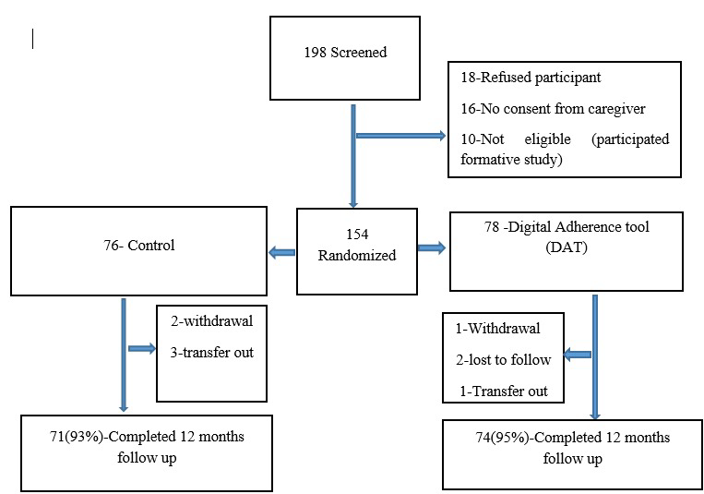

Appendix 3. Proportion of participants achieving 95% adherence and viral suppression at 12 months¹
Measure | Category | Control | Intervention | Total | P-value
Self-report | Adherent | 64(90%) | 62(84%) | 126(80%)
 | Non-adherent | 7(10%) | 12(16%) | 19(20%) | 0.26
 |  | 71(49%) | 74(51%) | 145
Medication Possession Ratio | Adherent | 63(85%) | 63(82%) | 126 (83%)
 | Non-adherent | 11(15%) | 14(18%) | 25(17%) | 0.58
 |  | 74(49%) | 77(51%) | 151
Viral suppression at 12 months | Suppressed | 51(72%) | 63(85%) | 114(79%)
 | Unsuppressed | 20(28%) | 11(15%) | 31(21%) | 0.046
 |  | 71(49%) | 74(51%) | 145
¹Self-report and Medication Possession Ratio adherence measures were not considered accurate or reliable (see part B of the main text)

Appendix 4: Effect of the intervention on adherence over time and viral suppression¹
 | Study arm | ARR² | 95% CI | P-value
Self-report | Control | — | — | —
Self-report | Intervention | 0.97 | 0.90,1.05 | 0.5
Medication Possession Ratio | Control | — | — | —
Medication Possession Ratio | Intervention | 0.996 | 0.93,1.07 | 0.94
Viral Suppression | Control | — | — | —
Viral Suppression | Intervention | 1.14 | 0.98,1.34 | 0.08
²ARR = Adjusted Risk Ratio, CI = Confidence Interval
¹Self-report and Medication Possession Ratio adherence measures were not considered accurate or reliable (see part B of the main text)

Appendix 4. Sensitivity, specificity, PPV, and NPV of DAT, MPR, and Self-report (at 95% cut-off) at viral load < 50 copies/ml
 | Sensitivity | Specificity | Positive Predictive Value  (PPV) | Negative Predictive Value  (NPV)
DAT | 90.91 | 57.14 | 27.03 | 97.3
MPR | 45.16 | 70.43 | 29.1 | 82.65
Self-report | 32.26 | 69.30 | 22.22 | 79.00

Appendix 6. Receiver operating characteristics (ROC) curves for each adherence method at (VL <50 copies/mL) based on continuous adherence data¹
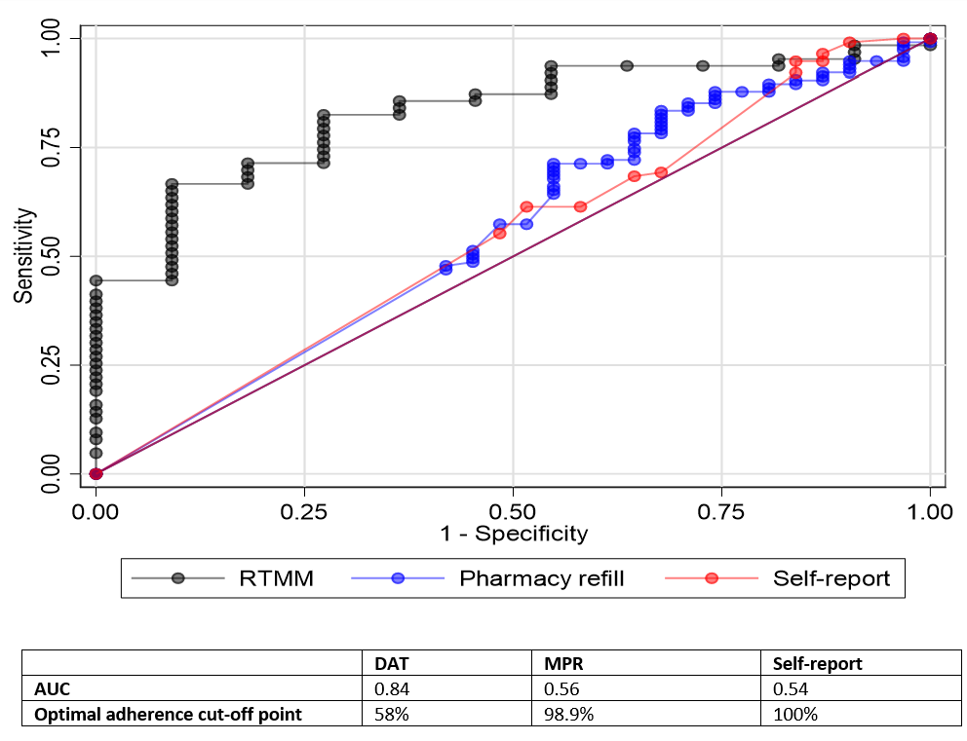
¹self-report and Medication Possession Ratio (MPR) adherence measures were not considered accurate or reliable (see part B of the main text)

