Supplementary Fig. 1 GWAS results of SAT and expression and haplotype analysis of candidate genes. a Manhattan plot for GWAS results of SAT in the whole population. b SAT distribution between indica and japonica subpopulations. c, d phenotypic distribution of SSD (c) and VGI (d) between two haplotypes of LOC_Os04g50970. e, f phenotypic distribution of SSD (e) and VGI (f) between two haplotypes of LOC_Os04g51009. g Differential expression analysis of three candidate genes between alkaline-tolerant and sensitive accessions after alkaline stress for 7 d. Statistical significance was calculated by two-tailed Student’s t-tests.
Supplementary Fig. 2 Protein sequences of OsNPF7.3 knockout mutants.
Supplementary Fig. 3 Comparison of morphological and physiological traits among the OsNPF7.3 transgenic lines under control and alkaline stress conditions. a Shoot lengt. b root length. c CAT content in shoots. d CAT content in roots. e POD content in shoots. f POD content in roots. Data represent mean ± s.d. (n = 3). Different letters represent significant differences at p < 0.05 based on Duncan’s multiple range test.
Supplementary Fig. 4 Phenotypic analysis of Zm00001d026221 knockout mutants under alkaline stress. Zm00001d026221 is the homolog gene of OsNPF7.3 in maize. B104 was used as WT. Data represent mean ± s.d. (n ≥ 5). Asterisks indicate statistical significance by two-tailed Student’s t-tests (**p < 0.01). Scale bar = 5 cm.
Supplementary Fig. 5 Na⁺ content in shoots and roots under control and alkaline stress conditions. Data represent mean ± s.d. (n = 2). Asterisks indicate statistical significance by two-tailed Student’s t-tests (*p < 0.05, n.s. indicates no significant difference).
Supplementary Fig. 6 Agronomic traits of WT and OsNPF7.3 transgenic lines in normal paddy fields.
a Whole plant morphology. b Main panicle morphology. c Grain yield per plant. d Panicle number per plant. e Filled grain number per panicle. f 1000 grain weight. g Plant height. Data represent mean ± s.d. (n = 3). Different letters represent significant differences at p < 0.05 based on Tukey’s HSD tests (n.s. indicates no significant difference). Scale bar = 5 cm.
Supplementary Fig. 7 Promoter sequence comparison between the two haplotypes of OsNPF7.3. G480 and C1016 belong to OsNPF7.3^{Hap1} and OsNPF7.3^{Hap2}, respectively.
Supplementary Fig. 8 Expressions profile of OsNPF7.3 and its expression difference in shoots between the two haplotypes under alkaline stress. a Expression pattern of OsNPF7.3 in shoots of ZH11 at different time points under alkaline stress. b Expression levels of OsNPF7.3 in shoots under alkaline stress in accessions carrying OsNPF7.3^{Hap1} (blue) and OsNPF7.3^{Hap2} (red). Data represent mean ± s.d. (n = 3). Asterisks indicate statistical significance by two-tailed Student’s t-tests (**p < 0.01, ***p < 0.001, and n.s. indicates no significant difference).
Supplementary Fig. 9 SAT and SSD of accessions carrying OsNPF7.3^{Hap1} and OsNPF7.3^{Hap2} under alkaline stress conditions. a SAT. b SSD. Data represent mean ± s.d. Statistical significance was calculated by two-tailed Student’s t-tests.
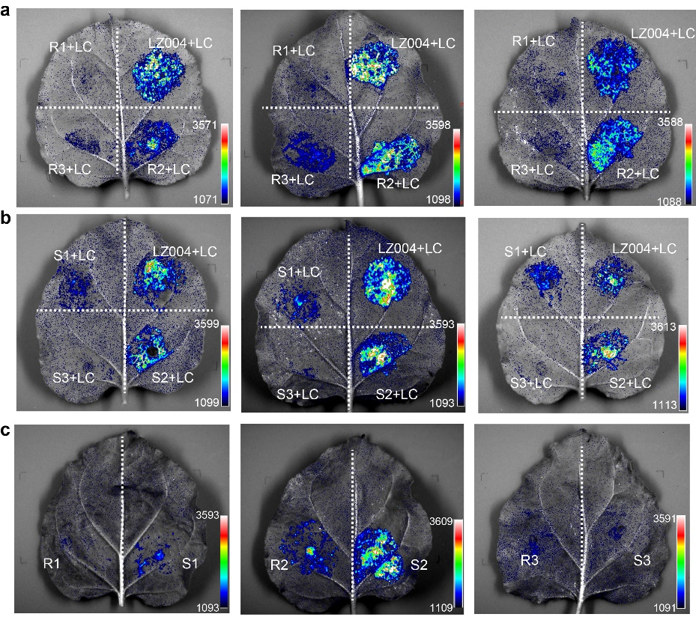
Supplementary Fig. 10 Biological replicates of dual-luciferase assay for three fragments of the OsNPF7.3 promoter.
Supplementary Fig. 11 EMSA verification of the binding of recombinant HIS-TF-DOF11 protein to the P2 fragment of OsNPF7.3^{Hap1} and OsNPF7.3^{Hap2}. The probe fragment was labeled with Cy5, covering the sequence of the DOF box.
Supplementary Fig. 12 Biological replicates of the regulatory effect of OsDOF11 on the P2 fragment of the OsNPF7.3 promoter. a Transactivation of the OsNPF7.3-P2 transcription activity by OsDOF11 in N. benthamiana leaves. b Statistical analysis of the results shown in a. Data represent mean ± s.d. (n = 4). Asterisks indicate statistical significance by two-tailed Student’s t-tests (*p < 0.05, ***p < 0.001, and n.s. indicates no significant difference).
Supplementary Fig. 13 Sequence comparison of the OsNPF7.3 CDS region between alkali-tolerant haplotype (G480) and alkali-sensitive haplotype (C1016) accessions.
Supplementary Fig. 14 Amino acid sequence comparison of OsNPF7.3 between alkali-tolerant haplotype (G480) and alkali-sensitive haplotype (C1016) accessions.
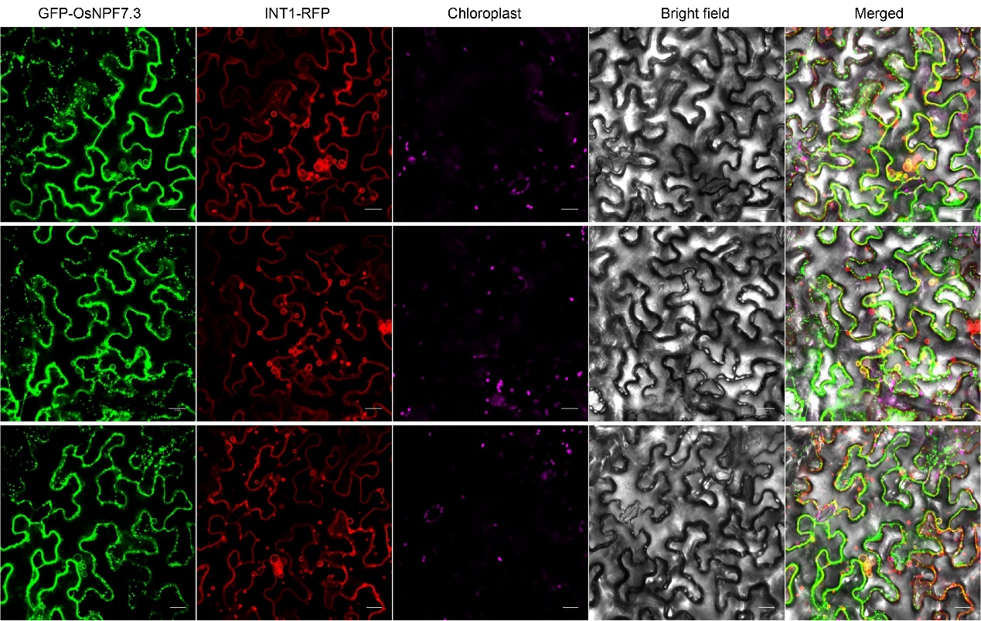
Supplementary Fig. 15 Biological replicates of the colocalization analysis between OsNPF7.3 and the vacuole membrane marker protein INT1 in N. benthamiana leaves. Scale bar = 20 μm.
Supplementary Fig. 16 Nitrate absorption analysis of OsNPF7.3 expressed in Xenopus laevis oocytes.
Supplementary Fig. 17 ¹⁵N ratios in different organs under control and alkaline stress conditions. a-f The ratio of ¹⁵N content in 3rd leaf and 1st leaf (a), in 3rd lead and stem (b), in 2nd leaf and root (c), 3rd lead and root (d), 2nd lead and stem (e), and in 1st leaf and root (f). Data represent mean ± s.d. (n ≥ 3). Asterisks indicate statistical significance by two-tailed Student’s t-tests (*p < 0.05, **p < 0.01 and ***p < 0.001, n.s. indicates no significant difference).
Supplementary Fig. 18 Transcriptome and metabolome analysis of OsNPF7.3-dependent genes associated with alkaline stress in rice. a, b Venn diagrams of DEGs (a) and DEMs (b) between OsNPF7.3 knockout mutant (KO) and WT (ZH11) under control and alkaline stress conditions. c, d KEGG pathway (c) and GO (d) enrichment analyses of DEGs.
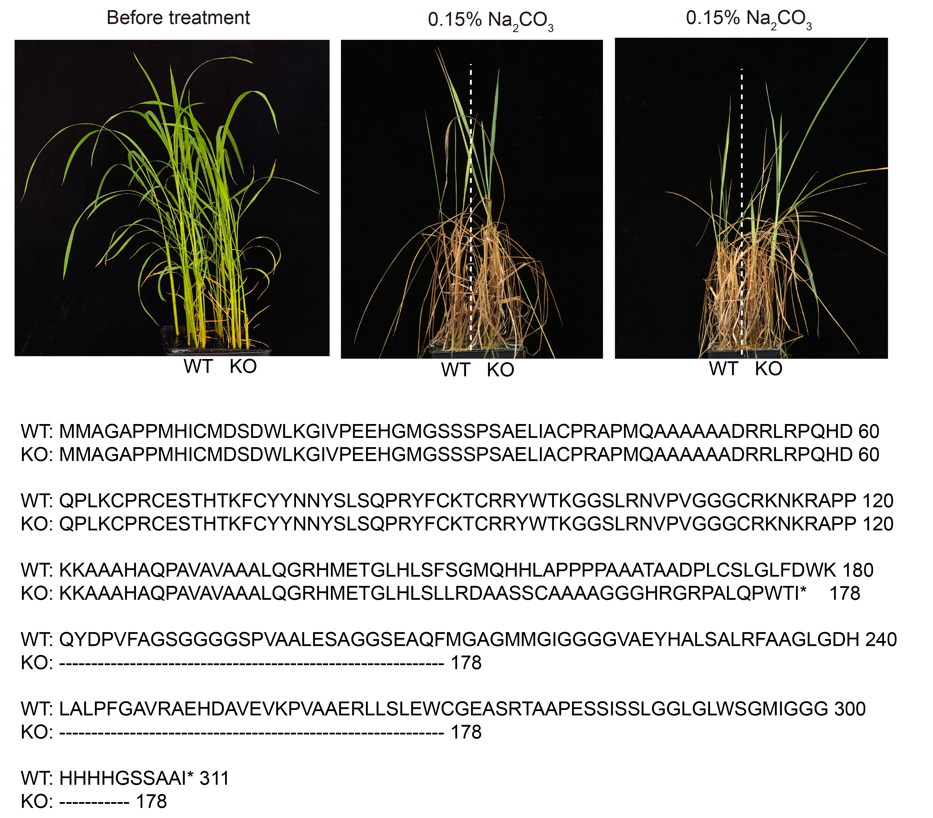
Supplementary Fig. 19 Phenotypic analysis of OsDOF11 knockout mutants under alkaline stress.

