Supplementary Figures

Fig. S1. SARS-CoV-2 does not infect Muse cells in vitro.
Messenger RNA expression of (A) ACE2 and TMPRSS2 and (B) CD147 and NRP1 in NIH/3T3 (SARS-CoV-2 resistant control), VeroE6/TMPRSS2 (SARS-CoV-2 sensitive control), Muse, and non-Muse cells is shown. Target gene expression was normalized with the housekeeping gene GUSB and expressed as 2^-ΔΔC_{T}. Averages ± standard deviations from triplicate samples are shown. (C-F) Cells were treated with 10^1.6 TCID₅₀/0.1 mL SARS-CoV-2 (Infect) or 0.1 mL saline (Mock), and triplicate samples were fixed at indicated time points. (C) Nuclei counts (left) and DAPI-stained area measurement (right) are shown for NIH/3T3, (D) VeroE6/TMPRSS2, (E) Muse, and (F) non-Muse cells. Bars in graphs denote standard deviations. Representative images from indicated time points are shown in the lower panel. Scale bars, 100 µm.
Fig. S2. Survival curves of SARS-CoV-2-infected cells in Vero cell media.
Cells were treated with 10^1.6 TCID₅₀/0.1 mL SARS-CoV-2 (Infect) or 0.1 mL saline (Mock) in Vero cell media, and triplicate samples were fixed at indicated time points. DAPI-stained nuclei area measurements are shown for (A) NIH/3T3, (B) VeroE6/TMPRSS2, (C) Muse, and (D) non-Muse cells. Orange circles denote infected, whereas green rectangles denote Mock (saline)-treated cells. Averages ± standard deviations from triplicates are shown. Representative images from indicated time points are shown in the lower panels. Scale bars, 100 µm. (E) TCID₅₀ of infected-cell supernatants from indicated time points were tested with VeroE6/TMPRSS2. Log₁₀ values of TCID₅₀ per 0.1 mL virus solution are shown. Bars indicate standard deviations. (F) SARS-CoV-2 nucleocapsid gene expression from supernatants of virus-infected cells was detected by RT-qPCR and 1/CT averages ± standard deviations from triplicates are shown.

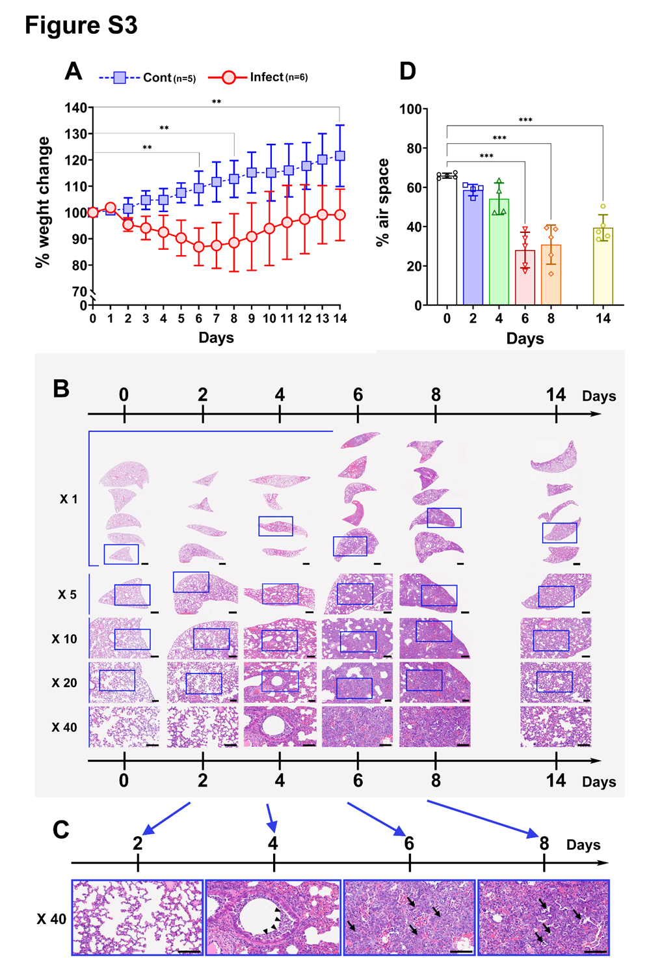
Fig. S3 Weight change and histopathology of SARS-CoV-2-infected hamster lungs.
(A) Weight change of SARS-CoV-2-infected (red) and control (blue) hamsters. Weight on the day of infection is set as 100%. Statistical analysis was performed by ANOVA with SPSS (version 27 IBM). p values < 0.05 are considered statistically significant. **p<0.01 between Day 0 and Day 6, Day 8, Day 14 groups. (B) hematoxylin and eosin (HE) staining of representative sections from day of infection are shown in low to high magnification X10 denotes a merged image of X5 objective fields and bars indicate 1 mm. Images from days 0, 2, 4, 6, 8, and 14 are shown at various magnifications. Label at the left (X50, X100, X200, and X400) denote magnification values. Insets in the lower magnification images are enlarged in the following higher magnification images. Bars in X1, X5, X10, X20, and X40 indicate 1 mm, 1 mm, and 250, 100, and 100 µm, respectively. (C) Images of X40 objective fields are shown enlarged. On day 4, neutrophil infiltration is focally observed in the bronchus. The alveolar structure is preserved. On day 4, the alveolar structure is focally destroyed by inflammatory infiltration. On day 6, destruction of the alveolar structure by inflammatory infiltration is more severe compared to that on day 4. The proliferation of type II pneumocytes with a gland-like structure is noted. On day 8, destruction of the alveolar structure by inflammatory infiltration is severe. The proliferation of type II pneumocytes with a gland-like structure is observed. Arrowheads indicate neutrophils (on day 4), whereas arrows denote type II pneumocytes (on day 6 and day 8). Bars, 50 µm. (D) Area of air space within the alveoli was measured and is expressed as percent of the whole area of the imaged lung HE-stained section. Day 6, Day 8, Day 14 groups vs. Day 0, ***p<0.001.

Figure S4
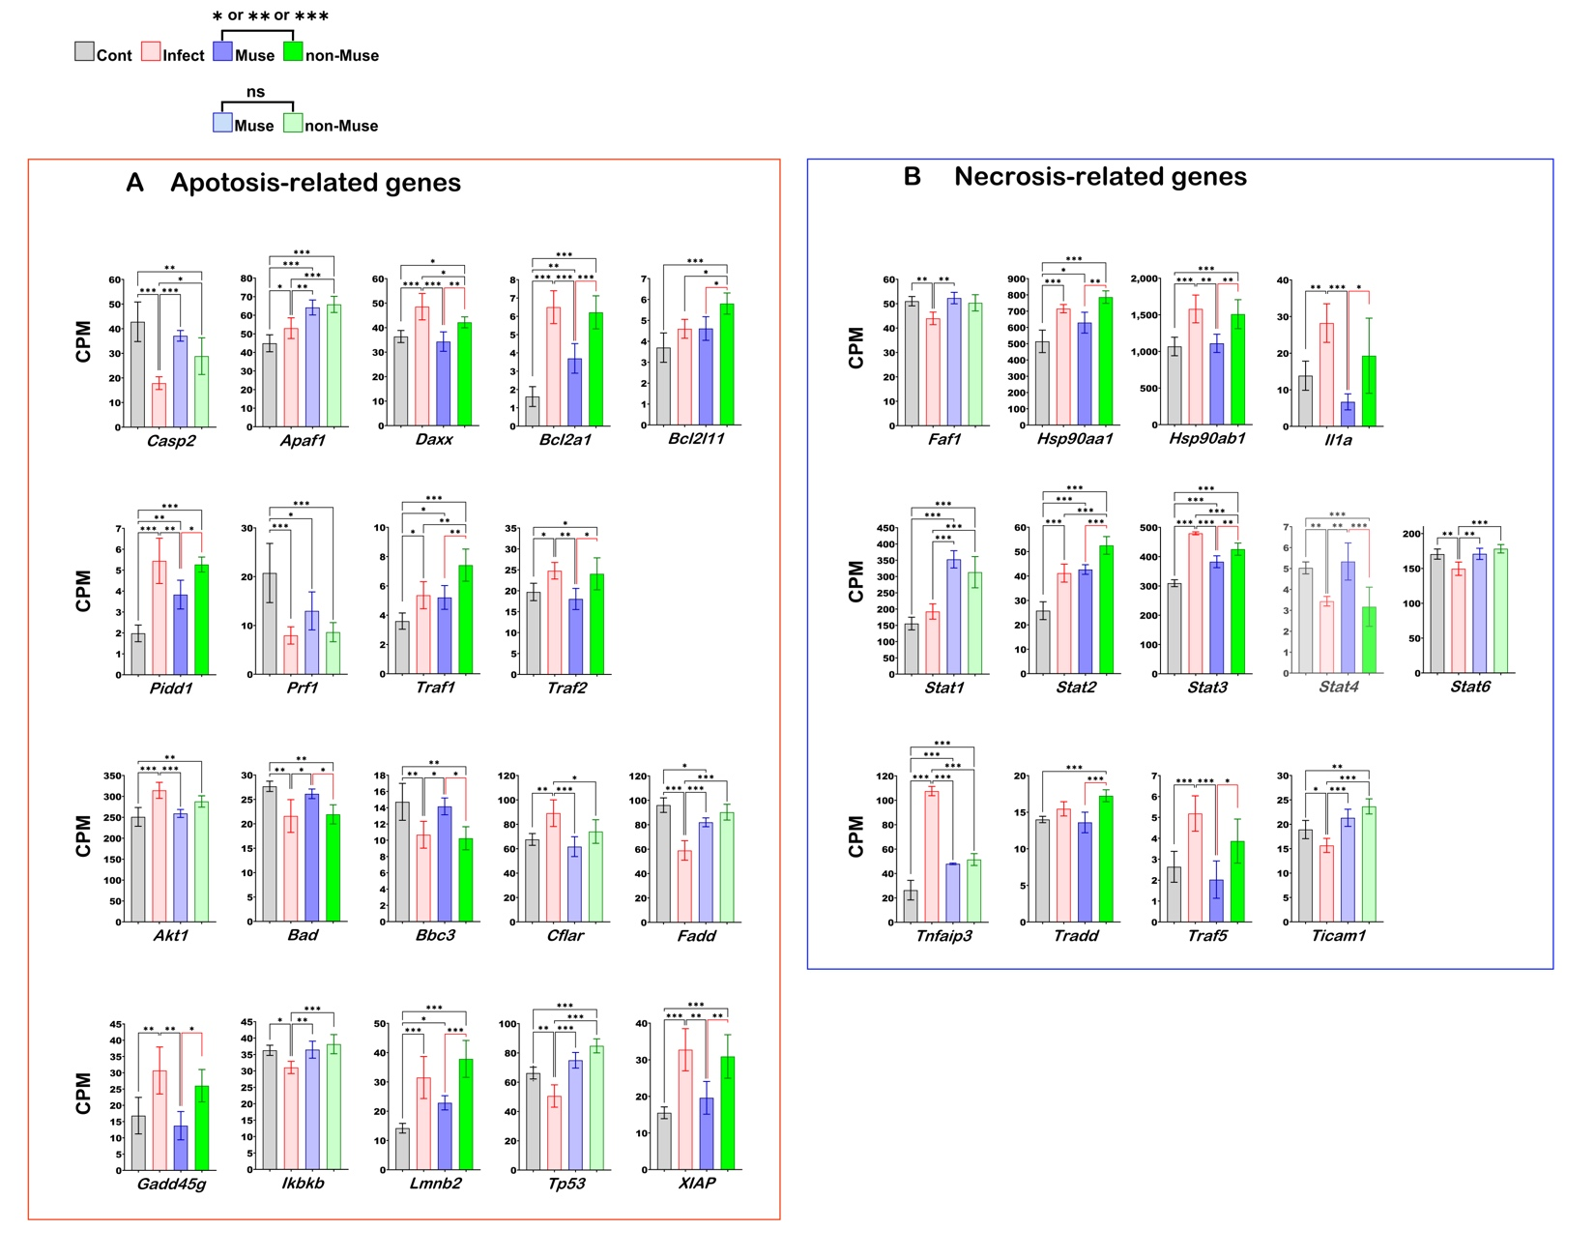
Fig. S4. Apoptotic and necrotic gene expression profiles from Muse cell-treated and SARS-CoV-2-infected hamster lungs.
(A) Apoptosis-related and (B) necrosis-related gene expression profiles from the lung RNA-seq are shown. *p<0.05, **p<0.01**and ***p<0.001.

Figure S5
Fig. S5. Fibrosis-related gene expression profiles from Muse cells-treated and SARS-CoV-2-infected hamster lungs.
Gene expression (CPM) for (A) vascular endothelial growth factor (Vegf), (B) platelet-derived growth factor (Pdgf), (C) fibroblast growth factor (Fgf), and (D) fibroblast growth factor receptor (Fgfr) families, and (E) other fibrosis-related factors. Gene expression profiles from the lung RNA-seq are shown. *p<0.05, **p<0.01, and ***p<0.001.
Figure S6
Fig. S6. Kyoto Encyclopedia of Genes and Genomes (KEGG) COVID-19 pathway analysis based on differential gene expression between Muse and non-Muse groups (expression ratio: Muse/non-Muse).
Counts per million mapped reads (CPM) data for genes expressed in the lungs with a p-value <0.05 and |logFC|>1 (indicating >two-fold change) after treatment with Muse or non-Muse cells were analyzed according to the KEGG COVID-19 pathway. Downregulated genes are shown in A and upregulated genes are shown in B.

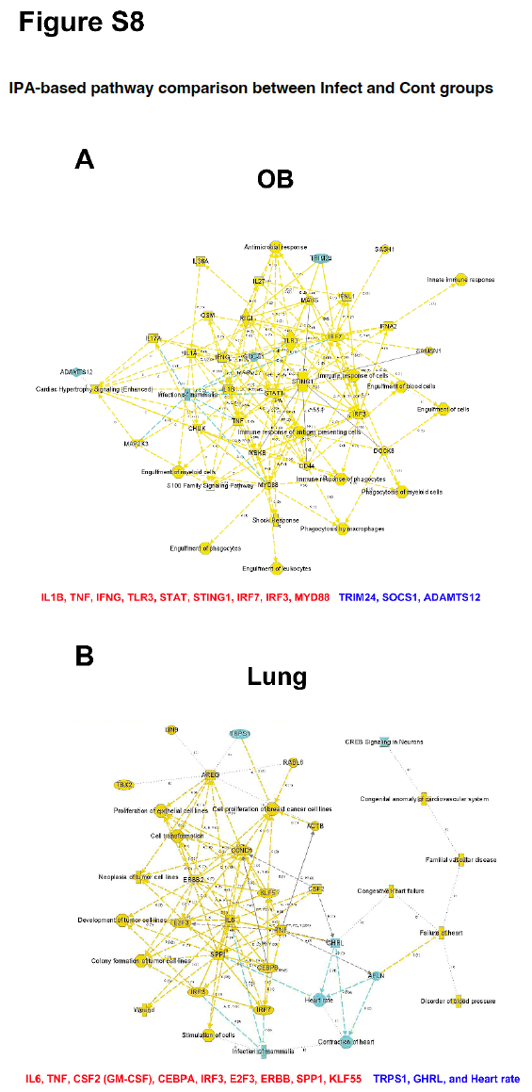
Figure S7

Fig. S7. IPA-based pathway comparison between Infect and Cont groups.
Gene expression profiles are compared in (A) the olfactory bulbs and (B) the lung. In the diagram, yellow indicates upregulated genes, whereas blue indicates downregulated genes in the Infect group relative to the Cont group. Genes of interest are summarized below each panel: red (higher expression in the Infect group) or blue (lower expression in the Infect group).

Figure S8
Fig. S8. Ingenuity pathway analysis (IPA) highlighting genes with opposite expression patterns in olfactory bulb and lung following SARS-CoV-2 infection.
This pathway analysis includes genes from Fig. 8A (Patterns A and B) as well as additional differentially expressed genes identified from RNA-seq (Table 1). The IPA diagrams depict expression changes between the Infect and Cont groups in olfactory bulb (OB) and lung tissues. Blue depicts genes downregulated in the Infect group compared with the Cont group. Yellow and red represent genes upregulated in the Infect group compared with the Cont group, with red indicating greater expression intensity. Green indicates no change in the expression. Genes of interest are shown at the bottom of the panel, with red indicating higher expression and blue indicating lower expression in the Infect group.

Figure S9
Fig. S9
We indicated additional 54 genes expression profiles from the olfactory bulb (OG) lung (Lung) RNA-seq are shown the RNA-seq data that displayed patterns consistent with Pattern A or Pattern B (Fig. 8A). The gene data (CPM) obtained by RNA-seq were analyzed with one-way ANOVA (*p<0.05, **p<0.01, ***p<0.001) with black lines. We used edgeR [E] program to detect the differentially expressed genes (DEGs). Normalized counts per million (CPM) values, log fold-changes (logFC) and p-values were obtained from the gene-level raw counts with red bidirectional arrow ( ). We further performed an unpaired t-test with blue lines ( ).
(†<0.1, *p<0.05, **p<0.01).

Figure S10
Fig. S10. Pathology of SARS-CoV-2-infected hamsters in the four groups: Infect, Cont, Muse, non-Muse.
(A) Schematic presentation of the experimental procedure. On day 0, Syrian hamsters were intranasally inoculated with SARS-CoV-2. AT 2 days post-infection (2 DPI), infected hamsters were injected intravenously with 5 X 10⁴ Muse cells (Muse, n=4), 5 X 10⁴ non-Muse cells (non-Muse, n=4), vehicle (saline, Infect, n=4). Controls (Cont, n=4) were not infected with SARS-CoV-2. Animals were killed at 6 DPI, and the lungs were harvested. (B) Changes in body weight, expressed as a percentage of baseline, for individual animals (B1, B3) and group means (B2, B4). Panels B1 and B2 show weight changes normalized to Day 0 (baseline = 100%), while panels B3 and B4 are normalized to Day 2 post-inoculation (2 DPI = 100%). (B2 and B4) average trace (%) between Muse and non-Muse groups. ns; not significant. The number of animals in each group is provided in the parentheses in the legend. (C) Representative HE-stained lung images are shown from each group. Scale bar, 2 mm. (D) Air space (%) corresponding to tissues from (C) are plotted. *p<0.05.

