Supplementary Material for “Illustrating the Assumptions of Meta-Regression in Treatment Networks”

Table of Contents
1. Table of Contents 1
2. Covariate Centering 2
3. Clinical Example and Detailed Analysis Results 9
4. Visualization Tools 11
1. Figure Toolkit 13
1.1. Comparison Adjusted Firefly Plots 13
1.2. Network Forest Plots 15
1.3. Fairylight Plot 20
1.4. Model Flashlight 21
2. List of Detailed Result Tables for the Clinical Example 21
5. References 22

Covariate Centering
Mean centering a covariate aligns model estimates with the observed region of the covariate distribution. Under this approach, the adjusted treatment effect represents the expected effect for a study with the average covariate value, improving interpretability by anchoring estimates within the plausible data range¹. In MCMC implementations, centering at the mean may also improve chain mixing and is generally recommended to support model convergence and estimation^{2,3}.
In consistency models, the centered value does not influence the interpretation and extrapolation of model estimates for interactions or treatment effects at other covariate values. Using hypothetical data from a densely connected network shown in Table 1, we implement the independent consistency model with and without mean centering. As shown in Table 2, the estimated treatment effect is identical in the frequentist implementation when predictions are made for $C=0$, confirming that mean centering does not alter estimation in this setting. Though not required, mean centering is still beneficial for ensuring that the adjusted treatment effect represent meaningful covariate values in consistency models.
In UMIE models, the choice of centering value affects both interpretation and estimation. While UMIE models do not enforce consistency in the treatment-by-covariate interactions, they require consistency in the adjusted treatment effects, $d_{hk}$, which represent the expected treatment effect at covariate value, $C=0$. Changing the centered value may shift both the estimated interactions and adjusted treatment effects depending on the available data. Using the data in Table 1, we implement the independent UMIE model with and without mean centering. The estimated treatment effects for the two centering strategies are differ in the centering strategies in both the frequentist and Bayesian implementations, highlighting the importance of the centering strategy (Table 3). While mean centering is often a practical default, alternative reference values may be more clinically meaningful and should be considered when specifying the model.

study | C_{study} | events  1 | events  2 | events  3 | n  1 | n  2 | n  3 | treat  1 | treat  2 | treat  3 | Favored  Status 1 | Favored  Status 2 | Favored  Status 3
1 | 0.784 | 2 | 17 | 20 | 92 | 92 | 92 | A | B | D | 0 | 1 | 1
2 | 0.545 | 4 | 9 | NA | 51 | 51 | NA | A | B | NA | 0 | 1 | NA
3 | 0.922 | 1 | 16 | NA | 67 | 67 | NA | A | C | NA | 0 | 1 | NA
4 | 0.723 | 20 | 12 | NA | 71 | 71 | NA | B | C | NA | 0 | 1 | NA
5 | 0.830 | 6 | 25 | NA | 56 | 56 | NA | A | C | NA | 0 | 1 | NA
6 | 0.968 | 12 | 53 | 65 | 91 | 91 | 91 | A | B | D | 0 | 1 | 1
7 | 0.563 | 20 | 46 | 53 | 66 | 66 | 66 | A | B | D | 0 | 1 | 1
8 | 0.867 | 2 | 8 | NA | 52 | 52 | NA | A | C | NA | 0 | 1 | NA
9 | 0.883 | 22 | 59 | NA | 74 | 74 | NA | A | C | NA | 0 | 1 | NA
10 | 0.798 | 2 | 5 | 16 | 71 | 71 | 71 | A | B | D | 0 | 1 | 1
11 | 0.725 | 1 | 8 | 19 | 83 | 83 | 83 | A | B | D | 0 | 1 | 1
12 | 0.952 | 14 | 49 | NA | 72 | 72 | NA | A | B | NA | 0 | 1 | NA
13 | 0.647 | 3 | 17 | 22 | 95 | 95 | 95 | A | B | D | 0 | 1 | 1
14 | 0.754 | 18 | 60 | 56 | 93 | 93 | 93 | A | B | D | 0 | 1 | 1
15 | 0.508 | 9 | 21 | NA | 87 | 87 | NA | B | C | NA | 0 | 1 | NA
16 | 0.611 | 5 | 8 | NA | 58 | 58 | NA | A | B | NA | 0 | 1 | NA
Table 1: Example Data for Covariate Centering

 |  | Centered at Mean |  |  |  |  |  | Centered at 0
 | Comparator,  Reference | Bayesian |  |  | Frequentist |  | Bayesian |  |  |  | Frequentist
 | Comparator,  Reference | Posterior  Mean | Posterior  SD | Rhat | Mean | SE | Posterior  Mean |  | Posterior  SD | Rhat | Mean | SE
Interaction | B,A | 2.518 | 1.349 | 1.000 | 1.544 | 0.984 | 2.299 |  | 1.434 | 1.217 | 1.544 | 0.984
Interaction | C,A | 0.372 | 2.024 | 1.001 | -0.763 | 1.656 | 1.441 |  | 2.117 | 1.082 | -0.763 | 1.656
Interaction | D,A | 2.229 | 1.726 | 1.001 | 1.751 | 1.059 | 1.591 |  | 2.086 | 1.439 | 1.751 | 1.059
Interaction | C,B | -2.147 | 1.878 | 1.002 | -2.307 | 1.569 | -0.858 |  | 1.861 | 1.007 | -2.307 | 1.569
Interaction | D,B | -0.289 | 1.577 | 1.001 | 0.207 | 0.640 | -0.708 |  | 1.607 | 1.150 | 0.207 | 0.640
Interaction | D,C | 1.857 | 2.361 | 1.002 | 2.514 | 1.659 | 0.150 |  | 2.499 | 1.078 | 2.514 | 1.659
Adjusted Treatment Effect when C=0 | B,A | -0.037 | 1.043 | 1.000 | 0.066 | 0.763 | 0.096 |  | 1.114 | 1.218 | 0.066 | 0.763
Adjusted Treatment Effect when C=0 | C,A | 1.688 | 1.629 | 1.001 | 1.800 | 1.332 | 0.858 |  | 1.696 | 1.089 | 1.800 | 1.332
Adjusted Treatment Effect when C=0 | D,A | 0.688 | 1.323 | 1.000 | 0.128 | 0.810 | 1.154 |  | 1.597 | 1.445 | 0.128 | 0.810
Adjusted Treatment Effect when C=0 | C,B | 1.725 | 1.408 | 1.002 | 1.734 | 1.188 | 0.762 |  | 1.384 | 1.006 | 1.734 | 1.188
Adjusted Treatment Effect when C=0 | D,B | 0.726 | 1.210 | 1.001 | 0.062 | 0.465 | 1.058 |  | 1.238 | 1.147 | 0.062 | 0.465
Adjusted Treatment Effect when C=0 | D,C | -1.000 | 1.820 | 1.002 | -1.672 | 1.261 | 0.297 |  | 1.902 | 1.069 | -1.672 | 1.261
Table 2: Independent Consistency: Results for Covariate Centering Strategies

 |  | Centered at Mean |  |  |  |  | Centered at 0
 | Comparator,  Reference | Bayesian |  |  | Frequentist |  | Bayesian |  |  | Frequentist
 | Comparator,  Reference | Posterior  Mean | Posterior  SD | Rhat | Mean | SE | Posterior  Mean | Posterior  SD | Rhat | Mean | SE
Interaction | B,A | 2.118 | 1.219 | 1.000 | 1.327 | 0.996 | 2.544 | 1.317 | 1.038 | 1.360 | 0.967
Interaction | C,A | 11.266 | 5.301 | 1.000 | 5.695 | 4.611 | -2.506 | 3.036 | 1.001 | -3.203 | 2.260
Interaction | D,A | 2.040 | 1.521 | 1.003 | 1.570 | 1.069 | 2.241 | 1.510 | 1.032 | 1.601 | 1.023
Interaction | C,B | -7.984 | 3.141 | 1.001 | -5.881 | 2.855 | -7.078 | 3.824 | 1.012 | -6.037 | 2.871
Interaction | D,B | 1.416 | 315.964 | 1.000 | 0.000 | NA | 1.321 | 316.730 | 1.000 | 0.000 | NA
Interaction | D,C | 1.072 | 316.208 | 1.000 | 0.000 | NA | 1.421 | 317.375 | 1.000 | 0.000 | NA
Adjusted Treatment Effect when C=0 | B,A | 0.219 | 0.939 | 1.000 | 0.195 | 0.768 | -0.126 | 1.016 | 1.037 | 0.161 | 0.747
Adjusted Treatment Effect when C=0 | C,A | -7.604 | 4.477 | 1.000 | -3.721 | 3.066 | 4.395 | 2.630 | 1.001 | 4.037 | 1.951
Adjusted Treatment Effect when C=0 | D,A | 0.787 | 1.161 | 1.001 | 0.237 | 0.832 | 0.620 | 1.162 | 1.032 | 0.192 | 0.781
Adjusted Treatment Effect when C=0 | C,B | 5.112 | 2.011 | 1.001 | 3.823 | 2.524 | 4.521 | 2.409 | 1.013 | 3.876 | 1.816
Adjusted Treatment Effect when C=0 | D,B | -0.560 | 238.553 | 1.000 | 0.225 | NA | 0.746 | 1.082 | 1.005 | 0.031 | NA
Adjusted Treatment Effect when C=0 | D,C | 0.616 | 238.739 | 1.000 | 0.843 | NA | -3.775 | 2.663 | 1.008 | -3.845 | NA
Table 3: Independent UMIE: Results for Covariate Centering Strategies

Clinical Example and Detailed Analysis Results
The clinical example dataset contains 10 treatments and has been previously analyzed in demonstrations of network meta-analysis^{4–6}. Some comparisons (e.g., acarbose vs sulfonylurea), are sparse, whereas others (e.g., placebo vs rosiglitazone), were well connected. We extracted study year from study labels, calculated the standard errors from reported measures, and generated two hypothetical sponsorship variables to highlight different operationalizations for similar concepts. We implemented analyses using netmeta for frequentist implementation and JAGSUI in R for Bayesian implementation. Results for both NMA implementations are available in supplementary Table 4. The netmeta implementation corresponds to the frequentist implementation for consistency models available in github.
The NMR models under consistency examined study year, standard error, and hypothetical study sponsorship as covariates. Supplementary Table 5, Table 6, and Table 7 show the frequentist and Bayesian results for each covariate in the independent NMR models under consistency. All Bayesian credible intervals for adjusted treatment effects and interactions included the Frequentist point estimates. Most confidence intervals for adjusted treatment effects and interactions included the Bayesian posteriors, except in the sulfonylurea vs placebo comparison. In this comparison, Bayesian estimates showed greater uncertainty for the interaction, contributing to slight differences in the adjusted treatment effect between methods. Supplementary Table 8, Table 9, and Table 10 show the frequentist and Bayesian results for each covariate in the common NMR models under consistency. All Bayesian point estimates were within the frequentist confidence intervals and vice versa indicating strong agreement between the implementations.
For the common UMIE model, we introduced a hypothetical treatment sponsorship variable with potential clinical meaning as a directionality variable. We used study year and standard error as covariates. Supplementary Table 11 and Table 12 show the results for each covariate. All Bayesian credible intervals for adjusted treatment effects and interactions include the Frequentist point estimates. In contrast, though the confidence intervals for all adjusted treatment effects include the Bayesian posterior, this does not occur for the estimated interaction. Again, the Bayesian interaction estimates reported considerable uncertainty, which may lead to the slight discrepancy in the estimated interactions in both implementations of the common UMIE models.
Independent UMIE models were implemented with two different directionality parameters. Supplementary Table 13 and Table 14 present results using treatment sponsorship as a directionality parameter, with study year and standard error as covariates. We also implemented models using treatment order as a directionality parameter, which supports identifiable and reversible comparisons as shown in supplementary Table 15, Table 16, and Table 17 with study year, standard error, and hypothetical study sponsorship as covariates. Again, all Bayesian credible intervals for adjusted treatment effects and interactions include the Frequentist point estimates. Although most confidence intervals for adjusted treatment effects and interactions include the Bayesian posterior, an exception occurs for the adjusted treatment effect in some comparisons such as sulfonylurea vs acarbose. In these cases, the Bayesian interaction estimates reported considerable uncertainty, which may lead to the slight discrepancy in the estimates between of both implementations of the independent UMIE model.
Forest plots are often used to visualize network meta-analysis results. Traditionally, forest plots show the point estimate and confidence interval for each treatment relative to a common comparator, with a vertical line indicating the threshold of no treatment benefit. When extended for NMR, each treatment effect $d_{hk}$ represents the treatment effect at a specific value of the covariate, such as the year 1994 in this example. Additionally, the plot contains the interactions for each treatment comparison. The vertical line at zero represents the threshold of no treatment benefit for treatment effects and the threshold of no interaction for interactions $β_{hk}$.

Visualization Tools
Comparison-adjusted firefly plots visualize covariate-related asymmetry in treatment effects across models. These plots extend the concept of comparison-adjusted funnel plots to incorporate additional covariates other than standard error, enabling exploration of interactions within treatment networks⁷. Comparison-adjusted firefly plots for all treatments relative to a specific reference treatment allow the exploration of interaction structure under the consistency assumption (Figure 2), whereas corresponding plots with directionality parameters enable the interaction structures for potential UMIE models (Figure 1).
The x-axis represents the covariate of interest and the y-axis captures the difference between study-level effects and their corresponding meta-analytic estimates. Symmetry around zero suggests no interaction between the covariate and treatment effects. Asymmetry signals potential interaction and can be quantified using NMR. Color-coded points can reveal asymmetry within specific comparisons. If patterns of asymmetry are similar across comparisons, regardless of whether comparisons are defined relative to a given reference or across comparisons for a given directionality parameter, a common interaction model may be suitable. Where asymmetry varies across comparisons, independent interaction structures may be more appropriate. Optionally included confidence regions for relevant NMR estimates incorporate uncertainty of treatment effect estimates in both UMIE and consistency-based settings.
Extended network forest plots visualize both treatment effects and interactions across models. Traditional forest plots were adapted to show treatment effects at a fixed covariate value (e.g., study year 1994) along with interaction estimates.
For NMR models with consistency, such as independent models with consistency (Figure 3) and the common model with consistency (Figure 4), interactions can be visualized relative to a common comparator, such as placebo in this example. For the UMIE models, although treatment effects remain consistent, interactions are no longer consistent by definition, and thus should be explored individually. As a result, the y-axis for interactions in the independent UMIE (Figure 5 and Figure 6) and common UMIE (Figure 7) extended network forest plots includes more potential comparisons than the y-axis for treatment effects.
For comparisons between models, the Fairy Light Plot extends network forest plots by incorporating multiple models in a forest plot for treatment effects, illustrating the impact of model selection on adjusted treatment effects (Figure 8). Due to the consistency of treatment effects in each model, treatment effects are visualized relative to a common comparator for a specific covariate value for multiple models simultaneously. Each model is distinguished by color or symbol.
The multi-model flashlight plots shows examine treatment effects across covariate values (Figure 9). This plot simultaneously illustrates estimated treatment effects and their uncertainty for a single treatment comparison (e.g., metformin vs placebo) across different models and covariate values.

Figure Toolkit

Comparison Adjusted Firefly Plots
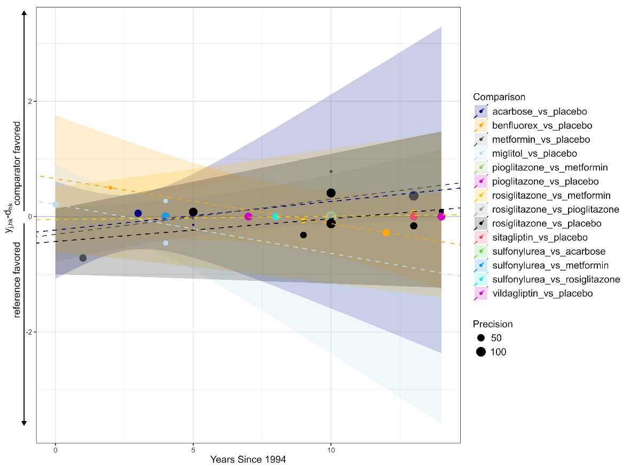
Figure 1 Comparison Adjusted Firefly Plot with Treatment Order as Direction
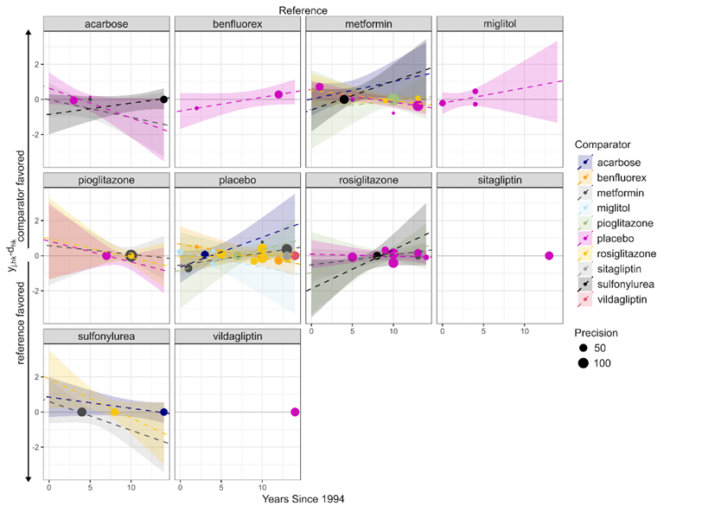
Figure 2 Comparison Adjusted Firefly Plot For all Each Treatment as Reference

Network Forest Plots
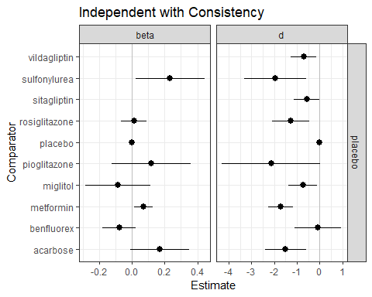
Figure 3: Estimates for Treatments Compared to Placebo: Independent Consistency Model

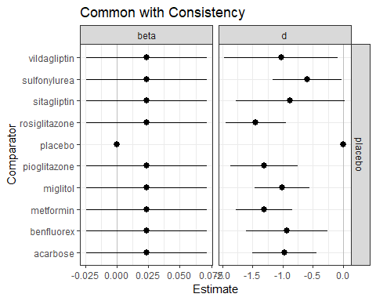
Figure 4: Estimates for Treatments Compared to Placebo: Common Consistency Model

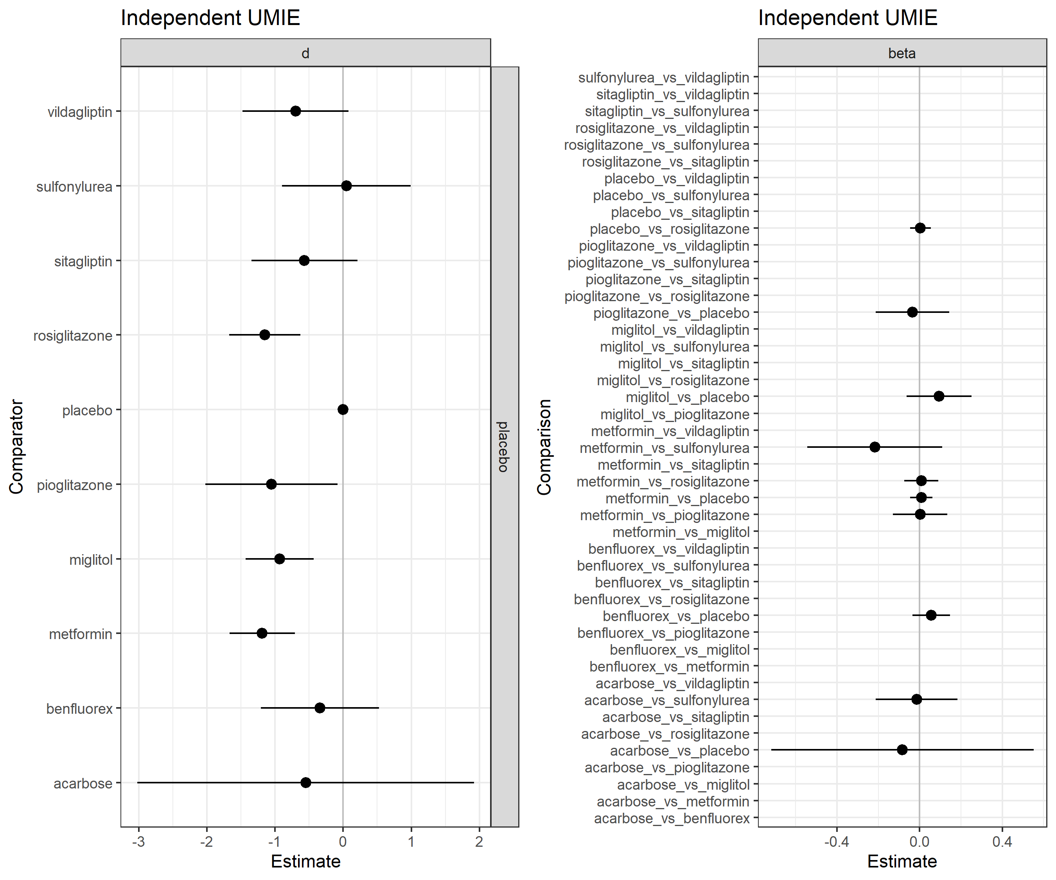
Figure 5: Estimates for Treatments Compared to Placebo: Independent UMIE Model and Treatment Order as Direction
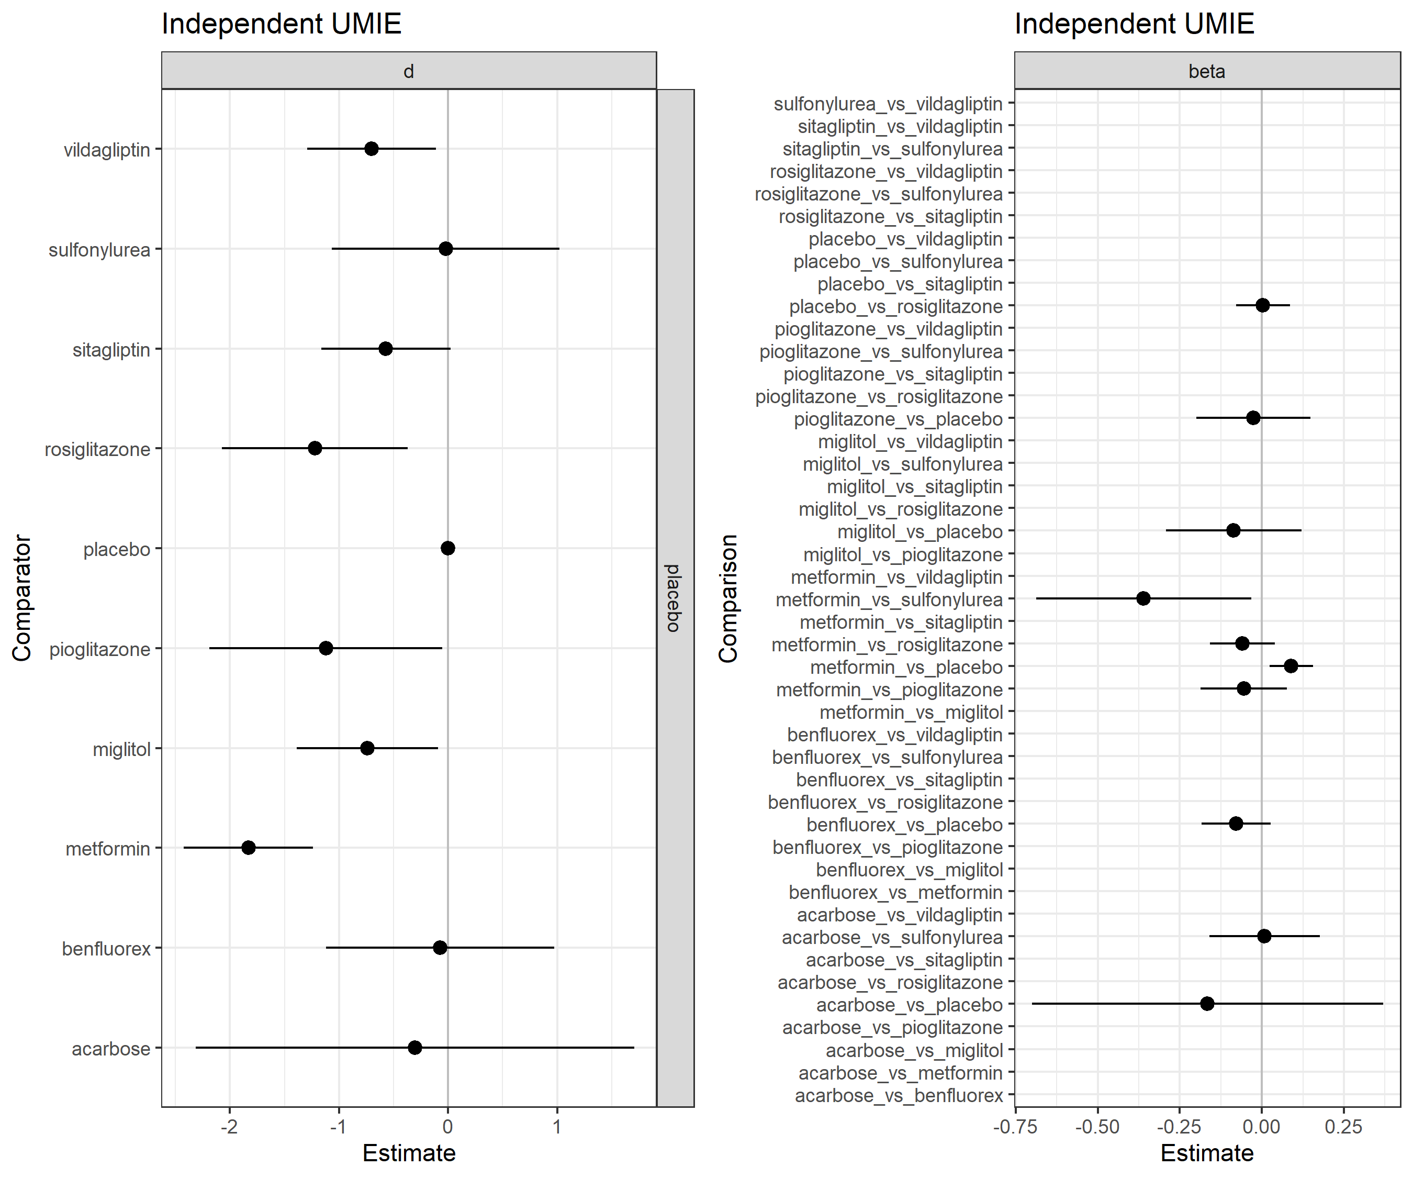
Figure 6: Estimates for Treatments Compared to Placebo: Independent UMIE Model and Hypothetical Treatment Sponsorship as Direction
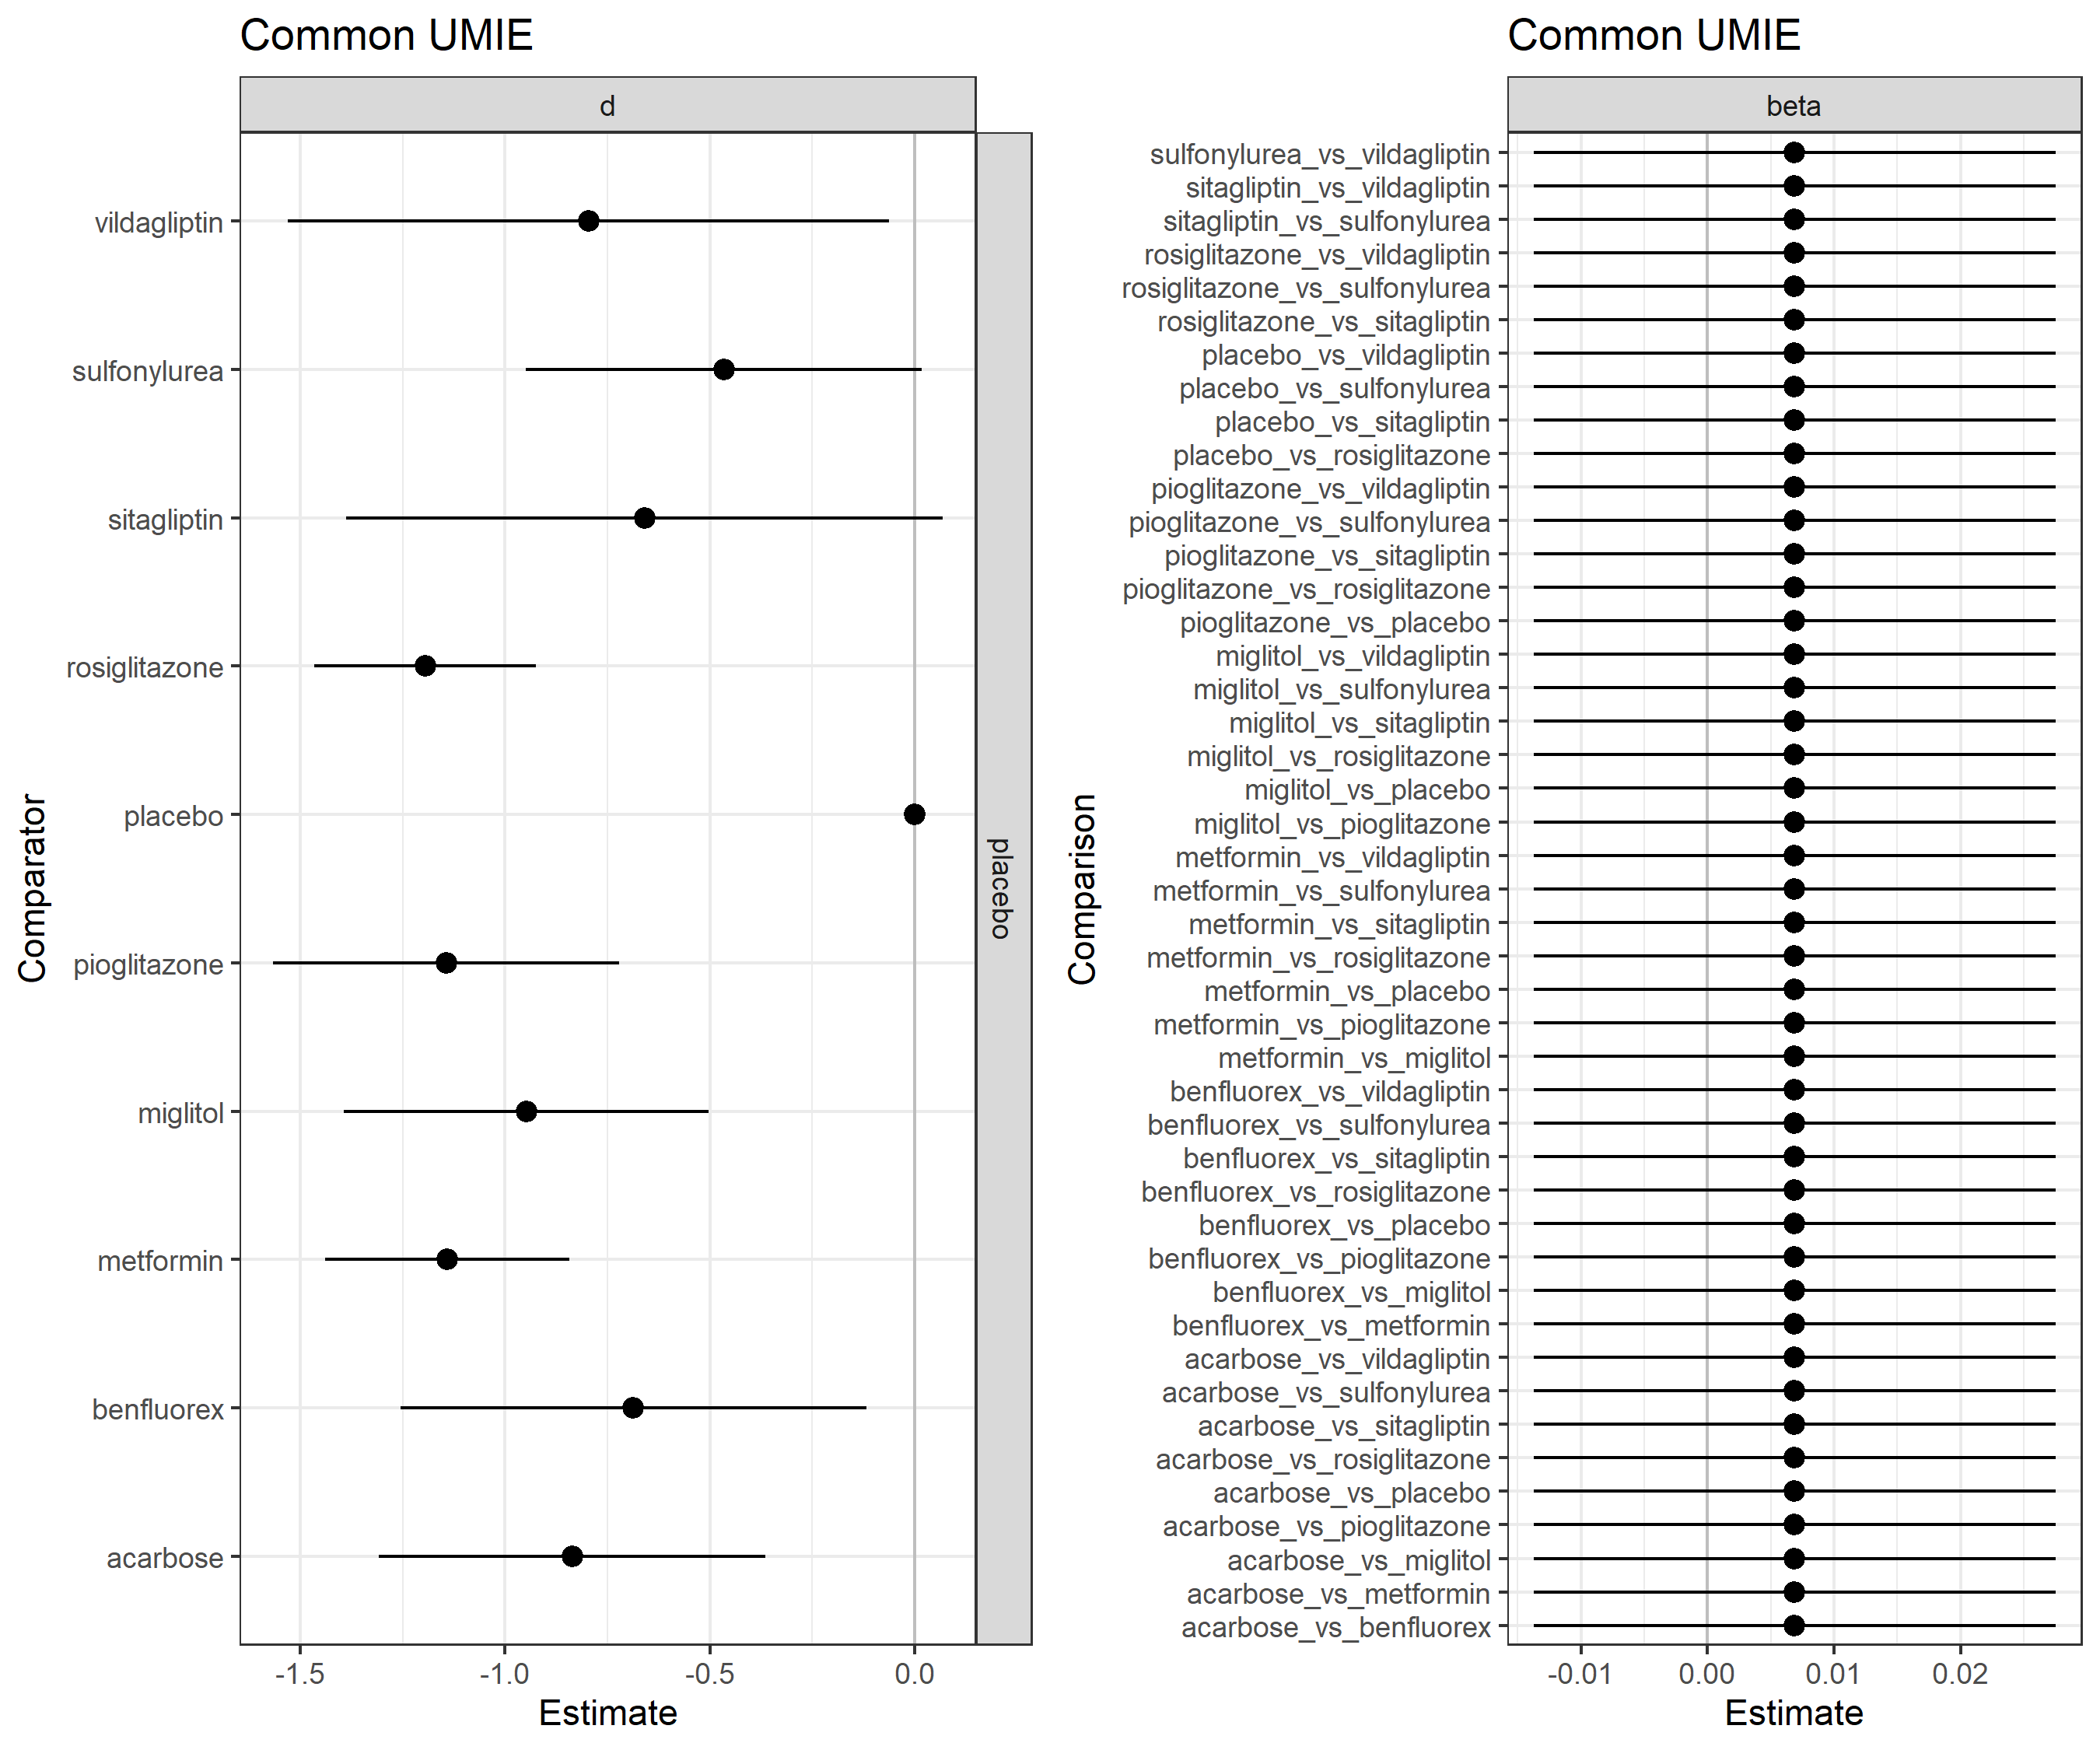
Figure 7: Estimates for Treatments Compared to Placebo: Common UMIE Model and Hypothetical Treatment Sponsorship as Direction

Fairylight Plot
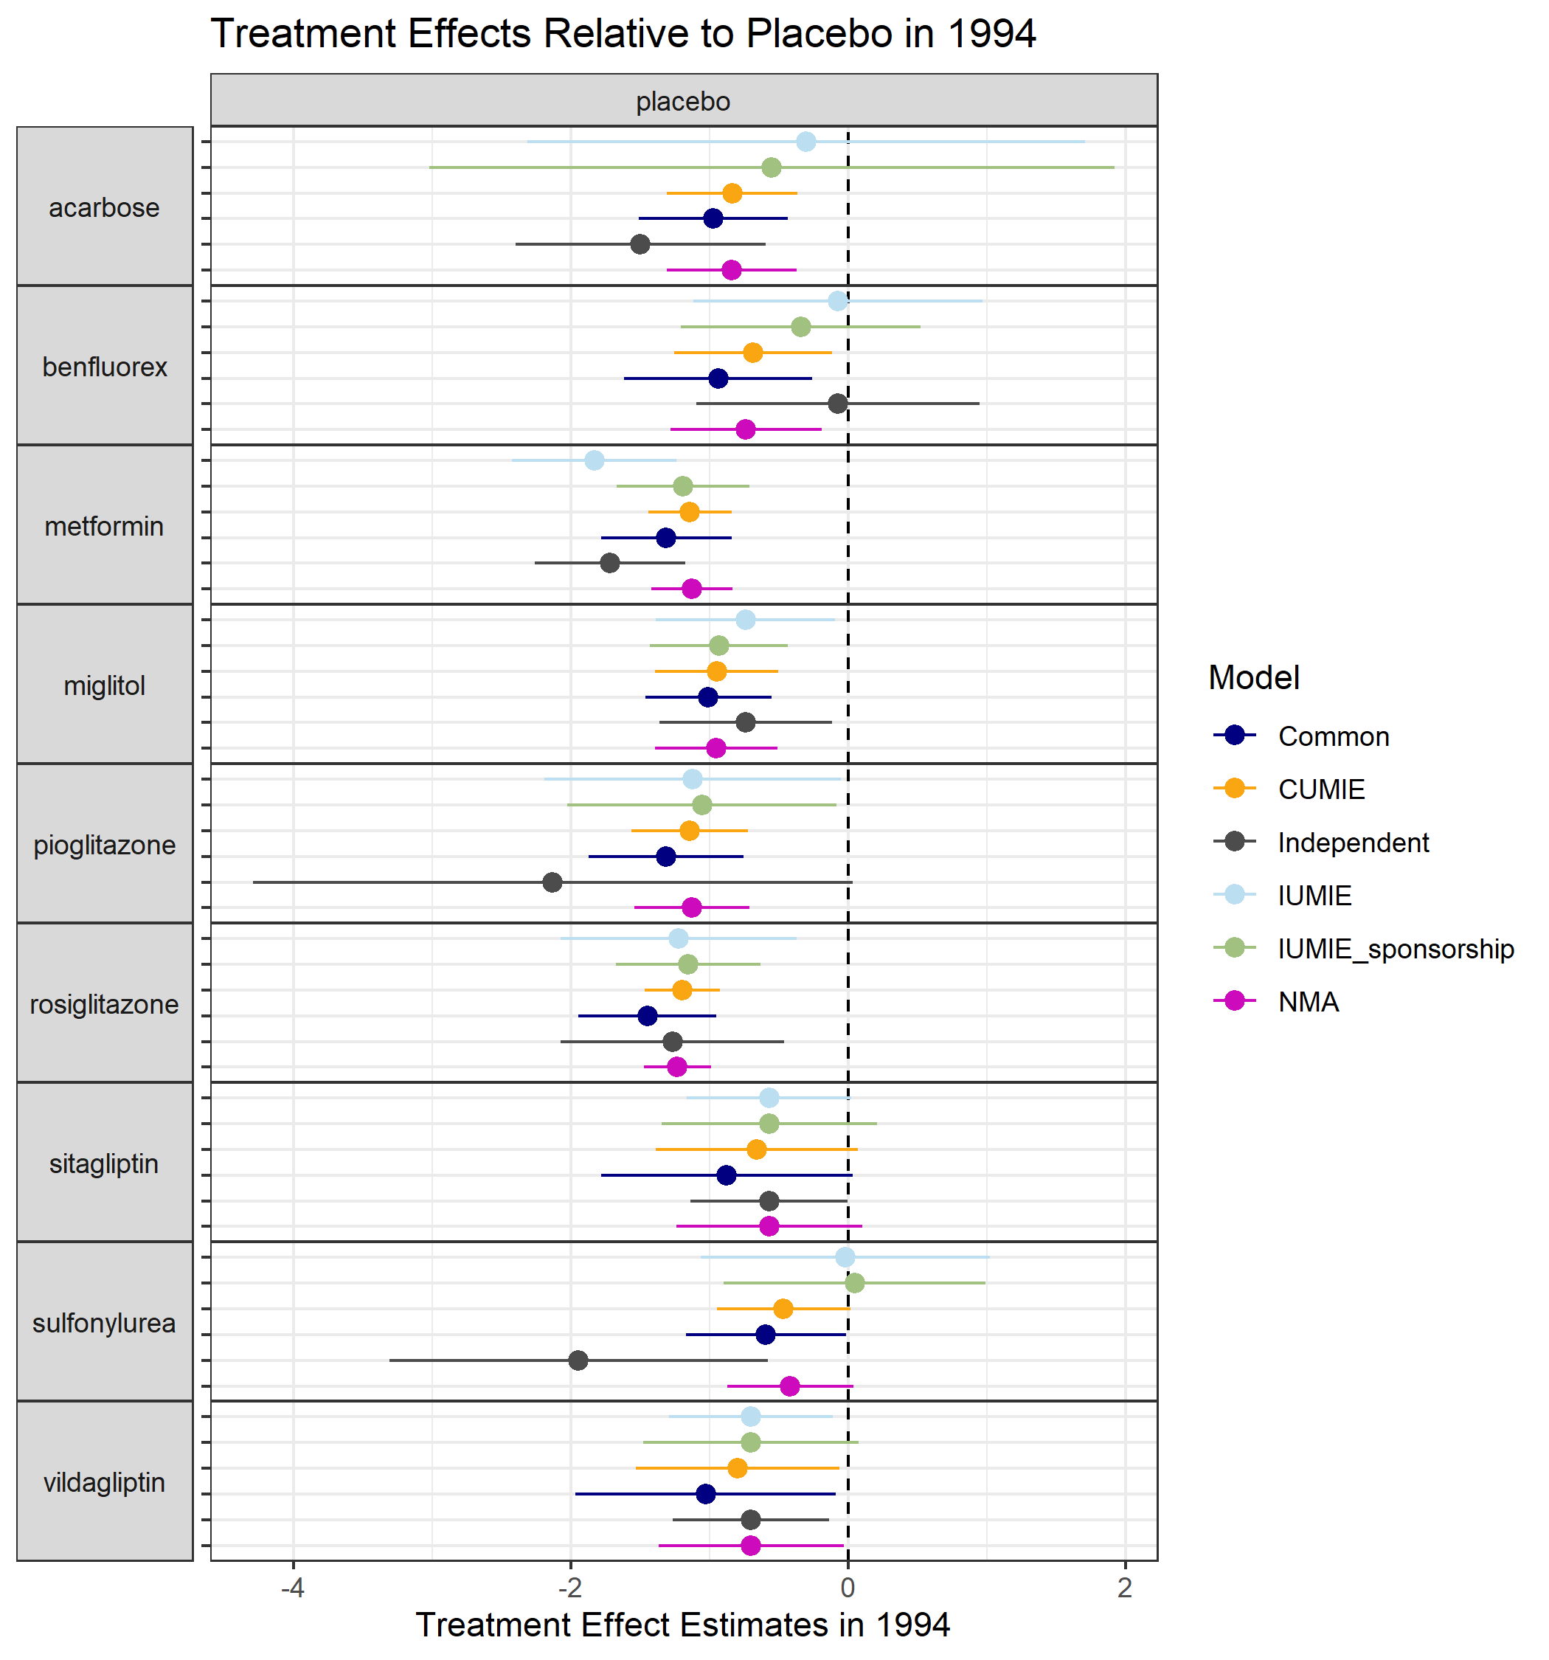
Figure 8: Treatment Effects Relative to Placebo in 1994

Model Flashlight
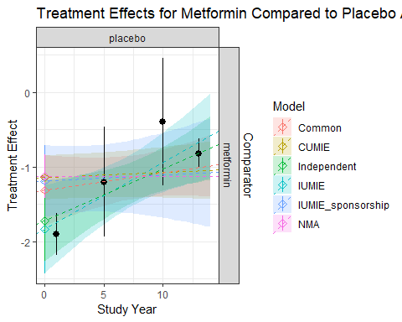
Figure 9: Treatment Effects for Metformin Compared to Placebo across All Study Years

List of Detailed Result Tables for the Clinical Example
Table 4: Frequentist and Bayesian NMA results
Table 5: Frequentist and Bayesian NMR: Independent Consistency Model: Study Year as Covariate
Table 6: Frequentist and Bayesian NMR: Independent Consistency Model: Standard Error as Covariate
Table 7: Frequentist and Bayesian NMR: Independent Consistency Model: Hypothetical Study Sponsorship as Covariate
Table 8: Frequentist and Bayesian NMR: Common Consistency Model: Study Year as Covariate
Table 9: Frequentist and Bayesian NMR: Common Consistency Model: Standard Error as Covariate
Table 10: Frequentist and Bayesian NMR: Common Consistency Model: Hypothetical Study Sponsorship as Covariate
Table 11: Frequentist and Bayesian NMR: Common UMIE Model: Study Year as Covariate
Table 12: Frequentist and Bayesian NMR: Common UMIE Model: Standard Error as Covariate
Table 13: Frequentist and Bayesian NMR: Independent UMIE Model: Study Year as Covariate and Hypothetical Treatment Sponsorship as Direction
Table 14: Frequentist and Bayesian NMR: Independent UMIE Model: Standard Error as Covariate and Hypothetical Treatment Sponsorship as Direction
Table 15: Frequentist and Bayesian NMR: Independent UMIE Model: Study Year as Covariate and Treatment Order as Direction
Table 16: Frequentist and Bayesian NMR: Independent UMIE Model: Standard Error as Covariate and Treatment Order as Direction
Table 17: Frequentist and Bayesian NMR: Independent UMIE Model: Hypothetical Study Sponsorship as Covariate and Treatment Order as Direction

References
1. Paccagnella O. Centering or Not Centering in Multilevel Models? The Role of the Group Mean and the Assessment of Group Effects. Eval Rev. 2006;30(1):66-85. doi:10.1177/0193841X05275649
2. Dias S, Sutton AJ, Welton NJ, Ades AE. Evidence synthesis for decision making 3: heterogeneity--subgroups, meta-regression, bias, and bias-adjustment. Med Decis Mak Int J Soc Med Decis Mak. 2013;33(5):618-640. doi:10.1177/0272989X13485157
3. Dias S, Sutton AJ, Welton NJ, Ades AE. Heterogeneity: Subgroups, Meta-Regression, Bias And Bias-Adjustment. National Institute for Health and Care Excellence (NICE); 2012. Accessed September 30, 2024. http://www.ncbi.nlm.nih.gov/books/NBK395886/
4. Senn S, Gavini F, Magrez D, Scheen A. Issues in performing a network meta-analysis. Stat Methods Med Res. 2013;22(2):169-189. doi:10.1177/0962280211432220
5. Rücker G, Schwarzer G. Ranking treatments in frequentist network meta-analysis works without resampling methods. BMC Med Res Methodol. 2015;15(1):58. doi:10.1186/s12874-015-0060-8
6. Rücker G. Network meta-analysis, electrical networks and graph theory. Res Synth Methods. 2012;3(4):312-324. doi:10.1002/jrsm.1058
7. Chaimani A, Salanti G. Using network meta‐analysis to evaluate the existence of small‐study effects in a network of interventions. Res Synth Methods. 2012;3(2):161-176. doi:10.1002/jrsm.57

