Supporting Information for:
Capability and Mechanism of Ammonium Adsorption from Aqueous Solution onto Various Biochars (wood, rice husk, bamboo)
Nguyen Van Hien^{a,}, Eugenia Valsami-Jones^{b}, Nguyen Thi Thanh Tamª, Bruno Glaser^{c,} Iseult Lynch^{b}
ª Department of Land Use, Soils and Fertilizers Research Institute, Hanoi, Vietnam
^{b} School of Geography, Earth and Environmental Sciences, University of Birmingham, Edgbaston, B15 2TT, UK
^{c} Soil Biogeochemistry, Martin Luther University Halle-Wittenberg, von-Seckendorff-Platz 3, 06120 Halle, Germany

Corresponding author: i.lynch@bham.ac.uk

Table 1. Physico-chemical characteristics of the three biochar
Parameters | Wood BC | Rice husk BC | Bamboo BC
pH | 10.11 ±0.04 a | 9.51 ±0.02 a | 9.94 ±0.02 a
CEC, Cmol/kg | 13.53 ±0.65 a | 26.70 ±1.57 c | 20.77 ±1.21 b
Moisture, % | 5.45 ±0.03 a | 5.37 ±0.05 a | 6.11 ±0.11 a
Volatile,% | 46.68 ±1.68 a | 45.61 ±0.54 a | 48.72 ±3.22 a
Ash,% | 1.93 ±0.03 a | 41.24 ±0.49 c | 8.08 ±0.20 b
Fixed carbon,% | 45.94 ±1.68 c | 7.82 ±0.10 a | 37.09 ±3.32 b
SA, m²/g | 479.34 ±0.88c | 434 .53 ±2.79b | 3.29 ±0.02a
C, % | 82.10 ±0.21 c | 47.82 ±0.18 a | 80.27 ±0.08 b
H, % | 2.33 ±0.01 a | 2.07 ±0.04 a | 2.07 ±0.04 a
N, % | 0.71 ±0.05 a | 0.62 ±0.06 a | 0.72 ±0.02 a
O, % | 12.93 ±0.16 a | 8.25 ±0.28 b | 8.86 ±0.02 b
P,% | 0.22 ±0.21 a | 0.22 ±0.20 a | 0.88 ±0.13 a
K,% | 1.58 ±0.62 a | 1.89 ±0.63 a | 0.47 ±0.13 a
Ca,% | 0.65 ±0.06 a | 2.37 ±0.18 b | 0.57 ±0.01 a
Mg,% | 0.21 ±0.05 a | 0.26 ±0.10 a | 0.14 ±0.03 a
Note: Data are mean values or ± standard deviation. The same letters indicate no significant difference (p<0.05) while different letters indicate statistically significant differences between the BCs.

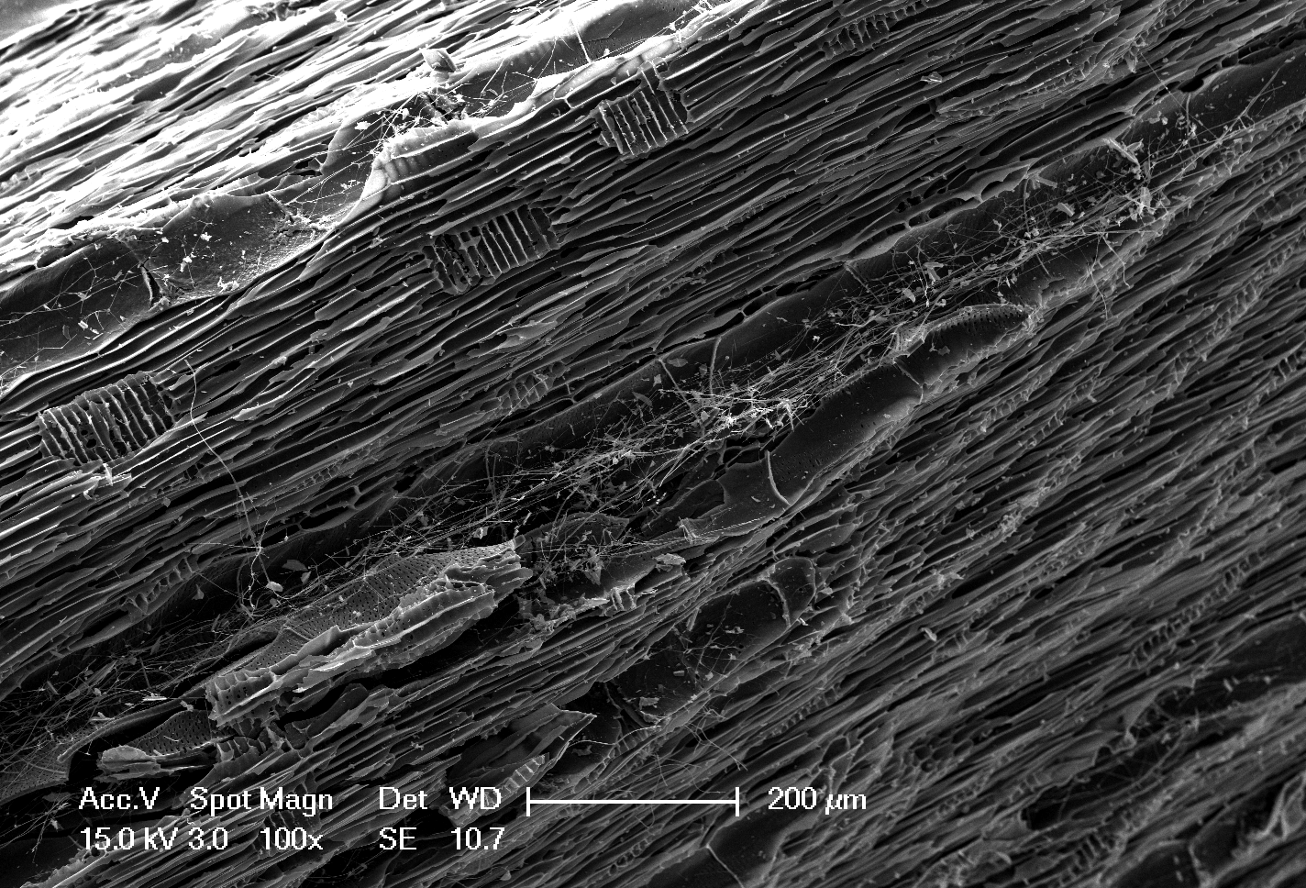
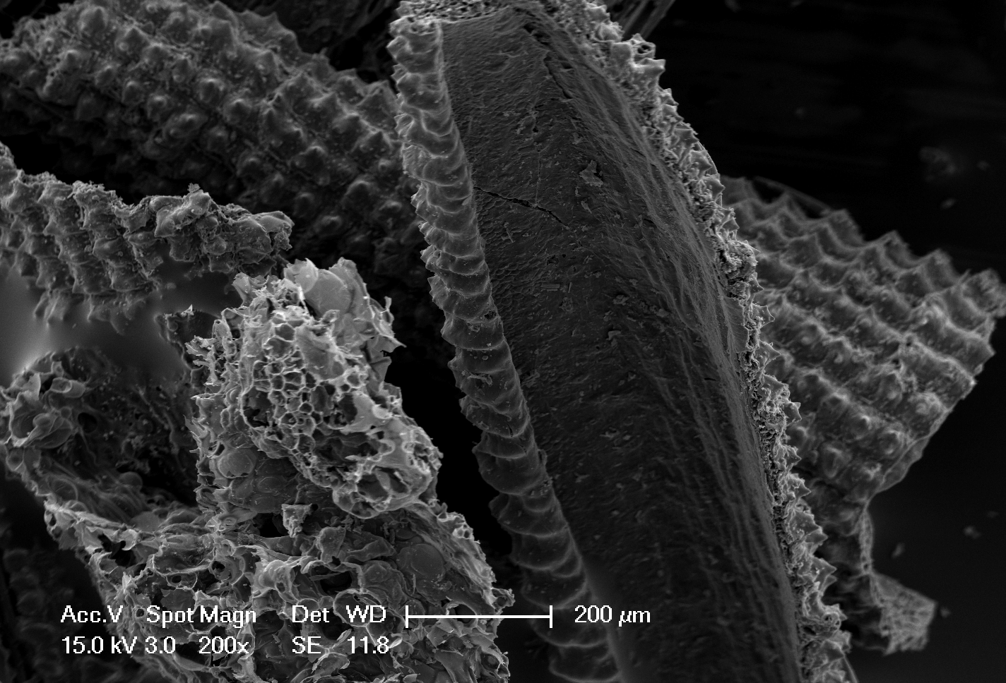
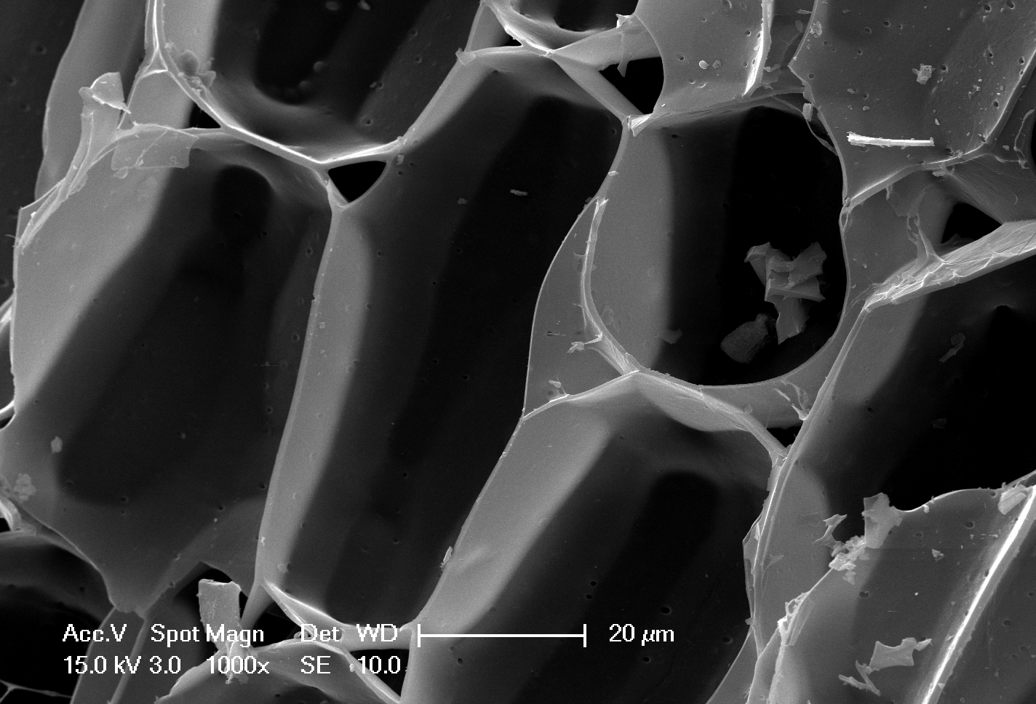
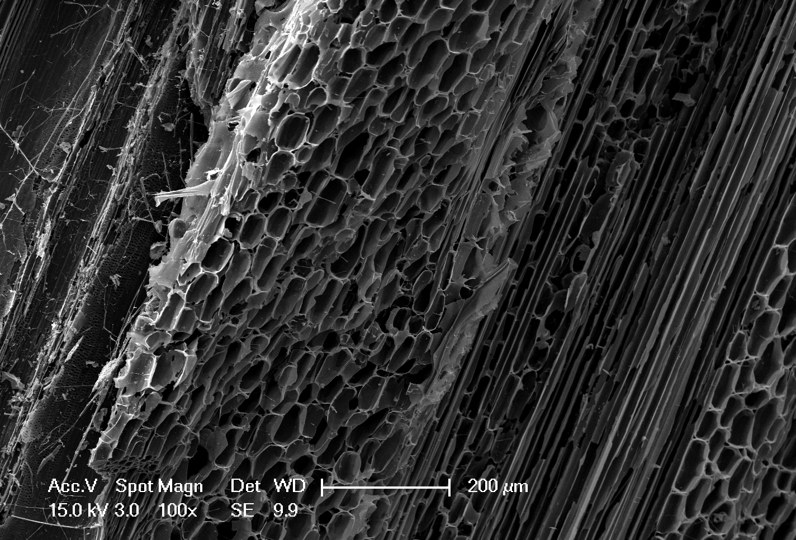
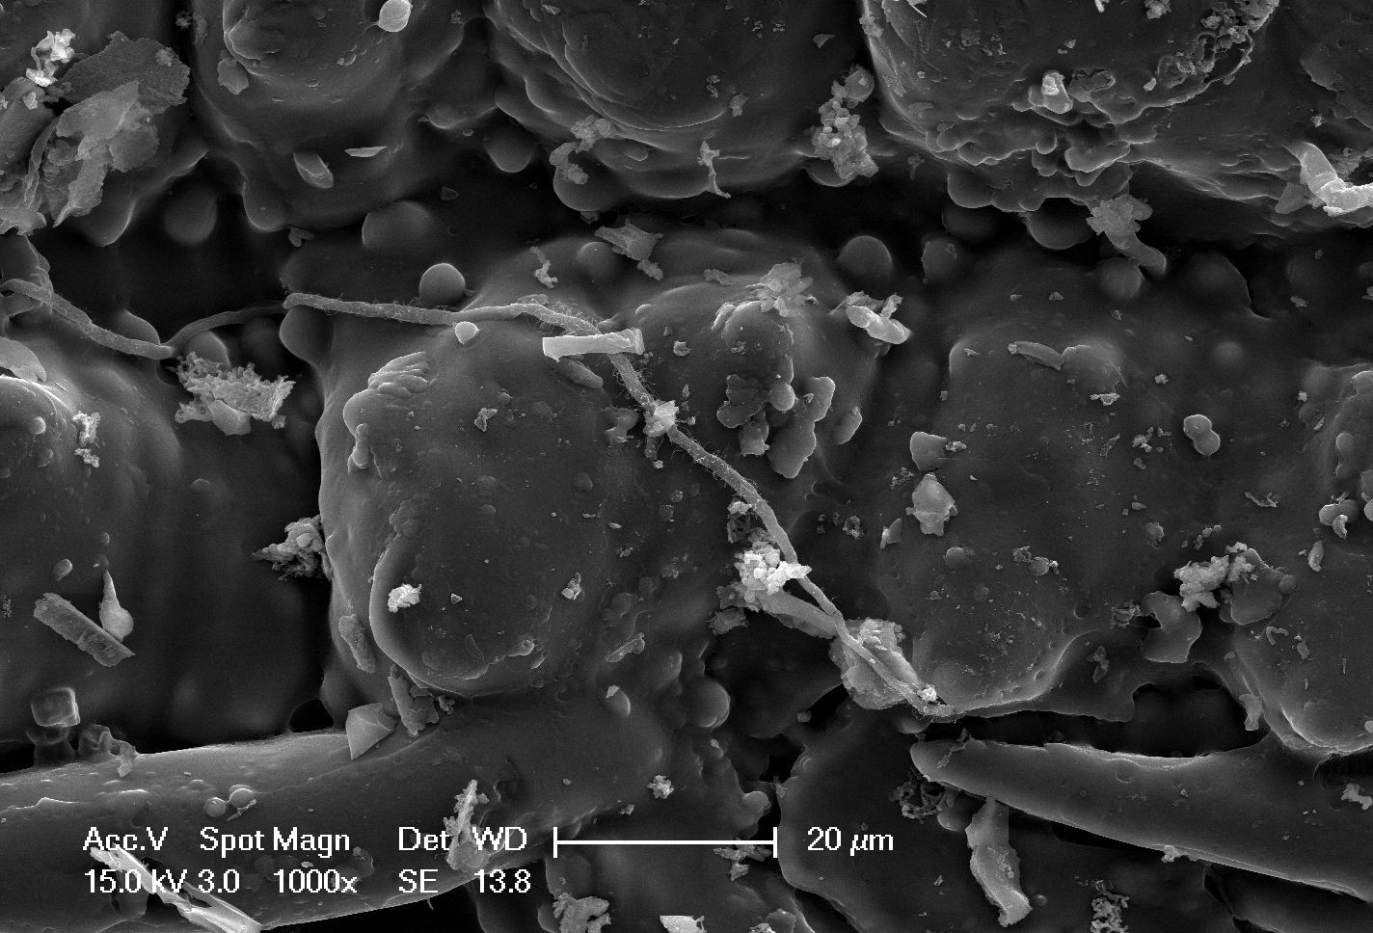
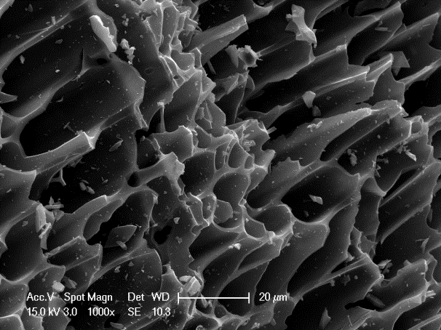
(a)
(b)
(d)
(c)
(e)
(e)

Figure S1. SEM photographs of biochar samples, (a, b) wood BC, (c, d) rice husk BC, and (e, f) bamboo BC. Magnifications are included in the images, all of which were taken from the same sample orientations.

875
796
2161
2349
1058
2532
2588
2535
2348
2362
2160
1587
1550
1560
1069
872
872
790
803
O-H stretching

Ester P-H and O-H ustretching
2161
Aliphatic -N≡C, alkynes’ C=C
Aromatic C=C
C-O, PO₄³⁻ Si-O-Si stretching
Aromatic C-H,CO₃²⁻
-NH₂ amines
1428
Si-C₆H₅
Rice husk BC
Bamboo BC
Wood BC
2922
2922
Aliphatic C-H stretching
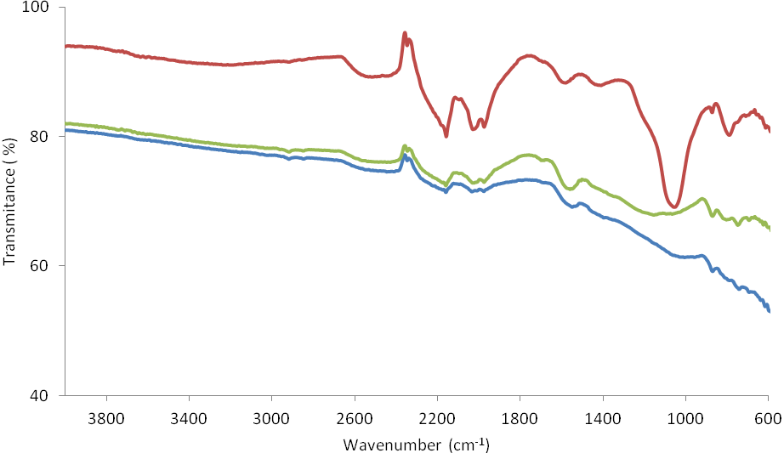
Figure S2. FTIR spectra of the three different biochar in the range 4000 – 400 cm⁻¹.

