Table 1 Structure of starting compounds 2, isolated products 3.
Entry | Substrate |  | Product |  | Yield of 3ª (%)
1 | 2a | 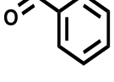 | 3a | 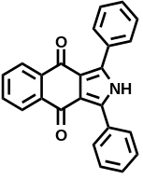 | 19
2 | 2b | 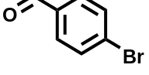 | 3b | 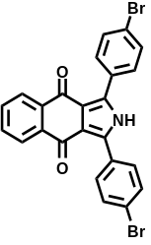 | 32
3 | 2c | 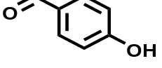 | 3c | 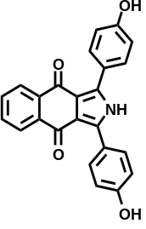 | 47
4 | 2d | 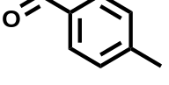 | 3d | 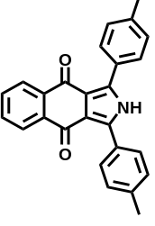 | 68
5 | 2e | 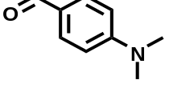 | 3e | 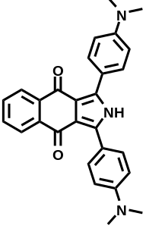 | 35
ª Isolated yield.

