Figure S1 MK test of winter temperature at typical stations during 1976–2017 (a Balunturuun. b Uliassutai. c Saybula. d Balunhala. e Gefuwugetaer. f Manlai. g Hailisu. h Alashanzuoqi. i Tulihe. j Aershan. k Balinzuoqi. l Chifeng)
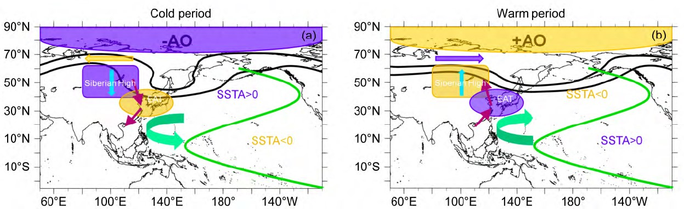
Figure S2 The schematic diagrams depicting the generalized features and flow patterns in (a) the cold and (b) warm periods. The black thick contours are for the geopotential height, with the northern (southern) contour corresponding to 5200 gpm (5300 gpm). The shading ellipses represent the area of the East Asian trough, the red (blue) shading box reflecting that the geopotential height is higher (lower) than normals. The shading boxes represent the area of the Siberian high, the red (blue) shading box reflecting that the sea level pressure is higher (lower) than normals. The red (blue) arrow in the high latitude means that the zonal wind is stronger (weaker) than normals. The purple arrows denote the 850-hPa wind anomaly. The yellow downward (upward) arrow denotes strong (weak) downdraft. The green thick solid line is the contour that SST anomaly (SSTA) is equals to 0°C. The green curved arrow is the cyclone (anticyclone) of the 850-hPa wind anomalies in the cold (warm) period. The red (blue) shading area in the polar region denotes positive (negative) SLP anomalies, corresponding to negative (positive) NAM/AO index (Liang et al. 2014)
Figure S3 Correlation between Westerly Index and Winter temperature

computer code
%%
clc
clear all
filename1 = 'F:\风场和水汽通量\uwnd.mon.mean.nc';
filename2 = 'F:\风场和水汽通量\vwnd.mon.mean.nc';
filename3 = 'F:\风场和水汽通量\hgt.mon.mean.nc';
a = ncinfo(filename1); % 看一看这个nv文件里面，到底都有什么内容
a.Variables.Name; % 输出nc文件的所有变量的名字，其中里面有lon lat tmp time 4个变量

% ncdisp(filename2)
lat = ncread(filename1,'lat');
lon = ncread(filename1,'lon');
level = ncread(filename1,'level');
time = ncread(filename1,'time');
U = ncread(filename1,'uwnd');
V = ncread(filename2,'vwnd');
H = ncread(filename3,'hgt');

%根据研究区截取范围
x=lon(25:61)';
y=lat(9:37)';
[X,Y]=meshgrid(x,y);
[n1,n2]=size(X);
% 切出所需数据格点
u_850_for=squeeze(U(25:61,9:37,3,157:480));%time需要根据自己的数据下载情况进行节选~
U1_850_for = reshape(u_850_for,37,29,12,27);
U1_850_for = permute(U1_850_for,[1,2,4,3]);
U1_850_Summer_for = U1_850_for(:,:,:,[12 1 2]);
U2_850_for= nanmean(U1_850_Summer_for,4);
U2_for= nanmean(U2_850_for,3);

v_850_for=squeeze(V(25:61,9:37,3,157:480));
V1_850_for = reshape(v_850_for,37,29,12,27);
V1_850_for = permute(V1_850_for,[1,2,4,3]);
V1_850_Summer_for = V1_850_for(:,:,:,[12 1 2]);
V2_850_for = nanmean(V1_850_Summer_for,4);
V2_for = nanmean(V2_850_for,3);

h_500_for=squeeze(H(25:61,9:37,6,157:480));
h1_500_for = reshape(h_500_for,37,29,12,27);
h1_500_for = permute(h1_500_for,[1,2,4,3]);
h1_500_Summer_for = h1_500_for(:,:,:,[12 1 2]);
h2_500_for = nanmean(h1_500_Summer_for,4);
HGT_for = nanmean(h2_500_for,3);

% 切出所需数据格点
u_850_back=squeeze(U(25:61,9:37,3,481:840));%time需要根据自己的数据下载情况进行节选~
U1_850_back = reshape(u_850_back,37,29,12,30);
U1_850_back = permute(U1_850_back,[1,2,4,3]);
U1_850_Summer_back = U1_850_back(:,:,:,[12 1 2]);
U2_850_back = nanmean(U1_850_Summer_back,4);
U2_back = nanmean(U2_850_back,3);

v_850_back =squeeze(V(25:61,9:37,3,481:840));
V1_850_back = reshape(v_850_back,37,29,12,30);
V1_850_back = permute(V1_850_back,[1,2,4,3]);
V1_850_Summer_back = V1_850_back(:,:,:,[12 1 2]);
V2_850_back = nanmean(V1_850_Summer_back,4);
V2_back = nanmean(V2_850_back,3);

h_500_back =squeeze(H(25:61,9:37,6,481:840));
h1_500_back = reshape(h_500_back,37,29,12,30);
h1_500_back = permute(h1_500_back,[1,2,4,3]);
h1_500_Summer_back = h1_500_back(:,:,:,[12 1 2]);
h2_500_back = nanmean(h1_500_Summer_back,4);
HGT_back = nanmean(h2_500_back,3);

clear U V H

%绘图
figure
hold on
[C,b]=contourf(X,Y,(HGT_back-HGT_for)');
quiver(X,Y,U2_back'-U2_for',V2_back'-V2_for','color','k');%风场图

% set(b,'ShowText','on','TextStep',get(b,'LevelStep'));
set(b,'LineColor','none')
color = jet(500);
colormap(color(50:460,:)) %等高线的颜asd 色分配，我记得有很多，像Pink，Bone什么的~自己选
%%添加句柄及中国地图

axis equal
xlim([X(1),X(end)])
ylim([Y(end),Y(1)])
% set(gca, 'xlim', [60, 150], 'ylim', [0, 70], ...
% 'xtick', 60:10:150, 'xticklabel', {'60E','70E', '80E', '90E', '100E', '110E', '120E','130E', '140E','150E'}, ...
% 'ytick', 0:10:70, 'yticklabel', {'0','','10N','','20N','','30N','','40N','','50N','','60N','','70N'});
geoshow('G:\GIS\研究区轮廓\研究区轮廓.shp','color','[0,0,1]','linewidth',2);
land = shaperead('G:\GIS\研究区轮廓\country', 'UseGeoCoords', true); %导入陆地框架
for i = 5: length(land)
plot(land(i).Lon,land(i).Lat,'k')
end
colorbar

