High-resolution wealth maps reveal Africa’s nonlinear trajectory of development and inequality

Supplementary Materials

Note 1: Overall Network Architecture
The input includes: A multispectral composite image $X∈R^{B×6×512×512}$, concatenated from Sentinel-1 and Sentinel-2 imagery. A nighttime light image $L∈R^{B×1×512×512}$, sourced from the SGDSAT dataset. The encoder $E(⋅)$, implemented using ResNet-50, extracts hierarchical spatial features from $X$, producing encoded features $F_{enc}$. The decoder $D(⋅)$ then performs progressive upsampling to recover spatial resolution, yielding intermediate decoded features $F_{up1}∈R^{B×128×256×256}$
Nighttime light features are encoded through a guiding subnetwork, LightNet (see Note 2), represented as:
$$F_{light}=L(L)∈R^{B×128×256×256}$$
The fusion of decoded and light features is computed as:
$$F_{fusion}=F_{up1}+F_{light}$$
The final high-resolution spatial prediction $\overset{ˆ}{Y}∈R^{B×1×512×512}$, representing per-pixel wealth levels, is generated via a final upsampling and convolution module:
$$\overset{ˆ}{Y}=C(U(F_{fusion}))$$
where $U(⋅)$ denotes the upsample layer and $C(⋅)$ is the final convolutional layer.
Furthermore, we design a joint supervision loss function that integrates region-level labels and pixel-level priors (i.e., the spatial wealth proxy) to enhance the model’s spatial reasoning. Without such guidance, the model's predictions may lack spatial plausibility and interpretability (see Figure S1). Specifically, the region-level (weak) supervision is computed by averaging the prediction $\overset{ˆ}{ Y}$ over built-up areas (non-null mask) and comparing it to the DHS-derived village-level label. In parallel, the pixel-level (strong) supervision utilizes the constructed spatial wealth proxy map. To ensure consistency, this proxy is mean-adjusted using the village-level label (original proxy has zero mean). The final loss combines both components as:
$$L=w_{\text{weak}}⋅{\left\|{\overset{ˆ}{y}}^{\text{region}}-y^{\text{region}}\right\|}_{1}+w_{\text{strong}}⋅{\left\|\overset{ˆ}{Y}-(Y^{\text{proxy}}+y^{\text{region}})\right\|}_{1}$$
where ${\overset{ˆ}{y}}^{\text{region}}$ denotes the average predicted wealth over the built-up region,$Y^{\text{proxy}}$ is the constructed spatial wealth proxy map, and $w_{\text{weak}}$, $w_{\text{strong}}$ are weights balancing region- and pixel-level supervision. In supplementary experiments, we evaluate various weight settings and demonstrate that joint supervision significantly improves both model robustness and interpretability.

Note 2: LightNet Network Architecture
We design a multi-scale guidance module, PyramidConvNet (referred to as LightNet), to extract economic activity features at different spatial scales from nighttime illumination and enhance the model’s sensitivity to urban lighting patterns and wealth heterogeneity during decoding.
The structure is as follows:
Input: SGDSAT nighttime light image $L∈R^{1×512×512}$.
Multi-scale encoding: The module contains three residual convolutional branches using 3×3, 5×5, and 7×7 kernels, capturing local, mid-scale, and large-scale illumination patterns, respectively:
$$\begin{matrix}F_{3×3} & ={\text{ResConv}}_{3×3}(L) \\ F_{5×5} & ={\text{ResConv}}_{5×5}(L) \\ F_{7×7} & ={\text{ResConv}}_{7×7}(L)\end{matrix}$$
Fusion: The outputs are upsampled to a common spatial size, concatenated along the channel dimension, and passed through a 1×1 convolution for feature fusion:
$$F_{light}={\text{Conv}}_{1×1}\left(\text{Concat}(F_{3×3},F_{5×5},F_{7×7})\right)$$
The resulting feature map $F_{light}∈R^{B,128,256,256}$represents high-level illumination features and is added to the decoder output $F_{up1}$ during the UNet decoding stage (see Methods). This enhances the model’s understanding of the spatial relationship between lighting intensity and economic wealth distribution.

Note 3: Explanation of Weight Adjustments
As shown in Table 2, Partial Least Squares regression (PLS) performs best in terms of R² (0.56) and explains 60% of the feature variance. However, the resulting feature weights conflict with known domain relationships between urban form and wealth [1]. For instance, building density (BD) presents a disproportionately high weight (0.471), potentially misclassifying dense informal settlements as high-wealth areas.
To mitigate this, we propose an empirically corrected weighting scheme—PLS with Adjustments (PLS-A)—which retains the predictive strength of PLS while enhancing its alignment with urban morphology knowledge. Adjustments include:
Building Area (BA): No change (0.505), indicating strong correlation with available residential space;
Building Density (BD): 0.471×0.5=0.235, reducing the correlation between dense built-up areas and wealth;
NDVI: -0.237 × (-1) = 0.237, highlighting a certain level of green space, rather than implying that less green space equates to greater wealth.;
Night-time Light (LIGHT): 0.331 × 0.5 = 0.165, reducing the weight to minimize the urban-rural disparity, as rural areas have sparse lighting.;
Road Density (ROAD) and POI Density: 0.462 × 0.5 = 0.231, 0.381 × 0.5 = 0.191, OSM data is missing in certain areas, so the weight needs to be reduced.

Note 4: Population-Weighted Wealth Share
The term “population-weighted wealth share” reflects the proportion of wealth within each spatial unit weighted by population. Population weighting primarily accounts for the agglomeration effects of population and development. Specifically, within a given geographic boundary, wealth agglomeration effects are measured by calculating the multiplication of population size and average wealth levels, thereby providing a more accurate assessment of socioeconomic disparities:
1. For each grid cell or spatial unit, obtain two values: the wealth index (W) and the population (P). Prior to this, the W needed to be shifted to non-negative values.
2. Pixel-level multiplication: W × P.
3. To compute the population-weighted wealth share of a specific region (e.g., capital city), divide the sum of W × P for that region by the total Σ(W × P) across the country.
Formula: Population-Weighted Wealth Share (region) = Σ(W × P)_region / Σ(W × P)_total

Table S1. Wealth-Tier Based Population Distribution across 30 African Countries (2020)
Country | Official  Population[2] | Ratio  High (≥80%) | Ratio  Low (≤20%) | Ratio  Mid(20%-80%)
Angola | 33451132 | 0.55 | 0.03 | 0.41
Benin | 13070169 | 0.40 | 0.13 | 0.47
Burkina Faso | 21478690 | 0.50 | 0.16 | 0.34
Burundi | 12617036 | 0.28 | 0.42 | 0.30
Cameroon | 26210558 | 0.23 | 0.50 | 0.27
Cote d Ivoire | 28915449 | 0.30 | 0.54 | 0.16
Ethiopia | 118917671 | 0.28 | 0.32 | 0.41
Gabon | 2322539 | 0.19 | 0.58 | 0.23
Gambia | 2515733 | 0.13 | 0.72 | 0.14
Ghana | 31887809 | 0.51 | 0.11 | 0.39
Guinea | 13371183 | 0.40 | 0.10 | 0.51
Kenya | 52217334 | 0.31 | 0.35 | 0.35
Lesotho | 2235727 | 0.35 | 0.21 | 0.44
Liberia | 5149463 | 0.46 | 0.03 | 0.50
Madagascar | 28953556 | 0.40 | 0.13 | 0.47
Malawi | 19533888 | 0.38 | 0.28 | 0.34
Mali | 21713836 | 0.73 | 0.05 | 0.22
Mauritania | 4600131 | 0.54 | 0.18 | 0.28
Mozambique | 30783688 | 0.26 | 0.54 | 0.20
Niger | 23717613 | 0.35 | 0.39 | 0.26
Nigeria | 213996181 | 0.18 | 0.49 | 0.33
Rwanda | 13065837 | 0.35 | 0.35 | 0.30
Senegal | 16789219 | 0.14 | 0.69 | 0.17
Sierra Leone | 7912558 | 0.16 | 0.67 | 0.18
South Africa | 60562381 | 0.29 | 0.18 | 0.53
Tanzania | 60972798 | 0.39 | 0.39 | 0.22
Togo | 8669720 | 0.14 | 0.65 | 0.21
Uganda | 44457152 | 0.36 | 0.35 | 0.29
Zambia | 19059395 | 0.29 | 0.51 | 0.20
Zimbabwe | 15526888 | 0.18 | 0.61 | 0.21

Figure S1. Identifying Prominent Patterns of Poverty and Inequality in 30 African Countries Using the Quintile Method
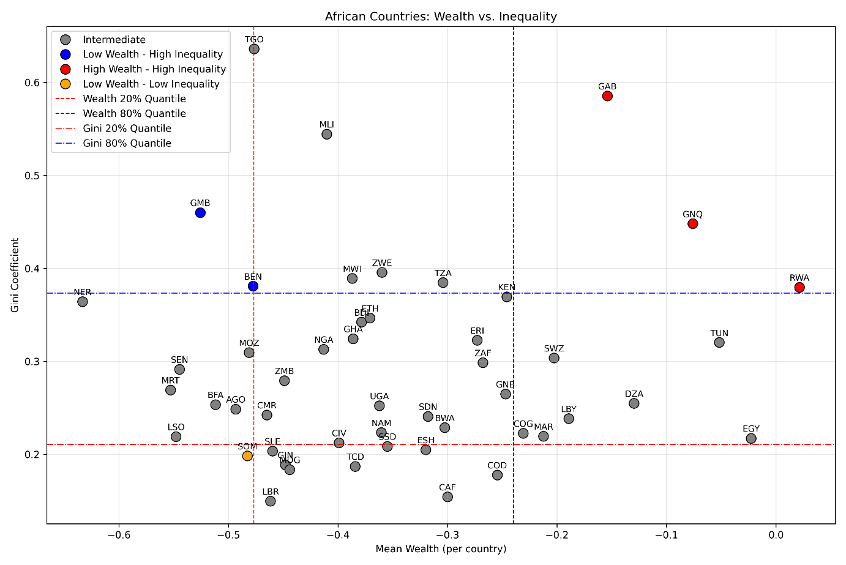

Figure S2. Evaluation of Spatial Wealth Proxy Construction Methods and Model Performance.
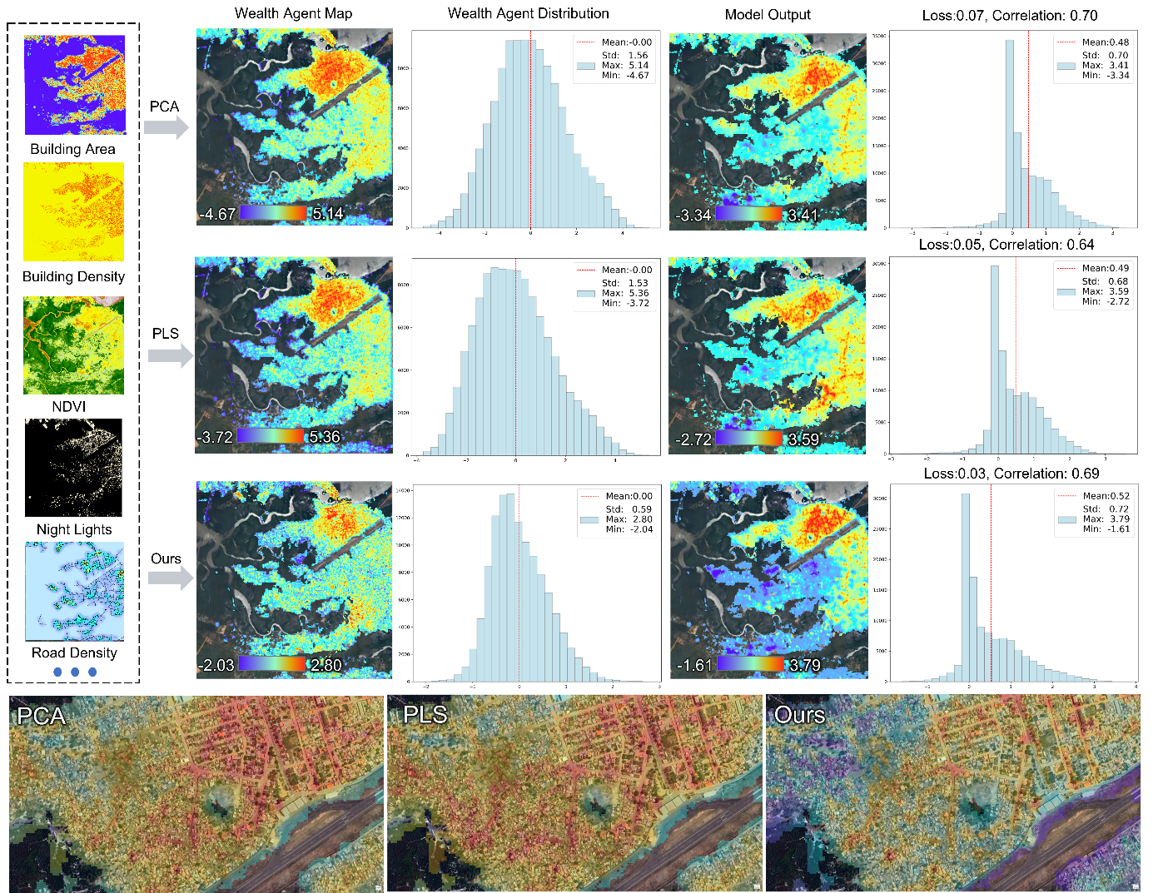
Figure S2 presents a comparative analysis of spatial wealth indices generated using PCA, PLS, and the proposed adjusted method (PLS-A). The figure includes Wealt Agent Map, Wealt Agent Distribution, Model Output, and corresponding statistical distributions. At the bottom, zoomed-in views show regional details for all three methods.
Detailed comparisons reveal that both PCA and PLS tend to assign higher wealth scores to areas with high building density. While this aligns with common perception, it may lead to misclassification in specific contexts—for instance, informal settlements (slums) exhibit dense building layouts yet reflect elevated wealth levels. The adjusted method (PLS-A) mitigates the overestimation of wealth levels in high-density areas, thereby better distinguishing low-income high-density zones from typical middle-to-high-income communities. This significantly enhances the model's structural interpretability and discriminatory power. Regarding distribution plots, the proxy distribution plot of PLS-A more closely resembles the model output distribution plot (Loss=0.03, Correlation=0.69).
Regarding model performance, all three methods achieve comparable results on the test set, with differences in Weak Loss below 0.01 (see Table S2). This suggests that the integration of empirical knowledge in PLS-A does not compromise model accuracy, while enhancing interpretability (Strong Loss = 0.160). In conclusion, the PLS-A method demonstrates advantages in spatial representation and model compatibility, making it a more appropriate approach for constructing spatial wealth proxy.

Table S2. Validation Accuracy of Spatial Wealth Proxy Strategies.
Method | Features Weights |  |  |  |  |  | Weak  Loss | Strong  Loss
Method | BA | BD | NDVI | LIGHT | ROAD | POI | Weak  Loss | Strong  Loss
PCA | 0.440 | 0.288 | -0.490 | 0.407 | 0.462 | 0.323 | 0.330 | 0.236
PLS | 0.505 | 0.471 | -0.237 | 0.331 | 0.462 | 0.381 | 0.335 | 0.238
PLS-A | 0.505 | 0.235 | 0.237 | 0.165 | 0.231 | 0.191 | 0.340 | 0.160

Figure S3. Accuracy and Visualization Performance of Different Weighting Strategies.
Strong Loss refers to the pixel-level loss between predictions and the proxy maps Correlation measures the consistency between predictions and the proxy maps for the shown samples.
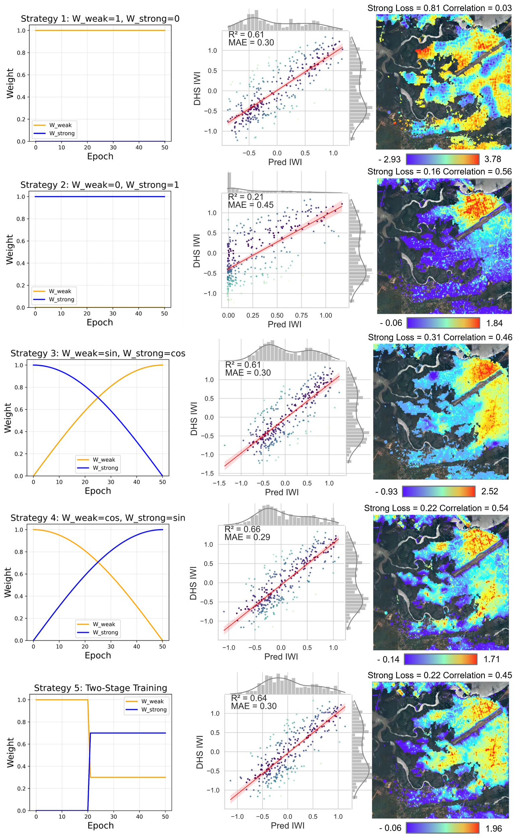
Figure S3 illustrates the performance of five loss weighting strategies (Strategy 1–5) used in the spatial wealth learning task, including weight schedules, predictive accuracy (R² and MAE), and qualitative evaluations of prediction maps.
Strategies 1 and 2 represent two extremes: weak supervision only (W_weak = 1, W_strong = 0) and strong supervision only (W_weak = 0, W_strong = 1), respectively. The former achieves reasonable prediction of regional wealth averages but lacks spatial detail fidelity. The latter is prone to overfitting noise or biases in the proxy map, leading to lower accuracy and interpretability (R² = 0.21, MAE = 0.45).
Strategies 3 (W_weak = sin, W_strong = cos) and 4 (W_weak = cos, W_strong = sin) introduce dynamic balancing via orthogonal functions. Strategy 4 emphasizes spatial supervision in later training stages, achieving a better trade-off between global consistency and fine-grained detail (R² = 0.66, MAE = 0.29), along with higher image-to-proxy consistency (Correlation = 0.54) and stable overall loss (Strong Loss = 0.22). The results suggest that well-designed proxy maps combined with adaptive weighting help the model capture fine-grained features relevant to wealth, improving both accuracy and interpretability beyond purely weak supervision.
Strategy 5 adopts a staged approach: it begins with weak supervision (Epoch ≤ 20: W_weak = 1, W_strong = 0), then shifts to combined supervision (Epoch > 20: W_weak = 0.3, W_strong = 0.7). While also effective, its performance on spatial detail is slightly below Strategy 4.
Considering all metrics, Strategy 4 provides the best balance between predictive accuracy, spatial detail quality, and generalization, and was therefore selected as the final training strategy in this study.

Figure S4. Modality Ablation Study: Accuracy and Visualization Across Different Input Combinations (Sentinel-1, Sentinel-2, S1+S2, S1+S2+SDGSAT).
The left column shows the input modality combinations; the middle column presents validation scatter plots for each combination; the right column displays corresponding prediction visualizations. Training follows Strategy 4 from Figure S2. Strong Loss denotes the pixel-level loss between predicted outputs and the spatial wealth proxy on the validation set, Correlation indicates the similarity between prediction maps and proxy maps for selected samples.
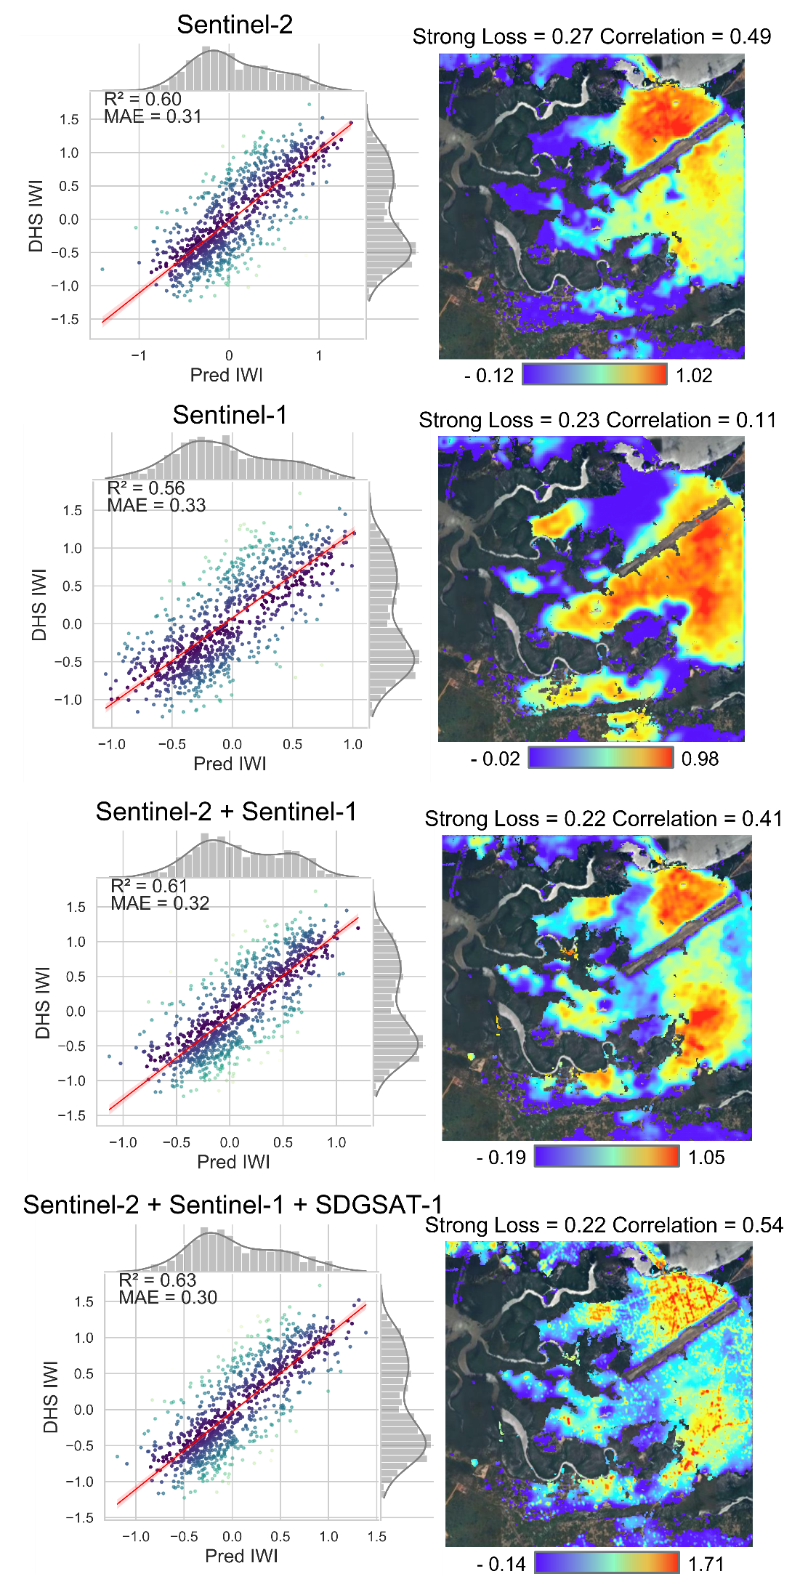

Figure S5. Application Test: Urban Wealth Evolution in Dar es Salaam, 2015–2025
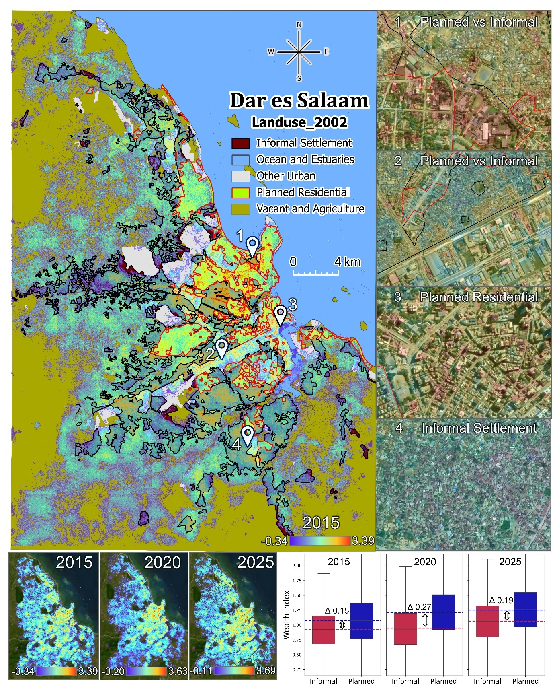
Figure S5 illustrates the spatial distribution and temporal evolution of urban wealth in Dar es Salaam [3] from 2015 to 2025, highlighting persistent socioeconomic disparities between informal and planned settlements. While the overall wealth index shows a steady increase, a pattern of widening inequality followed by slight convergence is observed, suggesting that rapid urban expansion may initially intensify disparities, with potential mitigation in later stages. By integrating spatial data and predictive modeling, this approach enables fine-grained monitoring of urban change over time. It offers a practical tool for identifying localized shifts in wealth, particularly relevant for rapidly growing cities with extensive informal sectors. The results can support urban upgrading efforts by informing equitable infrastructure investment, policy evaluation, and the targeting of underserved areas.

Table S3. Accuracy of the 5-Fold Cross-validation Dataset
Fold | Train Set |  |  |  | Validation Set |  |  |  |  | Test Set (Independent)
Fold | Count | R² | MAE | Count |  |  | R² | MAE | Count |  |  | R² | MAE
1 | 15496 | 0.76 | 0.22 | 3874 |  |  | 0.64 | 0.29 | 1863 |  |  | 0.63 | 0.34
2 | 15450 | 0.75 | 0.24 | 3863 |  |  | 0.64 | 0.29 | 1920 |  |  | 0.66 | 0.28
3 | 15159 | 0.77 | 0.23 | 3790 |  |  | 0.66 | 0.29 | 2284 |  |  | 0.64 | 0.27
4 | 15288 | 0.80 | 0.20 | 3822 |  |  | 0.65 | 0.28 | 2123 |  |  | 0.59 | 0.35
5 | 15453 | 0.82 | 0.19 | 3864 |  |  | 0.65 | 0.29 | 1916 |  |  | 0.57 | 0.29
Mean |  | 0.78 | 0.19 |  |  |  | 0.65 | 0.29 |  |  |  | 0.62 | 0.31
Ensemble | Count: 21998 |  |  |  |  | R²: 0.74 |  |  |  |  | MAE: 0.24

Table S4. Effect of Train Sample Size on Model Performance
Data use | Validation Set |  |  |  |  | Test Set
Data use | R² |  | MAE |  | R² |  |  | MAE
10% | 0.60 | 0.31 |  | 0.53 |  |  | 0.27
20% | 0.61 | 0.30 |  | 0.47 |  |  | 0.29
30% | 0.59 | 0.31 |  | 0.46 |  |  | 0.29
40% | 0.60 | 0.31 |  | 0.48 |  |  | 0.30
50% | 0.60 | 0.30 |  | 0.46 |  |  | 0.30
60% | 0.64 | 0.28 |  | 0.53 |  |  | 0.27
70% | 0.63 | 0.29 |  | 0.53 |  |  | 0.27
80% | 0.64 | 0.29 |  | 0.51 |  |  | 0.28
90% | 0.62 | 0.29 |  | 0.51 |  |  | 0.28
100% | 0.66 | 0.28 |  | 0.55 |  |  | 0.27

Table S5 Regional Divisions in Africa and Their Basis
Region | Country Name | ISO Code | Classification Rationale
North  Africa | Algeria | DZA | Classified as North Africa due to geographic and cultural alignment with the Mediterranean region and the Arab world.
North  Africa | Egypt | EGY
North  Africa | Libya | LBY
North  Africa | Morocco | MAR
North  Africa | Sudan | SDN
North  Africa | Tunisia | TUN
North  Africa | Western Sahara | ESH
North  Africa | Mauritania | MRT
West  Africa | Benin | BEN | Designated as West Africa based on ECOWAS membership and western Atlantic coastline location.
West  Africa | Burkina Faso | BFA
West  Africa | Cabo Verde | CPV
West  Africa | Côte d'Ivoire | CIV
West  Africa | Gambia | GMB
West  Africa | Ghana | GHA
West  Africa | Guinea | GIN
West  Africa | Guinea-Bissau | GNB
West  Africa | Liberia | LBR
West  Africa | Mali | MLI
West  Africa | Niger | NER
West  Africa | Nigeria | NGA
West  Africa | Senegal | SEN
West  Africa | Sierra Leone | SLE
West  Africa | Togo | TGO
East  Africa | Burundi | BDI | Grouped under East Africa due to their location along the East African Rift and socio-political ties in the Horn and Great Lakes regions.
East  Africa | Comoros | COM
East  Africa | Djibouti | DJI
East  Africa | Eritrea | ERI
East  Africa | Ethiopia | ETH
East  Africa | Kenya | KEN
East  Africa | Madagascar | MDG
East  Africa | Malawi | MWI
East  Africa | Mozambique | MOZ
East  Africa | Rwanda | RWA
East  Africa | Somalia | SOM
East  Africa | South Sudan | SSD
East  Africa | Tanzania | TZA
East  Africa | Uganda | UGA
East  Africa | Zambia | ZMB
East  Africa | Zimbabwe | ZWE
Southern Africa | Angola | AGO | Classified as Southern Africa based on SADC regional grouping and southernmost latitude.
Southern Africa | Botswana | BWA
Southern Africa | Lesotho | LSO
Southern Africa | Namibia | NAM
Southern Africa | South Africa | ZAF
Southern Africa | Eswatini | SWZ

References
  - Abascal, Angela, et al. "Identifying Degrees of Deprivation from Space Using Deep Learning and Morphological Spatial Analysis of Deprived Urban Areas." Computers, Environment and Urban Systems, vol. 95, 2022, p. 101820. https://doi.org/10.1016/j.compenvurbsys.2022.101820
  - World Bank. (2021). Population, total – Angola [Data set]. https://data.worldbank.org/indicator/SP.POP.TOTL
  - Sliuzas, R. V., et al. "Dar es salaam land use and informal settlement data set." NASA Socioeconomic Data and Applications Center (SEDAC) data set (2016): H43T9F56.

