Contextual Solvation Control for Nonlinear Kinetic Optimization in Dual-Cosolvent Electrolytes for Aqueous Zinc Metal Batteries

Method
Materials and Chemicals
All chemicals were purchased from Sigma-Aldrich and used without further purification. Zinc foil, copper foil, and Whatman glass fiber membranes were obtained from Guangdong Canrd New Energy Technology Co., Ltd.
For electrolyte preparation, a 2 M Zn(OTf)₂ aqueous stock solution was first prepared by dissolving Zn(OTf)₂ in deionized water. For 50 vol% cosolvent electrolytes (single- or dual-cosolvent), DMSO and/or DMC were added directly to a measured volume of the 2 M stock solution, with the total cosolvent volume equal to the volume of the stock solution. For 10–40 vol% DMSO electrolytes, the required amount of DMSO was added to the 2 M stock solution, and deionized water was added until the added volume matched the volume of the stock solution. In all cases, the total volume after mixing was twice the initial stock volume, resulting in a final Zn(OTf)₂ concentration of 1 M for all electrolytes. All electrolytes were stirred vigorously before use.
The NaV₃O₈·1.5H₂O (NaVO) cathode material was synthesized via a liquid–solid stirring method. Briefly, 1 g of commercial V₂O₅ powder was dispersed in 15 mL of 2 M NaCl aqueous solution and stirred at 30 °C for 96 h. The suspension was then washed sequentially with deionized water and ethanol, and the resulting precipitate was freeze-dried to obtain the brick-red product.

Electrochemical Measurements
Electrochemical tests were conducted using CR2032-type coin cells. The cells were assembled with the following components: zinc foil (16 mm diameter, 100 μm thickness), copper foil (16 mm diameter, 100 μm thickness), cathodes (14 mm diameter), glass fiber separators (Whatman GF/F, 19 mm diameter), and 100 μL of electrolyte per cell. Zinc foils were polished prior to assembly to ensure a clean and uniform surface. For pouch-cell tests, two layers of glass fiber separators (Whatman GF/A) were used.
Linear sweep voltammetry (LSV) and electrochemical impedance spectroscopy (EIS) were performed on Zn‖Zn symmetric cells after 10 formation cycles at 0.5 mA cm⁻² and 0.5 mAh cm⁻² using an Autolab PGSTAT204 workstation. EIS measurements were conducted with a 10 mV amplitude over a frequency range of 1 MHz to 0.01 Hz. LSV was recorded from –0.15 V to +0.15 V versus Zn/Zn²⁺ at 10 mV/s. Nyquist plots were fitted using an equivalent circuit of R(CR)(QR)(CR), and the distribution of relaxation times (DRT) was obtained using the DRTtools package.¹ Chronoamperometry (CA) was performed using a potential step of –150 mV.
The Marcus reorganization energy (λ) was determined by fitting the LSV polarization curves according to the Marcus–Hush–Chidsey (MHC) model. The relationship between current (i) and overpotential (η) is expressed as:²
$$\begin{aligned}x=\frac{Fη}{RT}\#Eq\left(1\right)\end{aligned}$$
$$\begin{aligned}i=\text{erfc}\left(\frac{a-\sqrt{1+\sqrt{a}+x^{2}}}{2\sqrt{a}}\right)\tanh\left(\frac{x}{2}\right)\sqrt{πa} S\#Eq\left(2\right)\end{aligned}$$
$$\begin{aligned}λ=\frac{aRT}{F}\#Eq\left(3\right)\end{aligned}$$
where F is the Faraday constant, R is the gas constant, T is the temperature, and a and S are fitting parameters representing the activation factor and scaling coefficient, respectively (a > 0, S > 0).
Experimentally, the overpotential (η) values from the LSV curves of Zn‖Zn symmetric cell were first converted to x using Eq. (1). The LSV data were then fitted using nonlinear least-squares regression based on Eq. (2), from which a and S were obtained. The reorganization energy (λ) was subsequently calculated using Eq. (3).
The activation energy (Eₐ) for charge transfer was calculated using the Arrhenius equation:
$$\begin{aligned}\ln{k}=\ln{A}-\frac{E_{a}}{R}⋅\frac{1}{T}\#Eq\left(4\right)\end{aligned}$$
where A is the pre-exponential factor, R is the gas constant, and T is the absolute temperature. The charge-transfer rate constant (k) was taken to be inversely proportional to the charge-transfer resistance (Rct) extracted from EIS measurements.
For preliminary CE evaluation, Aurbach’s reservoir method was applied. After three activation cycles at 1 mA cm⁻² and 2 mAh cm⁻², a reservoir capacity (Qᵣ) of 2 mAh was plated, followed by 20 plating/stripping cycles of 0.2 mAh (Q_{𝚌}) with a voltage cutoff of 0.5 V. For high-DOD CE evaluation (60% DOD), four activation cycles at 5 mA cm⁻² and 5 mAh cm⁻² were conducted, followed by plating a 5 mAh reservoir (Qᵣ) and then 200 plating/stripping cycles of 3 mAh (Q_{𝚌}) at 5 mA cm⁻² with a cutoff voltage of 0.5 V.
The average CE of a single independent measurement was calculated as:
$$\begin{aligned}\text{CE}=\frac{nQ_{c}+Q_{s}}{nQ_{c}+Q_{r}}\#Eq\left(5\right)\end{aligned}$$
where n is the number of cycles and Qₛ is the final stripping capacity.
NaV₃O₈·1.5H₂O cathodes were prepared by mixing the active material, Super P, and PVDF binder in N-methyl-2-pyrrolidone (NMP) at a mass ratio of 7:2:1. The slurry was cast onto Ti foil (10 μm) and dried overnight at 80 °C, yielding an active material loading of ~1.5 mg cm⁻².
Galvanostatic charge/discharge tests were carried out on a Neware BTS 4000 system. Full cells were activated for five cycles at 0.05 A g⁻¹ before testing at higher current densities. Specific capacities were calculated based on the mass of active material in the cathode.
All electrochemical measurements were performed at room temperature unless otherwise specified.

Material Characterization
Field-emission scanning electron microscopy (FE-SEM, JSM-7600F, JEOL Ltd.) was used for morphological imaging, energy-dispersive X-ray spectroscopy (EDS), and elemental mapping. X-ray photoelectron spectroscopy (XPS) was conducted using a PHI Quantera SXM Scanning X-ray Microprobe equipped with an Al Kα radiation source (1486.7 eV). All spectra were calibrated to the C 1s peak at 284.8 eV. Fourier-transform infrared spectroscopy (FTIR) measurements were carried out using a PerkinElmer FTIR Frontier spectrometer. ¹H NMR spectra were obtained on a JEOL Resonance 500 MHz NMR spectrometer. X-ray absorption fine structure (XAFS) measurements were performed in transmission mode at the Singapore Synchrotron Light Source (SSLS) and XAFCA beamline. Time-of-flight secondary ion mass spectrometry (TOF-SIMS) analysis was conducted using an ION-TOF TOF.SIMS 5 instrument. The dissolution of vanadium was quantified using inductively coupled plasma–optical emission spectrometry (ICP-OES, PerkinElmer Avio 200). After 50 cycles of full-cell operation, the separators were collected and immersed in aqua regia overnight to fully dissolve the vanadium species, and the resulting solution was analyzed by ICP-OES.

Molecular Dynamics (MD) Simulations
MD simulations were performed using LAMMPS (Large-scale Atomic/Molecular Massively Parallel Simulator). Initial configurations of Zn²⁺, OTf⁻, H₂O, DMSO, and DMC were constructed using PackMol to achieve the desired electrolyte compositions. All interatomic interactions were described using the COMPASS (Condensed-phase Optimized Molecular Potentials for Atomistic Simulation Studies) force field. Atomic partial charges were assigned based on RESP20.5 charge fitting at the B3LYP-D3(BJ)/def2-TZVP level with SMD-water solvation. Periodic boundary conditions were applied in all three dimensions, and long-range electrostatic interactions were treated using the particle-particle particle-mesh (PPPM) method. After energy minimization, all systems were equilibrated and simulated in the NPT ensemble using a Nosé–Hoover thermostat and barostat at 298 K and 1 atm. A timestep of 1.0 fs was used throughout all simulations.
The pairwise interaction energy between two selected moieties a and b (e.g., Zn–DMSO, Zn–DMC, Zn–OTf⁻, DMSO–DMC) was quantified using an energy-decomposition approach applied to each MD trajectory frame. For each frame, four potential-energy evaluations were performed:
- The total potential energy of the complete system: $E_{0}=E^{a}+E^{b}+E^{\text{rest}}+E^{\text{int}}\left(a,b\right)+E^{\text{int}}\left(a,\text{rest}\right)+E^{\text{int}}\left(b,\text{rest}\right)$
- The potential energy of the system with moiety b removed: $E_{1}=E^{a}+E^{\text{rest}}+E^{\text{int}}\left(a,\text{rest}\right)$
- The potential energy of the system with moiety a removed: $E_{2}=E^{b}+E^{\text{rest}}+E^{\text{int}}\left(b,\text{rest}\right)$
- The potential energy of the system with both a and b removed, corresponding to the “remainder” of the system: $E_{3}=E^{\text{rest}}$
where $E^{a},E^{b},and{ E}^{\text{rest}}$ denote the internal potential energies of moiety a, moiety b, and the remainder of the system, respectively.
The pairwise interaction energy is then obtained from:
$$E^{\text{int}}\left(a,b\right)=E_{0}-E_{1}-E_{2}+E_{3}$$
and was further normalized by the number of Zn ions.

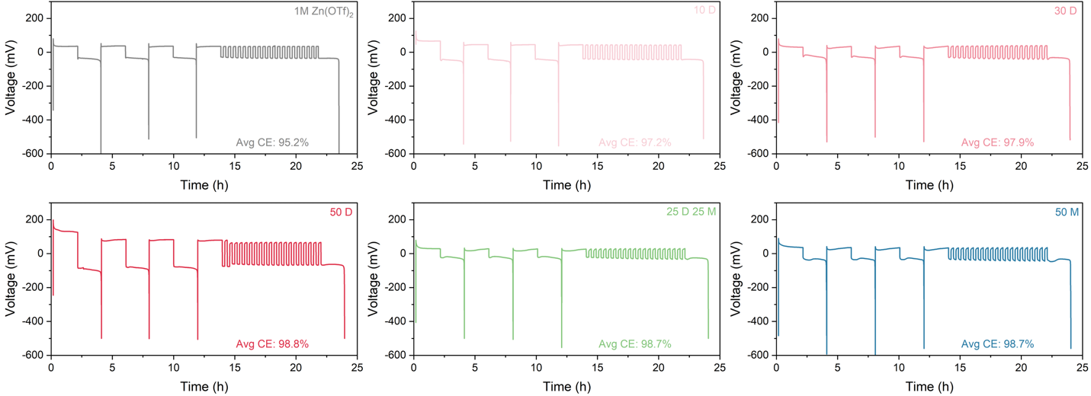
Figure S1. Representative voltage profiles and average CE of Cu‖Zn half cells for preliminary CE evaluation, measured using Aurbach’s reservoir method.

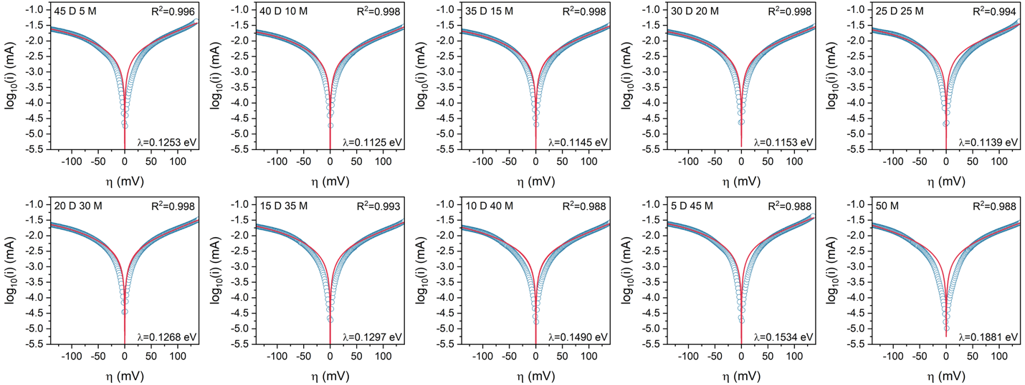
Figure S2. MHC model fitting of the LSV curves of Zn‖Zn symmetric cell with different cosolvent compositions, used to extract reorganization energy.

Figure S3. Nyquist plots obtained from EIS measurments of Zn‖Zn symmetric cells with different cosolvent compositions.

Figure S4. Example of DRT analysis from EIS of a Zn‖Zn symmetric cell with 50 D electrolyte, illustrating the separation of resistive contributions from different processes—including diffusion (R_{diff}), charge transfer (R_{ct}), migration (R_{mig}), and adsorption (R_{ads}).

Figure S5. ¹H NMR chemical shifts of electrolytes with different cosolvent compositions.

Figure S6. FTIR spectra showing the O–H stretching vibration of water in electrolytes with different cosolvent compositions.

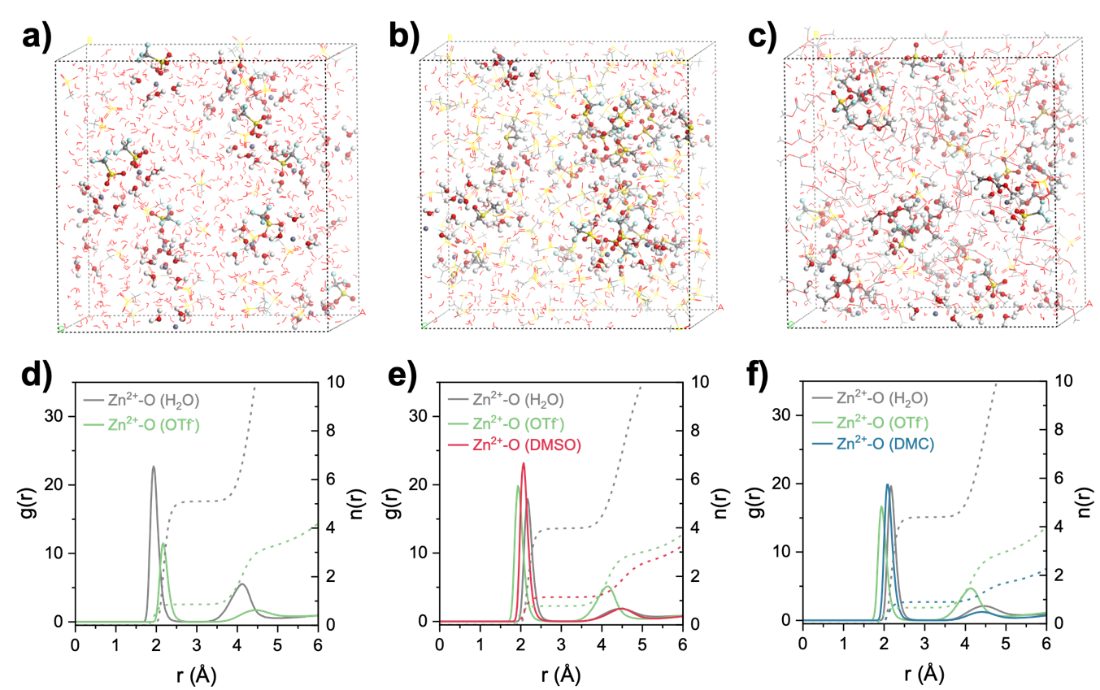
Figure S7. MD snapshots, RDFs, and CNs of Zn²⁺ solvation structures in (a, d) 1 M Zn(OTf)₂, (b, e) 50 D, and (c, f) 50 M electrolytes.

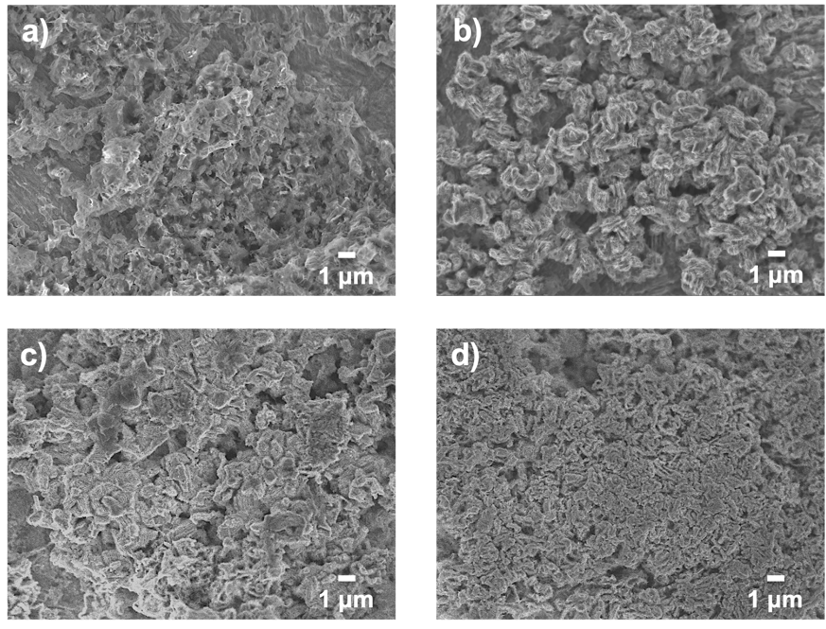
Figure S8. SEM images of cycled Zn anodes showing the morphology of deposits in a) 1 M Zn(OTf)₂, b) 50 D, c) 25 D 25 M, and d) 50 M electrolytes.
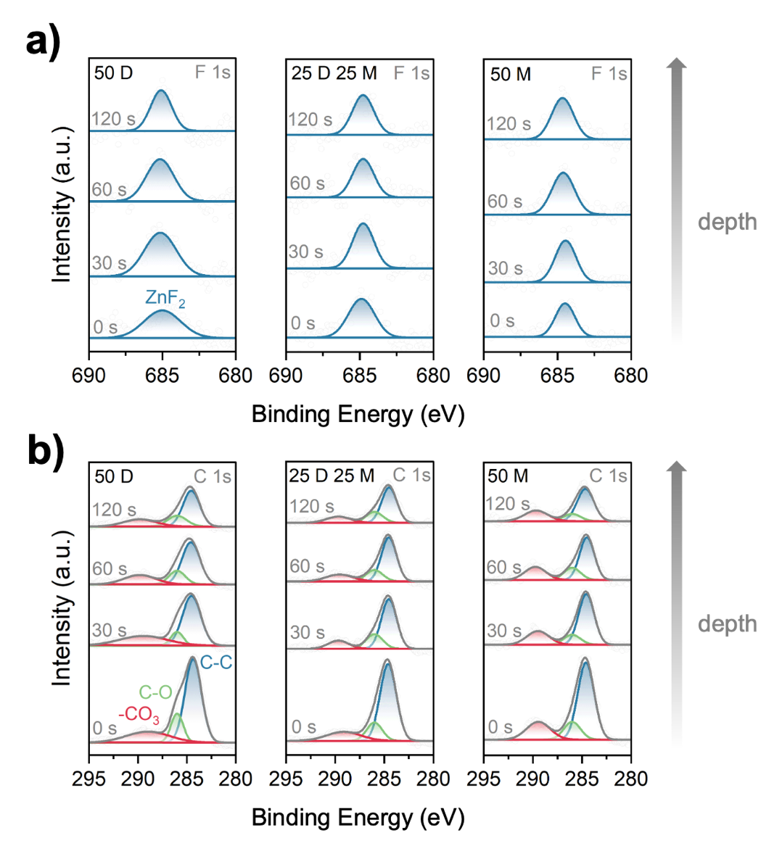
Figure S9. a) F 1s and b) C 1s XPS spectra of cycled Zn anodes in different cosolvent electrolytes, with Ar⁺ sputtering.
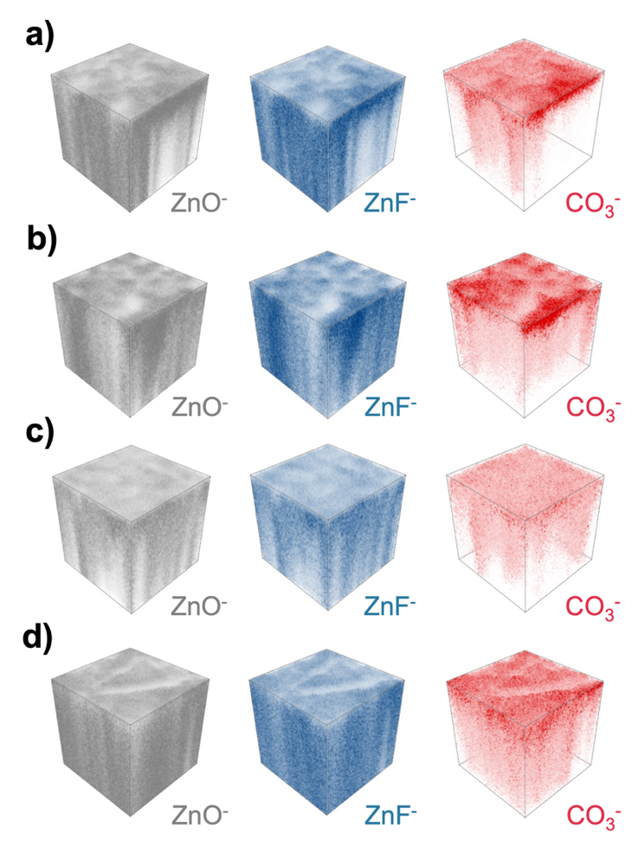
Figure S10. TOF-SIMS 3D render images of cycled Zn anode in a) 1 M Zn(OTf)₂, b) 50 D, c) 25 D 25 M, and d) 50 M electrolytes.

. 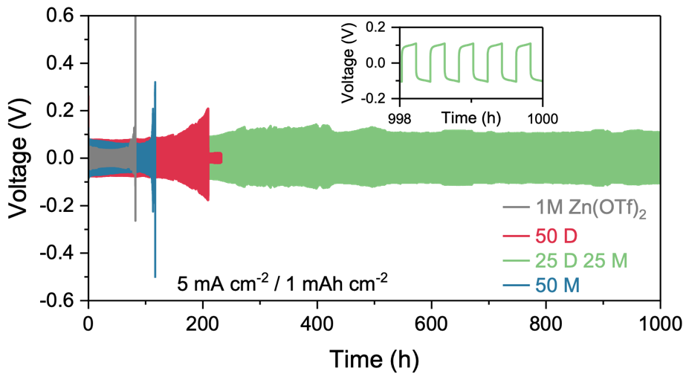
Figure S11. Voltage profiles of Zn‖Zn symmetric cells at 5 mA cm⁻², 1 mAh cm⁻² for different electrolyte.
Figure S12. CE of Cu‖Zn half cells of different electrolytes at 1 mA cm⁻² and 1 mAh cm⁻²

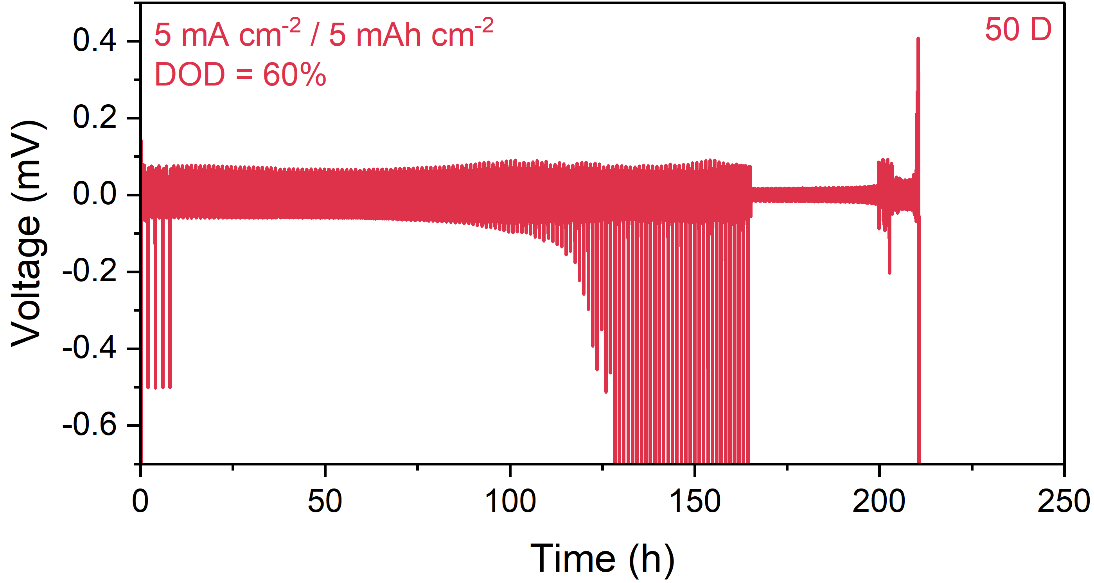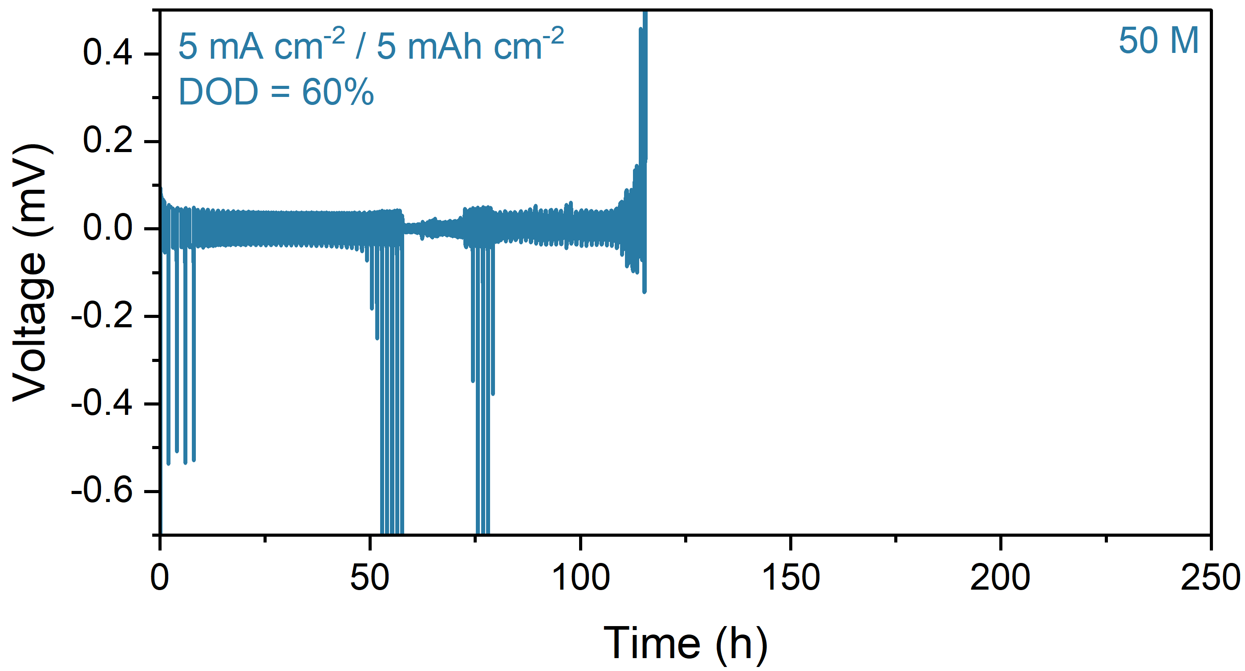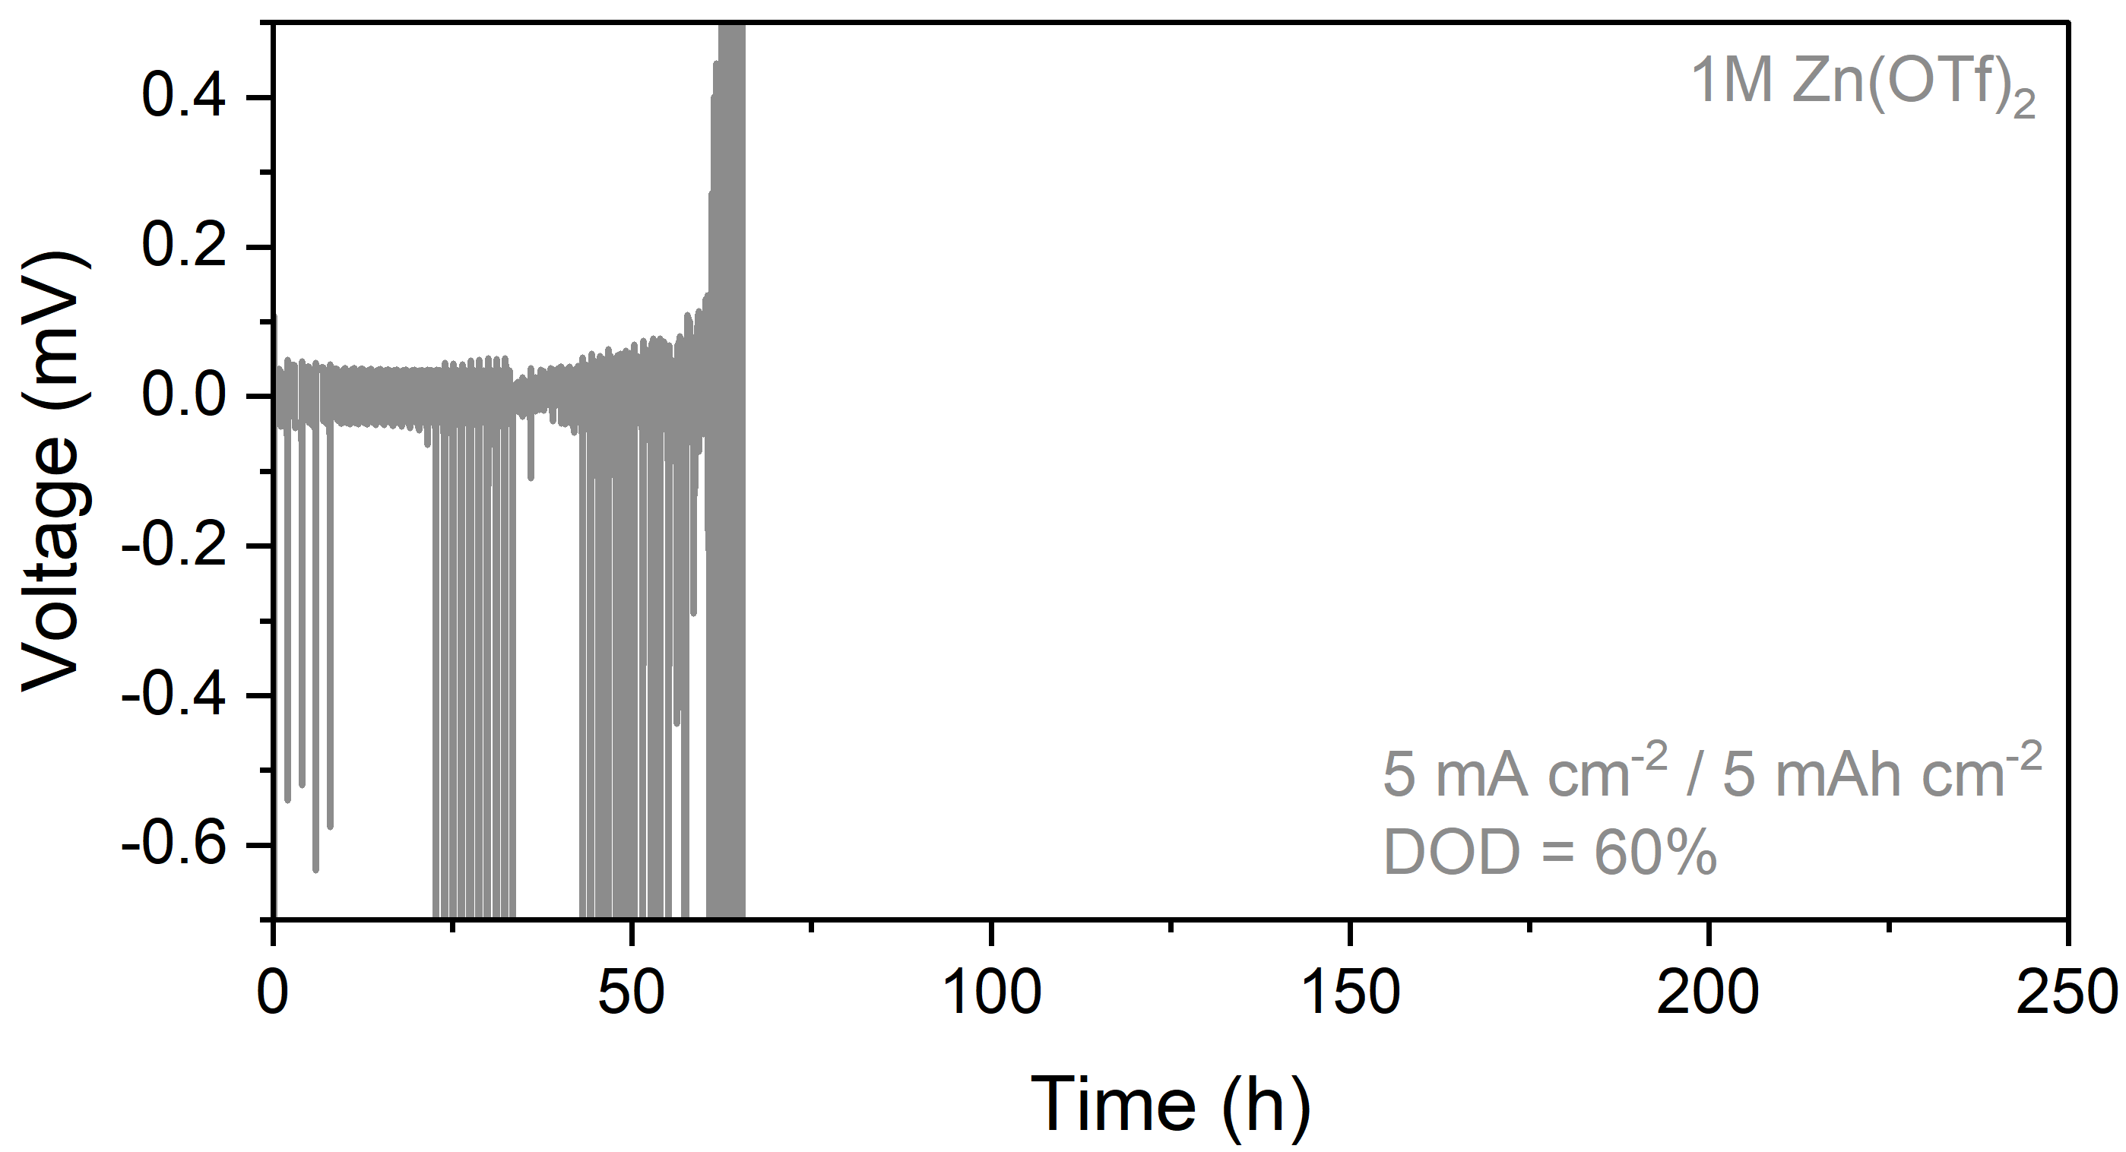
Figure S13. CE of Cu‖Zn half cells of different electrolytes, measured by Aurbach’s reservoir method with a depth of discharge (DOD) of 60%.

Sample | Vanadium Concentration (ppm)
1M Zn(OTf)₂ | 18.83
50 D | 19.58
25 D 25 M | 6.347
50 M | 3.299
Table S1. ICP-OES quantified vanadium dissolution after 50 full-cell cycles for different electrolytes.
Reference:
(1) Wang, Z.; Wang, Y.; Py, B.; Maradesa, A.; Liu, J.; Wan, T. H.; Saccoccio, M.; Ciucci, F. DRTtools: Freely Accessible Distribution of Relaxation Times Analysis for Electrochemical Impedance Spectroscopy. ACS Electrochem. 2025, acselectrochem.5c00334. https://doi.org/10.1021/acselectrochem.5c00334.
(2) Zeng, Y.; Smith, R. B.; Bai, P.; Bazant, M. Z. Simple Formula for Marcus–Hush–Chidsey Kinetics. Journal of Electroanalytical Chemistry 2014, 735, 77–83. https://doi.org/10.1016/j.jelechem.2014.09.038.

