Supplementary Materials

Figure A.1
Overall Flow of the Procedure
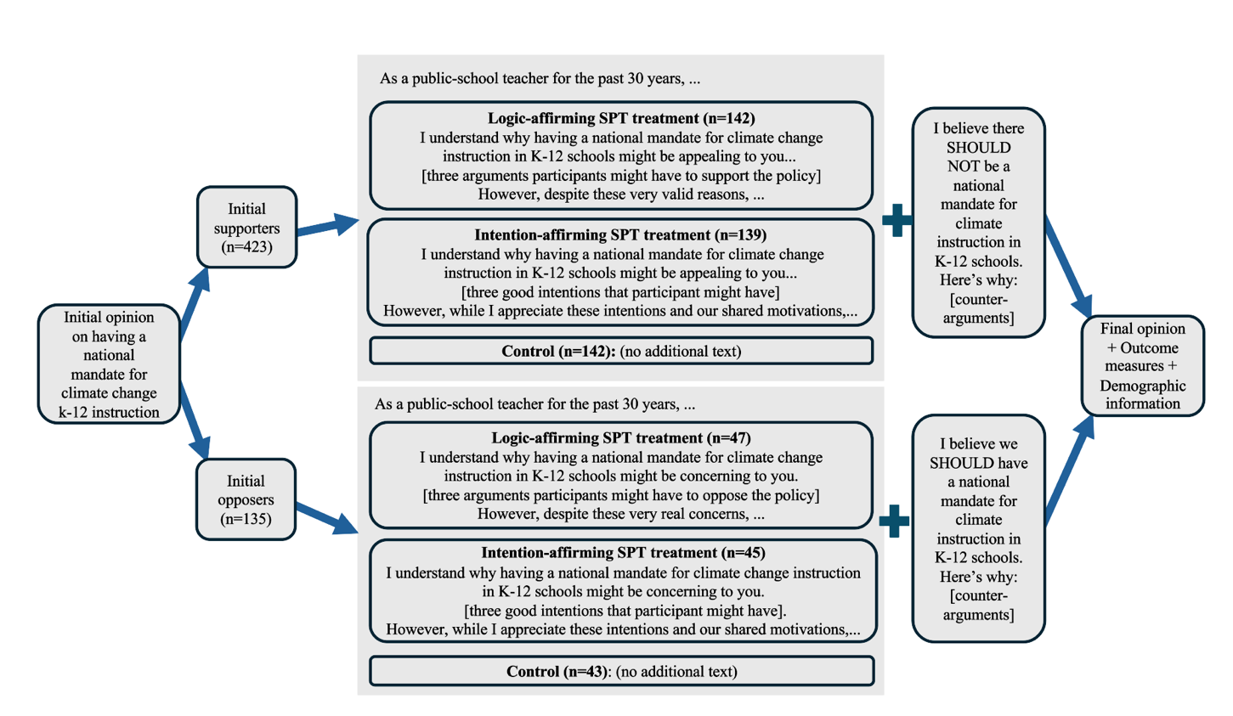

Figure A.2
Logic-Affirming SPT Treatment for Initial Supporters (left) and Initial Opposers (right)


Figure A.3
Intention-Affirming SPT Treatment for Initial Supporters (left) and Initial Opposers (right)


Figure A.4
Control Text for Initial Supporters (left) and Initial Opposers (right)


Table A.1
Items for Composite Scales
Scale | Statement | Choice Options & Codes
 |  | 1 | 2 | 3 | 4 | 5
Perceived SPT
Item 1 | In writing the post, how much effort do you think the teacher put into taking the perspective of people like you on this issue? | No effort at all | A bit of effort | A moderate amount of effort | Quite some effort | Lots of effort
Item 2 | Overall, how motivated do you think the teacher would be to understand how you feel about this issue? | Not motivated at all | Slightly motivated | Somewhat motivated | Quite motivated | Extremely motivated
Item 3 | How clearly do you think the teacher understood your point of view? | Not clearly at all | Slightly clearly | Somewhat clearly | Quite clearly | Extremely clearly
Item 4 | How accurately do you think the teacher would describe how you see this issue? | Not accurately at all | Slightly accurately | Moderately accurately | Quite accurately | Extremely accurately
Perceived Similarity
Item 1 | Overall, how much would you guess that you have in common with the teacher? | Almost nothing in common | A little bit in common | A moderate amount in common | Quite a bit in common | A great deal in common
Item 2 | How similar do you think your personality is to the teacher's personality? | Not similar at all | Slightly similar | Somewhat similar | Quite similar | Extremely similar
Item 3 | If you discussed the issue of national curriculum mandate with the teacher, how much common ground do you think you would find? | None at all | A little | A moderate amount | A lot | A great deal
Item 4 | For climate change education issues, how similar do you think your attitudes and the teacher's attitudes are? | Not similar at all | Slightly similar | Somewhat similar | Quite similar | Extremely similar
Perceived Fairness
Item 1 | Overall, how fair was the teacher's treatment of each side of the issue? | Not fair at all | Slightly fair | Somewhat fair | Quite fair | Extremely fair
Item 2 | How fair do you think the information presented was to both sides? | Not fair at all | Slightly fair | Somewhat fair | Quite fair | Extremely fair
Item 3 | How similar was the quality of the information that the teacher presented for both sides? | Not similar at all | Slightly similar | Somewhat similar | Quite similar | Extremely similar
Item 4 | For the two sides, how balanced was the amount of information that the teacher presented? | Not balanced at all | Slightly balanced | Somewhat balanced | Quite balanced | Extremely balanced
Anticipated Relationship
Item 1 | How much do you think you would enjoy having a conversation with the teacher? | Not enjoy at all | Enjoy a little | Enjoy a moderate amount | Enjoy a lot | Enjoy a great deal
Item 2 | If you met the teacher in person, how friendly do you think they would be towards you? | Not friendly at all | Slightly friendly | Somewhat friendly | Quite friendly | Extremely friendly
Item 3 | How respectful would the teacher be towards you? | Not respectful at all | Slightly respectful | Somewhat respectful | Quite respectful | Extremely respectful
Item 4 | In general, how caring do you think this teacher would be towards you? | Not caring at all | Slightly caring | Somewhat caring | Quite caring | Extremely caring
Personal SPT Effort
Item 1 | How hard did you try to understand the merits of the opposing points of view on this issue? | Not hard at all | Slightly hard | Somewhat hard | Quite hard | Extremely hard
Item 2 | How much did you try to understand the motivations of the supporters on the opposite side? | None at all | A little | A moderate amount | Quite a lot | A great deal
Item 3 | How much effort did you put into figuring out the possible goals of people who disagree with your position on this issue? | Almost no effort | A little bit of effort | Some effort | Quite a lot of effort | A tremendous amount of effort
Item 4 | As you were reading, how hard did you try to understand what supporters of the other side might be feeling? | Not hard at all | Slightly hard | Somewhat hard | Quite hard | Extremely hard
Item 5 | Overall, how much effort did you put into figuring out what people on the opposing side might be thinking? | Almost no effort | A little bit of effort | Some effort | Quite a lot of effort | A tremendous amount of effort

Table A.2
T-Test Results for Manipulation Checks
Manipulation  Variables | Initial Opinion | Treatment | Control |  | Treatment |  | Δ Mean | SE | 95% CI |  | t | p
Manipulation  Variables | Initial Opinion |  | n | Mean | n | mean
1. Percentage of supportive message | Support | Logic | 142 | 8.4 | 142 | 26.99 | 18.59 | 2.01 | -22.54 | -14.64 | –9.26 | <0.001
2. Percentage of opposing message | Oppose | Logic | 43 | 3.84 | 47 | 30.40 | 26.57 | 4.25 | -35.03 | -18.10 | –6.24 | <0.001
3. Percentage of intention-affirming message | Support | Intention | 142 | 26 | 139 | 41.58 | 15.58 | 2.95 | -21.39 | -9.77 | –5.28 | <0.001
3. Percentage of intention-affirming message | Oppose | Intention | 43 | 17.12 | 45 | 35.80 | 18.68 | 6.00 | -30.62 | -6.75 | –3.11 | 0.0025

Table A.3
Unstandardized and standardized regression output for preregistered hypothesis testing (N=557)
 | Perceived SPT | Perceived similarity | Perceived fairness | Anticipated relationship | Personal SPT effort | Opinion change
Unstandardized Coefficient
Logic-affirming SPT | 0.99*** | 0.55*** | 1.27*** | 0.57*** | 0.20* | 0.23
 | [0.82,1.17] | [0.39,0.72] | [1.09,1.45] | [0.40,0.74] | [0.04,0.36] | [-0.12,0.58]
Intention-affirming SPT | 0.40*** | 0.27** | 0.51*** | 0.30*** | 0.10 | 0.09
 | [0.22,0.58] | [0.10,0.44] | [0.32,0.70] | [0.13,0.47] | [-0.06,0.26] | [-0.25,0.44]
Initial opinion | 0.05** | 0.03* | 0.05** | 0.03 | 0.04* | 0.12**
 | [0.01,0.08] | [0.00,0.07] | [0.02,0.09] | [-0.01,0.06] | [0.01,0.07] | [0.05,0.19]
Political orientation | -0.04 | -0.01 | -0.03 | -0.01 | 0.02 | 0.10
 | [-0.09,0.01] | [-0.06,0.04] | [-0.08,0.03] | [-0.06,0.03] | [-0.03,0.06] | [-0.02,0.21]
Constant | 2.13*** | 2.00*** | 1.81*** | 2.73*** | 2.81*** | -0.51
 | [1.74,2.52] | [1.63,2.37] | [1.41,2.21] | [2.36,3.10] | [2.44,3.18] | [-1.42,0.39]
Standardized Coefficient
Logic-affirming SPT | 0.48*** | 0.30*** | 0.56*** | 0.31*** | 0.12* | 0.06
 | [0.82,1.17] | [0.39,0.72] | [1.09,1.45] | [0.40,0.74] | [0.04,0.36] | [-0.12,0.58]
Intention-affirming SPT | 0.19*** | 0.15** | 0.23*** | 0.16*** | 0.06 | 0.02
 | [0.22,0.58] | [0.10,0.44] | [0.32,0.70] | [0.13,0.47] | [-0.06,0.26] | [-0.25,0.44]
Initial opinion | 0.13** | 0.11* | 0.14** | 0.08 | 0.14* | 0.19**
 | [0.01,0.08] | [0.00,0.07] | [0.02,0.09] | [-0.01,0.06] | [0.01,0.07] | [0.05,0.19]
Political orientation | -0.08 | -0.02 | -0.04 | -0.03 | 0.04 | 0.10
 | [-0.09,0.01] | [-0.06,0.04] | [-0.08,0.03] | [-0.06,0.03] | [-0.03,0.06] | [-0.02,0.21]
R² | 0.20 | 0.08 | 0.26 | 0.08 | 0.03 | 0.03
adj. R² | 0.20 | 0.08 | 0.26 | 0.08 | 0.02 | 0.02
AIC | 1448.13 | 1381.15 | 1497.47 | 1382.05 | 1322.49 | 2205.62
BIC | 1469.74 | 1402.77 | 1519.08 | 1403.66 | 1344.11 | 2227.23
Note. The baseline group is the control condition; 95% confidence intervals in brackets. * p <.05, ** p <.01, *** p <.001

