Supplementary methods and materials
Immunohistochemical staining
Tissues sections were treated with autoclaving at 121°C for 15 min in 0.01 mol/L citrate-buffered saline (pH 6.0) for antigen retrieval. The sections were then immersed in 3% H₂O₂ for 30 min at room temperature to block the endogenous peroxidase activity. After deactivation, 10% normal goat serum was used to block nonspecific binding of the immunological reagents. After incubation of the antibodies against iNOS at 4°C overnight, each slide was rinsed three times in PBS and incubated with biotinylated anti-rabbit IgG and HRP-streptavidin at room temperature according to the immunohistochemical staining kit (Beyotime Biotechnology), stained with DAB substrate. Finally, nuclear counterstaining was done using hematoxylin.
Immunofluorescence staining
After the stimulation as indicated, cells were fixed with pre-warmed 4% paraformaldehyde and then permeabilized for 10 min using 1% Triton X-100 in dissolved in PBS followed by incubation with the primary antibodies at 4°C overnight. The cells were washed three times with PBS and incubated with Fluor-conjugated secondary antibody (Invitrogen). The nucleus was stained with 4',6-diamidino-2-phenylindole (DAPI) to locate the cell. Fluorescent pictures were obtained with a Zeiss fluorescence microscope.
Western blot analysis
Samples from the culture cells were pooled in ristocetin-induced platelet aggregation (RIPA) buffer containing protease and phosphatase inhibitors (Complete Protease Inhibitor Cocktail and PhosSTOP Phosphatase Inhibitor Cocktail; both from Roche), and then centrifuged at 12,000 g for 10 min at 4°C. The supernatant was collected. The total protein concentration in each sample was determined with a bicinchoninic acid (BCA) assay (QuantiPro BCA Assay Kit, Sigma-Aldrich) according to the manufacturer’s instructions. Equal amount of protein samples was separated by SDS-polyacrylamide gel electrophoresis and transferred to nitrocellulose membranes (Millipore). The membranes were blocked with 5% skimmed milk (wt/vol) in Tris-buffered saline supplemented with 0.1% Tween 20 (TBST) for 1 hr at room temperature and then incubated with the corresponding primary antibodies: rabbit anti-VCAM-1 (1:1000; Proteintech); rabbit anti-COX-2 (1:1000; Proteintech); rabbit anti-iNOS (1:1000; Cell Signal Technology); rabbit anti-Bax (1:500; Cell Signaling Technology); rabbit anti-Bcl-2 (1:500; Cell Signaling Technology); rabbit anti-PARP1 (1:1000; Proteintech); rabbit anti-Caspase 3 (1:1000; Cell Signaling Technology); mouse anti-Caspase 9 (1:1000; Proteintech); mouse anti-p53 (1:1000; Proteintech); rabbit anti-XBP-1 (1:1000; Cell Signaling Technology); rabbit anti-BIP (1:1000; Proteintech); rabbit anti-calnexin (1:1000; Cell Signaling Technology); rabbit anti-p-elf2α (1:1000; Proteintech); rabbit anti-p-PERK (1:1000; Proteintech); rabbit anti-p-IRElα (1:1000; Proteintech); rabbit anti-PARP16 (1:1000; Aviva); mouse anti-Caspase 1 (p20) (1:1000; Proteintech); rabbit anti-IL-18 (1:1000; Proteintech); rabbit anti-IL-1β (1:1000; Proteintech); rabbit anti-GSDMD (1:1000; Proteintech); mouse anti-GAPDH (1:20000; Proteintech); and mouse anti-β-tubulin (1:20000; Proteintech) at 4°C overnight. The members were then washed and incubated for 1 h at room temperature with the speciesappropriate horseradish peroxidase (HRP)-labeled secondary antibody (1:5000; Jackson ImmunoResearch Inc., USA). Protein-specific signals were detected using a Bio-Rad Imager (Bio-Rad, Hercules, CA, USA), and the bands were quantified by densitometric analysis (ImageJ software, NIH). The relative amounts of proteins were normalized against GAPDH or β-tubulin.
RNA extraction and quantitative real-time polymerase chain reaction (qRT-PCR)
Total RNA was isolated from the cells or tissues using TRIzol reagent (Takara Bio Inc., China). Reverse transcription was performed according to the instruction of the Prime RT Master Mix kit (Takara Bio Inc., China). Quantitative real-time PCR was performed in triplicate using SYBR Premix EX Taq II (Yeasen Biotech Co., Ltd. China). The sequences of primers were shown in Table S1.
Small interfering RNA (siRNA) transfection in vitro
Cells were plated in six-well culture dishes and were transfected with PARP16 and control small interfering RNA (siRNA) (GenePharma Co. Ltd. Shanghai, China) using Lipofectamine RNA iMAX (ThermoFisher Scientific) according to the manufacturer’s instructions. The sequences are as follows: PARP16 siRNA: 5’-CGGAUUUCCUAUUUGAAAUTT-3’ and the scrambled siRNA: 5’- AUUUCAAAUAGGAAAUCCGTT-3’. Experiments were performed 24 h after transfection.
Co-immunoprecipitation (Co-IP)
For co-immunoprecipitation experiments, HT22 cells were treated with OGD/R in the presence or absence of PARP16 siRNA, and were washed in PBS and lysed in a buffer containing 20 mmol/L Tris-HCl (pH 8), 137 mmol/L NaCl, 10% glycerol, 1% Nonidet P-40 (NP-40), 2 mmol/L EDTA, and protease inhibitor cocktail. Precleaning was achieved with 50 mL of protein A/G agarose beads (Santa Cruz, Dallas, TX, USA) for 1 h, and lysates were incubated overnight at 4°C in presence of 50 mL of protein A/G agarose or magnetic beads and 1-2 mg rabbit anti-PARP16 or rabbit anti-ADP antibody before analysis by western blotting. The same amount of irrelevant rabbit IgG (Santa Cruz) was used to control for nonspecific IgG binding to PARP16 or ADP.

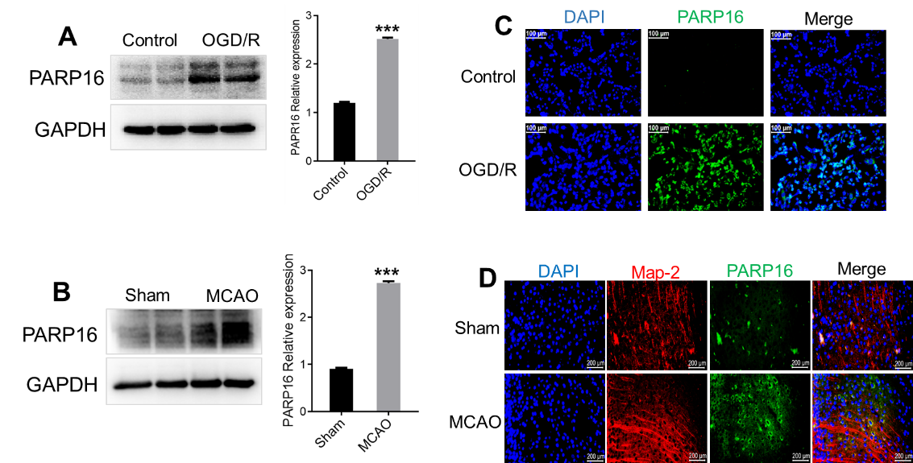
Fig. S1 Expression of PARP16 increases in HT22 cells after OGD/R and in brain of mice after MCAO. (A) Expression of PARP16 increases in HT22 cells after OGD/R. HT22 cells were treated with OGD 4 hr and 24 hr of reoxygenation, immunoblot analysis of PARP16, data are presented as mean ± S.D of four independent experiments; ***p < 0.001 compared with Control. (B) Expression of PARP16 increases in brain of mice after MCAO. Mice were subjected to 90-min middle cerebral artery occlusion (MCAO) followed by 24 hr reperfusion, immunoblot analysis of PARP16 in brain of mice, data are presented as mean ± S.D; ***p < 0.001 compared with Sham group, n=6. (C) Immunofluorescence staining of PARP16 in OGD/R-treated HT22 cells, Scale bars: 100 μm. (D) Immunofluorescence staining of Map-2 and PARP16 in cortices of mice after MCAO, Scale bars: 200 μm.

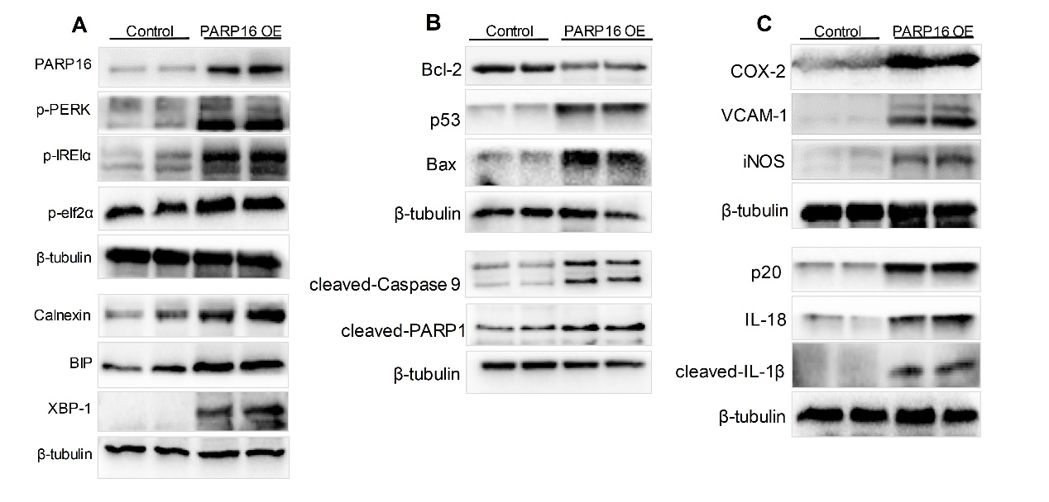
Fig. S2 PARP16 overexpression induces ER stress-mediated primary cortical neurons damage. The primary cortical neurons were transfected with lentivirus-mediated PARP16 cDNA (PARP16 OE) for 72 h, cell lysates were immunoblotted with antibody against PARP16 and ER stress-related proteins (p-PERK, p-elf2α, p-IRE1α, BIP, XBP-1 and Calnexin) (A); apoptosis-related proteins (Bcl-2, Bax, p53, cleaved-PARP1, cleaved-Caspase 9) (B); inflammation markers (iNOS, VCAM-1, COX-2) and NLRP3 inflammasome associated proteins (cleaved-IL-1β、p20、IL-18) (C). All results were repeated three times.

Table S1 Primers used for qRT-PCR validation.
Gene name | Primer name | Primer sequence (5´ to 3´)
Nos2 | Mouse _ Nos2_F | TTCACAGCTCATCCGGTACG
Nos2 | Mouse _ Nos2_R | GCCTAGGTCGATGCACAACT
Vcam-1 | Mouse _ Vcam-1_F | GCTGCGAGTCACCATTGTTC
Vcam-1 | Mouse _ Vcam-1_R | ACTTCGTTCCAGCTTCCCAG
p53 | Mouse _p53_F | AGACAGGCAGACTTTTCGCC
p53 | Mouse _p53_R | TCTTCTTCTGTACGGCGGTC
Bax | Mouse _ Bax _F | GCAGGGAGGATGTCTGGGGAGA
Bax | Mouse _ Bax _R | TCCAGACAAGCAGCCGCTCACG
GAPDH | Mouse _GAPDH_ F | CTTCTCTTGTGACAAAGTGGACAT
GAPDH | Mouse _GAPDH_ R | TTCTCAGCCTTGACTGTGCC

