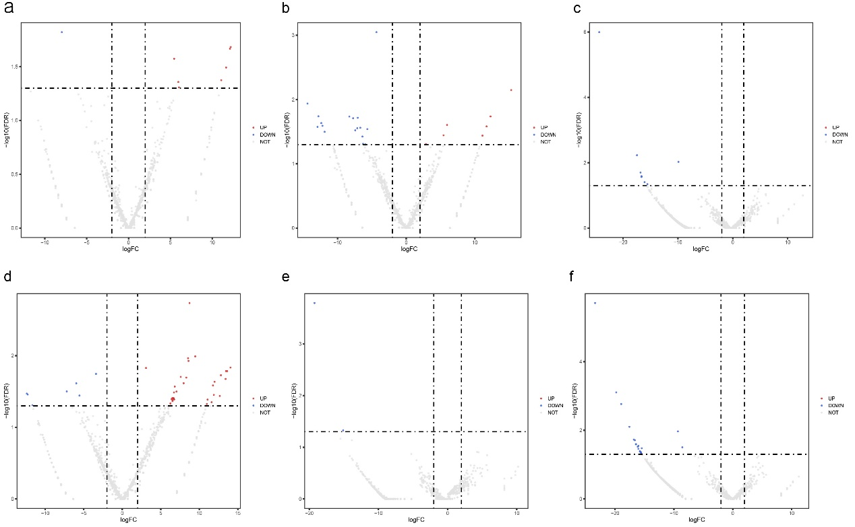
Figure S1 The volcano plots of cochlear sEV miRNA sequencing data. (a) P3 vs P7. (b) P3 vs P14. (c) P3 vs P21. (d) P7 vs P14. (e) P7 vs P21. (f) P14 vs P21. The significantly up-regulated miRNAs are shown as red dots, the significantly down-regulated miRNAs are shown as blue dots, and the non-significantly changed miRNAs are shown in gray dots.

Figure S2 Venn diagram of cochlear sEVs overlapped with the EV databases. (a) All proteins of cochlear sEVs matched to the Vesiclepedia database and Exocarta database. (b) The top 100 proteins of cochlear sEVs from P3, P7, P14, P21 matched to the top100 proteins of the Vesiclepedia database and Exocarta database, respectively. Proteins of from cochlear sEVs are in red, proteins from the Vesiclepedia database are in green, and proteins from the Exocarta database are in yellow.
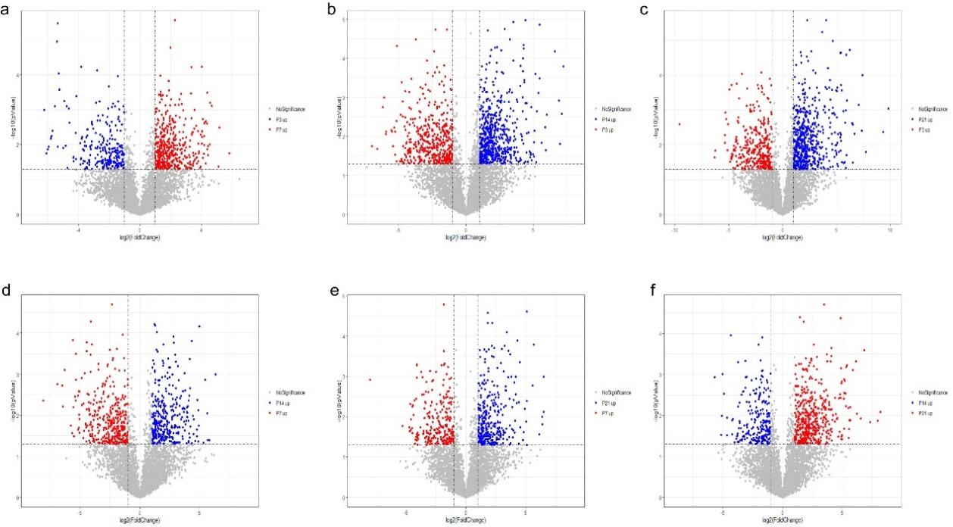
Figure S3 The volcano plots of cochlear sEV proteomics data. (a) P3 vs P7. (b) P3 vs P14. (c) P3 vs P21. (d) P7 vs P14. (e) P7 vs P21. (f) P14 vs P21. The significantly up-regulated proteins are shown in blue and red in all figures, respectively. Proteins without significant changes are shown as gray dots.

Table S1 The miRNA primer list
