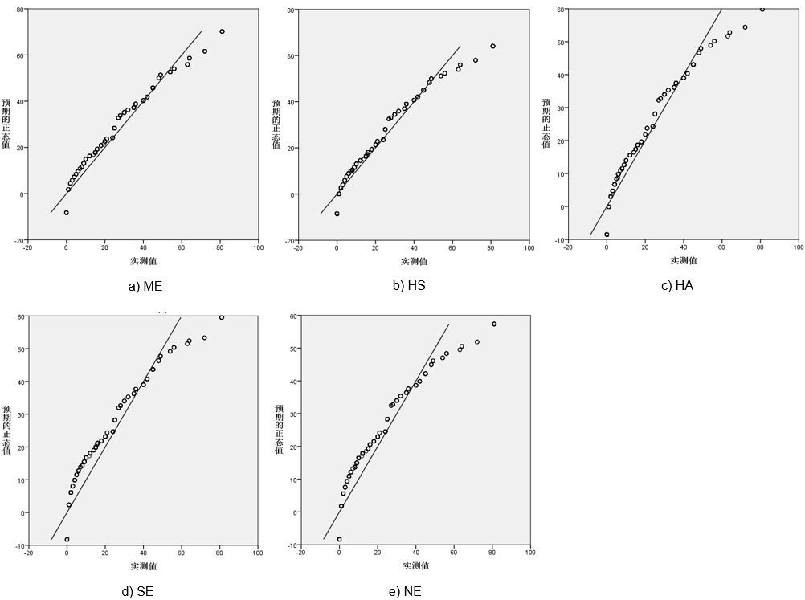
Figure A1. Normal Q-Q diagram of noise annoyance from five types of sound sources.

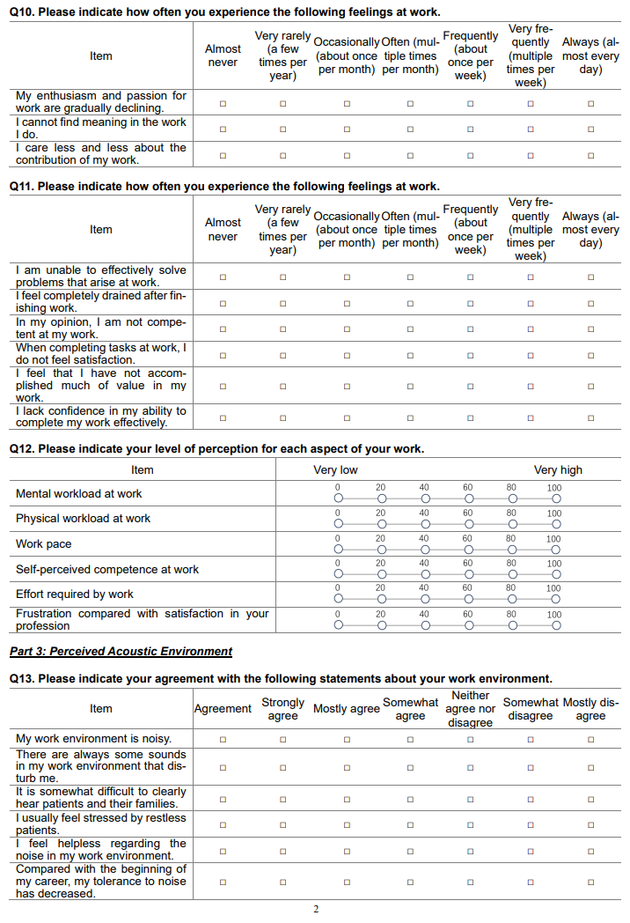
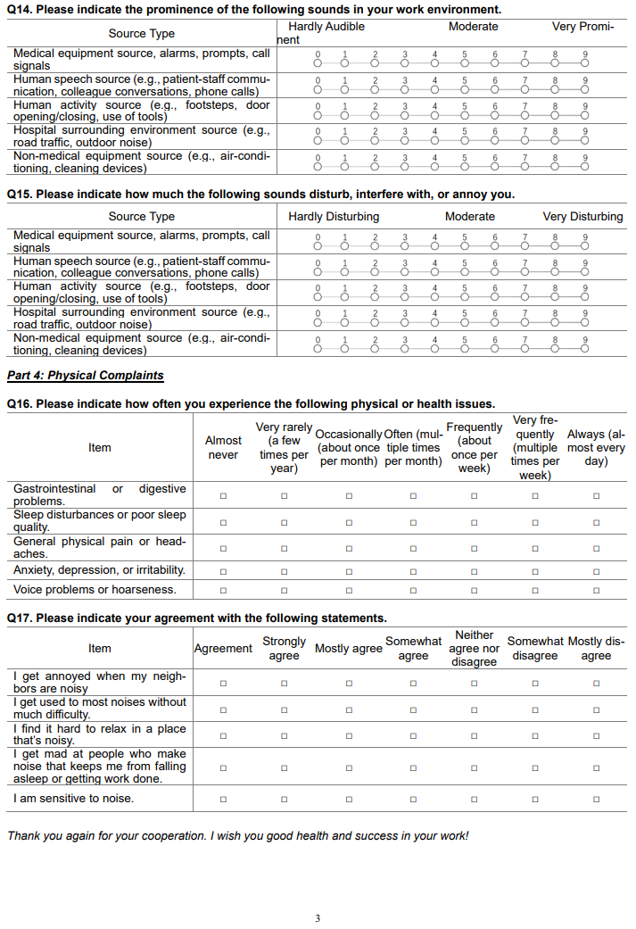Figure A2. Noise stress and health outcome questionnaire for healthcare workers.

Table A1. Characteristics of the 12 Participated Hospitals.
Region | City | Hospital Name | Grade | Classification
East China | Zaozhuang | Zaozhuang Maternal and Child Health Hospital | 3A | Specialized (MCH)
 |  | Zaozhuang Municipal Hospital | 3A | General
 |  | Zaozhuang Mining Bureau Hospital | 3A | General
 | Linyi | Linyi Traditional Chinese Medicine Hospital | 3A | Specialized (TCM)
 |  | Linyi People's Hospital | 3A | General
 | Jinan | Jinan Provincial Stomatological Hospital | 3A | Specialized (Dental)
Northeast | Shenyang | Northeast International Hospital | 3A | General
 |  | Liaoning Cancer Hospital | 3A | Specialized (Oncology)
 |  | Shenyang Sixth People's Hospital | 3A | Specialized (Infectious)
 |  | Shenyang Red Cross Hospital | 2A | General
 | Chaoyang | Chaoyang Second People's Hospital | 3A | General
Southwest | Chengdu | Chengdu Fifth People's Hospital | 3A | General
Note. 3A/2A: Chinese hospital classification (Tertiary/Secondary Grade A); MCH: Maternal and Child Health; TCM: Traditional Chinese Medicine.

Table A2. Classification of survey departments.
Primary Department | Secondary Departments
Outpatient Department | General Outpatient Clinic
Outpatient Department | Pediatric Outpatient Clinic
Outpatient Department | Gynecology Outpatient Clinic
Outpatient Department | Surgical Outpatient Clinic
Surgery | Neurosurgery
Surgery | Hepatobiliary, Pancreatic and Vascular Surgery
Surgery | Urology
Surgery | Orthopedic Surgery
Surgery | General Surgery
Surgery | Thoracic Surgery
Surgery | Otorhinolaryngology and Ophthalmology Clinic
Dentistry | Dental and Oral Surgery
Otorhinolaryngology | Otorhinolaryngology – Head & Neck Surgery
Pediatric Surgery | -
Pediatrics | Neonatology
Internal Medicine | Gastroenterology
Internal Medicine | General Internal Medicine
Internal Medicine | Neurology
Internal Medicine | Cardiology / Cardiovascular Medicine
Internal Medicine | Nephrology & Dialysis
Internal Medicine | Pulmonology / Respiratory and Critical Care Medicine
Internal Medicine | Rheumatology & Immunology
Internal Medicine | Geriatrics Medicine
Oncology | Medical Oncology / Cancer Center
Infectious Diseases | -
Rehabilitation Medicine | Joint and Sports Medicine
Rehabilitation Medicine | Rehabilitation Medicine
Child Health | Child Health and Development Center & Pediatric Rehabilitation
Obstetrics & Gynecology | Gynecology
Obstetrics & Gynecology | Gynecology Outpatient Clinic
Obstetrics & Gynecology | Labor–Delivery–Recovery–Postpartum Obstetrics
Obstetrics & Gynecology | Obstetrics
Operating Room | -
Emergency Department | -
Intensive Care Unit | -
Clinical Laboratory | -
Radiology | -
Pathology | -
Auxiliary Departments | Endoscopy Center
Auxiliary Departments | Health Screening and Check-up Center
Auxiliary Departments | Central Sterile Supply Department
Auxiliary Departments | Pharmacy
Auxiliary Departments | Medical Insurance Office

Table A3. Demographic characteristics of participants.
Category | Total | Physicians | Nurses | Administrative | Technical staff
N | 1182 | 352 (29.8) | 652 (55.2) | 65 (5.5) | 113 (9.6)
Age(years)
20-30 | 339 (28.7) | 56 (15.9) | 220 (33.7) | 16 (24.6) | 47 (41.6)
31-40 | 487 (41.2) | 139 (39.5) | 280 (42.9) | 26 (40.0) | 42 (37.2)
41-50 | 267 (22.6) | 105 (29.8) | 124 (19.0) | 17 (26.2) | 21 (18.6)
＞50 | 89 (7.5) | 52 (14.8) | 28 (4.3) | 6 (9.2) | 3 (2.7)
Tenure (years)
1-5 | 329 (27.8) | 70 (19.9) | 196 (30.1) | 20 (30.8) | 43 (38.1)
6-10 | 237 (20.1) | 74 (21.0) | 127 (19.5) | 13 (20.0) | 23 (20.4)
11-15 | 236 (20.0) | 65 (18.5) | 142 (21.8) | 10 (15.4) | 19 (16.8)
16-20 | 187 (15.8) | 57 (16.2) | 101 (15.5) | 15 (23.1) | 14 (12.4)
＞20 | 193 (16.3) | 86 (24.4) | 86 (13.2) | 7 (10.8) | 14 (12.4)
Education Level
Associate Degree | 174 (14.7) | 14 (4.0) | 145 (22.2) | 7 (10.8) | 8 (7.1)
Bachelor’s Degree | 830 (70.2) | 201 (57.1) | 498 (76.4) | 41 (63.1) | 90 (79.6)
Postgraduate and Above | 178 (15.1) | 137 (38.9) | 9 (1.4) | 17 (26.2) | 15 (13.3)
Professional Title
Junior | 387 (32.7) | 65 (18.5) | 240 (36.8) | 27 (41.5) | 55 (48.7)
Intermediate | 545 (46.1) | 138 (39.2) | 333 (51.1) | 30 (46.2) | 44 (38.9)
Associate Senior | 193 (16.3) | 100 (28.4) | 75 (11.5) | 6 (9.2) | 12 (10.6)
Senior | 57 (4.8) | 49 (13.9) | 4 (0.6) | 2 (3.1) | 2 (1.8)
Hearing
Normal | 599 (50.7) | 165 (46.9) | 354 (54.3) | 29 (44.6) | 51 (45.1)
Slight Decline | 431 (36.5) | 138 (39.2) | 230 (35.3) | 20 (30.8) | 43 (38.1)
Moderate Decline | 121 (10.2) | 38 (10.8) | 52 (8.0) | 14 (21.5) | 17 (15.0)
Marked Decline | 25 (2.1) | 9 (2.6) | 13 (2.0) | 2 (3.1) | 1 (0.9)
Severe Decline | 6 (0.5) | 2 (0.6) | 3 (0.5) | 0 (0.0) | 1 (0.9)
Family Care Responsibilities
Only children | 247 (20.9) | 78 (22.2) | 143 (21.9) | 14 (21.5) | 12 (10.6)
Only elderly | 125 (10.6) | 36 (10.2) | 65 (10.0) | 10 (15.4) | 14 (12.4)
Both children and elderly | 490 (41.5) | 151 (42.9) | 263 (40.3) | 21 (32.3) | 55 (48.7)
Neither children nor elderly | 320 (27.1) | 87 (24.7) | 181 (27.8) | 20 (30.8) | 32 (28.3)
Gender
Male | 283 (23.9) | 187 (53.1) | 39 (6.0) | 19 (29.2) | 38 (33.6)
Female | 899 (76.1) | 165 (46.9) | 613 (94.0) | 46 (70.8) | 75 (66.4)
Note. The numbers in parentheses represent percentages.
Table A4. Results of K-means clustering and Monte Carlo posterior power analysis.
Index/ Path | HWL: Avg β  (Power, 95% CI Cov) | MWL: Avg β  (Power, 95% CI Cov) | LWL: Avg β  (Power, 95% CI Cov)
N | 351 | 596 | 235
Final cluster center | 83.40 | 65.18 | 45.61
NSen-NA | 0.1547, 0.0535  (0.825, 0.175) | 0.1355, 0.0410  (0.902, 0.098) | 0.1349, 0.0654  (0.538, 0.462)
Age-NA | -0.0390, 0.0534  (0.113, 0.887) | -0.0424, 0.0410  (0.179, 0.821) | -0.0420, 0.0653  (0.102, 0.898)
Gender-NA | 0.1183, 0.0534  (0.603, 0.397) | 0.1202, 0.0410  (0.838, 0.162) | 0.1192, 0.0653  (0.451, 0.549)
NA-NStr | 0.2243, 0.0533  (0.985, 0.015) | 0.2149, 0.0409  (0.999, 0.001) | 0.2147, 0.0652  (0.904, 0.096)
NSen-NStr | 0.4406, 0.0541  (1.000, 0.000) | 0.4451, 0.0414  (1.000, 0.000) | 0.4448, 0.0659  (1.000, 0.000)
Age-NStr | 0.0694, 0.0534  (0.255, 0.745) | 0.0688, 0.0410  (0.386, 0.614) | 0.0691, 0.0653  (0.196, 0.804)
Gender-NStr | 0.0718, 0.0538  (0.265, 0.735) | 0.0182, 0.0413  (0.075, 0.925) | 0.0176, 0.0657  (0.064, 0.936)
NStr-BO | 0.3939, 0.0333  (1.000, 0.000) | 0.3936, 0.0257  (1.000, 0.000) | 0.2240, 0.0409  (0.999, 0.001)
Age-BO | 0.0375, 0.0378  (0.175, 0.825) | 0.0373, 0.0290  (0.253, 0.747) | 0.0369, 0.0462  (0.138, 0.862)
NA-NaHEs | 0.2626, 0.0386  (1.000, 0.000) | 0.2623, 0.0296  (1.000, 0.000) | 0.3180, 0.0471  (1.000, 0.000)
NStr-NaHEs | 0.2196, 0.0346  (1.000, 0.000) | 0.2196, 0.0265  (1.000, 0.000) | 0.1059, 0.0423  (0.701, 0.299)
Age-NaHEs | 0.1501, 0.0379  (0.973, 0.027) | 0.1500, 0.0291  (0.999, 0.001) | 0.1500, 0.0463  (0.894, 0.106)
Gender-NaHEs | 0.0709, 0.0381  (0.467, 0.533) | 0.0710, 0.0292  (0.680, 0.320) | 0.0704, 0.0465  (0.327, 0.673)
All Key Paths Significant | 7/13 | 8/13 | 6/13
Overall Power (%) | 53.8 | 61.5 | 46.2

Table A5. Questionnaire reliability and validity test results.
Dimensions | Item | Factor loading | Cronbach’s α  ＞0.7 | KMO  ＞0.6 | Cumulative variance explained %  ＞60%
EE | EE1 | 0.855 | 0.946 | 0.918 | 72.732
 | EE2 | 0.841
 | EE3 | 0.883
 | EE4 | 0.892
 | EE5 | 0.859
 | EE6 | 0.866
 | EE7 | 0.842
 | EE8 | 0.780
PA | PA1 | 0.821 | 0.922 | 0.918 | 72.161
 | PA2 | 0.855
 | PA3 | 0.882
 | PA4 | 0.808
 | PA5 | 0.867
 | PA6 | 0.861
NStr |  |  | 0.900 | 0.862 | 66.816
 | NStr1 | 0.758
 | NStr2 | 0.851
 | NStr3 | 0.803
 | NStr4 | 0.798
 | NStr5 | 0.855
 | NStr6 | 0.836
NSen |  |  | 0.737 | 0.808 | 77.258
 | NSen1 | 0.764
 | NSen2 | 0.998
 | NSen3 | 0.838
 | NSen4 | 0.894
 | NSen5 | 0.877
NA |  |  | 0.880 | 0.834 | 68.910
 | NA-ME | 0.746
 | NA-HS | 0.845
 | NA-HA | 0.889
 | NA-SE | 0.811
 | NA-NE | 0.852
WL |  |  | 0.799 | 0.831 | 72.643
 | Mental Demand | 0.787
 | Physical Demand | 0.756
 | Temporal Demand | 0.843
 | Performance | 0.768
 | Effort | 0.846
 | Frustration Level | 0.921
NaHEs |  |  | 0.861 | 0.845 | 64.752
 | SDist | 0.795
 | VF | 0.814
 | BA | 0.873
 | GID | 0.856
 | A/D | 0.669

Table A6. Measurement model reliability and validity.
Dimensions | Item | Validity |  | Composite Reliability  ＞0.60
Dimensions | Item | Factor loading＞0.5 | AVE＞0.50 | Composite Reliability  ＞0.60
NA |  |  | 0.615 | 0.888
 | NA-ME | 0.659
 | NA-HS | 0.808
 | NA-HA | 0.886
 | NA-SE | 0.750
 | NA-NE | 0.800
NStr |  |  | 0.603 | 0.901
 | NStr1 | 0.694
 | NStr2 | 0.801
 | NStr3 | 0.758
 | NStr4 | 0.757
 | NStr5 | 0.834
 | NStr6 | 0.808
EE |  |  | 0.688 | 0.946
 | EE1 | 0.846
 | EE2 | 0.833
 | EE3 | 0.878
 | EE4 | 0.890
 | EE5 | 0.840
 | EE6 | 0.823
 | EE7 | 0.792
 | EE8 | 0.721
PA |  |  | 0.667 | 0.923
 | PA1 | 0.776
 | PA2 | 0.824
 | PA3 | 0.865
 | PA4 | 0.758
 | PA5 | 0.840
 | PA6 | 0.832
NaHEs |  |  | 0.567 | 0.866
 | SDist | 0.774
 | VF | 0.819
 | BA | 0.854
 | GID | 0.716
 | A/D | 0.570

Table A7. Discriminant validity assessment: Heterotrait–Monotrait (HTMT) ratio.
Construct | NA | NStr | NaHEs | EE | PA
NA | - | - | - | - | -
NStr | 0.328 | - | - | - | -
NaHEs | 0.360 | 0.319 | - | - | -
EE | 0.330 | 0.345 | 0.657 | - | -
PA | 0.241 | 0.275 | 0.462 | 0.657 | -

Table A8. Spearman correlation analysis results of variables.
Category |  | NStr | BO |  | NaHEs
 |  | NStr | EE | PA | GID | SDist | BA | A/D | VF
NA | ME | 0.193** | 0.248** | 0.205** | 0.195** | 0.230** | 0.243** | 0.223** | 0.236**
NA | HS | 0.262** | 0.246** | 0.191** | 0.153** | 0.168** | 0.187** | 0.220** | 0.191**
NA | HA | 0.223** | 0.246** | 0.242** | 0.201** | 0.197** | 0.240** | 0.234** | 0.228**
NA | SE | 0.263** | 0.294** | 0.281** | 0.227** | 0.198** | 0.255** | 0.238** | 0.260**
NA | NE | 0.275** | 0.312** | 0.261** | 0.220** | 0.208** | 0.233** | 0.229** | 0.216**
NStr |  | 1.000 | 0.315** | 0.291** | 0.214** | 0.181** | 0.185** | 0.231** | 0.215**
NSen |  | 0.402** | 0.241** | 0.112** | 0.159** | 0.230** | 0.177** | 0.196** | 0.060*
Tenure |  | 0.017 | -0.027 | -0.069* | 0.099** | 0.127** | 0.123** | 0.108** | 0.114**
Gender |  | 0.073* | 0.064* | 0.046 | 0.039 | 0.048 | 0.121** | 0.075* | 0.073*
Education Level |  | -0.03 | 0.000 | 0.003 | 0.024 | -0.037 | -0.013 | 0.024 | 0.005
Professional Title |  | -0.002 | 0.018 | -0.014 | 0.131** | 0.117** | 0.117** | 0.134** | 0.126**
Hearing |  | 0.196** | 0.357** | 0.172** | 0.247** | 0.298** | 0.293** | 0.298** | 0.254**
Family Care Responsibilities |  | -0.015 | -0.014 | 0.000 | -0.006 | -0.028 | -0.059* | -0.055 | -0.059*
Age |  | 0.042 | -0.007 | -0.052 | 0.132** | 0.137** | 0.127** | 0.123** | 0.124**

Table A9. Intraclass Correlation Coefficients (ICC) for Main Variables at Province and Hospital Type.
Variable | Province ICC | Hospital Type ICC
Occupational Burnout | 0.000 | 0.000
Non-auditory health effects | 0.008 | 0.002
Noise stress | 0.139 | 0.006
Noise sensitivity | 0.000 | 0.027
Noise annoyance | 0.000 | 0.000
Workload | 0.016 | 0.001

Table A10. Structural equation model direct path standardized coefficient analysis.
Model Type | Path | B | β | Bootstrap 95% CIs |  | S.E. | CRat
 |  |  |  | Lower | Upper | S.E. | CRat
M1 | NSen-NA | 0.350 | 0.154 | 0.093 | 0.215 | 0.031 | 5.030
M1 | NA-NStr | 0.024 | 0.224 | 0.160 | 0.288 | 0.033 | 7.563
M1 | NSen-NStr | 0.108 | 0.441 | 0.386 | 0.493 | 0.027 | 15.516
M1 | NA-NaHEs | 0.018 | 0.262 | 0.187 | 0.331 | 0.037 | 7.873
M1 | NStr-NaHEs | 0.137 | 0.220 | 0.153 | 0.290 | 0.035 | 6.789
M1 | Age-NA | -0.061 | -0.040 | -0.099 | 0.025 | 0.032 | -1.318
M1 | Age-NStr | 0.011 | 0.068 | 0.014 | 0.121 | 0.028 | 2.527
M1 | Age-NaHEs | 0.015 | 0.150 | 0.091 | 0.208 | 0.030 | 5.181
M1 | Gender-NA | 3.870 | 0.120 | 0.067 | 0.175 | 0.028 | 3.919
M1 | Gender-NStr | 0.059 | 0.072 | -0.035 | 0.071 | 0.028 | 0.628
M1 | Gender-NaHEs | 0.154 | 0.072 | 0.017 | 0.125 | 0.027 | 2.474
M2 | NSen-NA | 0.299 | 0.135 | 0.073 | 0.197 | 0.032 | 4.470
M2 | NA-NStr | 0.024 | 0.215 | 0.150 | 0.283 | 0.034 | 7.403
M2 | NSen-NStr | 0.109 | 0.445 | 0.390 | 0.497 | 0.027 | 15.698
M2 | NStr-BO | 0.295 | 0.394 | 0.316 | 0.462 | 0.037 | 11.804
M2 | Age-NA | -0.065 | -0.043 | -0.101 | 0.021 | 0.045 | -1.452
M2 | Age-NStr | 0.011 | 0.068 | 0.014 | 0.121 | 0.004 | 2.531
M2 | Age-BO | -0.008 | 0.037 | -0.127 | -0.001 | 0.004 | -2.023
M2 | Gender-NA | 3.804 | 0.121 | 0.069 | 0.173 | 0.027 | 4.029
M2 | Gender-NStr | 0.062 | 0.018 | -0.035 | 0.073 | 0.094 | 0.660
M2 | Gender-BO | 0.094 | 0.037 | -0.027 | 0.096 | 0.080 | 1.176

Table A11. Multi-group analysis adaptation table of the mediation model.
Model Type | Model | CMIN | DF | CMIN/DF | RMSEA | TLI | CFI | GFI | AGFI
M1 | Unconstrained | 1201.109 | 426 | 2.820 | 0.039 | 0.918 | 0.932 | 0.904 | 0.872
M1 | Measurement weights` | 1274.737 | 452 | 2.820 | 0.039 | 0.918 | 0.928 | 0.899 | 0.872
M1 | Structural weights | 1305.978 | 474 | 2.755 | 0.039 | 0.921 | 0.927 | 0.897 | 0.876
M1 | Structural covariances | 1318.681 | 480 | 2.747 | 0.038 | 0.921 | 0.926 | 0.895 | 0.875
M1 | Structural residuals | 1391.644 | 486 | 2.863 | 0.040 | 0.916 | 0.921 | 0.889 | 0.870
M2 | Unconstrained | 891.040 | 285 | 3.126 | 0.042 | 0.918 | 0.935 | 0.916 | 0.879
M2 | Measurement weights | 948.670 | 305 | 3.110 | 0.042 | 0.918 | 0.931 | 0.911 | 0.880
M2 | Structural weights | 988.400 | 325 | 3.041 | 0.042 | 0.921 | 0.929 | 0.907 | 0.883
M2 | Structural covariances | 1001.102 | 331 | 3.024 | 0.041 | 0.922 | 0.928 | 0.905 | 0.883
M2 | Structural residuals | 1053.184 | 337 | 3.125 | 0.042 | 0.918 | 0.923 | 0.900 | 0.878

Table A12. Multi-group analysis invariance test table of the mediation model.
Model Type | Model | ΔCFI | ΔRMSEA | ΔTLI
M1 | Measurement weights | -0.004 | 0.000 | 0.000
M1 | Structural weights | -0.005 | 0.000 | 0.003
M1 | Structural covariances | -0.006 | -0.001 | 0.003
M1 | Structural residuals | -0.011 | 0.001 | -0.002
M2 | Measurement weights | -0.004 | 0.000 | 0.000
M2 | Structural weights | -0.006 | 0.000 | 0.003
M2 | Structural covariances | -0.007 | -0.001 | 0.004
M2 | Structural residuals | -0.012 | 0.000 | 0.000

Table A13. Analysis of path coefficients and effect sizes between groups in the mediation model of NaHEs-Model and BO-Model.
 | Path | B | β | Bootstrap95%CIs |  | S.E. | CRat
 |  |  |  | Lower | Upper | S.E. | CRat
M1-HWL | NSen-NA | 0.417 | 0.156 | 0.046 | 0.271 | 0.152 | 2.739
 | Age-NA | -0.193 | -0.096 | -0.207 | 0.016 | 0.113 | -1.713
 | Gender-NA | 3.898 | 0.090 | -0.006 | 0.141 | 2.433 | 1.602
 | NA-NStr | 0.030 | 0.335 | 0.222 | 0.439 | 0.005 | 6.121
 | NSen-NStr | 0.095 | 0.395 | 0.300 | 0.490 | 0.012 | 7.689
 | Age-NStr | 0.004 | 0.023 | -0.077 | 0.121 | 0.009 | 0.478
 | Gender-NStr | 0.122 | 0.031 | -0.073 | 0.141 | 0.192 | 0.637
 | NA-NaHEs | 0.008 | 0.145 | -0.009 | 0.296 | 0.003 | 2.291
 | NStr-NaHEs | 0.188 | 0.313 | 0.172 | 0.440 | 0.039 | 4.790
 | Age-NaHEs | 0.005 | 0.043 | -0.055 | 0.147 | 0.006 | 0.814
 | Gender-NaHEs | 0.264 | 0.113 | 0.007 | 0.218 | 0.126 | 2.099
Indirect | NA-NStr-NaHEs | 0.006 | 0.105 | 0.055 | 0.175 | 0.152 | -
 | NSen-NStr-NaHEs | 0.018 | 0.123 | 0.070 | 0.190 | 0.040 | -
Total | NSen- NaHEs | 0.024 | 0.163 | 0.093 | 0.241 | 0.113 | -
 | NA- NaHEs | 0.014 | 0.250 | 0.107 | 0.391 | 2.433 | -
M1-MWL | NSen-NA | 0.238 | 0.120 | 0.030 | 0.208 | 0.085 | 2.784
 | Age-NA | -0.079 | -0.064 | -0.146 | 0.022 | 0.054 | -1.452
 | Gender-NA | 3.038 | 0.118 | 0.038 | 0.196 | 1.137 | 2.673
 | NA-NStr | 0.026 | 0.216 | 0.124 | 0.303 | 0.005 | 5.061
 | NSen-NStr | 0.104 | 0.444 | 0.366 | 0.518 | 0.010 | 10.685
 | Age-NStr | 0.016 | 0.108 | 0.031 | 0.184 | 0.006 | 2.738
 | Gender-NStr | 0.073 | 0.024 | -0.051 | 0.095 | 0.121 | 0.608
 | NA-NaHEs | 0.013 | 0.161 | 0.066 | 0.256 | 0.004 | 3.425
 | NStr-NaHEs | 0.170 | 0.247 | 0.145 | 0.349 | 0.033 | 5.135
 | Age-NaHEs | 0.015 | 0.145 | 0.054 | 0.228 | 0.004 | 3.362
 | Gender-NaHEs | 0.093 | 0.045 | -0.038 | 0.122 | 0.089 | 1.042
Indirect | NA-NStr-NaHEs | 0.004 | 0.054 | 0.027 | 0.090 | 0.016 | -
 | NSen-NStr-NaHEs | 0.018 | 0.110 | 0.070 | 0.160 | 0.025 | -
Total | NSen- NaHEs | 0.022 | 0.136 | 0.083 | 0.194 | 0.028 | -
 | NA- NaHEs | 0.017 | 0.215 | 0.122 | 0.302 | 0.046 | -
M1-LWL | NSen-NA | 0.320 | 0.186 | 0.063 | 0.312 | 0.119 | 2.682
 | Age-NA | -0.059 | -0.050 | -0.199 | 0.114 | 0.081 | -0.727
 | Gender-NA | 2.795 | 0.114 | -0.028 | 0.231 | 1.686 | 1.657
 | NA-NStr | 0.012 | 0.074 | -0.067 | 0.212 | 0.010 | 1.165
 | NSen-NStr | 0.135 | 0.506 | 0.388 | 0.616 | 0.016 | 8.292
 | Age-NStr | 0.016 | 0.085 | -0.041 | 0.203 | 0.011 | 1.464
 | Gender-NStr | 0.053 | 0.014 | -0.110 | 0.139 | 0.222 | 0.240
 | NA-NaHEs | 0.023 | 0.315 | 0.151 | 0.483 | 0.006 | 4.204
 | NStr-NaHEs | 0.050 | 0.105 | -0.048 | 0.243 | 0.032 | 1.555
 | Age-NaHEs | 0.023 | 0.262 | 0.117 | 0.413 | 0.006 | 3.961
 | Gender-NaHEs | 0.148 | 0.082 | -0.039 | 0.210 | 0.117 | 1.270
Indirect | NA-NStr-NaHEs | 0.001 | 0.008 | -0.005 | 0.044 | 0.011 | -
 | NSen-NStr-NaHEs | 0.007 | 0.053 | 0.000 | 0.130 | 0.020 | -
Total | NSen-NaHEs | 0.014 | 0.113 | 0.035 | 0.197 | 0.042 | -
 | NA-NaHEs | 0.024 | 0.323 | 0.168 | 0.485 | 0.081 | -
M2-HWL | NSen-NA | 0.411 | 0.153 | 0.010 | 0.242 | 0.153 | 2.692
 | Age-NA | -0.194 | -0.097 | -0.210 | 0.016 | 0.113 | -1.720
 | Gender-NA | 3.912 | 0.091 | -0.005 | 0.193 | 2.438 | 1.604
 | NA-NStr | 0.031 | 0.345 | 0.224 | 0.442 | 0.005 | 6.312
 | NSen-NStr | 0.095 | 0.394 | 0.320 | 0.512 | 0.012 | 7.708
 | Age-NStr | 0.004 | 0.025 | -0.083 | 0.114 | 0.009 | 0.503
 | Gender-NStr | 0.120 | 0.031 | -0.068 | 0.145 | 0.191 | 0.628
 | NStr-BO | 0.436 | 0.479 | 0.279 | 0.569 | 0.050 | 8.715
 | Age-BO | -0.017 | -0.103 | -0.211 | 0.008 | 0.008 | -2.040
 | Gender-BO | 0.085 | 0.024 | -0.080 | 0.136 | 0.180 | 0.471
Indirect | NA-NStr-BO | 0.014 | 0.165 | 0.094 | 0.251 | 0.003 | -
 | NSen-NStr-BO | 0.047 | 0.214 | 0.136 | 0.302 | 0.040 | -
Total | NSen-BO | 0.043 | 0.196 | 0.121 | 0.283 | 0.008 | -
 | NA-BO | 0.012 | 0.144 | 0.078 | 0.230 | 0.003 | -
M2-MWL | NSen-NA | 0.234 | 0.118 | 0.059 | 0.226 | 0.085 | 2.737
 | Age-NA | -0.079 | -0.064 | -0.144 | 0.028 | 0.055 | -1.450
 | Gender-NA | 3.049 | 0.119 | 0.034 | 0.192 | 1.138 | 2.680
 | NA-NStr | 0.027 | 0.225 | 0.133 | 0.302 | 0.005 | 5.255
 | NSen-NStr | 0.103 | 0.440 | 0.473 | 0.605 | 0.010 | 10.582
 | Age-NStr | 0.016 | 0.108 | -0.019 | 0.124 | 0.006 | 2.745
 | Gender-NStr | 0.069 | 0.023 | -0.030 | 0.112 | 0.120 | 0.576
 | NStr-BO | 0.247 | 0.385 | 0.172 | 0.401 | 0.037 | 6.752
 | Age-BO | -0.014 | -0.150 | -0.182 | 0.031 | 0.004 | -3.218
 | Gender-BO | -0.078 | -0.040 | -0.114 | 0.059 | 0.091 | -0.853
Indirect | NA-NStr-BO | 0.007 | 0.087 | 0.045 | 0.136 | 0.002 | -
 | NSen-NStr-BO | 0.027 | 0.179 | 0.124 | 0.238 | 0.030 | -
Total | NSen-BO | 0.030 | 0.167 | 0.101 | 0.233 | 0.005 | -
 | NA-BO | 0.006 | 0.064 | 0.031 | 0.110 | 0.002 | -
M2-LWL | NSen-NA | 0.311 | 0.183 | -0.030 | 0.232 | 0.118 | 2.637
 | Age-NA | -0.059 | -0.051 | -0.182 | 0.132 | 0.080 | -0.745
 | Gender-NA | 2.702 | 0.112 | -0.034 | 0.230 | 1.668 | 1.620
 | NA-NStr | 0.013 | 0.080 | -0.129 | 0.127 | 0.010 | 1.257
 | NSen-NStr | 0.135 | 0.504 | 0.481 | 0.675 | 0.016 | 8.272
 | Age-NStr | 0.016 | 0.085 | -0.111 | 0.116 | 0.011 | 1.469
 | Gender-NStr | 0.051 | 0.013 | -0.147 | 0.098 | 0.222 | 0.231
 | NStr-BO | 0.127 | 0.226 | -0.090 | 0.222 | 0.040 | 3.214
 | Age-BO | 0.006 | 0.059 | -0.096 | 0.217 | 0.007 | 0.865
 | Gender-BO | 0.250 | 0.117 | -0.118 | 0.253 | 0.154 | 1.626
Indirect | NA-NStr-BO | 0.000 | 0.000 | -0.017 | 0.012 | 0.001 | -
 | NSen-NStr-BO | 0.017 | 0.114 | -0.010 | 0.150 | 0.030 | -
Total | NSen-BO | 0.003 | 0.041 | -0.052 | 0.129 | 0.007 | -
 | NA-BO | 0.000 | 0.000 | -0.017 | 0.012 | 0.001 | -

Table A14. Z-test results of indirect effects between groups.
Path | Comparison | B1 | SE1 | B2 | SE2 | Z | P
NA-NStr-NaHEs | HWL vs MWL | 0.006 | 0.002 | 0.004 | 0.016 | 0.120 | 0.900
NA-NStr-NaHEs | HWL vs LWL | 0.006 | 0.002 | 0.001 | 0.011 | 0.430 | 0.670
NA-NStr-NaHEs | MWL vs LWL | 0.004 | 0.016 | 0.001 | 0.011 | 0.160 | 0.870
NSen-NStr-NaHEs | HWL vs MWL | 0.018 | 0.040 | 0.018 | 0.025 | 0.000 | 1.000
NSen-NStr-NaHEs | HWL vs LWL | 0.018 | 0.040 | 0.007 | 0.020 | 0.380 | 0.700
NSen-NStr-NaHEs | MWL vs LWL | 0.018 | 0.025 | 0.007 | 0.020 | 0.470 | 0.640
NA-NStr-BO | HWL vs MWL | 0.012 | 0.003 | 0.006 | 0.003 | 1.410 | 0.160
NA-NStr-BO | HWL vs LWL | 0.012 | 0.003 | 0.000 | 0.001 | 3.870 | 0.000
NA-NStr-BO | MWL vs LWL | 0.006 | 0.003 | 0.000 | 0.001 | 1.900 | 0.058
NSen-NStr-BO | HWL vs MWL | 0.041 | 0.040 | 0.025 | 0.030 | 0.350 | 0.730
NSen-NStr-BO | HWL vs LWL | 0.041 | 0.040 | 0.017 | 0.030 | 0.390 | 0.700
NSen-NStr-BO | MWL vs LWL | 0.025 | 0.030 | 0.017 | 0.030 | 0.190 | 0.850

Table A15. Model fit indices for the robustness check configurations M1–M3.
Model | Scaling Correction Factor | RMSEA (90% CIs) | CFI | TLI | SRMR
M1 | 1.138 | 0.061 (0.058–0.064) | 0.876 | 0.848 | 0.044
M2 | 1.234 | 0.069（0.065-0.072） | 0.885 | 0.862 | 0.055
M3 | 1.195 | 0.062(0.059-0.066) | 0.885 | 0.860 | 0.047
Note. M1, Full-control model; M2, Personal characteristics block; M3, Occupational characteristics block. The Scaling Correction Factor refers to the robust estimator (MLR) used in Mplus.

Table A16.Comparison of standardized path coefficients and effects across models M1–M3.
Path | M1 | M2 | M3
NA-NStr | 0.228 | 0.250 | 0.229
NStr-BO | 0.320 | 0.369 | 0.308
NStr-NaHEs | 0.226 | 0.268 | 0.221
NA-NaHEs | 0.131 | 0.133 | 0.128
NSen-NA | 0.155 | 0.166 | 0.146
NSen-NStr | 0.404 | 0.419 | 0.408
NA-NStr-NaHEs | 0.052 | 0.067 | 0.051
NSen-NStr-NaHEs | 0.091 | 0.112 | 0.090
NA-NStr-BO | 0.073 | 0.092 | 0.071
NSen-NStr-BO | 0.129 | 0.155 | 0.126
NA-NaHEs (total effect) | 0.183 | 0.200 | 0.179
NA-BO (total effect) | 0.073 | 0.092 | 0.071
Note. M1, Full-control model incorporating all regional, personal, and occupational covariates; M2, Personal characteristics block; M3, Occupational characteristics block. All path coefficients and effects are statistically significant at p < 0.001.

