Supplementary Information of Keeping Raised Bog Remnants Wet Stabilizes Characteristic Pollinator Communities
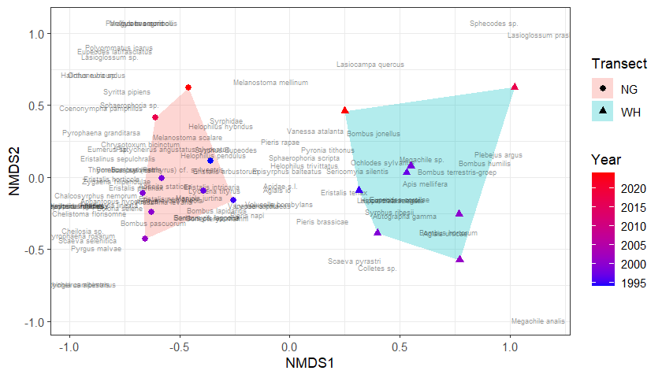
Fig. S1 Ordination plot of per year per pollinator transect using non-metric dimensional scaling (NMDS). Species composition of the pollinator transects varies per location and year. The Nardus grassland pollinator transect (NG) is depicted in red and indicated by circles, and the wet heathland pollinator transect (WH) is depicted in blue and indicated by triangles

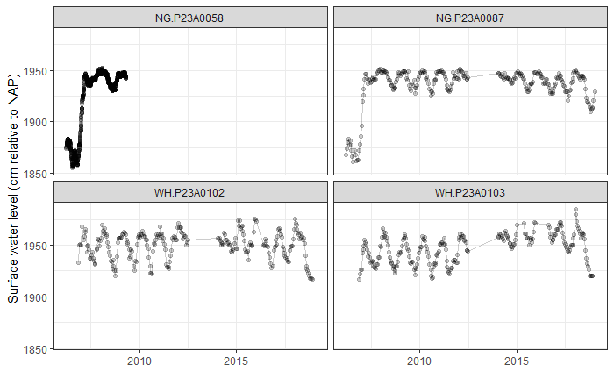
Fig. S2 Surface water level in cm relative to NAP (Normaal Amsterdams Peil) within the Nardus grassland pollinator and butterfly transects (NG and NG_B; ID = P23A0058 and P23A0087), and the wet heath pollinator and butterfly transects (WH and WH_B; ID= P23A0102 and P23A0103)

Models including daily weather variables retrieved from KNMI were explored. To account for the effect of weather during sampling on multi year abundance trends in the wet heathland pollinator transect (WH) and wet heathland butterfly transect (WH_B) and the Nardus grassland butterfly transect (NG_B), hourly weather variables were retrieved from KNMI weather-station Hoogeveen (station number 332). Data on hourly average wind speed (FH in 0.1 m/s), temperature during sampling (T in 0.1 °C), global irradiance (Q in J/cm²) and relative humidity (U in %) were collected. As no sampling time was recorded for the Nardus grassland pollinator transect (NG), averaged daily weather values were explored instead. Data on daily average wind speed (FG in 0.1 m/s), daily average temperature (TG in 0.1 °C), global irradiance (Q in J/cm²), daily total precipitation (RH in 0.1 mm), and daily average humidity (UG in %) were retrieved.

Several weather variables were found to be significantly correlated with daily pollinator abundances, but only marginally improved AIC and model fit. In addition, the estimated effect of year estimated by the basic model fell within the estimated effect of year in the models which did include weather variables (Table S1-S2). Accordingly, the decision was made to present the basic models in the main text.

Table S2 GLMM model summaries of the Nardus grasslands pollinator transect (NG). The basic structure of the models included the season score and a continuous year variable as fixed effects, as well as year as a random categorical variable in order to correct for nestedness within years. GLMM models including daily weather variables retrieved from KNMI were explored. Incidence rate ratios (IRR), p-values, marginal R2 (M R2), conditional R2 (C R2), and AIC for each separate model are presented. Significant p-values are indicated in bold. The basic model, found in the upper row of this table, was presented in the main text. The depicted model summaries are excluding the managed species Apis mellifera

 |  | Total pollinator Abundance |  | Syrphidae Abundance |  | Apidae Abundance |  | Butterfly Abundance
 |  | Year (Scaled) | Weather | Year (Scaled) | Weather | Year (Scaled) | Weather | Year (Scaled) | Weather
Basic model | IRR  [CI] | 1.08  [1.05 – 1.12] | - | 1.28  [1.13 – 1.46] | - | 1.57  [1.16 – 2.12] | - | 0.83  [0.75 - 0.92] | -
Basic model | p | <0.001 | - | <0.001 | - | 0.004 | - | <0.001 | -
Basic model | M R2 / C R2 | 0.949 / 0.956 |  | 0.679 / 0.879 |  | 0.476 / 0.732 |  | 0.949 / 0.977
Basic model | AIC | 1637.440 |  | 1557.775 |  | 322.870 |  | 1404.164
Basic + wind | IRR  [CI] | 1.08  [1.05 – 1.12] | 1.00  [0.97 - 1.03] | 1.27  [1.13 – 1.43] | 0.94  [0.90 – 0.99] | 1.57  [1.15 – 2.13] | 1.02  [0.85 – 1.22] | 0.83  [0.75 - 0.92] | 0.99  [0.95 - 1.03]
Basic + wind | p | <0.001 | 0.825 | <0.001 | 0.011 | 0.004 | 0.847 | <0.001 | 0.553
Basic + wind | M R2 / C R2 | 0.949 / 0.956 |  | 0.705 / 0.876 |  | 0.474 / 0.733 |  | 0.948 / 0.977
Basic + wind | AIC | 1639.391 |  | 1553.304 |  | 324.833 |  | 1405.812
Basic + temperature | IRR  [CI] | 1.09  [1.05 – 1.12] | 1.05  [1.02 - 1.08] | 1.28  [1.13 – 1.46] | 0.99  [0.95 – 1.03] | 1.60  [1.18 – 2.17] | 1.20  [1.01 – 1.41] | 0.83  [0.72 - 0.95] | 1.25  [1.20 - 1.30]
Basic + temperature | p | <0.001 | 0.002 | <0.001 | 0.607 | 0.002 | 0.033 | 0.007 | <0.001
Basic + temperature | M R2 / C R2 | 0.950 / 0.957 |  | 0.677 / 0.879 |  | 0.508 / 0.748 |  | 0.932 / 0.981
Basic + temperature | AIC | 1629.610 |  | 1559.51 |  | 320.430 |  | 1307.692
Basic + irradiation | IRR  [CI] | 1.08  [1.04 - 1.12] | 1.03  [1.00 - 1.06] | 1.28  [1.12 – 1.45] | 1.04  [0.99 – 1.09] | 1.55  [1.14 – 2.09] | 1.11  [0.93 – 1.31] | 0.81  [0.73 - 0.91] | 1.11  [1.06 - 1.15]
Basic + irradiation | p | <0.001 | 0.077 | <0.001 | 0.084 | 0.004 | 0.253 | <0.001 | <0.001
Basic + irradiation | M R2 / C R2 | 0.948 / 0.956 |  | 0.680 / 0.882 |  | 0.480 / 0.730 |  | 0.947 / 0.978
Basic + irradiation | AIC | 1636.285 |  | 1556.782 |  | 323.555 |  | 1381.715
Basic + precipitation | IRR  [CI] | 1.08  [1.03 - 1.12] | 0.93  [0.90 - 0.96] | 1.27  [1.12 – 1.44] | 0.93  [0.88 – 0.98] | 1.55  [1.14 – 2.11] | 0.91  [0.75 – 1.11] | 0.82  [0.74 - 0.92] | 0.95  [0.91 - 0.99]
Basic + precipitation | p | <0.001 | <0.001 | <0.001 | 0.006 | 0.005 | 0.358 | <0.001
Basic + precipitation | M R2 / C R2 | 0.944 / 0.957 |  | 0.695 / 0.881 |  | 0.474 / 0.735 |  | 0.945 / 0.977
Basic + precipitation | AIC | 1615.433 |  | 1551.757 |  | 323.967 |  | 1398.960
Basic + humidity | IRR  [CI] | 1.08  [1.05 - 1.12] | 1.00  [0.97 - 1.02] | 1.29  [1.13 – 1.48] | 1.08  [1.03 – 1.13] | 1.57  [1.16 – 2.12] | 1.00  [0.86 – 1.17] | 0.82  [0.73 - 0.92] | 0.92  [0.88 - 0.96]
Basic + humidity | p | <0.001 | 0.847 | <0.001 | 0.002 | 0.004 | 0.985 | 0.001 | <0.001
Basic + humidity | M R2 / C R2 | 0.949 / 0.956 |  | 0.671 / 0.882 |  | 0.476 / 0.732 |  | 0.940 / 0.978
Basic + humidity | AIC | 1673.340 |  | 1550.022 |  | 324.869 |  | 1387.737

Table S3 GLMM model summaries of the wet heathland pollinator transect (WH). The basic structure of the models included the season score and a continuous year variable as fixed effects, as well as year as a random categorical variable in order to correct for nestedness within years. GLMM models including hourly weather variables retrieved from KNMI were explored. Incidence rate ratios (IRR), p-values, marginal R2 (M R2), conditional R2 (C R2), and AIC for each separate model are presented. Significant p-values are indicated in bold. The basic model, found in the upper row of this table, was presented in the main text. The depicted model summaries are excluding the managed species Apis mellifera.

 |  | Total pollinator Abundance |  | Syrphidae Abundance |  | Apidae Abundance |  | Butterfly Abundance
 |  | Year (Scaled) | Weather | Year (Scaled) | Weather | Year (Scaled) | Weather | Year (Scaled) | Weather
Basic model | IRR  [CI] | 1.10  [0.80 - 1.51] | - | 1.08  [0.59 - 1.99] | - | 1.13  [0.91 - 1.40] | - | 1.08  [0.76 - 1.53] | -
Basic model | p | 0.547 | - | 0.797 | - | 0.255 | - | 0.666 | -
Basic model | M R2 / C R2 | 0.655 / 0.991 |  | 0.365 / 0.889 |  | 0.608 / 0.891 |  | 0.715 / 0.993
Basic model | AIC | 3697.580 |  | 491.361 |  | 1108.471 |  | 4004.654
Basic + wind | IRR  [CI] | 1.04  [0.77 - 1.42] | 0.82  [0.80 - 0.83] | 1.06  [0.57 - 1.96] | 0.90  [0.79 - 1.02 | 1.11  [0.89 - 1.38] | 0.90  [0.85 - 0.95] | 1.02  [0.73 - 1.43] | 0.81  [0.79 - 0.83]
Basic + wind | p | 0.780 | <0.001 | 0.860 | 0.098 | 0.360 | <0.001 | 0.919 | <0.001
Basic + wind | M R2 / C R2 | 0.684 / 0.991 |  | 0.369 / 0.892 |  | 0.616 / 0.899 |  | 0.736 / 0.993
Basic + wind | AIC | 3383.885 |  | 490.623 |  | 1096.979 |  | 3751.220
Basic + temperature | IRR  [CI] | 1.10  [0.80 - 1.50] | 1.08  [1.06 - 1.11] | 1.08  [0.59 - 1.98] | 0.97  [0.85 - 1.10] | 1.10  [0.91 - 1.39] | 1.08  [1.02 - 1.14] | 1.07  [0.76 - 1.51] | 1.12  [1.09 - 1.16]
Basic + temperature | p | 0.550 | <0.001 | 0.808 | 0.633 | 0.188 | 0.009 | 0.698 | <0.001
Basic + temperature | M R2 / C R2 | 0.668 / 0.991 |  | 0.366 / 0.888 |  | 0.637 / 0.887 |  | 0.729 / 0.993
Basic + temperature | AIC | 3659.882 |  | 493.135 |  | 1103.765 |  | 3947.232
Basic + irradiation | IRR  [CI] | 1.06  [0.79 - 1.43] | 1.16  [1.13 - 1.19] | 1.08  [0.59 - 1.99] | 1.00  [0.88 - 1.14] | 1.10  [0.91 - 1.34] | 1.15  [1.07 - 1.23] | 1.01  [0.73 - 1,41] | 1.22  [1.18 - 1.27]
Basic + irradiation | p | 0.710 | <0.001 | 0.799 | 0.947 | 0.315 | <0.001 | 0.931 | <0.001
Basic + irradiation | M R2 / C R2 | 0.697 / 0.991 |  | 0.364 / 0.889 |  | 0.651 / 0.888 |  | 0.761 / 0.993
Basic + irradiation | AIC | 3602.329 |  | 493.356 |  | 1094.635 |  | 3880.029
Basic + humidity | IRR  [CI] | 1.07  [0.80 - 1.44] | 0.78  [0.76 - 0.80] | 1.09  [0.61 - 1.95] | 1.12  [1.00 - 1.24] | 1.13  [0.92 - 1.39] | 0.97  [0.92 - 1.03] | 1.03  [0.75 - 1.43] | 0.73  [0.70 - 0.75]
Basic + humidity | p | 0.651 | <0.001 | 0.771 | 0.052 | 0.249 | 0.374 | 0.839 | <0.001
Basic + humidity | M R2 / C R2 | 0.724 / 0.992 |  | 0.378 / 0.882 |  | 0.616 / 0.889 |  | 0.776 / 0.993
Basic + humidity | AIC | 3336.420 |  | 489.619 |  | 1109.683 |  | 3542.843

Table S3 Complete species list of the species encountered in the pollinator grassland transect (NG), the butterfly grassland transect (NG_B), and the pollinator wet heathland transect (WH) per species-group. Y signifies the species was encountered at least once in the corresponding transect over the course of the study, and N signifies that the species was never encountered. Conservative choices were made in terms of species richness, meaning that in analyses on species richness all individuals counted at the genus level were not considered as a separate species unless no other species within the observed genus were encountered during the study. The closely related species belonging to the Bombus terrestris-complex were not identified to the species-level, as this cannot be reliably done based on field characteristics

Group
Apidae | Species | NG | WH
 | Apidae s.l. | Y | Y
 | Apis mellifera | Y | Y
 | Bombus cf. sylvestris | Y | N
 | Bombus hortorum | Y | Y
 | Bombus humilis | Y | Y
 | Bombus jonellus | Y | Y
 | Bombus lapidarius | Y | Y
 | Bombus pascuorum | Y | Y
 | Bombus pratorum | Y | N
 | Bombus terrestris-complex | Y | Y
 | Chelistoma florisomne | Y | N
 | Colletes sp. | Y | Y
 | Dasypoda hirtipes | Y | N
 | Halictus rubicundus | Y | N
 | Lasioglossum prasinum | N | Y
 | Lasioglossum sp. | Y | N
 | Megachile analis | N | Y
 | Megachile sp. | Y | Y
 | Sphecodes sp. | Y | Y
Butterflies | Species | NG | WH | NG_B
 | Adscita statices | Y | Y | Y
 | Aglais io | Y | Y | Y
 | Aglais urticae | Y | Y | Y
 | Anthocharis cardamines | N | N | Y
 | Aphantopus hyperantus | Y | N | Y
 | Araschnia levana | Y | N | Y
 | Autographa gamma | Y | Y | Y
 | Boloria selene | Y | N | N
 | Callophrys rubi | N | N | Y
 | Celastrina argiolus | Y | N | Y
 | Coenonympha pamphilus | Y | N | Y
 | Euclidia mi | N | N | Y
 | Favonius quercus | N | N | Y
 | Gonepteryx rhamni | Y | Y | Y
 | Hipparchia semele | N | Y | N
 | Lasiocampa quercus | N | Y | N
 | Lasiommata megera | N | Y | N
 | Leucodonta bicoloria | Y | N | N
 | Lycaena phlaeas | Y | Y | Y
 | Lycaena tityrus | Y | Y | Y
 | Maniola jurtina | Y | Y | Y
 | Ochlodes sylvanus | Y | Y | Y
 | Paragus aegeria | N | N | Y
 | Pieris brassicae | Y | Y | Y
 | Pieris napi | Y | Y | Y
 | Pieris rapae | Y | Y | Y
 | Plebejus argus | Y | Y | Y
 | Polygonia c-album | N | N | Y
 | Polyommatus icarus | Y | N | Y
 | Pyrgus malvae | Y | N | Y
 | Pyronia tithonus | Y | Y | Y
 | Thymelicus lineola | Y | Y | Y
 | Thymelicus sylvestris | Y | N | Y
 | Vanessa atalanta | Y | Y | Y
 | Vanessa cardui | Y | Y | Y
 | Zygaena filipendulae | Y | N | Y
Syrphidae | Species | NG | WH
 | Anasimyia lineata | Y | N
 | Chalcosyrphus nemorum | Y | N
 | Cheilosia fraterna | Y | N
 | Cheilosia sp. | Y | N
 | Chrysotoxum bicinctum | Y | N
 | Episyrphus balteatus | Y | Y
 | Eristalinus sepulchralis | Y | N
 | Eristalis arbustorum | Y | Y
 | Eristalis horticola | Y | N
 | Eristalis intricaria | Y | Y
 | Eristalis nemorum | Y | Y
 | Eristalis pertinax | Y | N
 | Eristalis tenax | Y | Y
 | Eumerus sp. | Y | N
 | Eupeodes corollae | Y | Y
 | Eupeodes latifasciatus | Y | N
 | Helophilus hybridus | Y | Y
 | Helophilus pendulus | Y | Y
 | Helophilus trivittatus | Y | Y
 | Melanostoma mellinum | Y | Y
 | Melanostoma scalare | Y | Y
 | Meliscaeva auricollis | Y | N
 | Orthonevra sp. | Y | N
 | Paragus haemorrhous | Y | N
 | Platycheirus albimanus | Y | N
 | Platycheirus angustatus/clypeatus | Y | N
 | Platycheirus peltatus | Y | N
 | Pyrophaena granditarsa | Y | N
 | Pyrophaena rosarum | Y | N
 | Rhingia campestris | Y | N
 | Scaeva pyrastri | Y | Y
 | Scaeva selenitica | Y | N
 | Sericomyia lappona | Y | N
 | Sericomyia silentis | Y | Y
 | Sphaerophoria scripta | Y | Y
 | Sphaerophoria sp. | Y | N
 | Syritta pipiens | Y | N
 | Syrphidae s.l. | Y | Y
 | Syrphus ribesii | Y | Y
 | Syrphus/Eupeodes | Y | N
 | Volucella bombylans | Y | Y
 | Xylota segnis | Y | N

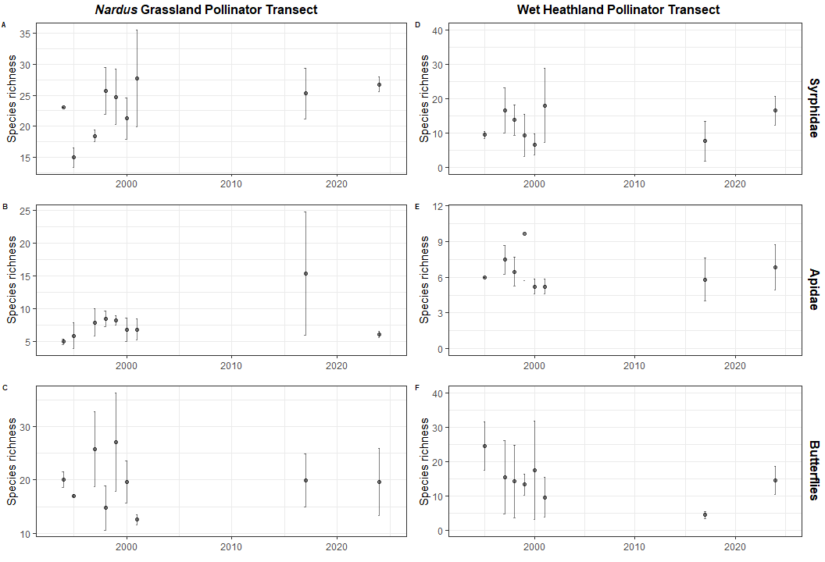
Fig. S3 Species richness in the Nardus grassland butterfly transect (NG_B). Chao-estimates including standard deviation of NG_B butterfly species richness

