SUPPLEMENTARY FILE
Supplementary Figure S1. Patient Selection Flowchart
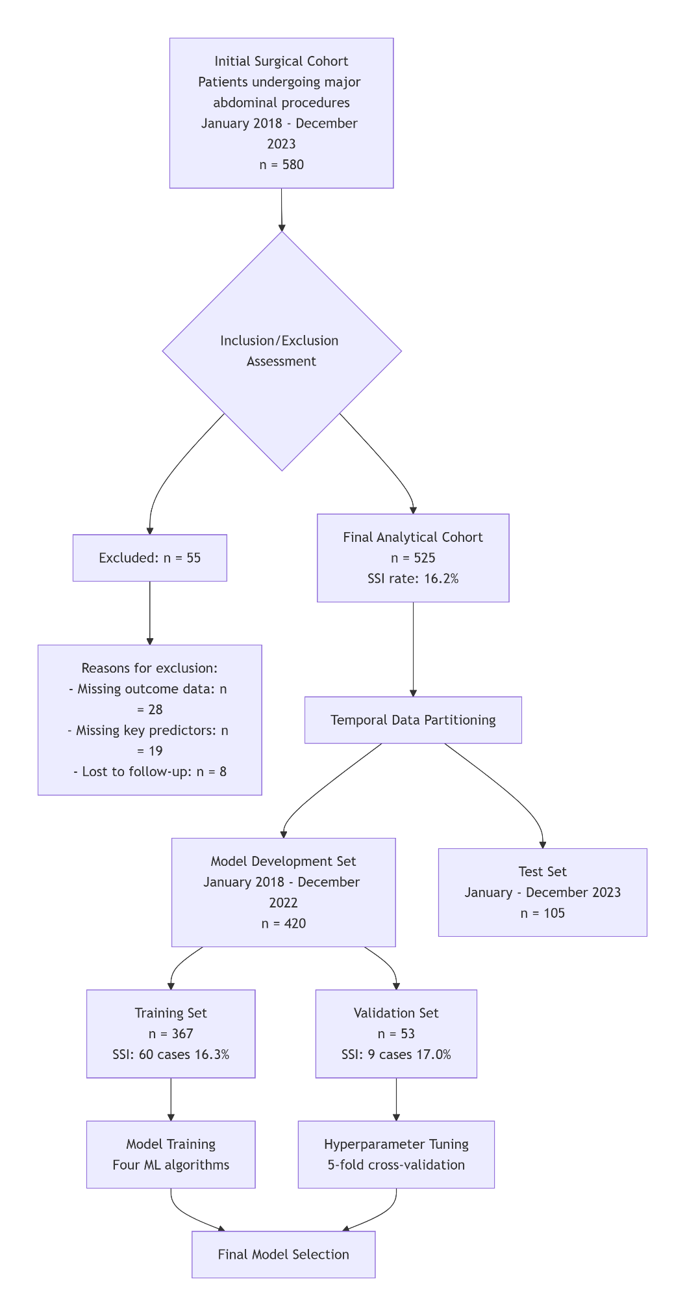

Description: Flow diagram illustrating patient selection process for the retrospective cohort study of surgical site infection prediction following major gastrointestinal surgery at Ibb University-affiliated hospitals (2018-2023). The chart details inclusion and exclusion criteria applied to the initial patient cohort, resulting in the final analytic sample used for machine learning model development and validation (1).

Supplementary Table S1. Detailed Baseline Characteristics by SSI Status
Characteristic | Overall (n=525) | SSI (n=85) | No SSI (n=440) | p-value
Demographics
Age, mean (SD), years | 52.4 (15.8) | 56.1 (14.3) | 51.7 (16.1) | 0.021
Age ≥60 years, n (%) | 220 (41.9) | 44 (51.8) | 176 (40.0) | 0.045
Male gender, n (%) | 304 (57.9) | 53 (62.4) | 251 (57.0) | 0.367
BMI Categories, n (%) |  |  |  | 0.289
Underweight/Normal (<25 kg/m²) | 287 (54.7) | 41 (48.2) | 246 (55.9)
Overweight (25-29.9 kg/m²) | 140 (26.7) | 25 (29.4) | 115 (26.1)
Obese (≥30 kg/m²) | 98 (18.7) | 19 (22.4) | 79 (18.0)
Comorbidities
Diabetes mellitus, n (%) | 112 (21.3) | 33 (38.8) | 79 (18.0) | <0.001
Hypertension, n (%) | 153 (29.1) | 27 (31.8) | 126 (28.6) | 0.556
Chronic renal failure, n (%) | 24 (4.6) | 6 (7.1) | 18 (4.1) | 0.245
Chronic liver disease, n (%) | 31 (5.9) | 7 (8.2) | 24 (5.5) | 0.310
Pulmonary disease, n (%) | 42 (8.0) | 9 (10.6) | 33 (7.5) | 0.345
Current smoker, n (%) | 116 (22.1) | 21 (24.7) | 95 (21.6) | 0.529
Surgical Characteristics
Procedure Type, n (%) |  |  |  | 0.038
Gastric surgery | 89 (17.0) | 12 (14.1) | 77 (17.5)
Small bowel surgery | 76 (14.5) | 10 (11.8) | 66 (15.0)
Colorectal surgery | 198 (37.7) | 40 (47.1) | 158 (35.9)
Hepatobiliary surgery | 162 (30.9) | 23 (27.1) | 139 (31.6)
Surgical Approach, n (%) |  |  |  | 0.012
Open | 387 (73.7) | 72 (84.7) | 315 (71.6)
Laparoscopic | 138 (26.3) | 13 (15.3) | 125 (28.4)
Emergency surgery, n (%) | 85 (16.2) | 23 (27.1) | 62 (14.1) | 0.003
Wound Class, n (%) |  |  |  | <0.001
Clean | 130 (24.8) | 8 (9.4) | 122 (27.7)
Clean-contaminated | 201 (38.3) | 25 (29.4) | 176 (40.0)
Contaminated | 122 (23.2) | 28 (32.9) | 94 (21.4)
Dirty | 72 (13.7) | 24 (28.2) | 48 (10.9)
Intraoperative Factors
Operative duration, mean (SD), min | 142.6 (68.3) | 188.4 (75.1) | 132.9 (63.2) | <0.001
Operative duration >180 min, n (%) | 108 (20.6) | 29 (34.1) | 79 (18.0) | 0.001
Estimated blood loss, mean (SD), mL | 285 (196) | 412 (234) | 258 (178) | <0.001
ASA Class, n (%) |  |  |  | 0.009
I-II | 336 (64.0) | 44 (51.8) | 292 (66.4)
III-V | 189 (36.0) | 41 (48.2) | 148 (33.6)
NNIS Risk Index, mean (SD) | 1.4 (0.9) | 2.1 (0.8) | 1.2 (0.8) | <0.001
Preop leukocytosis (>12×10⁹/L), n (%) | 97 (18.5) | 24 (28.2) | 73 (16.6) | 0.012
Abbreviations: SSI, surgical site infection; BMI, body mass index; ASA, American Society of Anesthesiologists; NNIS, National Nosocomial Infections Surveillance

Supplementary Table S2. Complete Variable Definitions and Coding
Domain | Variable | Type | Description/Coding
Demographics | Age | Continuous | Years (also dichotomized as ≥60 years)
 | Gender | Categorical | 0 = Female, 1 = Male
 | BMI Category | Categorical | 1 = Underweight/Normal (<25 kg/m²), 2 = Overweight (25-29.9 kg/m²), 3 = Obese (≥30 kg/m²)
Comorbidities | Hypertension | Binary | 0 = Absent, 1 = Present
 | Diabetes mellitus | Binary | 0 = Absent, 1 = Present
 | Chronic renal failure | Binary | 0 = Absent, 1 = Present
 | Chronic liver disease | Binary | 0 = Absent, 1 = Present
 | Pulmonary disease | Binary | 0 = Absent, 1 = Present
 | Smoking status | Categorical | 0 = Non-smoker, 1 = Former smoker, 2 = Current smoker
Procedural Variables | Procedure type | Categorical | 1 = Gastric, 2 = Small bowel, 3 = Colorectal, 4 = Hepatobiliary
 | Surgical approach | Categorical | 1 = Open, 2 = Laparoscopic, 3 = Robotic
 | Wound contamination | Categorical | 1 = Clean, 2 = Clean-contaminated, 3 = Contaminated, 4 = Dirty
 | Anesthesia type | Categorical | 1 = General, 2 = Regional, 3 = Combined
 | Surgical urgency | Categorical | 1 = Elective, 2 = Urgent, 3 = Emergency
 | Estimated blood loss | Continuous | Milliliters
Intraoperative Metrics | Operative duration | Continuous | Minutes (also dichotomized as >180 minutes)
 | Preoperative leukocyte count | Continuous | ×10⁹/L (also dichotomized as >12×10⁹/L)
 | Temperature status | Categorical | 1 = Hypothermic (<36°C), 2 = Normothermic (36-38°C), 3 = Hyperthermic (>38°C)
Risk Assessment | ASA physical status | Ordinal | 1-5 (also dichotomized as ≥3)
 | NNIS risk index | Ordinal | 0-3

Variable definitions and SSI criteria followed CDC NHSN guidelines (2).
Supplementary Table S3. Hyperparameter Tuning Results for Machine Learning Models
Model | Hyperparameters | Optimal Values | Search Range
Logistic Regression | Regularization (C) | 0.1 | [0.001, 0.01, 0.1, 1, 10, 100]
 | Penalty | L2 | [L1, L2]
 | Solver | liblinear | [liblinear, lbfgs]
Random Forest | Number of estimators | 200 | [100, 200, 300, 500]
 | Maximum depth | 15 | [5, 10, 15, 20, None]
 | Minimum samples split | 5 | [2, 5, 10]
 | Minimum samples leaf | 2 | [1, 2, 4]
 | Maximum features | sqrt | [sqrt, log2, None]
XGBoost | Learning rate | 0.1 | [0.01, 0.1, 0.2]
 | Maximum depth | 6 | [3, 6, 9]
 | Subsample | 0.8 | [0.6, 0.8, 1.0]
 | Colsample bytree | 0.8 | [0.6, 0.8, 1.0]
 | Gamma | 0.1 | [0, 0.1, 0.2]
 | Lambda | 1 | [0.1, 1, 10]
Neural Network | Hidden layer sizes | (64, 32) | [(32,), (64,32), (128,64)]
 | Activation function | ReLU | [ReLU, tanh]
 | Learning rate | 0.001 | [0.0001, 0.001, 0.01]
 | Dropout rate | 0.2 | [0.1, 0.2, 0.3]
 | Batch size | 32 | [16, 32, 64]
 | Epochs | 100 | [50, 100, 200]

Hyperparameter optimization was performed using Scikit-learn and XGBoost libraries with five-fold cross-validation (3, 4).
Supplementary Table S4. Detailed Subgroup Performance Analysis
Subgroup | n | SSI Rate (%) | XGBoost AUROC (95% CI) | Random Forest AUROC (95% CI) | Logistic Regression AUROC (95% CI)
Age
<60 years | 305 | 13.4 | 0.913 (0.854-0.955) | 0.902 (0.841-0.947) | 0.851 (0.782-0.907)
≥60 years | 220 | 20.0 | 0.967 (0.928-0.989) | 0.959 (0.916-0.985) | 0.891 (0.833-0.935)
Gender
Male | 304 | 17.4 | 0.921 (0.880-0.953) | 0.918 (0.876-0.951) | 0.862 (0.812-0.904)
Female | 221 | 14.5 | 0.943 (0.901-0.972) | 0.926 (0.880-0.960) | 0.876 (0.822-0.919)
Diabetes Status
Diabetic | 112 | 29.5 | 0.957 (0.901-0.987) | 0.979 (0.933-0.997) | 0.894 (0.821-0.945)
Non-diabetic | 413 | 12.6 | 0.912 (0.876-0.942) | 0.901 (0.862-0.933) | 0.859 (0.816-0.896)
Surgical Urgency
Elective | 329 | 11.6 | 0.929 (0.894-0.957) | 0.917 (0.879-0.947) | 0.868 (0.826-0.904)
Emergency | 85 | 27.1 | 0.951 (0.879-0.987) | 0.939 (0.861-0.981) | 0.871 (0.781-0.935)
Wound Class
Clean/Clean-contam. | 331 | 10.0 | 0.925 (0.889-0.953) | 0.912 (0.873-0.944) | 0.861 (0.818-0.898)
Contaminated/Dirty | 194 | 26.8 | 0.948 (0.905-0.976) | 0.941 (0.895-0.972) | 0.879 (0.822-0.924)
BMI Category
Non-obese (BMI<30) | 427 | 15.5 | 0.928 (0.897-0.953) | 0.919 (0.886-0.946) | 0.865 (0.827-0.898)
Obese (BMI≥30) | 98 | 19.4 | 0.945 (0.875-0.983) | 0.937 (0.864-0.978) | 0.881 (0.798-0.938)

Supplementary Note S1. Detailed Methodology for Simplified Risk Score Development
The simplified risk score was derived from the best-performing XGBoost model using the following systematic approach:
- Feature Selection: We identified the top 10 most important features from the XGBoost model using SHAP analysis. Clinical relevance and ease of assessment in resource-limited settings were prioritized.
- Variable Categorization: Continuous variables were dichotomized using clinically meaningful cutpoints:
  - Operative duration: >180 minutes vs. ≤180 minutes
  - Age: ≥60 years vs. <60 years
  - Preoperative leukocyte count: >12×10⁹/L vs. ≤12×10⁹/L
- Point Assignment: Points were assigned based on logistic regression coefficients from a model containing only the selected features. The beta coefficients were divided by the smallest coefficient and rounded to the nearest integer.
- Score Calculation: The final 7-variable risk score includes:
  - Wound contamination class (Dirty: 3 points, Contaminated: 2 points, Clean-contaminated: 1 point, Clean: 0 points)
  - Operative duration >180 minutes: 2 points
  - Diabetes mellitus: 2 points
  - ASA class ≥3: 2 points
  - Emergency surgery: 2 points
  - Age ≥60 years: 1 point
  - Preoperative leukocytosis (>12×10⁹/L): 1 point
- Risk Stratification: Total scores range from 0-13 points, with the following risk categories:
  - Low risk: 0-3 points (SSI risk: <10%)
  - Moderate risk: 4-6 points (SSI risk: 10-30%)
  - High risk: ≥7 points (SSI risk: >30%)

Supplementary References

1. Collins GS, Reitsma JB, Altman DG, Moons KG. Transparent reporting of a multivariable prediction model for individual prognosis or diagnosis (TRIPOD): the TRIPOD statement. Bmj. 2015;350:g7594.
2. Centers for Disease Control and Prevention. Surgical Site Infection Event (SSI). National Healthcare Safety Network (NHSN) Patient Safety Component Manual, Procedure-associated Module. Atlanta, GA: Centers for Disease Control and Prevention; January 2023. Available from: https://www.cdc.gov/nhsn/pdfs/pscmanual/9pscssicurrent.pdf. [
3. Chen T, Guestrin C. XGBoost: A Scalable Tree Boosting System. Proceedings of the 22nd ACM SIGKDD International Conference on Knowledge Discovery and Data Mining. 2016.
4. Collins GS, Reitsma JB, Altman DG, Moons KG. Transparent Reporting of a multivariable prediction model for Individual Prognosis or Diagnosis (TRIPOD): the TRIPOD statement. Ann Intern Med. 2015;162(1):55-63.

