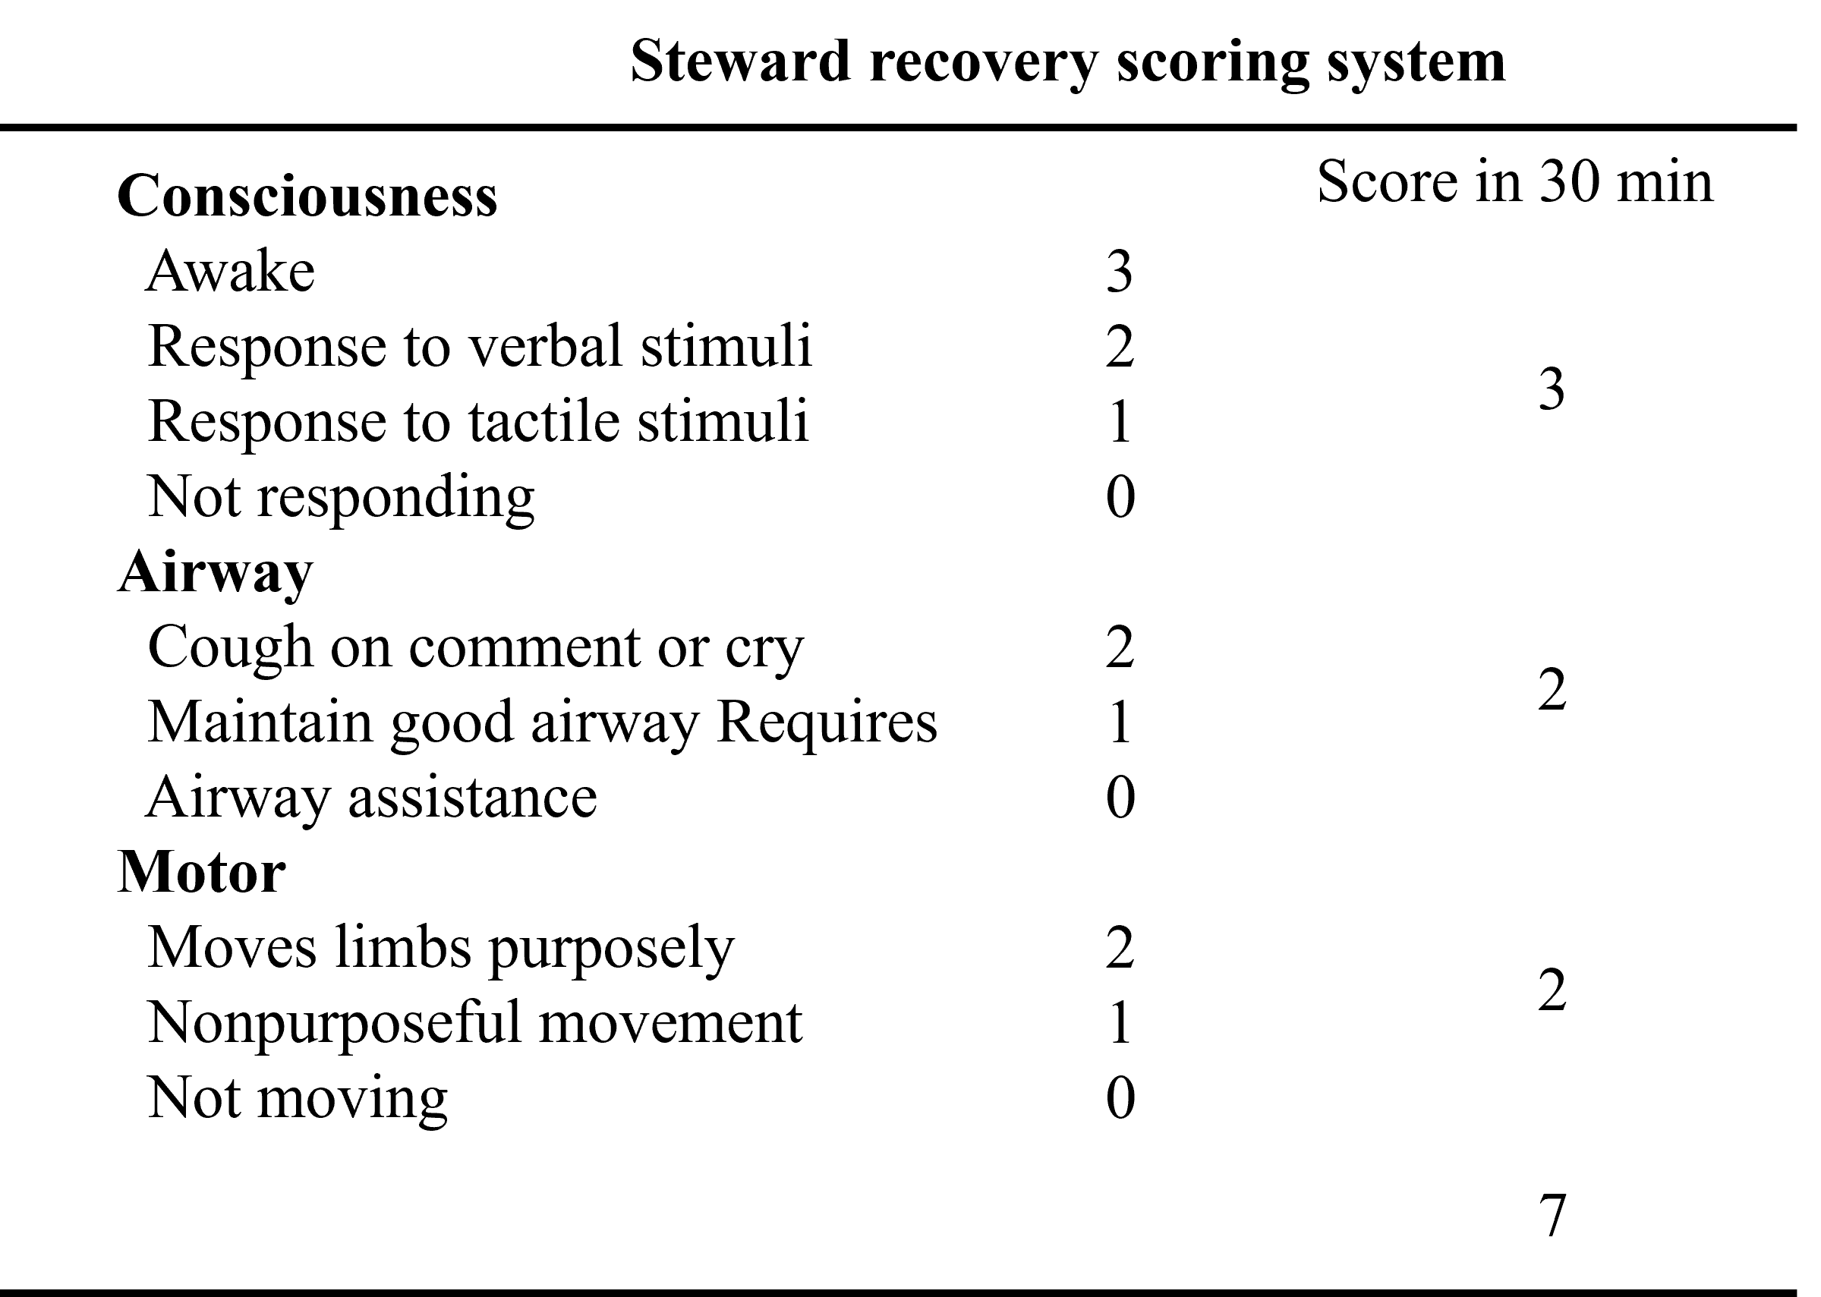

Table 1. Steward recovery score in 30 minutes at the PACU.

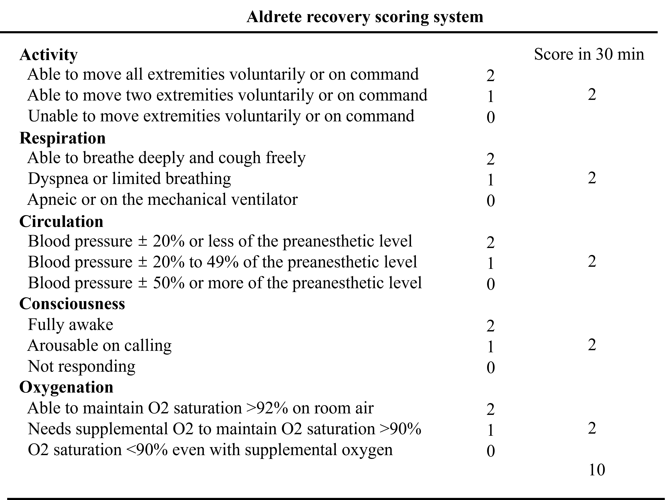

Table 2. Aldrete recovery score in 30 minutes at the PACU.

