

Focused Ultrasound and RadioTHERapy for Noninvasive Palliative Pain Treatment in Patients with Bone Metastases
- The FURTHER study –
13 January 2020
Version 2

Focused Ultrasound and RadioTHERapy for Noninvasive Palliative Pain Treatment in Patients with Bone Metastases

Protocol ID | NL71303.041.19
Short title | FURTHER trial
Version | 2
Date | 13-01-2020
Principal investigator(s) | UMC Utrecht  H.M. (Lenny) Verkooijen, MD PhD  Professor Evaluation of Image-guided Interventions  Imaging Division - University Medical Center Utrecht  E-mail: H.M.Verkooijen@umcutrecht.nl  Tel: +31 88 75 595 75

ISALA Zwolle

M.F. Boomsma, MD PhD

Radiologist - Isala Zwolle

Email: m.f.boomsma@isala.nl
Tel: +31 38 424 7202
Sub-investigator | M.M.T.J. Bartels, MD, PhD-student  Imaging Division - University Medical Center Utrecht  E-mail: M.M.T.Bartels-6@umcutrecht.nl  Tel: +31 88 75 50055
Sponsor | University Medical Center Utrecht
Subsidising party | European Commission Horizon 2020 program
Independent expert | Dr. I.C. van der Schaaf  Interventional Radiologist – UMC Utrecht, NL  Email: I.vanderschaaf@umcutrecht.nl  Tel: 088 – 755 66 87

PROTOCOL SIGNATURE SHEET

Name | Signature | Date
Head of Department:
Prof. dr. J. Hendrikse
Research Manager

Principal Investigator:
Prof. dr. H.M. Verkooijen
Clinical Epidemiologist

TABLE OF CONTENTS

1. INTRODUCTION AND RATIONALE 10
1.1. Cancer induced bone pain 10
1.2. Current standard of care: External beam radiotherapy (EBRT) 11
1.3. MR-HIFU for pain palliation in bone metastases 12
1.4. Rationale 14
2. OBJECTIVES 15
2.1. Primary Objective 15
2.2. Secondary Objectives 15
3. STUDY DESIGN 16
4. STUDY POPULATION 18
4.1. Population (base) 18
4.2. Inclusion criteria 19
4.3. Exclusion criteria 19
4.4. Sample size calculation 20
5. TREATMENT OF SUBJECTS 21
5.1. Treatment arm 1: MR-HIFU only 21
5.2. Treatment arm 2: EBRT only 22
5.3. Treatment arm 3: EBRT combined with MR-HIFU 24
5.4. Co-interventions & escape medication 26
6. METHODS 27
6.1. Study parameters/endpoints 27
6.1.1. Main study parameter/endpoint 27
6.1.2. Secondary study parameters/endpoints 28
6.1.3. Other study parameters 29
6.2. Randomization, blinding and treatment allocation 29
6.3. Study procedures 29
6.3.1. Patient recruitment, consent, enrolment and baseline data collection 29
6.3.2. Treatment 30
6.3.3. Follow-up 30
6.4. Withdrawal of individual subjects 31
6.5. Follow-up of subjects withdrawn from treatment 31
6.6. Premature termination of the study 31
7. SAFETY REPORTING 32
7.1. Temporary halt for reasons of subject safety 32
7.2. Definitions in safety reporting 32
7.2.1. Adverse events (AEs) 32
7.2.2. Serious adverse events (SAEs) 32
7.3. Safety reporting 33
7.3.1. Recording of adverse events 33
7.3.2. Reportable events 33
7.3.3. Reporting standards 33
7.4. Follow-up of adverse events 34
7.5. Data Safety Monitoring Board (DSMB) 34
8. STATISTICAL ANALYSIS 35
9. ETHICAL CONSIDERATIONS 36
9.1. Regulation statement 36
9.2. Recruitment and consent 36
9.3. Benefits and risks assessment, group relatedness 37
9.4. Compensation for injury 38
9.5. Incentives 38
10. ADMINISTRATIVE ASPECTS, MONITORING AND PUBLICATION 39
10.1. Handling and storage of data and documents 39
10.2. Monitoring and Quality Assurance 39
10.3. Amendments 40
10.4. Annual progress report 40
10.5. Temporary halt and (prematurely) end of study report 40
10.6. Public disclosure and publication policy 40
11. STRUCTURED RISK ANALYSIS 41
11.1. Potential issues of concern 41
11.2. Synthesis 45
12. REFERENCES 47

LIST OF ABBREVIATIONS AND RELEVANT DEFINITIONS

ADE | Adverse Device Effect
AE | Adverse Event
ASADE | Anticipated Serious Adverse Device Effect
BPI | Brief Pain Inventory
CCMO | Central Committee on Research Involving Human Subjects; in Dutch: Centrale Commissie Mensgebonden Onderzoek
CRF | Case Report Form
CT | Computed Tomography
CTCAE | Common Terminology Criteria for Adverse Events
DD | Device Deficiency
DNA | Deoxyribonucleic Acid
DSMB | Data Safety Monitoring Board
EBRT | External beam radiotherapy
EU | European Union
EM | Equivalent Minutes
GCP | Good Clinical Practice
GDPR | General Data Protection Regulation; in Dutch: Algemene Verordening Gegevensbescherming (AVG)
Gy | Gray
H2020 | European Commission Horizon 2020 Programme
IB | Investigator’s Brochure
IC | Informed Consent
IDEAL | Innovation, Development, Evaluation, Assessment and Long term evaluation
IRB | Institutional Review Board
METC | Medical research ethics committee (MREC); in Dutch: medisch-ethische toetsingscommissie (METC)
MR | Magnetic Resonance
MR-HIFU | Magnetic Resonance Image guided High Intensity Focused Ultrasound
MRI | Magnetic Resonance Imaging
NRS | Numeric Rating Scale
PREM | Patient Reported Experience Measure
PRESENT | Prospective Evaluation of Interventional Studies on Bone Metastases
PRFS | Proton Resonance Frequency Shift
PSA | Procedural Sedation and Analgesia
QA | Quality Assurance
RCT | Randomized Controlled Trial
RT | Radiotherapy
SADE | Serious Adverse Device Effect
SAE | Serious Adverse Event
Sponsor | The sponsor is the party that commissions the organisation or performance of the research, for example a pharmaceutical company, academic hospital, scientific organisation or investigator. A party that provides funding for a study but does not commission it is not regarded as the sponsor, but referred to as a subsidising party
UAVG | Dutch Act on Implementation of the General Data Protection Regulation; in Dutch: Uitvoeringswet AVG
UMC | University Medical Center
USADE | Unanticipated Serious Adverse Device Effect
WMO | Medical Research Involving Human Subjects Act; in Dutch: Wet Medisch-wetenschappelijk Onderzoek met Mensen

SUMMARY

Rationale: Cancer induced bone pain (CIBP) as a result of bone metastases strongly interferes with quality of life and daily functioning of patients with advanced cancer. The current standard of care for patients with painful bone metastasis includes palliative external beam radiotherapy (EBRT). While EBRT is a well-established treatment option, it takes up to 4-6 weeks for EBRT to induce optimal pain relief, and 30-40% of patients do not respond to EBRT. Pain palliation may be improved by including magnetic resonance image guided high intensity focused ultrasound (MR-HIFU) as alternative or in addition to EBRT.

Objective: The FURTHER study aims to evaluate the effectiveness and cost-effectiveness of MR-HIFU (alone or in combination with EBRT) compared to EBRT alone, the standard-of-care, as a palliative treatment option to relieve CIBP.

Study design: The FURTHER study is a prospective, multicenter, three-armed randomized controlled trial, performed in six hospitals in four European countries, all of which are partners in the FURTHER consortium. The UMC Utrecht is coordinating center. A total of 216 patients with painful bone metastases will be randomized in a 1:1:1 ratio to receive EBRT only, MR-HIFU only, or EBRT followed by MR-HIFU. In the Netherlands, we expect to enroll a minimum of 70 patients, and a maximum of 120 patients in two Dutch study sites.

Study population: The study will be performed in male and female adult (≥ 18 years) cancer patients capable of giving informed consent, who were referred to the department of radiation oncology for treatment of painful bone metastases (pain score on Numerical Rating Scale (NRS) ≥ 4).

Intervention: The intervention under study is MR-HIFU alone or in combination with EBRT. The intervention is aimed at rapid and persistent relief of CIBP. The intervention will be compared with standard treatment EBRT.

Main study endpoints: Primary outcome of the trial will be pain response at 14 days after completion of the treatment. Secondary outcomes include pain response at 14 days after inclusion, and pain scores, toxicity, adverse events, quality of life and survival in the first 6 months after treatment, and cost-effectiveness of the treatments.

Nature and extent of the burden and risks associated with participation, benefit and group relatedness: In terms of benefits, patients participating in this study may experience a more rapid pain relief as a result of the MR-HIFU intervention. In terms of burden, patients in the intervention arms will possibly need to pay an extra visit or visits to the hospital, they will undergo a rather lengthy (additional) intervention (MR-HIFU treatment) under sedation. In addition, all study participants will have to fill in a daily pain diary during the first 14 days after treatment and quality of life questionnaires at six time-points in the follow up period. Serious adverse events due to the intervention are not to be expected.
- INTRODUCTION AND RATIONALE
  - Cancer induced bone pain
Due to improved diagnostics and medical care, cancer patients can be treated more effectively and survive longer. An unfortunate side effect of this progress is the increasing number of patients living with metastatic disease, in whom cure is not an option. These patients enter (increasingly lengthy) palliative or end-of life care trajectories that are aimed at containment of their cancer and relief of suffering from side-effects. Sixty-five percent of patients with advanced cancer develop bone metastases, with pain as a common and devastating consequence (Ripamonti and Fulfaro, 2010; Portenoy, 2011; Lipton, 2010). Cancer induced bone pain (CIBP) strongly interferes with quality of life and daily functioning of patients and their families (Mantyh, 2014, Paice and Ferrell, 2011). It affects mobility, productivity and independence, thereby creating an extra burden for informal carers including family and friends. Many patients with bone metastases experience a rather slow clinical course, characterized by pain, mobility deficiencies and skeletal complications such as fractures and spinal cord compression.

The adult bone is richly innervated by nerve fibres that are activated by injury or damage. Upon the growth of tumor cells in bone, a cycle of tumor growth, bone destruction, inflammatory processes, and formation of woven bone is started. Cancer cells do not directly destroy bones but, together with stromal cells, activate pathways promoting the proliferation and hypertrophy of bone destroying osteoclasts. Tumor growth in bone can lead to both osteoblastic and osteolytic bone lesions. Stromal cells far outnumber cancer cells and include endothelial cells, fibroblasts, as well as a host of inflammatory and immune cells, including macrophages, mast cells, neutrophils, and T lymphocytes contributing to the inflammatory part of the pain. Cancer cells and their associated stromal cells secrete a wide variety of factors, many of which have previously been shown to sensitize or directly excite primary afferent neurons (Mantyh, 2014).

Cancer-induced bone pain is now seen as a complex pain state involving components of both inflammatory and neuropathic pain but also exhibiting elements that seem unique to cancer pain. In addition, the pain state is often unpredictable, and the intensity of the pain is highly variable, making it difficult to manage. In broad terms, pain can be divided into inflammatory pain (also called nociceptive pain), where the pain arises from chemical or natural stimuli from damaged tissue (surgery, osteoarthritis, or trauma), and neuropathic pain, caused by direct damage of the sensory nerves.

  - Current standard of care: External beam radiotherapy (EBRT)
Clinically, opioids remain the most effective pharmacologic treatment for severe pain. Opioids have a number of mechanisms related to analgesia, but one of the most important level of action is the spinal cord, where opioids reduce both painful inputs and inhibit spinal neuronal activity. However, adverse effects associated with the high doses required to adequately reduce pain make opioid therapy far from perfect. Pharmacologic studies have shown that the analgesic effects of opioids can be less effective in cancer-induced bone pain compared with other pain states.

The current standard of care for patients with uncomplicated painful bone metastases is palliative locoregional external beam radiotherapy (EBRT) (Ripamonti, 2010; Chow, 2014; Huisman, 2015), often in combination with systemic therapy and analgesics. The putative main mechanism of pain relief by EBRT involves the inactivation of osteoclasts to change the microenvironment of bone resorption followed by sterilization of cancer cells to reduce tumor-induced compression (Hartsell, 2007). EBRT alleviates pain through inhibition of the release of chemical pain mediators and slows tumor growth by induction of DNA damage.

Multiple randomized controlled trials and several systematic reviews over the past 30 years have demonstrated the efficacy of radiotherapy in palliating pain from uncomplicated bone metastases (Jones, 2014). Overall, approximately 60-70% of patients can expect some response to radiotherapy. On average, it takes four weeks for EBRT to induce adequate pain relief. In the Dutch Bone Trial, including 1100 patients, 71% of patients reported adequate pain response (van der Linden, 2004; Westhoff, 2015). In the large hospital based PRESENT (prospective evaluation of interventional studies on bone metastases; METC 13-261) cohort in which over 1600 unselected patients with bone metastases are included, 64% of patients experienced pain response following EBRT (van der Velden, 2018). Moreover, approximately 50% of responders experience recurrent pain. Radiotherapy retreatment of non-responders or those with recurrent bone pain is limited by cumulative doses of radiation delivered to sensitive structures surrounding the bone metastases. In addition, re-irradiation is only effective in a small majority (58%) of patients (Huisman, 2012).

In summary, while EBRT is an efficient and cost-effective treatment option, it can take up to four weeks for EBRT to induce adequate pain relief. As such, there is ample room for improvement for the local management of painful bone metastases. In particular in the palliative setting, where curation is no longer an option and where patients have limited life expectancy, it is crucial to provide fast and efficient pain relief, in order to optimize quality of life. This demonstrates that there is a clear clinical need for a treatment that provides rapid pain relief with a lasting effect (see figure 1). This need is underwritten by patients and their informal care givers, both of which would benefit from rapid and long lasting pain relief. In addition, since 30-40% percent of patients do not respond to EBRT, alternative treatment strategies could be of added value for the large group of patients that we are currently unable to treat effectively.

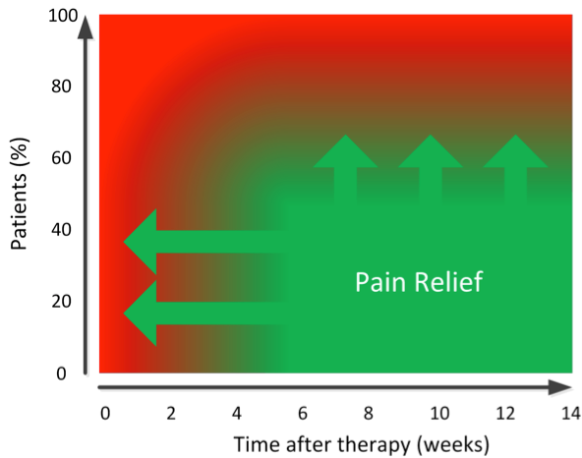
Figure 1
Radiotherapy achieves pain relief in 60-70% of patients after 4-6 weeks. There is a clinical need for more rapid pain relief, as well as for treatment options for the people that do not respond to EBRT, that MR-HIFU has the potential to address.
  - MR-HIFU for pain palliation in bone metastases
Pain palliation may be substantially improved by including Magnetic Resonance Image guided High Intensity Focused Ultrasound (MR-HIFU) as alternative or in addition to EBRT. MR-HIFU is a non-invasive treatment modality that delivers acoustic energy to heat tissue to ablative temperatures of more than 60°C. The combination of focused ultrasound with magnetic resonance imaging (MRI) enables physicians to perform localized tumor tissue ablation, with real-time temperature monitoring using magnetic resonance (MR) thermometry (Jolesz, 2008).

The pain–reducing mechanism of MR-HIFU works through denervation by thermal ablation of the periosteal nerves (Figure 3). The biological mechanism of action of MR-HIFU is heat-induced coagulative necrosis and apoptosis of tissue leading to rapid and durable pain relief from immediate periosteal nerve ablation and thermal necrosis of the targeted bone tumor. MR-HIFU hereby offers a low-risk, non-invasive, focal therapy, avoiding side-effects to surrounding normal tissue that occur with radiation therapy.
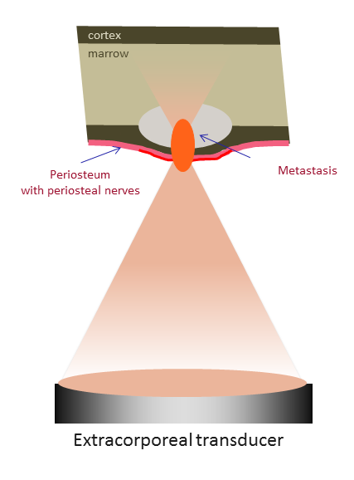
Figure 2: MR-HIFU uses a dedicated extracorporeal ultrasound transducer to focus a beam of ultrasound energy into a small volume at a site of the painful bone metastasis. The focused beam produces therapeutic hyperthermia in the target, while only harmlessly warming the immediate surrounding tissue. Tissue heating at >55 degrees Celsius for one second induces protein denaturation and cell death. During HIFU treatment MRI guidance is used to focus the ultrasound beam on the target and to perform real-time temperature mapping in and around the target. In MR-HIFU treatment of bone metastases, the target corresponds to the metastatic lesion and the adjacent periosteum. The periosteum is considered to be a major source of pain in patients with bone metastases, as it contains the nerves and vasculature for the tumor.
Preliminary clinical studies on the use of MR-HIFU for palliation of painful bone metastases demonstrated excellent response rates and safety (Catane, 2007; Gianfelice, 2008; Napoli, 2013; Huisman, 2014). Hurwitz et al (2014) reported results of a multicenter randomized placebo-controlled trial to evaluate safety and efficacy of MR-HIFU for treating bone metastases in patients with persistent or recurrent pain. This study demonstrated that MR-HIFU is a safe and effective, non-invasive treatment for alleviating pain caused by bone metastases. Response to MR-HIFU was typically rapid, with about two-thirds of responses seen within days after treatment (Hurwitz, 2014). A recent single-centre matched-pair study showed that MR-HIFU provides a similar overall treatment response rate but faster pain relief compared with EBRT and thus has the potential to serve as the first-line treatment for painful bone metastasis in selected patients (Lee, 2017). University Medical Center Utrecht participated in a multicenter pilot study (METC 12-035) in which an early improvement in pain and quality of life in patients with painful bone lesions treated with MR-HIFU was shown (Harding, 2018).

These studies were, however, performed in patients who were ineligible for EBRT, or who failed or declined radiation. As such, there is a lack of evidence that supports the uptake of MR-HIFU as a standard (first-line) treatment option and alternative to EBRT. In addition, a consensus report (Huisman et al. 2015) issued by an international panel of experts concluded with future directions that are in line with the proposed FURTHER project:
- The combination of HIFU with radiotherapy should be investigated.
- The value of HIFU incorporated into primary therapeutic options should be investigated, initially in patients with lesions in non-weight-bearing bones.
- The recommended trial design is a three-arm randomised controlled trial (RCT) to assess the efficacy of MR-HIFU, radiotherapy and a combination of these two modalities as a primary palliative treatment for bone metastases.

Since the mechanism of action of EBRT and MR-HIFU differ, MR-HIFU provides an alternative means to overcome radio-resistance and is recommended for patients with bone metastasis for whom radiotherapy (RT) is considered to have failed (Hurwitz, 2014). By combining both modalities, a substantial proportion of patients with painful bone metastases are expected to experience early pain relief and improved response durability, due to synergistic effects of the two treatments as a result of their different mechanisms of action. Additionally, it is recognised that radiation and heat both induce tumor-specific immune responses (Wattenberg 2014; Udono 1993; Milani 2002; Hurwitz 2010). By combining the two modalities in a third treatment arm in this study, the hypothesis can be tested whether the combined treatment has superiority over either modality alone regarding overall pain response.

  - Rationale
Previous studies suggest that pain palliation may be substantially improved by including MR-HIFU as an alternative or additional treatment option to standard EBRT. It is thought that MR-HIFU can have added benefit, providing fast and long lasting pain relief. However, evidence and context is lacking for wide-spread implementation of MR-HIFU into the standard-of-care for palliative treatment of painful bone metastases. Therefore, the FURTHER consortium sets out to evaluate the effectiveness and cost-effectiveness of MR-HIFU as a palliative treatment option to relief bone pain caused by metastases.

In order to achieve this, the FURTHER-trial will be performed. This will be an international multi-center, three-armed randomized controlled trial evaluating the impact of MR-HIFU with or without EBRT on early pain relief in patients with metastatic bone disease. The trial will compare early pain response in patients treated with standard EBRT (reference treatment), patients treated with MR-HIFU, and patients treated with the combined EBRT and MR-HIFU treatment.

- OBJECTIVES
  - Primary Objective
The FURTHER trial aims to answer the research question: Do patients treated with MR-HIFU experience a faster early pain response as compared to patients treated with the standard of care? Our primary outcome is patient reported pain response fourteen days after completion of treatment.

Patient reported pain response will be based on the numeric rating scale (NRS) and the pain severity index calculated from the Brief Pain Inventory (BPI) questionnaire [Cleeland 1994]. In addition, analgesic and anti-neuropathic drug use is recorded, and all opioid analgesics are expressed as the oral equivalent daily morphine use (OMED). The primary endpoint of the RCT will follow the International Consensus on Palliative Radiotherapy Endpoints for Future Clinical Trials in Bone metastases (Chow 2012). Patients will be categorized as responders when a complete or partial pain response is achieved. All other patients will be categorized as non-responders. More information about the primary endpoint can be found in chapter 6.1.1. of this protocol.

  - Secondary Objectives
Secondary endpoints are summed up in table 1. More information on the secondary endpoints can be found in chapter 6.1.2 of this protocol.

Table 1: Secondary outcomes of the FURTHER-trial
Pain response at 14 days after inclusion | Assessed using the BPI and patient pain-diary. Used to assess effectiveness of treatment taking hospital logistics and planning into account
Patient-reported pain scores | Assessed using the BPI and patient pain-diary during the first fourteen days, at four weeks and three and six months following treamtent.
Physician reported toxicity | Assessed by telephone call at three days, one, four and six weeks, and three and six months following completion of treatment according to the Common Terminology Criteria for Adverse Events (CTCAE) version 5.0
Patient-reported quality of life | Assessed using the EORTC QLQ BM22, C15-PAL and EQ-5D-5L and PGIC at baseline, two and four weeks, and three and six months following completion of treatment.
Local tumour control. | Assessed using CT and/or MRI imaging at patient discretion at three and/or six months after completion of treatment.
Levels of anxiety and depression | Assessed among patients, patients’ partners and caregivers by the Hospital Anxiety and Depression Scale (HADS) and EDIZ-list at baseline, two and four weeks, and three and six months following completion of treatment.
Cost-effectiveness of the treatment. | A hypothetical diagnosis related group (DRG) will be calculated from the perspective of the statutory health insurance (SHI). If possible a cost-effectiveness analysis will be performed.

- STUDY DESIGN
This study will be a prospective, multicenter, three-armed randomized controlled trial. The study will be performed in six hospitals in four European Union countries (The Netherlands, Finland, Germany, Italy), all of which are partners in the FURTHER consortium. In the Netherlands, the trial will be performed at the UMC Utrecht and Isala Zwolle. The six study sites will recruit and include a total of 216 patients (72 patients in each arm) over a 36 month period. Each centre will on average include 36 patients diagnosed with painful bone metastases, all of which meet the inclusion and exclusion criteria. Participants will provide informed consent before being randomized into one of the three intervention arms (Figure 3).

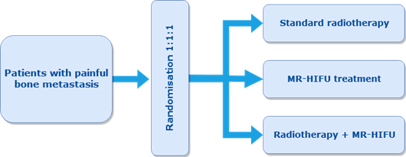
Figure 3 – MR-HIFU RCT1 trial design

Enrollment
Patients will be enrolled at the respective departments of Radiation Oncology. All patients who are referred with non-vertebral painful skeletal metastases are eligible for participation. The radiation oncologist will approach potentially eligible patients who meet the in- and exclusion criteria for study participation. (S)he will shortly explain the study (design) and the three treatment strategies (EBRT, MR-HIFU only, or combination therapy with EBRT + MR-HIFU). When patients express interest, they will receive more detailed information about the study. Also, research personnel will check with patients whether they have understood the aim and content of the study, and ask patients to sign informed consent. Given the urgent need for rapid pain relief, patients will be allowed to make a decision for participation in the study and sign informed consent directly after they received the information. The clinical researcher will then include and randomize the patient in the online CASTOR database. The treatment arm allocation will immediately be shown. Patients will be treated following the protocol for the treatment arm they are assigned to.

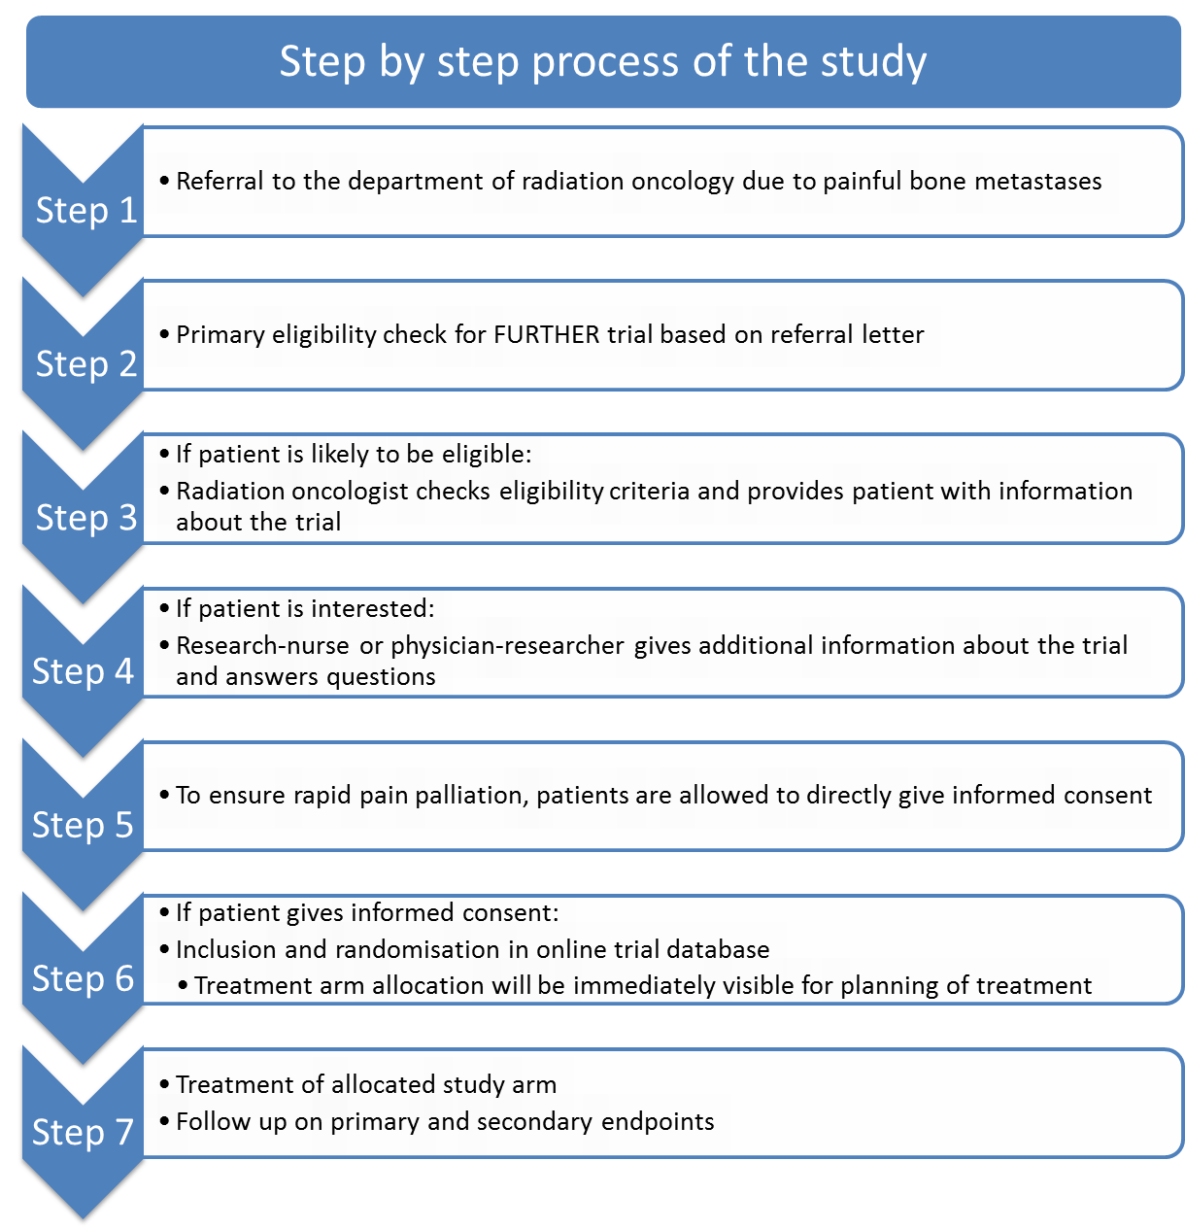

Follow up
During a follow-up period of six months, patients will be contacted at eight time points to retrieve information about their level of pain, quality of life and (serious) adverse events (table 2).

In the first 21 days following start of treatment, a patient diary will be used for daily self-reporting of pain levels and pain medication use. Quality of life and pain response will also be assessed at baseline, one, two and four weeks, and three and six months after treatment completion. (Serious) adverse events will be assessed by telephone at three, seven, and fourteen days, four and six weeks, and three and six months following last day of treatment. The patient will also be called fourteen days after inclusion to assess pain response and patient global impression of change. Local control will be assessed at patient discretion on a follow up CT and/or MRI at 3 and/or 6 months after completion of treatment if clinically available.
- STUDY POPULATION
  - Population (base)
The study population will consist of male and female adults (age ≥ 18 years) with painful bone metastases who are able to give informed consent. Patients will be recruited at the respective departments of Radiation Oncology. The UMC Utrecht is a referral centre for radiotherapy in which around 700 patients with bone metastases are treated annually. In Isala, approximately 600 patients present annually to the department of Radiation Oncology for the treatment of painful bone metastases.

  - Inclusion criteria
In order to be eligible to participate in this study, patients must meet all of the following criteria:
Inclusion criteria | Source
Age ≥ 18 years | Birth date
Patient capable of giving informed consent | Physician’s interview
Referral to radiotherapy department due to painful metastatic bone lesion (NRS > 4) | Referral letter
Pain from target lesion is distinguishable from other lesions * | Physician's interview
Target lesion location is accessible for MR-HIFU and EBRT ** | Radiology
Target lesion is visible on pre-treatment MR or CT imaging, with a maximum diameter of 8 cm | Radiology
Participant able to fit in the MRI gantry | Physician’s examination
Reasonable performance score (KPS > 50% or Zubrod/ECOG/WHO < 3) | Physician’s interview
Life expectancy > 3 months | Referral letter
* Solitary painful metastatic bone lesion or multiple metastatic lesions with one predominantly painful target lesion (≥2 points higher pain score than other lesions).
** e.g.: Extremities, pelvis (os pubis, os ilium, os ischium, sacrum, acetabulum), shoulders, in selected cases ribs and sternum (if no lung tissue in HIFU beam path)

  - Exclusion criteria
Patients who meet any of the following criteria will be excluded from participation in this study:
Exclusion criteria | Source
Previous surgery on the target location | Patient history
Neurological symptoms due to nerve involvement of target lesion | Physician’s examination
Need for surgery of targeted location due to (impending) pathological fracture | Referral letter
Unavoidable critical structures or dense tissues in target area * | Radiology
Curative intention of treatment plan | Referral letter
Contra indications MRI or sedation | Physician’s interview
Participant enrolled in another clinical interventional study related to bone metastases treatment or pain relief treatment | Physician’s interview
Clinically relevant medical history or physical findings that could interfere with the patient's safety as judged by the treating physician | Physician’s interview
* as judged by the operator. e.g.: nerve bundles, skin, extensive scarring, non-targeted bones, air (e.g. hollow viscera), (external) fixation device

  - Sample size calculation
The study will be powered to detect a difference in proportions of patients with pain response of the treated bone metastasis at fourteen days after completion of treatment. For this purpose the two MR-HIFU arms will be combined. We calculated we need 72 patients in each arm, using a one-sided alpha of 5%, a power of 90%, and a 10% post-randomization drop out. We base this calculation on previous research showing that the proportion of patients with successful pain palliation at fourteen days following end of treatment is 0.69 for MR-HIFU and 0.40 for EBRT (Hurwitz 2014, vd Velden 2018). We conservatively assume that 10% of patients allocated to the one of the MR-HIFU arms will not be able to undergo MR-HIFU and will therefore receive EBRT. Similarly, we assume that 10% of patients allocated to EBRT will receive MR-HIFU instead.

At 3 months, due to the reduced sample size caused by substantial mortality among patients, we will have a power of 80% to detect a difference of 25% in proportion of patients with pain relief between treatment arms and a 60% power to detect a difference of 20% (see figure 4). In order to make optimal use of all available patient data, and increase the power, we will conduct generalized linear mixed model for dichotomous outcomes, with correction for pain at baseline, as suggested by Thompson et al 2015 (Thompson, 2015).
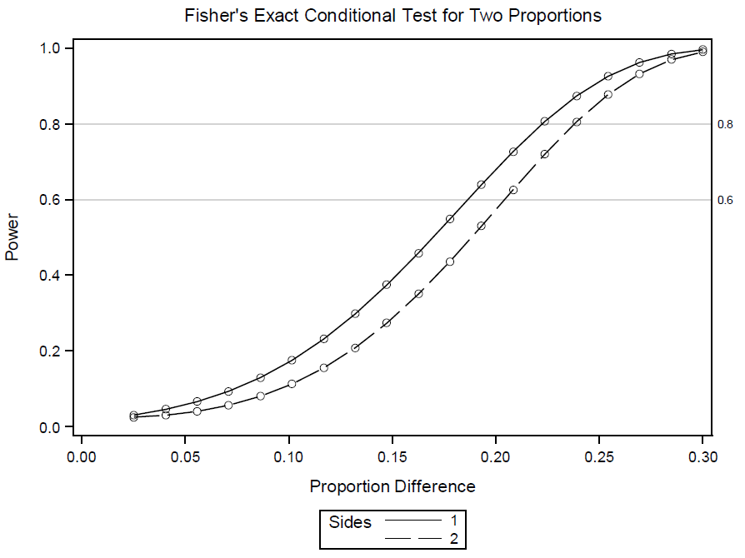

Figure 4: The power procedure: Fisher’s Exact conditional test for two proportions, with correction for multiple testing.
- TREATMENT OF SUBJECTS
  - Treatment arm 1: MR-HIFU only
The intervention treatment is MR-HIFU, which will be given as a standalone treatment or as a combined treatment with EBRT. MR-HIFU treatment will be delivered using The MR-HIFU Sonalleve® System (Profound Medical Corp., Toronto, Canada), which is a CE-marked device for pain palliation of bone metastases. For more details about the system, we refer to the Investigator’s Brochure.

Pathway of MR-HIFU treatment arm:
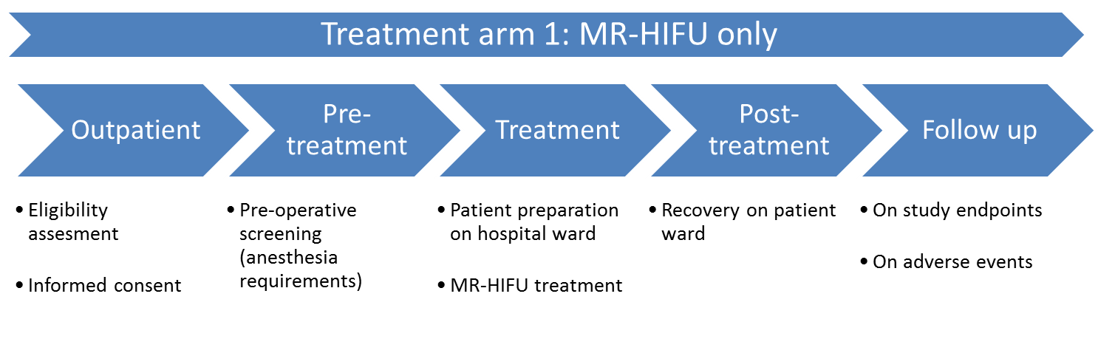

Preparation
During the treatment the patient will be under deep sedation, this will enable adequate pain control and ensure a stable patient position during treatment. The deep sedation will be administered and fully monitored by an anesthesiologist. This will be conducted according to local hospital protocol. Pre-operative screening will be performed to assess procedural sedation possibilities. During the procedure, i.v. medications (such as sedation and analgesics if required) will be administrated to the patient via an intravenous catheter. The need for a urinary bladder catheter is determined by the operator/treating physician. Before the start of treatment, participating patients will undergo MR imaging of the region of the intended target volume according to the clinical standard for HIFU treatments. The MRI imaging sequences to be used for baseline data collection include T2-weighted sequences, and T1-weighted sequences with and/or without contrast agent. The operator will locate the target tissue and mark the volume to be treated using MRI images. The operator starts the treatment and monitors the progress of the treatment with MR temperature and thermal dose maps according to the Sonalleve® Instructions for Use to ensure safety.

MR-HIFU treatment procedure
MR-HIFU treatment will aim at ablating the periosteum followed by ablation of the bone metastasis if feasible and safe. HIFU treatment will be performed conform the international consensus according to Huisman et al. [Huisman 2015]. Ablation can be performed with volumetric techniques, which are designed to allow heating of larger zones or cells in one sonication. During a sonication, the transducer applies heat in a continuous manner to adjacent points within the treatment cell. In the bone HIFU treatment, the treatment cells are placed within a target treatment area to sonicate the targeted bone. Full treatment is performed by stepping through several treatment cells with cooling times between each sonication. Each HIFU ablation is performed with user selected ultrasound power set to achieve sufficient tissue heating to ablate the periosteal nerves and/or bone lesions, typically achieved in the temperature range 55-70°C. The HIFU power will be adapted based on the presence, status and location of cortical bones, as well as safety concerns, such as critical structures in near and far field of the HIFU beam. The duration of the sonication is fixed for each cell size (for example, a 4mm cell has a duration of 16 seconds). Heating of the surrounding tissue can be monitored with real-time Magnetic Resonance imaging temperature monitoring.

Post-treatment
Following the MR-HIFU procedure, a set of MR images of the target region will be acquired with the use of a MR contrast agent. If the patient has a known gadolinium allergy, the procedure will be done without the contrast enhanced scan. When the whole planned volume has been treated, the operator stores the full treatment history and technical data as available from the Sonalleve® MR-HIFU device. The patients are then transferred to the recovery room or patient ward for medical supervision. When the patient has recovered from procedural sedation and no complications have occurred, the patient can be discharged. Before discharge, follow-up instructions will be given to the patient. When MR-HIFU treatment does not alleviate pain within four weeks after treatment, patients will be offered standard care (EBRT).

  - Treatment arm 2: EBRT only
In the control arm patients will undergo standard radiotherapy for painful bone metastases. The standard of care for pain palliation of bone metastases consists of single fraction external beam radiotherapy of 8 Gray (Gy). The radiation oncologist may decide to administer a multi-fraction regime of 20 Gy in 5 fractions, 24 Gy in 6 fractions or 30 Gy in 10 fractions. The radiation schedule is at the discretion of the treating radiation oncologist.

Pathway of EBRT only treatment arm:
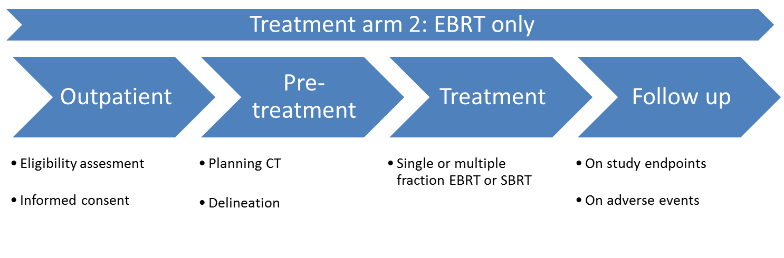
Preparation
Planning CT with or without contrast in treatment position is made for delineation. It is encouraged to register either diagnostic MR sequences or MR sequences in treatment position to the planning CT to help guide to define target definition or delineation.

Target Volume Definitions
- Virtual simulation
  - Visible lesion on CT or MRI with at least 1.5 cm isotropic margin.
- IMRT or VMAT planning
  - GTV = visible lesion on CT
  - CTV = GTV + 1.5 cm confined to bone (including soft-tissue components if applicable)
    - in case of pelvic/sacral lesions: CTV = bony compartment containing the metastasis
    - in case of lesions in the extremity: CTV = GTV + 2 cm
  - PTV margin should be institute dependent depending to local delivery technique (typically 1-10 isotropic margin)

Dose Specification
- Virtual simulation
  - Visible lesion should at least receive 80% of the prescribed dose using single or multiple treatment fields with a dose maximum of 115%. In case of multiple treatment field, typically two opposing fields are used or a box technique using 2 lateral beams in addition to the postero-anterior field. The leafs of the multileaf collimator are used to adjust the shape of the treatment field.
- IMRT or VMAT planning
  - At least 90% of the PTV should receive 95% of the prescribed dose (V90 > 95% ). A maximal 3D dose of 110% is allowed.
  - Stereotactic dose delivery using immobilization (e.g. S-frame thermoplastic mask or vacuum mattress) and online position verification protocol is registered as a minor deviation from standard care.

Dose in organs at risk
The maximum allowed dose in organs at risk will be according to local institutes’ protocol. It is encouraged to use a max dose of 50Gy (EQD2 alpha/beta=2) to the spinal cord.

Treatment and position verification
Automatic treatment plans may be delivered using intensity-modulated radiation therapy (IMRT), VMAT or SBRT technique. Position verification is at the discretion of the treating radiation oncologist in consultation with the clinical physicist. It is encouraged to use online position verification by use of conebeam CT at every fraction.

  - Treatment arm 3: EBRT combined with MR-HIFU
Patients allocated to the combined intervention arm will undergo both interventions as described in 5.1 and 5.2.

Pathway of combined treatment arm:
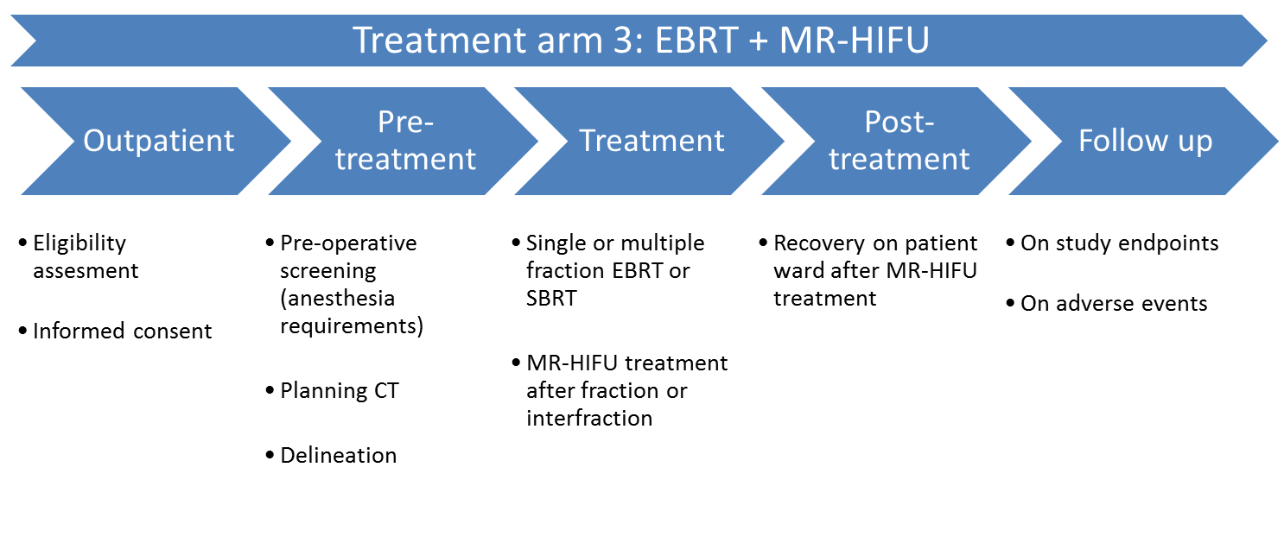

PRE-FURTHER
In the PRE-FURTHER study (METC #19-039) the feasibility of the EBRT/MR-HIFU combination treatment has been examined in six patients with painful bone metastases.
In this study, we showed that it is possible to plan the combination treatment within a timeframe of 4 days. The most apparent challenge for the logistical feasibility of the combination treatment was the ad hoc manner of planning that is necessary in this patient population. During this study the workflow for the combination treatment has been adjusted to make it as efficient as possible for the FURTHER-trial. From the PRE-FURTHER study we learned that complicated bone metastases are not suited for MR-HIFU. Because of this, the in- and exclusion criteria of the FURTHER study have been optimized.

Study participants filled in a ‘patient reported experience measure’ questionnaire after the treatment. All participants were very satisfied with the logistics concerning the combination treatment, and also about the treatment itself. For 4 of the 6 included patients, an extra hospital visit was necessary for the combination treatment. Only one of them saw this as a minor inconvenience, mostly because this patient underwent his radiotherapy in a different hospital then the MR-HIFU treatment.

Safety was also assessed in the PRE-FURTHER study. No treatment related serious adverse events occurred.

Preparation and treatment
In the combination treatment arm, both treatments will be planned as soon as possible following inclusion (preferably within one week), to ensure rapid pain palliation. The pre-treatment appointments (planning CT and pre-operative screening) will be planned in a way that is least burdensome for the patient. In case of single fraction EBRT, pre-operative screening can be planned on the same day as the planning CT or EBRT treatment. In case of multifraction EBRT, the pre-operative screening may also be planned on the same day as one of the radiotherapy fractions. In some cases, pre-operative screening can be done by telephone and no hospital visit will be needed. In the case of single fraction EBRT, the patient will receive the MR-HIFU treatment as soon as possible after the radiotherapy treatment. In the case of multifraction EBRT, the MR-HIFU treatment is preferably planned on the same day as one of the fractions, therefore interfraction MR-HIFU treatment is allowed. To ensure an efficient workflow for the combined arm, a regular standard MR-HIFU availability slot is advised. The workflow for both single fraction and multifraction EBRT could look like the following flowchart:
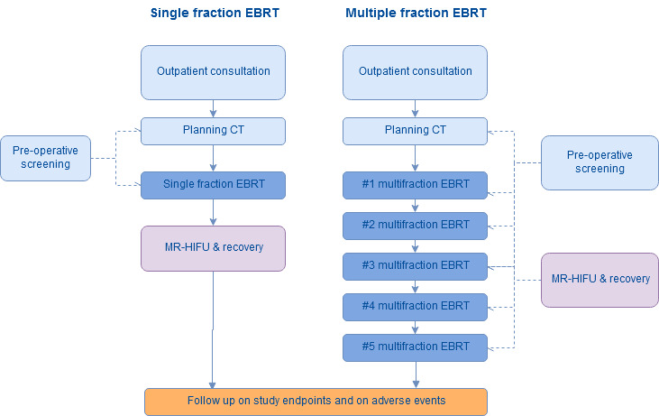

  - Co-interventions & escape medication
The use of co-interventions or medications will be allowed and comparable in all groups since complaints and complications in both groups will be treated according to the hospitals clinical protocols and are dependent on the attending physician’s own judgment. Co-interventions will be registered as documented in the attending physician’s notes.

Patients may receive pain medication as required by their symptoms, both before and after the EBRT and/or MR-HIFU treatment. The amount of pain medication used is part of the primary and secondary endpoints of the study and will be recorded at baseline before treatment and during follow-up. During the MR-HIFU treatment the patient will receive hypnotic and analgesic agents under the direct supervision of an anesthesiologist or sedationist for pain control and to ensure a stable patient position during treatment. Drug selection will be based on practitioner preference, full remote-site appropriate monitoring will be utilised.

- METHODS
  - Study parameters/endpoints
    - Main study parameter/endpoint
The primary outcome measure is patient reported pain response fourteen days after completion of treatment.

Patient reported pain response will be based on the numeric rating scale (NRS) and the pain severity index calculated from the Brief Pain Inventory. In addition, analgesic use is recorded, and all opioid analgesics are expressed as the oral equivalent daily morphine use (OMED), anti-neuropathic drug consumption will also be assessed. Patient’s pain response to treatment will be categorized into 4 groups using the same criteria as described in literature for palliation of painful bone metastases with radiotherapy (Chow 2011):
- Complete response (CR): Complete response is defined as a pain score of zero at the treated site with no concomitant increase in analgesic intake (stable or reducing analgesics in daily oral morphine equivalents).
- Partial Response (PR): Partial response is to be defined as any of the following: Pain reduction of 2 or more at the treated site on a 0-10 scale without analgesic increase; or analgesic reduction of 25% or more from baseline without an increase in pain.
- Pain Progression (PP): Pain progression is defined as an increase in the pain score of 2 or more points above baseline at the treated site with stable analgesic use or an increase of 25% or more in daily oral morphine equivalent compared with baseline with the pain score stable or 1 point above baseline.
- No Response (NR): All other cases are considered no response to treatment.

A patient will be considered responder to therapy when the patient has either a PR or CR. The endpoint is assessed by pain scores related to the target lesion treated as measured on a Numerical Rating Scale (NRS) in the Brief Pain Inventory (BPI) questionnaire [Cleeland 1994], and by change in pain medication as measured by patient diary and pain medication records.

Pain is measured by patient’s self-assessment on the NRS. Patients will rate the worst and average pain that they felt from the treated area over the last three days, and the pain they feel currently. For analysis, the reported worst pain will be used. This is consistent with the latest version of the International Consensus for clinical trial endpoints on bone pain palliation with radiotherapy (Chow 2012). The BPI questionnaire filled by the patient will be used for recording the NRS result. The BPI is a well-established, thoroughly validated tool for pain self-assessment, which can be considered a gold standard (Cleeland 1994). It also contains a body diagram for pain localization, and is compatible with the recommendations by the international Consensus (Chow 2012).

The NRS score used for success assessment will be the ‘worst pain in the last 3 days’, as recommended by the international consensus for bone pain palliation endpoints (Chow 2012). If the patient dies between days 0-30 for a non-treatment related reason, the patient will be excluded from analysis of this endpoint (the study has been powered to account for a post-randomization drop out of 20%).
    - Secondary study parameters/endpoints
Secondary endpoints will include patient reported pain response at fourteen days after inclusion will be a primary endpoint as well. By doing so, we take into account the logistic complexities associated with planning of MR-HIFU (i.e. EBRT is easier to plan due to less complicated logistics). These logistic challenges are important from the patient’s perspective, and need to be taken into account while comparing time to pain response between the treatment strategies.. We will evaluate patient quality of life at baseline, one, two and four weeks, and three and six months after treatment using validated questionnaires (EORTC QLQ BM22, EORTC C15-PAL and EQ-5D-5L). We will also compare the evolution of pain scores between MR-HIFU and EBRT treatment groups (time to pain palliation, time to pain progression, duration of pain palliation). We will measure symptoms of anxiety and depression among patients, their partners and informal care givers using the Hospital Anxiety and Depression Scale questionnaire and EDIZ-list.

Although the primary goal of both the interventions will be pain palliation, we will also evaluate local control. Local control will be assessed using MR and/or CT-imaging at 3 and/or 6 months at patient discretion. Although a pain palliation treatment approach can be significantly different from a total ablative treatment intention, there is still a balance between periosteum and tumor ablation in (durable) pain palliation treatment. If the tumor is ablated, local tumor control may be achieved and follow up of local control may lead to more knowledge about the best way to ablate these tumors.

A hypothetical diagnosis related group (DRG) will be calculated from the perspective of the statutory health insurance (SHI) based on a hypothetical pathway. If possible, a cost-effectiveness analysis will be performed as well. The additional effectiveness will be calculated by mapping information about pain response into pain-free days (PFDs) and, by estimating quality-adjusted life years (QALYs). PFDs during the 6-month follow-up period will be calculated from the pain responses assessed by the telephone calls. QALYs will be obtained from the EQ-5D. The expected additional costs of MR-HIFU as a basis for calculating a hypothetical DRG will be calculated using an actual cost accounting approach (based on the manual of calculation). For this approach, the following parameters will be included: (1) the intervention cost per patient (MR-HIFU); (2) the physician and nurse costs related to the use of MR-HIFU; (3) prescription and other medical cost data reflecting the patients’ health care use. Data on costs will be obtained from the controlling departments of the participating centers and via cost questionnaire in the telephone calls.
    - Other study parameters
Several patient and tumor related parameters will be captured, including as age, gender, primary tumor, performance score, location of targeted volume, number of symptomatic bone metastases, date of diagnosis of primary tumor, date of diagnosis of first symptomatic bone metastasis, prior systemic treatments received, current systemic therapy, and treatment data of radiotherapy (dose, fractionation) and MR-HIFU (treatment duration, total thermal dose).

  - Randomization, blinding and treatment allocation
After inclusion, patients are randomized to one of the three intervention arms and will either receive standard EBRT treatment, MR-HIFU only treatment, or combined EBRT and MR-HIFU treatment. Treatment has to be administered as soon as possible. Distributed over the six clinical centres of the consortium (UMCU, TUCH, ISALA, CSSP/URLS, UHC and IOR/UNIBO), a total of 216 patients will be randomized, 72 patients into each arm of the trial. Patients and doctors will not be blinded to treatment and treatment allocation will not be concealed. Randomization will be done at the study site, by a computer generated sequence in CASTOR. Patients meeting the in- and exclusion criteria will be randomized after informed consent on a 1:1:1 basis. We will stratify by institution and fractionation schedule (single fraction, multifraction, unknown).

  - Study procedures
    - Patient recruitment, consent, enrolment and baseline data collection
Patients will be recruited at the departments of radiation oncology at the participating study sites. Candidates for enrolment will already have a formal diagnosis of painful bone metastasis. Information on medical history and indication for treatment will be provided by the patients’ treating physician to the study site. When this information indicates that the patient is likely to meet inclusion and exclusion criteria, the study site will inform the patient about the details of the study. Patients will receive a participant information sheet, including the informed consent form, explaining the purpose and the details of the study, particularly the potential risks and burdens associated with the MR-HIFU treatment.

The principal investigator or an authorized delegate will conduct the informed consent process. If the patients want to join the study, they will consent to their participation in the study (including screening procedures and MR-HIFU treatment) by signing the informed consent form. In this study, given the urgency of the situation and the need for rapid pain relief, patients will be allowed to sign informed consent directly after having received the study information. After informed consent has been provided, the investigator or an authorized delegate will collect standard baseline demographic factors, disease history, and previous therapy for bone metastasis from participating patients and response to prior radiotherapy when applicable, and instruct the patient how to fill in the pain dairy and questionnaires.

Patient screening and enrollment will be recorded on the Screening / Enrollment log. Information on withdrawal will also be recorded in this log. The Screening / Enrollment log will be used for subject accountability.
    - Treatment
After informed consent and randomization, the participant will receive the treatment of one of the three study arms. This will either be EBRT only, MR-HIFU only, or EBRT combined with MR-HIFU in a shortest possible timeframe. The treatment of subjects is described in detail in sections 5.1 – 5.3 of this protocol.
    - Follow-up
Patient follow-up will take place at the study site where the patient was included. For an overview of planned follow-up moments see table 2 in section 3 of this protocol. During a follow-up period of six months, patients will be contacted at eight time points to retrieve information about their level of pain, quality of life and adverse events. In the first 14 days following the start of treatment, a patient diary will be used for daily self-reporting of pain levels and pain medication use. The diary will be supplied and explained to patients prior to the treatment. Quality of life will be assessed using patient-reported questionnaire outcomes at 1, 2 and 4 weeks, and 3 and 6 months after treatment completion. Adverse events will be assessed by telephone at three, seven, and fourteen days, four and six weeks, and three and six months following last day of treatment. The patient will also be called 14 days after inclusion to assess pain response and patient global impression of change. Local control will be assessed on CT and/or MR imaging at patient discretion.

  - Withdrawal of individual subjects
Subjects can leave the study at any time without any consequences. The investigator can decide to withdraw a subject from the study for urgent medical reasons. Patients will exit the study during the follow-up period if they have been referred to alternative palliative treatments of the treated metastasis for medical reasons (such as radiopharmaceuticals, surgery, cryotherapy, radio-frequency ablation or nerve blocks, or MR-HIFU in the EBRT arm). The reason for exit (e.g. alternative local therapy due to pain) will be recorded. Patients who exit the study after the treatment and before the 14-day follow-up visit due to alternative intervention will be registered as non-responders.

  - Follow-up of subjects withdrawn from treatment
Follow-up of withdrawn subjects will take place by their treating physician, according to standard clinical practice.

  - Premature termination of the study
No premature termination of the study is expected.
- SAFETY REPORTING
  - Temporary halt for reasons of subject safety
In accordance to section 10, subsection 4, of the WMO, the sponsor will suspend the study if there is sufficient ground that continuation of the study will jeopardize subject health or safety. The sponsor will notify the accredited METC without undue delay of a temporary halt including the reason for such an action. The study will be suspended pending a further positive decision by the accredited METC. The investigator will take care that all subjects are kept informed.

  - Definitions in safety reporting
According to EU Directive 90/385/EEC, 93/42/EEC (last amended Directive 2007/47/EC) and the ‘Guidelines on medical devices: MEDDEV 2.7/3 revision 3’, the following definitions are used in the safety reporting:
    - Adverse events (AEs)
Adverse events are defined as any untoward medical occurrence, unintended disease or injury or any untoward clinical signs in subjects, users or other persons, whether or not related to the investigational medical device. This definition includes events related to the investigational device or the comparator or the procedures involved. For users or other persons this is restricted to events related to the medical device.
    - Serious adverse events (SAEs)
A serious adverse event is any untoward medical occurrence or effect that:
- led to a death, injury or permanent impairment to a body structure or a body function.
- led to a serious deterioration in health of the subject, that either resulted in:
  - a life-threatening illness or injury, or
  - a permanent impairment of a body structure or a body function, or
  - in-patient hospitalization or prolongation of existing hospitalization, or
  - a medical or surgical intervention to prevent life threatening illness.
- led to foetal distress, foetal death or a congenital abnormality or birth defect.
An elective hospital admission or a planned hospitalization for a pre-existing condition, or a procedure required by the study protocol, without a serious deterioration in health, is not considered a serious adverse event.

  - Safety reporting
    - Recording of adverse events
All AEs are graded according to CTCAE (version 5.0) for acute and late toxicity. Due to the natural course of the disease, we expect that many patients with bone metastases suffer from study unrelated (S)AEs. Therefore, only study related AEs that are grade 3 or higher, reported spontaneously by the patient or observed by the investigator or his staff will be recorded at each contact up to 6 months after the MR-HIFU treatment. An increase in pain will not be reported seperately as a study related AE, but will be monitored closely using the follow up BPI questionnaires.

The following aspects will be recorded for each event:
- type (category) of the AE according to the CTCAE version 5.0
- date of onset
- date of recovery
- grade according to the CTCAE version 5.0
- attribution factor
- action taken
- outcome of the AE
    - Reportable events
The following events are considered reportable events in accordance with Annex 7, section 2.3.5 and Annex X, section 2.3.5 of the above mentioned Directives (18):
- any SAE;
- any device deficiency that might have led to a SAE if:
- suitable action had not been taken or
- intervention had not been made or
- circumstances had been less fortunate.
- new findings/updates in relation to already reported events.
    - Reporting standards
The sponsor will report study related SAEs within 6 months after MR-HIFU treatment through the web portal ToetsingOnline to the accredited METC that approved the protocol, within 7 days of first knowledge for SAEs that result in death or are life threatening followed by a period of maximum of 8 days to complete the initial preliminary report. All other study related SAEs within 6 months after MR-HIFU treatment will be reported within a period of maximum 15 days after the sponsor has first knowledge of the study related serious adverse event. SAEs that are not study related will not be reported through the web portal Toetsingonline. These events however will be reported in line-listings in the yearly progress report (‘voortgangsrapportage’).

  - Follow-up of adverse events
All study related AEs will be followed until they have abated, or until a stable situation has been reached. Depending on the event, follow up may require additional tests or medical procedures as indicated, and/or referral to the general physician or a medical specialist. SAEs need to be reported until end of study within the Netherlands, as defined in the protocol.

  - Data Safety Monitoring Board (DSMB)
As this is a low risk study, no Data Safety Monitoring Board will be installed. Within the FURTHER consortium, the advisory board, consisting of Jorrit-Jan Verlaan (UMCU), Yvette van der Linden (LUMC), Maurice van den Bosch (OLVG), Brad Wood (NCI, USA) and Marc Hurwitz (Jefferson Univ. Hosp., USA), will be regularly (yearly) informed about the progress of the study.

- STATISTICAL ANALYSIS
Data will be analyzed according to the intention to treat principle. In case of post-treatment dropout (i.e. patients not surviving longer than a week, or patients unable to provide pain scores and analgesic use), a worst-case analysis will be performed, where dropped-out patients will be classified as non-responders.

The primary outcome (i.e. proportion of patients with pain response at fourteen days following completion of treatment) will be presented in absolute numbers and proportions. Differences in pain response between arms will be compared by χ²-test with a sensitivity analysis. We will also conduct a time to event analysis of the data on pain response. In order to make optimal use of all available patient data, and maximize power, we will conduct generalized linear mixed model for dichotomous outcomes, with correction for pain at baseline (Thompson, 2015). Differences in overall survival will be analyzed by Kaplan-Meier analysis. Toxicity will be presented as the overall incidence of grade 3-4 toxicity and differences will be tested with the χ²-test. A comparison in quality of life will be made between the baseline quality of life and at three and six months after treatment completion. A change of 10% of the scale breadth will be considered a clinically relevant change in quality of life. Data will be presented as improved (≥10% increase), stable, or worsened (≥10% decrease) quality of life. We will evaluate the pattern of quality of life as a continuous outcome over time using mixed models. Differences with a P-value of <0.05 will be considered statistically significant. Data characterized by normal distribution will be expressed as mean with standard deviation. Parameters not normally distributed will be expressed as median with the inter quartile range (IQR).

We aim to generate a model for individualized prediction of the effects of MR-HIFU treatment on pain response in patients with painful bone metastases. Selected determinants of pain response will include MR-HIFU treatment received (yes or no), primary tumor site (breast and prostate, lung or other), performance status, age (continuous), presence of visceral metastases at time of therapy, previous systemic treatment (yes or no) and baseline pain score (continuous). A logistic regression model will be developed in a complete dataset to obtain odds ratios for pain response with 95% confidence intervals for the selected parameters. Using a backward stepwise approach an optimal prediction model will be built, based on Akaike’s information criterion. The concordance statistic (c-statistic), which is equivalent to the area under the receiver operating characteristic curve, will be used to assess the model’s discriminative ability. The model can be used to calculate an absolute probability of rapid pain relief with and without the use of MR-HIFU. The difference between the two probabilities is the added value of MR-HIFU. The model will individualize treatment prediction and allow shared decision making. The model will be validated after the project.

- ETHICAL CONSIDERATIONS
  - Regulation statement
The research activities of the FURTHER project comply with the international conventions and codes of conduct, and the latest Helsinki Declaration of the World Medical Association adopted by the World Medical Assembly. Participants in the FURTHER project fully conform to national legislation and applicable codes of conduct, and seek the approval of the relevant ethics committee prior to the start of the trial activities (99/167/EC; Council Decision of 25/1/99). In addition, the research activities of the FURTHER project comply with the international conventions and codes of conduct:
- The Helsinki declaration (Fortaleza, Brazil 2013) of the World Medical Association adopted by the World Medical Assembly.
- The declaration of the European Council on human rights (4/4/1997) and the Additional Protocol on the Prohibition of Cloning Human Beings (12/1/1998);
- Directive 98/44/EC of the European Parliament and of the Council of 6 July 1998 on the legal protection of biotechnological interventions; the opinions of the European Group on ethics in Science and New Technologies (as from 1998);
- GDPR;

  - Recruitment and consent
Patients will be recruited at the outpatient clinic of the Department of Radiation Oncology. The radiation oncologist will perform a first eligibility check on the basis of clinical parameters and images which are usually available when patients with painful bone metastases are referred to the Department of Radiation Oncology. After information on medical history, indication for treatment and capability to communicate with the physician indicate that the patient is likely to satisfy the inclusion and exclusion criteria (section 4.2 and 4.3), the radiation oncologist will inform the patient about the FURTHER study. Patients interested in participating will receive a participant information sheet including the informed consent form explaining the purpose and the details of the study, particularly the potential risks and burdens associated with the MR-HIFU treatment or combined treatment. Potentially eligible patients, will be discussed in detail in a Multidisciplinary Consultation Meeting with the radiation oncologist and radiologist. The investigator or an authorized delegate will take informed consent after the patient has had an opportunity to ask questions about the study procedures. The patients are requested to sign the informed consent form before the preoperative screening, the MR-HIFU treatment and before any other data are collected. Thus, patients also have the chance to revoke consent at this stage. Signature to the consent form should take place in the presence of the principal investigator or an authorized delegate. In this study, given the urgency of the situation and the need for urgent pain relief, patients will also be allowed to sign informed consent directly after receiving the study information.

  - Benefits and risks assessment, group relatedness
The FURTHER-trial is designed to evaluate the efficacy of different treatment strategies concerning pain palliation in patients with painful bone metastases. EBRT is the current standard of care. EBRT does not induce pain relief in up to 30-40% of the treated patients and it takes up to 4-6 weeks before adequate pain reduction is achieved. The most common risk of EBRT is a temporal increase of the pain after the treatment also known as pain flare (Mavrogenis, 2016). ‘Pain flare’ is observed in 2 to 44 percent of patients and can have an important impact on quality of life. Pathologic fractures of weight-bearing bones occur in 10-20% of patients with bone metastases, with femoral metastases accounting for the largest part of these fractures (Body, 1992; Eastley, 2012). The risk of pathological fractures after radiotherapy has been well documented. In the most recent systematic review of palliative radiotherapy trials for bone metastases, comparing single versus multiple fraction regimens, one of the secondary outcomes was pathological fracture rate after radiotherapy (Chow, 2007). Several studies reported data for pathological fracture rates (Bone Pain Trial Working Party, 1999; Cole, 1989; Hartsell, 2005; Kaasa, 2006, Nielsen, 1998; Price, 1986; Roos, 2005), which ranged from 2.8% to 3.2% with no significant differences for treatment schedules. Most of these studies excluded patients with (impending) pathological fractures, which is also the case in the FURTHER-study.

The addition of MR-HIFU treatment as a pain palliation strategy in combination with EBRT or alone, is expected to lead to a more rapid pain relief. MR-HIFU is a non-invasive procedure, and besides occasional minor thermal skin burns, no serious adverse effects are expected as a result of the MR-HIFU treatment. A detailed summary of the results of the complete risk analysis performed by the Supplier is given in the Investigator’s Brochure (chapter 10 and appendix 1). The Investigator’s Brochure summarizes the outcomes and reported adverse events of previous key MR-HIFU studies. The benefits and positive outcomes reported in these previous studies have been weighed against the identified risks. This weighing has led to CE labeling of the device.

MR-HIFU is considered a low risk intervention. The duration of the experimental treatment is, however, longer than that of the standard external beam radiotherapy, namely up to three hours. Also, patients will be under sedation during the treatment, and in unavoidable cases they will have an extra hospital visit for the pre-procedural anesthesiological screening. In our Patient Information Form, patients will be informed about the exact details of the experimental intervention.

In addition to those procedure related adverse events the following adverse events are anticipated in this patient population, but expected to be unrelated to the study procedures:
- Death due to progression of the underlying cancer or cancer-related complications;
- Hospitalization for cancer treatment or due to cancer-related complications;
- Fracture at site(s) of bone metastases unrelated to treatment requiring hospitalization and/or surgical intervention;
- Increase of cancer-related pain unrelated to treatment;
- Progression of the underlying disease.

  - Compensation for injury
The national coordinator per consortium country has a liability insurance which is in accordance with article 7 of the WMO or local legislation. This insurance provides cover for damage to research subjects through injury or death caused by the study. The insurance applies to the damage that becomes apparent during the study or within 4 years after the end of the study.

  - Incentives
Reasonable travel expenses arising from an additional or prolonged hospital visit because of the MR-HIFU treatment will be reimbursed. There will be no additional compensation for study participants.

- ADMINISTRATIVE ASPECTS, MONITORING AND PUBLICATION
  - Handling and storage of data and documents
An CASTOR database will be developed by the coordinating centre (UMC Utrecht). As part of the data entry workflow, the CASTOR software will assign a “study ID”. The reference between the study ID and the hospital patient number is listed in the Subject Identification Log per site. The Subject Identification Log will only be accessible by authorized personnel. The study ID will also be used to tag the inbound technical patient data. Data will be pseudonymized according to the applicable regulations and rules. Each eCRF will be completed on site by the investigator or an authorized staff member. EBRT, MRI and HIFU data will be stored on location.

All individual patient data records will be collected on confidential basis and according to the applicable national data protection, privacy, and secrecy laws (General Data Protection Regulation (GDPR) (In Dutch: Algemene Verordening Gegevensbescherming (AVG)). The investigators, auditors, monitors and employees of the ‘Inspectie Gezondheidszorg en Jeugd’ may have access to the medical and research data of the patients. It is the investigator’s responsibility to complete and approve all treatment related data.

Pseudonymized data collected from patients treated under this protocol may be used in submissions to regulatory agencies, and for publications. Summaries of data and information from each patient data form may be used for reporting of the investigation's findings during the study. Records of the study must be maintained at least as long as local document retention regulations require. In the event that the investigator withdraws or relocates, study records will be transferred to identified site personnel or to the sponsor. This transfer is subject to the sponsor’s approval. Procedures for data management are detailed in a separate Data Management Plan.

  - Monitoring and Quality Assurance
UMCU (Sponsor) is responsible for trial management and monitoring. For each country, a separate National Coordinator will be identified and responsible for quality assurance. The clinical monitor will be responsible for verifying adherence to the protocol, reviewing subject records and source data, maintaining records of all actions taken to correct protocol deficiencies during the investigation, and assuring that the data needed to complete the study is complete and accurate. Monitoring will be documented to the study files by monitor reports. The monitor plan for this low risk study is added as a separate document.

  - Amendments
Amendments are changes made to the research after a favorable opinion by the accredited IRB has been given. All amendments will be notified to the METC.

  - Annual progress report
The sponsor will submit a summary of the progress of the trial to the accredited METC once a year. Information will be provided on the date of inclusion of the first subject, numbers of subjects included and numbers of subjects that have completed the trial, serious adverse events, other problems, and amendments.

  - Temporary halt and (prematurely) end of study report
The investigator/sponsor will notify the accredited METC of the end of the study within a period of 8 weeks. The end of the study is defined as the last patient’s last follow-up moment 6 months after completion of treatment. The investigator will notify the METC immediately of a temporary halt of the study, including the reason of such an action. In case the study is ended prematurely, the sponsor will notify the accredited METC within 15 days, including the reasons for the premature termination. Within one year after the end of the study, the sponsor will submit a final study report with the results of the study, including any publications/abstracts of the study, to the accredited METC.

  - Public disclosure and publication policy
Data collected from subjects treated under this protocol will be used for conferences and publication according to the CCMO statement on publication policy (www.ccmo.nl). This statement contains the basic principles of the CCMO’s position on the disclosure/publication of research results obtained from studies involving human subjects. It is the opinion of the CCMO that the results of scientific research involving human subjects must be disclosed unreservedly.

- STRUCTURED RISK ANALYSIS
  - Potential issues of concern
In the FURTHER-trial patients with painful bone metastases will receive either EBRT, MR-HIFU or a combination of both treatment modalities. Since EBRT is the current standard of care for these patients this structured risk analysis focuses on any risks caused by the MR-HIFU treatment and by the combination of the two treatments.

The risks are determined mainly by the physics of HIFU heating and by the clinical practice. The most important risk is unintended heating of tissue causing burns. To reduce the risk of skin burn, the Sonalleve device is equipped with a Direct Skin Cooling Device. The system also offers real-time feedback to inform the operator of various safety parameters. The user can monitor for:
- Undesired temperature elevations in off-focal and focal areas.
- A significant drop in transmitted power.
- A significant drop in temperature versus time curve at the focus

The ultrasound system will automatically shut down if:
- The transducer heats to critical temperatures.
- The measured output power is higher or substantially lower than the requested power.
- High levels of reflected/backscattered power are detected in the amplifiers.
- Any system control element fails to respond correctly to a control request.

The sonication can also be shut down manually by the Patient Emergency Stop Button, the operator controlled Safety Device, or the stop button in the User Interface. A sonication shut down is indicated both by the user interface and by an indicator light on the operator console. A manual reset or other action by the operator is required to continue use of the system after a safety shutdown or use of the stop button by a patient.

The duration of the treatment is dependent on the area that needs to be ablated. In general, it takes one to two hours to treat the average patient with one or more painful bone metastases. Since EBRT only takes up to 20 minutes and there is no need for sedation, patients might experience the MR-HIFU treatment as more cumbersome. Based on the results from previous studies we have valid reason to tell our patients that, even though MR-HIFU is more cumbersome, it is expected to lead to much faster pain relief and perhaps even longer lasting pain relief in the majority of patients. Based on the results of the PRE-FURTHER (METC# 19-039) study, patients experience the additional treatment duration due to the MR-HIFU treatment as only a minor inconvenience.

a. Level of knowledge about mechanism of action
The putative main mechanism of pain relief by EBRT involves the inactivation of osteoclasts to change the microenvironment of bone resorption followed by sterilization of cancer cells to reduce tumor-induced compression (Hartsell et al 2007). The direct mechanism of action of EBRT is damage to DNA of tissues. The mechanism of action of MR-HIFU is coagulative necrosis and apoptosis of tissue due to heat leading to denaturalization of the cell membrane. This results in rapid and durable pain relief because of immediate periosteal nerve ablation and thermal necrosis of the targeted bone tumor.

Since the mechanism of action of EBRT and MR-HIFU differ, MR-HIFU provides an alternative means to overcome radioresistance and is already recommended for patients with bone metastasis for whom RT is considered to have failed (Hurwitz, 2014). The two methods may also have a synergistic effect in the first-line treatment. Heat-induced coagulative ablation is the main action of MR-HIFU, hence its pain palliation effect is expected to be rapid. In addition, preclinical data have demonstrated that MR-HIFU treatments led to tumor and bone lesion control through ablation of tumor, inflammatory cells, osteoblasts and osteoclasts (Yeo 2015) Therefore, local ablation of periosteal nerves by MR-HIFU might complement the systemic responses after EBRT.

Some other effects of the combined treatment should be mentioned:
- Hyperthermia (temperatures 42-45°C) beyond the ablated area results in complementary radiosensitization (reduction of hypoxia; inhibition of DNA repair mechanisms) (van der Zee, 2000; Dababou, 2018) thereby theoretically increasing the risk of damage to surrounding tissue. Previous research has shown that long duration hyperthermia only improves the effectiveness of EBRT with no increase in damage to the surrounding tissue (Chi, 2017), therefore the short hyperthermia created during the MR-HIFU treatment will most likely have no negative effect on the surrounding tissue.
- Coagulative ablation by MR-HIFU (temperatures around 60°C) also may lead to reduction/elimination of local perfusion leading to hypoxia of the treated area. Although hypoxia may theoretically render subsequent EBRT less efficient due to less production of oxygen radicals, this negative effect will diminish rapidly after tissue temperatures return to normal. Therefore, EBRT in the treated area will still be efficient.
b. Previous exposure of human beings with the test product(s) and/or products with a similar biological mechanism
To date, MR-HIFU treatments of uterine fibroids, prostate cancer, breast cancer, bone metastases, brain tumors and pancreas-, liver- and kidney tumors are either a clinical application or in development. Currently HIFU is mostly used for the ablation of prostate cancer and uterine fibroids. Many HIFU treatments are performed under MR-guidance. MRI provides accurate guidance during HIFU treatment, as it offers good soft tissue visualization and enables treatment planning. Moreover, MRI provides temperature maps for excellent therapy monitoring and evaluation of treatment results. For these reasons, MRI is considered the best and safest method for HIFU guidance. Results of previous studies are presented in chapter 1.3 and the Investigator’s Brochure.

c. Can the primary or secondary mechanism be induced in animals and/or in ex-vivo human cell material?
Animal studies on MR-HIFU were focused on:
- The Treatment Protocol for sonication on bone (homogeneous bone with animal model)
- Safety Issues including skin, near field heating, cooling times, targeting accuracy
- Technical validation of integrated HIFU in a representative in vivo model
- In vivo investigation unraveling the underlying pain relief mechanism of MR-HIFU
- In vivo assessment of bone mechanical properties on MR-HIFU heating.

These studies confirmed the potential benefit but their relevance to the clinical situation is limited because of the following reasons (Yeo, 2015):
- The origin of the primary tumor in the FURTHER project varies (breast, prostate, etcetera), and hence also the genotype and phenotype of the bone metastasis.
- The anatomical location of the bone metastasis varies necessitating an individual planning and adaptation of both EBRT and MR-HIFU.
- The degree of bone lysis/bone growth differs affecting the ultrasound absorption necessitating specific MR-HIFU planning.
- EBRT efficacy varies with relation to the degree of hypoxia and perfusion.
- MR-HIFU efficacy differs with respect to ultrasound absorption, incidence angle of the ultrasound beam, and degree of bone lysis/bone growth.

In addition, pain scores are difficult to obtain in animal models. Also, the starting pain level in drug refractory patients in this trial is at such an elevated level that animal models are ethically questionable. See for more detail page 21-24 of the Sonalleve Investigator’s brochure. To the best of our knowledge there are no data available from animal studies that combined EBRT and MR-HIFU.

d. Selectivity of the mechanism to target tissue in animals and/or human beings
MR-HIFU thermal ablation depends on the temperature evolution of the heated regions. MR imaging is used for target definition and allows the physician to depict organs at risk of thermal damage (in the HIFU beam, i.e. in front of, or behind the focal point). The targeting precision is in the range of millimeters.

e. Analysis of potential effect
Thermal damage can be quantified with the thermal dose concept, which has been validated extensively ex vivo, in vivo and in the clinical setting (Chung, 1999; Dewhirst, 2003; McDannold, 2000 & 2006; Yarmolenko, 2011). A thermal dose of > 240 cumulative equivalent minutes (EM) at 43°C is generally considered lethal. In addition, tissue that is heated (for any duration) to > 60°C can be considered coagulated. This is regardless of whether malignant or (accidently) healthy tissue is targeted. During the MR-HIFU procedure, the thermal dose and temperature are visualized on the HIFU console in real-time. This allows the physician to continuously monitor the deposition of thermal energy, and to abort the sonication when a temperature elevation or thermal dose deposition is observed outside the targeted location. Thus, adjacent healthy organs can be monitored continuously for damage, and the physician can act immediately to prevent damaging these organs.

f. Pharmacokinetic considerations
Not applicable for this study.

g. Interaction with other products
Not applicable for this study.

h. Study population
The research subjects are male and female adults (age ≥ 18 years) with painful bone metastases. This is a group of (often elderly) patients, with a limited life expectancy. Since we will only include patients with a life expectancy longer than 3 months, the condition of these patients is expected to be in well enough performance status to undergo treatment. Eligibility for the study will be assessed by the treating radiation oncologist and radiologist, the anesthesiologist and the investigator.

i. Predictability of effect
MR-HIFU tissue ablation has been demonstrated to have a high predictability of effect. Protein denaturation, causing cell death, occurs at temperatures ≥ 60°C, or when a cumulative thermal dose is reached of ≥ 240 EM. In addition, periosteal denervation, leading to pain relief, has been demonstrated preclinically using behavioral pain measurement and histology (Yeo, 2015). MR-HIFU tissue ablation demonstrated both ex vivo and in vivo in multiple studies, and has been validated in clinical studies on uterine fibroid ablation (Chung, 1999; Dewhirst, 2003; McDannold, 2000 & 2006; Yarmolenko, 2011). In addition, each treatment is preceded by a test sonication. This is a low-powered sonication that only causes a small increase in temperature. It is used to validate (and, if required, adjust) the HIFU beam targeting for optimal accuracy of the therapeutic shots.

j. Can effects be managed?
During MR-HIFU sonications, temperature development in the targeted and surrounding tissue is closely monitored with the proton resonance frequency shift (PRFS) method. The treating physician is able to follow the deposition of thermal energy in real-time. If needed, sonications are aborted in order to, for example, prevent too much heating of surrounding healthy tissue. Abortion of the sonications is automatically done by the system or manually by the treating physician. Additionally, an anesthesiologist will monitor the patient during treatments. He or she may abort or pause the treatment in case changes in the patient’s vital signs indicate to do so.

After the MR-HIFU procedure, the patient will be allowed to recover from the procedural sedation and analgesia (PSA), after which he/she will be transferred to the ward. Local standard procedures, if applicable, will be followed. In principle, patients will stay in the hospital at the nursing unit for a few hours after the procedure and will be discharged on the treatment day or one day after the treatment (depending on local standard procedure), unless clinical indications dictate otherwise. This allows (per)acute complications to become overt. In that case, adequate medical and/or surgical support is left at the discretion of the attending physician.

  - Synthesis
MR-HIFU ablation is a powerful technique that can rapidly increase the temperature in tissues to induce ablation as a result of denaturalization of the cell membrane. This makes it a useful tool for the treatment of a whole array of diseases. However, MR-HIFU can also potentially induce thermal damage to vital tissues and organs. For this reason, clinical studies focus on real-time treatment monitoring and optimizing the accuracy and precision of the ablation process. Previous MR-HIFU studies for painful bone metastases demonstrated that MR-HIFU is safe and effective. The MR-HIFU procedures are performed under MRI guidance which means that the treated tissue is visualized during the entire treatment and that the temperature of the targeted region is continuously depicted in temperature maps. In the presented literature, minor adverse events occurred in some patients and mainly consisted of mild skin burns and pain. No severe adverse events were reported. All minor adverse events subsided within a maximum of 10 days and had no sequelae.

The use of sedation for the MR-HIFU treatment has two major advantages . First, patients are able to lie still during the entire treatment, which decreases the risk of side effects and impaired treatment efficacy due to patient motion. Second, patients experience less discomfort and pain during MR-HIFU treatment. The risks of the sedation used are very low.

We believe that the potential benefits of this study, both to the individual patient, as manifested by potential rapid and long lasting pain relief at the treated lesion, and in the end to the wider patient community, as manifested by potential wider availability of an additional non-invasive option for pain palliation in bone metastases, outweigh the potential risks.

- REFERENCES

Body JJ. Metastatic bone disease: clinical and therapeutic aspects. Bone, 1992; 13 S1: S57-62.

Bollen L, van der Linden YM, Pondaag W, Fiocco M, Pattynama BPM, et al. Prognostic factors associated with survival in patients with symptomatic spinal bone metastases: a retrospective cohort study of 1043 patients. Neuro-Oncology. 16 (7), 991-998, 2014.

Bone Pain Trial Working Party. 8 Gy single fraction radiotherapy for the treatment of metastatic skeletal pain: randomised comparison with a multifraction schedule over 12 months of patient follow-up. Radiother Oncol 1999;52(2):111-21.

Catane R, Beck A, Inbar Y, Rabin T, Shabshin N, Hengst S, et al. MR-guided focused ultrasound surgery (MRgFUS) for the palliation of pain in patients with bone metastases – Preliminary clinical experience. (2007)Ann Oncol (18) pp. 163–7

Choi Yoo SJ, Nyman JA, Cheville AL, Kroenke K. Cost effectiveness of telecare management for pain and depression in patients with cancer: results from a randomized trial. Gen Hosp Psychiatry. 2014 Nov-Dec;36(6):599-606.

Chow E, Harris K, Fan G, Tsao M, Sze WM. Palliative radiotherapy trials for bone metastases: a systematic review. J Clin Oncol 2007 April 10;25(11):1423-36.

Chow E, van der Linden YM, Roos D, Hartsell WF, Hoskin P, Wu JS, Brundage MD, Nabid A, Tissing-Tan CJ, Oei B, Babington S, Demas WF, Wilson CF, Meyer RM, Chen BE, Wong RK. Single versus multiple fractions of repeat radiation for painful bone metastases: a randomised, controlled, non-inferiority trial. (2014) Lancet Oncol. 2014 15 (2) pp. 164-71.

Chung AH, Jolesz FA, Hynynen K. Thermal dosimetry of a focused ultrasound beam in vivo by magnetic resonance imaging. Medical physics. 1999;26(9):2017-26.

Cleeland CS, Ryan KM. Pain assessment: global use of the Brief Pain Inventory. Ann Acad Med Singapore. 1994 Mar;23(2):129-38.

Cole DJ. A randomized trial of a single treatment versus conventional fractionation in the palliative radiotherapy of painful bone metastases. Clin Oncol (R Coll Radiol) 1989;1(2):59-62.

Coleman RE. Clinical features of metastatic bone disease and risk of skeletal morbidity. Clin Cancer Res. 2006;12(20 Pt 2):6243s-9s.

Dababou S, Marrocchio C, Scipione R, Erasmus HP, Ghanouni P, Anzidei M, et al. High-Intensity Focused Ultrasound for Pain Management in Patients with Cancer. Radiographics. 2018:170129.

Dewhirst MW, Viglianti BL, Lora-Michiels M, Hanson M, Hoopes PJ. Basic principles of thermal dosimetry and thermal thresholds for tissue damage from hyperthermia. International journal of hyperthermia : the official journal of European Society for Hyperthermic Oncology, North American Hyperthermia Group. 2003;19(3):267-94.

Eastley N, Newey M, Ashford RU. Skeletal metastases – The role of the orthopaedic and spinal surgeon. Surg Oncol. 2012 21(3):216-22.

Gianfelice D, Gupta C, Kucharczyk W, Bret P, Havill D, Clemons M. Palliative treatment of painful bone metastases with MR imaging-guided focused ultrasound. Radiology 2008;249:355–63

Harding D, Giles SL, Brown MRD, Ter Haar GR, van den Bosch M, Bartels LW, Kim YS,
Deppe M, deSouza NM. Evaluation of Quality of Life Outcomes Following Palliative Treatment
of Bone Metastases with Magnetic Resonance-guided High Intensity Focused Ultrasound: An
International Multicentre Study. (2018) Clin Oncol (R Coll Radiol). 30 (4), pp. 233-242.

Hartsell WF, Scott CB, Bruner DW, Scarantino CW, Ivker RA, Roach M, III et al. Randomized trial of short- versus long-course radiotherapy for palliation of painful bone metastases. J Natl Cancer Inst 2005;97(11):798-804.

Hartsell WF, Yajnik S. Chapter 92: palliation of bone metastases. In: Halperin EC,
Perez CA, Brady LW, editors. Perez and Brady’s principles and practice of radiation
oncology. 5th ed. Philadelphia: Lippincott Williams & Wilkins; 2007. p 1986-99.

Huisman M, van den Bosch MA, Wijlemans JW, van Vulpen M, van der Linden YM, Verkooijen HM. Effectiveness of reirradiation for painful bone metastases: a systematic review and metaanalysis. Int J Radiat Oncol Biol Phys. 2012 Sep 1;84(1):8-14.

Huisman, M., Lam, M.K., Bartels, L.W., Nijenhuis, R.J., Moonen, C.T., Knuttel, F.M.,
Verkooijen, H.M., van Vulpen, M., van den Bosch, M.A. Feasibility of volumetric MRI-guided high intensity focused ultrasound (MR-HIFU) for painful bone metastases. (2014) Journal of Therapeutic Ultrasound, 2 (1), art. no. 16 .

Huisman, M., Ter Haar, G., Napoli, A., Hananel, A., Ghanouni, P., Lövey, G., Nijenhuis, R.J., Van Den Bosch, M.A.A.J., Rieke, V., Majumdar, S., Marchetti, L., Pfeffer, R.M., Hurwitz, M.D. International consensus on use of focused ultrasound for painful bone metastases: Current status and future directions. (2015) International Journal of Hyperthermia, 31 (3), pp. 251-259.

Hurwitz, M.D., Ghanouni, P., Kanaev, S.V., Iozeffi, D., Gianfelice, D., Fennessy, F.M., Kuten, A., Meyer, J.E., Leblang, S.D., Roberts, A., Choi, J., Larner, J.M., Napoli, A., Turkevich, V.G., Inbar, Y., Tempany, C.M.C., Pfeffer, R.M. Magnetic resonance-guided focused ultrasound for patients with painful bone metastases: Phase III trial results. (2014) Journal of the National Cancer Institute, 106 (5), art. no. dju082.

Hurwitz MD, Kaur P, Nagaraja GM, Bausero MA, Manola J, Asea A. Radiation therapy induces circulating serum Hsp72 in patients with prostate cancer. Radiother Oncol 2010;95:350–58.

Jolesz, F., McDannold, N., Clement, G., Kinoshita, M., Fennessy, F., Tempany, C. MRI-guided FUS and its clinical applications. (2008) Image-Guided Interventions: Technology and Applications, pp. 275-307.

Kaasa S, Brenne E, Lund JA, Fayers P, Falkmer U, Holmberg M et al. Prospective randomised multicenter trial on single fraction radiotherapy (8 Gy x 1) versus multiple fractions (3 Gy x 10) in the treatment of painful bone metastases. Radiother Oncol 2006;79(3):278-84.

McCulloch P, Altman DG, Campbell WB, Flum DR, Glasziou P, Marshall JC, Nicholl J; Balliol Collaboration, Aronson JK, Barkun JS, Blazeby JM, Boutron IC, Campbell WB, Clavien PA, Cook JA, Ergina PL, Feldman LS, Flum DR, Maddern GJ, Nicholl J, Reeves BC, Seiler CM, Strasberg SM, Meakins JL, Ashby D, Black N, Bunker J, Burton M, Campbell M, Chalkidou K, Chalmers I, de Leval M, Deeks J, Ergina PL, Grant A, Gray M, Greenhalgh R, Jenicek M, Kehoe S, Lilford R, Littlejohns P, Loke Y, Madhock R, McPherson K, Meakins J, Rothwell P, Summerskill B, Taggart D, Tekkis P, Thompson M, Treasure T, Trohler U, Vandenbroucke J. No surgical innovation without evaluation: the IDEAL recommendations. Lancet. 2009 Sep 26;374(9695):1105-12.

Jones, J.A., Lutz, S.T., Chow, E., Johnstone, P.A. Palliative radiotherapy at the end of life: A critical review. (2014) CA Cancer Journal for Clinicians, 64 (5), pp. 295-310.

Lee, H.-L., Kuo, C.-C., Tsai, J.-T., Chen, C.-Y., Wu, M.-H., Chiou, J.-F. Magnetic resonance guided focused ultrasound versus conventional radiation therapy for painful bone metastasis: A matched-pair study.(2017) Journal of Bone and Joint Surgery - American Volume, 99 (18), pp. 1572-1578.

Lipton, A. Management of bone metastases in breast cancer (2005) Current Treatment Options in Oncology, 6 (2), pp. 161-171.

Lutz S, Berk L, Chang E, et al. Palliative radiotherapy for bone metastases: An ASTRO evidence-based guideline. Int J RadiatOncolBiolPhys 2011; 79:965-976.

Mantyh, P.W. Bone cancer pain: From mechanism to therapy (2014) Current Opinion in Supportive and Palliative Care, 8 (2), pp. 83-90

Mavrogenis AF, Angelini A, Vottis C, Pala E, Calabro T, Papagelopoulos PJ, et al. Modern Palliative Treatments for Metastatic Bone Disease: Awareness of Advantages, Disadvantages, and Guidance. Clin J Pain. 2016;32(4):337-50.

McDannold NJ, King RL, Jolesz FA, Hynynen KH. Usefulness of MR imaging-derived thermometry and dosimetry in determining the threshold for tissue damage induced by thermal surgery in rabbits. Radiology. 2000;216(2):517-23.

McDannold N, Tempany CM, Fennessy FM, So MJ, Rybicki FJ, Stewart EA, et al. Uterine leiomyomas: MR imaging-based thermometry and thermal dosimetry during focused ultrasound thermal ablation. Radiology. 2006;240(1):263-72.

Milani V, Noessner E, Ghose S, Kuppner M, Ahrens B, Scharner A, et al. Heat shock protein 70: Role in antigen presentation and immune stimulation. Int J Hyperthermia 2002;18: 563–75.

Mirels H. Metastatic disease in long bones: a proposed scoring system for diagnosing impending pathologic fractures. 1989. Clin Orthop Relat Res. 2003 Oct;415(Suppl):S4-13.

Napoli, A., Anzidei, M., Marincola, B.C., Brachetti, G., Ciolina, F., Cartocci, G., Marsecano, C., Zaccagna, F., Marchetti, L., Cortesi, E., Catalano, C. Primary pain palliation and local tumor control in bone metastases treated with magnetic resonance-guided focused ultrasound.(2013) Investigative Radiology, 48 (6), pp. 351-358.

Nielsen OS, Bentzen SM, Sandberg E, Gadeberg CC, Timothy AR. Randomized trial of single dose versus fractionated palliative radiotherapy of bone metastases. Radiother Oncol 1998;47(3):233-40.

Paice, J.A., Ferrell, B. The management of cancer pain (2011) CA Cancer Journal for
Clinicians, 61 (3), pp. 157-182.

Portenoy, R.K. Treatment of cancer pain (2011). The Lancet, 377 (9784), pp. 2236-2247.

Price P, Hoskin PJ, Easton D, Austin D, Palmer SG, Yarnold JR. Prospective randomised trial of single and multifraction radiotherapy schedules in the treatment of painful bony metastases. Radiother Oncol 1986;6(4):247-55.

Ripamonti, C., Fulfaro, F. Malignant bone pain: pathophysiology and treatments. (2000) Current review of pain, 4 (3), pp. 187-196.

Ripamonti C., Fulfaro, F. Pathogenesis and pharmacological treatment of bone pain in skeletal metastases.(2001) Quarterly Journal of Nuclear Medicine, 45 (1), pp. 65-77.

Roos DE, Turner SL, O'Brien PC, Smith JG, Spry NA, Burmeister BH et al. Randomized trial of 8 Gy in 1 versus 20 Gy in 5 fractions of radiotherapy for neuropathic pain due to bone metastases (Trans-Tasman Radiation Oncology Group, TROG 96.05). Radiother Oncol 2005;75(1):54-63.
Mantyh, P.W. Bone cancer pain: From mechanism to therapy (2014) Current Opinion in
Supportive and Palliative Care, 8 (2), pp. 83-90.

Suva LJ, Washam C, Nicholas RW, Griffin RJ. Bone metastasis: mechanisms and therapeutic opportunities. Nat Rev Endocrinol. 2011;7(4):208-18

Udono H, Srivastava PK. Heat shock protein 70-associated peptides elicit specific cancer immunity. J Exp Med 1993;178: 1391–6.

van der Linden YM, Lok JJ, Steenland E, Martijn H, van Houwelingen H, Marijnen CA, Leer JW; Dutch Bone Metastasis Study Group. Single fraction radiotherapy is efficacious: a further analysis of the Dutch Bone Metastasis Study controlling for the influence of retreatment. Int J Radiat Oncol Biol Phys. 2004 59(2):528-37.

van der Velden J. Towards Personalised Treatment for Patients with Bone Metastases. Thesis. Utrecht University 2018. Utrecht the Netherlands ISBN 978-94-6361-068-1

van der Zee J, Gonzalez Gonzalez D, van Rhoon GC, van Dijk JD, van Putten WL, Hart AA. Comparison of radiotherapy alone with radiotherapy plus hyperthermia in locally advanced pelvic tumours: A prospective, randomised, multicenter trial. Dutch Deep Hyperthermia Group. Lancet 2000; 355(9210):1119–25.

Verkooijen HM, Kerkmeijer LGW, Fuller CD, Huddart R, Faivre-Finn C, Verheij M, Mook S, Sahgal A, Hall E, Schultz C. R-IDEAL: A Framework for Systematic Clinical Evaluation of Technical Innovations in Radiation Oncology. Front Oncol. 2017 Apr 3;7:59.

Wattenberg MM, Fahim A, Ahmed MM, Hodge JW. Unlocking the combination: Potentiation of radiation-induced antitumor responses with immunotherapy. Radiat Res 2014;182:126–38.

Westhoff PG, de Graeff A, Monninkhof EM, Pomp J, van Vulpen M, Leer JW, Marijnen CA, van der Linden YM; Dutch Bone Metastasis Study Group. Quality of Life in Relation to Pain Response to Radiation Therapy for Painful Bone Metastases.(2015) Int J Radiat Oncol Biol Phys. 93 (3) pp. 694-701.

Yarmolenko PS, Moon EJ, Landon C, Manzoor A, Hochman DW, Viglianti BL, et al. Thresholds for thermal damage to normal tissues: an update. International journal of hyperthermia : the official journal of European Society for Hyperthermic Oncology, North American Hyperthermia Group. 2011;27(4):320-43.

Yeo, S. Y. et al. Bone metastasis treatment using magnetic resonance-guided high intensity focused ultrasound. Bone 81, 513–523 (2015)

