Table X1: ACSC Definitions
ACSC Condition | Inclusion Diagnosis | Exclusion Diagnosis
Asthma | J450, J451, J458, J459, J46 | E84, P27, Q254, Q31, Q32, Q33, Q34, Q39, Q893
CHF | I110, I130, I132, I500, I501, I509
COPD | J41, J42, J43, J44, J47
Diabetes | E10, E11, E13, E14
Hypertension | I10, I12, I13.1
Angina | I20, I24.0, I24.8, I24.9
Convulsions and Epilepsy | G40, G41
Pneumonia | J13, J14, J1521, J153, J154, J157, J159, J160, J168, J180, J181, J188, J189 | D57,B20, B59, C802, C888, C944, D4622, D47, D610, D618, D70, D71, D720, D728, D738, D76, D80, D81, D82, D83, D84, D893, D898, D899, E40, E41, E42, E43, I120, I131, I132, K912, N185, T86, Z482, Z49, Z94, Z992
UTI | N10, N12, N151, N159, N16, N2884, N2885, N2886, N300, N309, N390 | N11, N130, N136, N137, N139, Q60, Q61, Q62, Q63, Q6

Table X2: Geographical Areas and Marginal Deprivation Elements by Country

Australia
Geographical Area | Based off SA1 level, approximately 200-800 people.
Elements Included in the SES Deprivation Index | - People with stated annual household equivalised income between $1 and $25,999 (approx. 1st and 2nd deciles)  - Families with children under 15 years of age who live with jobless parents  - Occupied private dwellings with no internet connection  - People aged 15 years and over whose highest level of education is Year 11 or lower. Includes Certificate I and II  - People (in the labour force) unemployed  - Employed people classified as 'labourers'  - Occupied private dwellings paying rent less than $215 per week (excluding $0 per week)  - One parent families with dependent offspring only  - People aged under 70 who have a long–term health condition or disability and need assistance with core activities  - People aged 15 and over who are separated or divorced  - Employed people classified as Machinery Operators and Drivers  - Employed people classified as Low Skill Community and Personal Service Workers  - Occupied private dwellings with no cars  - Occupied private dwellings requiring one or more extra bedrooms (based on Canadian National Occupancy Standard)  - People aged 15 years and over who have no educational attainment  - People who do not speak English well
Canada
Geographical Area | Based on Dissemination Area. Population 500-1500
Elements Included in the SES Deprivation Index | - Education: Proportion of the population aged 20+ without a high-school diploma  - Social: Proportion of families who are lone parent families  - Poverty: Proportion of the population receiving government transfer payments  - Total Unemployment: Proportion of the population aged 15+ who are unemployed  - Poverty: Proportion of the population considered low income  - Housing: Proportion of households living in dwellings that are in need of major repair
England
Geographical Area | Lower-Layer Super Output Areas (LSOAs) level which is at neighbourhood level with approximately 1,500 residents or 650 households.
Elements Included in the SES Deprivation Index | - Income Deprivation Domain: the proportion of the population experiencing deprivation relating to low income  - Employment Deprivation Domain: the proportion of the working-age population in an area involuntarily excluded from the labour market  - Education, Skills and Training Deprivation Domain: lack of attainment and skills in the local population  - Health Deprivation and Disability Domain: risk of premature death and the impairment of quality of life through poor physical or mental health  - Crime Domain: risk of personal and material victimisation at local level  - Barriers to Housing and Services Domain: physical and financial accessibility of housing and local services.  - Living Environment Deprivation Domain: quality of the local environment
Finland
Geographical Area | For the whole population, population sizes for used areas had median 1008 (and Q1=519 and Q3=1749, i.e. IQR=1230) and mean 1273 (std 1231).
Elements Included in the SES Deprivation Index | n.a.
France
Geographical Area | Social deprivation index is calculated at the municipality level. There are on average 2,147 inhabitants per municipality and median population: 528
Elements Included in the SES Deprivation Index | - Income: percentage of population under median income  - Employment: percentage of Blue-collar workers; unemployment rate  - Education: Proportion of the population who do not have a high-school diploma
New Zealand
Geographical Area | Meshblocks containing 30-60 households or 60-120 residents.
Elements Included in the SES Deprivation Index | - Communication: People with no access to the Internet at home  - Income: People aged 18-64 receiving a means tested benefit  - Income: People living in equivalised* households with income below an income threshold  - Employment: People aged 18-64 unemployed;  - Qualifications: People aged 18-64 without any qualifications  - Owned home - People not living in own home;  - Support - People aged <65 living in a single parent family  - Living space: People living in equivalised* households below a bedroom occupancy threshold  - Living condition: People living in dwellings that are always damp and/or always have mould greater than A4 size  *Equivalisation: methods used to control for household composition.
Spain
Geographical Area | Median population: 823
Elements Included in the SES Deprivation Index | n.a.
Switzerland
Geographical Area | Based on 706 sub-cantonal geographical units known as MedStat areas  Median population: 10,564
Elements Included in the SES Deprivation Index | - Social support: proportion of people receiving social support  - Income deprivation: proportion of households earning less than CHF 25,000 per year  - Education: proportion of adults (>19 years old) who did not complete compulsory schooling  - Unemployment: share of the unemployed among the active population  - Occupational status: proportion of active population who are unskilled workers.
United States
Geographical Area | Block Group geographic area divisions of census tracts with between 600 and 3000 people.
Elements Included in the SES Deprivation Index | - Socioeconomic Status: Below 150% Poverty, Unemployed, Housing Cost Burden, No High School Diploma, No Health Insurance  - Household Characteristics: Age 65 & Older, Aged 17 & Younger, Civilian with a Disability, Single-Parent Household, English Language Proficiency  - Racial & Ethnic Minority Status: Hispanic or Latino, Black or African American, American Indian or Alaskan Native, Native Hawaiian or Pacific Islander, Two or More Races  - Housing Type & Transportation: Multi-Unit Structure, Mobile Homes, Crowding, No Vehicle, Group Quarters

Table X3: Country-level Frequencies for 9 Conditions 18+

 | Canada | England | Finland | France | New Zealand | Spain | Switzerland*
Count of hospitalizations by ACSC (% of hospitalizations)
Angina (n(%)) | 6270 (5.3) | 41,449 (5.5) | 3998 (4.1) | 76,982 (9.4) | 6675 (9.5) | 10,031 (2.7) | 6037 (6.5)
Asthma (n(%)) | 2167 (1.8) | 41,224 (5.5) | 2645 (2.7) | 19,036 (2.3) | 4455 (6.4) | 16,495 (4.4) | 1730 (1.9)
Congestive Heart Failure (n(%)) | 28,919 (24.2) | 79,839 (10.7) | 19,635 (20.2) | 237,736 (28.9) | 11,517 (16.5) | 97,828 (26.2) | 22,895 (24.8)
Convulsions/epilepsy (n(%)) | 4085 (3.4) | 23,251 (3.1) | 4698 (4.8) | 49,429 (6.0) | 2694 (3.9) | 9989 (2.7) | 6877 (7.4)
COPD (n(%)) | 27,649 (23.2) | 125,907 (16.8) | 7691 (7.9) | 94,126 (11.5) | 13,377 (19.1) | 68,273 (18.3) | 12,648 (13.7)
Diabetes (n(%)) | 15,272 (12.8) | 37,566 (5.0) | 3635 (3.7) | 93,033 (11.3) | 5547 (7.9) | 40,870 (11.0) | 6921 (7.5)
Hypertension (n(%)) | 2413 (2.0) | 19,050 (2.5) | 5318 (5.5) | 25,087 (3.1) | 1581 (2.3) | 5467 (1.5) | 2907 (3.1)
Pneumonia (n(%)) | 18,435 (15.4) | 222,553 (29.8) | 30,323 (31.2) | 128,945 (15.7) | 12,540 (17.9) | 63,965 (17.1) | 18,970 (20.5)
UTI (n(%)) | 14,111 (11.8) | 157,170 (21.0) | 19,095 (19.7) | 97,002 (11.8) | 11,544 (16.5) | 60,127 (16.1) | 13,361 (14.5)
* Age 15+; COPD Congestive Obstructive Pulmonary Disease; UTI Urinary Tract Infection
 | Australia | Canada | England | Finland | France | New Zealand | Spain | Switzerland | US
Count of hospitalizations by ACSC (% of hospitalizations)
Angina (n(%)) | 563 (9.4) | 3818 (4.6) | 25,891 (5.1) | 2827 (3.7) | 52,481 (8.8) | 4617 (10.8) | 6871 (2.4) | 4043 (5.9) | 7608 (0.6)
Asthma (n(%)) | 102 (1.7) | 829 (1.0) | 10,164 (2.0) | 1699 (2.2) | 6438 (1.1) | 873 (2.0) | 6812 (2.4) | 742 (1.1) | 9690 (0.8)
Congestive Heart Failure (n(%)) | 1238 (20.6) | 24,818 (29.8) | 70,888 (14.0) | 18,091 (23.5) | 219,941 (36.7) | 9153 (21.4) | 89,275 (31.5) | 21,126 (30.8) | 477,053 (39.0)
Convulsions/epilepsy (n(%)) | 79 (0.6) | 1123 (1.3) | 6641 (1.3) | 2083 (2.7) | 22,028 (3.7) | 570 (1.3) | 4203 (1.5) | 3155 (4.6) | 30,605 (2.5)
COPD (n(%)) | 1382 (23.0) | 20,971 (25.2) | 96,060 (18.9) | 6365 (8.3) | 71,844 (12.0) | 9708 (22.7) | 54,893 (19.4) | 9455 (13.8) | 188,301 (15.4)
Diabetes (n(%)) | 461 (7.6) | 6342 (7.6) | 13,158 (2.6) | 1927 (2.5) | 42,239 (7.0) | 2292 (5.4) | 26,605 (9.4) | 4011 (5.8) | 117,997 (9.6)
Hypertension (n(%)) | 165 (2.7) | 1371 (1.6) | 8788 (1.7) | 4504 (5.9) | 16,358 (2.7) | 921 (2.2) | 3457 (1.2) | 2130 (3.1) | 17,331 (1.4)
Pneumonia (n(%)) | 1124 (18.7) | 13351 (16.0) | 173,384 (34.2) | 23,446 (30.5) | 100,783 (16.8) | 8640 (20.2) | 47,585 (16.8) | 14,571 (21.2) | 188,864 (15.4)
UTI (n(%)) | 896 (14.9) | 10,566 (12.7) | 102,456 (20.2) | 15,913 (20.7) | 67,172 (11.2) | 5973 (14.0) | 43,789 (15.4) | 9357 (13.6) | 185,567 (15.2)
Table X4: Country-level Frequencies for 9 Conditions 65+
COPD Congestive Obstructive Pulmonary Disease; UTI Urinary Tract Infection

Figure X1: SII by Material Deprivation for 5 Countries Using the 9 Condition ACSC Definition (18+)

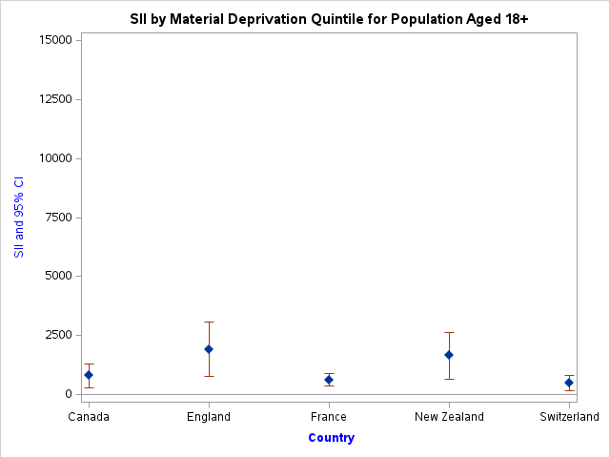
Figure Legend:
SII – Slope Index of Inequality. Higher SII values indicate a greater difference in hospitalizations and a greater difference in the absolute equity gap.
CI – Confidence Interval

Figure X2: RII by Material Deprivation for 5 Countries Using the 9 Condition ACSC Definition (18+)

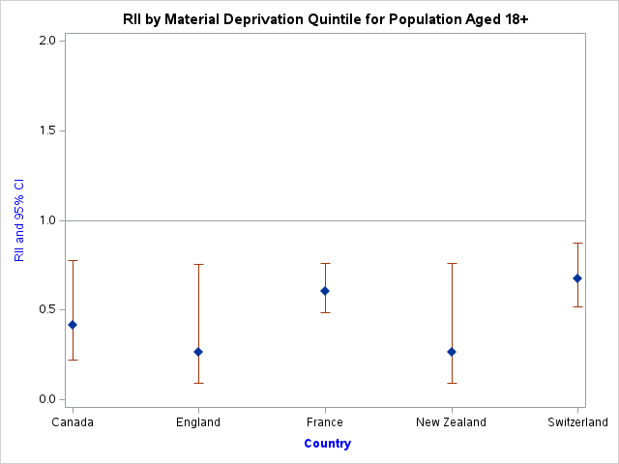
Figure Legend:
RII – Relative Index of Inequality. An RII value <1 indicates relative inequality between the lowest and highest income/deprivation quintiles, with smaller values (closer to 0) indicating the greatest relative inequality.
CI – Confidence Interval

Figure X3: SII by Material Deprivation for 7 Countries Using the 5 Condition ACSC Definition (65+)

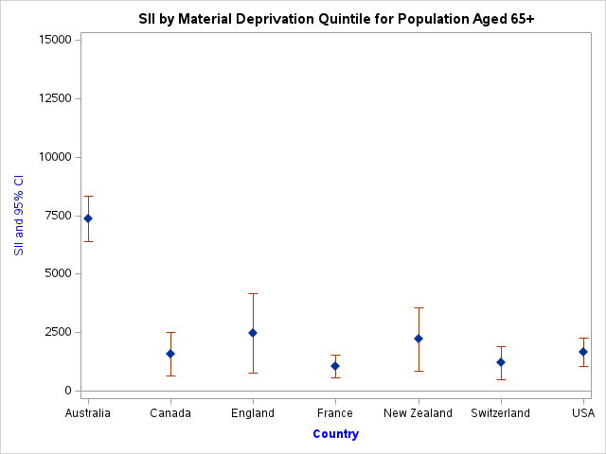
Figure Legend:
SII – Slope Index of Inequality. Higher SII values indicate a greater difference in hospitalizations and a greater difference in the absolute equity gap.
CI – Confidence Interval

Figure X4: RII by Material Deprivation for 7 Countries Using the 5 Condition ACSC Definition (65+)

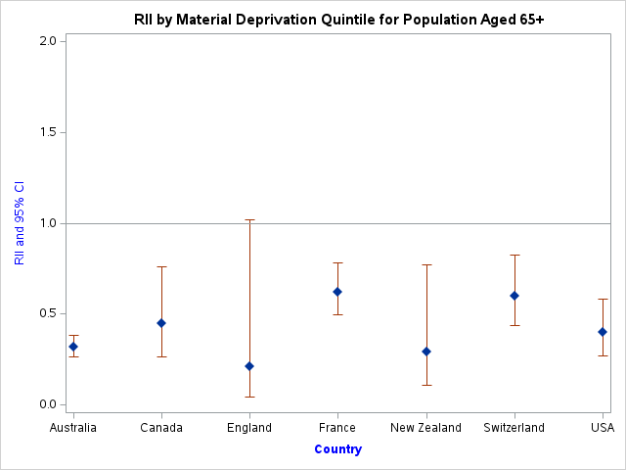
Figure Legend:
RII – Relative Index of Inequality. An RII value <1 indicates relative inequality between the lowest and highest income/deprivation quintiles, with smaller values (closer to 0) indicating the greatest relative inequality.
CI – Confidence Interval

Figure X5: SII by Material Deprivation for 7 Countries Using the 9 Condition ACSC Definition (65+)

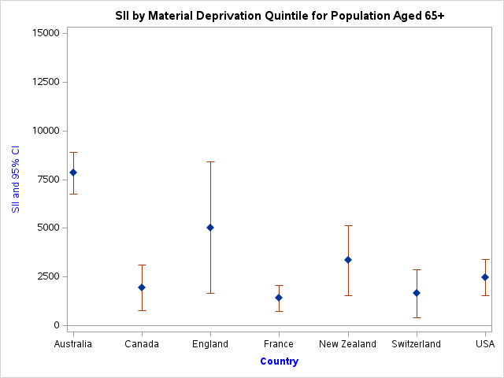
Figure Legend:
SII – Slope Index of Inequality. Higher SII values indicate a greater difference in hospitalizations and a greater difference in the absolute equity gap.
CI – Confidence Interval

Figure X6: RII by Material Deprivation for 7 Countries Using the 9 Condition ACSC Definition (65+)

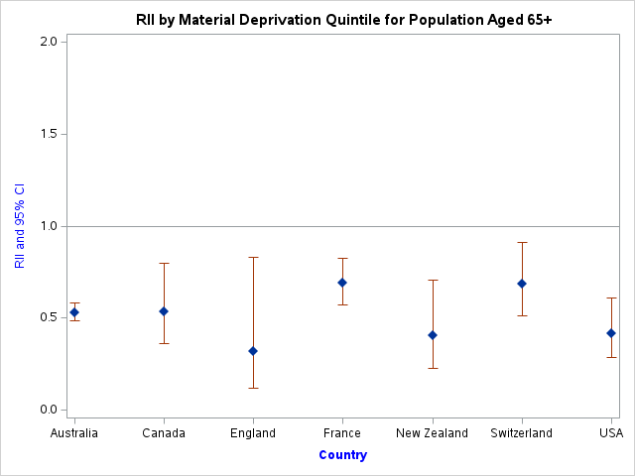
Figure Legend:
RII – Relative Index of Inequality. An RII value <1 indicates relative inequality between the lowest and highest income/deprivation quintiles, with smaller values (closer to 0) indicating the greatest relative inequality.
CI – Confidence Interval

