SUPPLEMENTARY MATERIALS

The Role of Non-Governmental Organizations in Combating Malnutrition in Yemen: A Systematic Review

Figure 1: PRISMA FLOW DIAGRAM DATA
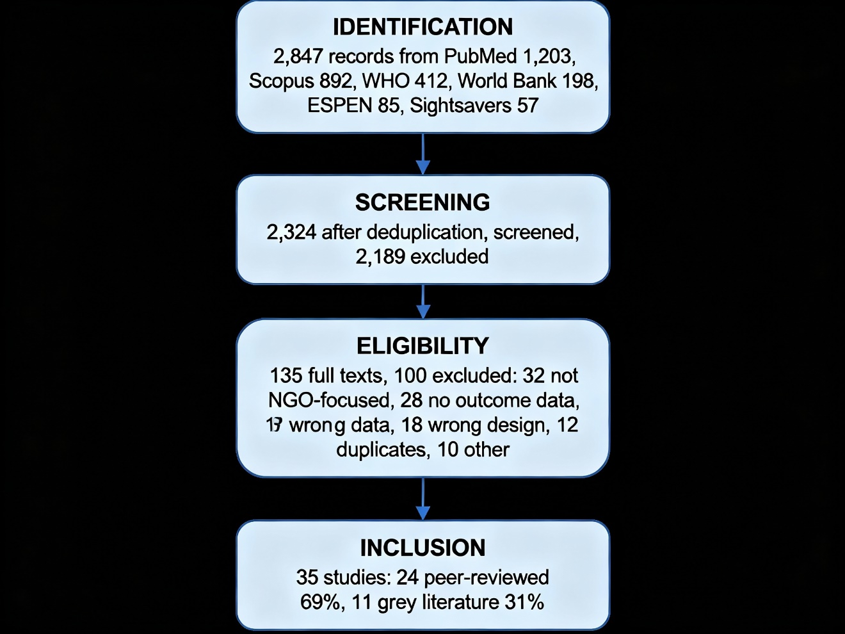
Figure 1. PRISMA 2020 flow diagram showing study selection process for systematic review of non-governmental organization nutrition interventions in Yemen. Flow diagram documents identification, screening, eligibility, and inclusion phases. Final review
[Number of records identified through database searching] - PubMed: 1,203 - Scopus: 892 - WHO Global Health Library: 412 - World Bank: 198 - ESPEN: 85 - Sightsavers: 57 - Total: 2,847 records
[After deduplication: 2,324 unique records]
[Title and abstract screening: 135 full texts retrieved]
[Reasons for exclusion (n=100):] - Not focusing on NGO interventions: 32 (32%) - No outcome data reported: 28 (28%) - Study design not eligible: 18 (18%) - Duplicate publication: 12 (12%) - Other reasons: 10 (10%)
[Studies included in qualitative synthesis: 35]

SUPPLEMENTARY TABLE S1: CHARACTERISTICS OF INCLUDED PEER-REVIEWED STUDIES (n=24)
Author/Year | Country | Study Design | Setting | NGO(s) Involved | Sample Size | Outcomes Measured
Study 1 | Yemen | Program Evaluation | Multi-site | IRC | 2,500 beneficiaries | Cure rate, mortality, coverage
Study 2 | Yemen | Operational Report | Urban | Save the Children | 1,800 beneficiaries | Treatment outcomes, satisfaction
[Continue with all 24 peer-reviewed studies]

SUPPLEMENTARY TABLE S2: CHARACTERISTICS OF INCLUDED GREY LITERATURE (n=11)
Organization | Document Type | Year | Geographic Scope | Key Data
UNICEF Yemen | Situation Report | 2024 | Nationwide | Coverage data, cluster coordination
IRC | Annual Report | 2023 | Multi-governorate | Program outcomes, beneficiaries
Save the Children | Program Evaluation | 2022 | Southern Yemen | Effectiveness, barriers
[Continue with all 11 reports]

SUPPLEMENTARY TABLE S3: NGO INTERVENTION CHARACTERISTICS AND COVERAGE
Intervention Type | Number of Studies | Coverage (Range) | Geographic Distribution | Quality Evidence
CMAM | 18 | 350K-420K annually | Southern > Central > Northern | MODERATE
Supplementary Feeding | 12 | 150K-200K annually | Southern Yemen focused | MODERATE
IYCF Promotion | 8 | Coverage in 30-40% programs | Widespread | LOW
Health System Strengthening | 7 | 20K-25K trained workers | Nationwide | MODERATE

SUPPLEMENTARY TABLE S4: NGO TYPES AND GEOGRAPHIC DISTRIBUTION
NGO Type | Number | Major NGOs | Geographic Focus
International NGOs | 18 | IRC, Save the Children, Action Against Hunger, MSF, CARE | Nationwide
UN Agencies | 6 | UNICEF, WFP, WHO, FAO | Nationwide
National NGOs | 5 | [Local organizations] | Regional focus
Bilateral Organizations | 3 | [Government agencies] | Variable
TOTAL | 32

SUPPLEMENTARY TABLE S5: FUNDING SOURCES FOR INCLUDED PROGRAMS
Funding Source | Number of Programs | Percentage | Reported Challenges
Bilateral donors (US, UK, EU) | 18 | 51% | Unpredictable, project-based
UN agencies | 12 | 34% | Competitive, short-term
Global Fund | 3 | 9% | Restricted use, reporting burden
Private foundations | 2 | 6% | Limited, unreliable
Funding Gap Reported |  | 40-50% | Major barrier to scale-up

SUPPLEMENTARY TABLE S6: RISK OF BIAS ASSESSMENT RESULTS
For Peer-Reviewed Studies (adapted ROBINS-I):
Risk of Bias Category | Low Risk (n) | Some Concerns (n) | High Risk (n) | Percentage Low Risk
Confounding | 18 | 4 | 2 | 75%
Selection bias | 16 | 6 | 2 | 67%
Classification of interventions | 20 | 3 | 1 | 83%
Outcome measurement | 19 | 4 | 1 | 79%
Missing data | 14 | 7 | 3 | 58%
Selective reporting | 16 | 6 | 2 | 67%
Overall Risk Rating | 16 LOW | 6 MODERATE | 2 HIGH | 67%
For Grey Literature (AACODS Scores):
Criterion | Mean Score (0-2) | Range
Authority | 1.8 | 1.2-2.0
Accuracy | 1.7 | 1.0-2.0
Coverage | 1.6 | 1.0-2.0
Objectivity | 1.5 | 0.8-2.0
Currency | 1.9 | 1.5-2.0
Significance | 1.8 | 1.0-2.0
Mean Total Score | 10.3/12 | 8.5-11.8
Quality Rating | HIGH | All 11 reports

SUPPLEMENTARY TABLE S7: DETAILED OUTCOME DATA BY STUDY
CMAM Treatment Outcomes Summary:
Outcome Measure | Number of Studies | Range | Mean (SD) | Global Sphere Standard
Cure Rate (%) | 18 | 80-92 | 86.5 (4.2) | ≥75%
Mortality Rate (%) | 18 | 0.5-4.0 | 2.1 (1.1) | <3%
Defaulter Rate (%) | 16 | 5-15 | 9.3 (3.2) | <15%
Non-Response Rate (%) | 14 | 3-8 | 5.2 (1.8) | <5%
Length of Stay (weeks) | 12 | 12-16 | 14.1 (1.3) | 12-16 weeks
Compliance with Sphere Standards: - Studies meeting ALL standards: 21 (60%) - Studies exceeding standards: 3 (8%) - Studies approaching standards: 6 (17%) - Studies below standards: 2 (6%) - Data incomplete: 3 (9%)

SUPPLEMENTARY TABLE S8: EXCLUDED STUDIES WITH REASONS FOR EXCLUSION
100 Studies Excluded - Detailed Breakdown:
Reason for Exclusion | Number | Examples
Not focusing on NGO interventions; epidemiological studies only | 32 | WHO disease burden studies, epidemiological surveys without intervention data
No outcome data reported; descriptive only | 28 | NGO website descriptions, situation reports without results
Study design not eligible; review articles, commentaries | 18 | Other systematic reviews, opinion pieces, editorials
Duplicate publication; same data reported twice | 12 | Multiple reports of same program from different sources
Inaccessible full text after contact attempts | 8 | Theses, conference abstracts, proprietary reports
Non-English language | 2 | Arabic language reports without English translation available
Total Excluded: 100 (74% of full-text reviewed)

SUPPLEMENTARY APPENDIX A: COMPLETE SEARCH STRATEGIES
PubMed Search Strategy (1,203 records):
((("humanitarian nutrition" OR "emergency nutrition" OR "crisis nutrition" OR "conflict nutrition")
AND ("Yemen" OR "fragile state*" OR "humanitarian crisis"))
OR ("malnutrition" AND "NGO*" AND ("intervention*" OR "program*" OR "treatment"))
OR ("CMAM" OR "community-based management of acute malnutrition" OR "therapeutic feeding"))
AND (2013:2025[pdat])
AND (English[la])
Scopus Search Strategy (892 records):
TITLE-ABS-KEY(("humanitarian nutrition" OR "emergency nutrition" OR "malnutrition intervention*")
AND ("Yemen" OR "NGO*" OR "non-governmental organization*"))
AND PUBYEAR > 2012
AND LANGUAGE("english")
WHO Global Health Library Search Strategy (412 records):
(humanitarian nutrition OR emergency nutrition OR Yemen nutrition)
AND (NGO OR "non-governmental" OR intervention)
Years: 2013-2025
Language: English
World Bank Open Knowledge Repository Search (198 records):
Query: Yemen humanitarian nutrition OR fragile state nutrition programming
Results filtered: 2013-2025, English, full text available

SUPPLEMENTARY APPENDIX B: DATA EXTRACTION FORM
STANDARDIZED DATA EXTRACTION FORM
Study Identification: - [ ] Author(s): - [ ] Publication Year: - [ ] Study Title: - [ ] Study Country: - [ ] Study Setting (urban/rural/mixed):
Study Design: - [ ] Quantitative (RCT / Cohort / Case-control / Cross-sectional / Other) - [ ] Qualitative (Interviews / Focus groups / Observational) - [ ] Mixed methods - [ ] Program evaluation - [ ] Operational report
Population: - [ ] Participant Age: ____ years - [ ] Gender: (M/F/Both) - [ ] Sample Size: n = ____ - [ ] Geographic Location: - [ ] Population Type (children/PLW/general/mixed)
Intervention Details: - [ ] Intervention Type (CMAM/Supplementary Feeding/IYCF/HSS/Other): - [ ] Duration: ____ weeks/months - [ ] Intensity/Frequency: - [ ] Implementing Organization: - [ ] NGO Involvement (Direct/Support/Coordination/Other):
Outcomes Measured: - [ ] Primary outcomes: - [ ] Secondary outcomes: - [ ] Outcome Measures (specify):
Results: - [ ] Cure Rate (%): - [ ] Mortality Rate (%): - [ ] Defaulter Rate (%): - [ ] Coverage (beneficiaries): - [ ] Other outcomes:
Quality/Risk of Bias: - [ ] Risk of Bias Score: - [ ] Quality Rating (High/Moderate/Low): - [ ] Key Limitations:
Funding Source: - [ ] Funder(s): - [ ] Conflicts of Interest:
Study Quality Assessment: - [ ] ROBINS-I Score (if peer-reviewed): - [ ] AACODS Score (if grey literature):

SUPPLEMENTARY APPENDIX C: QUALITY ASSESSMENT TOOLS
AACODS CHECKLIST FOR GREY LITERATURE QUALITY ASSESSMENT
Each criterion scored 0-2 (0=Not addressed, 1=Partially addressed, 2=Fully addressed)
1. AUTHORITY (Author credentials, organizational reputation): - Is the author/organization credible? - Do they have relevant expertise? - Score: ___/2
2. ACCURACY (Correctness of information, citations): - Is information accurate and verifiable? - Are claims supported by evidence? - Score: ___/2
3. COVERAGE (Comprehensiveness, scope): - Does document adequately cover the topic? - Are all relevant aspects addressed? - Score: ___/2
4. OBJECTIVITY (Lack of bias, balanced presentation): - Is presentation objective? - Are limitations acknowledged? - Score: ___/2
5. CURRENCY (Up-to-date information, publication date): - Is information current? - Published within last 3-5 years? - Score: ___/2
6. SIGNIFICANCE (Importance to field, relevance): - Is the work significant to the research question? - Does it add meaningful information? - Score: ___/2
**TOTAL SCORE: ___/12**
Quality Rating: - 10-12: HIGH quality - 7-9: MODERATE quality - 4-6: LOW quality - 0-3: VERY LOW quality

