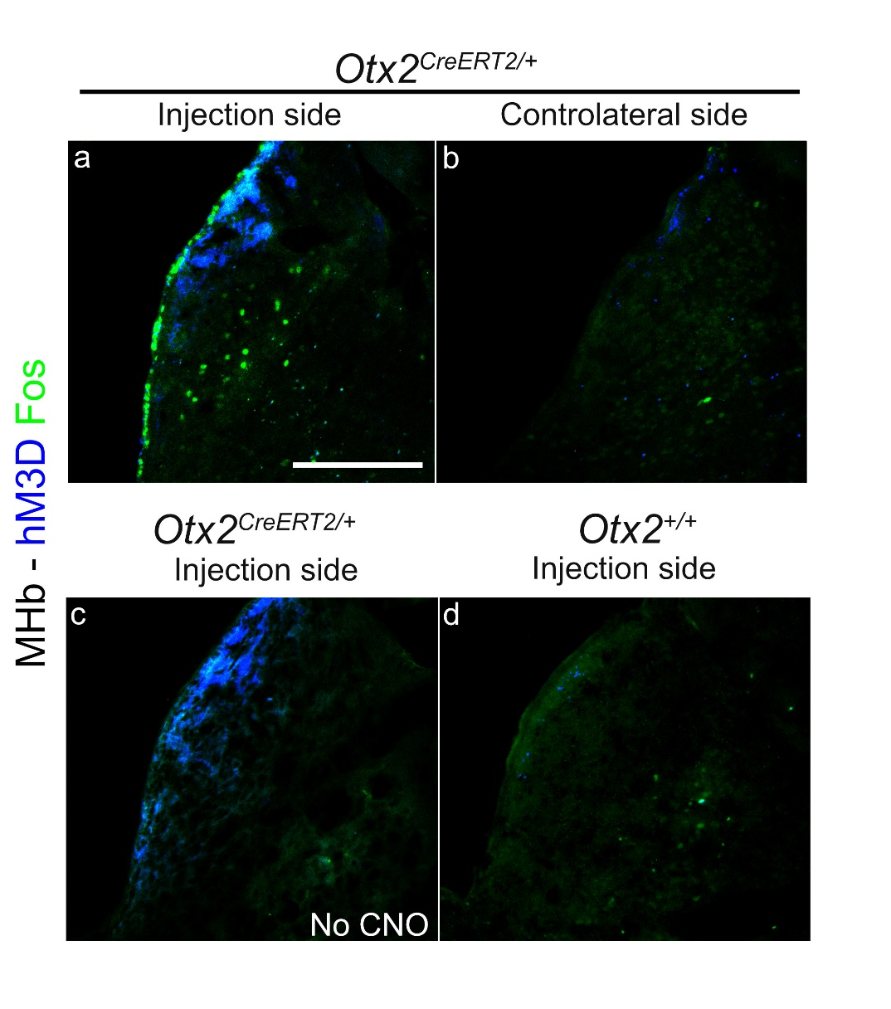

Supplemental figure S1. Control experiments of Otx2^{High} neurons chemoactivation in the MHb. a-d, Labelling of coronal sections at the level of the MHb with hM3D-cherry (in blue) and anti-Fos antibodies (in green), in mice stereotaxically injected in the MHb in one side of the brain with viruses expressing the DREADDs. The injected side (a) and the controlateral side of the injection (b) in Otx2^{CreERT2/+} mice that have been injected with CNO (n=3) are shown. The injected side (c) in Otx2^{CreERT2/+} mice that did not receive CNO (n=3) is shown. The injected side in wild type mice that were injected with CNO (n=3) is shown. Scale bar : 100 µm.

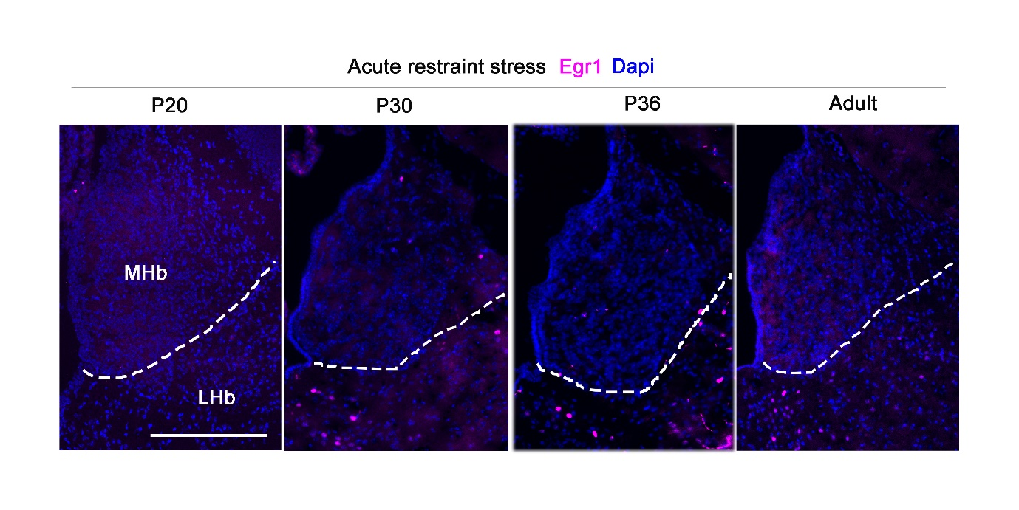
Supplemental figure S2. Effect of acute stress on neuronal activation in the MHb. Coronal sections at the level of the MHb stained with anti-Egr1 antibodies (in magenta) and DAPI staining (in blue) from brains collected at different developmental stages (from P20 to Adulthood) after an acute restraint stress. Scale bar : 100 µm.

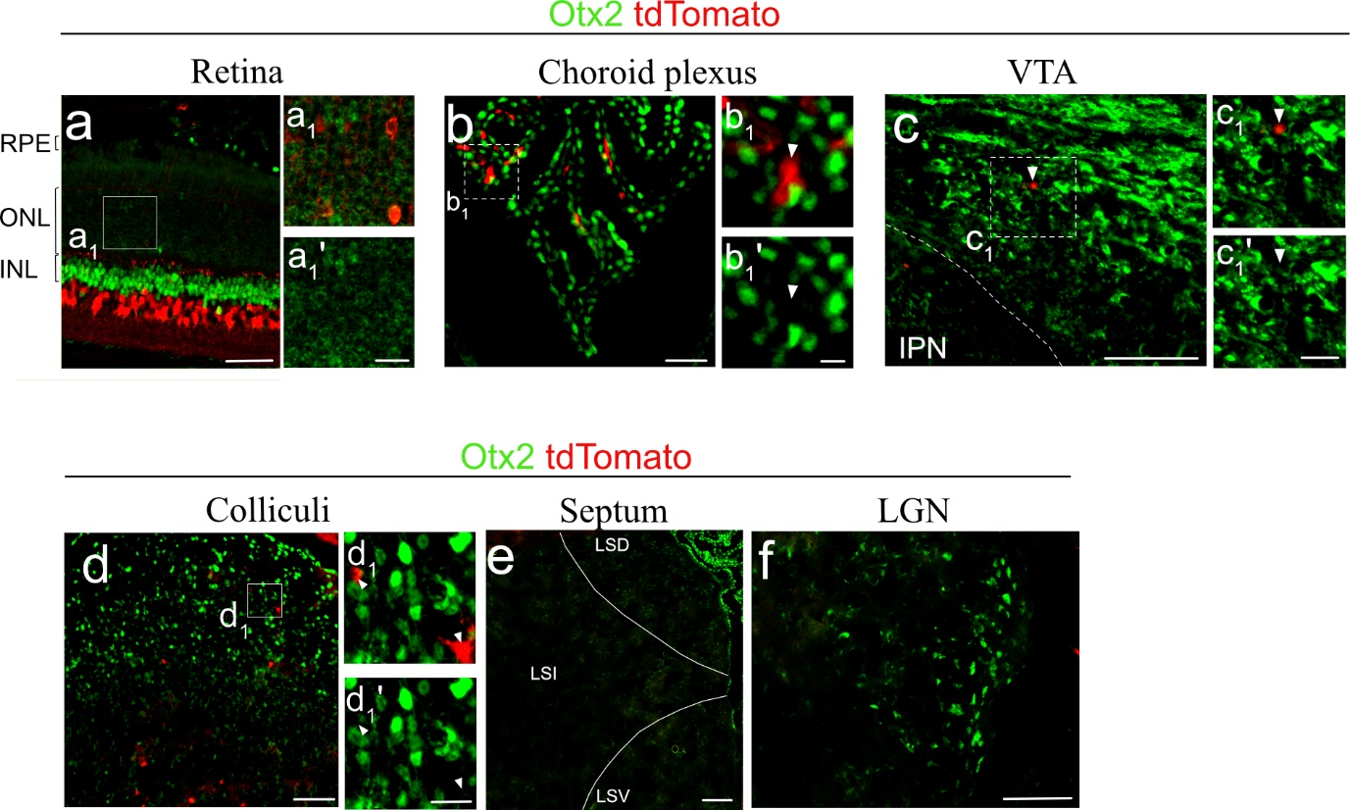

Supplemental figure S3. Regions expressing Otx2 and TdTomato in Otx2^{+/+};Ngn1Cre^{ERT2} ;Ai14/Ai14 mice. a-f, Labelling with anti- Otx2 antibodies (in green) and tdTomato (in red) of retina sections (a), coronal section of the choroid plexus (b), VTA (c), colliculi (d), septum (e) and LGN (f). a1-a1', b1-b1', c1-c1', d1-d1' Zoom on the area framed in a, b, c, and d, respectively. RPE: retinal pigmented epithelium. ONL: outer nuclear layer containing photorecepors. INL: inner nuclear layer containing bipolar cells. LSD: lateral septum dorsal part. LSI: lateral septum intermediate part. LSV: lateral septum ventral part. LGN: lateral geniculate nucleus. Scale bars: a-f = 100 µm; a1-d1' = 25 µm (shown in a1’-d1’).

