Figure 1. Theoretical–Analytical Framework Integrating Ethical AI, Strategic Knowledge Governance, and Sustainable Value Creation (Theoretical–Analytical Framework underpinning SEG-F (Figure 4).
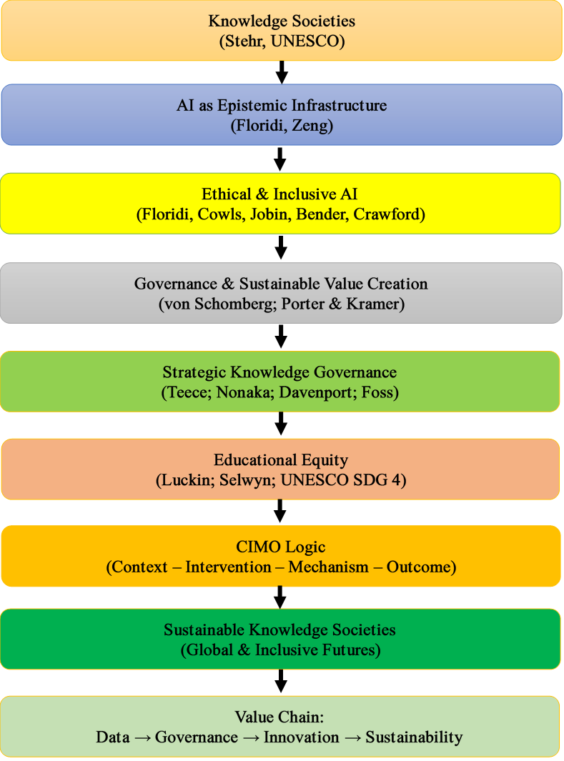

Figure 2. Studies Design Flow: PICo–PRISMA–CIMO Framework

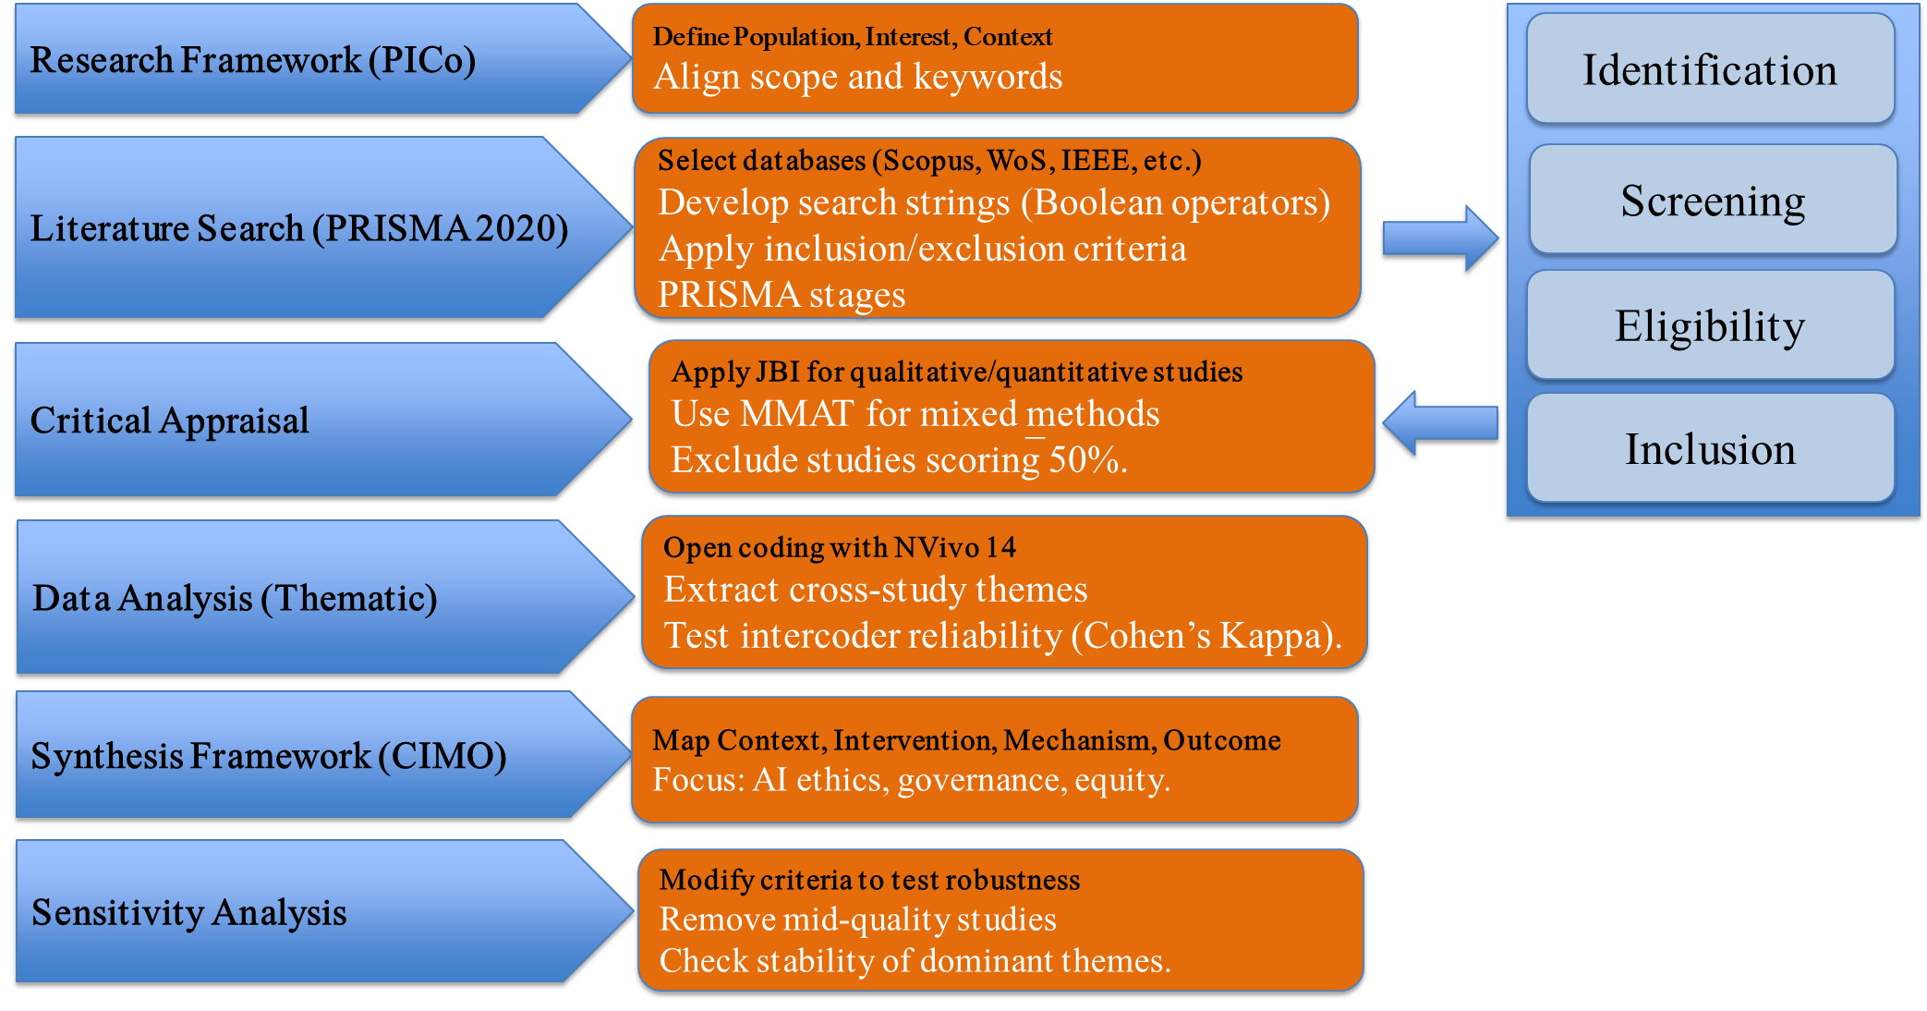

Figure 3. PRISMA Flow diagram.
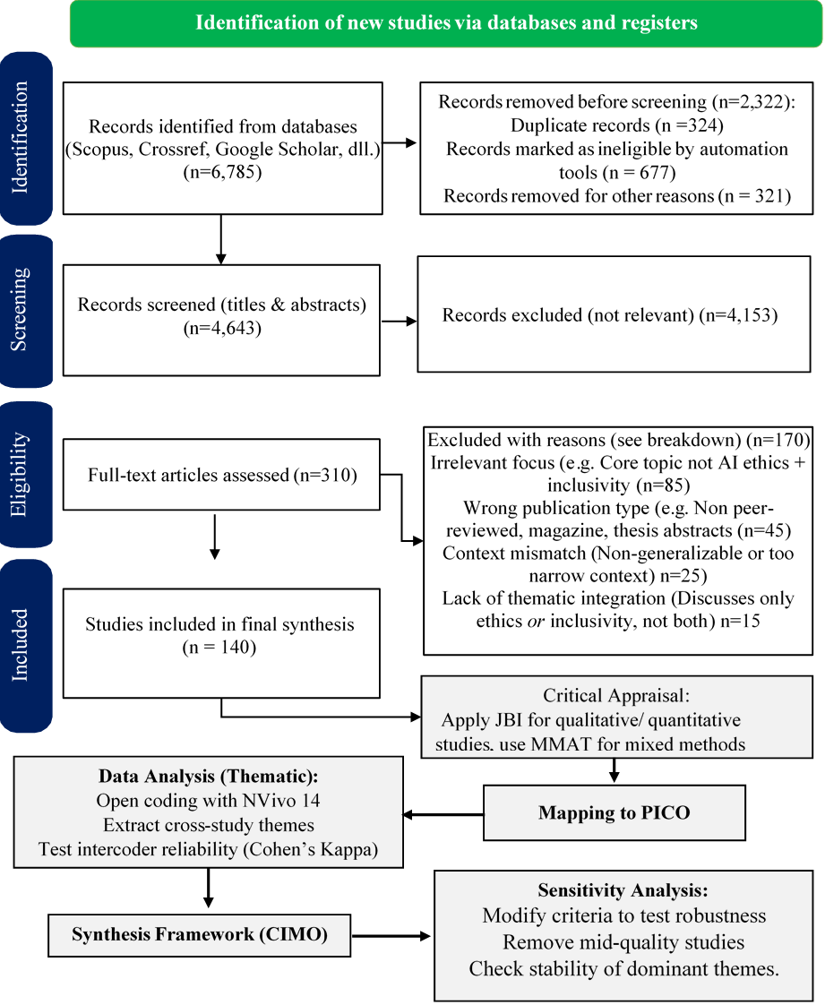

Figure 4. Strategic Ethical Governance Framework (SEG-F): Integrating Knowledge, Ethics, and Innovation toward Sustainable Value Creation.

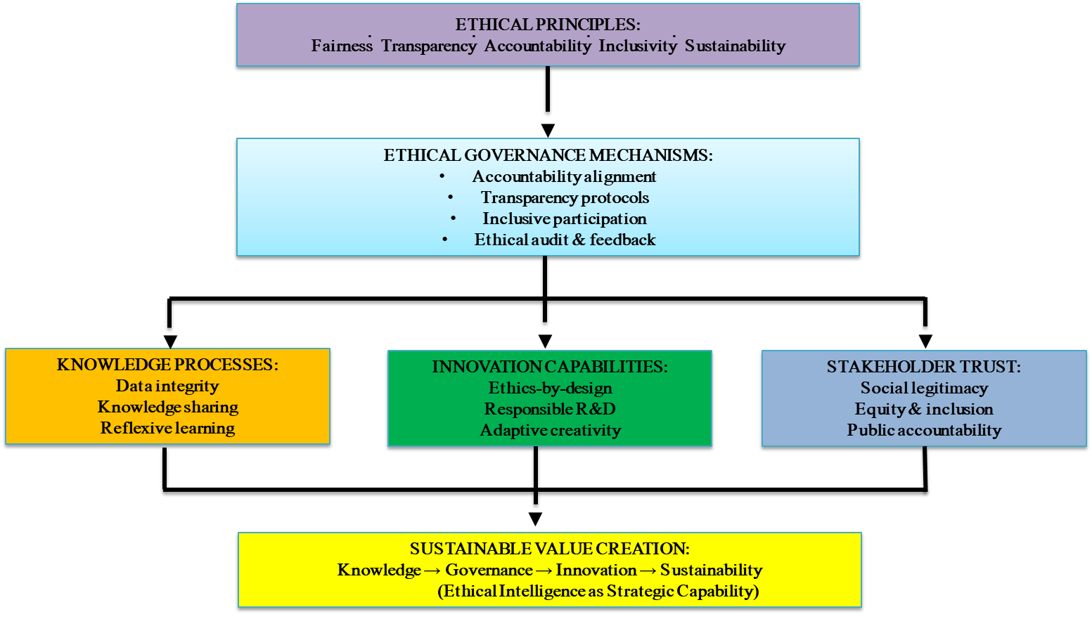

Figure 4. The Strategic Ethical Governance Framework (SEG-F) synthesizes the study’s thematic results into a dynamic model connecting ethical principles, governance mechanisms, organizational integration, and sustainability outcomes.
The framework illustrates how four interdependent mechanisms—Transparency–Trust, Accountability–Alignment, Inclusivity–Capability, and Sustainability–Value Creation—form a continuous governance cycle. This cycle links ethical AI with strategic knowledge management, enabling organizations to transform compliance obligations into innovation capacity and long-term societal value.
By embedding these mechanisms into the knowledge–governance–innovation–value continuum, SEG-F positions ethical AI as both a managerial capability and a strategic resource for sustainable knowledge societies.

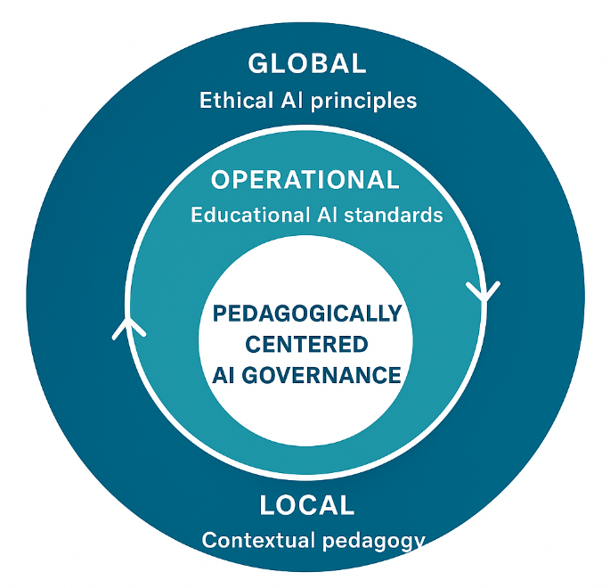

Figure 5. Integrated Framework: From Pedagogically-Centred AI Governance (PCAG) to Sustainable Educational Governance Framework (SEG-F)
This integrative model illustrates the continuum between pedagogical micro-level governance and global macro-level coherence in ethical AI for education. The Pedagogically-Centred AI Governance (PCAG) model anchors ethics within teaching, learning, and capacity-building processes, positioning pedagogy as the operational core of ethical inclusion. These pedagogical mechanisms feed into the Sustainable Educational Governance Framework (SEG-F), which aligns technical, regulatory, and participatory infrastructures across global, sectoral, and local levels. Together, the two frameworks form a dynamic governance learning system that operationalises Floridi’s concept of the infosphere and Sen’s capability approach—transforming ethical AI from normative abstraction into an actionable architecture for sustainable knowledge societies.

