supplementary-original figures

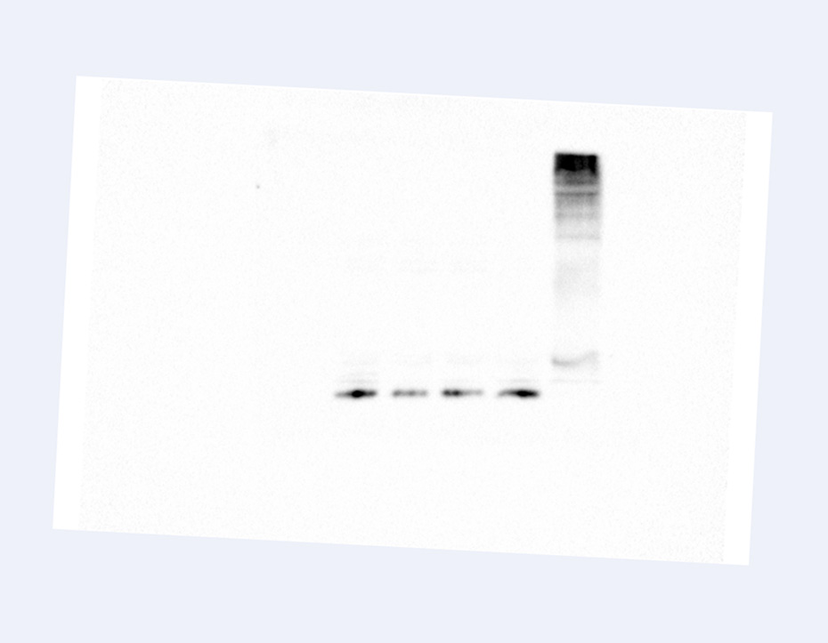
Fig.s1 original figure used in figure 7A (Anti-ubiquitin)

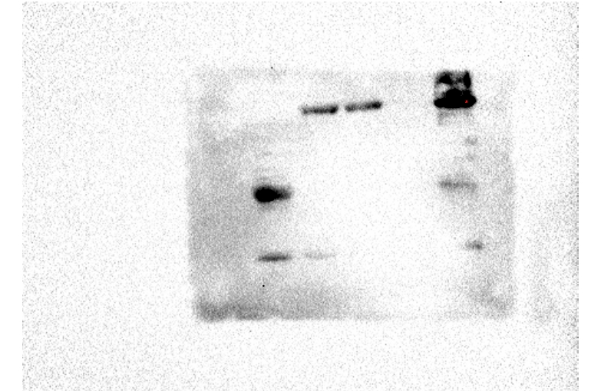
Fig.s2 original figure used in figure 7A (Anti-MBP)

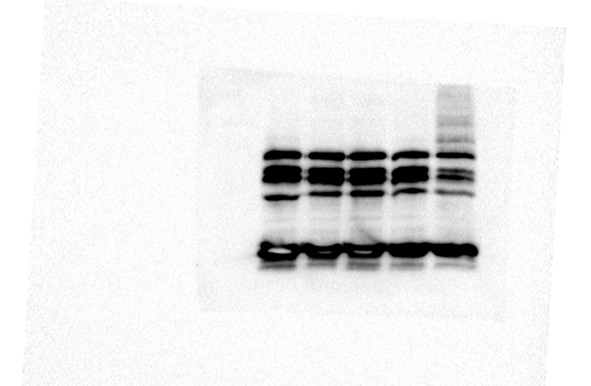
Fig.s3 original figure used in figure 7A (Anti-GST)

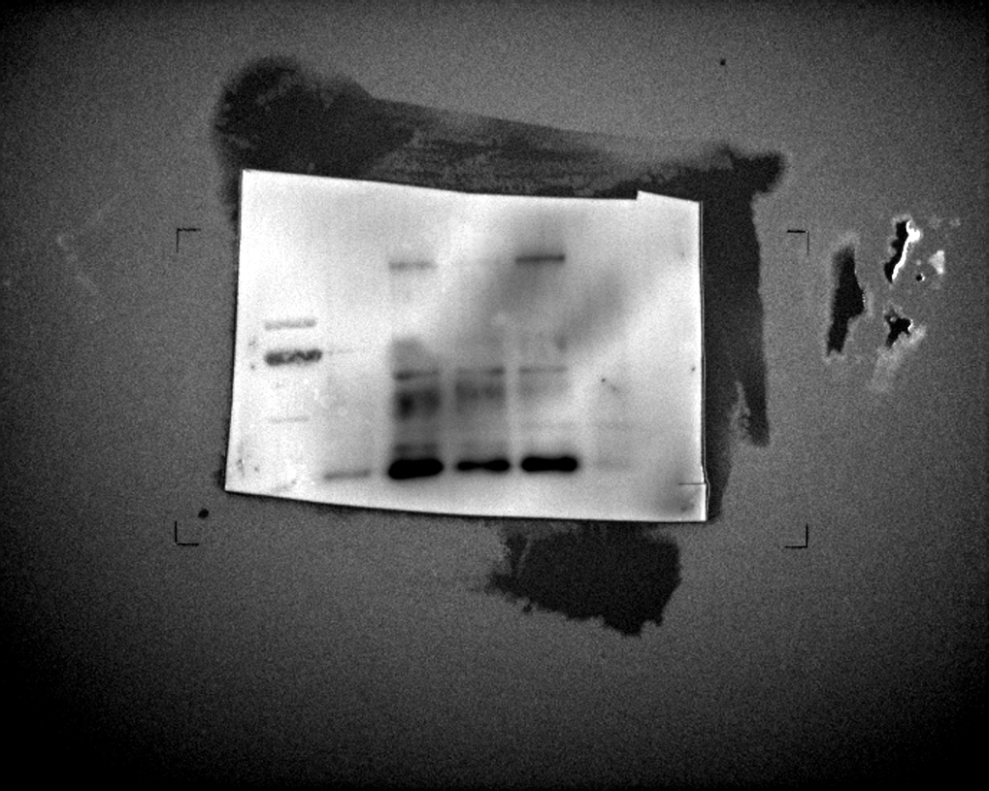
Fig.s4 original figure used in figure 7C (Anti-His)

Fig.s5 original figure used in figure 7C (Anti-GFP)

Fig.s6 original figure used in figure 7C (Anti-actin)

Fig.s7 original figure used in supplementary figure S4
CA：bacterial lysate before IPTG induction；CB：bacterial lysate after IPTG induction；down：pellet after cell lysis and centrifugation；up：supernatant after cell lysis and centrifugation；C：flow-through from purification column； E1：first elution buffer of GST-HcWRKY1 E2：second elution buffer of GST-HcWRKY1.

Fig.s8 original figure used in supplementary figure S5
M：marker；CA：bacterial lysate before IPTG induction；CB：bacterial lysate after IPTG induction；down：pellet after cell lysis and centrifugation；up：supernatant after cell lysis and centrifugation；C：flow-through from purification column；W1： first column wash buffer；W2：second column wash buffer；E1：first elution buffer of MBP-HcPUB30；E2：second elution buffer of MBP-HcPUB30.

