Supplementary figures
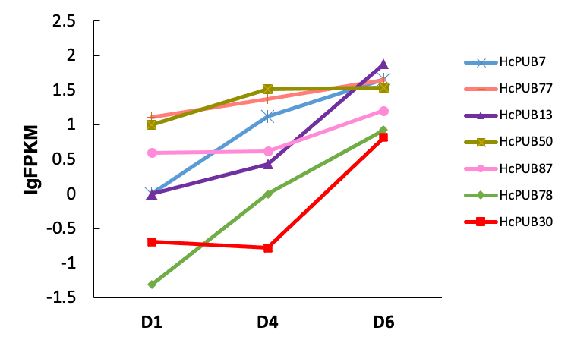
Fig. S1 Transcriptome expression level of candidate HcPUBs at different stages
D1 (bud stage), D4 (full-bloom stage), and D6 (senescence stage).

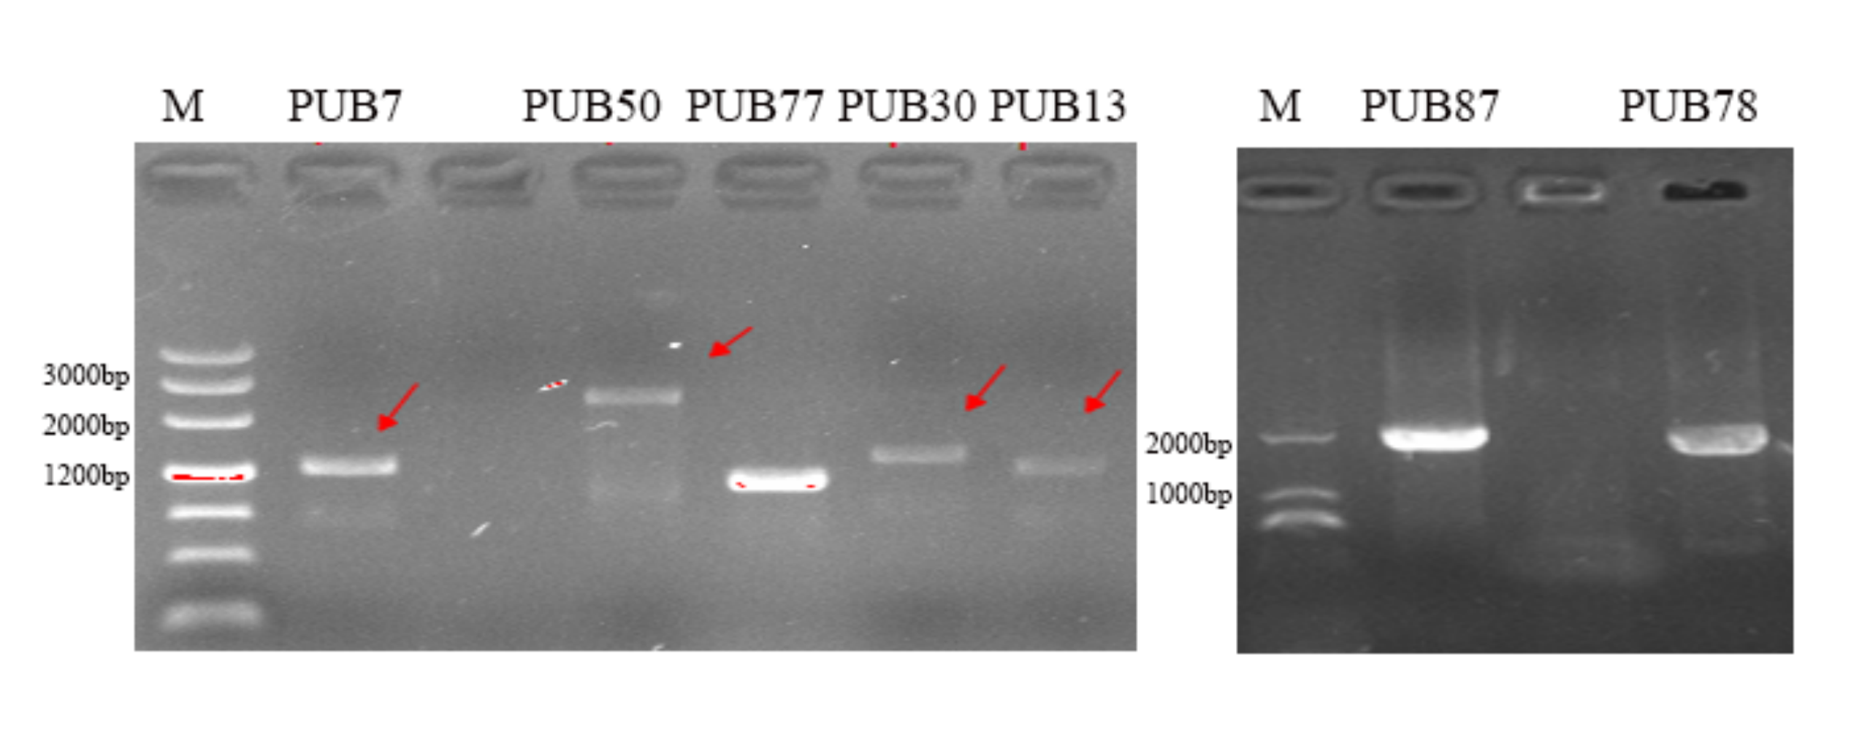
Fig. S2 Gene cloning of seven candidate HcPUBs
M: maker. Red arrows indicate the correct fragments of HcPUB7, HcPUB50, HcPUB30 and HcPUB13.

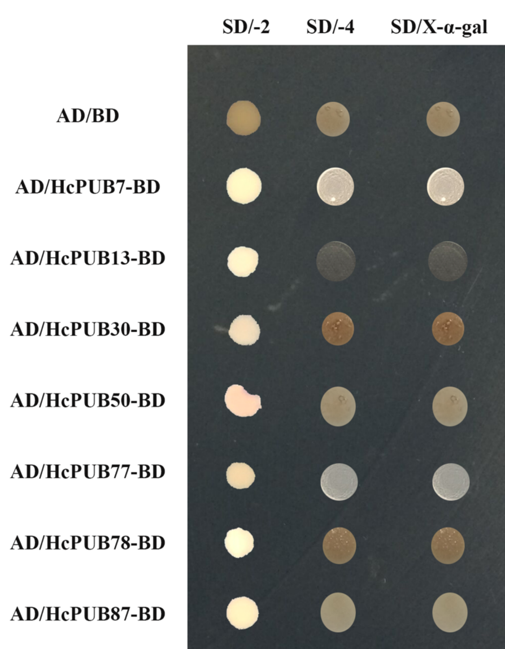
Fig. S3 Self-activation assay of seven candidate HcPUBs in yeast cell

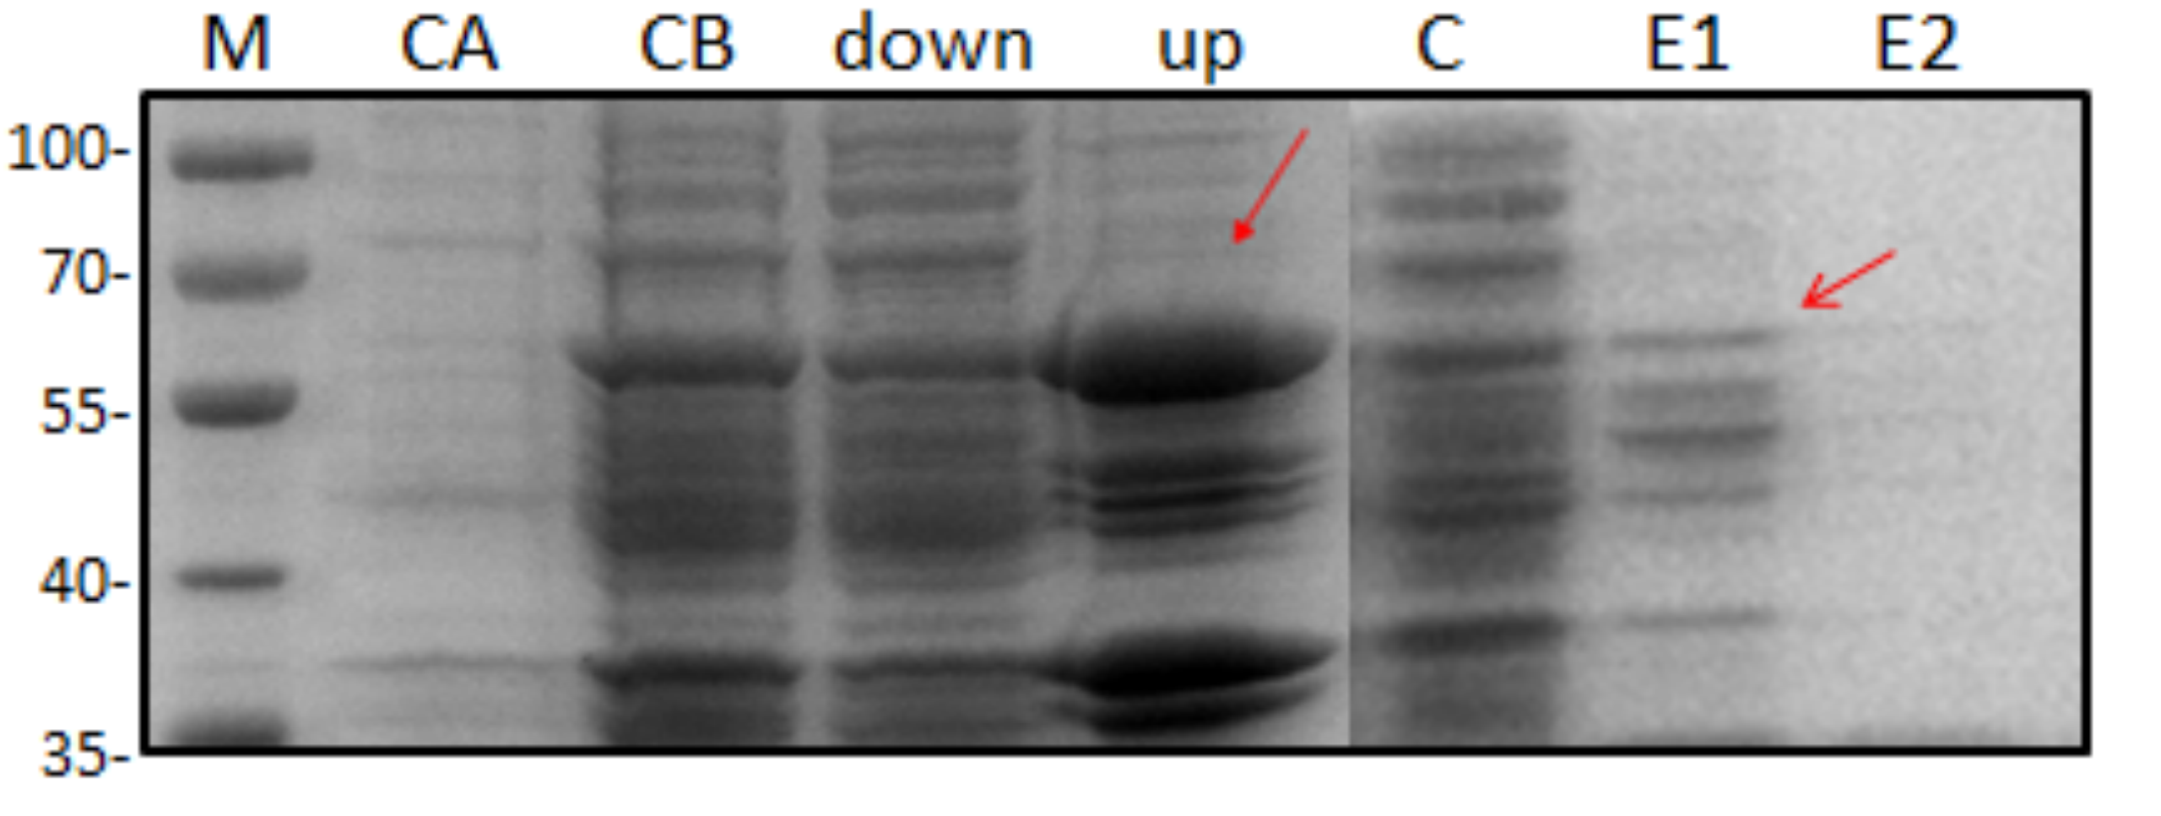
Fig. S4 GST-HcWRKY1 protein purification in vitro
M：marker；CA：bacterial lysate before IPTG induction；CB：bacterial lysate after IPTG induction；down：pellet after cell lysis and centrifugation；up：supernatant after cell lysis and centrifugation；C：flow-through from purification column；W1： first column wash buffer；W2：second column wash buffer；E1：first elution buffer of GST-HcWRKY1 E2：second elution buffer of GST-HcWRKY1.
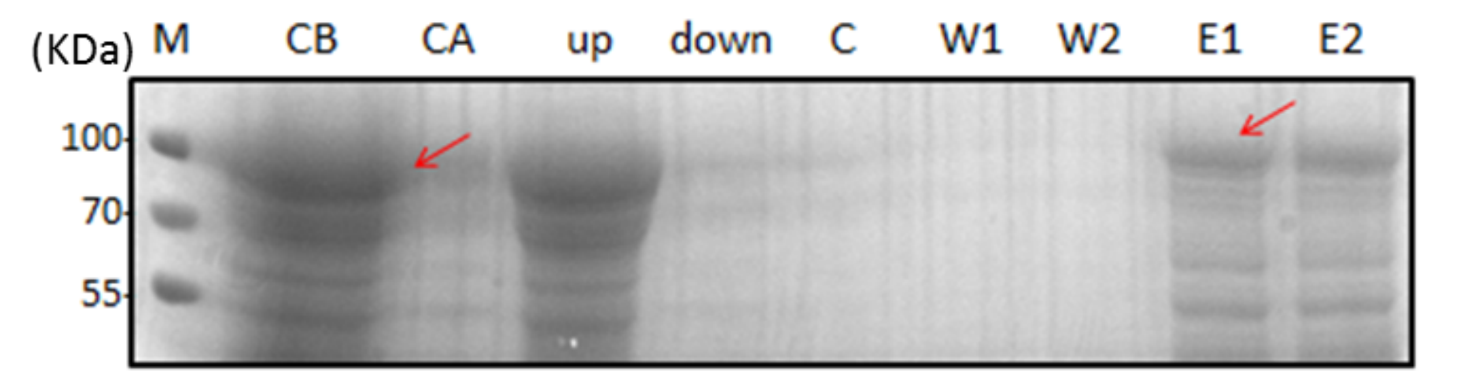
Fig. S5 MBP-HcPUB30 protein purification in vitro
M：marker；CA：bacterial lysate before IPTG induction；CB：bacterial lysate after IPTG induction；down：pellet after cell lysis and centrifugation；up：supernatant after cell lysis and centrifugation；C：flow-through from purification column；W1： first column wash buffer；W2：second column wash buffer；E1：first elution buffer of MBP-HcPUB30；E2：second elution buffer of MBP-HcPUB30.

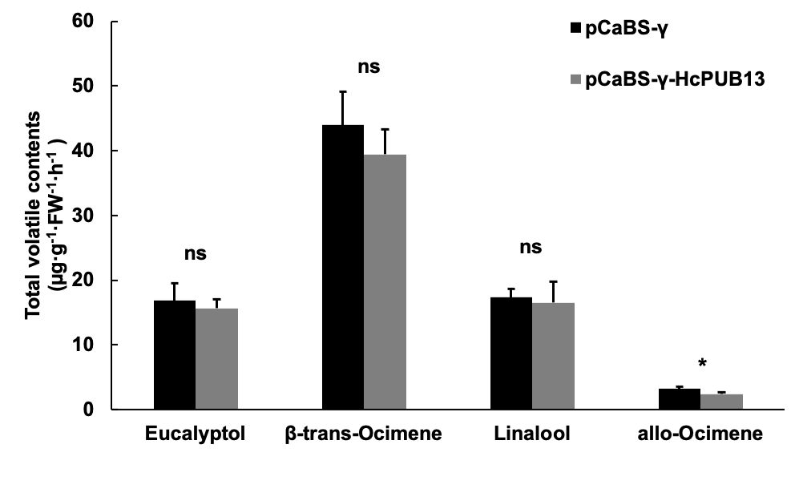
Fig. S6 Analysis of volatiles content in HcPUB13 transient silencing and control petals
Values represent the means+SD (n=3). Significant difference between data were analyzed with Student’s t-test. ns, not significant; *, P<0.05.

