Supporting Information
Overcoming the conversion-selectivity trade-off in plasma catalytic conversion of methane to ethylene
Zitong Zhang^{a#}, Youran Wang^{b#}, Liujia Zhangª, Zhendong Liu^{b*}, Weiming Wan^{a*}

a College of Chemistry and Chemical Engineering, Lanzhou University, Lanzhou 730000, China
b State Key Laboratory of Chemical Engineering and Low-carbon Technology, Department of Chemical Engineering, Tsinghua University, Haidian District, Beijing 100084, China
# The author contributes equally

Supplementary Methods
Materials. Tetraethyl orthosilicate (TEOS, 98 wt.%) was obtained from Sinopharm Chemical Reagent Co., Ltd. Tetrabutylphosphonium hydroxide (TBPOH, 40 wt.%) was purchased from TCI Chemicals Co., Ltd. HS-40 colloidal silica (40wt.% suspension in H₂O) was purchased from Sigma-Aldrich. It was dried and calcined into a solid before being used. Silica sand (80-120 mesh and 120-150 mesh) was purchased from Macklin Inc. Ar(99.99%), CH₄(99.99%), H₂(99.99%), and D₂(99.9%) were high purity. All chemicals were used as received without further purification.

Hydroxyl Group Removal Experiment. A U-shaped quartz tube replaced the straight version, and the catalyst was packed to a height of 1.5 cm. The Ar flow of 40 mL/min was maintained, and the temperature was raised from ambient to 700 °C at 10 °C/min, then to 900 °C at 5 °C/min, then held at 900 °C for 90 minutes to remove surface hydroxyls. After cooling to room temperature, the feed gas was switched to 6 % CH₄. After the flow had stabilized, the plasma was initiated.

H₂O-TPD. Temperature-programmed desorption of H₂O (H₂O-TPD) was performed using a fixed-bed microreactor setup. In the experiment, 50 mg of catalyst was placed in the quartz tube and heated from 150 to 900 °C at 10 °C/min under flowing Ar (40 mL/min). The desorbed species were analyzed in real-time using an online mass spectrometer (MS, Shanghai Accurate MLS211). The desorption of H₂O was confirmed by monitoring the signal at amu18.

Hydrogenation Experiment. To sharpen the conversion and selectivity trends, the plasma input power was fixed at 10 W. The total flow was kept at 60 mL/min with 6 % CH₄, and H₂ was stepped from 0% to 5% and 10%. Products were analyzed by on-line gas chromatography (Agilent 8890).

Supplementary Figures
Figure S1. Schematic diagram of the plasma-assisted catalytic reaction apparatus.

a
Figure S2. The reaction temperature measured by an infrared camera for (a) blank and (b) SiO₂ with an input power of 3 W.

Figure S3. Comparison of ethylene yield over different catalysts. Reaction conditions, 3 W input power, 60 ml/min total flow rate, 6% CH₄ in Ar, 25 °C, 1 atm.

Figure S4. Lissajous plots of Blank, silica sand, and SPP under conditions of an input power of 3 W, a total flow rate of 60 ml/min, and a CH₄ concentration of 6%.

Figure S5. (a) Gas chromatogram for co-injection of acetylene and ethylene; (b) Gas chromatogram for co-feeding of methane, ethylene, ethane, propylene, propane, butylene, and butane.

Figure S6. Carbon equilibrium for the reaction with SPP as catalyst. Reaction conditions: input power 3 W, total flow rate 60 ml/min, CH₄ concentration 6%

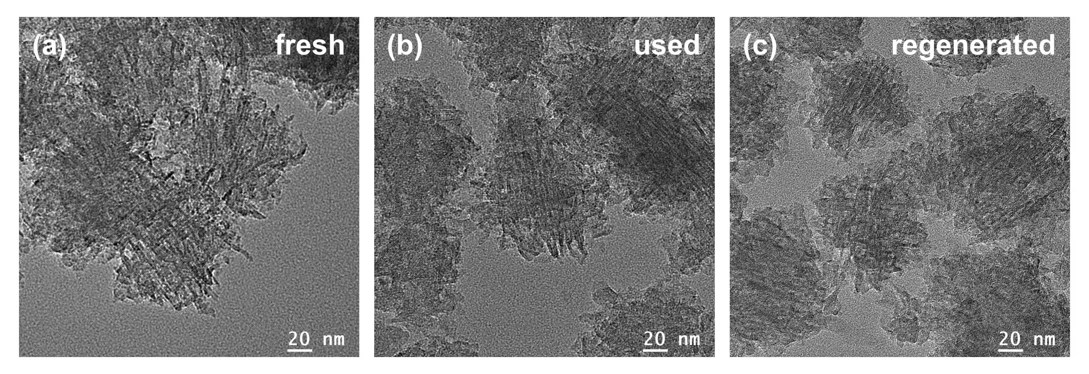
Figure S7. High-resolution transmission electron microscopy images of (a) fresh SPP, (b) reacted SPP and (c) O₂-plasma regenerated SPP.

Figure S8. Comparison of conversion and selectivity between H-ZSM-5 and De-aluminated zeolite. Reaction conditions: 3 W input power, 60 ml/min total flow rate, 6% CH₄ in Ar, 25 °C, 1 atm.

Figure S9. N₂ adsorption and desorption isotherms.

Figure S10. H₂O-TPD profiles of HS-40 and SPP.
Hydrogen Temperature Programmed Desorption (H₂-TPD) was conducted from 150 ℃ to 900 ℃ at a heating rate of 10 ℃/min. The results revealed the dehydroxylation temperatures of HS-40 and SPP are approximately 300 ℃ and 400 ℃.

Figure S11. FTIR spectra of the surface species formed on tungsten mesh by plasma-assisted non-oxygen coupling of methane. A mixture of 10 mL/min CH₄ and 40 mL/min Ar was fed for 10 minutes under plasma treatment.

Figure S12. Ethylene yield of blank and SPP at different input powers (3 W, 8 W), pressures (1 bar, 0.45 bar), total flow rates (60 ml/min, 22.5 ml/min) and CH₄ concentrations (6%, 2%).

Table S1. Comparison of the reported catalysts for CH₄ conversion to C₂H₄ products.
Catalysts | Reaction conditions |  | CH₄  conversion（%） | C₂H₄  Selectivity (%) | C₂H₄  yield (%) | Ref
Catalysts | Type | Power (W) or temperature (K)
SPP | DBD | 3 | 10.1 | 58.8 | 5.9 | This work
SPP | DBD | 8 | 56.6 | 71.1 | 40.2 | This work
MFM-300(Fe) | DBD | 2 | ＜3 | 96  (C₂H₄+C₂H₂) | 1.2  (C₂₊) | ¹
WMO/m-SiO₂ | DBD | 17 | 39 | 42.3 (C₂H₄+C₂H₂) | 16.5  (C₂H₄+C₂H₂) | ²
α-Al₂O₃ | DBD | 44.1 | 55 | 7 | 3.85 | ³
Sea sand | DBD | 43 | 55 | 5 | 2.75 | ³
KIT-6 | DBD | 39 | 20 | 14 | 2.80 | ³
NaY | sliding arc | 6.5 | 40 | 4 | 1.6 | ⁴
CuO/CeO₂ | DBD | 15-16 | ~8 | 36.1 | ~2.9 | ⁵
14 wt%Pd/γ-Al₂O₃ | DBD | 2.8 | 32.5 | 6 | 1.95 | ⁶
8 wt%Pt/γ-Al₂O₃ | DBD | 14.2 | 12 | 11 | 1.3 | ⁷
5 wt%Pd/γ-Al₂O₃ | DBD | 7-8 | 52 | 2.1 | 1.09 | ⁸
Fe@SiO₂ | thermal | 1363 | 48.1 | 48.4 | 23.3 | ⁹
Pt1Sn2/H-ZSM-5 | thermal | 973 | 0.5 | 80 | 0.4 | ¹⁰
Pt/CeO₂ | thermal | 1180 | 14.4 | 50 | 7.2 | ¹¹

References
1. Ma, Y. et al. Direct Conversion of Methane to Ethylene and Acetylene over an Iron-Based Metal–Organic Framework. J. Am. Chem. Soc. 145, 20792-20800 (2023).
2. Lu, C. et al. Shielded bifunctional nanoreactor enabled tandem catalysis for plasma methane coupling. Nat. Commun. 16, 4585 (2025).
3. Kim, J. et al. Effects of dielectric particles on non-oxidative coupling of methane in a dielectric barrier discharge plasma reactor. Chem. Eng. J. 377, 119896 (2019).
4. Liu, C.-j., Mallinson, R. & Lobban, L. Nonoxidative Methane Conversion to Acetylene over Zeolite in a Low Temperature Plasma. J. Catal. 179, 326-334 (1998).
5. Liu, R. et al. Plasma-driven non-oxidative coupling of methane to ethylene and hydrogen at mild temperature over Cu_{x}O/CeO₂ catalyst. J. Catal. 440, 115810 (2024).
6. García-Moncada, N., van Rooij, G., Cents, T. & Lefferts, L. Catalyst-assisted DBD plasma for coupling of methane: Minimizing carbon-deposits by structured reactors. Catal. Today 369, 210-220 (2021).
7. Jo, S., Kim, T., Lee, D.H., Kang, W.S. & Song, Y.-H. Effect of the Electric Conductivity of a Catalyst on Methane Activation in a Dielectric Barrier Discharge Reactor. Plasma Chem. Plasma Process. 34, 175-186 (2013).
8. Taheraslani, M. & Gardeniers, H. Plasma Catalytic Conversion of CH₄ to Alkanes, Olefins and H₂ in a Packed Bed DBD Reactor. Processes 8, 774 (2020).
9. Guo, X. et al. Direct, Nonoxidative Conversion of Methane to Ethylene, Aromatics, and Hydrogen. Science 344, 42-45 (2014).
10. Gerceker, D. et al. Methane Conversion to Ethylene and Aromatics on PtSn Catalysts. ACS Catal. 7, 2088-2100 (2017).
11. Zhang, H. et al. Pt/CeO₂ as Catalyst for Nonoxidative Coupling of Methane: Oxidative Regeneration. J. Phys. Chem. Lett. 14, 6778-6783 (2023)

