Supplementary Information

Dysregulation of human ClpP using small molecules with piperazine-based scaffold for diffuse intrinsic pontine glioma therapy validated by patient-derived tumor organoids
Morena Miciaccia¹, Domenico Armenise¹, Olga Maria Baldelli¹, Anselma Liturri¹, Mariachiara Mammone², Giovanni Graziano², Marialessandra Contino², Francesca Rizzo³, Paola Loguercio Polosa³, Francesco Bruni³, Clémence Deligne⁴, Laura Broutier⁴, Gianfranco Cavallaro⁵, Cosimo Gianluca Fortuna⁵, Anna Tolomeo⁶, Cadell Green⁷, Alessandro Bonifazi⁷, Emily Majaesic⁸, Marim M. Barghash⁹, Nok Pang Josh Lee⁹, Walid A. Houry^{8,9}, Carmen Gratteri¹⁰, Carmine Talarico¹¹, Silvana Filieri¹², Giuseppe Micalizzi¹³, Danilo Donnarumma¹³, Paola Dugo^{13,14}, Luigi Mondello^{13,14}, Annamaria Sardanelli¹², Javad Nazarian¹⁵, Savina Ferorelli¹, Maria Grazia Perrone^{1*}, Antonio Scilimati^{1*}

¹Research Laboratory for Woman and Child Health, Department of Pharmacy - Pharmaceutical Sciences, University of Bari “Aldo Moro”, 70125 Bari, Italy;
²Department of Pharmacy - Pharmaceutical Sciences, University of Bari “Aldo Moro”, 70125 Bari, Italy;
³Department of Biosciences, Biotechnologies and Environment, University of Bari “Aldo Moro”, 70125 Bari, Italy;
⁴Childhood Cancer & Cell Death Team (C3 Team), Consortium South-ROCK, LabEx DEVweCAN, Institut Convergence Plascan, Centre Léon Bérard, Centre de Recherche en Cancérologie de Lyon (CRCL), Université Claude Bernard Lyon 1, INSERM 1052, CNRS 5286, 69008 Lyon, France;
⁵Laboratory of Molecular Modelling and Heterocyclic Compounds ModHet, Department of Chemical Sciences, University of Catania, 95125 Catania, Italy;
⁶ITELPHARMA, ITEL Telecomunicazioni S.R.L., 70037 Ruvo di Puglia, Italy;
⁷Department of Pharmacology and Toxicology, Center for Addiction Sciences and Therapeutics, University of Texas Medical Branch, Galveston, TX 77555, USA;
⁸Department of Chemistry, University of Toronto, Toronto, Ontario M5S 3H6, Canada;
⁹Department of Biochemistry, University of Toronto, Toronto, Ontario M5G 1M1, Canada;
¹⁰LIGHT S.c.a.r.l., 25123 Brescia, Italy;
¹¹Dompé Farmaceutici SpA, EXSCALATE, I-80131 Napoli, Italy;
¹²Department of Basic Medical Sciences, Neuroscience and Sense Organs, University of Bari “Aldo Moro”, 70124 Bari, Italy;
¹³Messina Institute of Technology c/o Department of Chemical, Biological, Pharmaceutical and Environmental Sciences, former Veterinary School, University of Messina, 98168 Messina, Italy;
¹⁴Chromaleont s.r.l., c/o Department of Chemical, Biological, Pharmaceutical and Environmental Sciences, former Veterinary School, University of Messina, 98168 Messina, Italy;
¹⁵Children's Research Center, University Children's Hospital Zurich, Zurich, Switzerland.

Content:
- ¹H NMR, ¹³C NMR and HPLC chromatograms of the target compounds.
- Table S1. Radioligand Binding Data for hD2R and hD3R.
- Table S2. Crystallographic data and refinement statistics
- Table S3. List of fatty acids detected in SH-SY5Y and SU-DIPG-36 cell lines untreated and treated with ONC201 and 26 (DA29).
- Table S4. List of lysophosphocholine (LPC), phoshocholine (PC), and sphingomyelin (SM) detected in SH-SY5Y and SU-DIPG-36 cell lines untreated and treated with ONC201 and 26 (DA29).
- Table S5. List of triglycerides (TGs) detected in SH-SY5Y and SU-DIPG-36 cell lines untreated and treated with ONC201 and 26 (DA29).
- Table S6. Choline-containing lipids identified in the SU-DIPG-36 and SH-SY5Y cell lines.
- Table S7. Triacylglycerols (TG) identified in SU-DIP-G36 and SH-SY5Y cell lines.
- Figure S1. FLAP analysis and Molecular docking with AutoDock Vina of 26 (DA29) and ZK53 (PDB code: 8HGK)
- Figure S2. Histograms relative to the percentage content of choline-containing lipids (LPCs, PCs and SMs).
- Figure S3. Histograms relative to the percentage content of TGs.

- ¹H NMR, ¹³C NMR and HPLC chromatograms of the target compounds and references

1,4-Bis(4-chlorobenzyl)piperazine 1 (DA1)
¹H-NMR (300 MHz, CDCl₃)
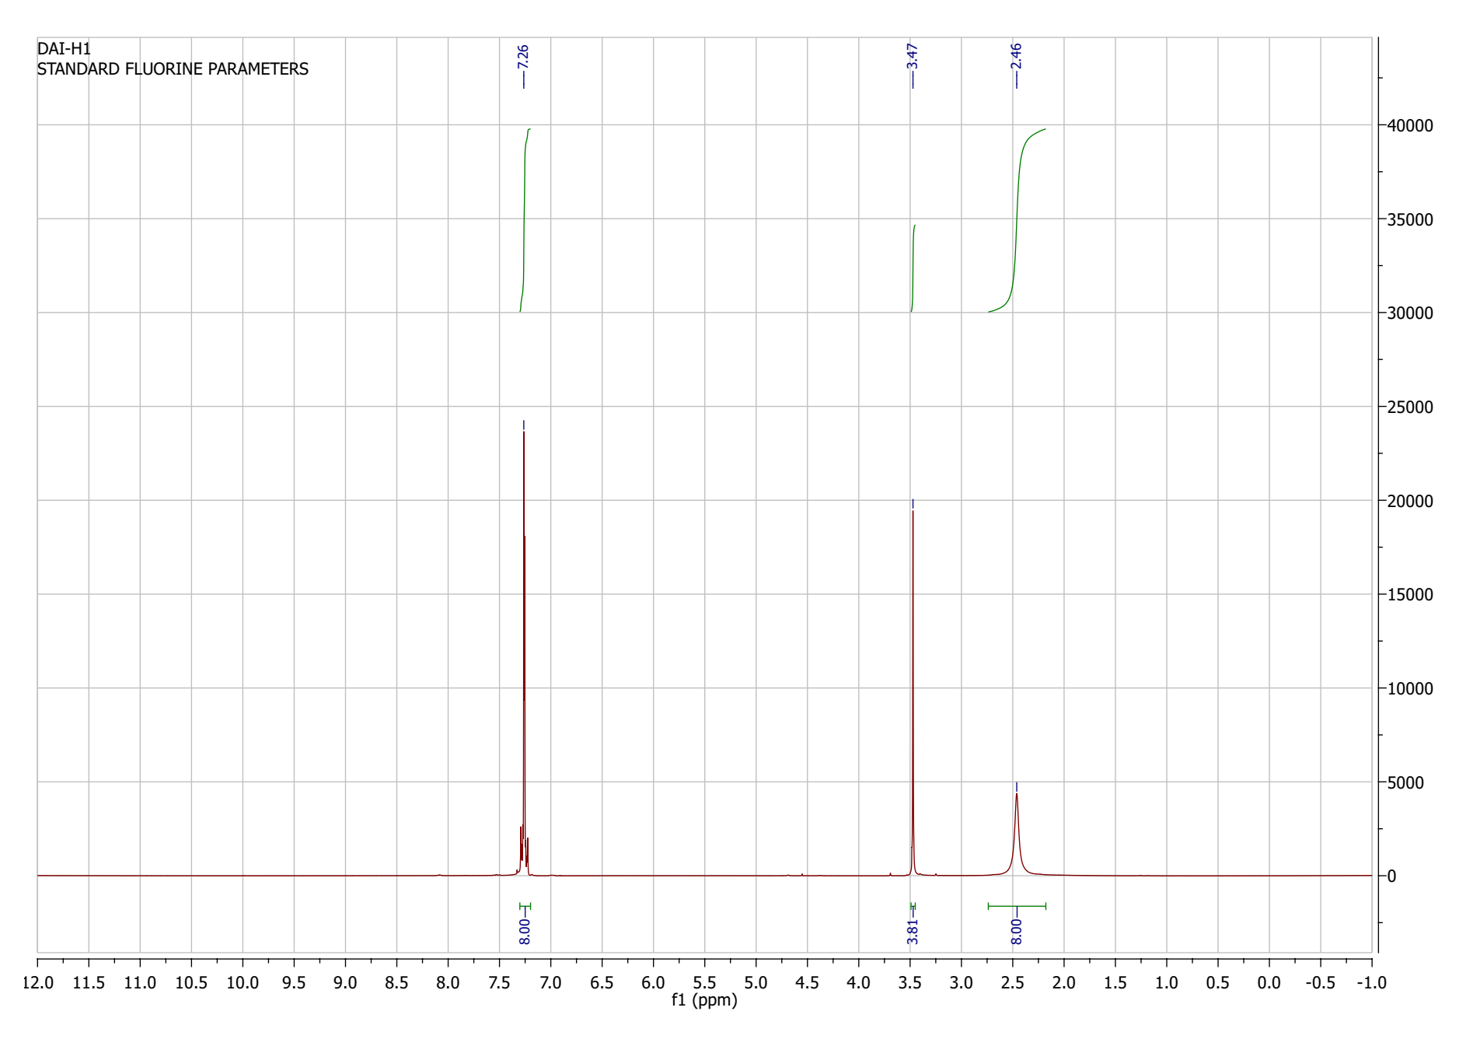

¹³C-NMR (125 MHz, CDCl₃)
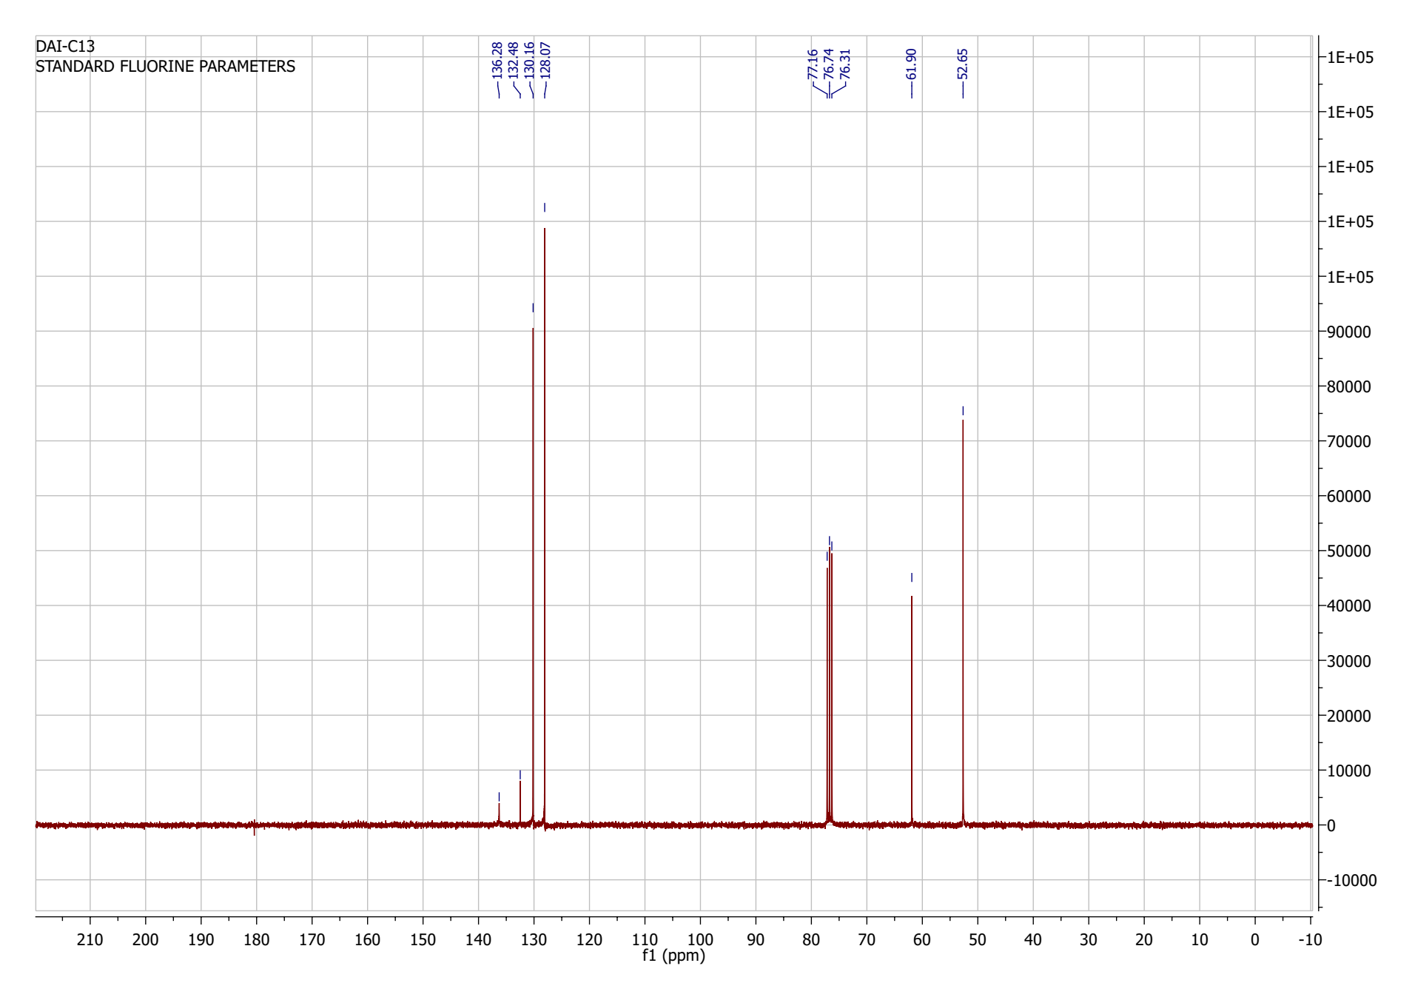

HPLC chromatogram (purity >98 %)

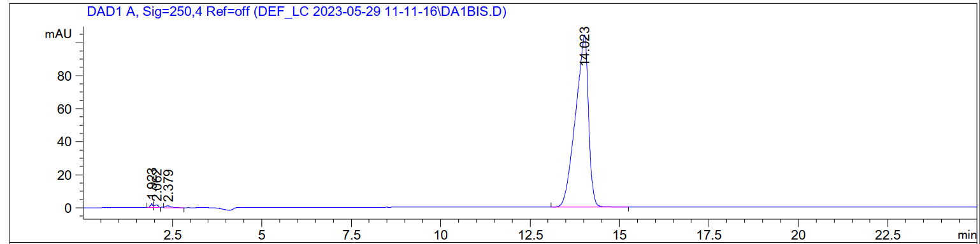

1,4-Bis(4-cyanobenzyl)piperazine 2 (DA4)

¹H-NMR (500 MHz, CDCl₃)
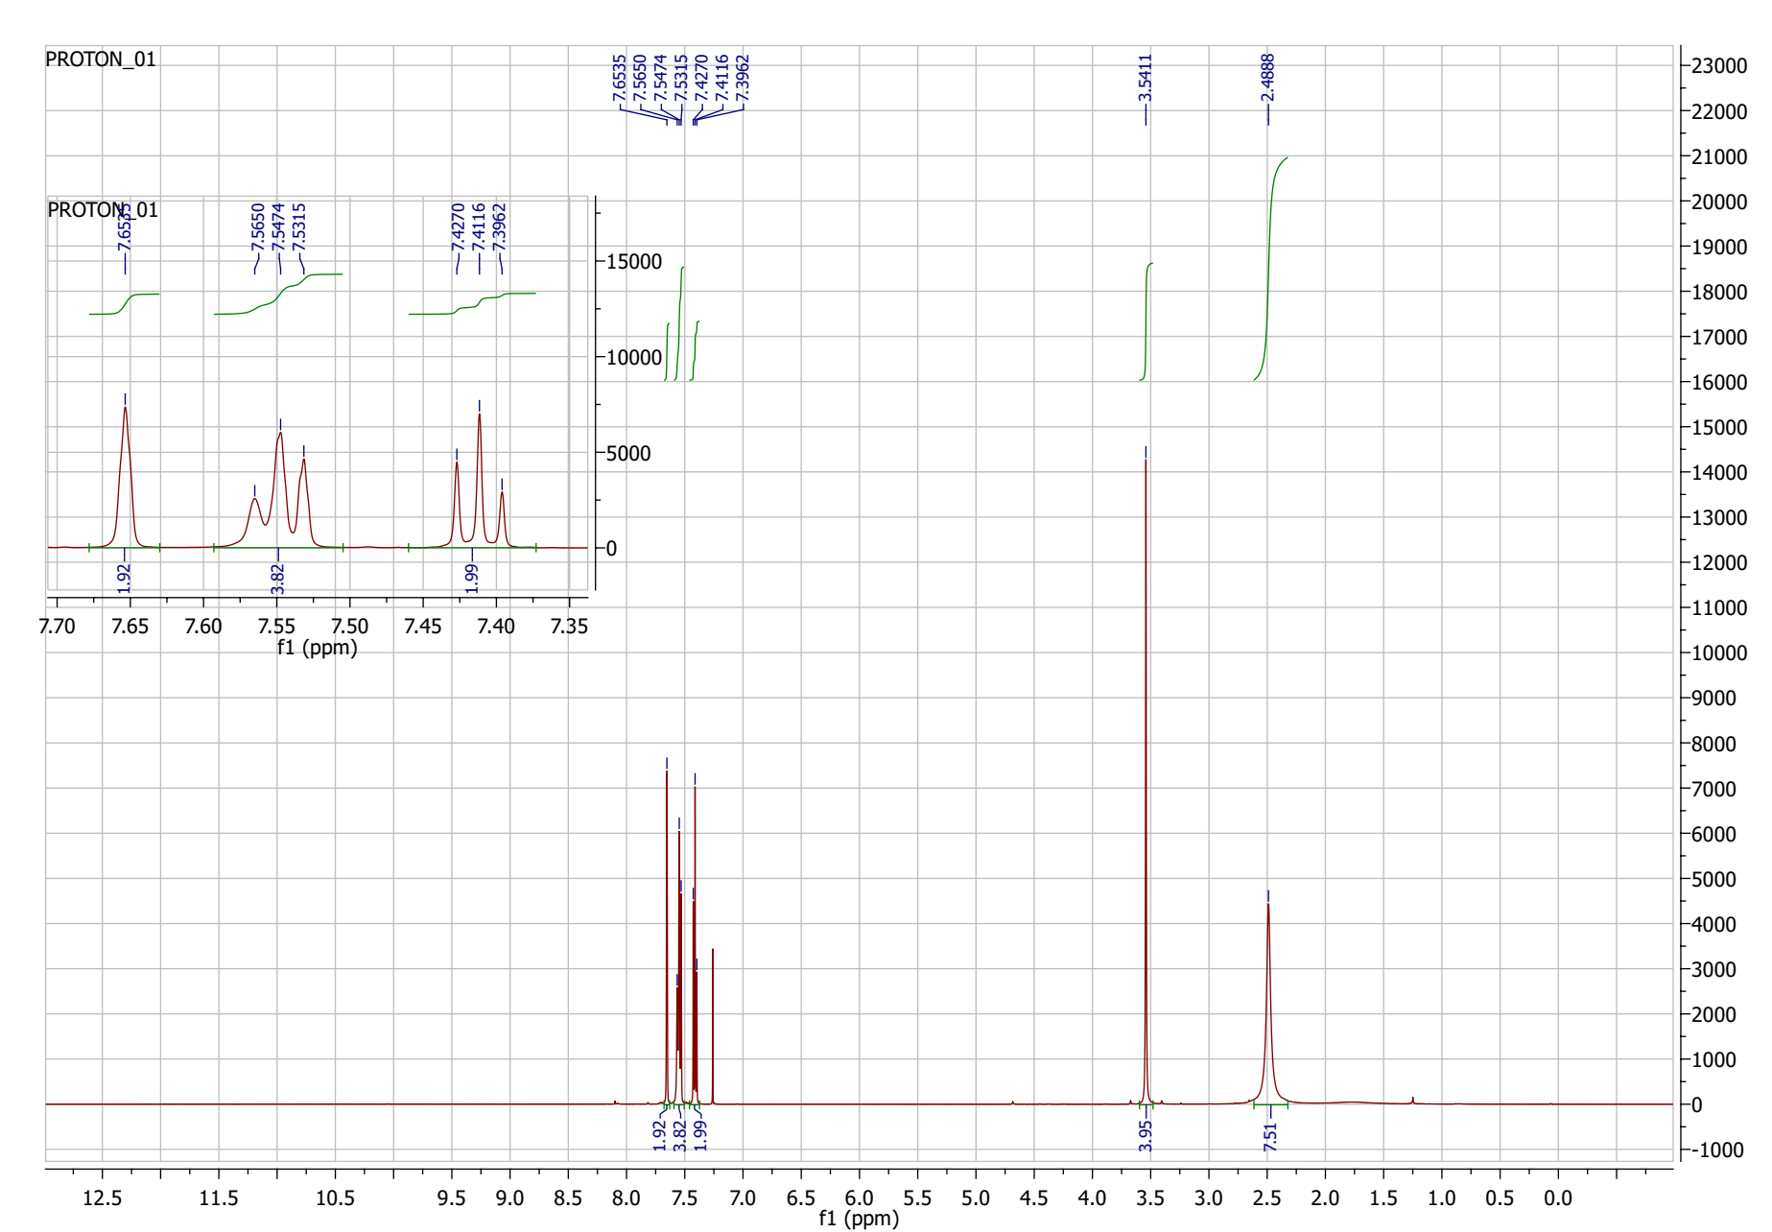

¹³C-NMR (125 MHz, CDCl₃)
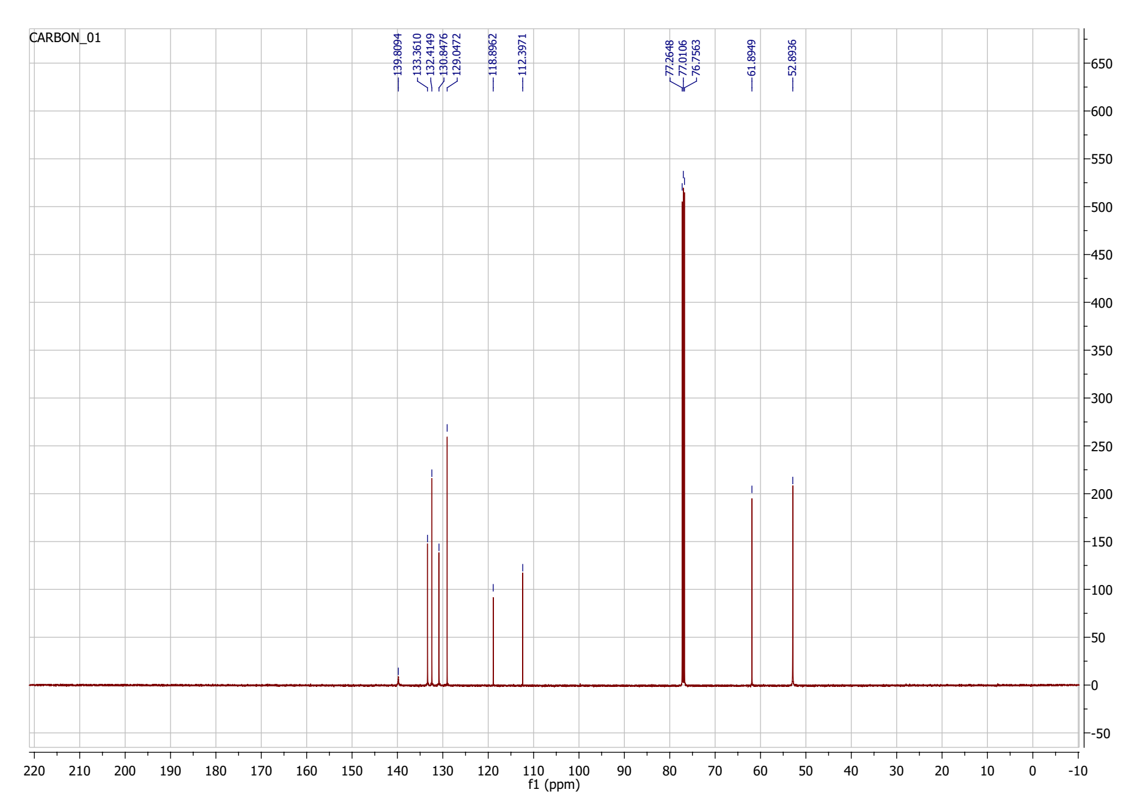

HPLC chromatogram (purity >98 %)
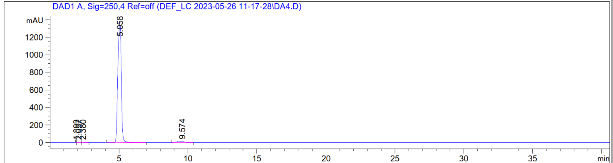

1-(3-Cyanobenzyl)-4-(3-(trifluoromethyl)benzyl)piperazine 4 (DA7)

¹H-NMR (500 MHz, CDCl₃)

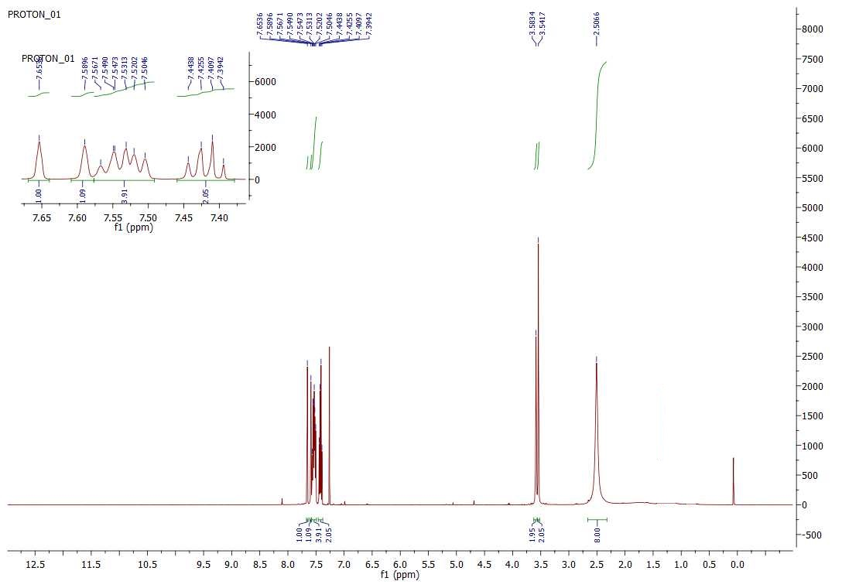

¹³C-NMR (125 MHz, CDCl₃)

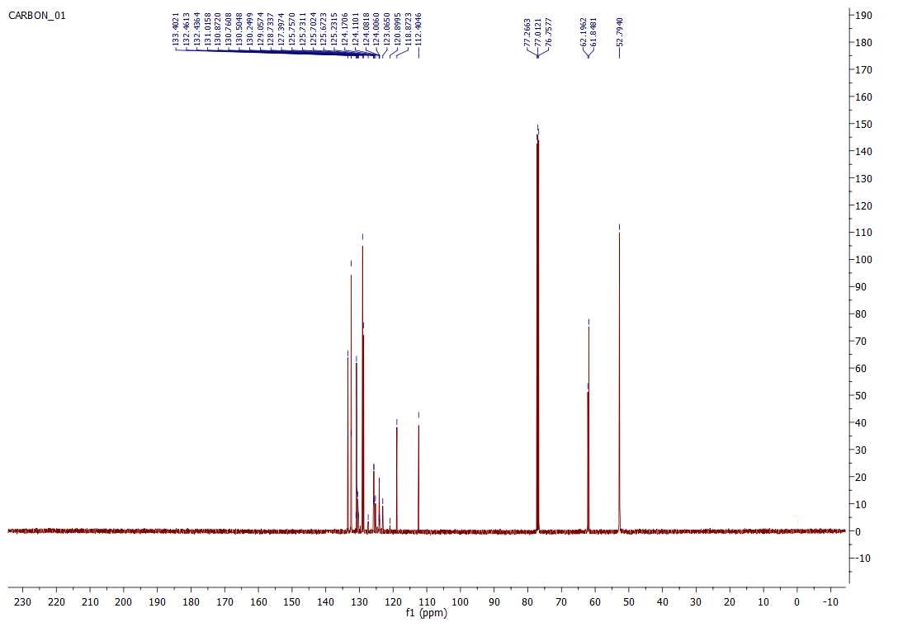

HPLC chromatogram (purity >99 %)

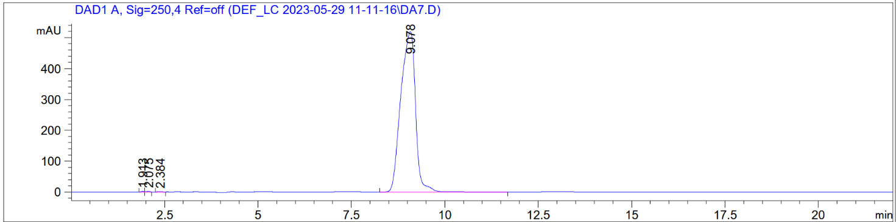

1,4-Dibenzoylpiperazine 7 (DA12)

¹H-NMR (300 MHz, CDCl₃)
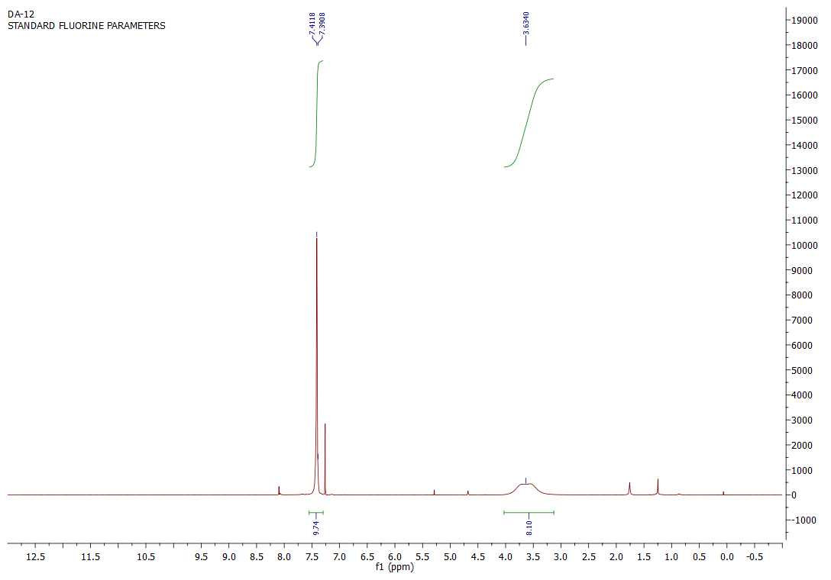

¹³C-NMR (125 MHz, CDCl₃)

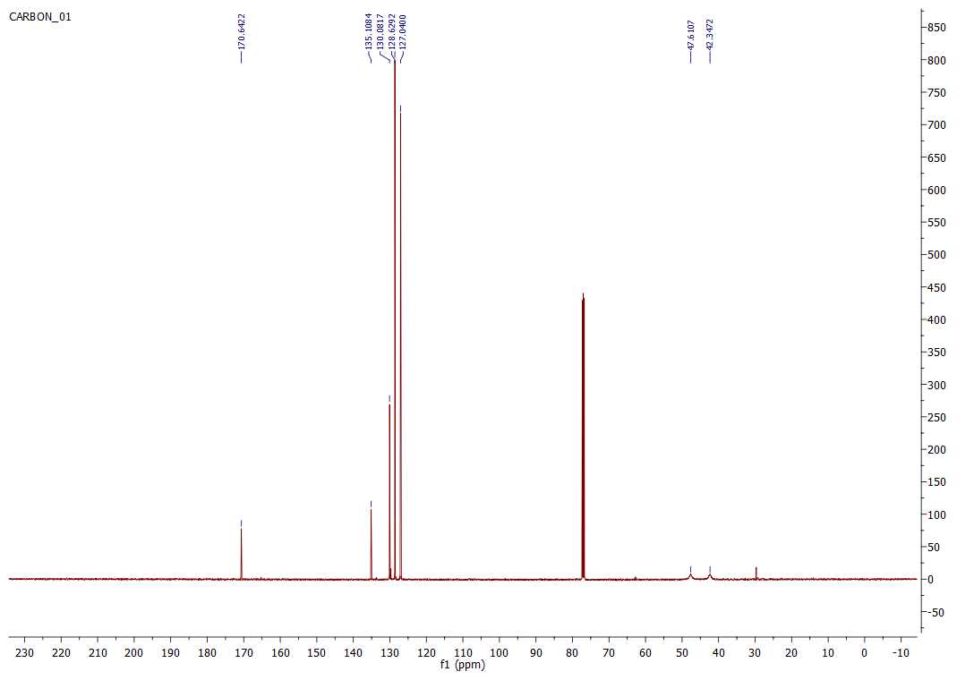

HPLC chromatogram (purity >98 %)

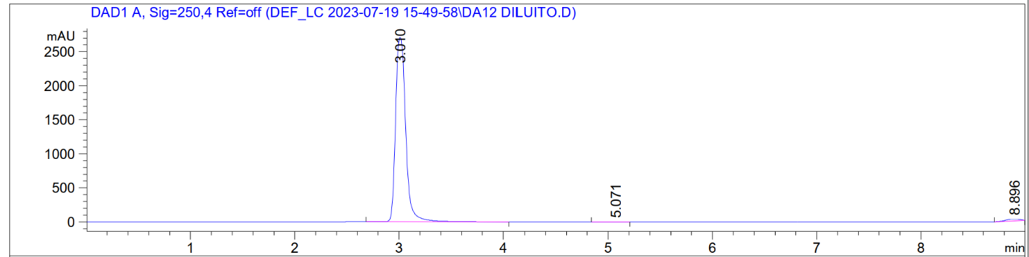

3,3'-(Piperazine-1,4-dicarbonyl)dibenzonitrile 8 (DA15)

¹H-NMR (500 MHz, DMSO)
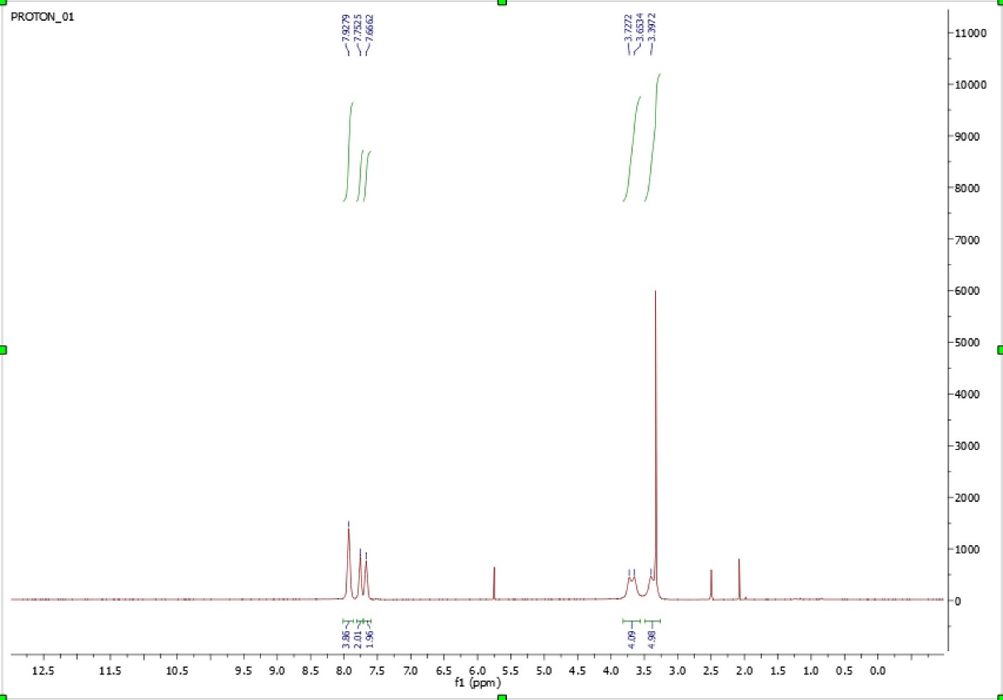

¹³C-NMR (125 MHz, DMSO)
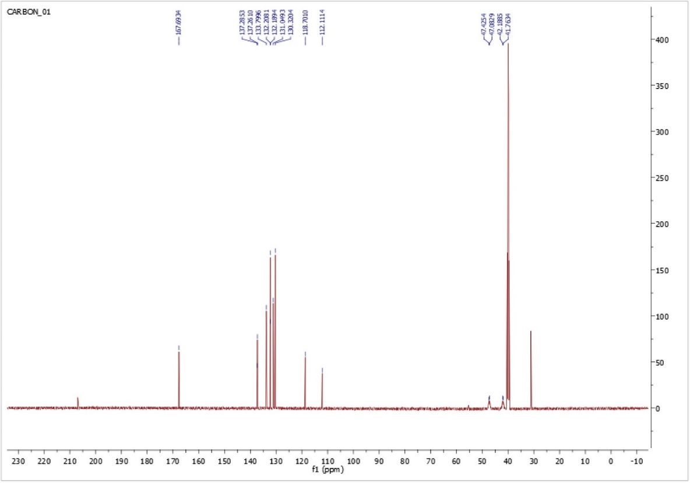

HPLC chromatogram (purity >98 %)

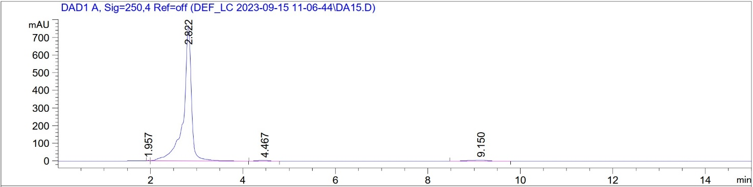

1-(3-Cyanobenzoyl)-4-(4-chlorobenzoyl)piperazine 9 (DA17)

¹H-NMR (300 MHz, CDCl₃)

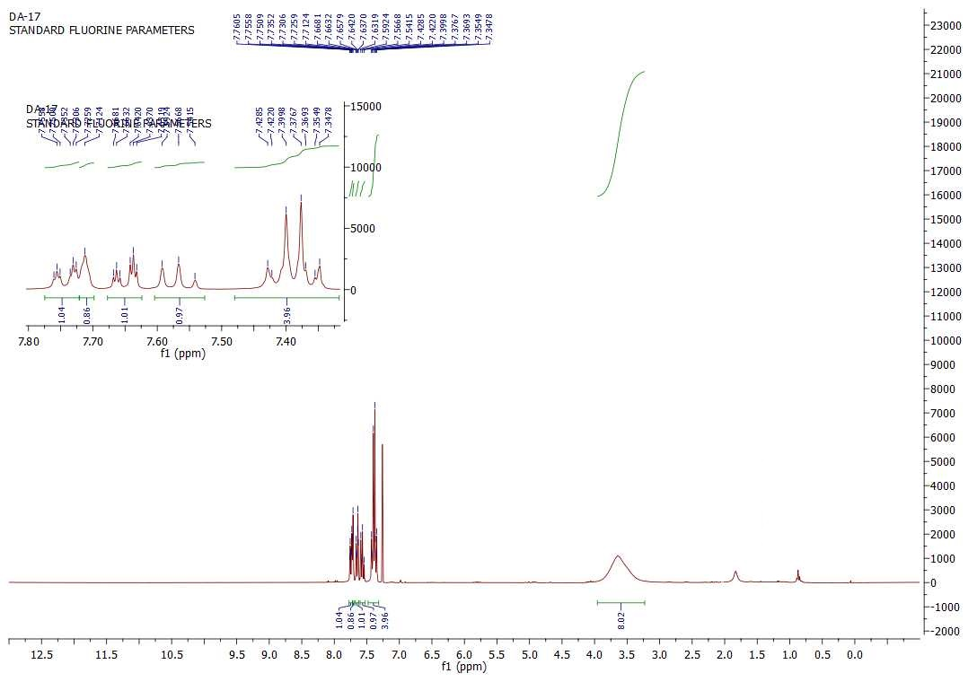

¹³C-NMR (125 MHz, CDCl₃)

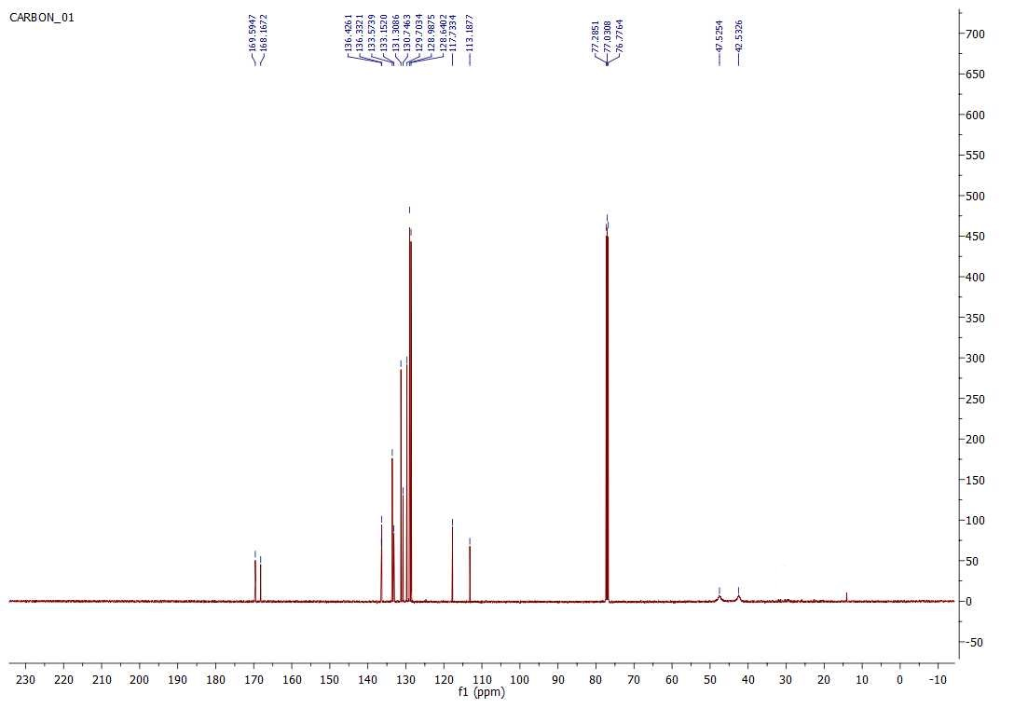
HPLC chromatogram (purity >99 %)
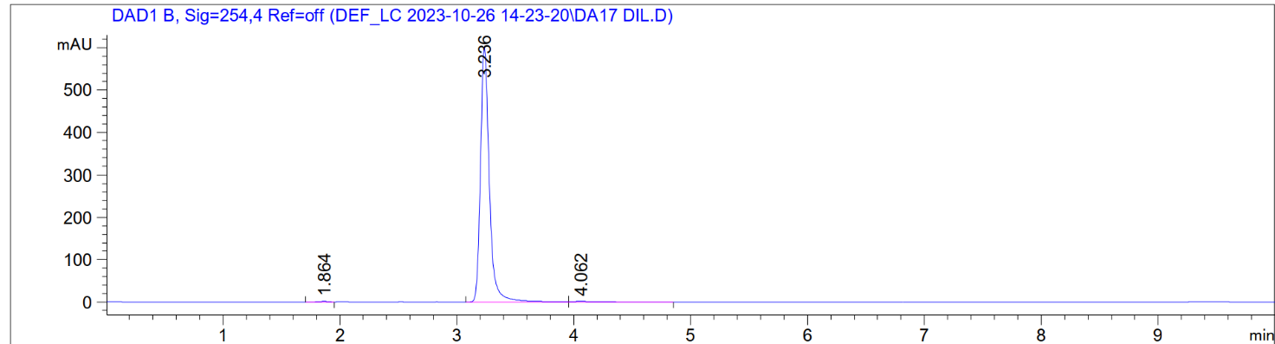

3,3'-((2-Oxopiperazine-1,4-diyl)bis(methylene))dibenzonitrile 10 (DA9)

¹H-NMR (500 MHz, CD₃OD)
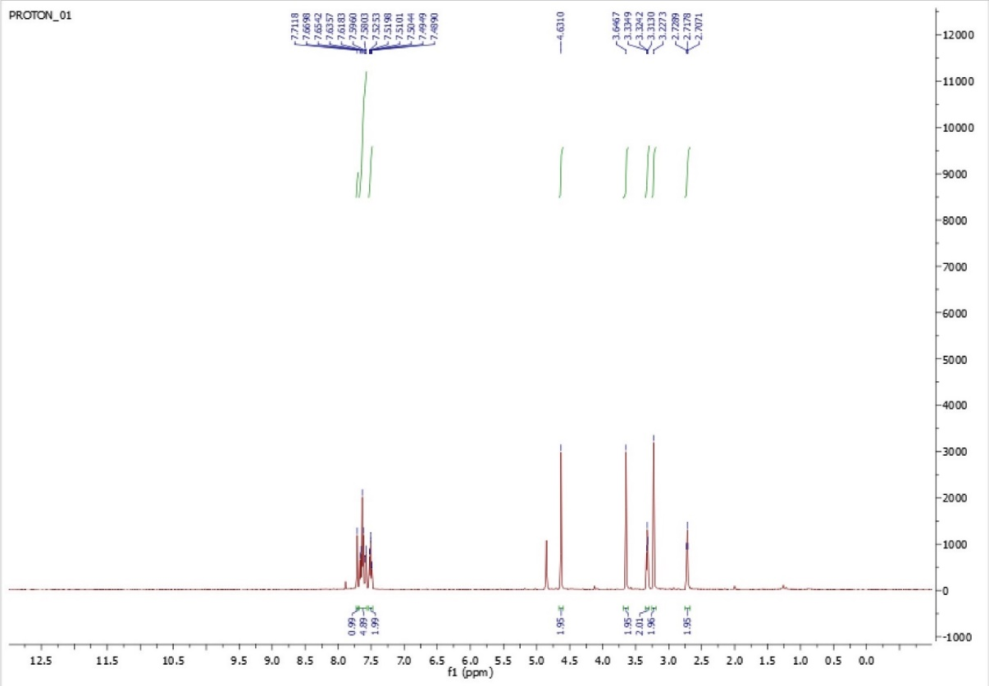

¹³C-NMR (125 MHz, CD₃OD)
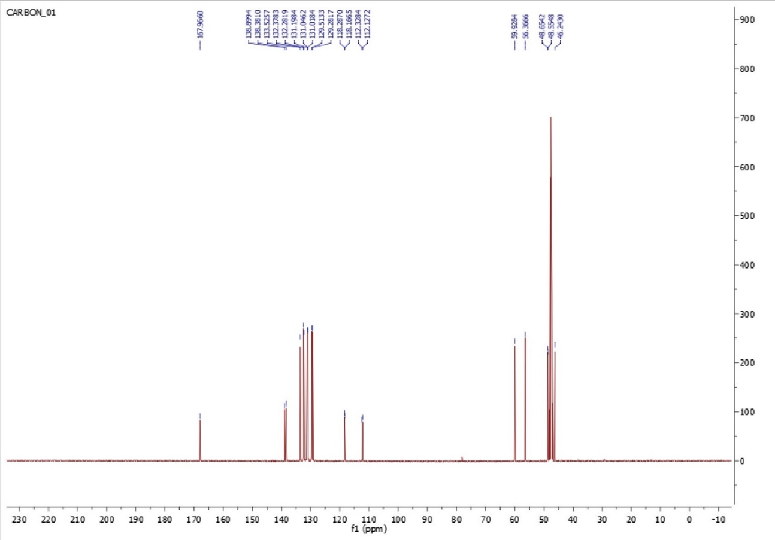

HPLC chromatogram (purity >99 %)
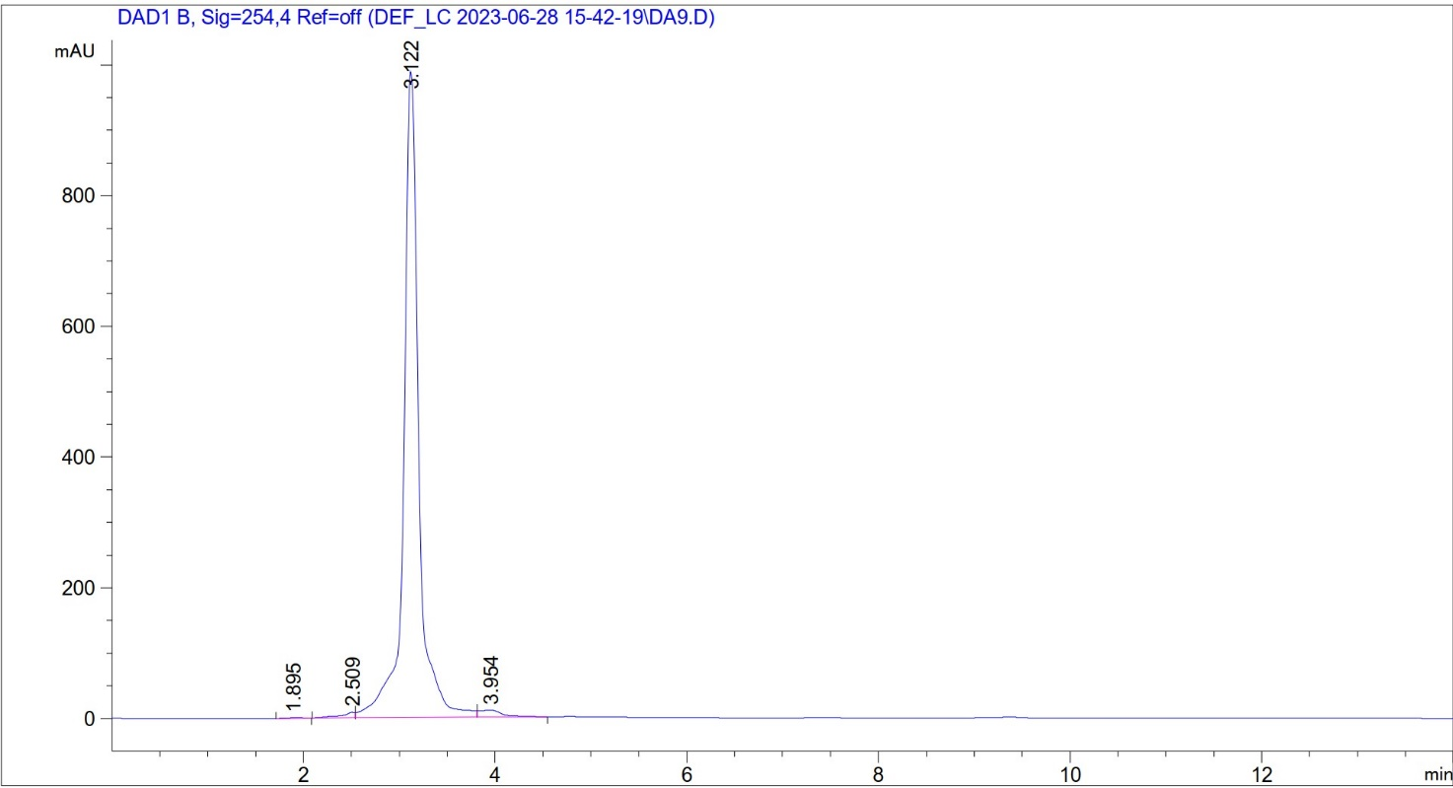

1,4-Bis(3-(Trifluoromethyl)benzyl)piperazin-2-one 11 (DA24)

¹H-NMR (300 MHz, CDCl₃)

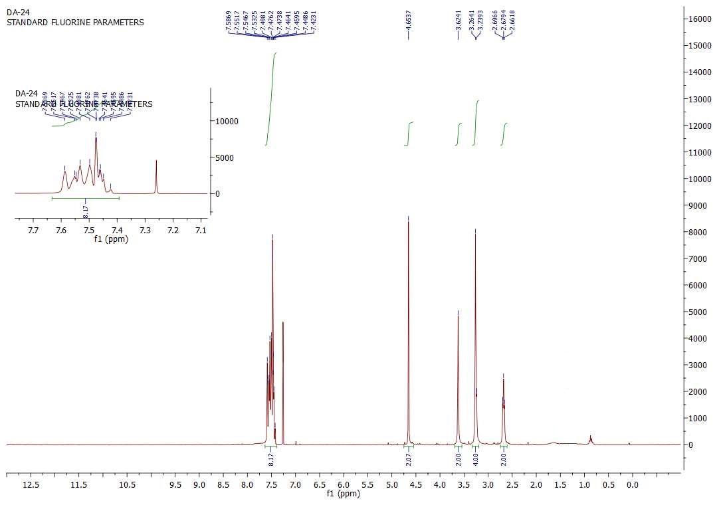

¹³C-NMR (125 MHz, CD₃OD)

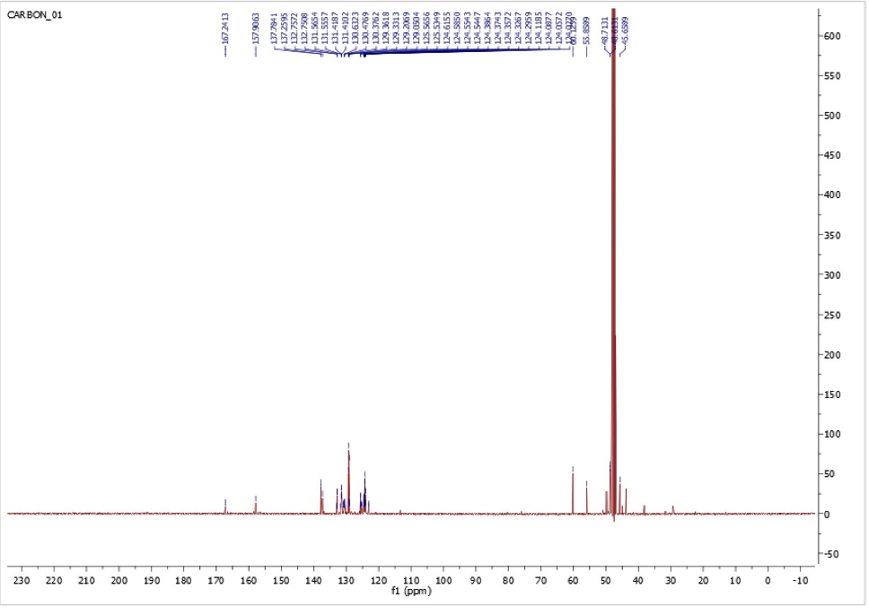

HPLC chromatogram (purity >97 %)
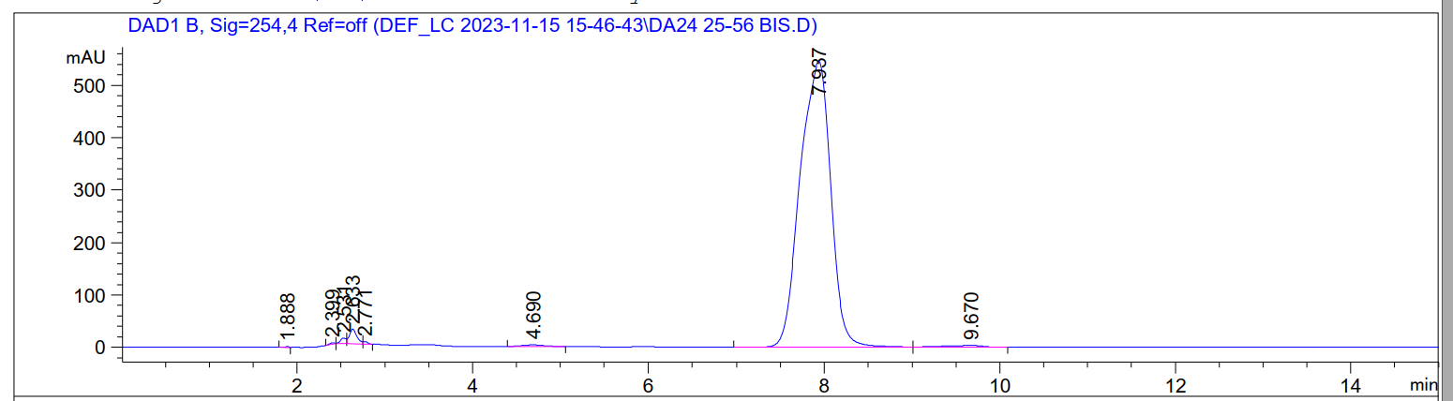

1,4-Bis(2-fluorobenzyl)piperazin-2-one 12 (DA32)

¹H-NMR (500 MHz, CDCl₃)
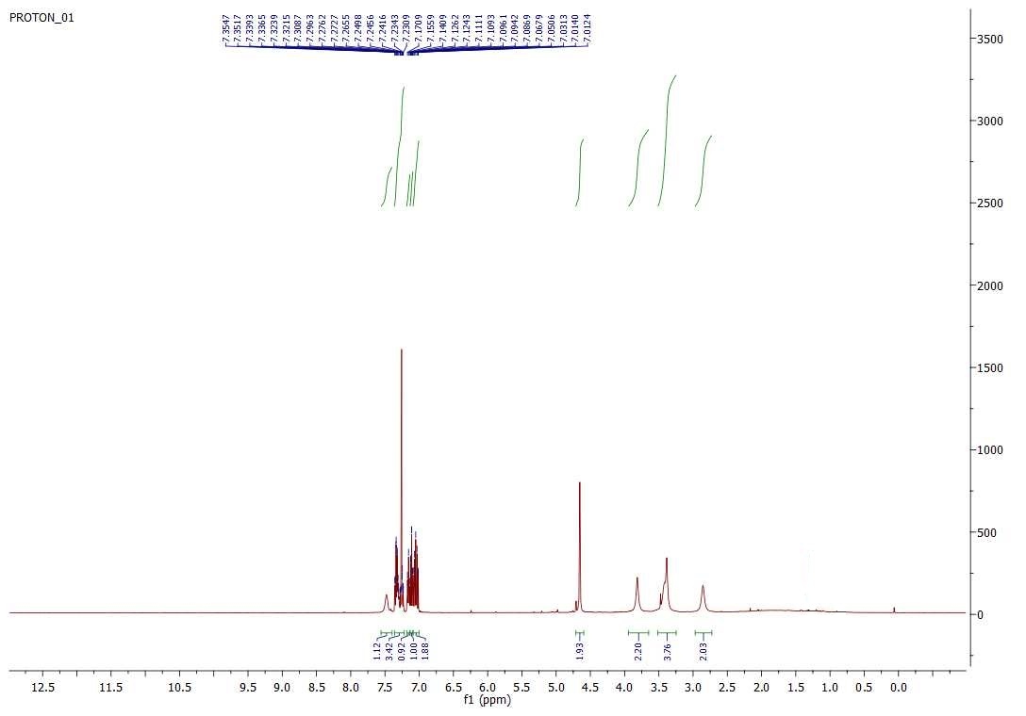

¹³C-NMR (125 MHz, CDCl₃)
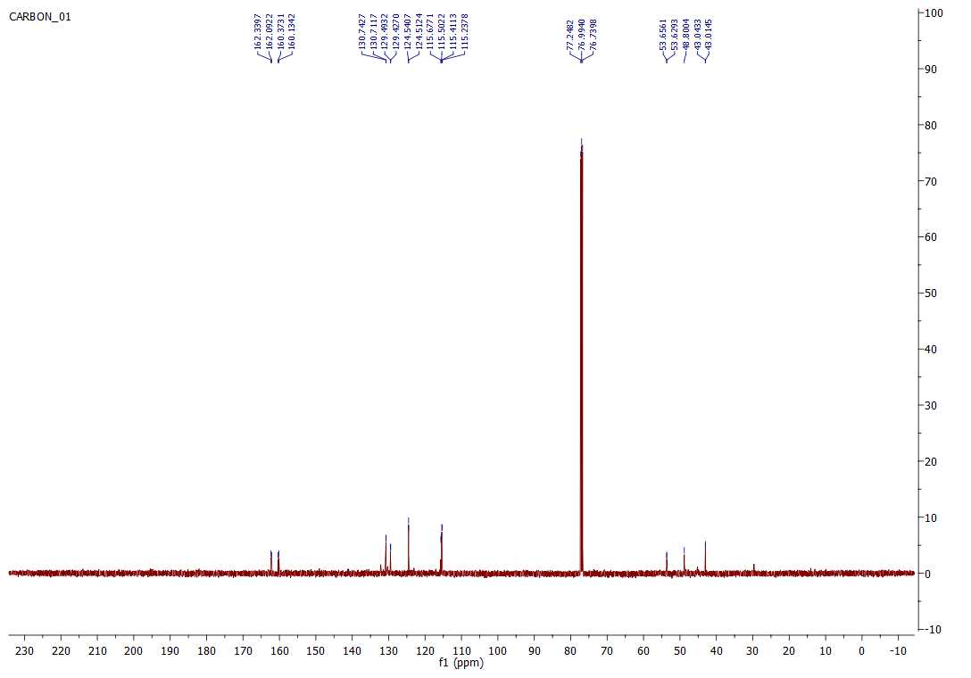

HPLC chromatogram (purity >96 %)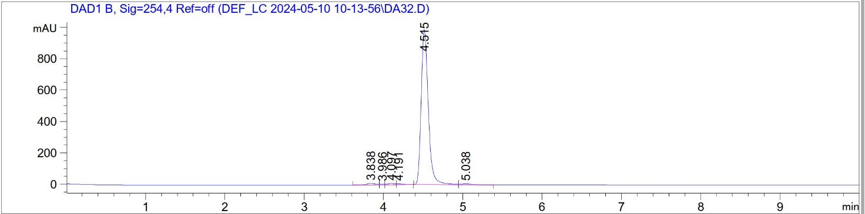

1,4-Bis(4-fluorobenzyl)piperazin-2-one 13 (DA36)

¹H-NMR (500 MHz, CDCl₃)
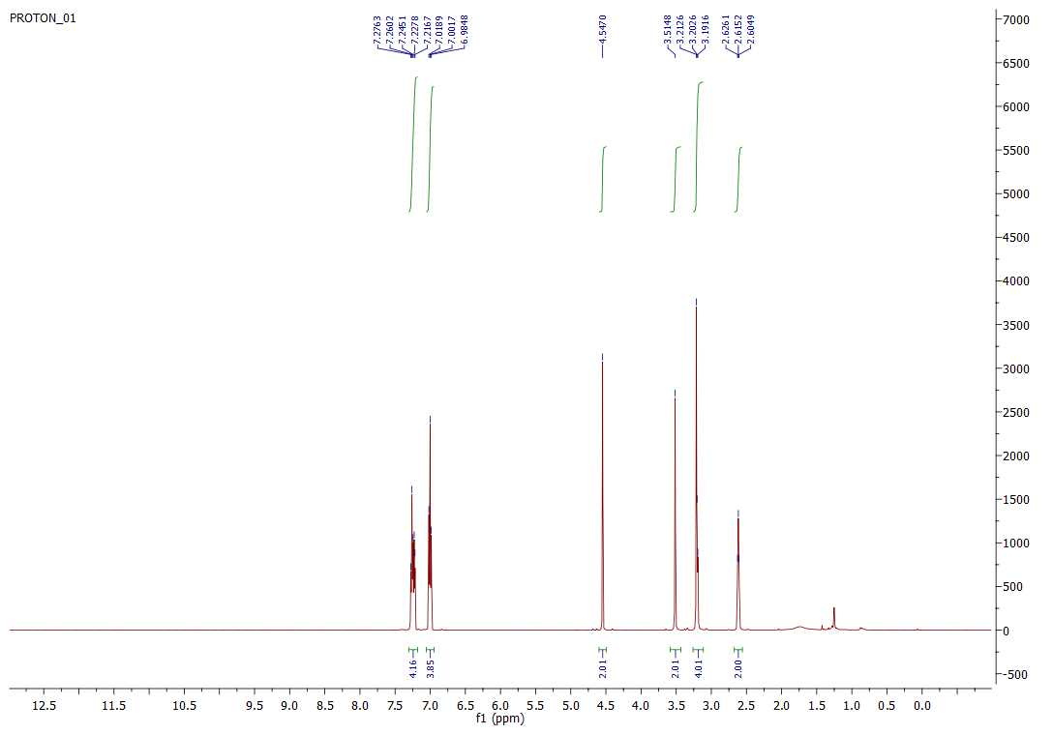

¹³C-NMR (125 MHz, CDCl₃)
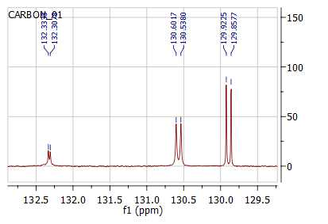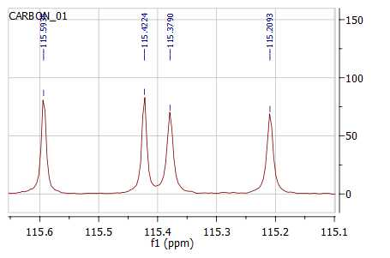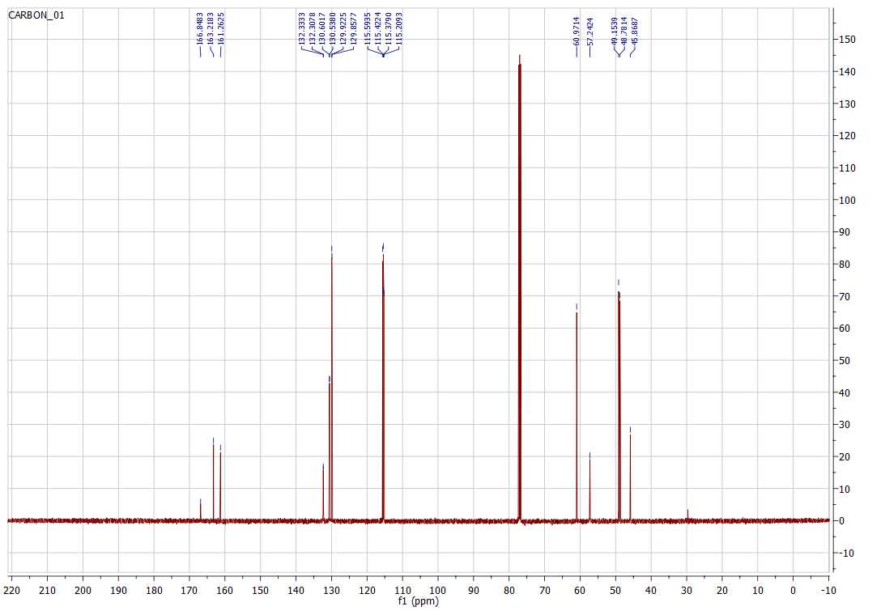
HPLC chromatogram (purity >97 %)
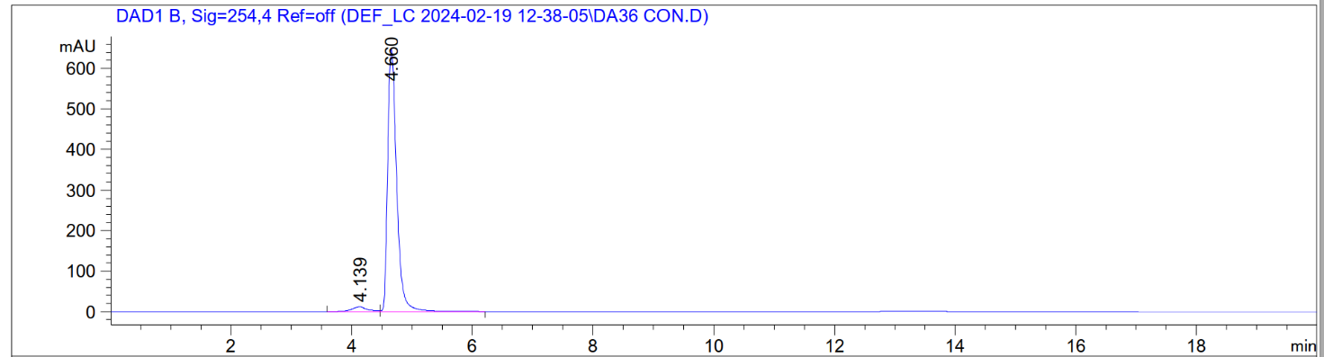

1,4-Bis(2-bromobenzyl)piperazin-2-one hydrochloride 14 (DA33)

¹H-NMR (500 MHz, CD₃OD)

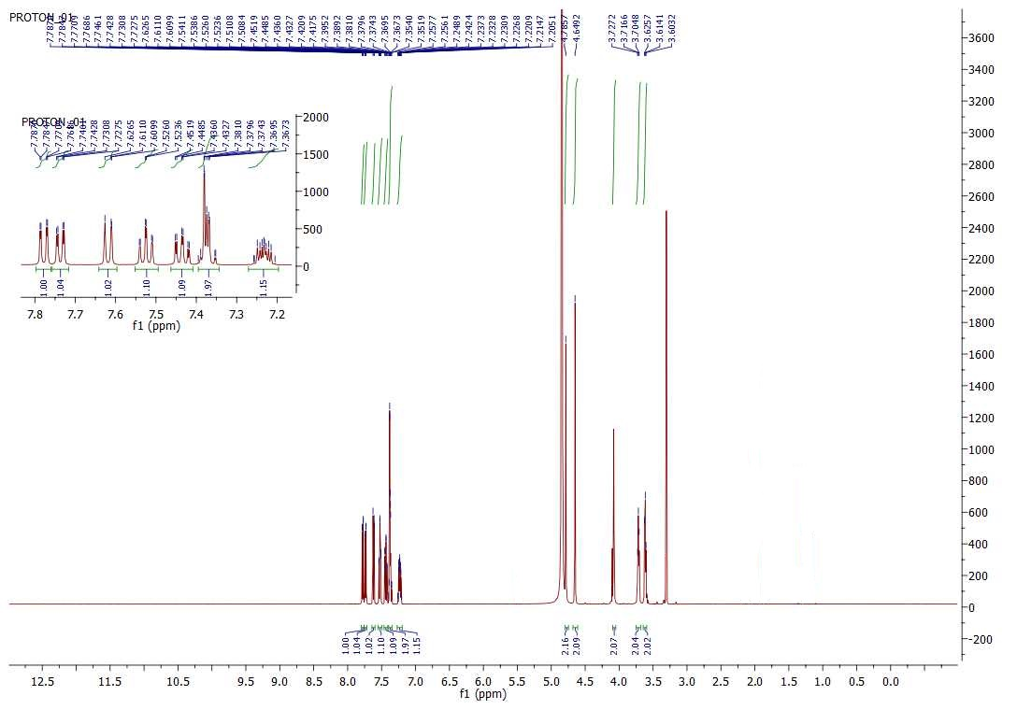

¹³C-NMR (125 MHz, CD₃OD) 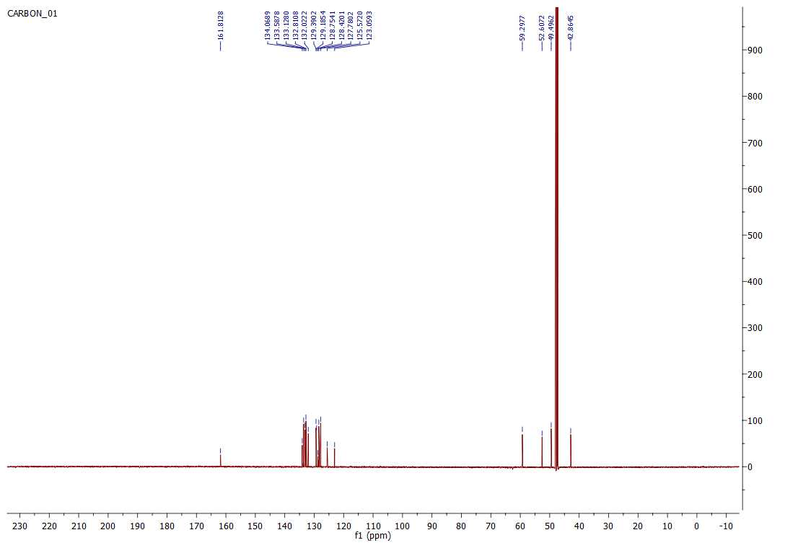

HPLC chromatogram (purity >99 %)

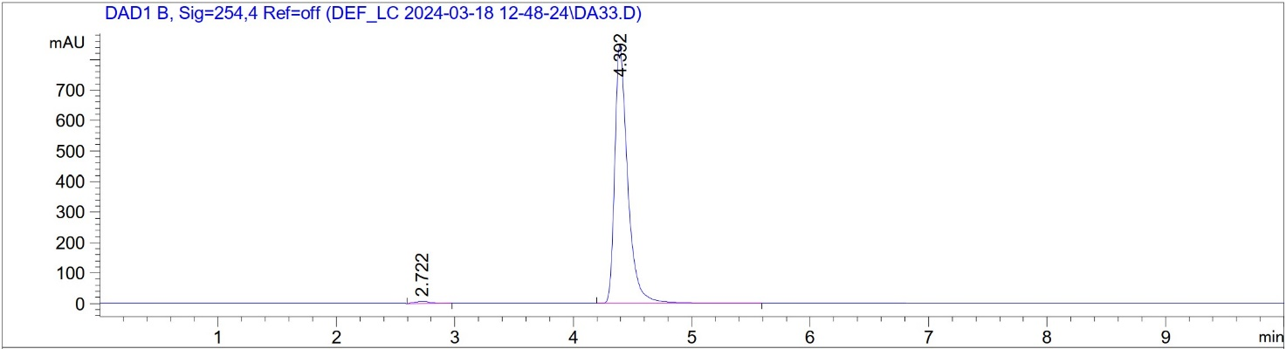

1,4-Bis(4-bromobenzyl)piperazin-2-one 15 (DA35)

¹H-NMR (500 MHz, CDCl₃)

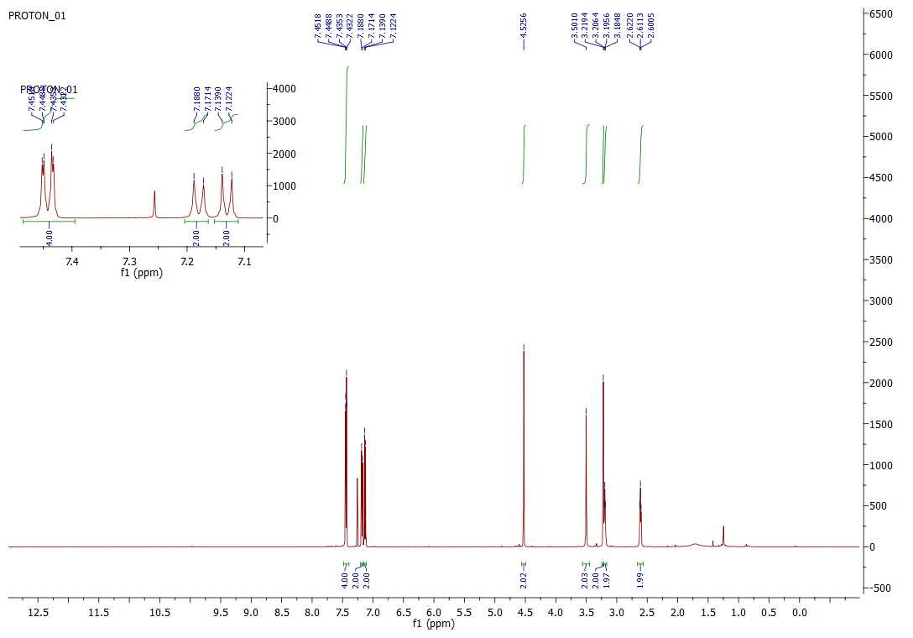

¹³C-NMR (125 MHz, CDCl₃)

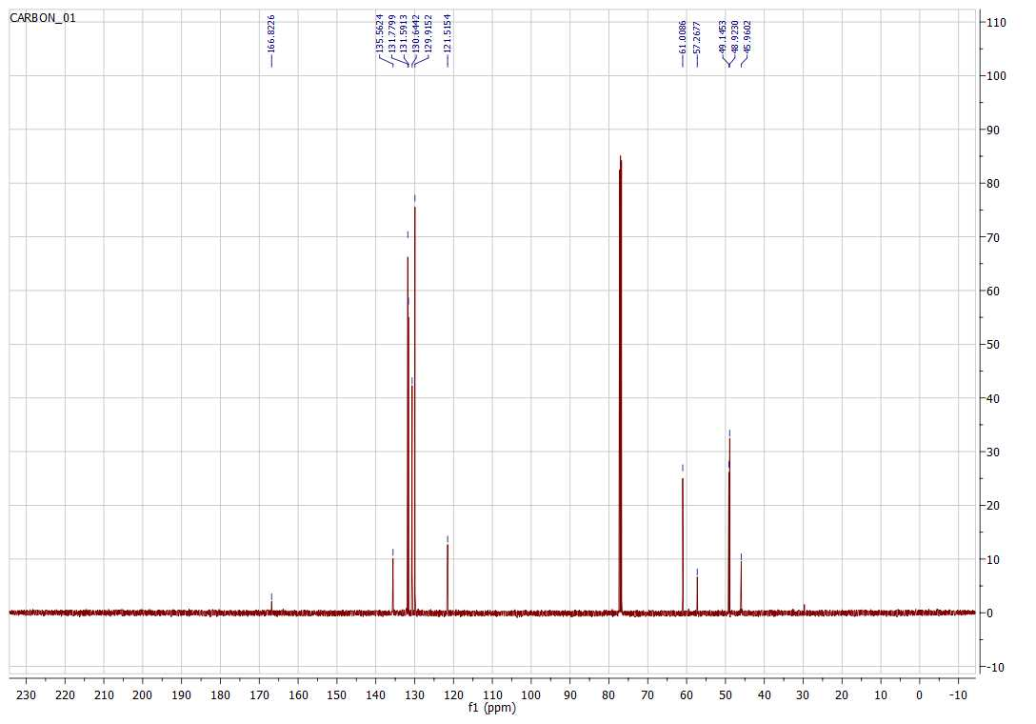

HPLC chromatogram (purity >98 %)
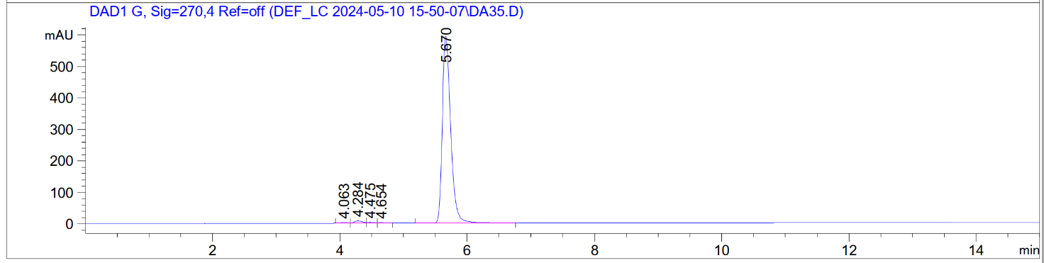

1,4-Bis(4-chlorobenzyl)piperazin-2-one 16 (DA53)

¹H-NMR (500 MHz, CDCl₃)
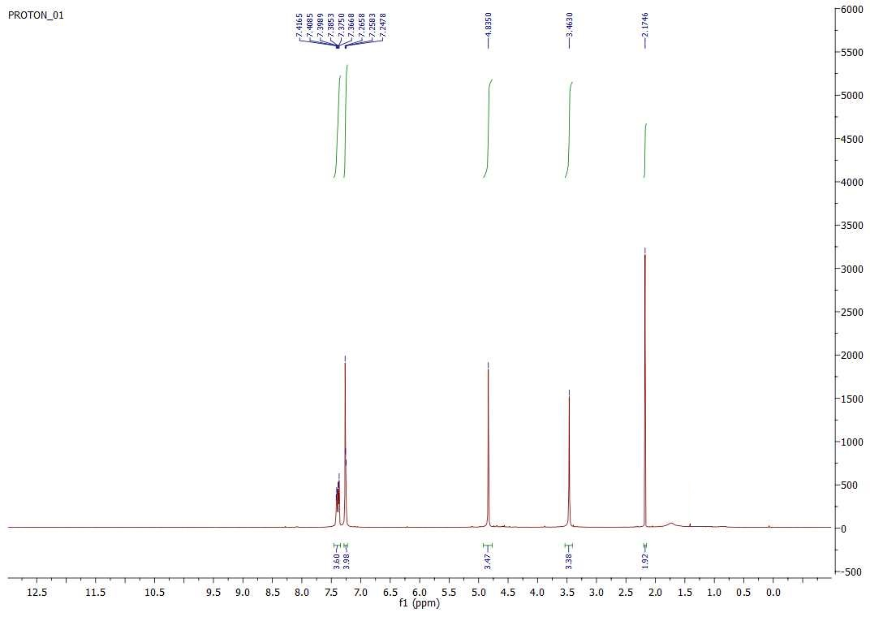

¹³C-NMR (125 MHz, CDCl₃)

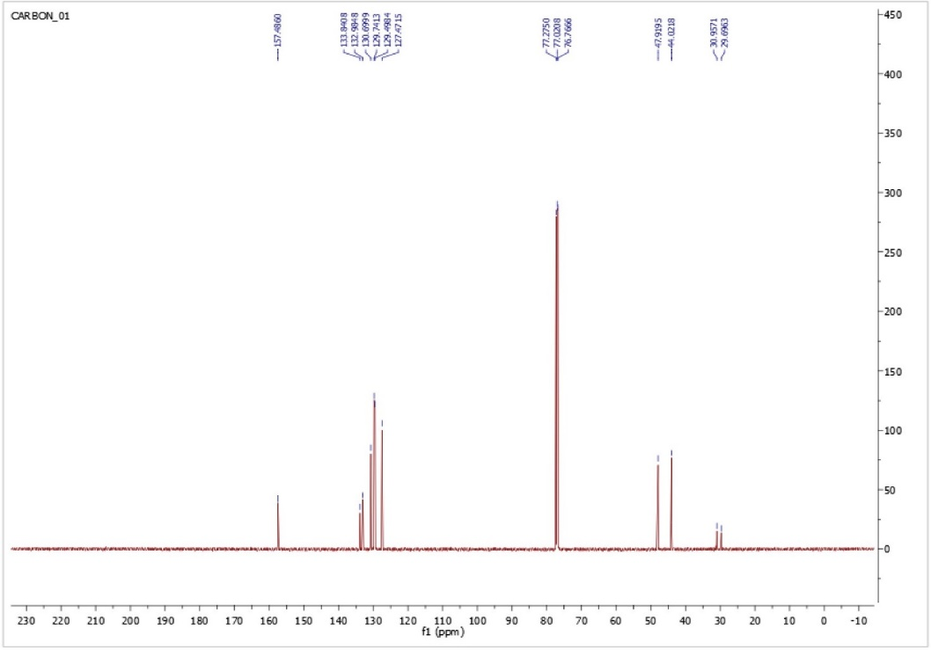

HPLC chromatogram (purity >97 %)

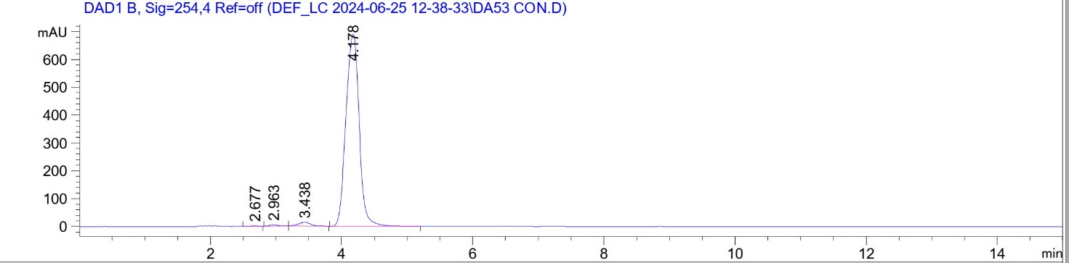

4-(3-Cyanobenzyl)-1-(4-chlorobenzyl)piperazin-2-one 21 (DA11)

¹H-NMR (500 MHz, CDCl₃)

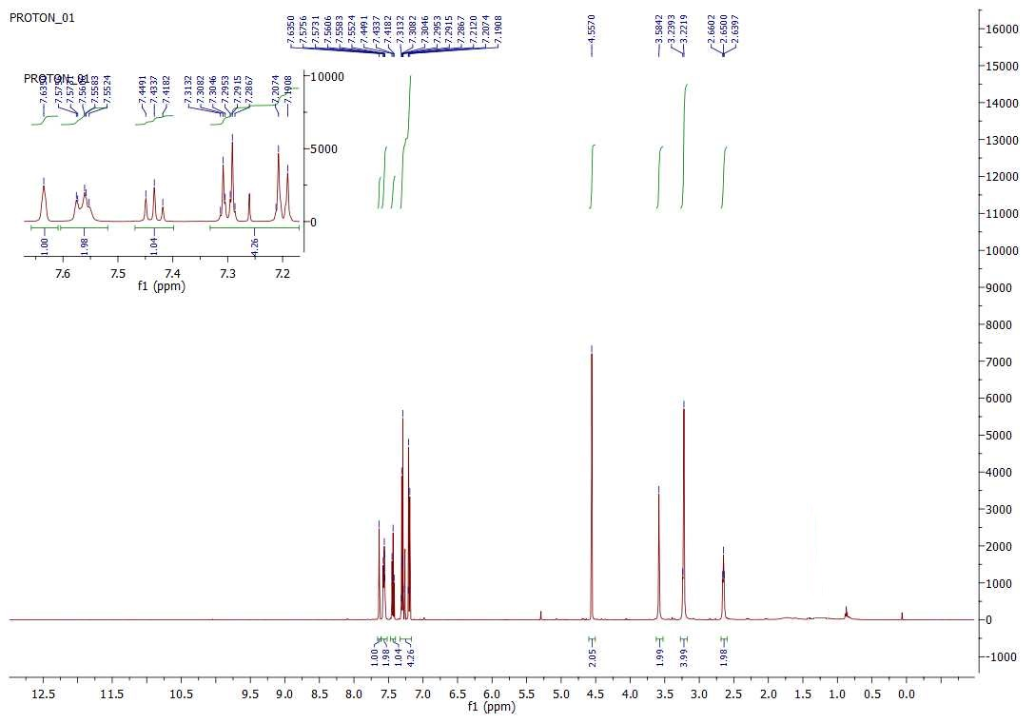

¹³C-NMR (125 MHz, CDCl₃)
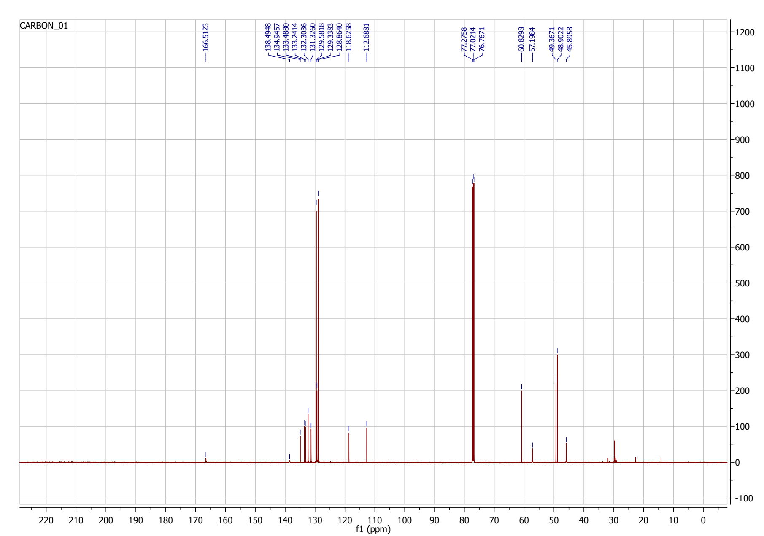

HPLC chromatogram (purity >97 %)

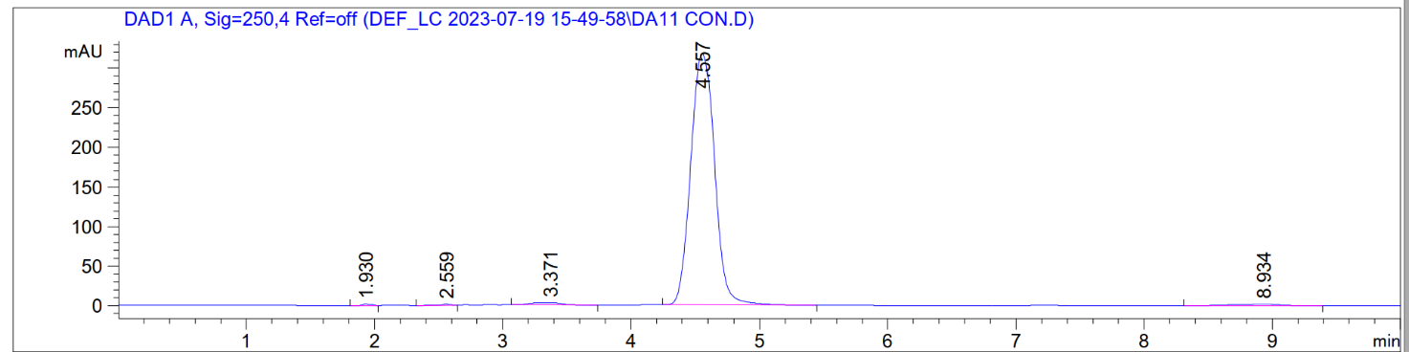

4-(3-Cyanobenzyl)-1-(4-(trifluoromethyl)benzyl)piperazin-2-one 22 (DA14)

¹H-NMR (500 MHz, CDCl₃)

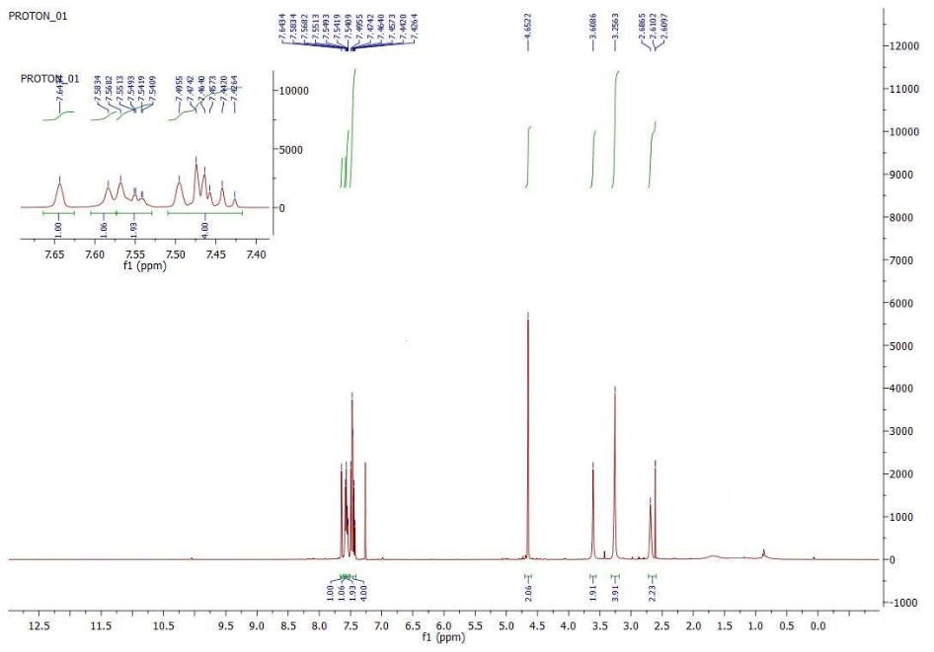

¹³C-NMR (125 MHz, CDCl₃)
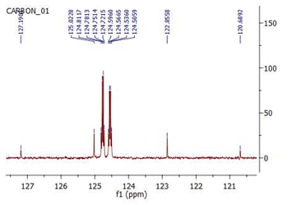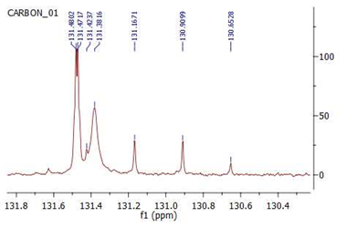
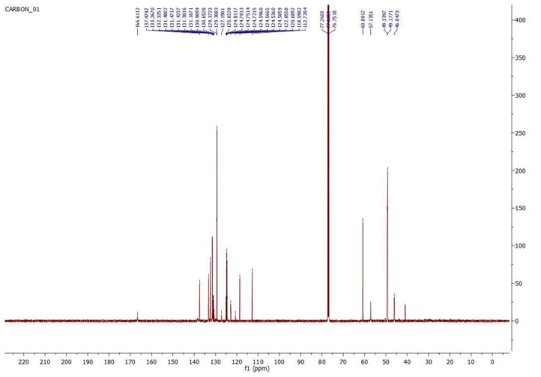

HPLC chromatogram (purity >95 %)

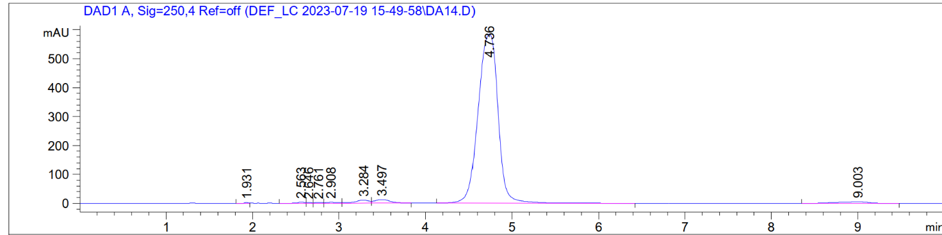

3-((4-(4-Fluorobenzyl)-3-oxopiperazin-1-yl)methyl)benzonitrile 23 (DA25)

¹H-NMR (500 MHz, CDCl₃)
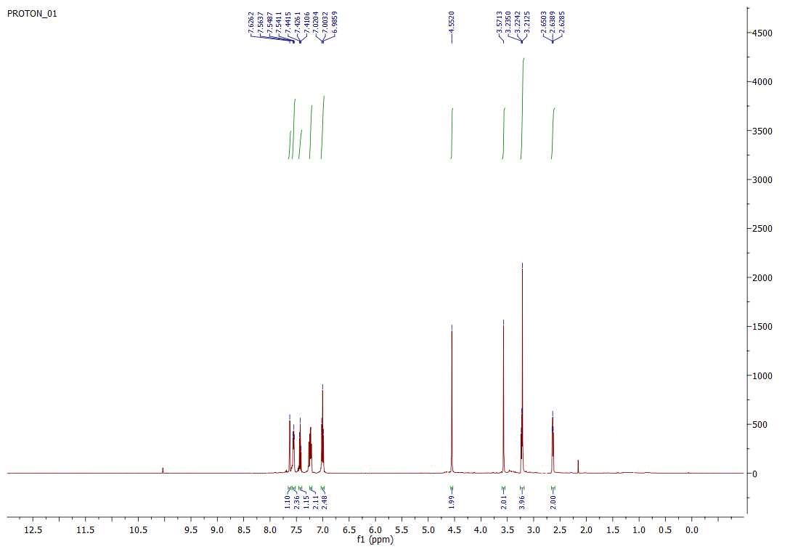

¹³C-NMR (125 MHz, CDCl₃)

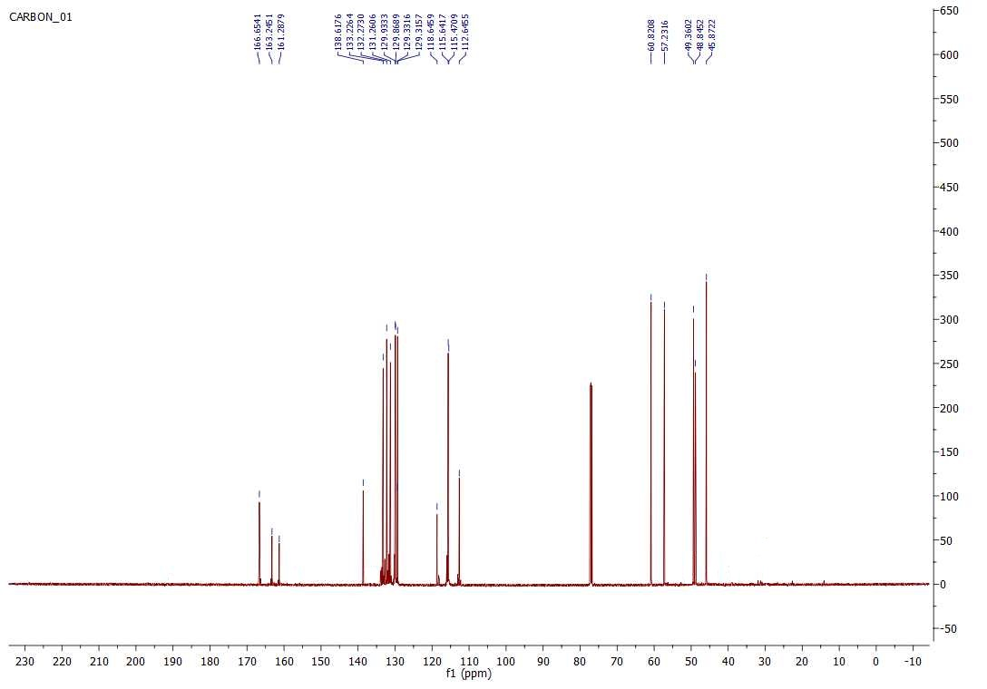

HPLC chromatogram (purity >96 %)
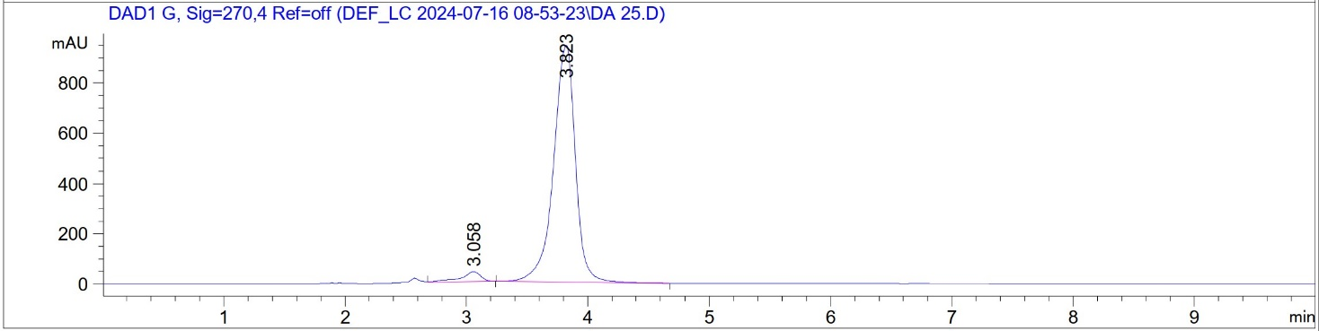

4-(3-Cyanobenzyl)-1-(3,4-dichlorobenzyl)piperazin-2-one 24 (DA26)

¹H-NMR (300 MHz, CDCl₃)

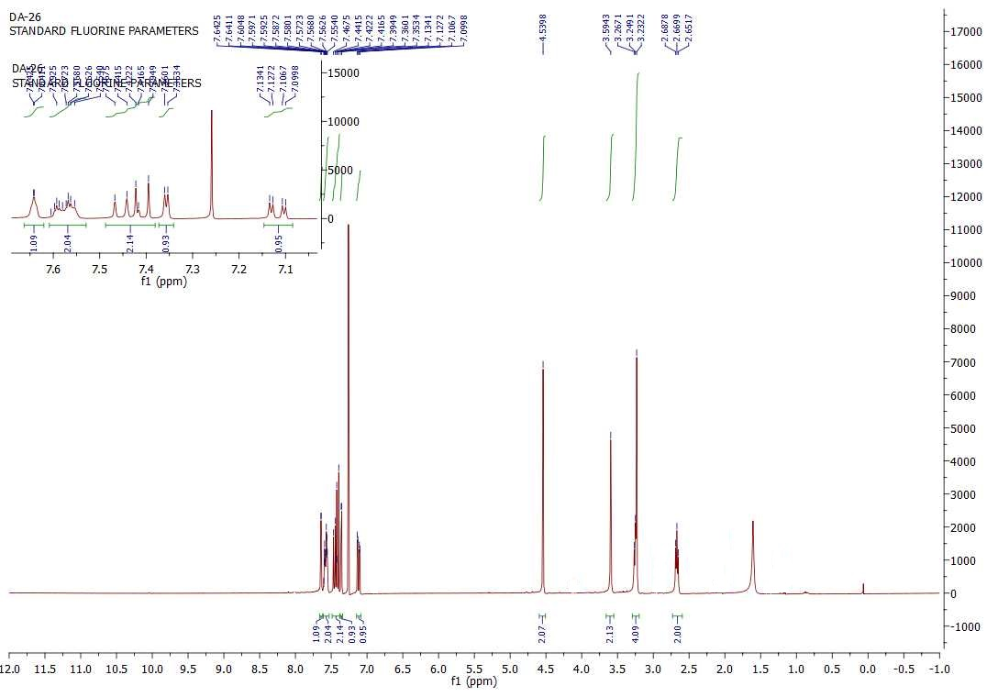

¹³C-NMR (125 MHz, CDCl₃)

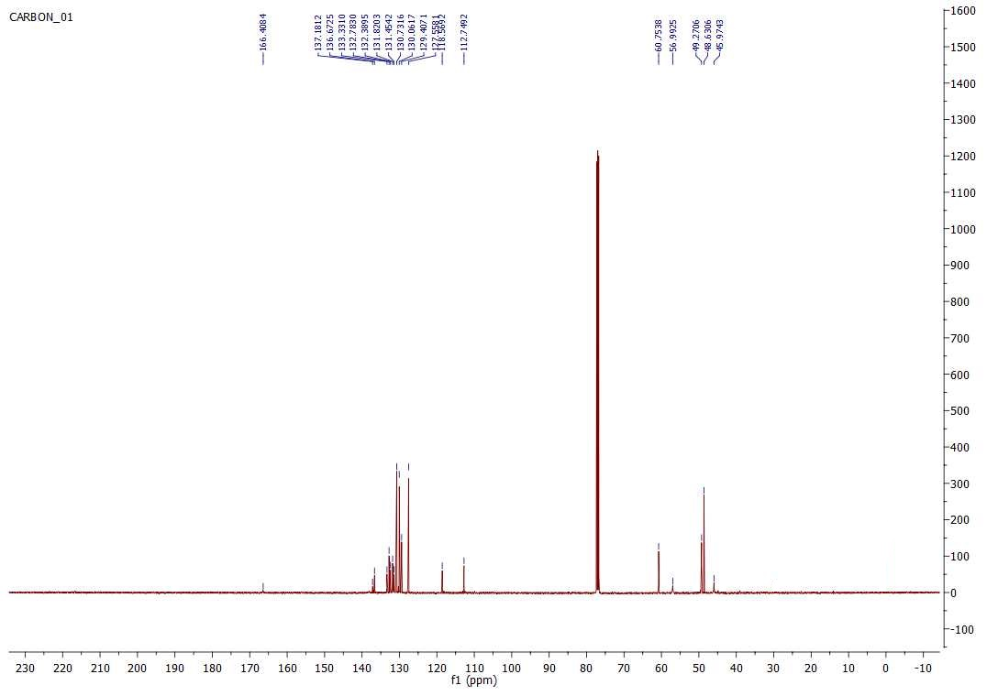

HPLC chromatogram (purity >99 %)
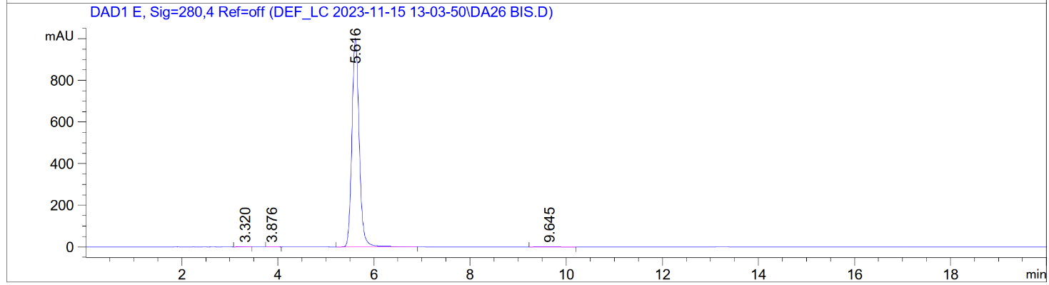

4-(3-Nitrobenzyl)-1-(3-(trifluoromethyl)benzyl)piperazin-2-one 25 (DA23)

¹H-NMR (300 MHz, CDCl₃)

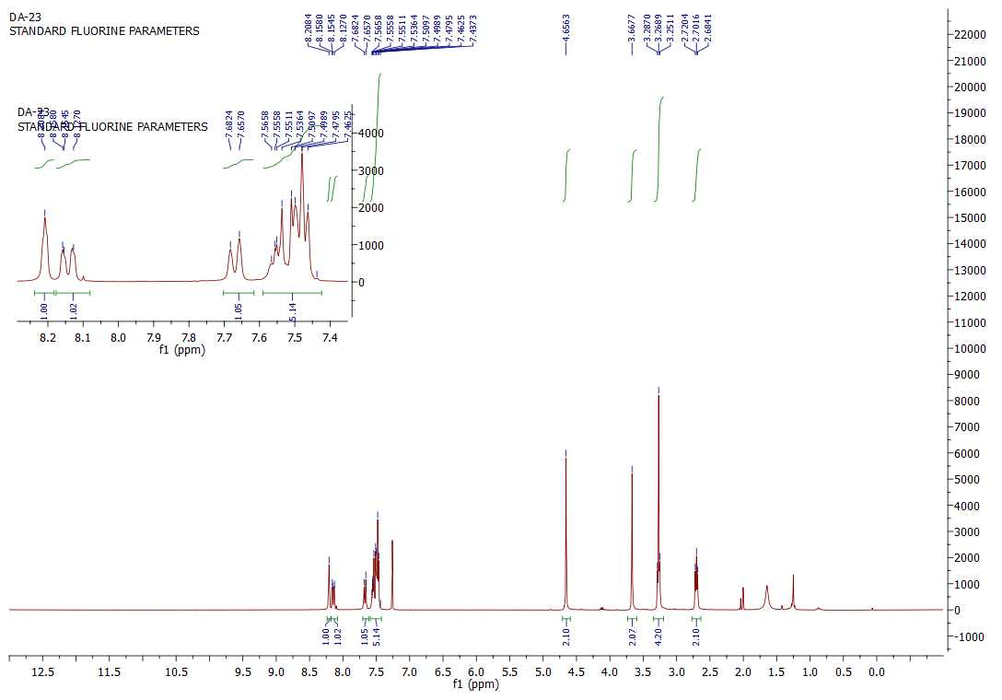

¹³C-NMR (125 MHz, CDCl₃)

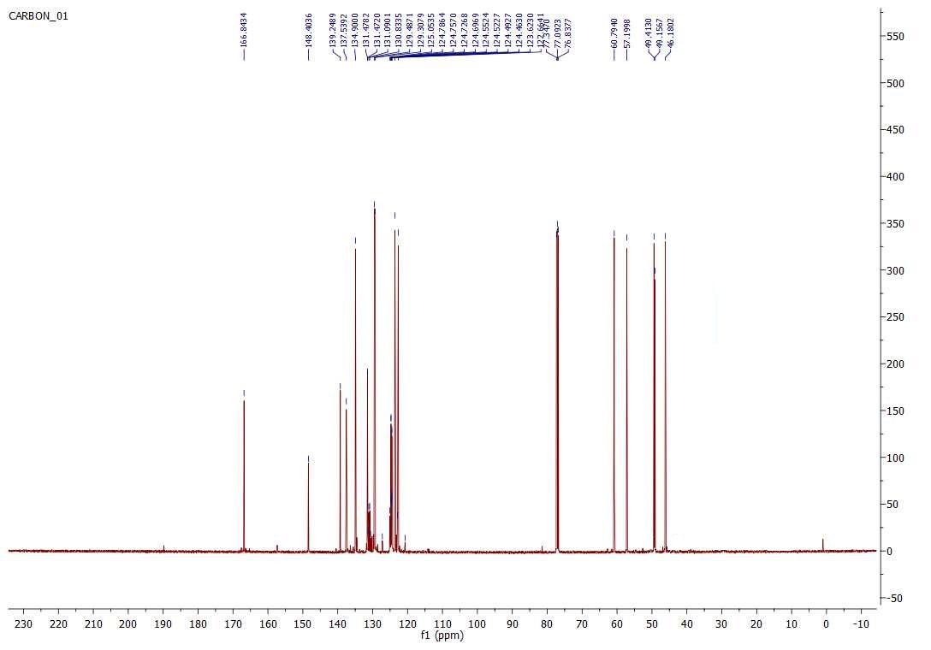

HPLC chromatogram (purity >97 %)
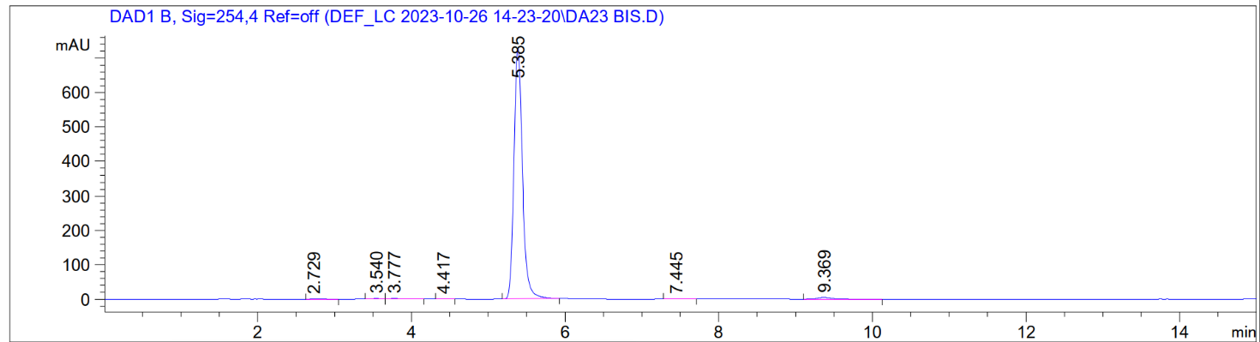

4-(3-(Trifluoromethyl)benzyl)-1-(4-(trifluoromethyl)benzyl)piperazin-2-one 26 (DA29)

¹H-NMR (300 MHz, CDCl₃)
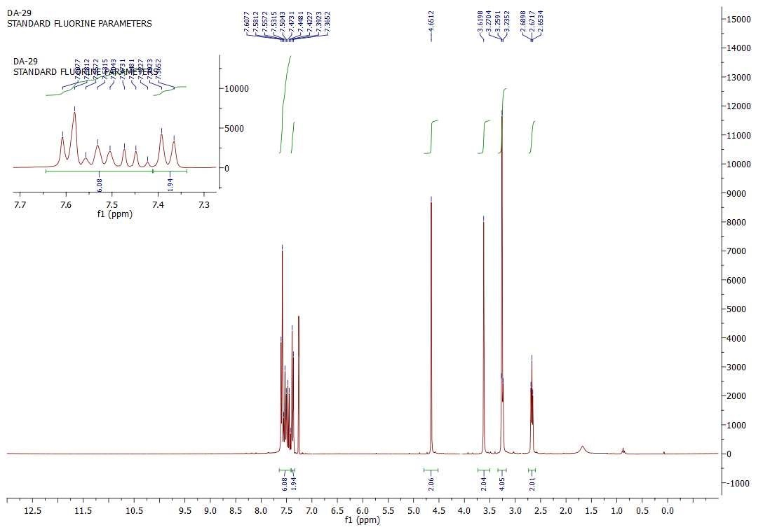

¹³C-NMR (125 MHz, CDCl₃)
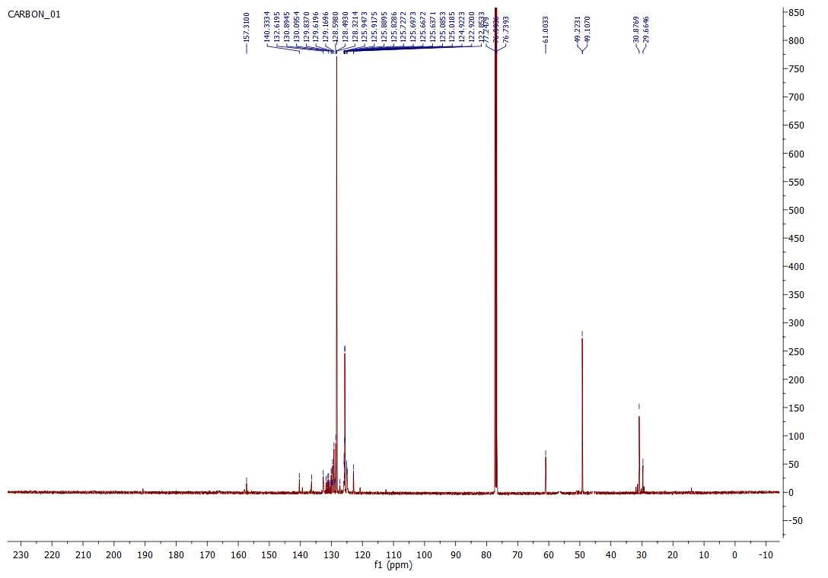

HPLC chromatogram (purity >96 %)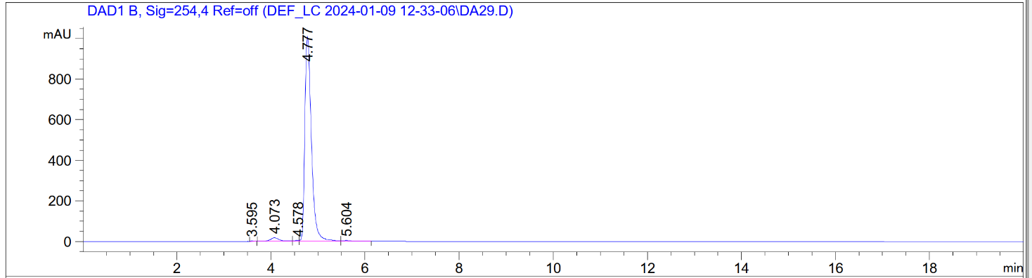

1-(3-Bromo-4-fluorobenzyl)-4-(4-(trifluoromethyl)benzyl)piperazin-2-one 27 (DA42)

¹H-NMR (500 MHz, CD₃OD)

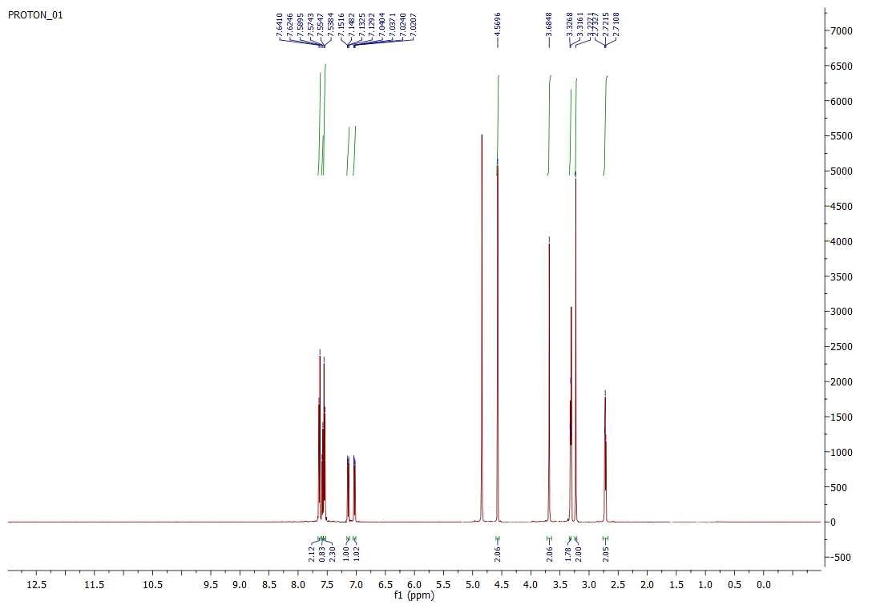

¹³C-NMR (125 MHz, CDCl₃)

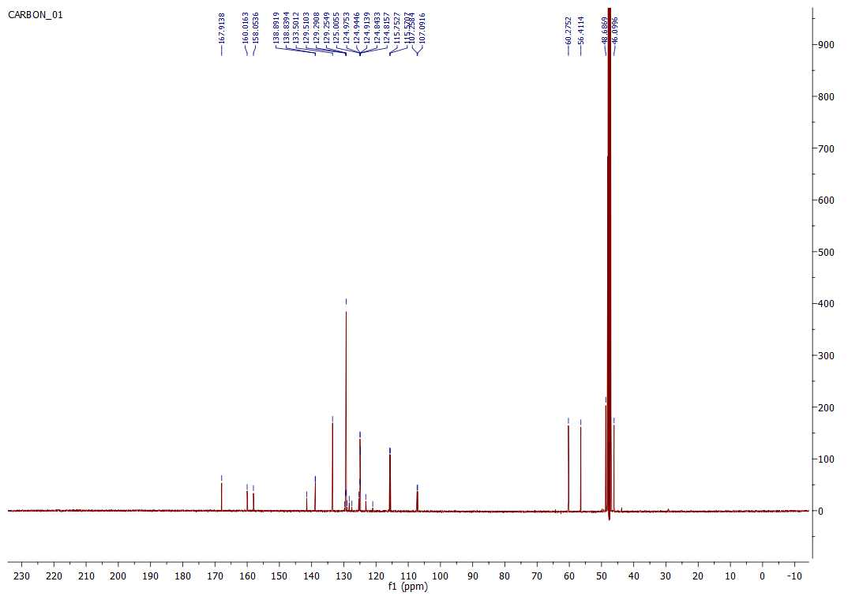

HPLC chromatogram (purity > 97 %)

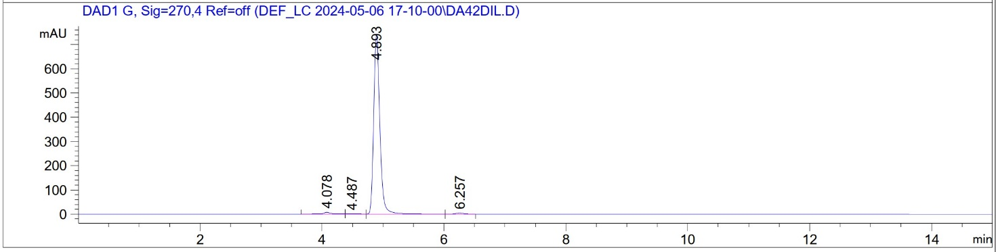

4-(2-(3,4-Dichlorophenyl)acetyl)-1-(4-(trifluoromethyl)benzyl)piperazin-2-one 31 (DA45)

¹H-NMR (500 MHz, DMSO)
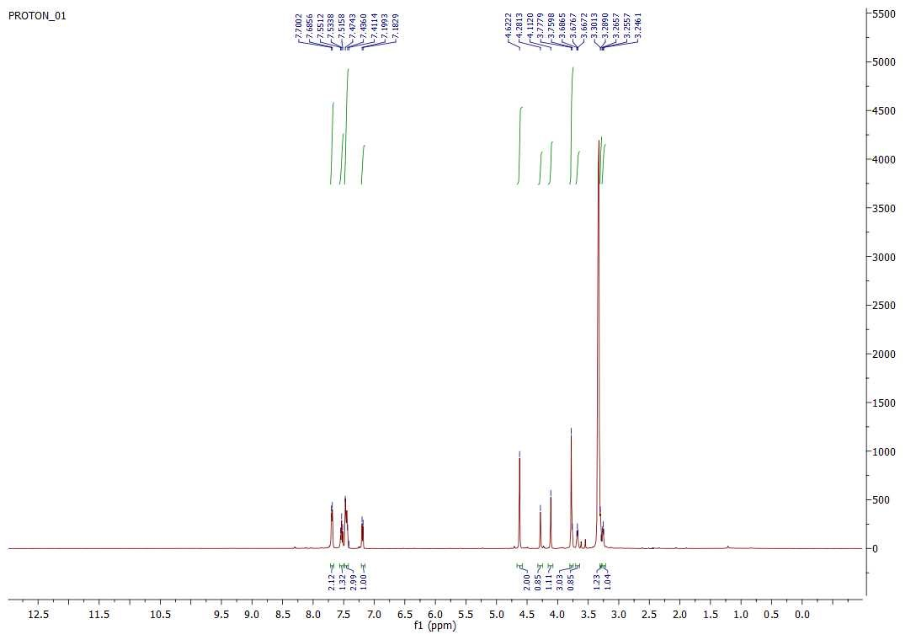

¹³C-NMR (125 MHz, DMSO)

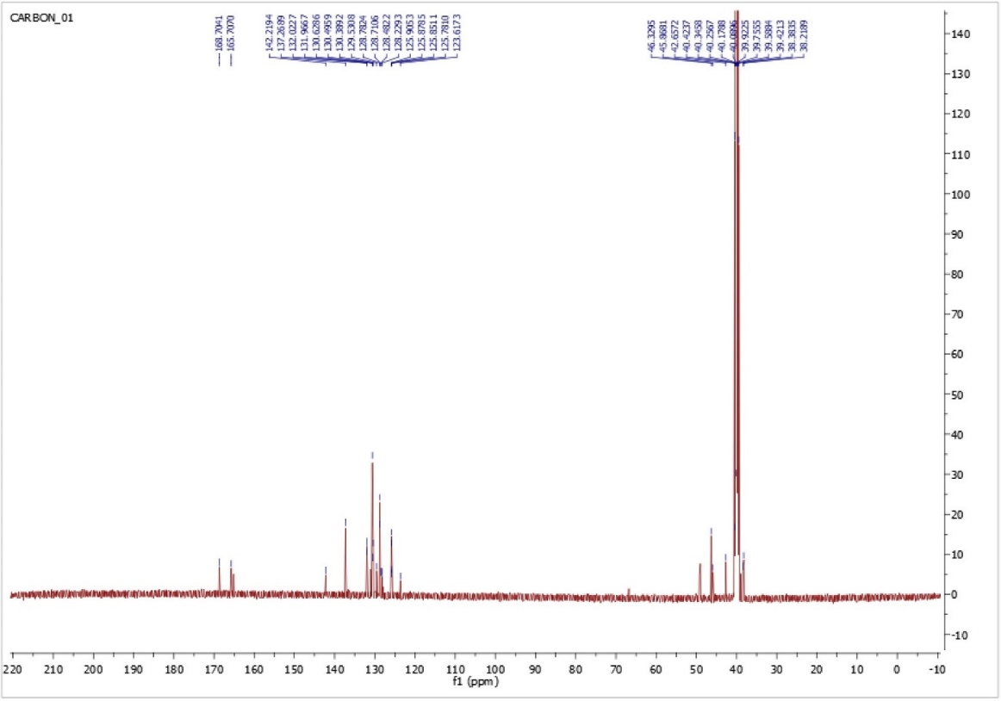
HPLC chromatogram (purity > 98 %)
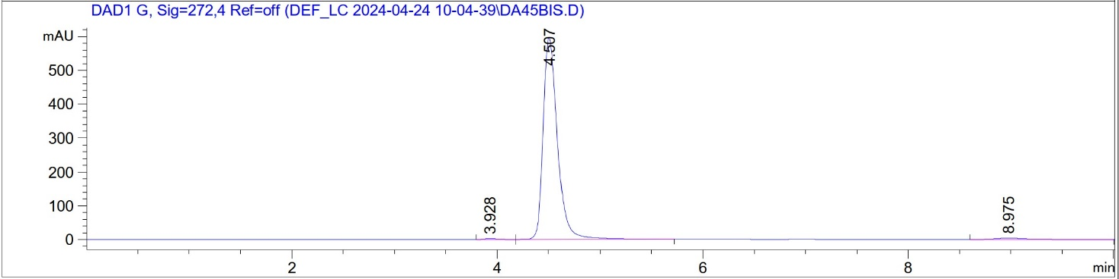

1,4-Dibenzylpiperazine-2,5-dione 33 (DA28)

¹H-NMR (300 MHz, CDCl₃)
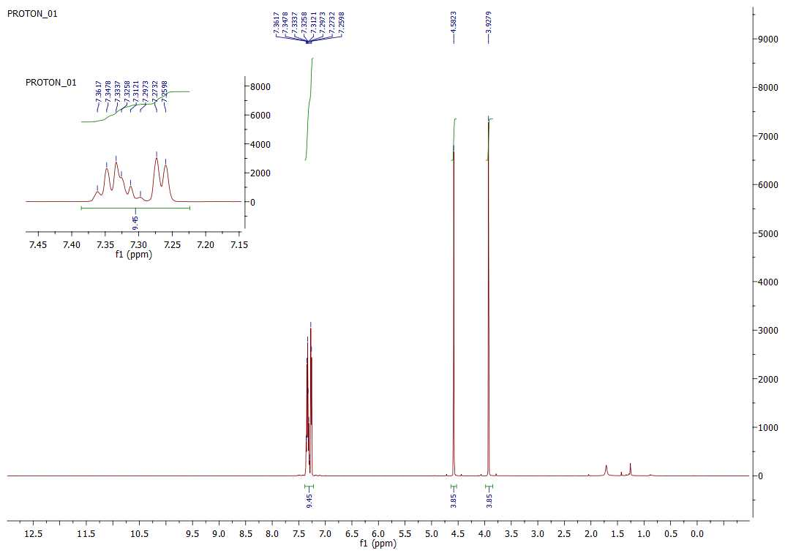

¹³C-NMR (125 MHz, CDCl₃)
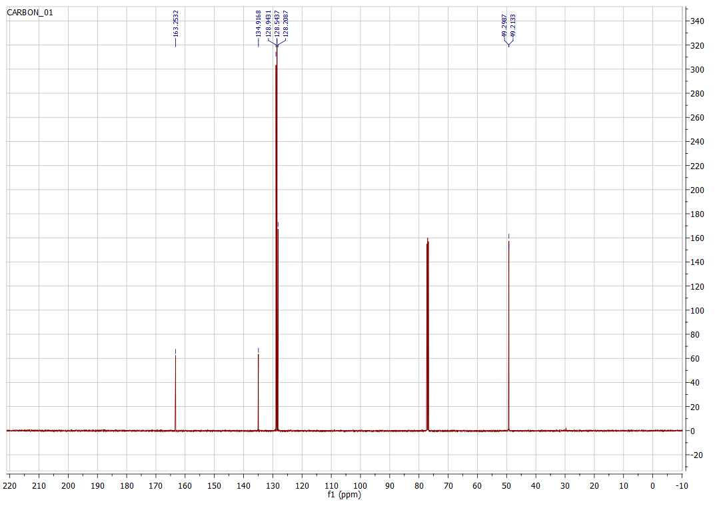

HPLC chromatogram (purity >99 %)
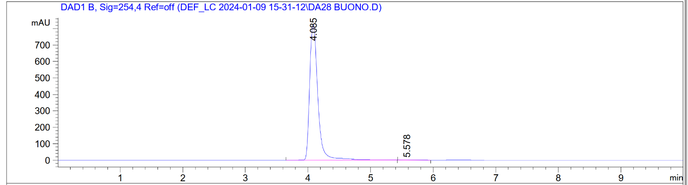

1,4-Bis(3-(trifluoromethyl)benzyl)piperazine-2,5-dione 34 (DA34)

¹H-NMR (500 MHz, CDCl₃)
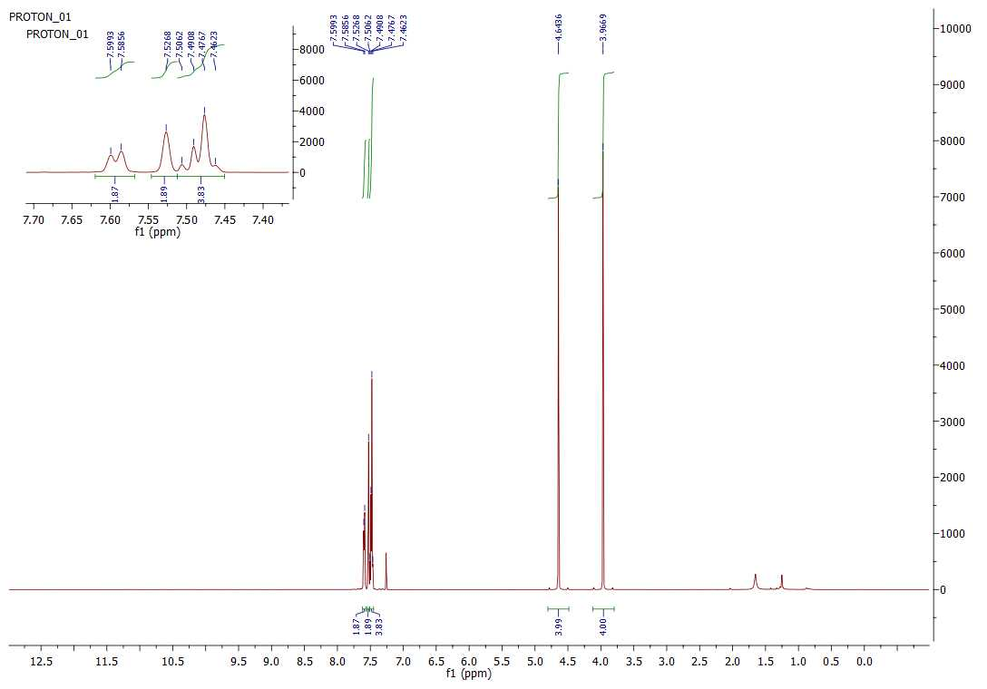

¹³C-NMR (125 MHz, CDCl₃)
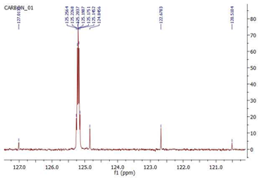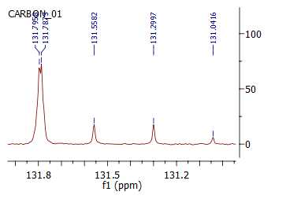

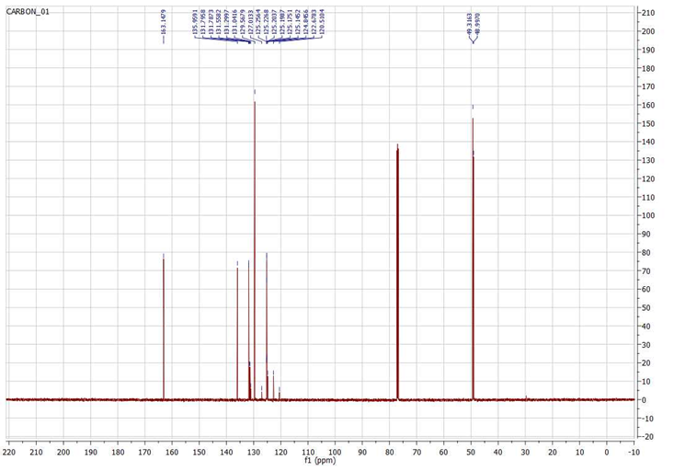
HPLC chromatogram (purity >99 %)
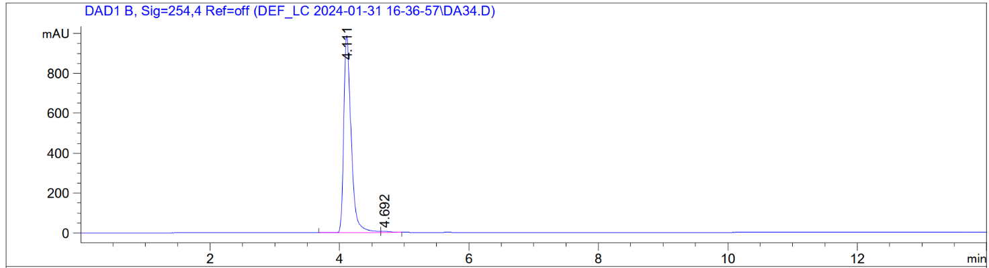

- Supplementary Table S1
Competition vs [³H]-N-Methylspiperone
Compound | hD₂R | hD₃R
Compound | pKi ± SEM | pKi ± SEM
9 (DA17) | <5 | <5
11 (DA24) | <5 | <5
12 (DA32) | <5 | <5
14 (DA33) | <5 | <5
15 (DA35) | <5 | <5
16 (DA53) | <5 | <5
26 (DA29) | <5 | <5
27 (DA42) | <5 | <5
31 (DA45) | <5 | <5
33 (DA28) | <5 | <5
34 (DA34) | <5 | <5

Table S1. Radioligand Binding Data for hD2R and hD3R. Radioligand competition binding assays performed on HEK293 cells stably expressing hD₂R and hD₃R in the presence of [³H]-N-Methylspiperone. Equilibrium dissociation constants (K_{i}) were derived from IC₅₀ values using the Cheng−Prusoff equation. pKi = -log₁₀(Ki). pKi <5 represents <50% inhibition at the highest tested concentration of 10 μM.

3. Supplementary Table S2
Human ClpP with 26 (DA29)
PDBID | 9Z3C
Wavelength | 0.979338
Resolution range | 34.41 - 2.781 (2.84 - 2.78)
Space group | C 1 2 1
Unit cell | 170.061 121.139 100.826 90 116.58 90
Total reflections | 332548
Unique reflections | 46004 (2866)
Multiplicity | 7.2
Completeness (%) | 99.95 (99.90)
Mean I/sigma(I) | 7.1
Wilson B-factor | 39.83
R-merge | 0.296
R-meas | 0.347
R-pim | 0.179
CC1/2 | 0.977
CC* | 0.994
Reflections used in refinement | 46004 (2866)
Reflections used for R-free | 2307 (150)
R-work | 0.1898 (0.3009)
R-free | 0.2407 (0.3657)
Number of non-hydrogen atoms | 9818
macromolecules | 9479
ligands | 209
solvent | 130
Protein residues | 1223
Nucleic acid bases | 0
RMS (bonds) | 0.002
RMS (angles) | 0.51
Ramachandran favored (%) | 95.94
Ramachandran allowed (%) | 4.06
Ramachandran outliers (%) | 0
Rotamer outliers (%) | 0.67
Clashscore | 3.25
Average B-factor | 40.04
macromolecules | 40.01
ligands | 43.49
solvent | 37.04
*Statistics for the highest resolution shells are found in parentheses

Table S2. Data collection and refinement statistics for hClpP bound with 26 (DA29).

4. Supplementary Table S3

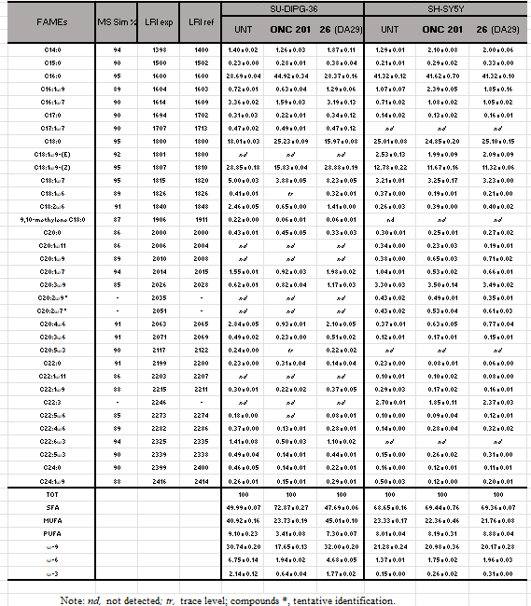

Table S3. List of fatty acids detected in SH-SY5Y and SU-DIPG-36 cell lines untreated and treated with ONC201 and 26 (DA29). Identification parameters: mass spectral similarity (MS sim.); experimental linear retention index (LRI exp.); reference linear retention index (LRI ref.). FAMEs amounts were expressed in area % (GC-FID area normalized) ± standard deviation. Fatty acids were also grouped in chemical class as follows: SFA: saturated fatty acid; MUFA: monounsaturated fatty acid; PUFA: polyunsaturated fatty acid; ω-9: omega-9; ω-6: omega-6; ω-3: omega-3. UN= Untreated.

5. Supplementary Table S3

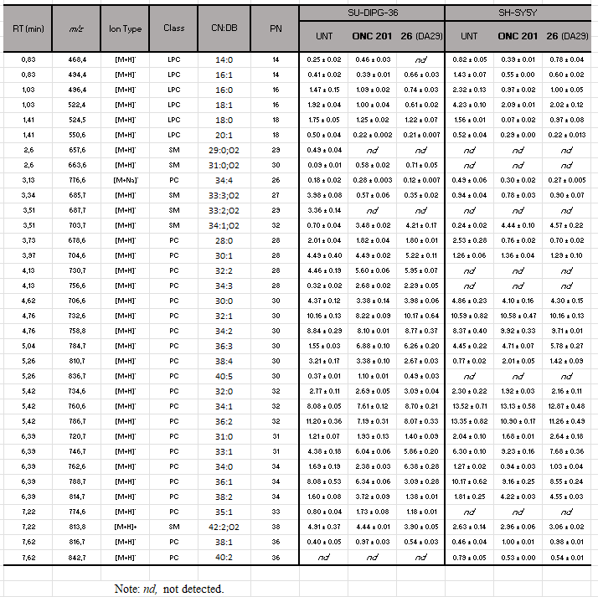

Table S3. List of lysophosphocholine (LPC), phoshocholine (PC), and sphingomyelin (SM) detected in SH-SY5Y and SU-DIPG-36 cell lines untreated and treated with ONC201 and 26 (DA29). Abbreviations: RT (min), retention time; m/z, mass/charge ratio; CN:DB, carbon number and double bond; PN: partition number. Lipid amounts were expressed in area % ± standard deviation. UNT=Untreated.
6. Supplementary Table S5

RT (min) | m/z | Ion Type | Class | CN:DB | PN | SU-DIPG-36 |  |  | SH-SY5Y
 |  |  |  |  |  | UNT | ONC  201 | 26 | UNT | ONC 201 | 26
9.67 | 844.6 | [M+NH4]⁺ | TG | 50:4 | 42 | 0.41 ± 0.01 | 1.49 ± 0.05 | 1.06 ± 0.09 | 1.10 ± 0.09 | 0.60 ± 0.00 | 0.59 ± 0.01
9.67 | 870.7 | [M+NH4]⁺ | TG | 52:5 | 42 | 0.09 ± 0.00 | - ± - | - ± - | 1.04 ± 0.02 | - ± - | - ± -
9.97 | 794.8 | [M+NH4]⁺ | TG | 46:1 | 44 | 2.27 ± 0.16 | 5.24 ± 0.33 | 4.67 ± 0.34 | 1.78 ± 0.09 | 3.49 ± 0.04 | 3.31 ± 0.02
9.97 | 820.8 | [M+NH4]⁺ | TG | 48:2 | 44 | 2.15 ± 0.37 | 7.21 ± 0.33 | 8.82 ± 0.41 | 2.21 ± 0.11 | 5.43 ± 0.17 | 4.50 ± 0.07
9.97 | 846.8 | [M+NH4]⁺ | TG | 50:3 | 44 | 1.94 ± 0.23 | 5.20 ± 0.11 | 6.41 ± 0.05 | 1.12 ± 0.06 | 2.67 ± 0.05 | 2.05 ± 0.07
9.97 | 872.9 | [M+NH4]⁺ | TG | 52:4 | 44 | 0.73 ± 0.07 | 3.28 ± 0.16 | 1.91 ± 0.16 | 0.77 ± 0.06 | 1.26 ± 0.02 | 1.29 ± 0.05
11.00 | 796.9 | [M+NH4]⁺ | TG | 46:0 | 46 | 1.90 ± 0.13 | 2.87 ± 0.09 | 1.97 ± 0.16 | 2.34 ± 0.20 | 1.62 ± 0.04 | 1.91 ± 0.03
11.00 | 822.9 | [M+NH4]⁺ | TG | 48:1 | 46 | 5.68 ± 0.53 | 6.40 ± 0.08 | 7.02 ± 0.17 | 6.56 ± 0.39 | 6.86 ± 0.09 | 6.87 ± 0.19
11.00 | 848.9 | [M+NH4]⁺ | TG | 50:2 | 46 | 5.67 ± 0.53 | 8.87 ± 0.13 | 8.64 ± 0.38 | 8.49 ± 0.68 | 9.85 ± 0.02 | 10.39 ± 0.42
11.00 | 874.9 | [M+NH4]⁺ | TG | 52:3 | 46 | 1.40 ± 0.13 | 9.26 ± 0.23 | 8.55 ± 0.31 | 5.73 ± 0.21 | 6.52 ± 0.08 | 6.95 ± 0.40
11.00 | 900.7 | [M+NH4]⁺ | TG | 54:4 | 46 | 0.94 ± 0.13 | 3.91 ± 0.19 | 4.14 ± 0.25 | 1.76 ± 0.04 | 1.60 ± 0.06 | 2.13 ± 0.07
12.25 | 850.9 | [M+NH4]⁺ | TG | 50:1 | 48 | 4.45 ± 0.54 | 6.24 ± 0.11 | 7.45 ± 0.11 | 12.30 ± 0.12 | 10.01 ± 0.14 | 9.43 ± 0.15
12.25 | 876.9 | [M+NH4]⁺ | TG | 52:2 | 48 | 11.13 ± 0.33 | 13.64 ± 0.05 | 13.75 ± 0.24 | 15.78 ± 0.76 | 14.04 ± 0.05 | 13.90 ± 0.11
12.25 | 902.9 | [M+NH4]⁺ | TG | 54:3 | 48 | 19.37 ± 1.14 | 12.33 ± 0.62 | 13.78 ± 0.54 | 11.64 ± 0.51 | 12.30 ± 0.79 | 11.59 ± 0.19
13.99 | 878.9 | [M+NH4]⁺ | TG | 52:1 | 50 | 13.49 ± 0.62 | 3.84 ± 0.11 | 3.50 ± 0.17 | 10.76 ± 0.58 | 8.20 ± 0.22 | 8.04 ± 0.59
13.99 | 904.8 | [M+NH4]⁺ | TG | 54:2 | 50 | 17.60 ± 0.93 | 6.19 ± 0.17 | 5.19 ± 0.10 | 9.88 ± 0.35 | 8.95 ± 0.28 | 10.41 ± 0.66
13.99 | 930.9 | [M+NH4]⁺ | TG | 56:3 | 50 | 7.17 ± 0.36 | 2.56 ± 0.08 | 1.95 ± 0.11 | 2.92 ± 0.05 | 3.89 ± 0.03 | 4.07 ± 0.17
15.14 | 906.8 | [M+NH4]⁺ | TG | 54:1 | 52 | 3.62 ± 0.29 | 1.48 ± 0.02 | 1.19 ± 0.09 | 3.82 ± 0.07 | 2.71 ± 0.04 | 2.58 ± 0.11

Table S5. List of triglycerides (TGs) detected in SH-SY5Y and SU-DIPG-36 cell lines untreated and treated with ONC201 and 26 (DA29). Abbreviations: RT (min), retention time; m/z, mass/charge ratio; CN:DB, carbon number and double bond; PN: partition number. Lipid amounts were expressed in area % ± standard deviation. UNT= Untreated.

7. Supplementary Table S6
 | SU-DIPG-36 |  | SH-SY5Y
Lipid | ONC201 | 26 (DA29) | ONC201 | 26 (DA29)
LPC 14:0 | ↑ | ↓ | ↓ | ns
LPC 16:1 | ns | ↑ | ↓ | ↓
LPC 16:0 | ↓ | ↓ | ↓ | ↓
LPC 18:1 | ↓ | ↓ | ↓ | ↓
LPC 18:0 | ↓ | ↓ | ↓ | ↓
LPC 20:1 | ↓ | ↓ | ↓ | ↓
SM 29:0;O2 | ↓ | ↓ | nd | nd
SM 31:0;O2 | ↑ | ↑ | nd | nd
PC 34:4 | ↑ | ns | ↓ | ↓
SM 33:3;O2 | ↓ | ↓ | ↓ | ns
SM 33:2;O2 | ↓ | ↓ | nd | nd
SM 34:1;O2 | ↑ | ↑ | ↑ | ↑
PC 28:0 | ↓ | ↓ | ↓ | ↓
PC 30:1 | ns | ↑ | ns | ns
PC 32:2 | ↑ | ↑ | nd | nd
PC 34:3 | ↑ | ↑ | nd | nd
PC 30:0 | ↓ | ↓ | ↓ | ns
PC 32:1 | ↓ | ns | ns | ns
PC 34:2 | ↓ | ns | ↑ | ↑
PC 36:3 | ↑ | ↑ | ns | ↑
PC 38:4 | ns | ↓ | ↑ | ↑
PC 40:5 | ↑ | ↑ | nd | nd
PC 32:0 | ns | ↑ | ns | ns
PC 34:1 | ↓ | ↑ | ns | ns
PC 36:2 | ↓ | ↓ | ↓ | ↓
PC 31:0 | ↑ | ↑ | ↓ | ↑
PC 33:1 | ↑ | ↑ | ↑ | ↑
PC 34:0 | ↑ | ↑ | ↓ | ↓
PC 36:1 | ↓ | ↓ | ns | ns
PC 38:2 | ↑ | ns | ↑ | ↑
PC 35:1 | ↑ | ↑ | nd | nd
SM 42:2;O2 | ns | ↓ | ↑ | ↑
PC 38:1 | ↑ | ↑ | ↑ | ↑
PC 40:2 | nd | nd | ↓ | ↓

Table S6. Choline-containing lipids identified in the SU-DIPG-36 and SH-SY5Y cell lines and their relative trends upon 24 h treatment with ONC201 and 26 (DA29). Legend: ↑, significant increase; ↓, significant decrease; ns, not significant; nd, not detected.
8. Supplementary Table S7

 | SU-DIPG-36 |  | SH-SY5Y
Lipid | ONC201 | 26 (DA29) | ONC201 | 26 (DA29)
TG 50:4 | ↑ | ↑ | ↓ | ↓
TG 52:5 | ↓ | ↓ | ↓ | ↓
TG 46:1 | ↑ | ↑ | ↑ | ↑
TG 48:2 | ↑ | ↑ | ↑ | ↑
TG 50:3 | ↑ | ↑ | ↑ | ↑
TG 52:4 | ↑ | ↑ | ↑ | ↑
TG 46:0 | ↑ | ns | ↓ | ns
TG 48:1 | ns | ↑ | ns | ns
TG 50:2 | ↑ | ↑ | ↑ | ↑
TG 52:3 | ↑ | ↑ | ↑ | ↑
TG 54:4 | ↑ | ↑ | ns | ns
TG 50:1 | ↑ | ↑ | ↓ | ↓
TG 52:2 | ↑ | ↑ | ↓ | ↓
TG 54:3 | ↓ | ↓ | ns | ns
TG 52:1 | ↓ | ↓ | ↓ | ↓
TG 54:2 | ↓ | ↓ | ↓ | ns
TG 56:3 | ↓ | ↓ | ↑ | ↑
TG 54:1 | ↓ | ↓ | ↓ | ↓

Table S7. Triacylglycerols (TG) identified in SU-DIPG-36 and SH-SY5Y cell lines and their relative trends upon 24 h treatment with ONC201 and 26 (DA29). Legend: ↑, significant increase; ↓, significant decrease; ns, not significant; nd, not detected.
9. Supplementary Figure S1

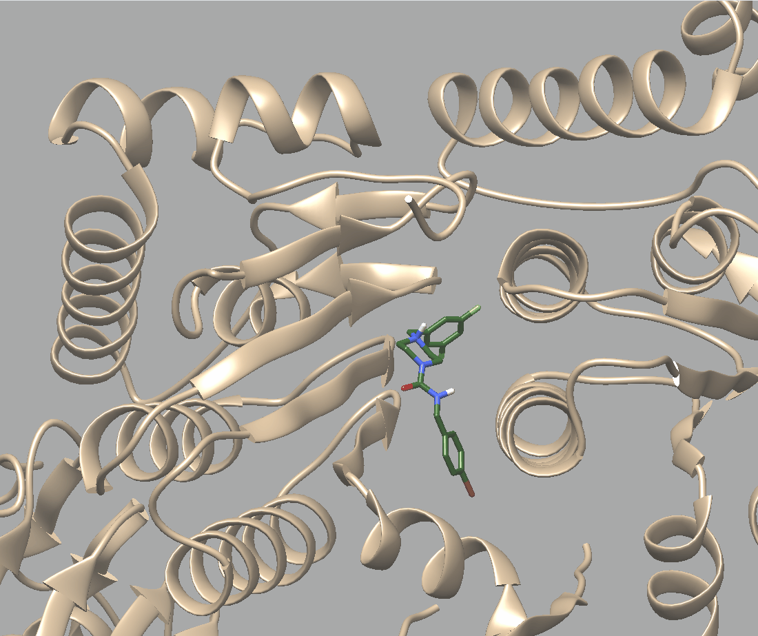 | 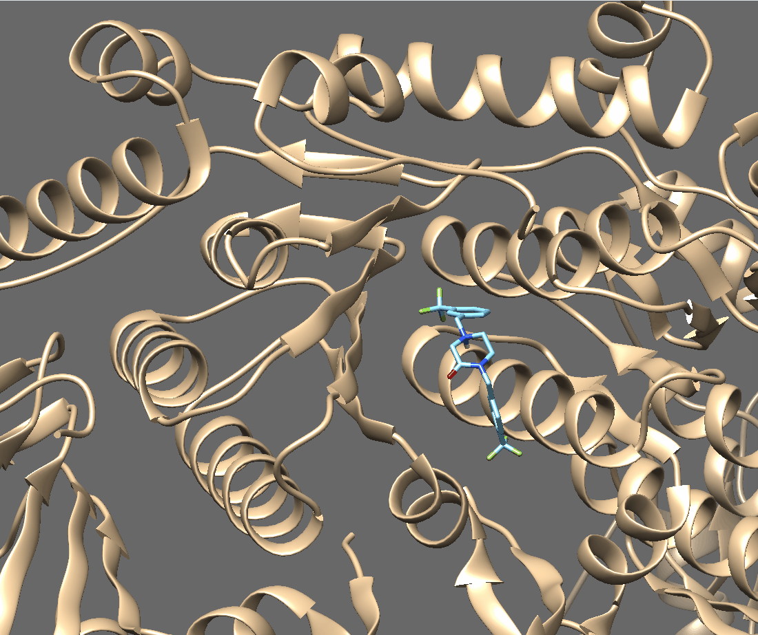
ZK53 | 26 (DA29)

Candidate | Glob-Prod | Glob-Sum | Distance | H | N1 | DRY | O
26 (DA29) | 0.71519 | 2.66693 | 9.37175 | 0.975046 | 0 | 1.61296 | 0.22648
ZK53 | 0.568031 | 2.32319 | 8.3225 | 0.961466 | 0.1117 | 1.53997 | 0.214764

FLAP analysis shows that 26 (DA29) achieves higher Glob-Prod and Glob-Sum scores than ZK53, reflecting a better field overlap. Both compounds share similar hydrogen-bonding contributions, but 26 (DA29) exhibits stronger hydrophobic interactions and slightly higher oxygen-based contributions, supporting its stronger binding profile. From the FLAP screening, 26 (DA29) occupies a lateral position within the pocket, comparable to ZK53. The 2D poses indicate highly similar interaction areas, with 26 (DA29) showing an increase in donor/acceptor hydrogen-bond regions. Both ligands interact with W146 and Y118 through π–π and CH–π contacts, while 26 (DA29) additionally engages V145 via hydrogen bonding. The two CF₃ groups of 26 (DA29) expand the interaction surface, enhancing binding (Data not shown).

Molecular docking with AutoDock Vina confirmed these findings: 26 (DA29) displayed a binding energy of −10.3 kcal/mol compared with −9.3 kcal/mol for ZK53, consistent with the stronger interaction profile predicted by FLAP. Computational studies were performed using FLAP (v2.2.2) in structure-based virtual screening mode. Molecular Interaction Fields (MIFs) were calculated with the GRID algorithm on the crystal structure of hClpP in complex with ZK53 (PDB code: 8HGK, 1.90 Å). Docking validation was conducted with AutoDock Vina (via UCSF Chimera) using grid boxes defined from the FLAP-identified pocket and visualized with PyMOL.

10. Supplementary Figure S2

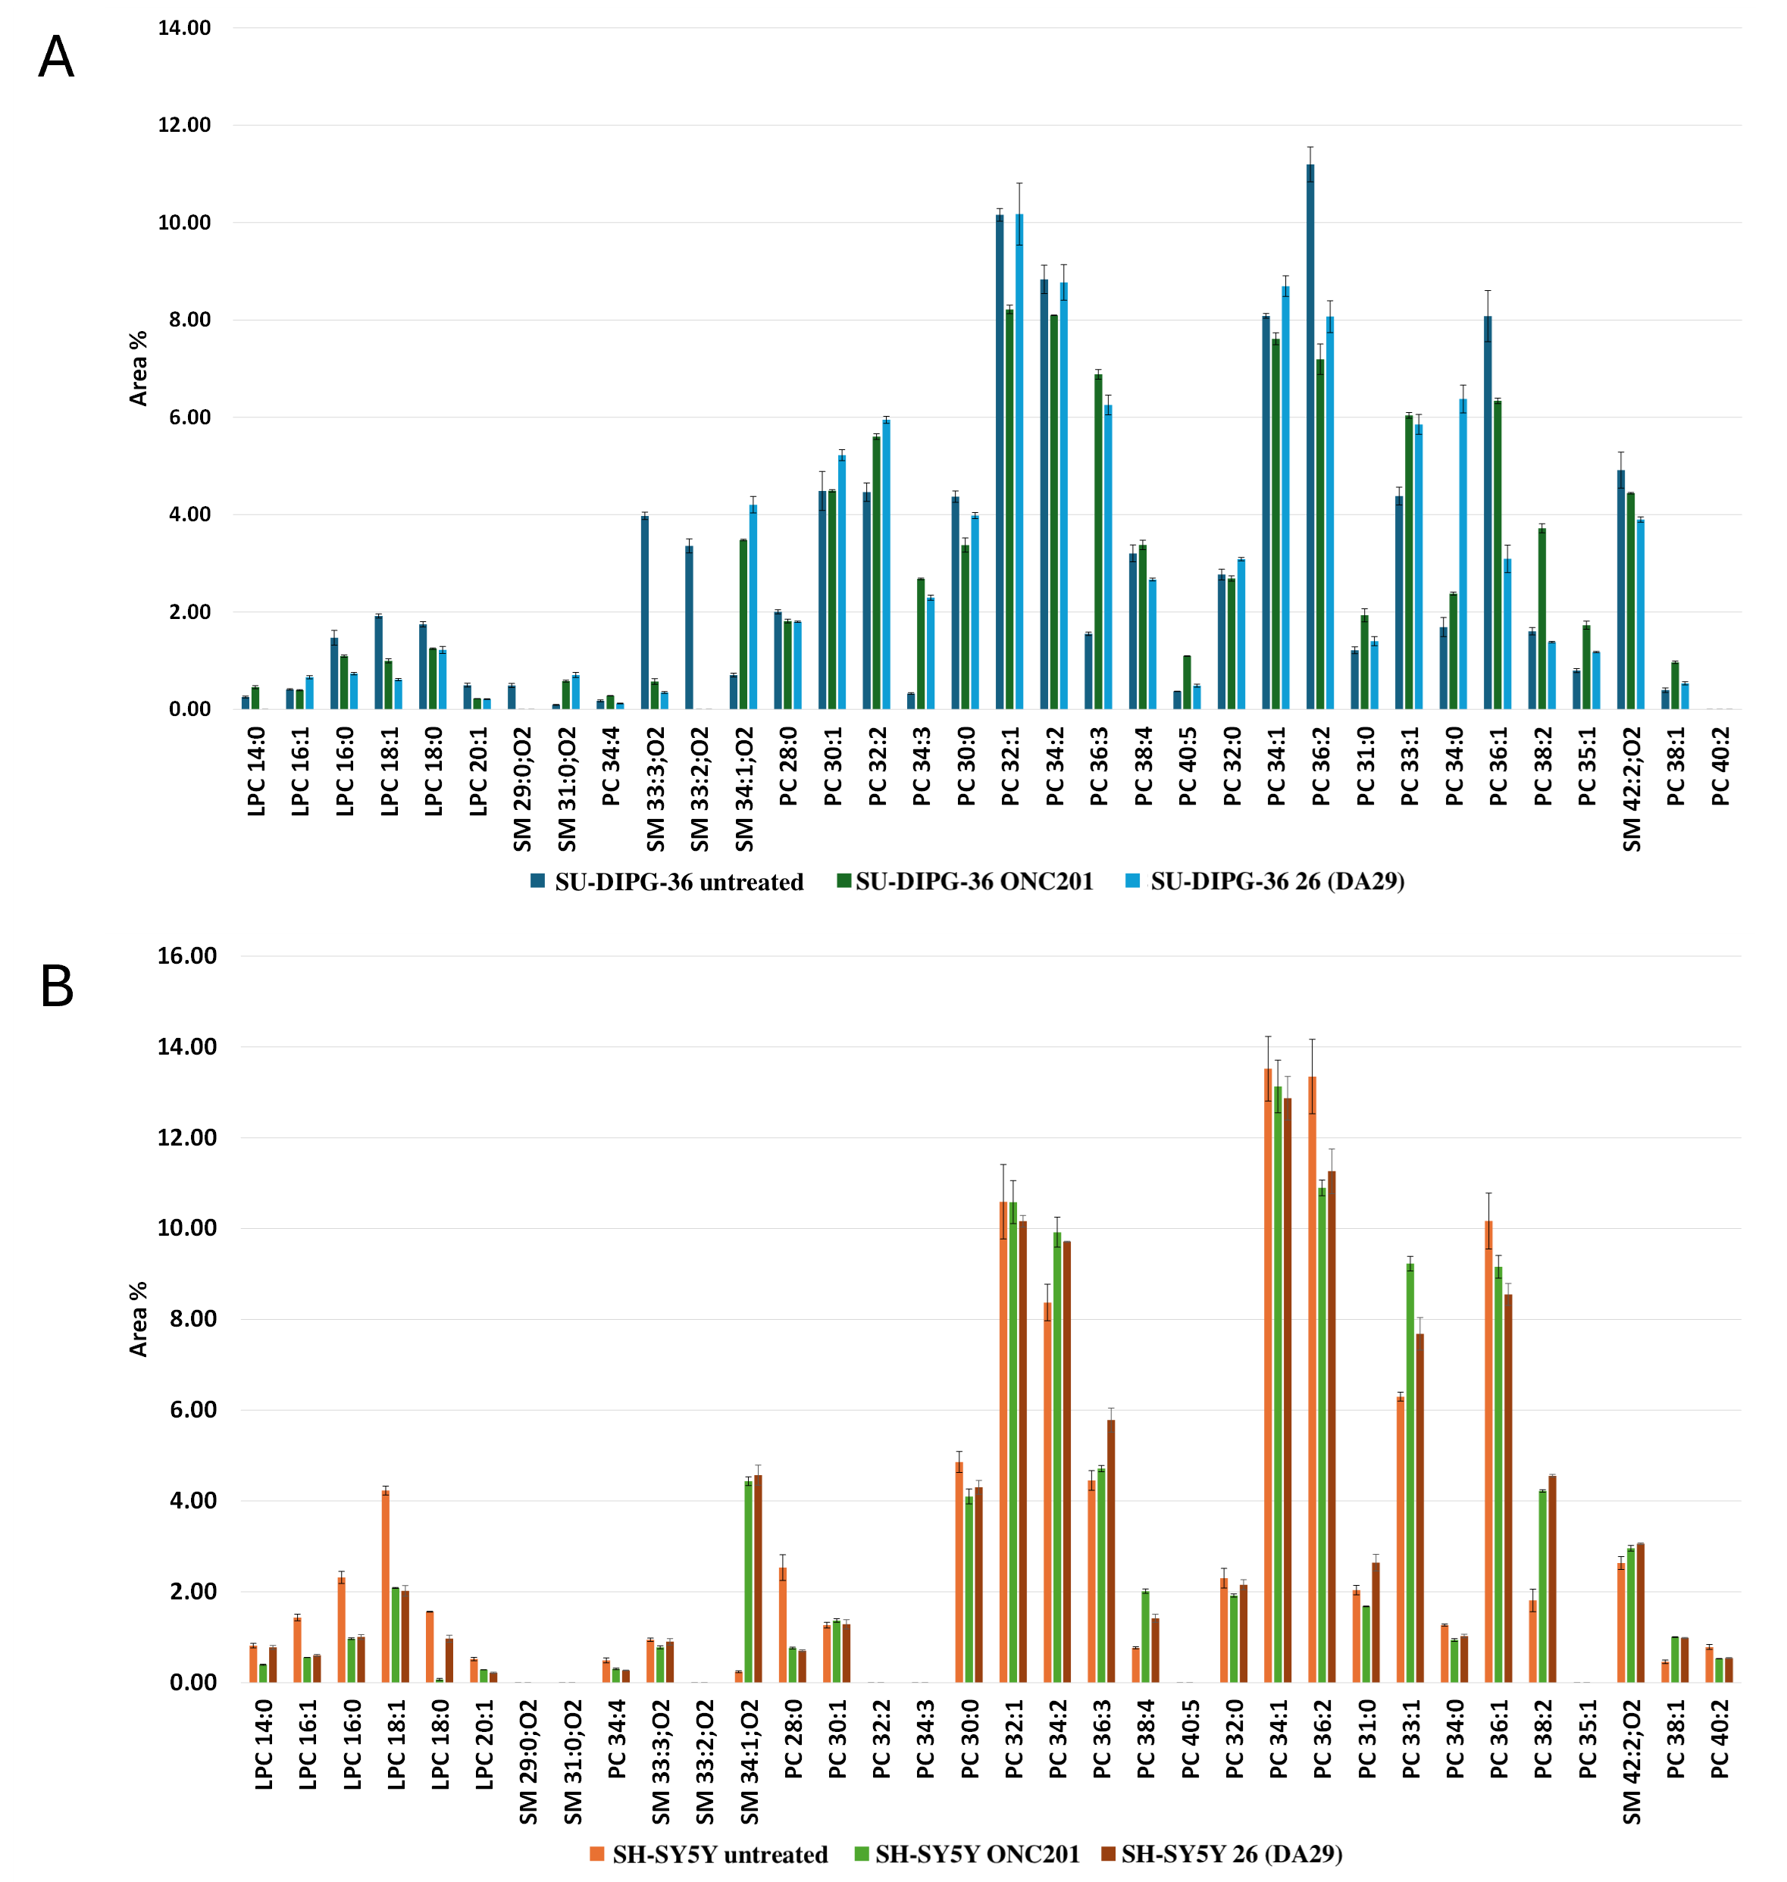
Figure S2. Histograms related to the percentage content of choline-containing lipids (LPCs, PCs and SMs), reported according to increasing retention time for SU-DIPG-36 (A) and SH-SY5Y (B) cells untreated and treated with ONC201 and 26 (DA29). For each identified species, the error bars indicate the standard deviation.

11. Supplementary Figure S3
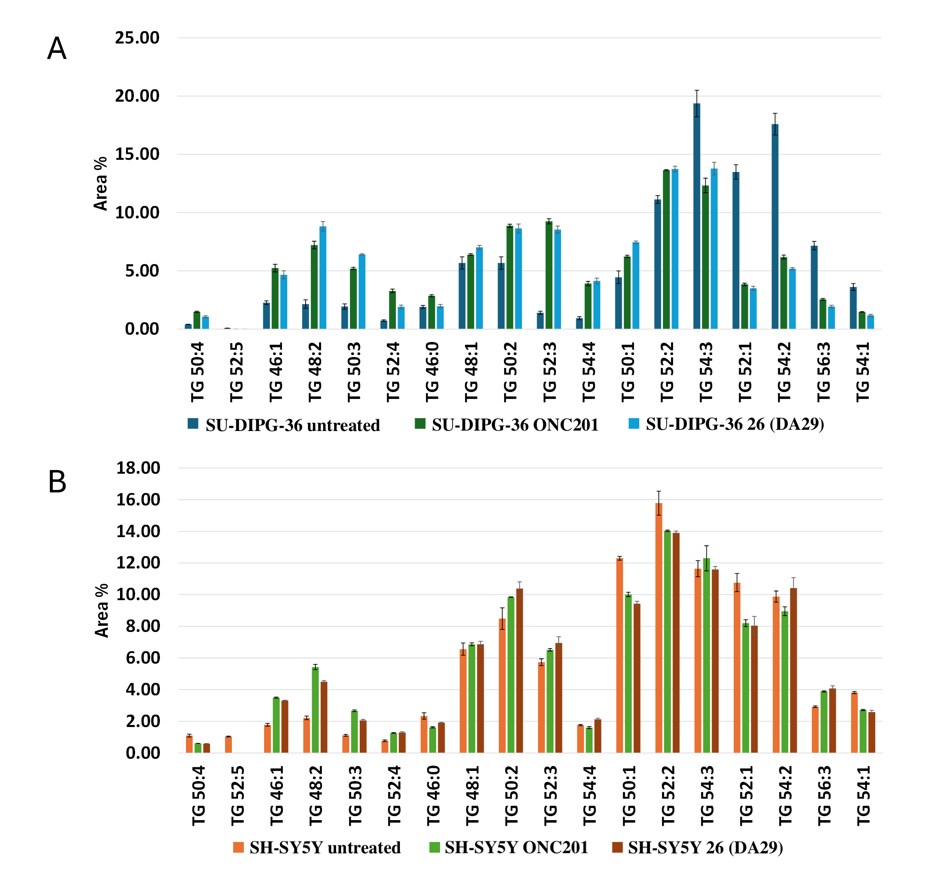
Figure S3. Histograms related to the percentage content of TGs, reported according to increasing retention time for SU-DIPG-36 (A) and SH-SY5Y (B) cells untreated and treated with ONC201 and 26 (DA29). For each identified species, the error bars indicate the standard deviation.

