Supplementary information

Figure 1. Evaluating occlusal patterns with the Bruxchecker

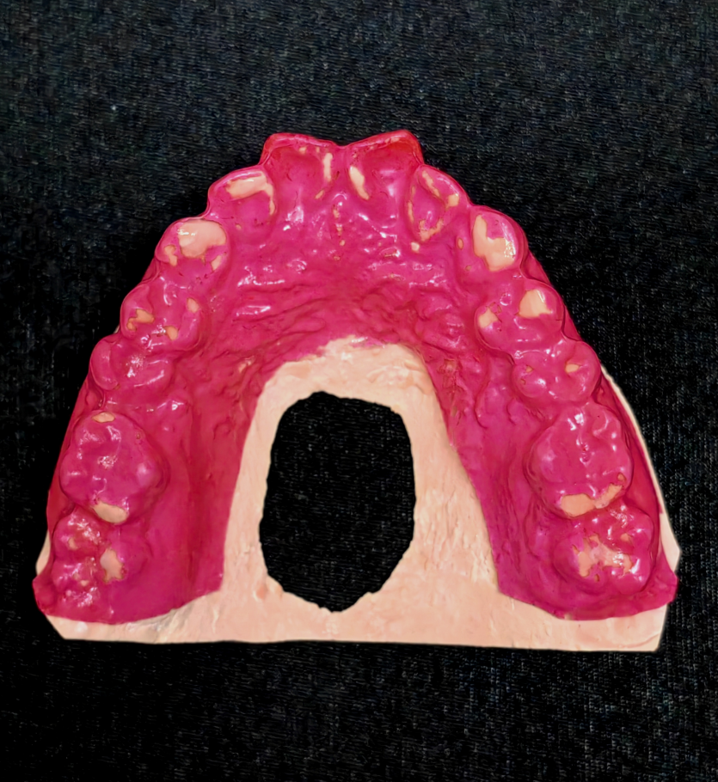

*
Working - side tooth guidance
Non-working side lateral occlusal interference

Figure 2. Measurement of cusp guidance slope
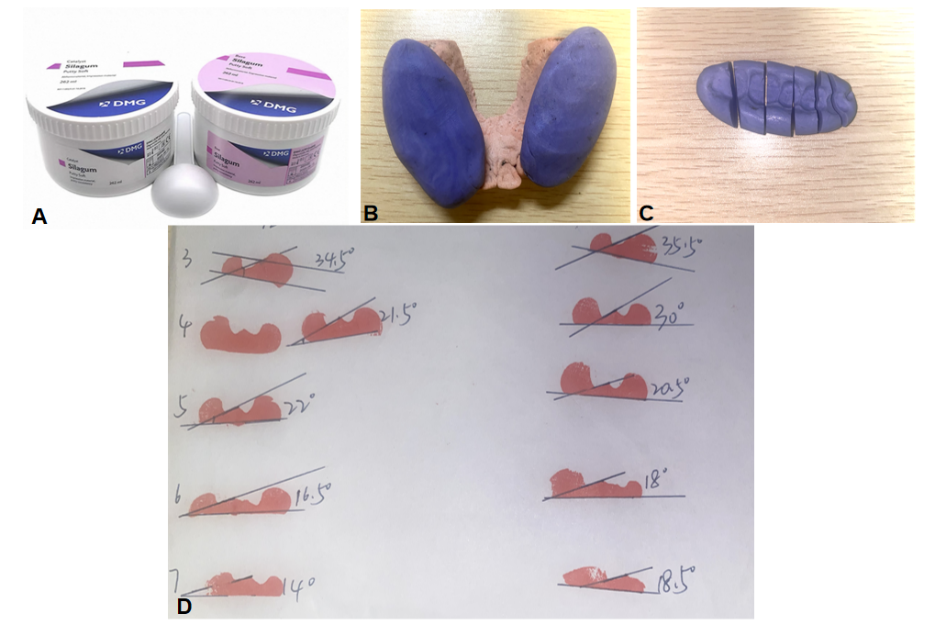

* A: Silicone rubber impression material is prepared according to the manufacturer's specifications.
B: An impression of the maxillary dental arch is made using the prepared silicone rubber material, capturing the occlusal surfaces and cusp details
C: The cured silicone impression is carefully sectioned (cut) along the guide planes formed by the cuspal inclines during functional movements. This sectioning exposes the internal surfaces corresponding to these guide planes.
D: Each exposed guide plane surface within the sectioned impression is coated with transfer ink. The inked guide plane surface is then precisely transferred onto white paper by contacting the paper with the inked surface. The resulting tracing on the paper represents the angle of the specific cuspal incline. This angle is then measured directly from the tracing on the paper.

Figure 3. Analysis of malocclusion measurements
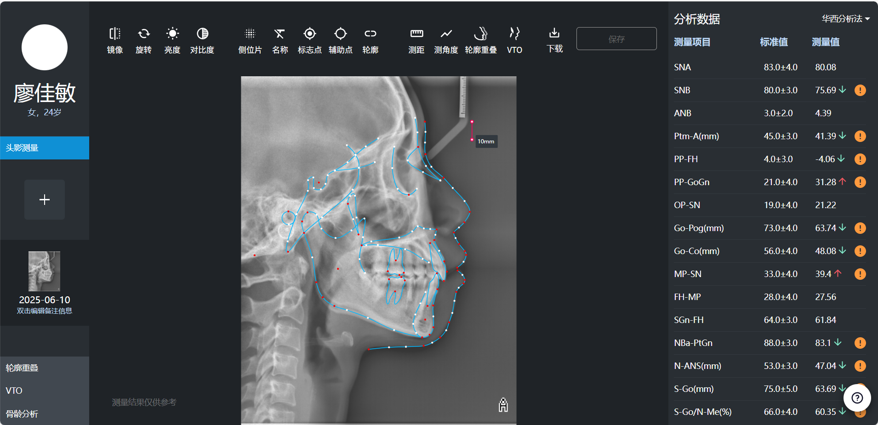
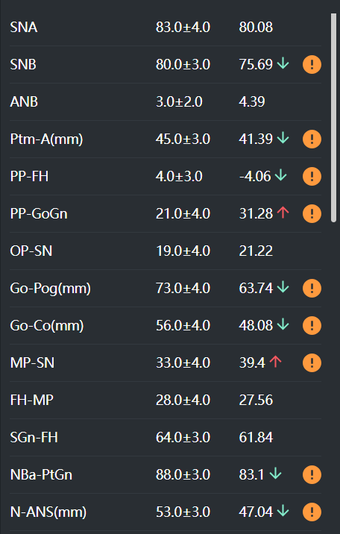

* ANB: A point–Nasion–B point angle; MP-SN: Mandibular Plane to Sella–Nasion plane angle; OP-SN：Occlusal Plane to Sella–Nasion plane angle

Table 1. DASS-21 Psychometric Scale
DASS-21Name: Date:
Please read each statement and circle a number 0, 1, 2 or 3 which indicates how much the statement applied to you over the past week. There are no right or wrong answers. Do not spend too much
time on any statement.
The rating scale is as follows:
0 Did not apply to me at all
1 Applied to me to some degree, or some of the time
2 Applied to me to a considerable degree or a good part of time
3 Applied to me very much or most of the time
1 (s)  2 (a)  3 (d)  4 (a)  5 (d)  6 (s)  7 (a)  8 (s)  9 (a)  10 (d)  11 (s)  12 (s)  13 (d)  14 (s)  15 (a)  16 (d)  17 (d)  18 (s)  19 (a)  20 (a)  21 (d) | I found it hard to wind down  I was aware of dryness of my mouth  I couldn’t seem to experience any positive feeling at all  I experienced breathing difficulty (e.g. excessively rapid breathing, breathlessness in the absence of physical exertion)  I found it difficult to work up the initiative to do things  I tended to over-react to situations  I experienced trembling (e.g. in the hands)  I felt that I was using a lot of nervous energy  I was worried about situations in which I might panic and make a fool of myself  I felt that I had nothing to look forward to  I found myself getting agitated  I found it difficult to relax  I felt down-hearted and blue  I was intolerant of anything that kept me from getting on with what I was doing  I felt I was close to panic  I was unable to become enthusiastic about anything  I felt I wasn’t worth much as a person  I felt that I was rather touchy  I was aware of the action of my heart in the absence of physical exertion (e.g. sense of heart rate increase, heart missing a beat)  I felt scared without any good reason  I felt that life was meaningless | 0  0  0  0  0  0  0  0  0  0  0  0  0  0  0  0  0  0  0  0  0 | 1  1  1  1  1  1  1  1  1  1  1  1  1  1  1  1  1  1  1  1  1 | 2  2  2  2  2  2  2  2  2  2  2  2  2  2  2  2  2  2  2  2  2 | 3  3  3  3  3  3  3  3  3  3  3  3  3  3  3  3  3  3  3  3  3

