Supplementary materials

Sleep loss differentially reconfigures neural circuits governing pain and neuropsychological homeostasis

Teruyo Kishino, Yasuyuki Nagumo, Yusuke Hamada, Michiko Narita, Takumi Yoshizawa, Jion Takise, Tomohisa Mori, Yukari Suda, Naoko Kuzumaki, Minoru Narita

Contents:
Supplementary Table
Supplementary Table. 1: Primer sequences used by RT-qPCR.
Supplementary Fig. 1: Regional expression patterns of opioid-related genes under sleep-deprived conditions.

Supplementary Table 1. Primer sequences used by RT-qPCR.

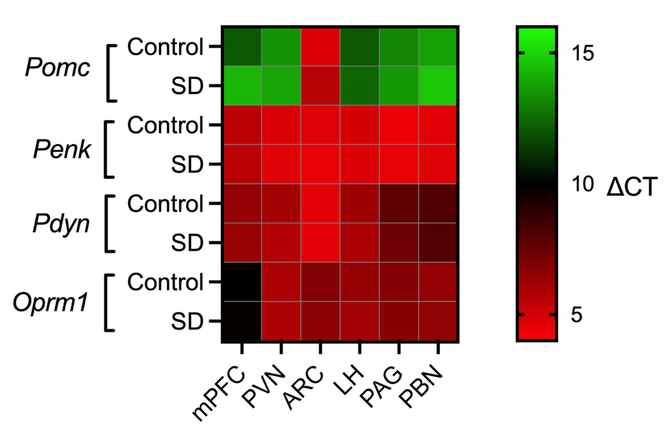
Supplementary Fig. 1. Region-specific expression landscapes of opioid-related transcripts following sleep deprivation.

Heatmaps illustrate relative mRNA abundance (ΔCt values) of Pomc, Penk, Pdyn, and Oprm1 across the medial prefrontal cortex (mPFC), paraventricular nucleus (PVN), arcuate nucleus (ARC), lateral hypothalamus (LH), periaqueductal gray (PAG), and parabrachial nucleus (PBN) in control and sleep-deprived mice. A lower ΔCt reflects higher gene expression.

