Supplementary Tables

Table S1 Summary of SNPs used for GWAS analysis in the rice genetic resource
Chr | Length  (bp, IRGSP-1.0) | SNP position  (bp, start-end) | No. of SNPs | SNPs/Mb
1 | 43,270,923 | 1,695−43,269,728 | 37,852 | 860.3
2 | 35,937,250 | 1,933−35,935,363 | 33,110 | 919.7
3 | 36,413,819 | 2,137−36,402,891 | 33,400 | 902.7
4 | 35,502,694 | 5,098−3,549,193 | 22,160 | 615.6
5 | 29,958,434 | 28,278−29,766,349 | 21,579 | 719.3
6 | 31,248,787 | 40,333−31,236,749 | 24,680 | 771.3
7 | 29,697,621 | 4,996−29,682,463 | 21,120 | 704.0
8 | 28,443,022 | 10,132−28,439,244 | 20,976 | 723.3
9 | 23,012,720 | 38,929−22,938,953 | 18,284 | 795.0
10 | 23,207,287 | 4,426−23,205,938 | 18,890 | 787.1
11 | 29,021,106 | 25,385−29,011,352 | 20,967 | 698.9
12 | 27,531,856 | 51,004−27,529,256 | 16,551 | 591.1
Total (aver.) | 373,245,519 | - | 289,569  (24,131) | (757.4)

Table S2 List of ORFs within ±150 kb of the peak SNPs
Chr | MSU ID | RAP ID | Function
7 | LOC_Os07g39470 | Os07g0583600 | gibberellin response modulator protein, putative, expressed
 | LOC_Os07g39480 | Os07g0583700 | WRKY87, expressed
 | LOC_Os07g39490 | Os07g0583800 | expressed protein
 | LOC_Os07g39500 | Os07g0583900 | expressed protein
 | LOC_Os07g39510 | Os07g0584000 | yippee zinc-binding protein, putative, expressed
 | LOC_Os07g39520 | Os07g0584100 | STE_PAK_Ste20_Slob_Wnk.5 - STE kinases include homologs to sterile 7, sterile 11 and sterile 20 from yeast, expressed
 | LOC_Os07g39530 | Os07g0584200 | BTBN16 - Bric-a-Brac, Tramtrack, Broad Complex BTB domain with non-phototropic hypocotyl 3 NPH3 domain, expressed
 | LOC_Os07g39550 | Os07g0584366 | expressed protein
 | LOC_Os07g39560 | Os07g0584500 | RNA recognition motif-containing protein, putative, expressed
 | LOC_Os07g39570 | Os07g0584750 | expressed protein
 | LOC_Os07g39590 | Os07g0584900 | Spotted leaf 11, putative, expressed
 | LOC_Os07g39600 | - | transposon protein, putative, CACTA, En/Spm sub-class
 | LOC_Os07g39610 | - | transposon protein, putative, CACTA, En/Spm sub-class, expressed
 | LOC_Os07g39620 | Os07g0585000 | C2 domain-containing protein, putative, expressed
 | LOC_Os07g39630 | Os07g0585100 | calcium-binding protein, putative, expressed
 | LOC_Os07g39640 | Os07g0585200 | LTPL64 - Protease inhibitor/seed storage/LTP family protein precursor, expressed
 | LOC_Os07g39650 | Os07g0585251 | hypothetical protein
 | LOC_Os07g39660 | - | hypothetical protein
 | LOC_Os07g39670 | - | retrotransposon protein, putative, Ty1-copia subclass, expressed
 | LOC_Os07g39680 | Os07g0585500 | UV-induced protein uvi15, putative, expressed
 | LOC_Os07g39690 | Os07g0585600 | GCN5-related N-acetyltransferase, putative, expressed
 | LOC_Os07g39700 | Os07g0585700 | expressed protein
 | LOC_Os07g39710 | Os07g0585800 | NADH dehydrogenase iron-sulfur protein 4, mitochondrial precursor, putative, expressed
 | LOC_Os07g39720 | Os07g0585900 | expressed protein
Table S2 List of ORFs within ±150 kb of the peak SNPs (continued)
Chr | MSU ID | RAP ID | Function
7 | LOC_Os07g39730 | Os07g0586000 | ZCW7, putative, expressed
 | LOC_Os07g39740 | Os07g0586100 | GDSL-like lipase/acylhydrolase, putative, expressed
 | LOC_Os07g39750 | Os07g0586200 | GDSL-like lipase/acylhydrolase, putative, expressed
 | LOC_Os07g39760 | Os07g0586332 | expressed protein
 | LOC_Os07g39770 | Os07g0586400 | expressed protein
 | LOC_Os07g39780 | Os07g0586500 | SUMO-activating enzyme subunit 2, putative, expressed
8 | LOC_Os08g05250 | - | retrotransposon protein, putative, Ty3-gypsy subclass, expressed
 | LOC_Os08g05260 | - | retrotransposon protein, putative, unclassified
 | LOC_Os08g05270 | Os08g0148100 | retrotransposon protein, putative, unclassified, expressed
 | LOC_Os08g05280 | Os08g0148200 | oxidoreductase family, NAD-binding Rossmann fold containing protein, expressed
 | LOC_Os08g05290 | Os08g0148300 | receptor-like protein kinase 5 precursor, putative, expressed
 | LOC_Os08g05300 | Os08g0148400 | expressed protein
 | LOC_Os08g05310 | Os08g0148566 | expressed protein
 | LOC_Os08g05320 | Os08g0148600 | expressed protein
 | LOC_Os08g05330 | - | expressed protein
 | LOC_Os08g05340 | Os08g0149000 | expressed protein
 | LOC_Os08g05360 | - | transposon protein, putative, unclassified, expressed
 | LOC_Os08g05370 | Os08g0149333 | conserved hypothetical protein
 | LOC_Os08g05380 | - | expressed protein
 | LOC_Os08g05390 | - | transposon protein, putative, CACTA, En/Spm sub-class, expressed
 | LOC_Os08g05400 | - | transposon protein, putative, CACTA, En/Spm sub-class, expressed
 | LOC_Os08g05410 | - | expressed protein

Table S2 List of ORFs within ±150 kb of the peak SNPs (continued)
Chr | MSU ID | RAP ID | Function
8 | LOC_Os08g05420 | Os08g0149900 | transposon protein, putative, CACTA, En/Spm sub-class, expressed
 | LOC_Os08g05430 | - | transposon protein, putative, CACTA, En/Spm sub-class, expressed
 | LOC_Os08g05440 | Os08g0150150 | NB-ARC domain-containing protein, expressed
 | LOC_Os08g05450 | - | transposon protein, putative, unclassified, expressed
 | LOC_Os08g05460 | Os08g0150500 | OsFBL40 - F-box domain and LRR-containing protein, expressed
 | LOC_Os08g05470 | Os08g0150600 | expressed protein
 | LOC_Os08g05480 | Os08g0150700 | OsFBX261 - F-box domain-containing protein, expressed
 | LOC_Os08g05490 | Os08g0150800 | tRNA synthetase, putative, expressed
 | LOC_Os08g05500 | - | retrotransposon protein, putative, unclassified
 | LOC_Os08g05510 | Os08g0151000 | MYB family transcription factor, putative, expressed
 | LOC_Os08g05520 | Os08g0151100 | myb-like DNA-binding domain containing protein, putative, expressed
 | LOC_Os08g05530 | Os08g0151400 | LSM domain-containing protein, expressed
 | LOC_Os08g05540 | Os08g0151500 | expressed protein
 | LOC_Os08g05550 | Os08g0151600 | expressed protein
 | LOC_Os08g05560 | Os08g0151700 | zinc finger, C3HC4 type domain containing protein, expressed
 | LOC_Os08g05570 | Os08g0151800 | monodehydroascorbate reductase, putative, expressed
 | LOC_Os08g05580 | Os08g0151900 | aquaporin protein, putative, expressed
 | LOC_Os08g05590 | Os08g0152000 | aquaporin protein, putative, expressed
 | LOC_Os08g05600 | Os08g0152100 | aquaporin protein, putative, expressed
11 | LOC_Os11g05080 | Os11g0148200 | powdery mildew resistant protein 5, putative, expressed
 | LOC_Os11g05090 | Os11g0148300 | peptidyl-prolyl isomerase, putative, expressed
 | LOC_Os11g05100 | Os11g0148400 | nucleolar GTPase, putative, expressed

Table S2 List of ORFs within ±150 kb of the peak SNPs (continued)
Chr | MSU ID | RAP ID | Function
11 | LOC_Os11g05110 | Os11g0148500 | pyruvate kinase, putative, expressed
 | LOC_Os11g05120 | Os11g0148600 | expressed protein
 | LOC_Os11g05130 | Os11g0148700 | PHD-finger family protein, expressed
 | LOC_Os11g05140 | Os11g0148800 | expressed protein
 | LOC_Os11g05150 | Os11g0148900 | hydroxyproline-rich glycoprotein family protein, putative, expressed
 | LOC_Os11g05160 | Os11g0149100 | DNA-binding protein, putative, expressed
 | LOC_Os11g05170 | Os11g0149200 | expressed protein
 | LOC_Os11g05180 | Os11g0149300 | expressed protein
 | LOC_Os11g05190 | Os11g0149400 | phytosulfokines precursor, putative, expressed
 | LOC_Os11g05200 | Os11g0149500 | zinc finger, C3HC4 type domain containing protein, expressed
 | LOC_Os11g05210 | - | retrotransposon protein, putative, unclassified, expressed
 | LOC_Os11g05220 | - | transposon protein, putative, unclassified, expressed
 | LOC_Os11g05230 | Os11g0149800 | zinc finger, C3HC4 type domain containing protein, expressed
 | LOC_Os11g05240 | Os11g0149900 | PAN domain-containing protein At5g03700 precursor, putative, expressed
 | LOC_Os11g05250 | - | hypothetical protein
 | LOC_Os11g05260 | Os11g0150100 | phosphoglycerate mutase, putative, expressed
 | LOC_Os11g05270 | - | hypothetical protein
 | LOC_Os11g05280 | - | expressed protein
 | LOC_Os11g05290 | Os11g0150400 | Stress-responsive A/B Barrel domain-containing protein, expressed
 | LOC_Os11g05300 | Os11g0150450 | RING-H2 finger protein, putative, expressed
 | LOC_Os11g05310 | Os11g0150632 | expressed protein
 | LOC_Os11g05320 | Os11g0150700 | AGC_PVPK_like_kin82y.1 - ACG kinases include homologs to PKA, PKG and PKC, expressed

Table S2 List of ORFs within ±150 kb of the peak SNPs (continued)
Chr | MSU ID | RAP ID | Function
11 | LOC_Os11g05340 | - | transposon protein, putative, unclassified, expressed
 | LOC_Os11g05350 | - | expressed protein
 | LOC_Os11g05360 | - | RCLEA9 - Root cap and Late embryogenesis related family protein precursor, putative, expressed
 | LOC_Os11g05370 | Os11g0151300 | 60S ribosomal protein L26-1, putative, expressed
 | LOC_Os11g05380 | Os11g0151400 | cytochrome P450, putative, expressed
 | LOC_Os11g05390 | Os11g0151500 | transporter, major facilitator family, putative, expressed
 | LOC_Os11g05394 | Os11g0151600 | nucampholin, putative, expressed
 | LOC_Os11g05400 | Os11g0151700 | Ser/Thr protein phosphatase family protein, putative, expressed
 | LOC_Os11g05410 | Os11g0151800 | Ser/Thr protein phosphatase family protein, putative, expressed
 | LOC_Os11g05420 | Os11g0151900 | expressed protein
 | LOC_Os11g05430 | - | expressed protein
 | LOC_Os11g05440 | - | expressed protein
 | LOC_Os11g05450 | Os11g0152025 | expressed protein
 | LOC_Os11g05460 | Os11g0152150 | expressed protein
 | LOC_Os11g05470 | Os11g0152500 | RCN1 Centroradialis-like1 homogous to TFL1 gene; contains Pfam profile PF01161: Phosphatidylethanolamine-binding protein, expressed
 | LOC_Os11g05480 | Os11g0152700 | transcription factor, putative, expressed
 | LOC_Os11g05490 | Os11g0153000 | expressed protein
 | LOC_Os11g05494 | Os11g0153100 | expressed protein
 | LOC_Os11g05500 | - | conserved hypothetical protein
 | LOC_Os11g05510 | - | carbonic anhydrase family protein, putative, expressed
 | LOC_Os11g05520 | - | bifunctional monodehydroascorbate reductase and carbonic anhydrasenectarin-3 precursor, putative, expressed

Table S2 List of ORFs within ±150 kb of the peak SNPs (continued)
Chr | MSU ID | RAP ID | Function
11 | LOC_Os11g05530 | Os11g0153300 | expressed protein
 | LOC_Os11g05540 | Os11g0153400 | rhoGAP domain-containing protein, expressed
 | LOC_Os11g05550 | Os11g0153500 | expressed protein
 | LOC_Os11g05552 | Os11g0153600 | signal recognition particle 54 kDa protein, chloroplast precursor, putative, expressed
 | LOC_Os11g05556 | Os11g0153700 | signal recognition particle 54 kDa protein, putative, expressed
 | LOC_Os11g05562 | Os11g0153800 | 40S ribosomal protein S25, putative, expressed

Supplementary Figures

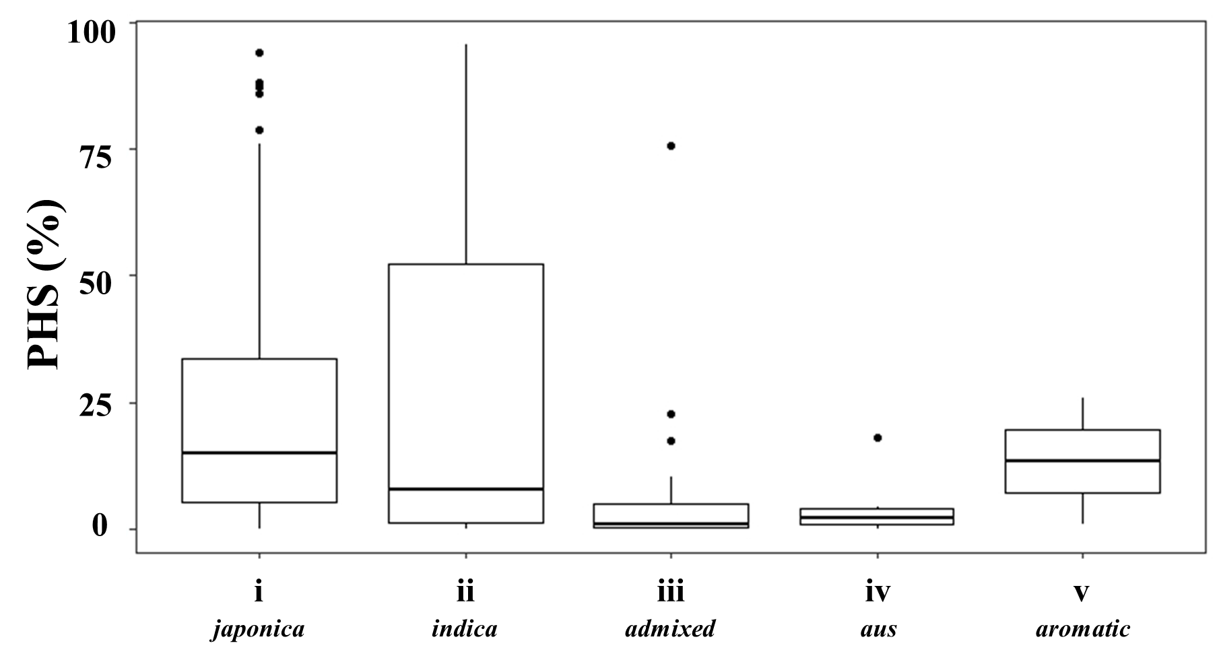
Fig. S1 Pre-harvest sprouting (PHS) rates of 182 rice genetic resources grouped by ecotype: i, Japonica; ii, Indica; iii, Admixed; iv, Aus; v, Aromatic. The figure illustrates variations in germination rates among ecotypes and highlights differences in PHS resistance across groups

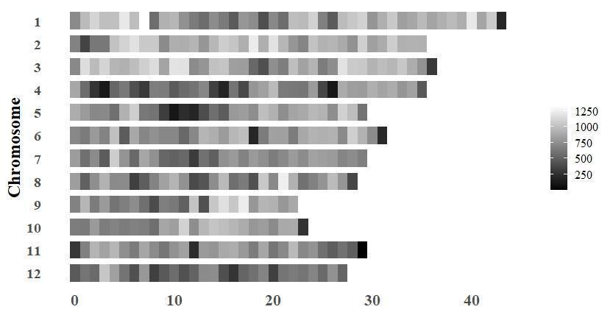
Fig. S2 SNP density on each chromosome, represented as the number of SNPs per Mb. SNP, single-nucleotide polymorphism

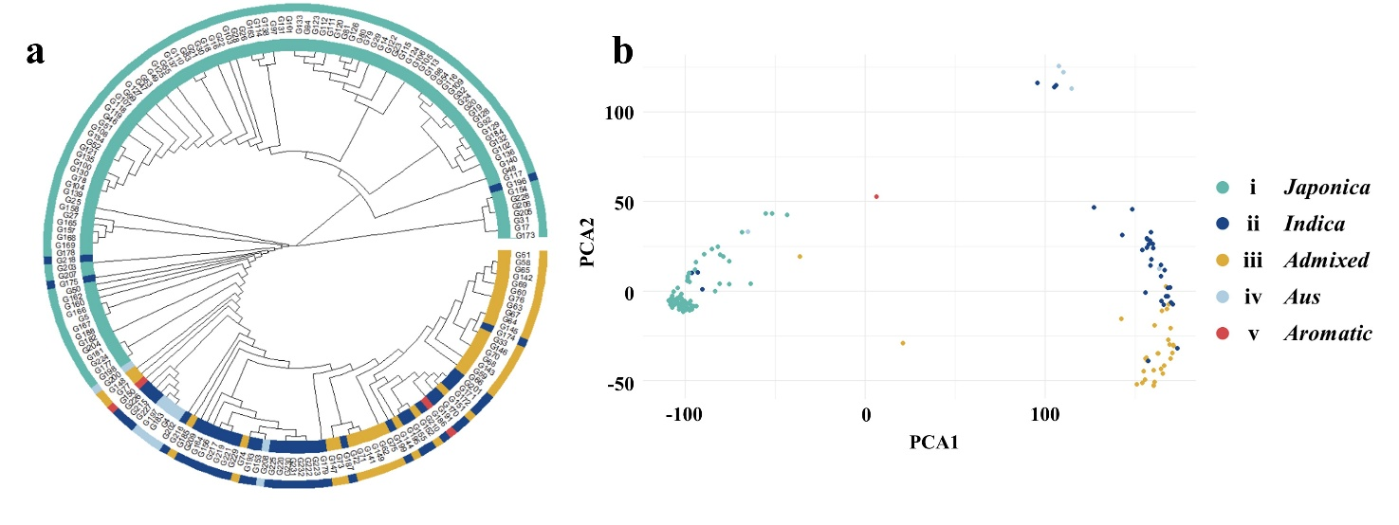Fig. S3 Genetic diversity among 182 rice genetic resources illustrated using two complementary approaches. a Phylogenetic tree constructed using the neighbor-joining method based on genome-wide SNPs. b PCA showing genetic clustering based on SNP variation. Ecotype groups are color-coded as follows: i, Japonica; ii, Indica; iii, Admixed; iv, Aus; v, Aromatic. SNP, single-nucleotide polymorphism; PCA, principal component analysis

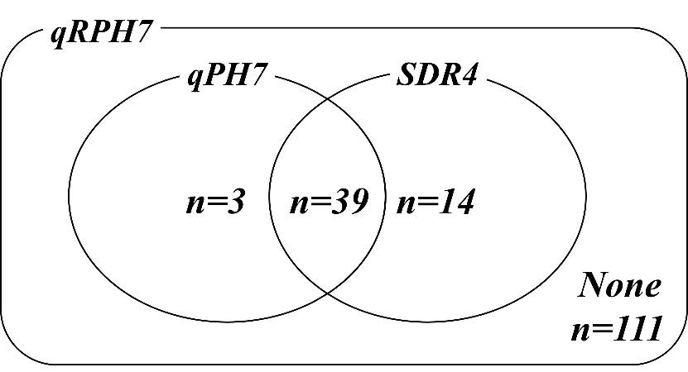
Fig. S4 Venn diagram showing the genotypic overlap between qPH7 and SDR4 among 167 rice genetic resources carrying qRPH7

